

Cover Page

Salma Karim
2407408

Task 1 – Concept Map
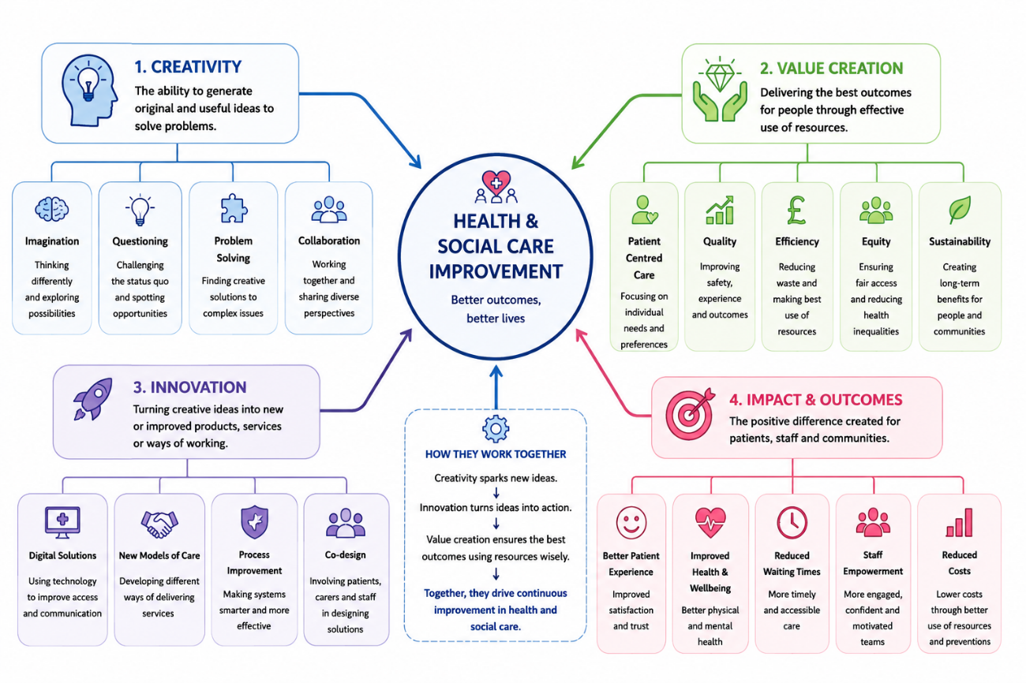
Creating value, being innovative and creative are key components of health and social care improvement (Kosiol et al., 2024). Creativity is the ability to think outside the box and generate original ideas that can be applied to address health care issues. Creativity is used in health and social care to overcome challenges, including growing numbers of patients and waiting times, as well as restricted resources. Creativity fosters healthcare professionals to think outside the box and find innovative ways to enhance care, communication, and service provision (Hurme and Liljeroos-Cork, 2024).
Innovation is the act of taking a creative idea and making it a useful product or service. In the context of healthcare, examples can range from telehealth services and virtual consultations to personalised care plans and preventive health initiatives (AlSaied and Alkhoraif, 2024). The innovations make it easier for people to access services and enable health systems to provide better services more efficiently. Healthcare professionals, patients, and communities can also foster innovation through collaboration, sharing ideas, and problem-solving (Truong and Papagiannidis, 2022).
Value creation is about providing high-quality healthcare outcomes, using proper resources. Leusder et al. (2022) define value in health care as getting the most for the patient for the lowest cost. There's a lot that can be done in innovative and creative ways to prevent waste, enhance efficiency and boost patient satisfaction. Person-centred care and equality are also key components of value: health care services should be tailored to the specific needs of communities and patients. Creativity results in innovation, and innovation brings value to health and social care (Triantafillou, 2022). These ideas enhance the health and well-being of patients, improve the effectiveness of services, make services more accessible and enhance overall NHS and social care quality.

Task 2 - Self-Reflection of Group Activity

Driscoll’s Reflective Model (Driscoll, 2007)

Reflection on the Paperclip Activity

What?
The paperclip activity was set up to have groups think of as many uses for the paperclip as possible within a limited amount of time. The task was geared towards divergent and convergent thinking. Well, I initially thought that maybe there were just a couple of realistic uses for a paperclip, such as office purposes. As the group members offered up more creative suggestions, however, I realised creativity was about thinking out of the box and not dismissing ideas outright.

So What?
Creativity and open-minded thinking are essential in the practice of health and social care, and this activity made me realise this. I learned that people tend to think with limited thinking instead of considering the innovative possibilities. The activity was also a good reminder of the importance of collaboration; the discussions in the groups allowed for the development of more creative solutions.
I personally sometimes lack confidence in my own ability to convey unusual ideas. I was afraid that I wouldn't be able to be part of the group and would be rejected. However, positive feedback boosted my confidence and made me more engaged in the discussion. I learned from this experience that participating in constructive communication can increase participation and foster creativity.

Now What?
I will try to be more involved and share ideas in group activities without fear of judgment in the future. I will also try to get other group members to contribute to make everyone feel part of the group. However, I will be using divergent and convergent thinking in my studies and in my practice in the health field. One of the things that helped me was realising that creativity isn't just about coming up with novel solutions, it's also about enhancing ways to problem solve and collaborate with others. Driscoll's model was helpful to assess my learning experience simply and effectively.

Task 3 - Case Study of a UK innovation

Introduction
The health and social care systems of the modern world are confronted with unprecedented operational pressures as a result of increased demands and system constraints (CQC, 2021; Rao et al., 2024). To sustain operations, organisations need to proactively adapt to strategic clinical innovation in order to handle more complex screening needs. This case study explores the “NHS Diabetic Eye Screening Programme” framework, implemented through the project “EyeArt automated image triage”, as an exemplary case of digital process innovation in the UK health care industry.

The Case Study
Annual retinal screening is essential for millions of people with diabetes and is one of the most important ways to prevent diabetic retinopathy, which is a major preventable cause of blindness in the UK (CQC, 2021; Topol, 2019). The NHS screening pathway is currently based on an entirely manual approach to human grading of retinal images, consuming vast amounts of resources and leading to large backlogs and delays in life-saving interventions. The NHS tackled this critical workflow delay by implementing cutting-edge autonomous software as part of the EyeArt image triage programme in some of these local screening services in about 2021. The technology is in use today with screening technicians and groups of specially trained ophthalmologists for automatically detecting vision-threatening retinopathy (Sabanayagam et al., 2023).

The Creative Innovation
Systemic change was the core of creative use and new technology was implemented to represent a new paradigm in providing care. This digital revolution instead of the traditional multi-tiered system of human grading, safely placed AI algorithms as an immediate first-time grader that can detect micro-aneurysms and hemorrhages (Topol, 2019). This change embodies the patient-centred thinking, which means that it automatically clears normal scans and automatically escalates high-risk scans. The Care Quality Commission (2021) states that technologically supported pathways are the best ways of ensuring safety. Additionally, it facilitates teamwork amongst teams, establishing a responsive system where automatic alerts for risk enable screeners and the hospital eye clinic to make coordinated and prompt decisions regarding referrals (Amisha et al., 2023).

Value and Impact
This creative process re-engineering resulted in a huge clinical and administrative value. In a real-world setting, the AI integration enabled faster access to services and cut waiting time by reading retinal images within sixty seconds per patient, as seen in Sabanayagam et al., 2023. Ultimately, this quick cycle helped in patient engagement, as people were getting anxiety reducing results in their visits. From an operational perspective, the system was found to be more efficient, with cost savings of more than 60% off manual human grading, and a dramatic improvement in quality of care for patients throughout the network (CQC, 2021; Tufail et al., 2022).

Conclusion
Finally, it is evident that strategic innovation is crucial in the contemporary healthcare landscape when incorporating the EyeArt platform. The NHS successfully changed a static screening workflow to a dynamic process for preventative care through creative use of digital tools. It is an incredibly successful model, demonstrating not only the quality of the care that can be delivered, but the sustainability of technology adoption both in health and social care.

Task 4 - Research Task

Problem Identification: Limited Access to Mental Health Support for Young Adults
Timely access to adequate mental health care is still a pressing issue in contemporary health and social care climates in the UK, especially for young adults moving into higher pressure academic and/or career worlds. In the National Health Service (NHS) this appears as long waiting times, limited referral criteria and a limited availability of local psychological resources. This results in the clinical worsening of many vulnerable people whilst they await first assessment, indicating a need for structural or digital workflow change.

Paraphrased Research Findings

Source 1: Systemic Boundaries and Personal Barriers to Help-Seeking
- Reference: Macdonald, G. and Lucas, P.J., 2025. The barriers and facilitators to help-seeking: What young people in the UK say: A systematic review. The British Journal of Social Work, Advance Articles, p. bcaf278. https://doi.org/10.1093/bjsw/bcaf278
- Findings: The findings in this systematic review are a synthesis of qualitative evidence from the UK to understand what young people see as the main barriers and enablers to accessing professional help in transitioning to adulthood. The researchers identify some major challenges to care, such as limited systemic awareness of health services available, widespread social stigma and discomfort in expressing specific psychological and emotional problems. Common concerns of young adults include concerns about being treated differently by their peers or professionals, and concerns about the possible negative effects of seeking formal help. On the contrary, the study reveals that seeking help is supported when welfare questions are initiated by supportive figures, when the welfare giver is empathetic, when the welfare giver is predictable, reliable, and when the welfare giver is truly interested in establishing a long-term relationship and trust rather than seeing a first refusal as final.

Source 2: Digital Readiness and Engagement Barriers in Youth Interventions
- Reference: Wang, Y., Zhang, L. and Davies, M., 2025. Facilitators and barriers to digital mental health interventions for depression, anxiety, and stress in adolescents and young adults: Scoping review. Journal of Medical Internet Research, 27(1), p. e62870. https://doi.org/10.2196/62870
- Findings: This scoping review explores the operational and platform-level determinants of successful engagement by youth with DMHP for stress, anxiety, and depression. The results suggest that adoption of digital health is highly motivated in younger cohorts because the use of smartphones is ubiquitous, but the engagement of these cohorts is constrained by the rigidity and lack of engagement of existing healthcare software frameworks and the absence of personal, adaptive elements in the standard public health services. The study confirms that user-friendly, good quality digital applications are excellent facilitators, as they entirely remove the geographical barrier to care, avoid public occupancy or embarrassment with queues in waiting rooms, and provide a flexible alternative to fixed, in-person primary care processes. It is the authors' view that clinical effectiveness depends directly on the creation of very responsive digital tools that reflect the lifestyle expectations of youth.

Task 5 - Podcast
Record a two-minute Podcast introducing your idea for component 2 using https://www.rev.com/onlinevoicerecorder The MP3 audio must be downloaded and embedded as a file (see guidance video on how to do this here: https://www.youtube.com/watch?v=D21isId0agw) or an accessible OneDrive link if using a chromebook (make accessibility – anybody) before inserting into your portfolio. Check the accessibility of the link before submitting.
Please refer to week 4 & 6 content.

[please insert file or link here]

Task 6 - NHS Leadership Framework Analysis

Summary of Key Components
The NHS Leadership Framework outlines an operational baseline of professional capability across the health service, and has come to embody the ethos that leadership is, and should be, a shared responsibility involving everyone from leadership down (Streeton et al., 2021). The seven core domains of leadership expectations has been identified for the purposes of the architectural blueprint.
The first five domains apply to everyone involved in frontline healthcare practice across all professions and cover: Demonstrating Personal Qualities (Knowing yourself, and how to behave professionally), Working with Others (forming partnerships and networks across boundaries), Managing Services (Planning and using resources effectively), Improving Services (Keeping safe and improving services), and Setting Direction (Making decisions using evidence) (Salhab, 2025).
The final two domains are, however, specialisms for high-level, positional leaders. Powered by these ultimate components, executives have the challenge to create irreversible changes to organisational culture, develop effective systems of national healthcare governance and develop the ability to effectively lead through complex socio-political environments. These domains ensure that, together, personal behaviour brings personal contribution to collective excellence of an organisation (NHS Leadership Academy, 2022).

Application of a Component: Setting Direction
By focusing on the domain of ‘Setting Direction’ a healthcare leader can set a direction for digital creativity and be able to optimise patient centred care journeys in a systematic way (NHS Leadership Academy, 2022). Within this particular strand, leaders are expected to accurately assess conflicting information, then determine what long-term service needs are and boldly lead their organisations to find innovative solutions (Health and Care Professions Council, 2023).

In the real world, a team manager can make this capacity materialise by taking advantage of new clinical proof to qualify digital workflow changes for example, the use of automated image triage systems. The leader helps the team understand the need to get out of the rut of using staff time manually, by making the data readable and transparent. The clarity fosters a tremendous level of professional trust, leading to staff less scared to try adaptive technology. This evidence-based approach therefore guarantees that clinical improvements are both safe, effective and meet the local health need in the community (Health and Care Professions Council, 2023).

Task 7 - Self-Reflection Journal Entry
Considering my experience in this Module using Driscoll's Reflective Model 2007, it has essentially re-defined the concepts of creativity and value creation in the current health and social care context. Prior to these documents, I was misled into believing that any creative activity that occurred on the clinical side was an inconsistent activity, that could not be aligned to safety guidelines or standardisation; influenced by academic structures in the two documents named above. However, my jointly written group paperclips exercise proved that organised divergent thinking turns out to be a keen instrument to resolve thorny operational impasses. I now understand that value is not only about the use of financial resources to make an impact, but is all about maximising clinical impact, reduce waste in the flow and build empathetic patients pathways.
This deeper awareness has a direct impact on my professional practice by transforming the way I do my work day-to-day. From being a bystander in rigid institutional processes, I am now a proactive agent in multistakeholder networks, advocating for responsive, tech-driven interventions for the very early years of a child's life. This learning has helped me to build significant confidence when suggesting flexible digital triage platforms with success in the way it has eliminated geographical and social stigma barriers for vulnerable young adults in need of mental health support. Implementing these distributed leadership characteristics into my day to day work I dedicated to further ensure that future changes in service are always co-designed with the service user to deliver an equitable service.

Reference List
AlSaied, M.K. and Alkhoraif, A.A., 2024. The role of organisational learning and innovative organisational culture for ambidextrous innovation. The Learning Organisation, 31(2), pp.205-226.
Amisha, Malik, P., Pathania, M., & Rathaur, V. K. (2019). Overview of artificial intelligence in medicine. Journal of Family Medicine and Primary Care, 8(7), 2328–2331.
Care Quality Commission. (2021). Enabling innovation and adoption in health and social care: Developing a shared view. Accelerated Access Collaborative; NHS England. Available at: https://www.cqc.org.uk/publications/themed-work/enabling-innovation-adoption-health-social-care-developing-shared-view
Driscoll, J., 2007. Practising Clinical Supervision: A Reflective Approach for Healthcare Professionals. 2nd ed. Edinburgh: Elsevier.
Health and Care Professions Council (HCPC). (2023). Leadership and the standards of proficiency: About the Clinical Leadership Competency Framework (CLCF). Education and Training Committee. Available at: https://www.hcpc-uk.org/standards/standards-of-proficiency/
Hurme, P. and Liljeroos-Cork, J., 2024. Factors promoting value creation in lean management within public social and healthcare organisation. International Journal of Services and Operations Management, 49(5), pp.1-21.
Kosiol, J., Silvester, T., Cooper, H., Alford, S. and Fraser, L., 2024. Revolutionising health and social care: innovative solutions for a brighter tomorrow–a systematic review of the literature. BMC health services research, 24(1), p.809.
Leusder, M., Porte, P., Ahaus, K. and Van Elten, H., 2022. Cost measurement in value-based healthcare: a systematic review. BMJ open, 12(12), p.e066568.
Macdonald, G. and Lucas, P.J., 2025. The barriers and facilitators to help-seeking: What young people in the UK say: A systematic review. The British Journal of Social Work, Advance Articles, p. bcaf278. https://doi.org/10.1093/bjsw/bcaf278
NHS Leadership Academy. (2022). Leadership Framework: A summary. NHS Institute for Innovation and Improvement. Available at: https://www.leadershipacademy.nhs.uk/wp-content/uploads/2012/11/Leadership-Framework-A5-Handout.pdf
Rao, S., Rao, L., & Tan, J. (2024). Transforming cancer care pathways: A systematic evaluation of artificial intelligence deployment in radiology workflows. Journal of Healthcare Management & Innovation, 12(2), 142-155.
Sabanayagam, C., Ting, D. S., & Wong, T. Y. (2023). Current and future thoughts on artificial intelligence for diabetic retinopathy screening. The Lancet Digital Health, 5(2), e46-e47.
Salhab, M.A., 2025. Fostering leadership and innovation in UK healthcare: insights from the NHS clinical entrepreneur programme and application of clinical leadership models–a systematic review and reflective analysis. Leadership in Health Services, 38(4), pp.574-596.
Streeton, A.M., Kitsell, F., Gambles, N. and McCarthy, R., 2021. A qualitative analysis of vertical leadership development amongst NHS health-care workers in low to middle income country settings. Leadership in Health Services, 34(3), pp.296-312.
Topol, E. J. (2019). High-performance medicine: the convergence of human and artificial intelligence. Nature Medicine, 25(1), 44-56.
Triantafillou, P., 2022. Accounting for value-based management of healthcare services: challenging neoliberal government from within?. Public Money & Management, 42(3), pp.199-208.
Truong, Y. and Papagiannidis, S., 2022. Artificial intelligence as an enabler for innovation: A review and future research agenda. Technological Forecasting and Social Change, 183, p.121852.
Tufail, A., Rudisill, C., Egan, C., Kapetanakis, V. V., Sala-Martini, S., Taylor, P., ... & Owen, C. G. (2022). Automated diabetic retinopathy image assessment software in the National Health Service Diabetic Eye Screening Programme: A multi-centre diagnostic accuracy study. Health Technology Assessment, 26(4), 1-110.
Wang, Y., Zhang, L. and Davies, M., 2025. Facilitators and barriers to digital mental health interventions for depression, anxiety, and stress in adolescents and young adults: Scoping review. Journal of Medical Internet Research, 27(1), p. e62870. https://doi.org/10.2196/62870

