Business Plan
By Anita Carmina Polyak

Business Plan

In today’s market starting a new business can be challenging and discouraging having regard the national and global social changes due to the pandemic Covid-19. However, this situation is also a great opportunity to make money if a person has the necessary skills, courage and budget for investing in a business.
Because I don’t like to take on huge risks, I would start an (online) grocery shop. For me this seems a good idea because the food industry must survive in any circumstances for people to have access to products to feed themselves.
The name of the shop would be given by my full name initials (Anita-Carmina Polyak) but also would give the slogan to my company: Amazing Cheap Products so the name of the business will be “ACP Store”. I will want to pursue the plan as the sole trader if I manage to gather the funds for the business, but the idea for opting for a partnership is secondary to it. If I would be forced to be in partnership probably I would choose someone with previous experience in business and not from family and friends.

Aim and objective of the business:
The business of mine will be established with the sole aim of providing the people facilities of grocery at their doorstep amid the COVID pandemic but even after for the people who are disabled and unable to go shopping for any reason. Now since people are practicing social distancing this is a great opportunity for such businesses that can provide people with facilities at their homes. People can take maximum benefits and such a business's ideas can thrive.
My business will be focused on providing groceries not just to the people but also to the food businesses. I as the business owner intend to promote the business with the facility of home delivery. The business of this nature will require a fresh stock of the things along with the facility of delivery available. The store will be located in Llanelli’s suburban area and away from the other hypermarkets because the business needs to flourish first before it develops the heat of competition.
To spread the awareness regarding the shop and its delivery service to the people I will be opting for social media marketing. Considering the present digital era, this domain of marketing is the most effective (Aspara J., Lamberg J., Laukia A., Tikkanen, 2013, pp. 459–474).
I believe most businesses of this nature have been established on such grounds and the mode of marketing. Many such businesses did not have a tangible store and a large inventory yet they were able to make themselves mainstream among the people due to their efforts in marketing. The ACP store services is a simple business idea that intends to generate its profit from the effort by providing comfort to the people of the local area. This type of business idea is extremely workable with a small amount of investment and is usually launch by a sole proprietor (Lilly, B., & Stanley, S. M., 2016, pp. 49-56).

Location of the business:
Many business owners don’t consider these factors before they start their venture but it has a significant impact on their business (Adner R., Kapoor K, 2010, pp. 306–333).
For example, setting up a market in a public place can attract more people, however, in the current situation of the COVID pandemic the ACP store can be set up on a street that has major facilities like a pharmacy. This will spread the word about my business in less time and the customers will be able to avail the facilities being provided by my brand.

Staff and Management for the supermarket business:
This business can function with fewer employees. Mainly, they require a manager and probably a supervisor (Ehrnrooth, M., & Bjorkman, 2012, pp. 1109–1135).
The managers according to the business idea can work in different shifts to make sure the delivery process does not stop (Delery, J. E., & Roumpi, 2017, pp. 1–21. My business will also require a deliveryman to proceed with the home delivery idea. The employees in such businesses cannot be rapidly hired the business is functioning on a small scale and giving them wages will be a difficult task (Crook, T. R., Todd, S. Y., Combs, J. G., Woehr, D. J., & Ketchen, 2011, pp. 443–456).
However, with time the business can employ them later when the profits increase (Coff, R. W., & Raffiee, 2015, pp. 326–341). The small amount of labour can be beneficial for the business in the initial years. This can be dependent on the firm's size for the effectiveness of its labour to make the transaction between the costing and the wage costs efficient (Coff, R. W., & Kryscynski, 2011, pp. 1429–1443). Some small businesses are unable to maintain their employee quality (Argote, L., & Miron-Spektor, 2011, pp. 1123–1137).
However, this is possible to through the application of different human resource strategies such as the following:
- I will be hiring the right people at the right time for the growth of my business. The ACP store will have to keep in mind their skills, education, and work experience. Clear job descriptions will be set and the I will need to understand the dynamics of similar businesses and the way they hire their staff. I as the owner will have to study the data that is based on the staffing, transaction, and the costing to come up with an effective competency model.
- The mission and the vision should be clear since the day it will be established. This will give me a base for establishing effective human resource strategies to keep the employees interested in their work. The future of my business will be clear and this will significantly help the business grow and meet its goals.
- The owner can perform workforce analysis as part of human resource strategies. This analysis can help the company to pinpoint the gaps and help come up with strategies that can improve those flaws.
According to many researchers conducted regarding the business domain the human resource management is often not paid attention at the start of the business. This is the major reason small businesses often don’t flourish due to their lack of attention towards the employees. The owner will be investing in the people and encouraging them to work hard (Alfes, K., Shantz, A. D., Truss, C., & Soane, 2013, pp. 330–351).
The small companies often ignore the human resource while working on small businesses because the owners are not focused on the staff rather they are more focused on the profits and cost of the inventory (Campbell, B. A., Saxton, B. M., & Banerjee, 2014, pp. 531–556). I will be hiring one or two managers to maintain the three-shift routine for the ACP store. I will be focusing on the people with a background in sales and because they can help increase, the customer input. Through the method of acquisitions, the businesses can grow with the economical boundaries and the businesses can expand, however, the process is not widely applied by the entrepreneurs by the method is effective to grow the business with few investments and better strategies. A major reason they don’t apply it to their business is that most believe that their business model should be brand new. However, with my brand, this is not possible as this idea has been applied by many businesses and has been able to generate results.
I believe my business can flourish when the owner strengthens the employees and can build stronger communication between the brand and the customers. The employees can build that by instant responses and staying true to their brand however if they do not act according to such principles the business will be destined to fail.
The people being hired by my store will be sourced based on the daily profits initially because uplifting the business will take at least two months or so. The employees will eventually be hired on the monthly wage when the profits of the business will become fixed. The usual job roles will become a sales manager in the initial period and the brand will be focused on hiring only two to three employees. This will enable the employer to maintain the cash flow.

Market Research:
Market research is essential for the growth of any business. One major aspect that requires extensive market research is the factor of marketing. Marketing is a key feature utilized by every firm and organization functional in the entire world (Collinson, 2017, pp. 131-150).
The concept of Marketing can be defined as the activity followed by a set of organizations and firms, it is a creative process that is comprised of communication, deliverance, and exchange and added value of the customer and product. This helps increase the firm's market presence and performance and the international marketing strategy as a whole. The firms usually think out of the box when it comes to marketing because the content should approach the diverse population and not just one particular community (Glick, W., Tsui, A., & Davis, 2018), pp. 32-37).
The firms can increase and decrease their sales prices based on cost reduction improved delivery times and this will ultimately increase the company’s international market performance. The effect of marketing management is larger than usually anticipated because their strategies may include product differentiation and customer trust. Many businesses fail or fail to reach the global spectrum because of a lack of knowledge (Bocconcelli, R., Cioppi, M., Fortezza, F., Francioni, B., Pagano, A., Savelli, E., & Splendiani, 2018, pp. 227-254).
They don’t have the accurate methods adapted from the marketing literature to develop the strategies that will reach more people and create brand awareness on a larger level. the market literature is equipped with knowledge regarding the global marketing environment factors, diverse buyers characteristics, effective global marketing ethics, and the impact of other factors on the value of the products. The inadequate understanding of the marketing strategies has created obstacles for the company’s money matters and sales, materials and production, product value, and human resource (Collinson, 2017, pp. 131-150).
The concept of social media marketing is being applied by many business ventures to sell their products to their target audience. Some very basic strategies that my store will be using are:
- Setting up a Facebook page is free. Hence, the page can be designed to target the locals. The page can showcase the products with images and even posts that cover the benefits of consuming the products.
- Similarly, Facebook ads are a cheaper source of marketing and have been able to generate revenue for numerous businesses. These ads do not need a professional to design and launch.
- Attracting the audience of the advertisements through a free home delivery facility.
- Another great source of social media marketing is the sending of already established and well-known bloggers public relations packages of the product you sell. Most businesses opt for the bloggers that are local so that the brand can get the local audience to choose their brand more than the rivals.
- People respond to giveaways. The ACP Store can also have a weekly or a monthly give away that they can announce on their page.
- Another major source of attracting audiences in the time of COVID 19 can be printing flyers and distributing them to the local pharmacy stores. However, this is not a social media marketing strategy but it can have a great impact on the business growth modal.
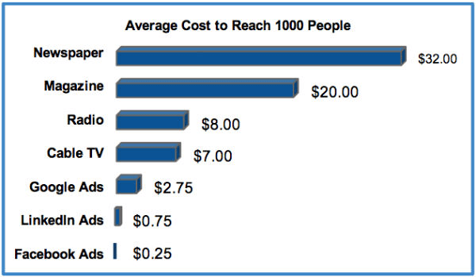

Financial Resources:
I intend to start the venture with my investment. I have also considered to opt for a partnership or even a bank loan that can help me with this cause. Usually, starting a small business with personal savings and investments becomes a risk and many brands suggest avoiding. This can even lead to low motivation towards the venture as the business will not owe anything to anyone and I will at some point lose interest in developing the brand more. However, if I am developing the venture with someone else's investment then I will be determined to generate a target profit and repay the dues.
As the business owner I will be faced with the challenge of developing a financial plan that has the potential for two years and is elaborate. The financial plan will cover the cost, product, and sales. Some hypothetical drafts for the ACP Store financial plan are presented below.

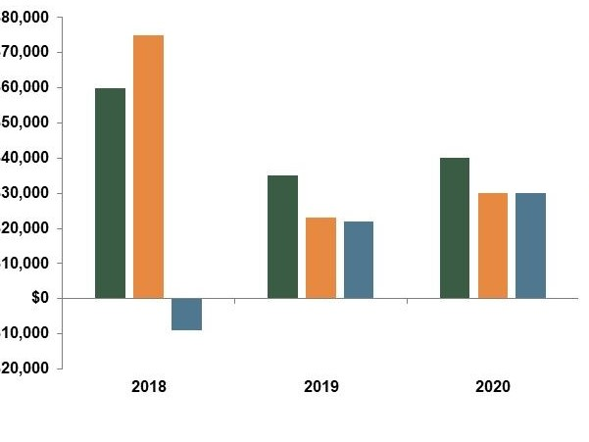

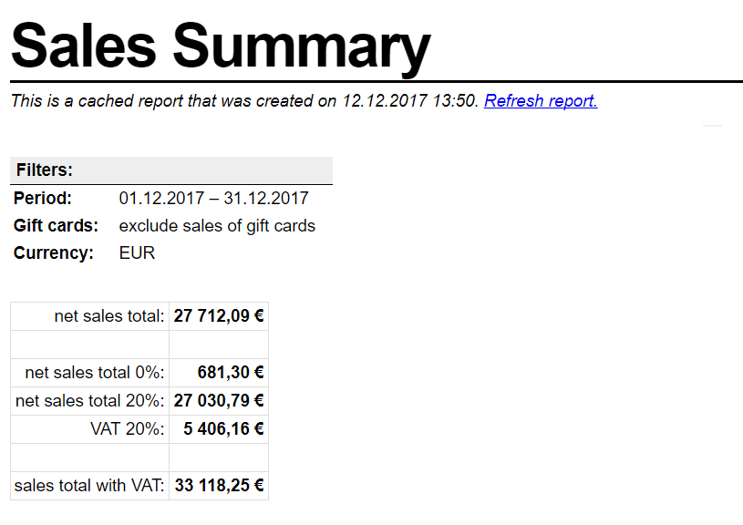

The financial plan will be able to help determine what items have been profitable for my business and that items need to be promoted more in the general public. This plan will also be able to set the marketing budget for the promotion of the store and its overall development. The plan will be elaborate and will cover the total expenses budget which will be approximately twenty-three thousand pounds in the initial business years. This amount will be further divided into four-part according to the financial plan:
- The store and staff maintenance
- Supply and inventory
- Marketing
- Saving

ONE-YEAR FINANCIAL PLAN
Total Investment | £ 28,000
Total Budget | £ 23,000
Product and Inventory | £10,000
Delivery Service Investment | £ 7,000
Store Maintenance | £ 1,200 – 1,500
Employees | £ 3,700 – 5,000

The store target will be to surpass the budget and develop a sales mark-up of at least ten percent more than the total investment. This plan will be a yearly plan. Another similar but smaller quarterly financial plan will be determined to cover the major and minor store maintenance and delivery service maintenance. Since the delivery service is free of cost the store I will have to include the fuel and vehicle services in the financial plan as well. All these things will be covered and they will help construct the business modal more elaborately.
These minor details that are being included in the financial plan will be able to bring a larger impact of growth in the business venture I as the business owner will be prepared to deal with setbacks because the working on every little aspect will be done beforehand. Hence, a financial plan is a crucial part of any business idea because it can determine the future chances of growth of that business and its potential to fulfil the public demand.

Product Selection Criteria:
Since the superstores require fresh supply to fulfil, the public demand at the ACP store we will follow the three major guidelines for the effective supply of the inventory.
A market survey before launching the brand can help the store to know what products their customers require. In the current pandemic, most customers will be looking to buy the essential items from their grocery list. Hence, I will be designing a small survey that can be circulated online in the local community. This will enable me to know which products are in high demand.
Most storeowners start by buying bulk inventory, which often goes to waste. We will firmly avoid that approach for our brand since the store will be built on small premises maintaining large product inventory for a small business like the ACP store. Investing in a large inventory can be a huge set back if any of it goes to waste in the initial stage of setting up the business. Hence, in this case, more is not better however, we will be maintaining the inventory according to the customer demand and I believe it is the best approach. The store will initially opt for cheaper products that can be sold in a limited period these products eventually mean higher sale volume and the expensive products in such cases have a lower margin and increase the store expenses. They are very poor at generating profit for the business. I will be focused on maintaining a balance between the products and the sale. I believe this will be able to produce a higher margin in this way. With cheaper products and better quality, it can also be maintained and the customers are also satisfied. The products will be selected considering the current market scenario and that will be able to establish a price list for the products that will be sold at the store. The product selection criteria will target customers from both premium quality and cheaper opting customers. I believe these key steps have been approached by small and large businesses to maintain their customer trust in them and generate profit. By applying these steps, they have been able to develop their products that were based on the market survey and the customers that have been attached to them since the initial business years.

Waste Control Strategies:
Since this is a grocery store and it functions solely on the home delivery services for now. There may be incidents when some of the products might go to waste. However, there have been strategies that my store will use.
These strategies are:
Some products have a very short shelf life and expiration date. These products expiration date and shelf life can be tracked and when a product is three weeks near its expiration date it can be donated to goodwill or charity so that it can be consumed. Many businesses in the world are applying this idea and when their products are about to go bad like before a month they either donate them or keep them outside their store for homeless person goodwill (Abdelkafi N., Täuscher, 2016, pp. 74–96).
- Another strategy that we will be applying is the commonly used recycling strategy. The products that can be recycled can be given to such organizations. However, there are not many options considering the current COVID situation hence, as the store owner I can also take matters into her own hands and minimize the waste being produced.

Growth and Development:
As its owner, I believe that the store has many chances of growth because it is being launched in the time when people are avoiding going out. Another factor that will contribute to its growth is that it is not a complicated business plan. A grocery store can be workable in the locality due to the area being suburban. This will positively affect business growth.
As the business owner I have no prior experience of leading such a business venture which can affect the decisions in the future however, I do have the capability to manage the employees. The business idea will be efficient and functional if I give my full potential and stay active. There have been numerous examples where the business owners had to present themselves in the initial years of the business and later onwards they were able to work solely as the owners and not the marketers. These certain factors indicate that to make a business successful it is essential that the owners are willing to completely participate in all the business-related activities (Amit R., Zott, 2015, pp. 331–350).
The hiring procedure of my business venture will be very thorough since the managers will have all the responsibility in the initial years of my store. The mangers can be hired considering their social skills and their capability to and the social media management as well. Since the business will be working with grocery products, I as the store owner will have to make sure the word is spread fast regarding my business for the business to grow.
The growth prospects of this business are very concrete and require extreme efforts from me initially, and later the staff working in the store. Later, when the store develops a reputation I intend to introduce more products and even an ACP’s line of products. At this point, this will be a safe investment and the business will be strong enough to handle setbacks.

Strengths of ACP Store:
The strengths of this business modal can be its time of launch and the public being approached. Amid the crisis of COVID 19, a home delivery grocery business has a great chance of success and can become popular in a very short period if the owner invests in the right marketing tools. Another major strength of this business is that it can flourish with minimum investment because it is a small-scale business and can develop with less in the investment domain.
Another strength that has been considered by looking at the business idea that it does not require a large employee pool to become a fully functioning brand. It can be established with one employee working side by side with the owner and a good marketing strategy.

The opportunities, and threats of the business:
My business will create many opportunities for unemployed people. It will be able to provide the labor daily wager class with an opportunity to support their families in the current times of crisis. This business venture will be able to provide the local community the economic support and will serve as a ray of hope for the residents that have been dealing with the crisis along. Hence, such business ideas are very much actively supported in such times because their sole purpose is to promote goodwill among the people of a particular community.
The threats this business will face will need to be handled sufficiently. The major threat is the economic decline of the country which has impacted small and big businesses. Hence, expecting economic support from the state in such circumstances will not be assured. However, this threat will be dealt with accordingly and a backup plan will be determined to implicate another source of financing the business. Another threat that will be faced by my business is getting the supply. Considering the current scenario most suppliers do not have fresh supply or supply has been short hence, the supply will have to be searched hardly to get and then alter onwards maintained.

References
Alfes, K., Shantz, A. D., Truss, C., & Soane, E. C. (2013). The link between perceived human resource management practices, engagement and employee behaviour: A moderated mediation model. The International Journal of Human Resource Management, 24, pp. 330–351.
Argote, L., & Miron-Spektor, E. (2011). Organizational learning: From experience to knowledge. Organization Science, 22, pp. 1123–1137.
Abdelkafi N., Täuscher K. (2016). Business models for sustainability from a system dynamics perspective. Organization & Environment, 29, pp. 74–96.
Adner R., Kapoor R. (2010). Value creation in innovation ecosystems: How the structure of technological interdependence affects firm performance in new technology generations. Strategic Management Journal, 31, pp. 306–333.
Amit R., Zott C. (2015). Crafting business architecture: The antecedents of business model design. Strategic Entrepreneurship Journal, 9, pp. 331–350.
Aspara J., Hietanen J., Tikkanen H. (2010). Business model innovation vs replication: Financial performance implications of strategic emphases. Journal of Strategic Marketing, 18, pp. 39–56.
Aspara J., Lamberg J., Laukia A., Tikkanen H. (2013). Corporate business model transformation and inter-organizational cognition: The case of Nokia. Long Range Planning, 46, pp. 459–474.
Bocconcelli, R., Cioppi, M., Fortezza, F., Francioni, B., Pagano, A., Savelli, E., & Splendiani, S. (2018). SMEs and marketing: A systematic literature review. International Journal of Management Reviews, 20(2), pp. 227-254.
Campbell, B. A., Saxton, B. M., & Banerjee, P. M. (2014). Resetting the shot clock: The effect of comobility on human capital. Journal of Management, 40, pp. 531–556.
Coff, R. W., & Kryscynski, D. (2011). Drilling for micro-foundations of human capital–based competitive advantages. Journal of Management, 37, pp. 1429–1443.
Coff, R. W., & Raffiee, J. (2015). Toward a theory of perceived firm-specific human capital. Academy of Management Perspectives, 29, pp. 326–341.
Crook, T. R., Todd, S. Y., Combs, J. G., Woehr, D. J., & Ketchen, D. J. J. (2011). Does human capital matter? A meta-analysis of the relationship between human capital and firm performance. Journal of Applied Psychology, 96, pp. 443–456.
Collinson, E. (2017). Small business marketing. In A. MacLaren, T. Farrington, & K. O’Gorman (Eds.), Marketing perspectives, (131-150).
Delery, J. E., & Roumpi, D. (2017). Strategic human resource management, human capital and competitive advantage: Is the field going in circles? Human Resource Management Journal, 27(1), pp. 1–21.
Ehrnrooth, M., & Bjorkman, I. (2012). An integrative HRM process theorization: Beyond signalling effects and mutual gains. Journal of Management Studies, 49, pp. 1109–1135.
Glick, W., Tsui, A., & Davis, G. (2018). The moral dilemma of business research. BizEd, 17(3), pp. 32-37.
Lilly, B., & Stanley, S. M. (2016). Leveraging partnerships with local companies as a method of teaching sales: A constructivist approach. Journal for Advancement of Marketing Education, 24, pp. 49-56.

