DS 1 Template

My Screenshots/Photos
- Please add 4–6 screenshots or photos of your digital life.
- You can use your phone or laptop.
- For each screenshot, write one or two sentences explaining what it shows.

Screenshot/Photo 1
WhatsApp

This screenshot shows my WhatsApp chats. I use WhatsApp to communicate with my family, friends, and classmates.

Screenshot/Photo 2
Gmail Inbox
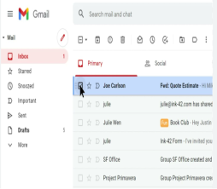
This screenshot shows my Gmail inbox. I use Gmail to receive important emails from my university and other service.

Screenshot/Photo 3
Microsoft Word
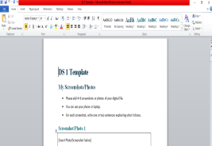
This screenshot shows my homework in Microsoft Word. I use Word to write assignments and complete my coursework.

Screenshot/Photo 4
Google

This screenshot shows Google. I use Google to search for information and find answers for my studies.

Screenshot/Photo 5
Student Module
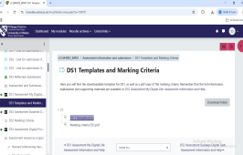
This screenshot shows my student module. I use it to check my course materials, assignments, and study information.

Screenshot/Photo 6
Laptop, Phone, and Book

This photo shows my laptop, phone, and a book. I use these tools togheter when I study and complete my work.

My Short Reflection
- Write 5–8 simple sentences about your digital life.
- You can use the sentence starters below if helpful.
I use digital tool to study, communicate, and find information. I often use WhatsApp, Gmail, Microsoft Word, Google, and my student module. I feel confident when I use these tools for my university work. I want to improve my digital skills and learn new programs. I sometimes feel nervous when I have technical problems. I hope this module will help me become more confident with technology. Digital skills are important for me because they help me study and prepare for my future career.

Sentence starters
- I use digital tools to … complete my schoolwork
- I feel confident when I …use computer
- I want to improve …my typing skills
- I often use these tools: …Microsoft Word, Google, and email
- I sometimes feel nervous about …making mistakes
- I hope this module will help me …become more confident with technology
- Digital skills are important for me because …they help me in everyday life.
You can write more if you want.

Submission Checklist
Before you submit, please check:
​​​ ☐ I added 4–6 screenshots
☐ I wrote short sentences for each screenshot
☐ I wrote my short reflection
☐ My work is my own
☐ My file opens correctly
​​☐ My file opens correctly

