
Introduction to Web and Database Concepts
CertHE Computing Skills for Workplace
ACCA4023 _LON
DR. Suresh Shanmugasundaram
University of Wales Trinity Saint David
(London Campus)
Student Name: Cinthya Vera Mendoza
Student Number: 2528123
Group: 01

Table of Contents
Introduction 3
Scenario Analysis 4
Entity Relationship Diagram (ERD). 5
Data Structure Development 6
Normalization Compliance 10
Problem with the UNF table 11
Functional Dependencies (FDs) 12
First Normal Form (1NF) 12
Second Normal Form (2NF) 14
Third Normal Form (3NF) 15
Sample Data Population 15
Query Development 19
Forms and Reports 22
Validation and testing 30
Reflection 34
Conclusion 35
References 35
Appendices 35

Introduction

Database design that is a process of decomposing data into multiple table[1].
This report is based on the design and implementation of a database using Microsoft Access for the AutoPark Management System. The main objective is to create a database that can efficiently manage information related to customers, vehicles, parking spaces, bookings, and payments. Access in just one of many relational databases[2].
Currently, the company records all its information manually, which can lead to data loss, human errors, and difficulties in managing daily operations. For this reason, this project proposes the development of a database that stores information in an organised way, making it easier to access, manage, and maintain accurate records.
In this repost, the given scenario will be analysed by identifying the main entities and relationships between them. An Entity Relationship Diagram (ERD) will be designed, followed by the creation of tables and relationships in Microsoft Access. The database will then be normalised to Third Normal Form (3NF), sample data will be added, queries will be developed, and finally, the system will be tested to ensure that it functions correctly and meets the system requirements.

Scenario Analysis

In this project, I designed a database for the AutoPark Management System. The company currently keeps its records manually, which can make managing bookings and customer.
This method increases the risk of human errors, data loss, and difficulties in managing daily operations.
To solve these problems, the company requires a database developed using Microsoft Access that can store all information in an organised and secure way.
The system will consist of different entities, including Customers, Vehicles, Parking Sites, Parking Slots, Bookings, and Payments. These entities will be related to each other to ensure data integrity and reduce data redundancy.
The implementation of this database will allow the company to access information more quickly, monitor the availability of parking spaces, manage bookings and record payments more efficiently. In addition, the database will support the generation of reports that will help management make better decisions and improve the overall performance of the parking management system.

Entity Relationship Diagram (ERD).

https://lucid.app/lucidchart/0322ceda-43e2-4eb1-b1bb-8fcaa720f7fd/edit?viewport_loc=-594%2C-702%2C3535%2C1890%2C0_0&invitationId=inv_8866edf4-9b88-482d-84f7-f3b689c22993
The diagram identifies the main entities, their attributes, primary keys, foreign keys, and the relationship them.

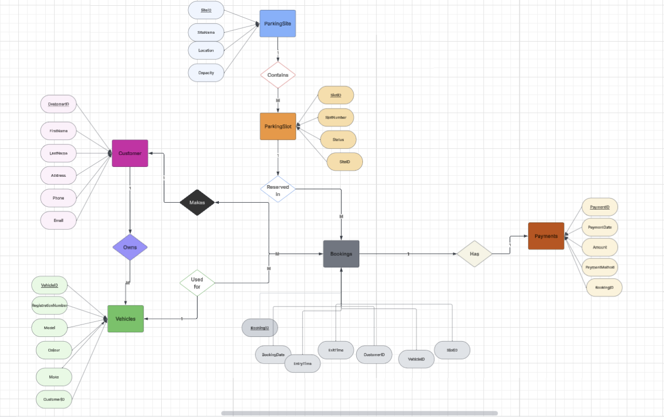
Figure 1 Entity Relationship Diagram (ERD)

Data Structure Development

Customers
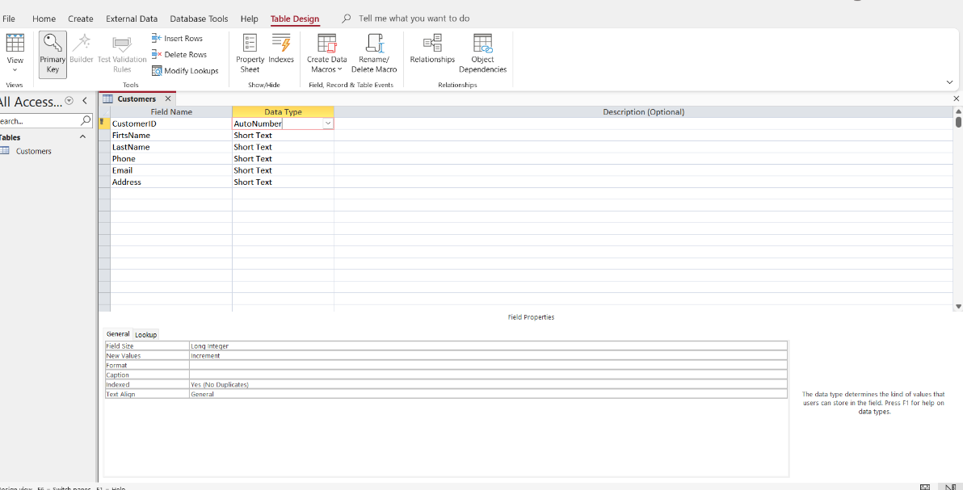
Figure 2

Vehicles
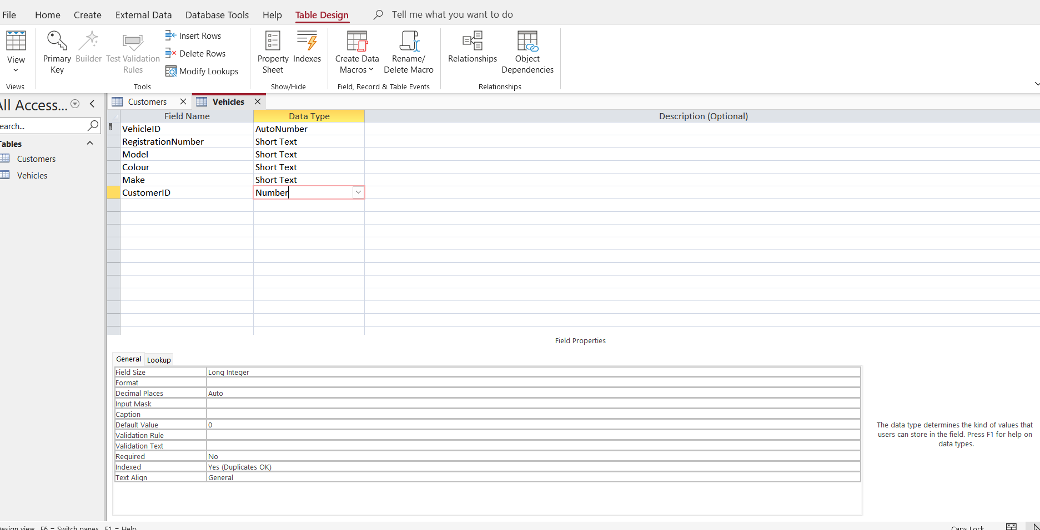
Figure 3

ParkingSites
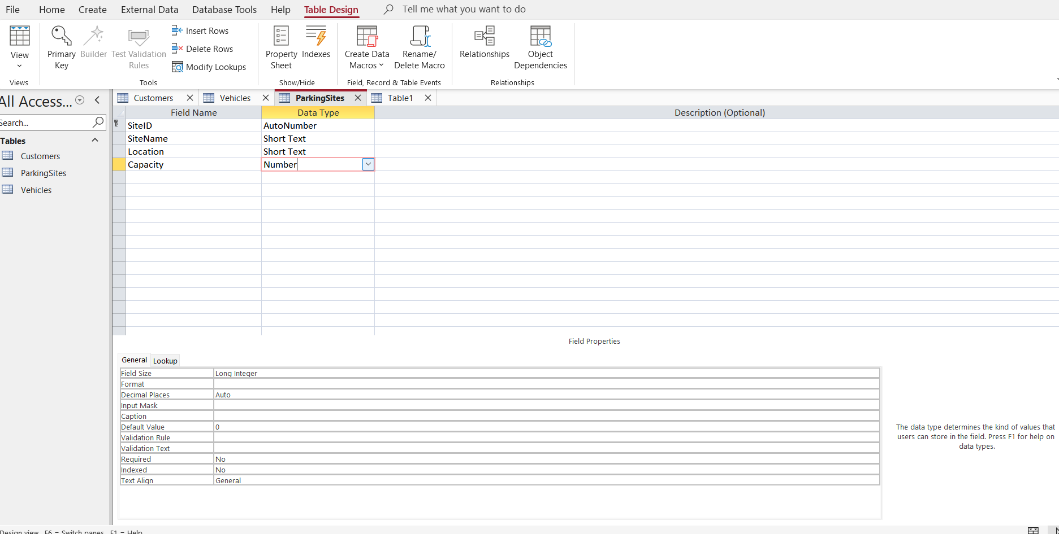
Figure 4

ParkingSlots
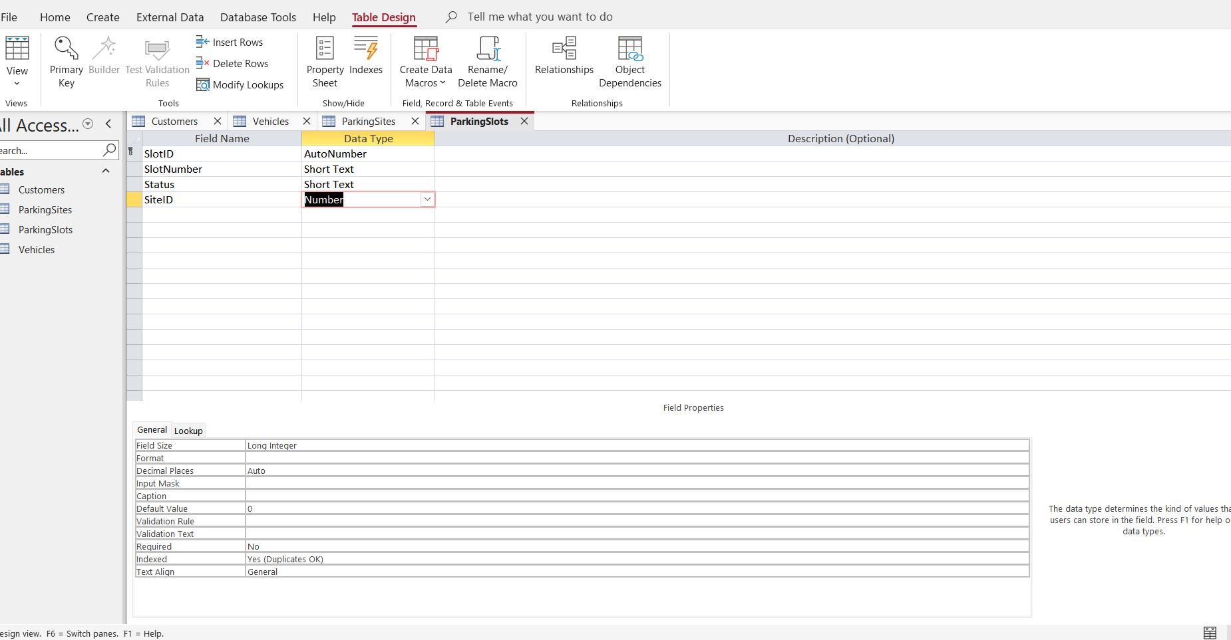
Figure 5

Bookings
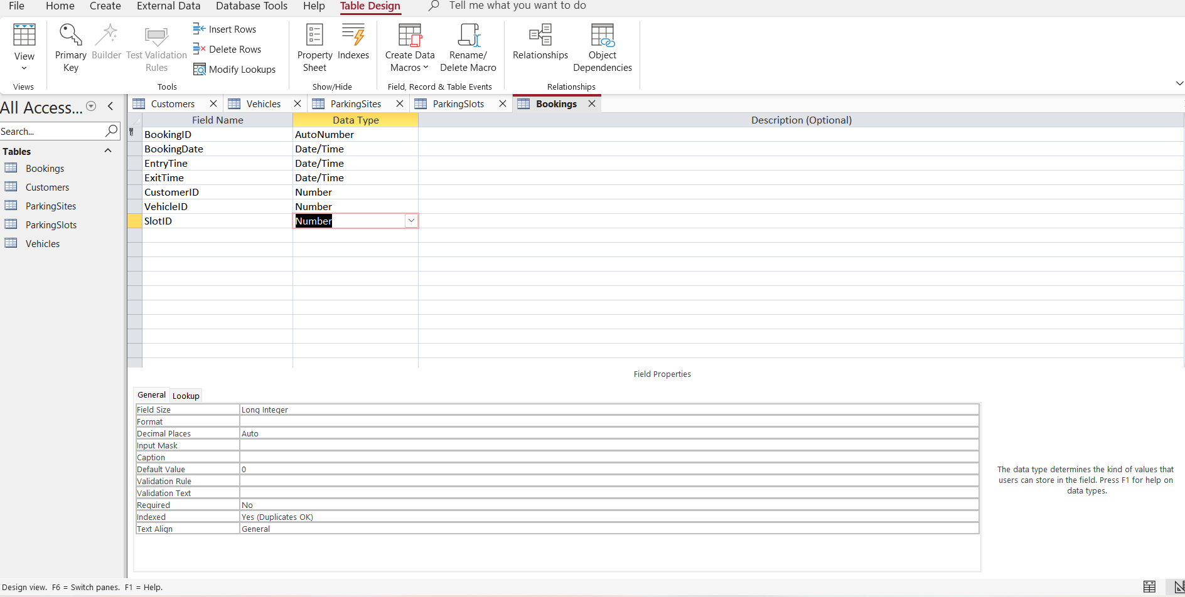
Figure 6

Payments
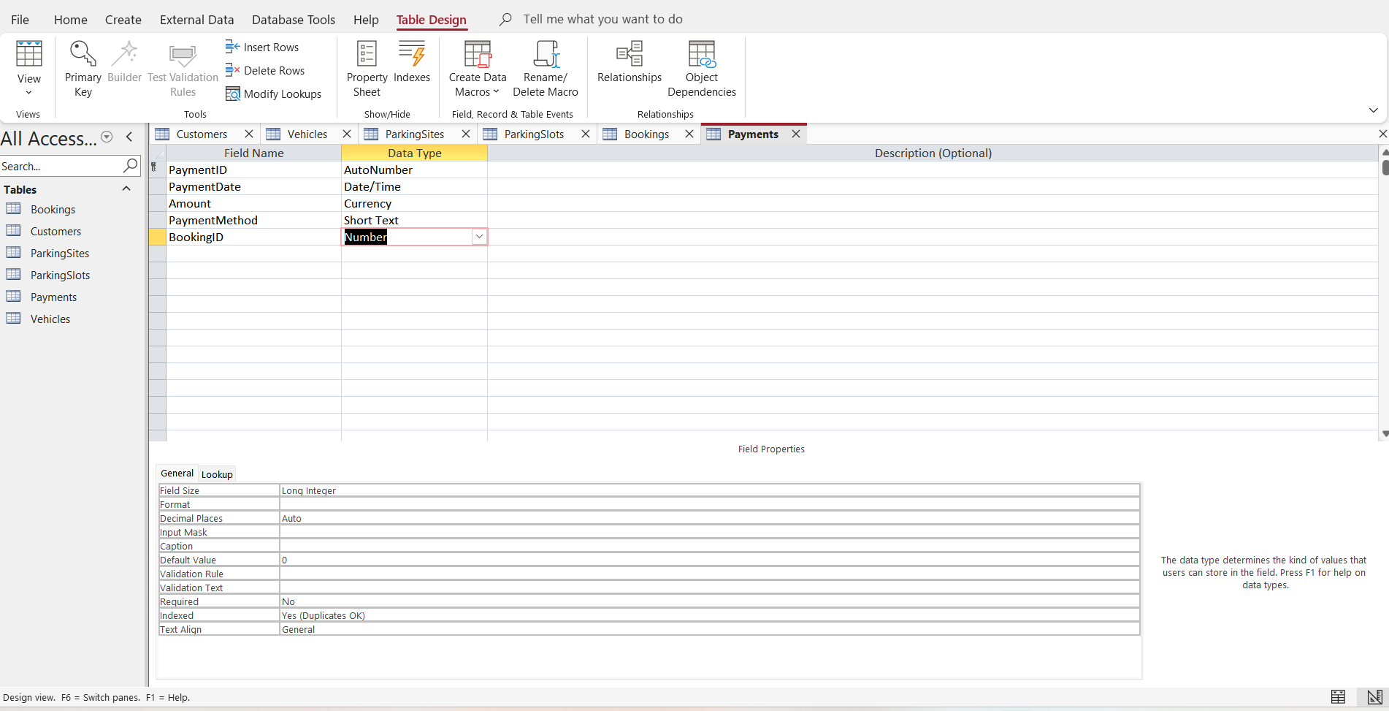
Figure 7

Relationships 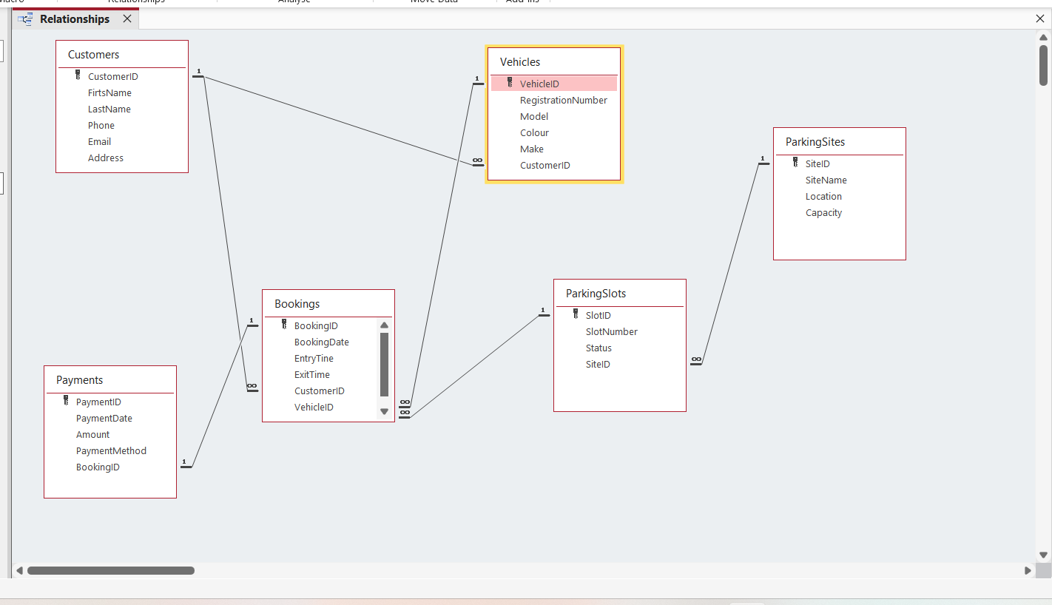
Figure 8

Customers 1 ∞ Vehicles
CustomersID --- CustomersID
Customers 1 ∞ Bookings
CustomersID --- CustomersID
Vehicles 1 ∞ Bookings
VehicleID --- VehicleID
ParkingSites 1 ∞ ParkingSlots
SiteID --- SiteID
ParkingSlots 1 ∞ Bookings
SlotID --- SlotID
Bookings 1 1 Payments
BookingID --- BookingID

Normalization Compliance
(AutoPark Management System)
5.1 Original Unnormalized Table (UNF)
BookingID | BookingDate | EntryTime | ExitTime | CustomerID | FirtsName | LastName | Phone | Email | Address | Vehicle ID | RegistrationNumber | Model | Colour | SlotID | SlotNumber | PaymentID | Amount
1 | 3/07/2026 | 08.00 | 10.00 | 1 | Selena | Smith | 07111111111 | selena@gmail.com | 15 high street | 1 | AB12CDE | Fiesta | Black | 1 | A01 | 1 | £10.00
2 | 04/07/2026 | 09.00 | 12.00 | 2 | Luciana | Brown | 07222222222 | luciana@gmai.com | 22 Exeter Road | 2 | VY34ZTR | Golf | Blue | 2 | A02 | 2 | £12.50
3 | 04/07/2026 | 11.00 | 15.00 | 3 | Ian | Johson | 07352632563 | ian@gmail.com | 8 London Road | 3 | SI45VER | Corolla | White | 3 | B01 | 3 | £15.00
4 | 05/07/2026 | 10.00 | 16.00 | 4 | Austin | Wilson | 07444444444 | austin@gmail.com | 34 Green Lane | 4 | GV38TYS | Civic | Green | 4 | B02 | 4 | £25.00
5 | 05/07/2026 | 13.00 | 17.00 | 5 | David | Vera | 07565555555 | david@gmail.com | 40 Curtis Field Road | 5 | WT98WSI | Model 3 | Red | 5 | C01 | 5 | £20.00

The AutoPark Management System was first considered as a single large table containing booking information together with customer, vehicle, parking slot, parking sites and payments details. Although the sample data only contains five bookings and therefore does not show much duplicate information, this design would become inefficient as the database grows. For example, if Customer 1 book a parking space several times, their details would have to be stored repeatedly for every booking, also the parking site and payment details would also repeated.

Problem with the UNF table
Redundancy
A single table stores information from several different entities. As more bookings are added, customer information, vehicles details and parking sites information would be repeated many times. This unnecessary duplicate increases storage requirements and makes data management less efficient.
For Example, if CustomerID 1 book five times the customer’s name, email, phone and vehicle registration number would appear five times of once.
Update Anomaly
If a customer changes their phone number or email, every booking containing that customer’s information would have to be updated. If one record is forgotten, inconsistent information would exit within the database.
For example, if Selena Smith changes her email address, every booking belonging to Selena would need to be edited individually.
Insertion Anomaly
A new customer or vehicle could not easily be added unless a booking also existed because all information is stored within the same table.
For example, a customer who has registered but has not yet made a booking cannot be stored efficiently in the database.
Deletion Anomaly
If the last booking of a customer is deleted, important information about that customer and their vehicle could be also removed.
For example, if BookingID 5 is deleted and it was David Vera’s only booking, the customer’s details and vehicle information would also disappear.

Functional Dependencies (FDs)

The following functional dependencies were identified in the AutoPark Management System:

- CustomerID FirstName, LastName, Phone, Email, Address
- VehicleID RegistrationNumber, Model, Colour, Make, CustomerID
- SiteID SiteName, Location, Capacity
- SlotID SlotNumber, Status, SiteID
- BookingID BookingDate, EntryTime, ExitTime, CustomerID, VehicleID, SlotID
- PaymentID PaymentDate, Amount, PaymentMethod, BookingID
These dependencies show that each primary key uniquely determines the remaining attributes of its own entity. This observation guided the decision to separate the original table into multiple related tables during the normalisation process.

First Normal Form (1NF)

In the First Normal Form (1NF) I removed the repeating groups and ensured that each column contain only one value.
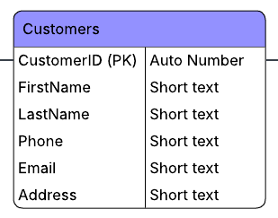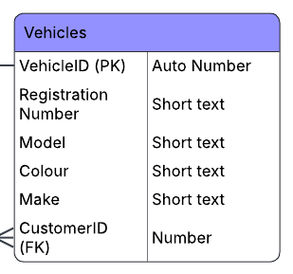
Figure 9 Customer Table Figure 10 Vehicle table

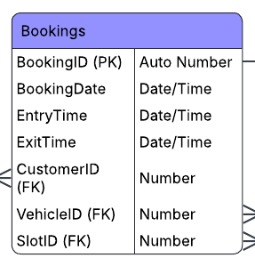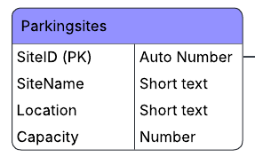
Figure 11 Booking Table Figure 12 ParkingSites Table

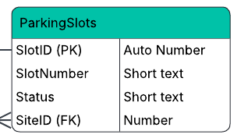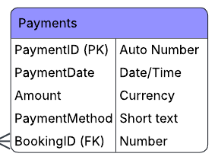
Figure 13 ParkingSlots Table Figure 14 Payments Table

The information is separated into an individual tables. This helps organise the data better and prepares the database for the next normalization stage.
Design Decisions
The first design decisions was to separate the information according to the real- world entities involved in the parking management process. Customer information was stored inly in the customer table.

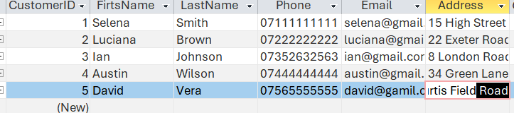

Second Normal Form (2NF)

In the Second Normal Form (2NF) I checked that all attributes depend on the primary key of each table. In my database, each table has only one primary key, and the information has been separated into Customer, Vehicles, Bookings, ParkingSite, ParkingSlot, and Payments.
Therefore, there are no partial independencies, and the table stores data about only one entity.
Design Decisions
During this stage, foreign keys were introduced to connect the tables.
The following design decisions were made achieve Second Normal Form (2NF):
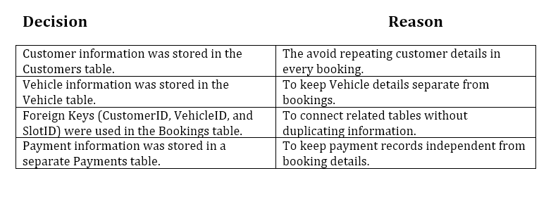
Figure 15 Design Decision after applying Second Normal Form (2NF)
These design decisions ensure that every non-key attribute depends on the whole primary key of its table. This eliminate partial dependencies and improves the organisation of the database.

Third Normal Form (3NF)

The database is in Third Normal Form (3NF) because each table stores information about a single entity.
There are no transitive dependencies, and every non-key attributes depend only on its table’s primary key. This structure improves data integrity and reduces redundancy and make database easier to maintain the information.
Design Decisions
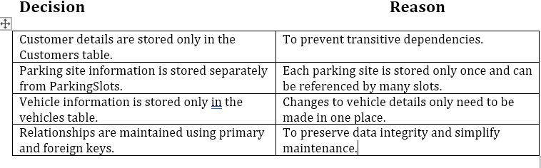
Figure 16 The data should be normalized to Third Normal Form (3NF)

Sample Data Population

Sample data was added to each table to test the database structure, relationships and referential integrity. I entered five records into the Customers, Vehicles, Bookings, ParkingSite, ParkingSlot, and Payments table.
The screenshot below shows the sample data entered into each table after the database was successfully normalised.

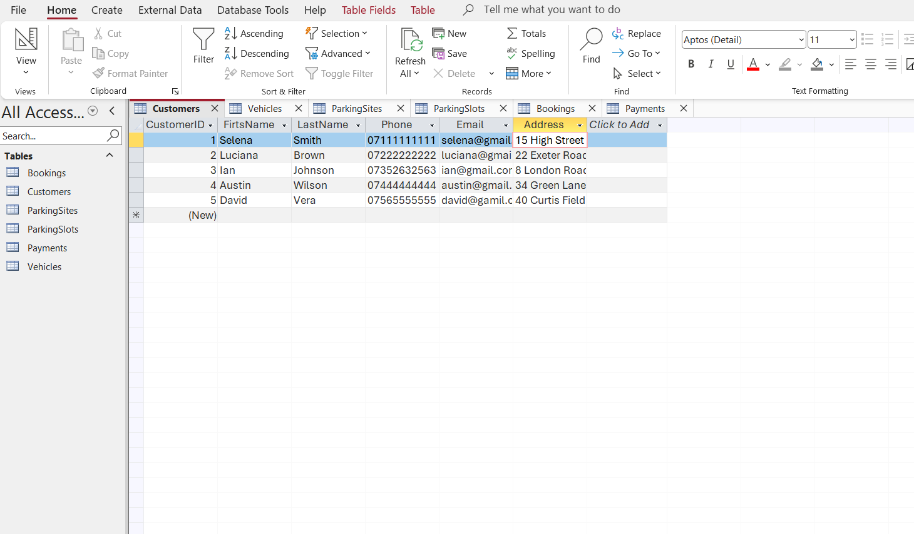
Figure 17.

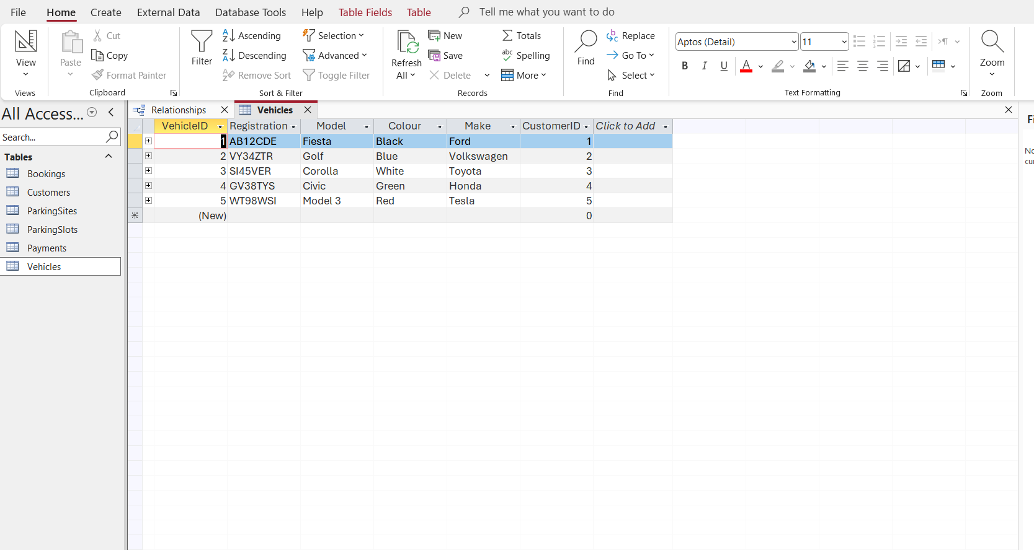
Figure 18.

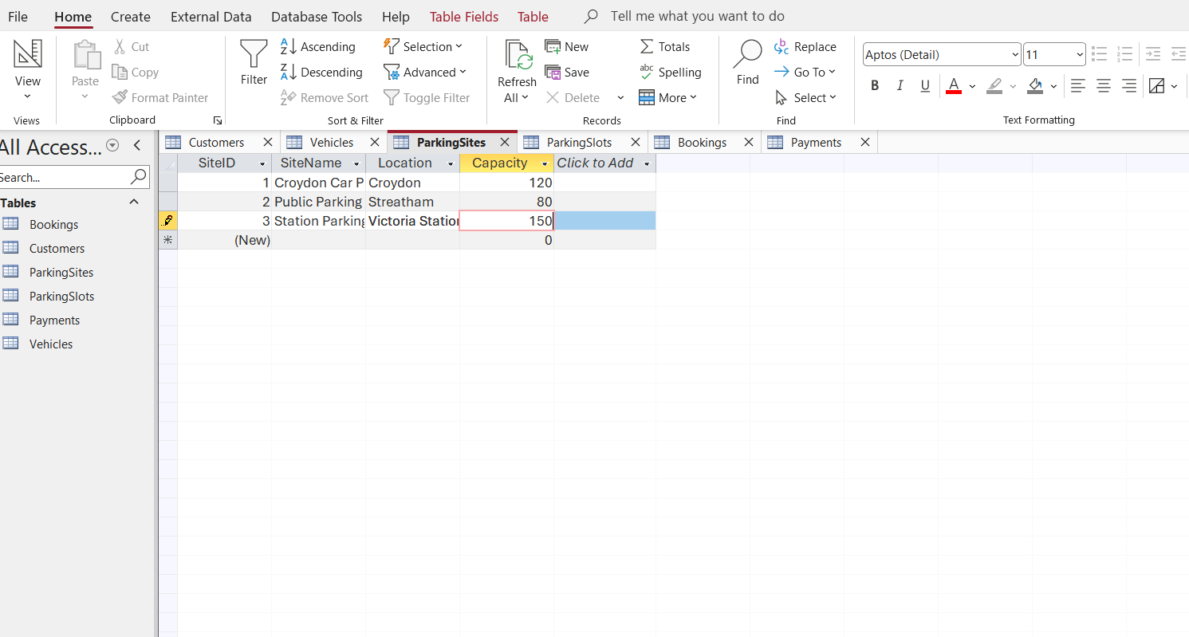
Figure 19.

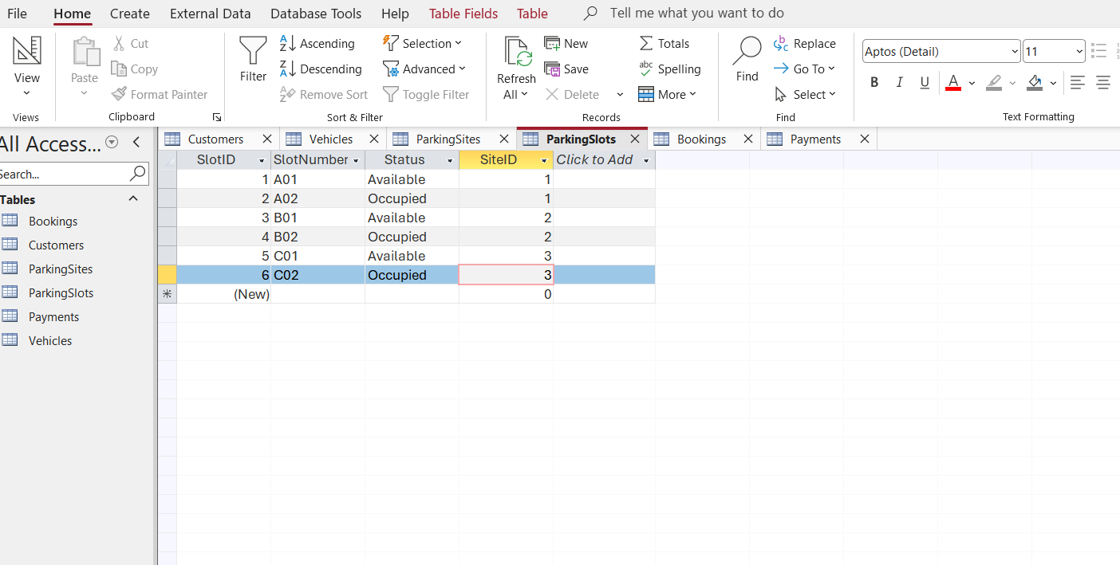
Figure 20.

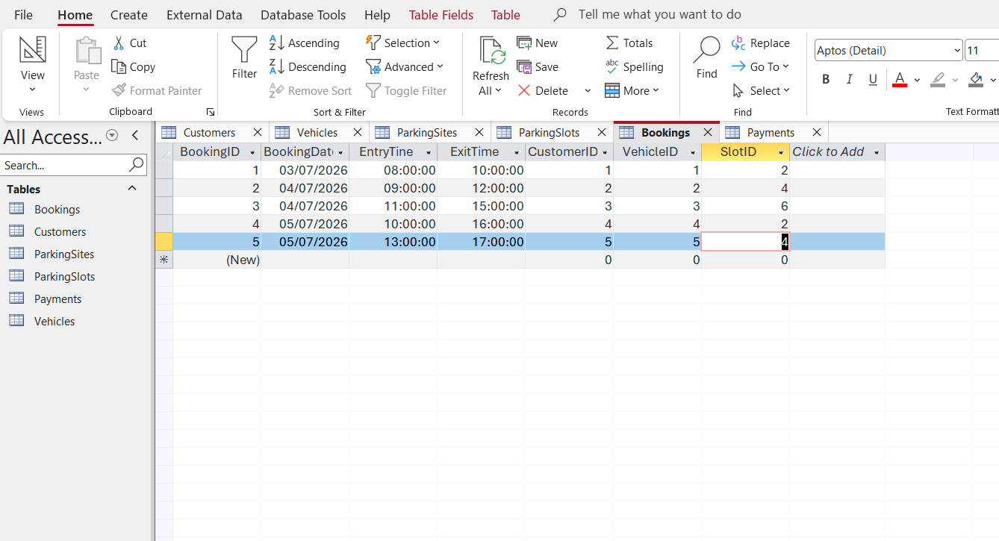
Figure 21.

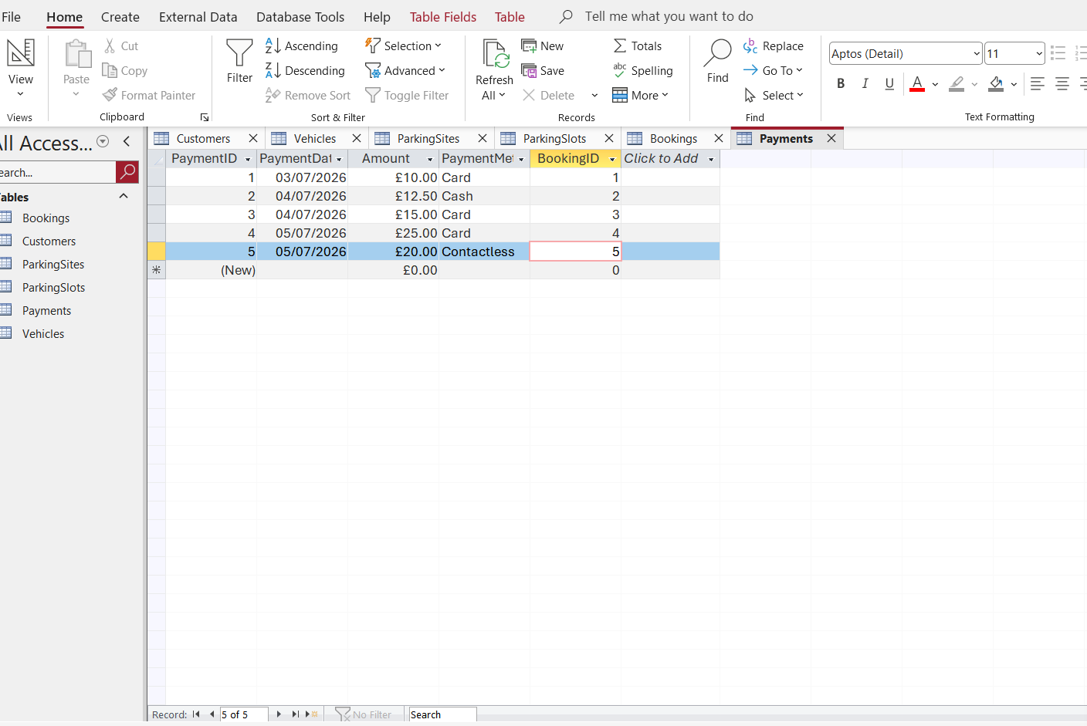
Figure 22.

Query Development

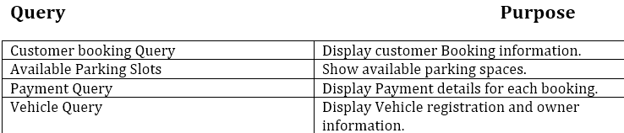

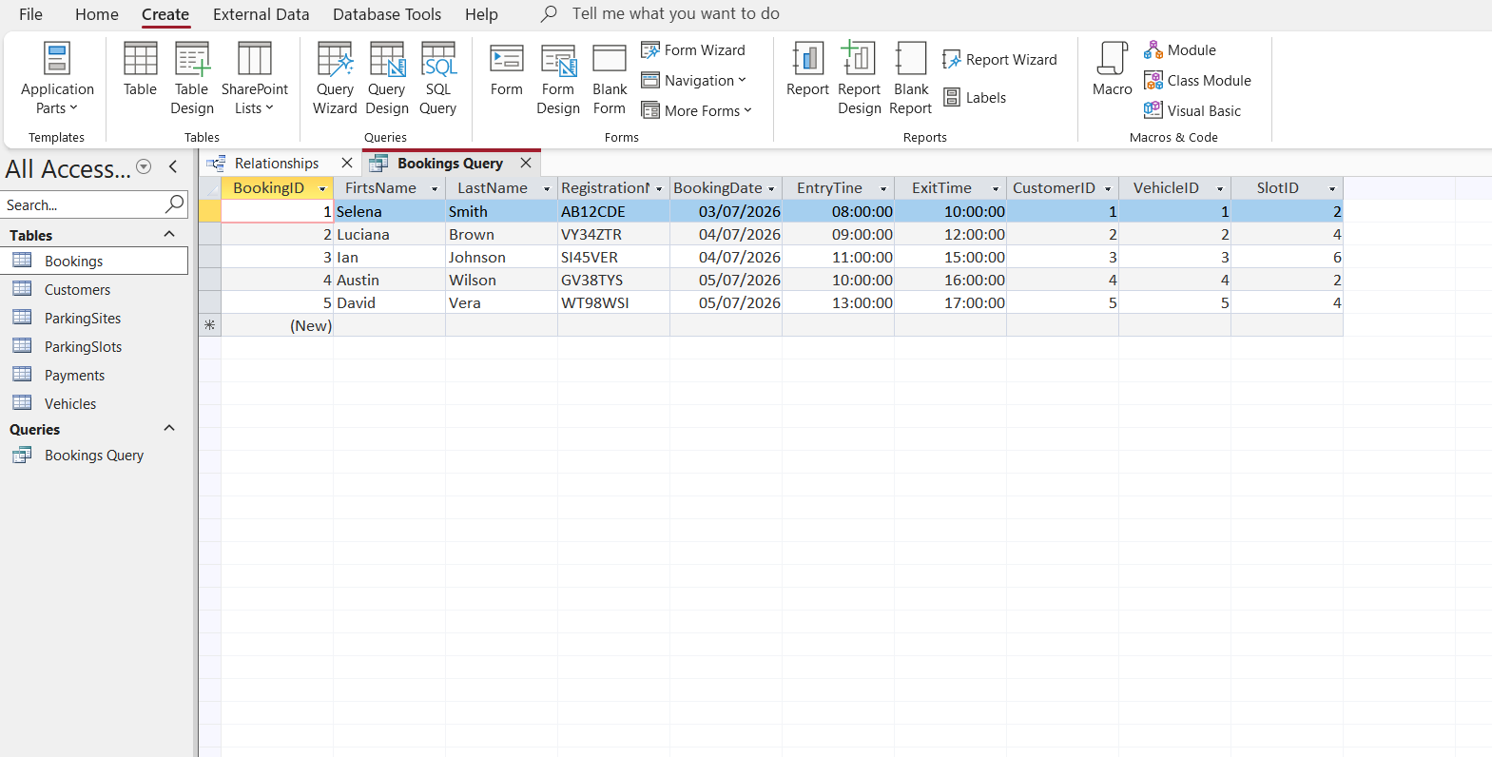
Figure 23.

Bookings Query: this query displays all booking records stored in the database.

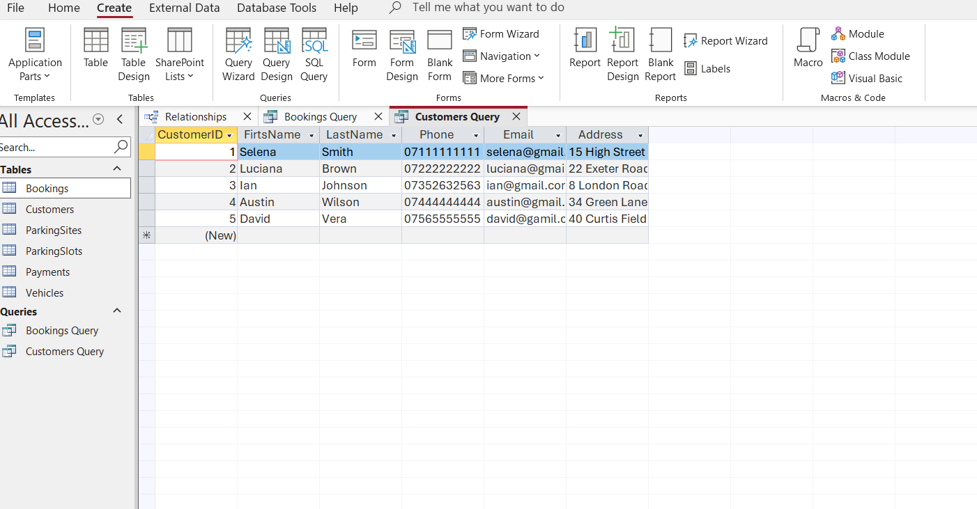
Figure 24.
Customers Query: this query displays all customer information.

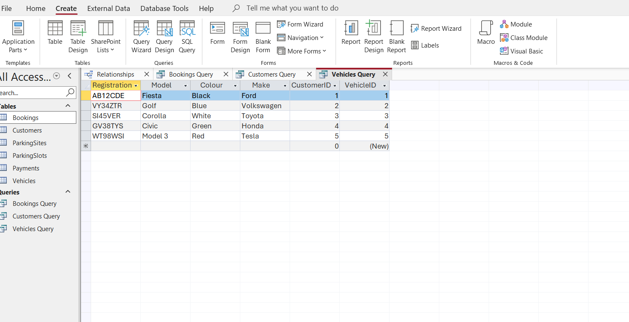
Figure 25.
Vehicles Query: this query displays all registered vehicles.

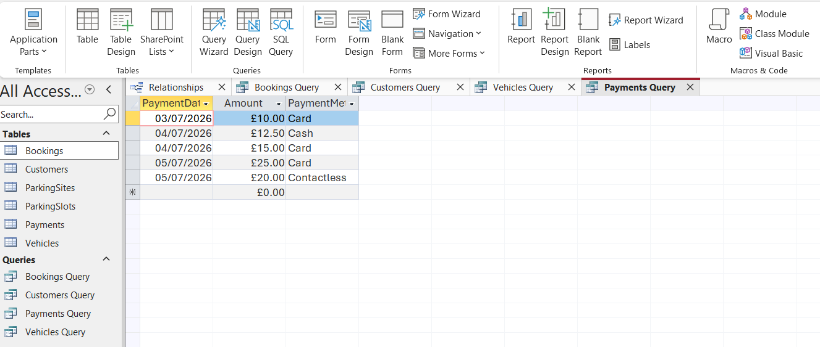
Figure 26.
Payments Query: this query displays all payment records.

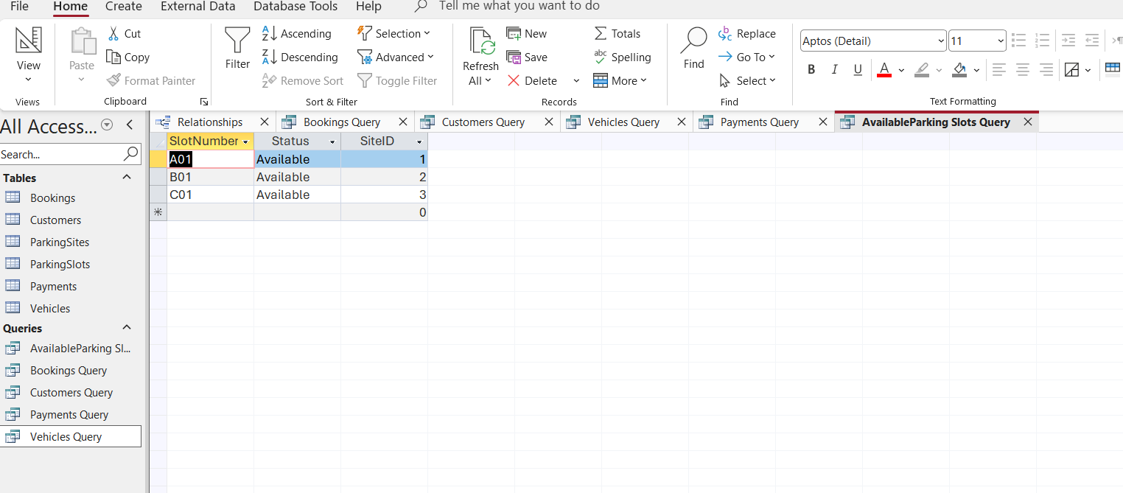
Figure 27.
Available Parking Slots Query: this query shows the parking slots that are currently available.

Forms and Reports

Booking Forms
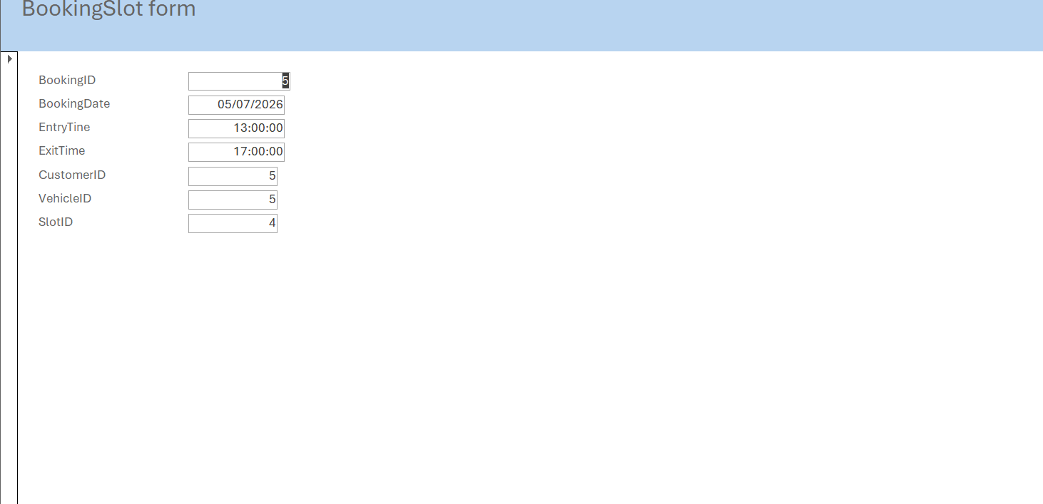
Figure 28

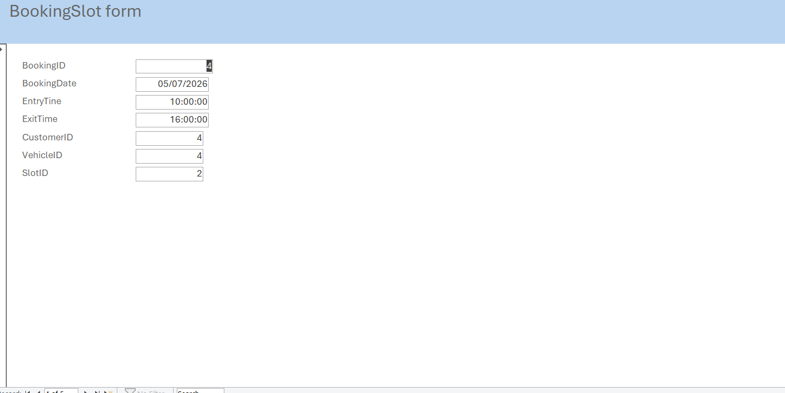
Figure 29
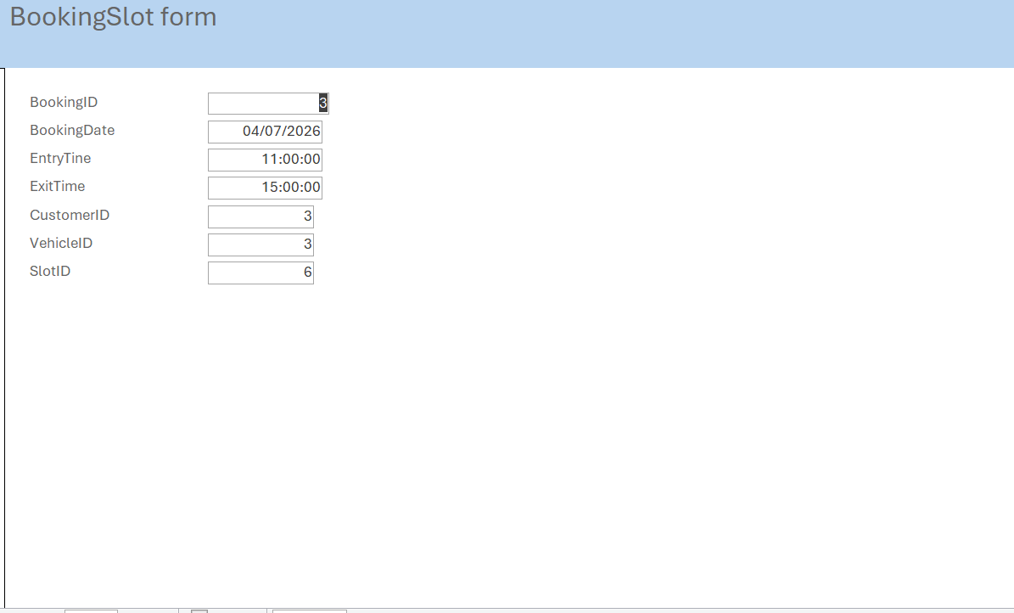
Figure 30

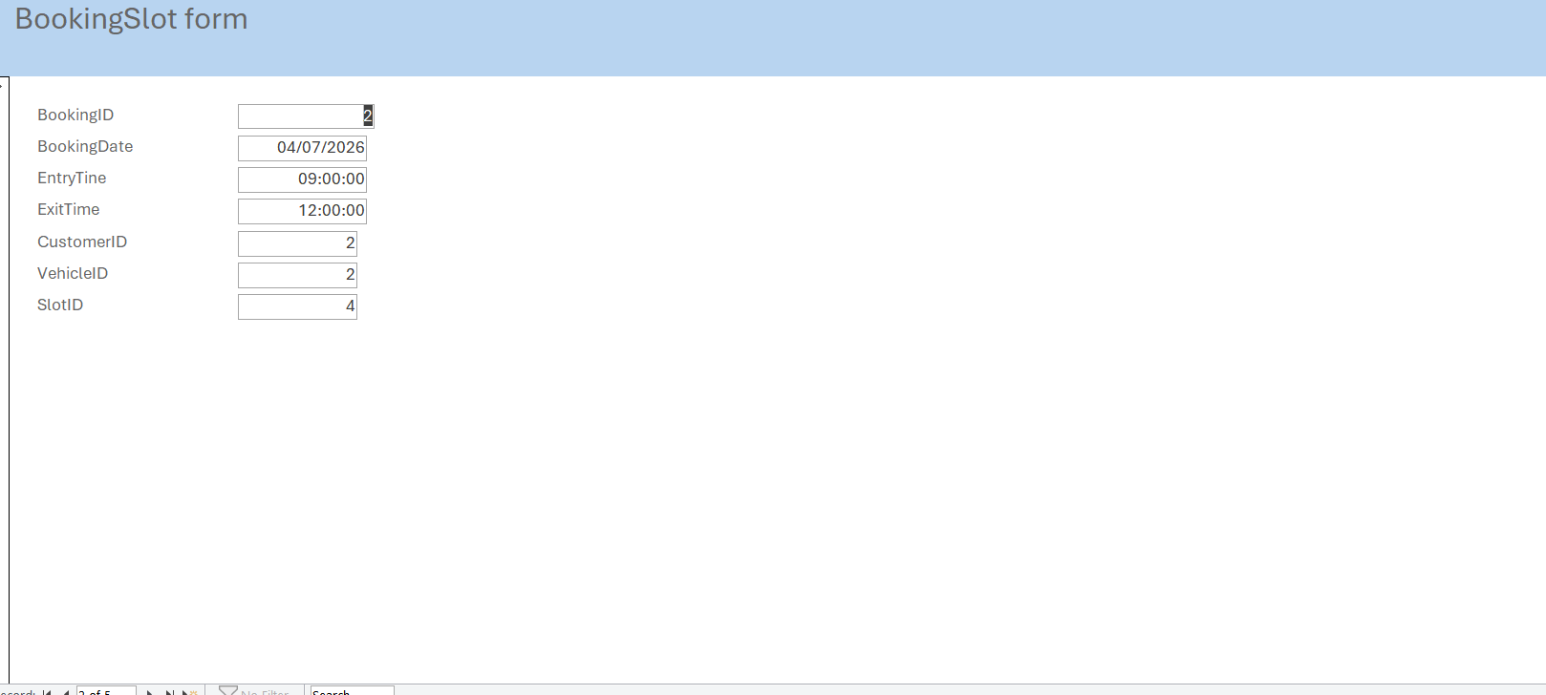
Figure 31
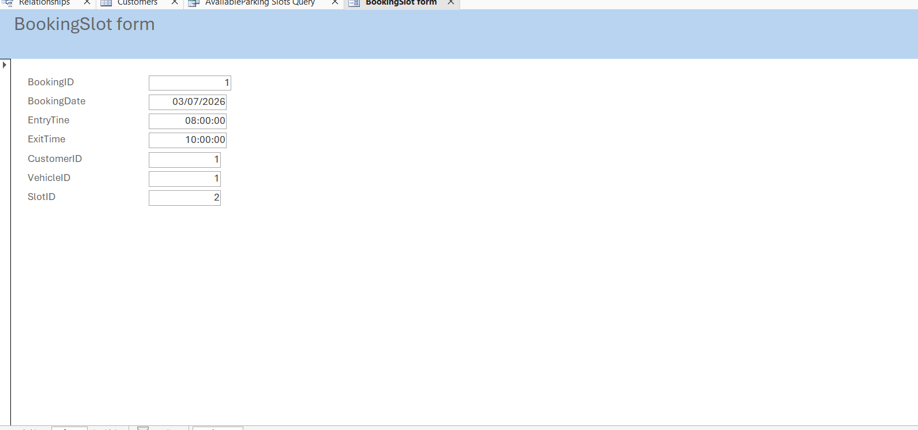
Figure 32

To created and updated parking bookings.

ParkingSlots Form

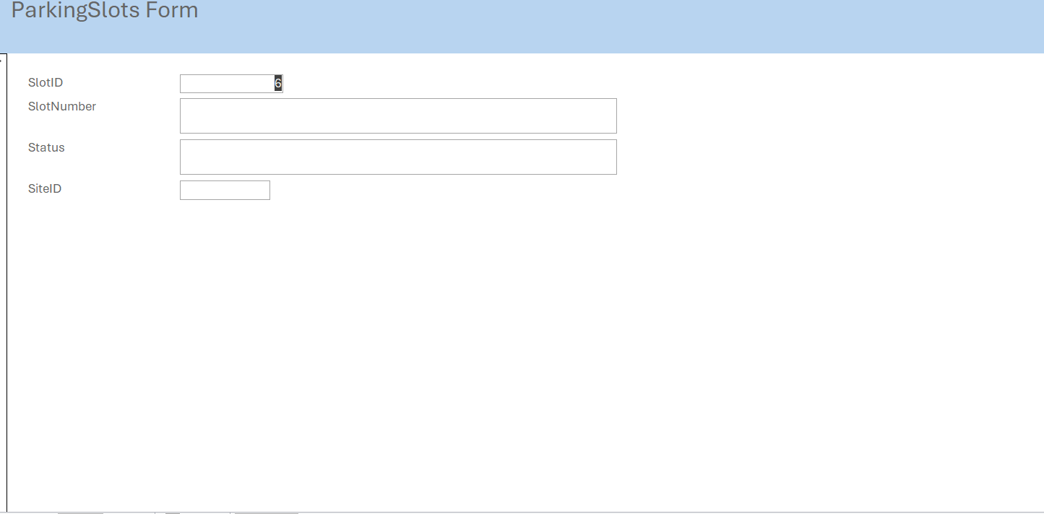
Figure 33

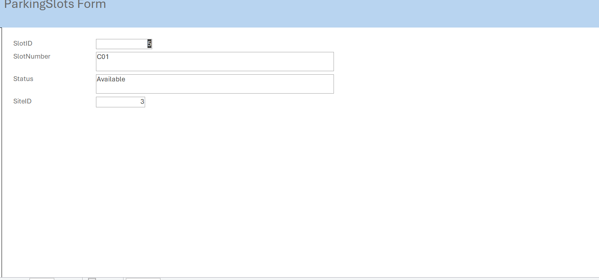
Figure 34

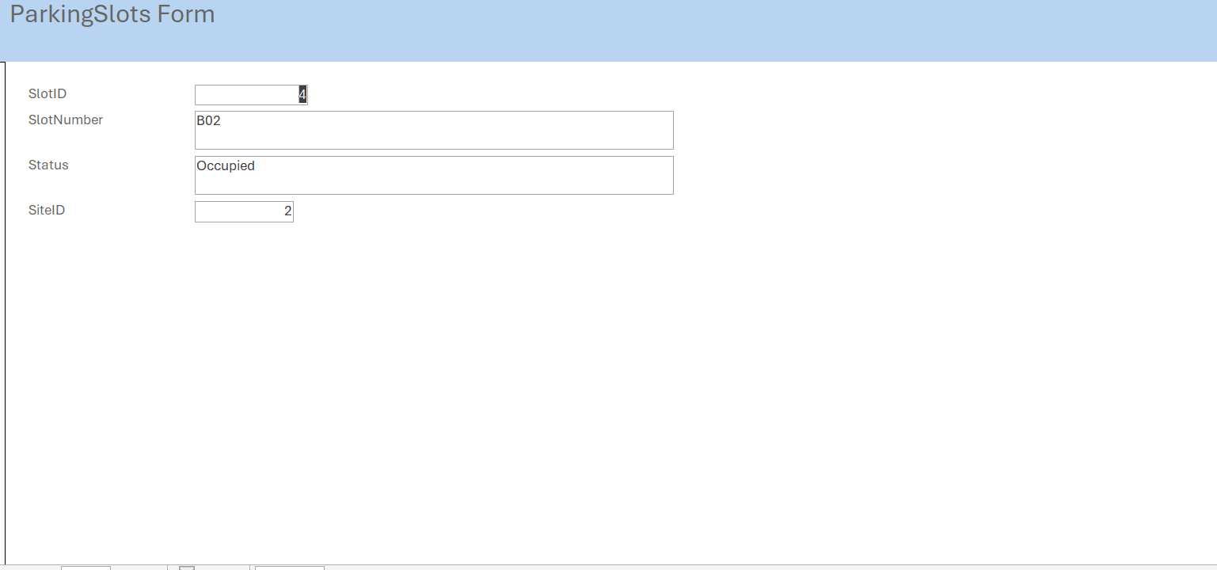
Figure 35
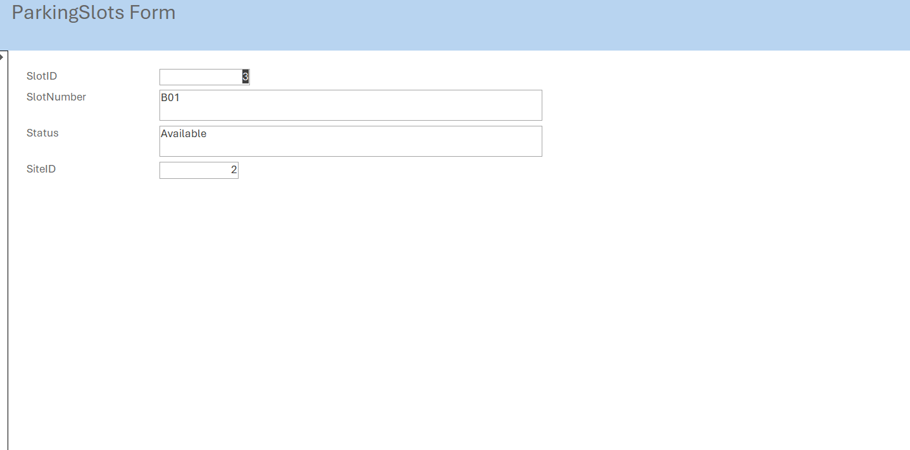
Figure 36

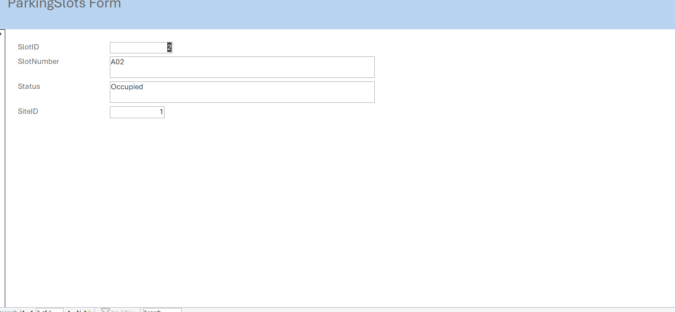
Figure 37
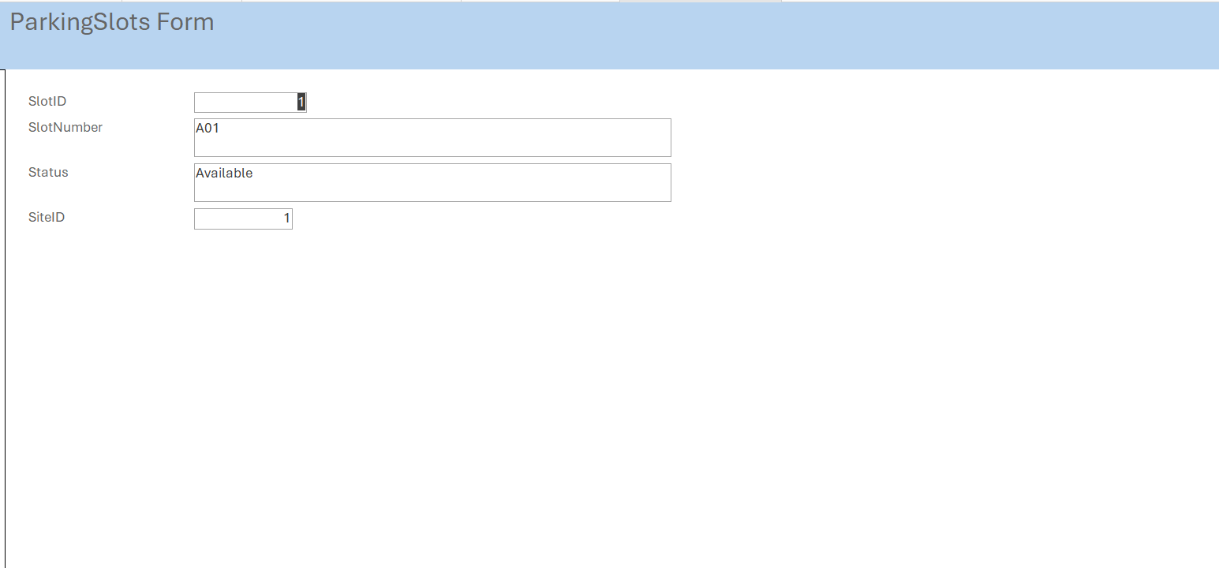
Figure 38

The Parking Slot Form makes it easier to manage parking spaces. Users can view and updated the slot number, its current status (Available or Occupied), and the parking site it belongs to.

Customers Form

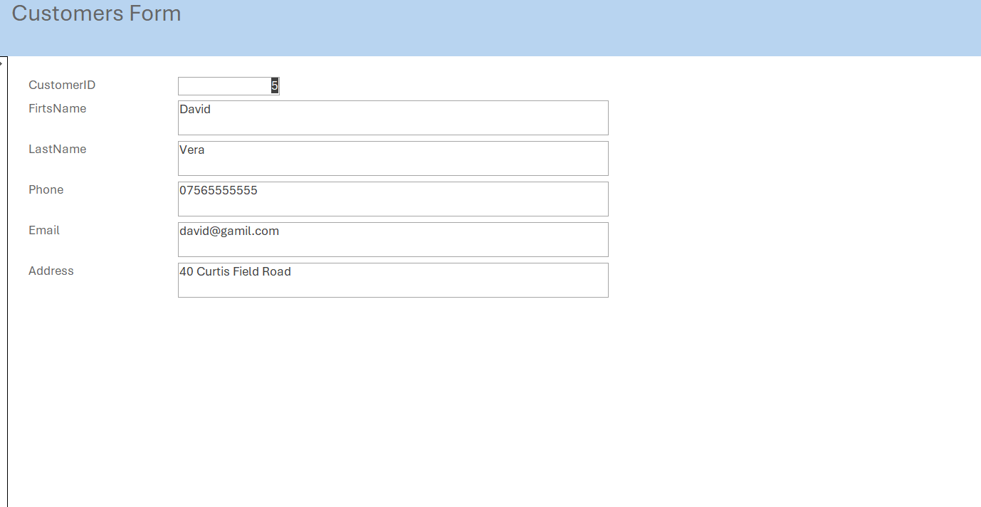
Figure 39
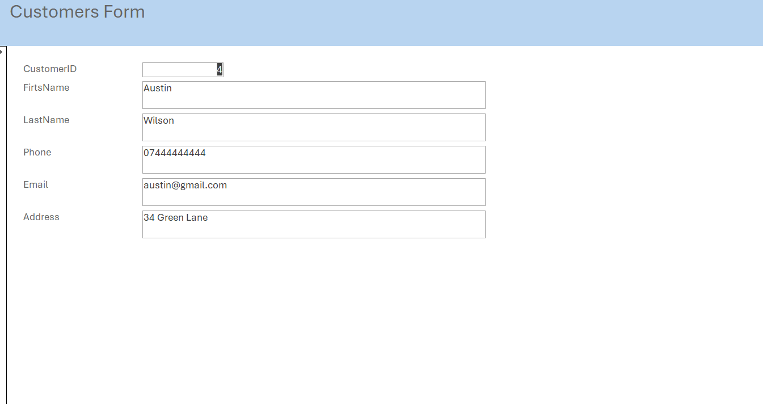
Figure 40

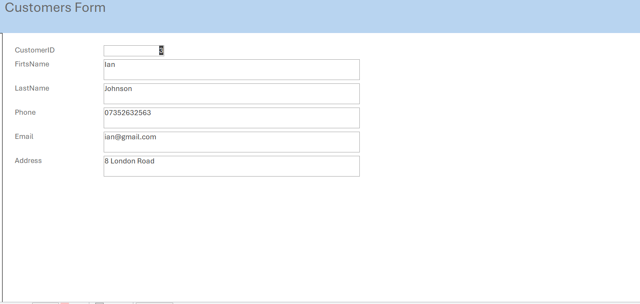
Figure 41

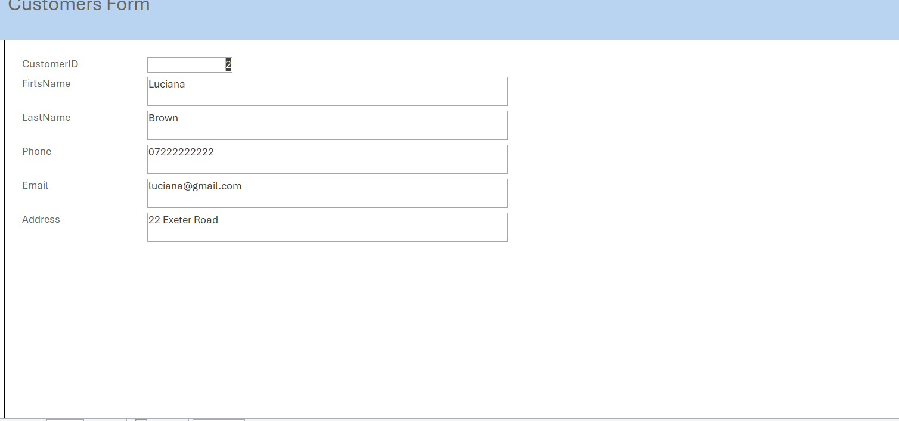
Figure 42

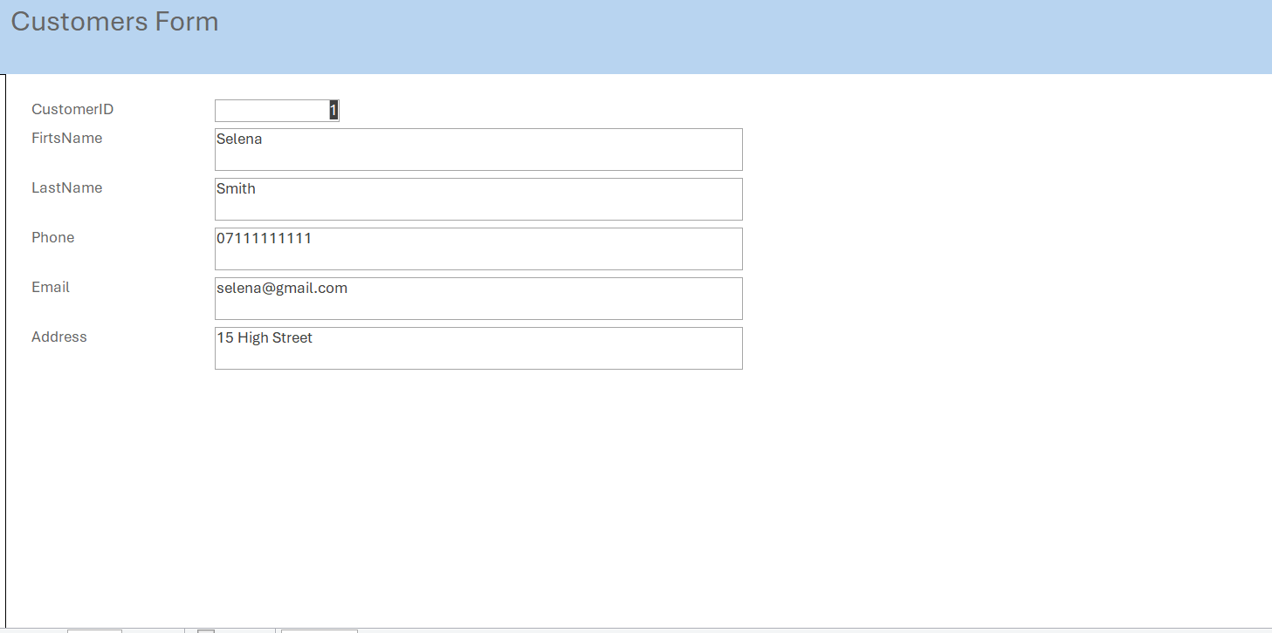
Figure 43

The customer form was created to make it easier to view and updated customer information. It allows users to manage customer details without opening the customers table directly, making the database easier to use.

Validation and testing

Validation Rule:
The validation rule was created for the Status field in ParkingSlots table ensure that only the values “Available” or “Occupied” can be entered.
In “Available”, “Occupied”
Validation text: Status must be either Available or Occupied.

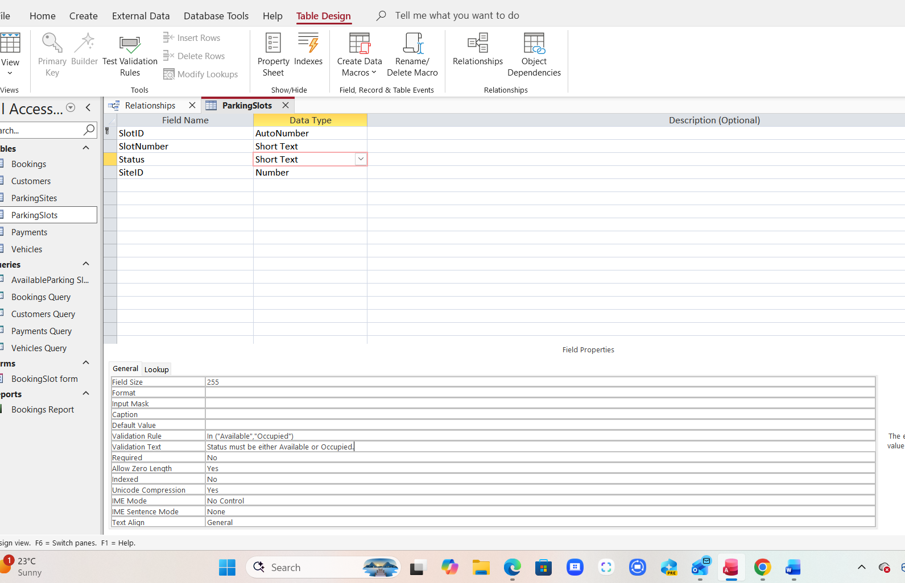
Figure 44.
Testing:
The validation rule was tested by entering an invalid value (“Busy”) into the status field. Microsoft Access rejected the value and displayed the validation message: “Status must be either Available or Occupied.
This confirms that the validation rule is working correctly and prevent invalid data from being stored in the database.

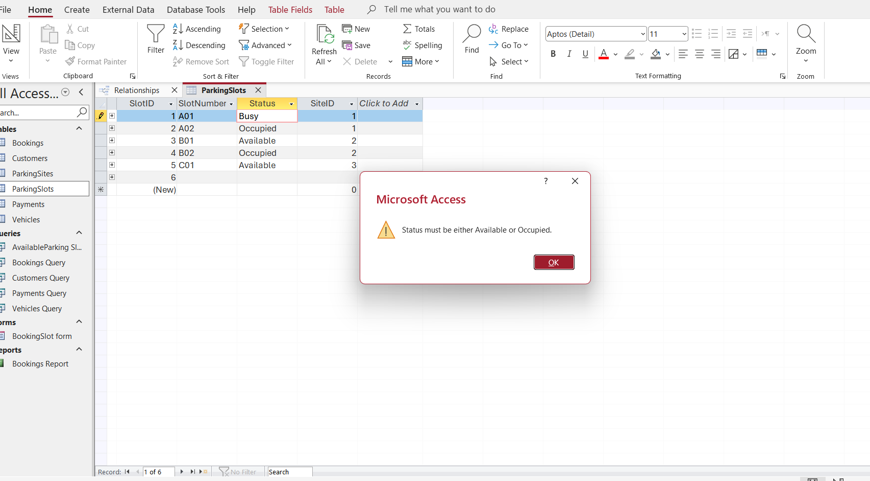
Figure 45.

Validation Rule

The validation rule was created for the Status field in Vehicles table ensure that the Registration Number is Required values.
Validation text: Registration Number is required.
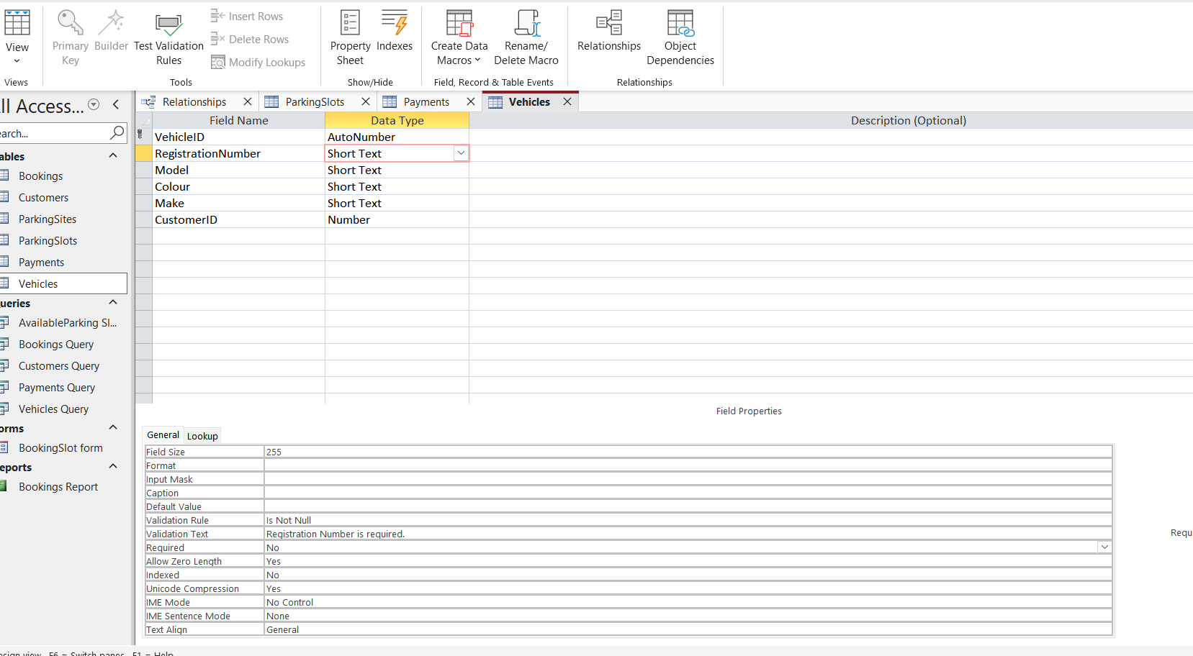
Figure 46.
Testing:
The validation rule was tested by deleted the Registration Number. Microsoft Access rejected and displayed the validation message: Registration Number is required.

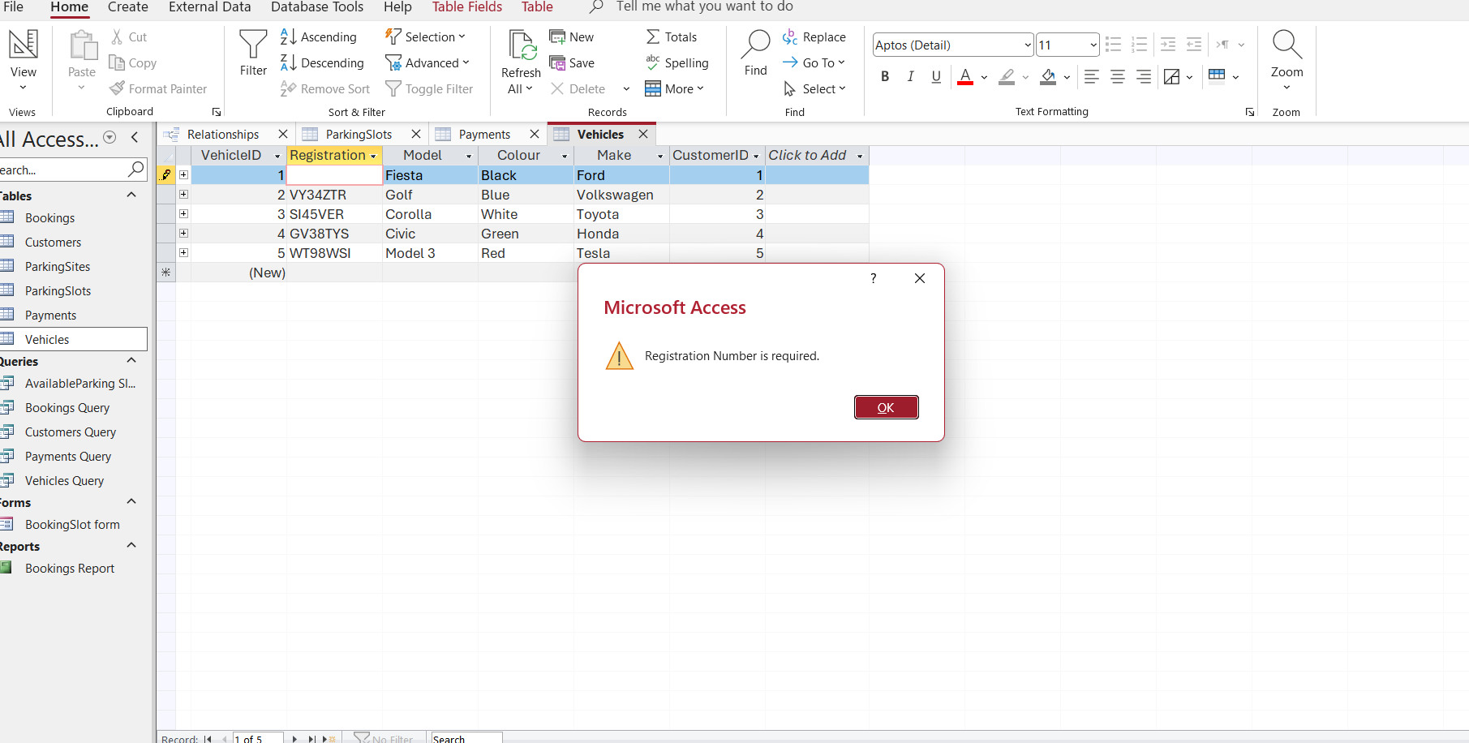
Figure 47.

Validation Rule
The validation rule was created for the BookingDate field in Bookings table to ensure that the booking date cannot be in the future.
<=Date()
Validation text: Booking date cannot be in the future.

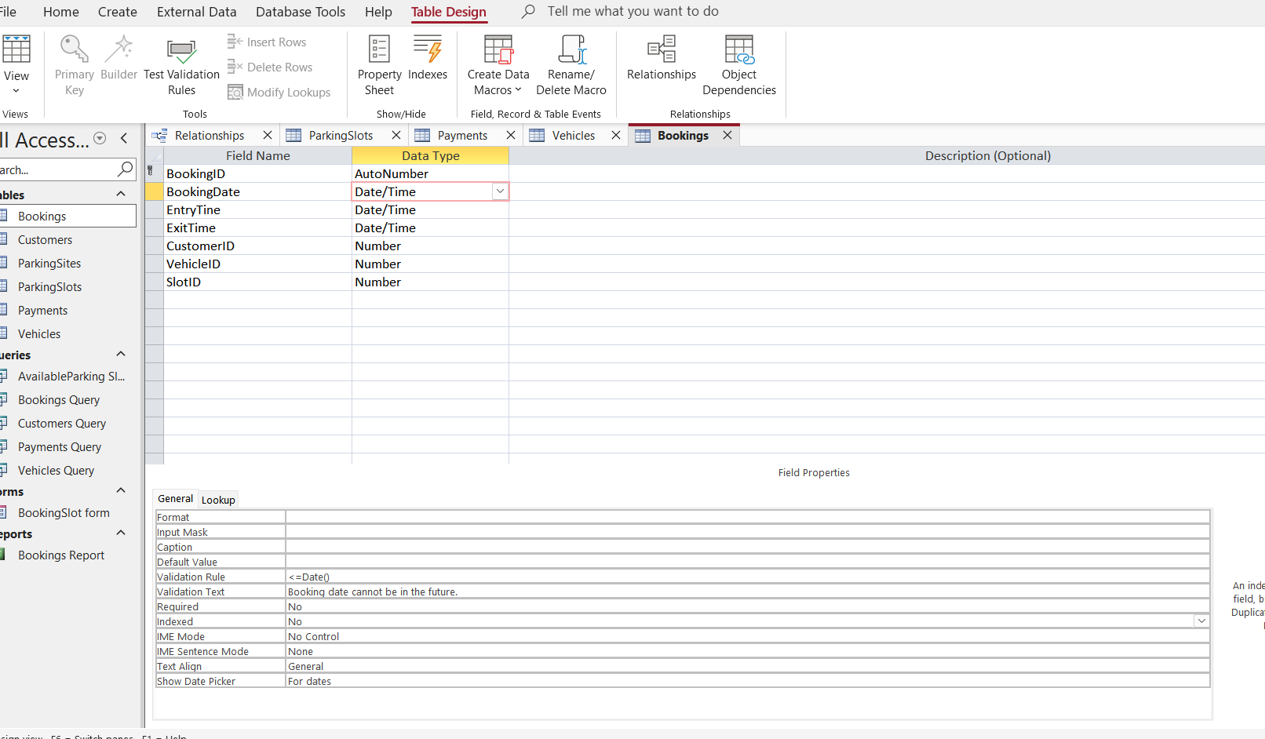
Figure 48

Testing
The validation rule was tested by entering the future booking date. Microsoft Access rejected the value and displayed the validation message: Booking date cannot be in the future. This confirm that future dates cannot be entered into the database.

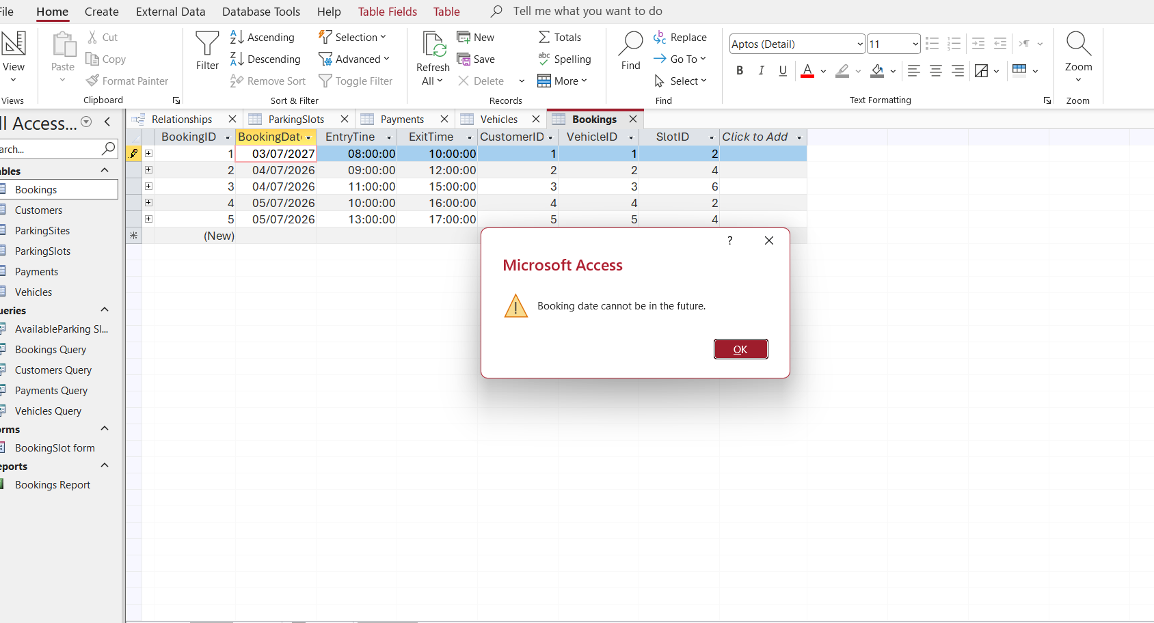
Figure 49.

Reflection

Challenges Faced
I think the most difficult part was understanding the normalisation process and deciding how to divide the information into different tables. I also had some difficulties creating the relationships between the tables and understanding primary and foreign keys. However, with practice, I was able to understand better how a relational database works.
Improvements for Future
In the future, I would like to add more features to the system, such as allowing users to cancel bookings and automatically updating the status of parking spaces when a booking is made. I would also like to create a login system for different users. These are features I would like to learn how to implement in the future.

Conclusion

This project allowed me to design and develop an AutoPark Management System using Microsoft Access. The database was normalised to reduce data redundancy and improve data organisation. I learnt about the concepts and structure and understand how a relational database is designed and managed using Microsoft Access. Also, I learn how to normalise data, create relationships, queries, forms and reports to build a working database.
In conclusion I’m happy with the final result because the system meets the project requirements and has improve my database skills.

References

[1] J. Eckstein and B. R. Schultz,Introductory relational database design for business, with Microsoft Access, John Wiley & Sons, 2018.
[2] S. Roman and P. S. Roman,Access database design and programming, " O'Reilly Media, Inc.", 2002.

Appendices

No Additional appendices were required because all relevant screenshots and evidence have been included in the main body of the report.

