Targed/Target 1 | Ensure I consider detail of practice.  I have worked towards this target by considering different details of cross-curriculum teaching within part two of the assignment.
Targed/Target 2 | Proofread through before handing it in.  I have proofread my work before handing it in to Turnitin.
Targed/Target 3 | Continue to develop the ability to critique. Considering strengths and weaknesses in the material.  I have considered the strengths and weaknesses of cross curricular teaching in the main body of part two.

Professional and Pedagogic Studies: Leading the Learning: what, how and why I am teaching?

Part one:

Subject Knowledge Development (Tab 5).

Welsh Language development
For PTE2 a target of mine was to develop my Welsh language skills. From the start of my time in Foundation Phase I asked the teacher if it was possible to take all the Welsh sessions for the term. The Topic was ‘Mae hi’n Oer’ and was all about Artic animals and the way they moved. To develop my Welsh language skills, I used apps such as Duolingo and YouTube to understand the vocabulary and practice my grammar as Krashen (1970) states that something that corrects language and performance and pressures you to correctly communicate by correcting a grammar mistake is part of the monitor model which helps you acquire a second language. I also listened to other people reading the story on YouTube to help me with pronunciation as Krashen (1970) states that second language acquisition occurs with comprehension input, for example, hearing or reading things that are slightly above current language level. I then created snap cards to learn the Welsh names of the Artic animals which I went on to using in my Welsh lessons. I created cue cards which I used to teach myself the movements of the animals in Welsh. I watched YouTube videos on Artic animals and the way they moved to help develop my subject knowledge on this topic. All of these activities really helped me develop my Welsh language skills and confidence before I taught this topic. This impacted my approach to teaching as I used some of the strategies in the classroom to support the learning and develop Welsh language skills.
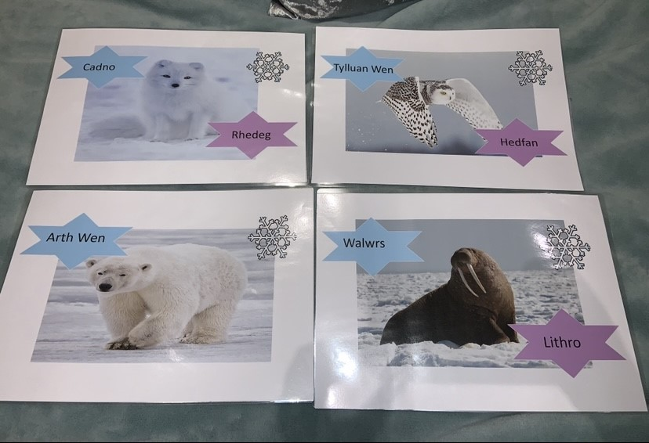

Humanities - The Romans
For PTE2 I had to teach the Topic of The Romans. This was a Topic I did myself in school however I was very unfamiliar with the key dates and the Roman timeline. To develop my subject knowledge, I watched episodes of Horrible Histories which was a good way of learning key facts and information. I also did some reading on the Romans, using the classroom library. I then found a song on YouTube which I learnt called ‘Like a Roman’ which taught me so many interesting facts about the Romans and how they lived. I then created an A3 Roman Timeline which I took into school with me and hung in the classroom to ensure I was familiar with the key dates. I chose to use these visual learning methods to develop my subject knowledge as I find I learn best by hearing (auditory learning) and by using images and diagrams to remember key information such as key dates. All of these activities helped me develop my subject knowledge on The Romans and without them I would have lacked confidence to teach this topic. This impacted my approach to teaching as I allowed me to explore the topic in greater detail and allowed me to plan fun and engaging learning opportunities for the pupil’s which I was confident in teaching. I also incorporated the Roman song into one of my lessons as I knew how much the song had developed my own knowledge on the topic, so I wanted to give the learners the same opportunity. This impacted the learning as pupils were keen to ask questions which resulted in them being more engaged and motivated with their learning.
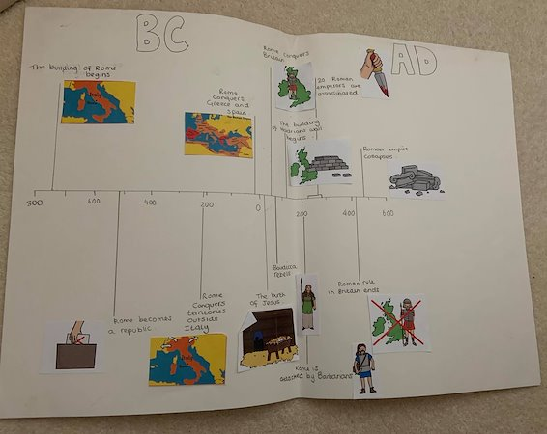

Digital competence – Remote learning
For my third PTE I developed my digital competence skills as we switched to remote learning. I had to learn how to use new technology and how to teach effectively online. I decided to develop my subject knowledge on DCF due to the current Covid-19 pandemic and because the Welsh Government (2018) state that DCF is the responsibility of all practitioner and teachers to include in their lessons. They state that it is part of their mission for educators to provide all learners with high-level digital skills to ensure our young people are digitally competent (Welsh Government, 2018). I developed my subject knowledge by going onto Hwb and completing CPD courses which taught me how to use different online platforms such as J2E, Loom, Flipgrid and more. I also took part in SeeSaw training as this was one of the main platforms my class used. I found the training on their website, this taught me how to create activities, how to assign a task, how to approve of post, when to allow brain breaks and how to provide feedback online. I developed skills such as how to record voice overs, how to upload online tasks, how to create engaging lessons, how to keep students motivated and how to mark work online. When planning online activities, I had to develop DCF skills such as presentation to ensure the PowerPoint task slides looked eye catching and child friendly, I did this by using bright colours and adding in my bitmoji so the children could make links to me. I also had to ensure the activities were engaging and accessible for all learners to do at home. I also developed the skills of allowing balance, being mindful of screen time and allowing brain breaks. This impacted my approach to teaching online as it allowed me to develop lots of new skills and approaches to online learning. By developing my subject knowledge on DCF it has boosted my confidence to take on new opportunities with the DCF framework and will be something I take into my future practice.

Asset:
Notes on training/ CPD courses (See appendix 1 for the rest of notes).
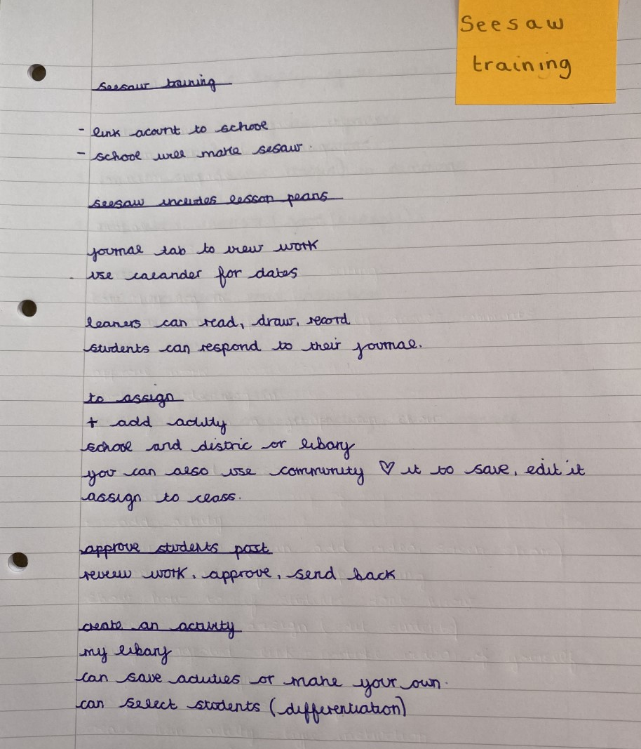

Reflection on planning for progression (Tab 7)

Progression in learning: Literacy lessons on conjunctions

What did you do and why?
On PTE2 whilst in Foundation Phase I taught literacy lessons every week. Over the half term I planned for progression over a series of lessons I did this by using a tracking chart to monitor pupils progress and plan using next steps. Wiliam (2004, p.2) talks about the role that assessment plays in ‘keeping learning on track’. I chose to use a tracking chart to track learner progression in Literacy as Leahy and Wiliam (2007, p.3) state formal systems for testing students on a regular basis may have a role to play in the effective monitoring of student progress. They state some means of tracking student progress over the medium term and taking action to address any problems was essential. After each lesson I filled out the tracking chart to see where each learner was and where they needed to go next. This then helped me plan the next session ensuring I was acting upon learner’s next steps and planning for progression. I always included learners next steps within my following lesson to ensure progress was being made. This gave me a foundation to planning lessons and was a great way to plan for progression over a series of lessons. In literacy we focused on conjunctions and over a series of lessons pupils had to learn what a conjunction was, fill in the missing conjunctions to the sentence and then create their own sentences/ paragraphs using conjunctions. To start off the learning process I showed the pupils a PowerPoint on conjunctions and we discussed conjunctions as a class, I also used hotseat to question pupils about conjunctions and to recap in the following lessons. Then I asked pupils to identify the conjunctions in the examples of various text. In the following session pupils had to choose the missing conjunction to fill into the sentence. Finally, pupils were given the task to independently create sentences or paragraphs using conjunctions. The learners made great progress over the series of lessons and could work independently to create their own paragraphs or stories using conjunctions by the end of the term.

What have you learned?
Using a tracking chart after each literacy lesson was an effective way to track and plan for progression. This experience did meet intended outcomes as it allowed me to use learners next steps to plan future sessions and ensured progress was being made across the class. This experience was important as it helped me plan for progression and ensured I acted on learners next steps to ensure every child within the class was making progress. This helped me teach conjunctions to the class and acted as a good foundation to plan my lessons. I have learnt that when planning for progression a tracking chart was an effective way to ensure progression was happening and ensure every child was making progress. It also showed me how to plan for progression, from looking at learners next steps it helped me identify where the class or ability groups needed to go next and how I could plan for progression within the next session. This relates to my overall development as it has helped me plan for progression over a series of lessons and helped me worked towards the QTS standard of planning for progression. This was a good opportunity which helped me develop as a teacher as it allowed me to plan for progression and ensure the whole class was making progress over a series of lessons. It also allowed me to track pupil progress and ensure I was acting upon all learners next steps and embedding them within my next lesson. To reflect on this experience, using a tracking chart helped me plan a series of lessons in literacy where I could ensure progression was taking place, it gave me a solid foundation to plan my lessons from and acted as a guide for planning a series of lessons.

Links to professional standard
- Advancing learning: Progression in leaning

What next?
​​​Within the future I will continue to use a tracking chart after all lessons to track and monitor pupil’s progress. I will also use the tracking chart to plan future sessions and ensure I am acting upon learners next steps when planning a series of lessons. This was an effective way to plan for progression over a series of lessons and will be something I look forward to further developing within the future. I will continue to work towards the standard of planning for progression in other AoLE’s and embed the tracking chart in other lessons to ensure progression is taking place over a series of lessons.

Assets:
Introduction PowerPoint on conjunctions

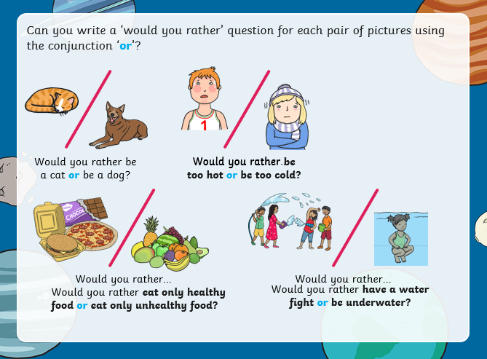
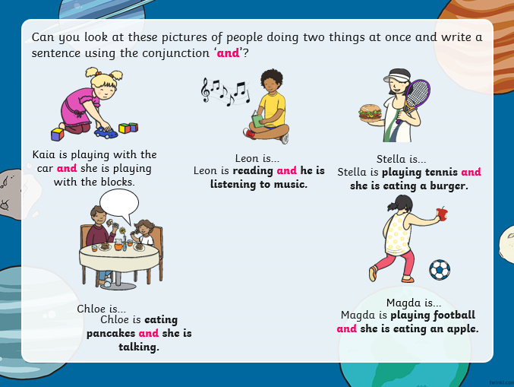
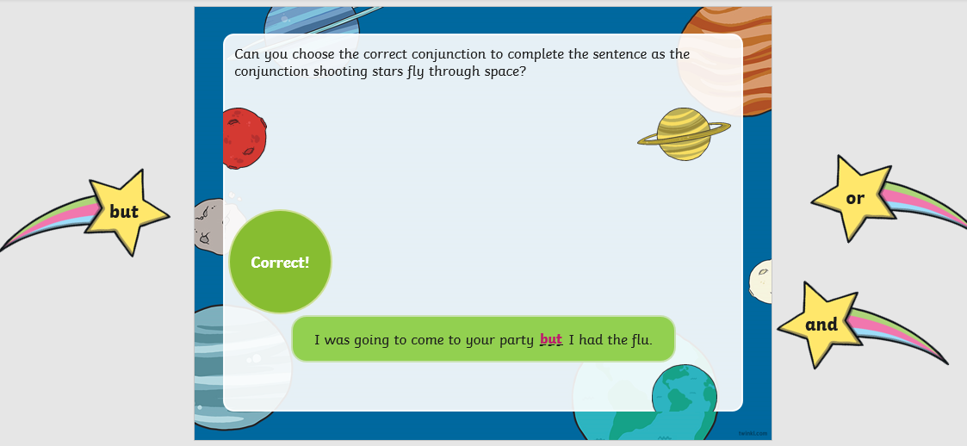
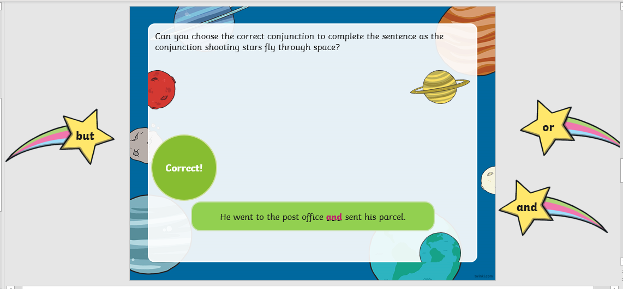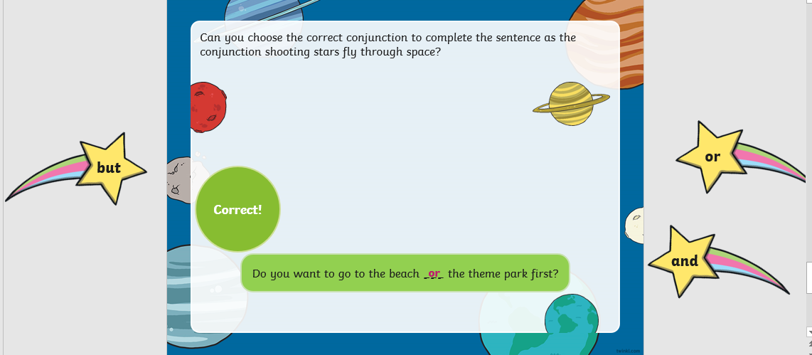

Tracking chart for Literacy lesson on conjunctions.
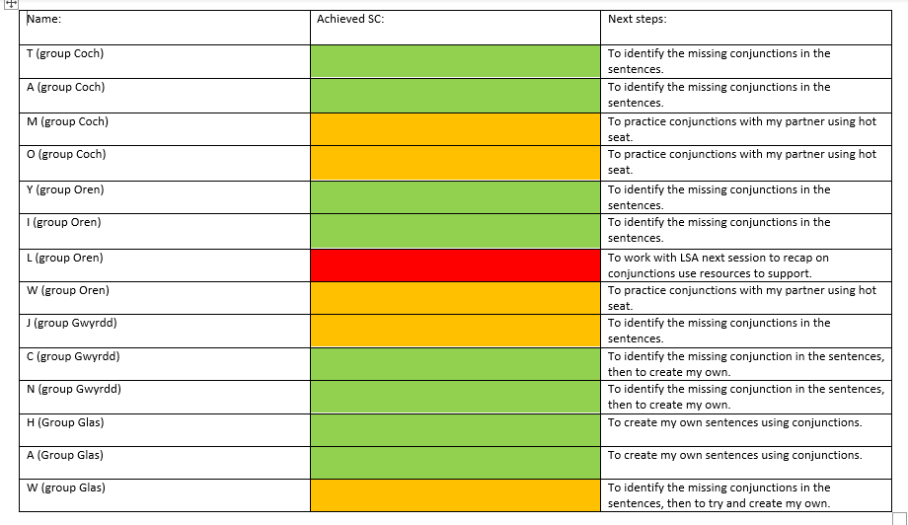

Lesson plan on conjunctions:

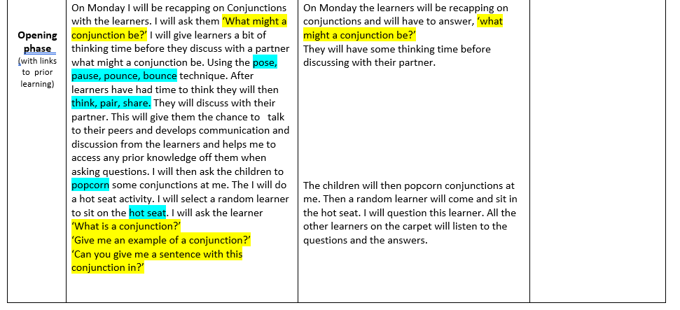
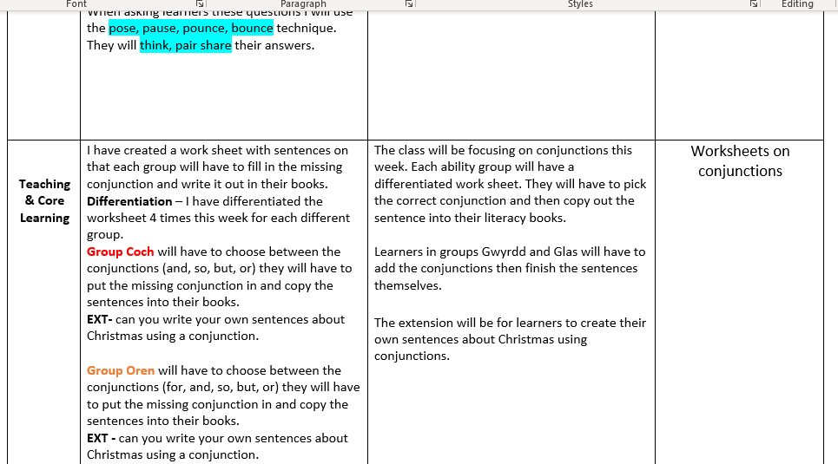
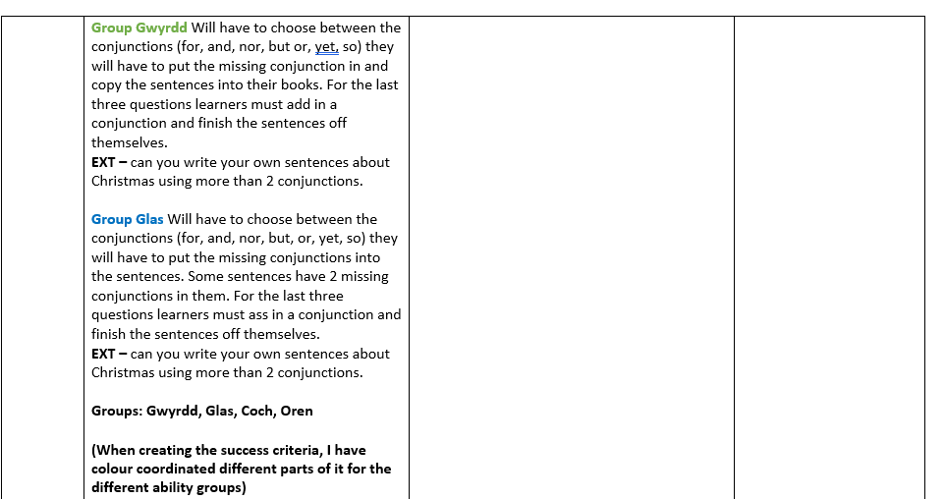

Progression in learning: Welsh language sessions

What did you do and why?
Throughout my time in Foundation Phase (PTE2) I taught my Year 2 class Welsh every week. The class was limited to 15 minutes of Welsh per day. Our topic for the half term was ‘Mae hi’n Oer’ which was all about Artic animals and the way they move. To start of the leaning process, I showed the children a video of Artic animals on YouTube I did this to ensure they had real life authentic context of the story as some of the learners had never seen a video of a polar bear before. I then read the story to them throughout the week and asked them to join in for the repetitive bits. To teach the children the animals and their names I created a game of snap to match the animal to its Welsh name, the children loved this activity, and all picked up the Welsh vocabulary very quickly. Then to teach the learners the movement I created cue cards which we used each lesson to recap before reading the story. I then asked the class to create actions that we could add in with the story. They created different actions which they could use to associate with the polar bear, snowy owl and the other animals and the movements they made. This helped the children learn the animal’s and movements. Finally, we listened to a video on YouTube of the story being told by someone else, this ensured we were pronouncing the words correctly. Every week I ensured I planned for progression within our Welsh language sessions by adding in new resources and new vocabulary until by the end of the term all learners were confident enough with the story that they could independently create their own Welsh sentences about it. To plan these sessions, I used Bruner’s (1960) Spiral Curriculum. This involved information being structured so that complex ideas could be taught at a simplified level first, and then re-visited at more complex level later on (McLeod, 2018). I also used Bruner’s spiral curriculum to teach these sessions as we started off the sessions with some easy activities then gradually increased difficulty as we went on each week. By the end of term all children could independently problem solve using their Welsh language skills.

What have you learned?
I have learnt that by planning for progression within a sequence of my Welsh sessions that the learners all made significant progress over the half term. By incorporating resources and games this also aided the progression as the learners found these activities fun and engaging. By creating actions, the learners progressed with their Welsh vocabulary and understanding. This experience was important as it showed me how much progression the class had made over time from not understanding the story at all to going on to independently create their own sentences about it. I thought this would be a challenge as the Welsh sessions were only fifteen minutes long a week, however, by using Bruner’s (1960) Spiral Curriculum the learners made significant progress over the weeks which allowed me to increase difficulty in the tasks. This related to my overall learning as this approach will be something, I ensure I use within the future. This experience exceeded my intended outcomes as the learners made more progress than I imagined in such a short time period. To reflect on this experience, I believe that using a method such as Bruner’s spiral curriculum really helped the learning move forward and ensured progression was being made each session over a series of lessons. I think the use of different resources also aided progression such as snap cards, cue cards and sentence patterns. The children used the resources each week to become more confident with the topic and to develop their oral skills. I also believe that developing my own subject knowledge before carrying out these lessons really helped me as it allowed me to experiment with helpful resources, ensured I was pronouncing vocabulary correctly and helped me plan sessions.

Links to professional standard
- Advancing learning: Progression in learning

What next?
In the future I will always ensure I plan for progression within my lessons but also ensure I set appropriate challenge for the learners like I did within this topic. I will also continue to use theory to plan my lessons such as Bruner’s spiral curriculum as this really helped the class progress within the sessions by revisiting the same vocabulary each week but ensuring the difficultly increased over the series of lessons.

Assets

Lesson plan week 2:
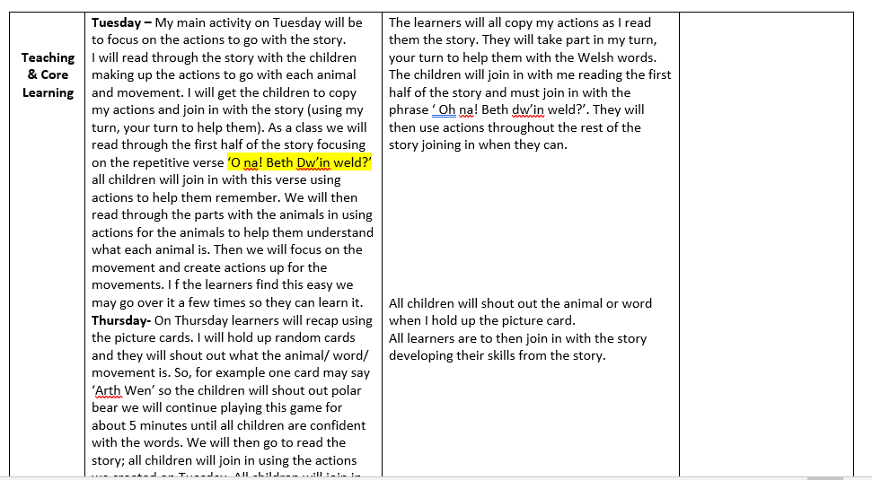

Lesson plan week 3: 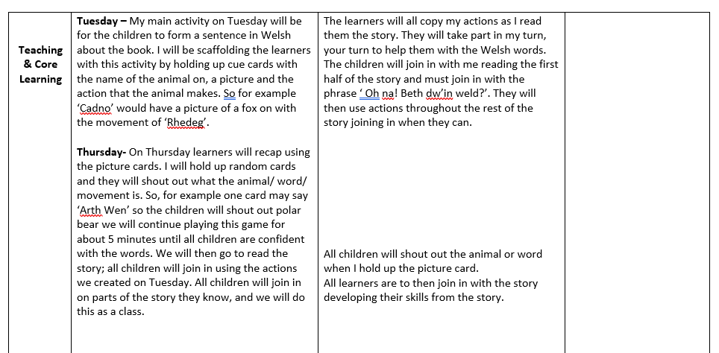
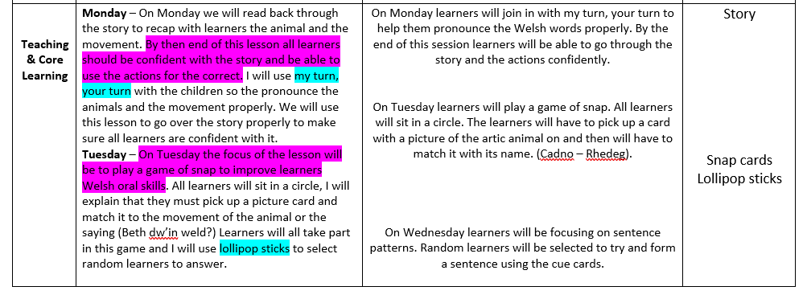
Lesson plan week 4:
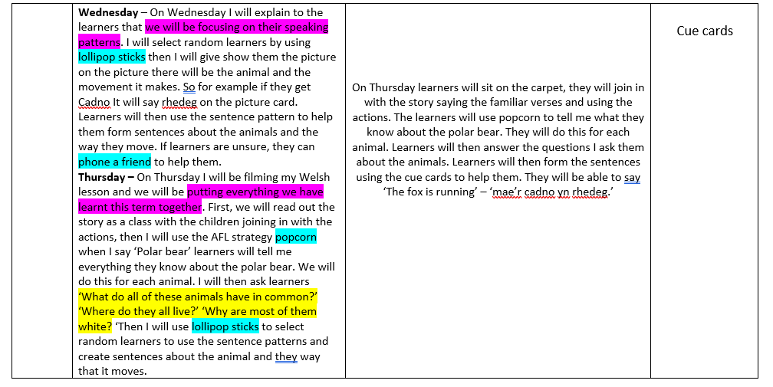
Resources
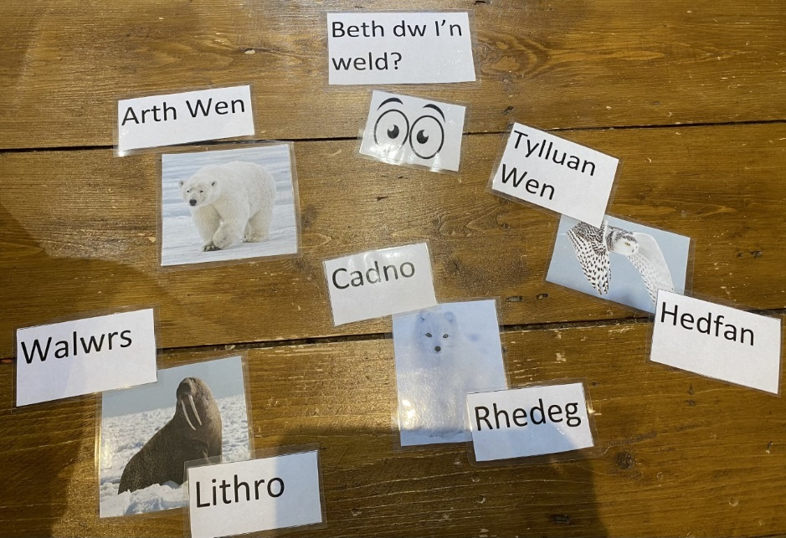

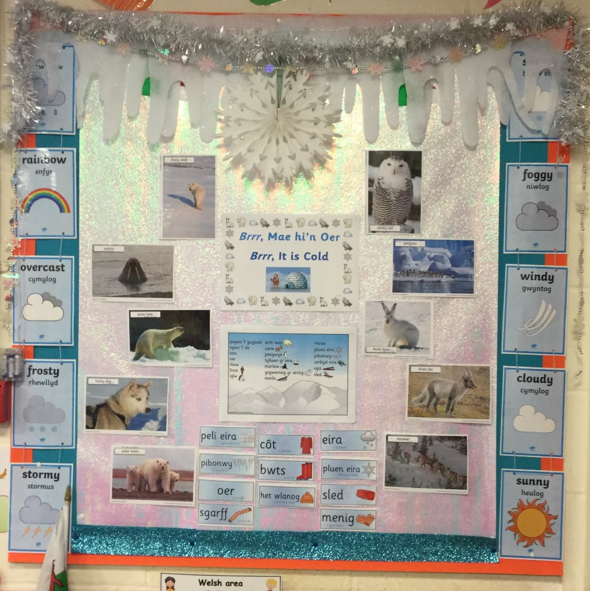

Reflection on planning for four purposes (Tab 7)

Planning for the Four Purposes - The Romans (Ambitious, capable learners, Enterprising, creative contributors, and Ethical informed citizens).

What did you do and why?
For a Topic lessons in KS2 (PTE2) I planned using the four purposes. I chose to do this as it was advice given to me by my senior mentor. In addition to this Welsh Government (2020, p.24) state ‘The four purposes should be the starting point when planning’. The Topic lessons were taught as a carousel throughout the week and each group would be working on a different task, the activities were Maths and Numeracy, DCF and Language, Literacy and Communication. Within each of these AoLE’s we focused on a different purpose as Donaldson (2015, p.40) states ‘each of the Areas of Learning and Experience should make distinct and strong contributions to developing the four purposes of the curriculum. Within these sessions I embedded the four purposes to plan my lessons. For the Maths activity we worked towards the purpose of ‘Ambitious, capable learners’ where the children had to complete an independent challenge on multiplication and division. They then had to use their knowledge to create their own challenge ensuring they were setting themselves high challenge and are questioning and enjoy solving problems. For the Language, Literacy and Communication activity we worked towards the purpose of ‘Enterprising creative contributors’ where the children had to use their knowledge on persuasive writing to write a job application to become a Roman solider. They had to connect and apply their knowledge and skills to create ideas and products, think creatively and express emotion through different media. Finally, for the DCF activity we worked towards the purpose of Ethical informed citizens to plan the task which was to research Roman solider weapons and create an online data base. Within this task the children had to find, evaluate, and use evidence to form views, engage with issues based on their knowledge and values and be knowledgeable about their culture and world now and in the past.

What have you learned?
This experience was relevant as it developed my knowledge and understanding on how to plan for the Four purposes and the Curriculum for Wales 2022. This has aided my development as I have found using the four purposes within my planning has given me a foundation to plan the lesson and ensures all learners are making progress towards the four purposes (Welsh Government, 2020, p.13) This experience was relevant as it gave me the opportunity to embed the Curriculum for Wales 2022 within my lesson plans and activities and gave me experience for using the curriculum for the future. This experience did meet intended outcomes as I could see learners making progress towards the four purposes and developing specific skills. To reflect on this experience, I believe that using the four purposes was a good foundation to my lessons, however, I did find it difficult incorporating three different purposes within one lesson as a carousel, as it was hard to introduce the different purposes to the class as each group was focusing on a different purpose within the carousel. Also, some tasks were independent where the children may not have fully understood the purpose. Within the future I will try to focus on one purpose within my lesson to ensure I can introduce it to the whole class, and we can discuss how it relates to the task.

Links to professional standard
- Advancing learning: Four purposes for learners

What next?
In the future I will continue to use the four purposes to plan lessons and ensure the children are aware what purpose they are working towards. I would also like to focus on creating an activity where I only focus on the one purpose within the session as I think it will be less confusing for the learners and we will be able to address and discuss the purpose as a class and understand how we will be working towards it.

Assets:
Activities:
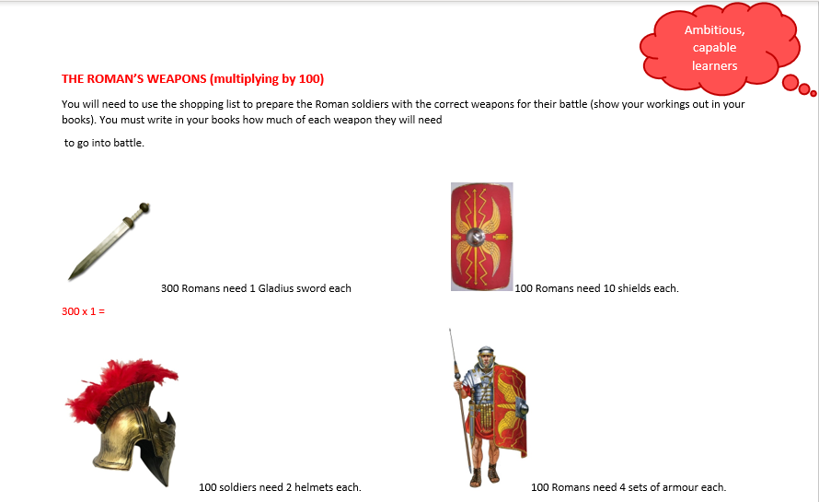
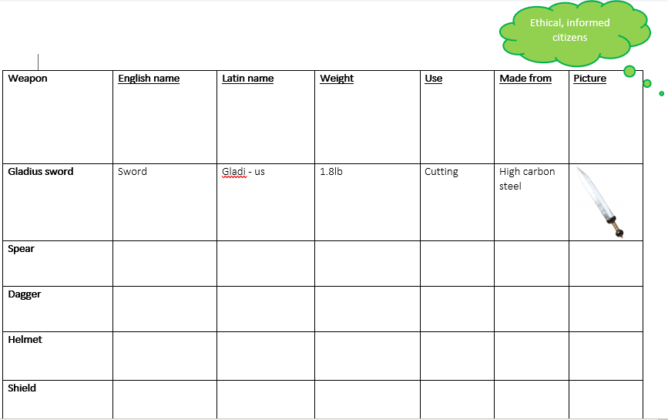
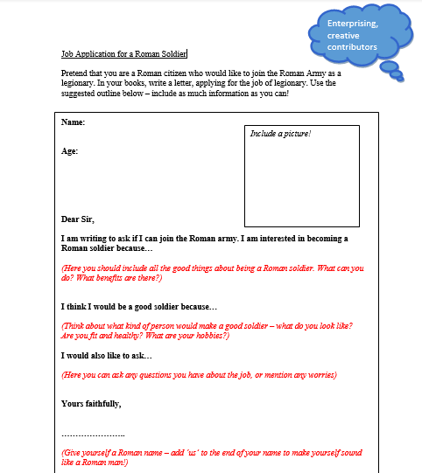

Poster used to plan sessions
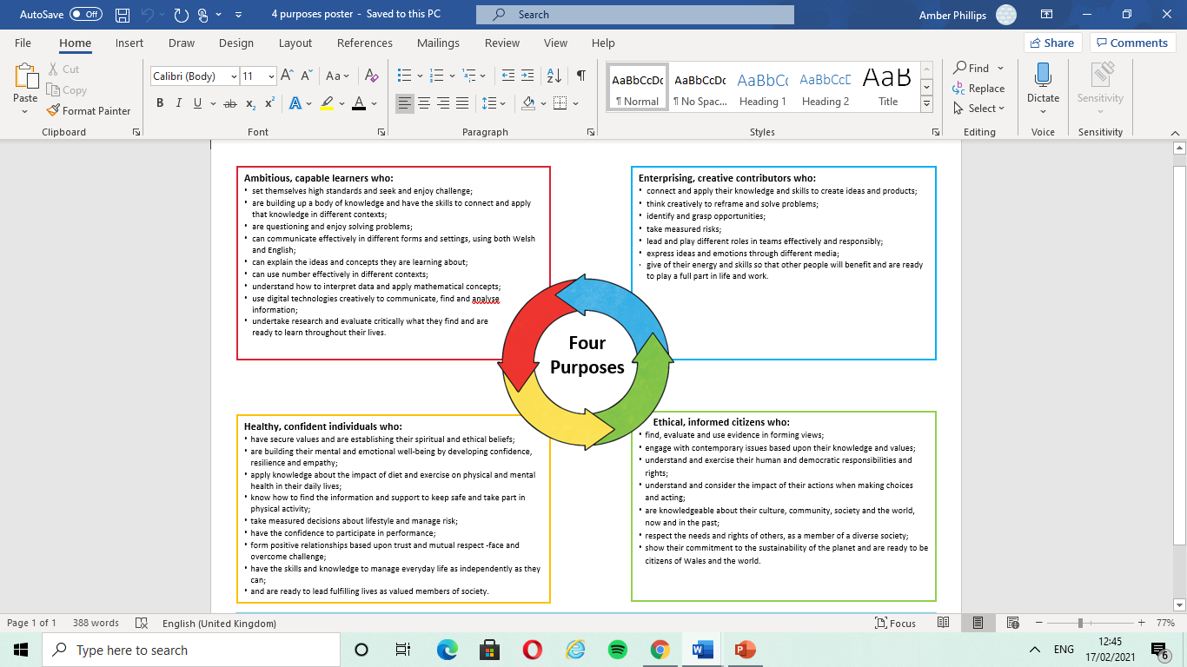

Roman Lesson plan showing the 4 Purposes.
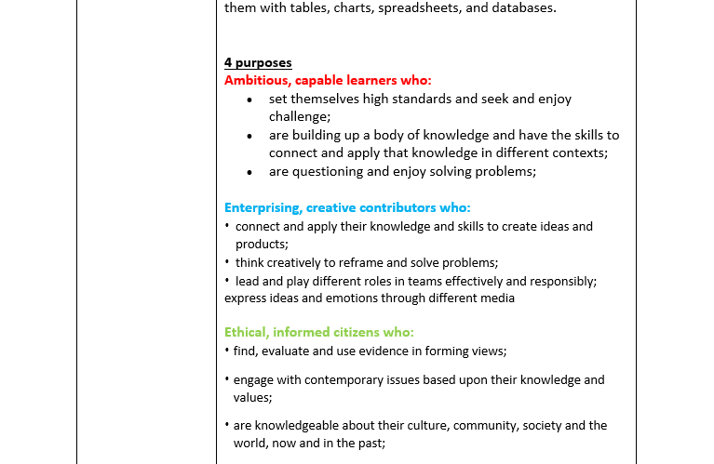

Planning for the four purposes – Health and Well-being (Healthy, confident individuals).

What did you do and why?
For PTE3 I planned online Health and Well-Being sessions. To plan for these sessions, I used the Curriculum for Wales 2022 and the four purposes. For one of these sessions, I created a lesson on a nature hunt and focused on the purpose ‘Healthy confident individuals’ where the learners would be applying their knowledge on the impact of exercise on physical and mental health in their daily lives. For this task they had to take a break from their screens to go on a nature hunt outdoors. The learners had a set of instructions to follow to ensure they completed the task correctly which asked them to use their senses while going on an outdoor walk. When they came back in the learners were asked to draw a picture or write a sentence about how the nature hunt made them feel and why it made them feel this way. When uploading the task to SeeSaw I always ensured I put a slide showing what one of the four purposes we would be working towards today and how we would achieve it, so the children understood what they needed to do. This was important as the Welsh Government (2020, p.23) state that the aim is always to help learners realise the four purposes. By putting a slide in which addressed the purpose and how we would be working towards it helped the learners realise the purpose and understand why we were doing the task.

What have you learned?
I have learned that by embedding the four purposes within my lesson plans it has allowed me to develop an understanding of the Curriculum for Wales 2022. I also learned how to link the purpose to the AoLE and progression steps. I have learned how important it is to share the purpose we are working towards with the learners as this set’s clear expectations and ensures they identify the purpose and understand how and why we are working towards it within the task. I have also learned that it is important to show how we will be working towards the purpose within my lesson plans as Donaldson (2015, p.97) states there should be a clear statement of how the Area of Learning and Experience promotes the four purposes of the curriculum. To reflect on this experience, I think that using one of the four purposes within a session was very meaningful and ensured all the children fully understood the reason behind the task and why we were doing it. Focusing on one purpose allowed me to address it to the class before starting the task and explain why we would be working towards it. I also think this helped the learners understand the four purposes more, as they could identify them and link them to their work.

Links to the professional standard
- Advancing learning: Four purposes for learners.

What next?
This has helped me develop an understanding of the Curriculum for Wales 2022; it has also helped me develop a clearer understanding of the four purposes and how to achieve them throughout a lesson. I will continue to use the four purposes within my future planning and continue sharing the purpose with the children when explaining the task. I would also like to continue planning for the Health and well-being AoLE as this was my first opportunity and is an area, I have great interest in.

Assets:
Task for Health and Well-being. 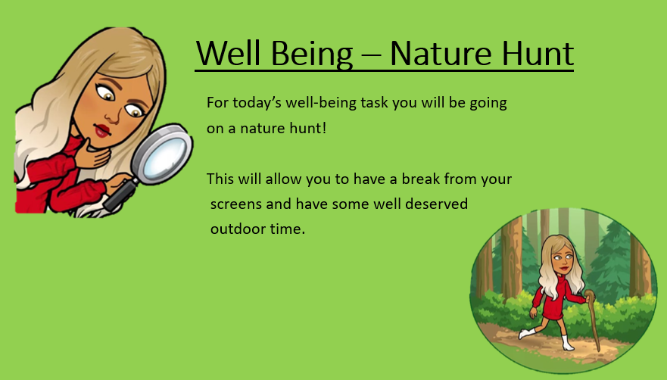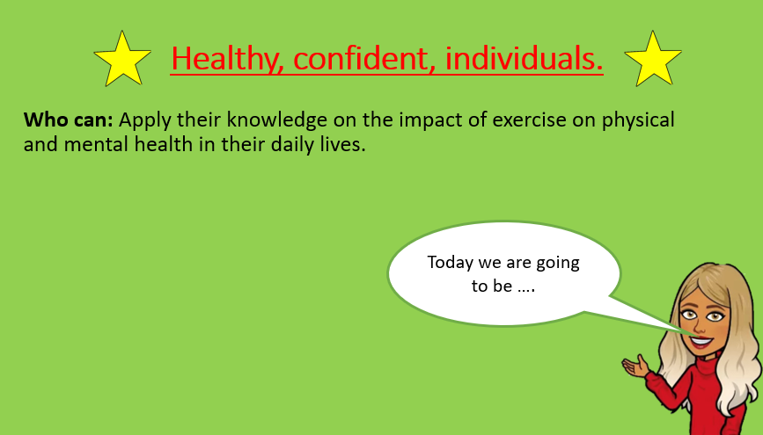
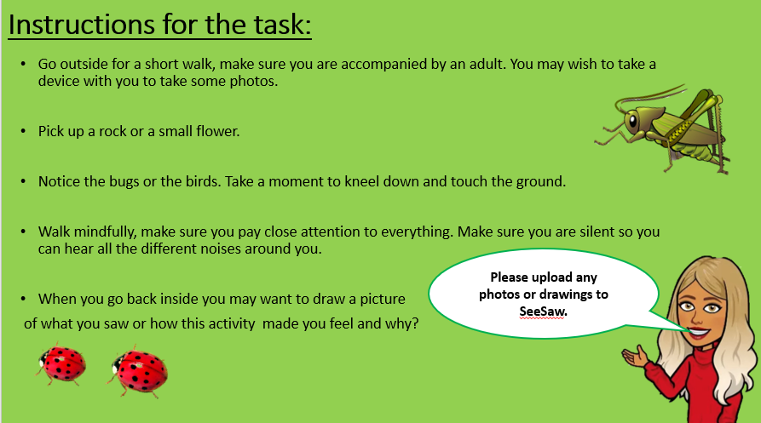

Poster used to plan sessions

Lesson plan showing the purpose ‘Healthy, confident individuals.
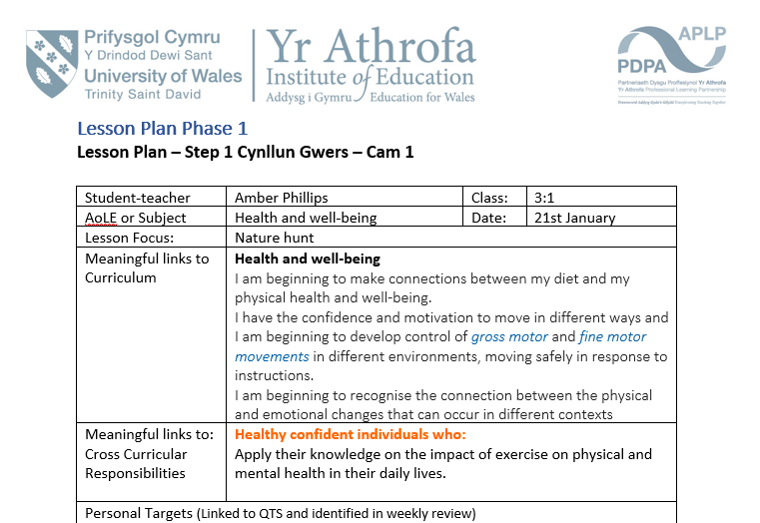

Part two

This assignment aims to research and deepen understanding of pedagogical approaches to ensure progression across the curriculum and identify and justify areas for development.
From the evidence gathered in part one, I will be identifying an aspect of my practice to improve. Part one displays two opportunities I have had to plan for progression in learning. I used planning for progression throughout a series of Welsh language sessions which I developed my subject knowledge on first. I also used planning for progression throughout literacy sessions where I tracked and monitored pupil’s progress using a tracking chart, this is evident in part one after a lesson on conjunctions. Planning for progression is a standard I feel confident with as I have spent a lot of time putting this into practice throughout previous PTE’s. It is also something I have had positive feedback on from my senior mentor and class teacher within my previous placements. Part one also displays two opportunities I had to use the four purposes to plan sessions. I used the four purposes to plan a Humanities lesson on the Romans which I developed my subject knowledge on first. This was a valuable lesson to embed the four purposes within as it covered cross-curricular themes therefore linked to more than one purpose. I also used the four purposes to plan online Health and Well-being sessions, the Health and well-being sessions were short activities for learners to complete independently to have some time away from the screens. This was a AoLe that I did not have the opportunity to teach live due to the current Covid-19 situation and all sessions were asynchronous. Although the sessions were asynchronous it was clear the pupils would be progressing towards the chosen purpose as the task was centred around the purpose. However, it was hard to embed other skills such as cross-curricular learning or embedding more than one purpose as I did not want to cause confusion for the learners as they were working independently for a short period of time.

Given that, the aspect of my practice I have identified to develop is cross-curricular responsibility of the Health and Well-being Area of Learning Experience. This aspect has been identified as an area to improve as it was an AoLE that I have not yet had that many opportunities to engage with or plan across the curriculum throughout my professional teaching practice. I also have not had the opportunity to teach this AoLE synchronously to the children. Within part one of this assignment, I discussed a lesson that I taught on Health and well-being; where I focused on ‘developing physical health and well-being having lifelong benefits’, this promoted the purpose of healthy, confident, individuals. This would be an AoLE I would like to explore in greater detail within the future and embed across the curriculum in other areas of learning. Health and well-being are essential parts of the Curriculum for Wales 2022 as the Welsh Government (2020) state ‘Good health and well-being are important to enable successful learning’. What’s more, Donaldson (2015, p.47) states that teachers will be able to make strong links between the Health and well-being Area of Learning and Experience and other Areas of Learning and Experience across the curriculum. Such as, Expressive arts and Language, literacy, and communication, where pupils can explore relationships through drama and literature. In the Humanities Area of Learning and Experience pupils can explore ethical matters, and within Science and technology pupils can learn about nutrition and reproduction.

Another reason this aspect has been identified to develop is that it relates closely to learner progression, ‘children need to experience different aspects of well-being to thrive and engage successfully with their education’ (Donaldson, 2015, p.45). The Welsh Government (2020) support this as they state that engaging with this area enables Health and well-being to permeate all aspect of school life. In addition to this, Brooks (2014, p.4) states that there is clear evidence which demonstrates that education and health are closely linked. Therefore, promoting Health and wellbeing across the curriculum for all pupils within schools has the potential to improve their educational outcomes. Rose, Gilberts and Richards (2016, p.2) agree with this as they associate children who have higher levels of well-being with having an increased capacity to learn and being more deeply engaged, motivated, and interested with their learning. Gutman and Vorhaus (2012) support this as they found that wellbeing also predicted later academic progression and engagement. Similarly, they argue that well-being and learning are associated with one and other. Gutman and Vorhaus’ study demonstrates the importance of wellbeing for children throughout their primary and secondary education. From reviewing previous research, their key findings were children with higher levels of social, emotional, and behavioural well-being have higher levels of academic achievement and are more engaged with school. What’s more, children who have better emotional well-being make more progress in primary school and are more engaged in secondary school (Gutman and Vorhaus,2012, p.3). This suggest that teaching Health and well-being cross-curricular should impact pupils progress and achievement and also increase pupil engagement in school.

Significantly, Gutman and Vorhaus (2012, p.8) state for academic progression, better emotional wellbeing is a key factor in primary school. This implies that schools should promote well-being as often as possible throughout the curriculum to aid academic progression. By embedding Health and well-being cross-curricular there will be various opportunities for the pupils to develop their well-being which will then result in better academic achievement and engagement throughout primary and secondary school.
There are many benefits of promoting Health and wellbeing cross-curricular including: pupils being more engaged in their learning process, improved literacy and numeracy skills, and pupils having higher self-esteem, confidence, and better behaviour in the classroom (Welsh Government, 2012, p.3). One of the benefits of teaching cross-curricular is developing literacy and numeracy skills and the Welsh Government (2020, p.27) state where there are opportunities learners should extend and apply their skills across different areas, for example, promoting well-being through literacy. Literacy is a fundamental enabler of well-being as it provides learners with the opportunity to communicate their feelings, express emotions, develop relationships, and seek advice and support when needed (Welsh Government, 2020, p.85). Ultimately, literature has significant potential to support learners’ empathy, mental health, and emotional well-being (Welsh Government, 2020 p.85).
Faultley and Savage (2012, quoted in Barnes, 2015, p.62) support this as they state cross curricular methods have been perceived to have motivating, inclusive, enriching, and uniting effects on learning. Barnes agrees as he argues cross curricular teaching can be effective when teaching ethical solutions or building individual or group motivation (Barnes, p.62). This suggest that embedding Health and well-being cross-curricular will have significant effects on pupils learning, motivation and engagement in different Areas of Learning and Experience.

In order to teach Health and well-being effectively across the curriculum Barnes (2015, p.63) states that good cross-curricular pedagogy should be relevant, such as increasing interaction with the world and knowledge of the children’s here and now. He states this will increase motivation, participation, and engagement in lessons. This suggest that when embedding Health and well-being cross curricular it is important to link the lessons to our world and the here and now, this will make the lessons more interesting and engaging for the pupils. This could be done by arranging local visits within the community and by providing real life authentic context to the learners. Rowley and Cooper (2009) support this as they state that we should search for examples of links between different subjects and relate them through children’s experiences. They found that foundation subjects are often ways into other subjects and believe that by teaching cross-curricular it is possible for pupils to study subjects in more depth. This suggest that when embedding Health and well-being cross-curricular it is important to make links to the children’s experience by making the activities meaningful to all. This may result in the pupils studying the subject in greater detail.

Focusing on Estyn’s (2018) effective practice Taverspite school has been developing engaging learning activities to enhance pupils cross-circular skills in meaningful contexts. It was said that the pupils had benefited from experiencing engaging and exciting learning experiences that were well structured and thoughtfully engineered to refine and develop a wide range of cross-curricular skills in meaningful context (Estyn, 2018). This impact was identified by observing improvements in pupil outcomes.

Above all, Barnes (2018) argues that for some children separate subject teaching is the way forward, but for many more it is clear the traditional methods are not working therefore, cross curriculum approaches should be used to close the gap of underachievers and improve pupil outcomes.

By contrast, Barnes (2015, p.63) argues that there are also limitations to embedding subjects cross curricular. He states that cross curricular learning can equally be ineffective, confusing, or misleading by failing to provide a moral context. He argues that poor cross-curricular teaching can result in untransferable and difficult unarticulated learning (Barnes, 2015, p.65). This suggest that embedding Health and well-being cross curricular may be confusing for the learners or misleading, to reduce the risks of this happening, I will ensure I develop my cross-curricular pedagogy to ensure I teach the pupils effectively and have secure subject knowledge in the area. In addition to this, Barnes (2012, p.16) states that in the past when using cross curricular teaching, links were often made between too many subjects and progression was not possible. He argues that this is because progress towards particular subject objectives is not easy to manage when two subjects are involved. However, Barnes (2012, p.15) argues that cross-curricular learning is generally effective in securing progression, but this is only when the teacher’s subject knowledge is secure, and children are aware of their subject understanding. Barnes (2018) states that although most primary school teachers are trained across the curriculum, cross curriculum links are rarely integrated, and most teachers make links between separate subjects for a short time period. This means that many teachers are not using cross-curricular approaches, this may be because they find it difficult to ensure progression is being made when teaching cross-curricular or do not have the correct subject knowledge on teaching it effectively. However, this does suggest that many pupils are missing out on the benefits of cross-curricular learning.

To conclude, I will need to take specific actions to improve my practice and ensure I teach the Health and Well-being AoLE effectively cross-curricular.
Firstly, I will need to develop my subject knowledge as Coe et al (2014, p.3) state ‘The most effective teachers have deep subject knowledge of the subjects they teach’. They argue that if teacher’s subject knowledge falls below a certain level it impacts the students learning. Ko and Sammons (2013) agree with this as they argue in order to achieve good teaching, good subject knowledge is essential. That said, before embedding Health and well-being cross- curricular I must first develop my subject knowledge on the area of learning to ensure progression can be made by all pupils. In addition to this, I will also need to develop my cross-curricular pedagogy as Barnes (2012, p.17) states ‘successful cross-curricular activities need commitment and enthusiasm on the part of the teacher. As a result of meaningful professional development, teachers will be able to plan a series of powerful experiences for each class (Barnes, 2012, p.17). Another way to ensure my teaching is effective will be to encourage child led learning as Barnes (2012, p.17) states the pedagogy of cross-curricular might include allowing the children to choose an experience that they deem important. This is supported by Rowley and Cooper (2009) as they previously stated that learning should link to the child’s experience.
Another action I will take to ensure successful teaching and learning will be tracking and monitoring pupil progression. I will do this by using the descriptors of learning and the progression steps from the Curriculum for Wales 2022 (Welsh Government, 2020) and also by using the professional teaching standard of ‘progression in learning’ (Welsh Government, 2019). What’s more, I will use different forms of assessment to track and monitor pupil’s progress after each session, ensuring I am acting upon pupils next steps. Another important aspect of aiding progression will be ensuring pupils are active participants in their learning process (Welsh Government, 2020, p.31). This means assessment and progression will need to be understood not only by the teacher but also by the pupil to ensure they know how they can progress within their learning (Welsh Government, 2020, p.9). Finally, the last action I will take will be embedding the four purposes and ensuring pupils experiences in these areas contribute to the purposes. Donaldson (2015, p.38) states each Area of Learning and Experience should make distinct and strong contributions to developing the four purposes of the curriculum. I will do this by incorporating the four purposes within my lesson planning and also by using the professional teaching standard of ‘four purposes for learners’ (Welsh Government, 2019) to drive the learning experiences. By undertaking all of these specific actions, I hope to successfully teach Health and well-being cross-curricular within my future teaching practice and hope to see increased pupil engagement and progression across the school.

Part 2- Word count: 2198

References

Barnes, J. (2012) An introduction to cross-curricular learning. The primary curriculum: A creative approach, pp.235-254.

Barnes, J. (2015) Cross Curricular learning 3 -14. 3rd Ed. London. Sage.

Barnes, J. (2018) Applying cross-curricular approaches creatively (Learning to teach in the Primary School Series). Oxon. Routledge.

Breeden (2021) The search for a unified theory of language learning. Available at: https://www.fluentu.com/blog/theory-of-language-learning/ (Accessed 21st March 2021).

Brooks, F. (2014) The link between pupil health and wellbeing and attainment: a briefing for head teachers, governors, and staff in education settings: London: Crown Copyright.

Coe R, Aloisi C, Higgins S, Elliot Major L. (2014) What Makes Great Teaching? Review of the Underpinning Research. Durham: Centre for Evaluation and Monitoring/The Sutton Trust.

Donaldson, G. (2015) Successful Futures. Available at: https://gov.wales/sites/default/files/publications/2018-03/successful-futures.pdf. (Accessed 18th February 2021).

Estyn (2018) Developing a skill-based curriculum in a primary school. Available at: https://www.estyn.gov.wales/effective-practice/developing-skills-based-curriculum-primary-school. (Accessed 4th March 2021).

Gutman, L. M. and Vorhaus, J. (2012) The impact of pupil behaviour and wellbeing on educational outcomes. Institute of Education. University of London.

Ko J. and Sammons P. (2013) Effective Teaching: A Review of Research and Evidence. Reading: CfBT Education Trust.

Leahy, S. and Wiliam, D. (2007) From teachers to schools: scaling up professional development for formative assessment. University of London. London.

McLeod, S. (2019) Bruner – Learning Theory in Education. Available at: https://www.simplypsychology.org/bruner.html (Accessed 18th February 2021).
Rowley, C. and Cooper, H. eds. (2009) Cross-curricular approaches to teaching and learning. Sage.

Rose, J., Gilberts, L. and Richards, V. (2016) Health and Well-being in Early Childhood. London: Sage.

Welsh Government (2010) Thinking positively: Emotional Health and Well-being in school and early years settings. Available at: https://gov.wales/sites/default/files/publications/2018-12/thinking-positively-emotional-health-and-well-being-in-schools-and-early-years-settings.pdf (Accessed 23rd February 2021).

Welsh Government (2020) Area of Learning Experience: Health and Well-being. Available at: https://hwb.gov.wales/curriculum-for-wales/health-and-well-being/ (Accessed 21st February).

Welsh Government (2020) Curriculum for Wales guidance. Available at: https://hwb.gov.wales/api/storage/afca43eb-5c50-4846-9c2d-0d56fbffba09/curriculum-for-wales-guidance-120320.pdf (Accessed 18th February 2021).

Welsh Government (2018) Digital Competence Framework. Available at: https://hwb.gov.wales/storage/337437b8-cfe3-4305-ae32-f47ad82f3e76/digital-competence-framework-guidance-2018.pdf (Accessed 21st March 2021).

Welsh Government (2019) Professional standards for teaching and leadership. Available at: https://hwb.gov.wales/api/storage/19bc948b-8a3f-41e0-944a-7bf2cadf7d18/professional-standards-for-teaching-and-leadership-interactive-pdf-for-pc.pdf. (Accessed 5th March 2021).

Wiliam, D. (2004) Keeping learning on track: integrating assessment with instruction. 12. Philadelphia. International Association for Education Assessment.

Appendix
- Notes on CPD courses for DCF SKD

