

University of Wales Trinity Saint David
School of Engineering

Advanced Engine Design
M6X00410
CON-ROD ACCELERATIONS, FORCES & DISPLACEMENTS
Stuart Harries
Malcolm McDonald
04/11/19

Table of Contents
1 Introduction 1
1.1 Assumptions 1
2 Background Research 2
3 Methodology 3
3.1 Peak Gas Force 3
3.2 Inertia Loads 4
3.3 Compressive Force & Tensile Load 4
3.4 Compressive & Tensile Stresses 4
3.5 Nominal Static Safety Factors 5
3.6 Compression Distance & Tensile Stretch 5
4 Results & Analysis 6
4.1 Modified Engine 6
4.2 Peak Gas Forces 6
4.3 Inertia Loads 7
4.4 Compressive Force & Tensile Load 8
4.5 Compression & Tensile Stresses 8
4.6 Nominal Static Safety Factors 8
4.7 Compression Distance & Tensile Stretch 9
5 Conclusion 10
6 References 11
7 Appendix A 12
8 Appendix B 13
9 Appendix C Further Work 14
9.1 Methodology 14
9.2 Results & Analysis 16

Table of Tables
Table 1- Dimensions & masses for ford 1.6 engine (Powder Forged Steel) 1
Table 2- For modified engine (Titanium) 1
Table 3- Peak gas force results 6
Table 4- Compressive force (N) & tensile load (N) 8
Table 5- Compressive & tensile stresses 8
Table 6- Nominal static safety factors 9
Table 7- Compression distance & tensile stretch 9
Table 8- Titanium Con-Rod 9
Table 9- Piston ring 14
Table 10- Work done & power loss 16
Table 11- Torque 16

Table of Figures
Figure 1- Forces acting on the connecting rod (Rao, 2013) 2
Figure 2- Peak gas forces 3
Figure 3- Cylinder pressure 6
Figure 4- Graph showing the peak gas force for the production engine 7
Figure 5- Graph for inertia loads on rod 7
Figure 6- Inertia loads on rod (production & modified) 8
Figure 7- Cylinder pressure data for 6000rpm 12
Figure 8- Excel calculations for 6000rpm 12
Figure 9- Modified engine pressure for 10000rpm 13
Figure 10- calculations for 10000rpm (modified) 13
Figure 11- Work done calculations - Part 1 14
Figure 12- Work done calculations - Part 2 15
Figure 13- Torque calculations 15
Figure 14- Side force @ 6000rpm 16
Figure 15- Gas torque at 6000 rpm 17

Table of Equations
Equation 1- Peak gas force (N) 3
Equation 2- Inertia load (N) 4
Equation 3- First order acceleration 4
Equation 4- Second order acceleration 4
Equation 5- Maximum compressive force on rod (N) 4
Equation 6- Maximum tensile load on rod (N) 4
Equation 7- Stress 4
Equation 8- Nominal static safety factor 5
Equation 9- Distance/Stretch 5

Introduction
The aim of this assignment is to calculate the forces, con-rod accelerations and displacements, using the Ford 1.6-cylinder pressure data provided, and for a modified engine. A Microsoft Excel simulation model has been created which is used to accurately calculate these results. Additionally, the work done per cylinder and torque of the engine has been calculated using the cylinder pressure data from the Ford 1.6 engine at 6,000 rpm.

Assumptions
Table 1- Dimensions & masses for ford 1.6 engine (Powder Forged Steel)
Bore Diameter | 0.079 | m
Cross-sectional Area of Con-Rod | 195 | mm²
Ultimate Tensile Stress (UTS) | 750 | Mpa
Youngs Modulus (E) | 170 | Gpa
Stiffness (K) | 247388.06
Crank Radius | 0.0407 | m
Con-Rod Length | 0.134 | m
Piston Mass | 0.2577 | kg

Table 2- For modified engine (Titanium)
Titanium
UT S | 950 | Mpa
Youngs Modulus | 130 | Gpa
Stiffness (K) | 189179.1

Background Research
A connecting rod connects the piston head to the crankshaft. The connecting rod is an integral part of an internal combustion engine and when designing the connecting rod, the forces acting on the rod must be taken into consideration. This is shown in figure 1. (Rao, 2013)
The connecting rod may be made of carbon steel or any other alloy. (Dh, 2017)

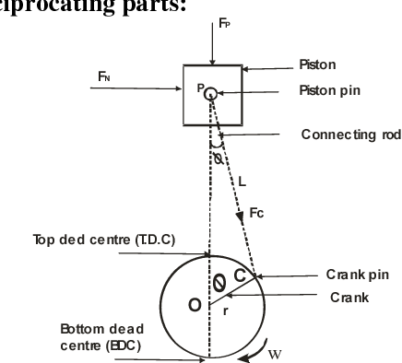
Figure 1- Forces acting on the connecting rod (Rao, 2013)

Methodology
The data for the production engine is obtained from a Ford 1.6 engine with the rpm ranging from 1,000rpm to 6,000rpm. For the modified engine, the engine rpm is increased to 10,000rpm. 10,000rpm has been chosen as modern F1 engines are running at a maximum 15,000rpm (FIA, 2019), which is based on similar size engines, which are also turbo-charged. It should be reasonable to expect the modified engine therefore to achieve 10,000rpm.
To determine the increase in cylinder pressure for the modified engine; the peak gas forces were calculated for each rpm from 1,000 to 6,000; and the graph shown in figure 2 was created. The trendline shown then gives the equation y = 3.7774x + 25424 and x is replaced with the required rpm. This gives the maximum gas force for 10,000rpm. This value for the gas force is divided by the peak gas force for 6,000rpm to find the percentage increase. The mean cylinder pressure for 6,000 rpm is multiplied by the percentage increase.

Figure 2- Peak gas forces

Peak Gas Force
To calculate the peak gas force in the cylinder equation 1 is used. P_{max} is the maximum pressure in the cylinder (Pa) and d is the bore diameter (m).
$$Peak Gas Force=p_{max}×\frac{πd^{2}}{4}$$
Equation 1- Peak gas force (N)

Inertia Loads
To calculate the inertia loads that the piston exerts on the rod, equation 2 is used. First Order and Second Order are the piston accelerations and $φ$ is the rod angle. The rod angle is included in this equation to display the inertia load across the rod. is the rod angle.
$$Inertia Load=Piston Mass ×\left(First Order+Second Order\right)×cos$$
Equation 2- Inertia load (N)
$$First Order Acceleration=R×ω^{2}× cosθ$$
Equation 3- First order acceleration
$$Second Order Accleration= \frac{R}{L} ×R×ω^{2}×cos$$
Equation 4- Second order acceleration
Where first and second order are the piston accelerations.

Compressive Force & Tensile Load
Equation 5 is used to calculate the maximum compressive force, and equation 6 is used to calculate the maximum tensile load.
$$Maximum Compressive Force on Rod = \frac{ p_{\max{×(\frac{πd^{2}}{4})}}- Inertia Force (At P_{max})}{cos}$$
Equation 5- Maximum compressive force on rod (N)

$$Maximum Tensile Load on Rod= \frac{Inertia Force-Gas Force(Max)}{cos}$$
Equation 6- Maximum tensile load on rod (N)

Compressive & Tensile Stresses
To calculate the compression stress, the maximum compressive force on rod is used. For the tensile stress, the maximum tensile load on rod is used.
$$σ=\frac{F}{A }$$
Equation 7- Stress

Nominal Static Safety Factors
Using the results calculated for compressive and tensile stresses, equation 8 is used to calculate the nominal static safety factor for both compressive and tensile.
$$Safety Factor =\frac{Ultimate Tensile Strength (UTS)}{Stress (σ)}$$
Equation 8- Nominal static safety factor

Compression Distance & Tensile Stretch
This equation is used to calculate the maximum compression and stretch, using the results calculated for compression and tensile stresses.
$$Maximum Distance/Stretch(x)= \frac{( Stress (σ) ×Area) }{Stiffness (K)}$$
Equation 9- Distance/Stretch

Refer to Appendix A and Appendix B for the Excel Calculations for the production engine and modified engine.

Results & Analysis

Modified Engine
The graph shown in figure 3 has been created to demonstrate the increase in cylinder pressure between 6,000rpm and 10,000rpm.
Figure 3- Cylinder pressure

Peak Gas Forces
Table 3 shows the results that were calculated for the peak gas forces in the cylinder. From the calculations the peak gas force for the production engine was at 6,000rpm, and 10,000rpm for the modified engine.
Table 3- Peak gas force results
Peak Gas Forces
Production (N) | Modified (N)
46862.91 | 63198

The peak gas forces have been calculated for other rpms in the cylinder pressure data set and a graph (see figure 4) is created to demonstrate when the rpm is increased, the gas force in the cylinders will also increase.

Figure 4- Graph showing the peak gas force for the production engine

Inertia Loads
Figure 5- Graph for inertia loads on rod

Figure 5 is a graph that shows the inertia loads which the piston exerts on the rod per crank angle degree. As the graphs shows, when the rpm is increased, the inertial loads will also increase. This is further shown in figure 6 which compares the inertia loads with 6,000rpm for the production engine, and 10,000rpm for the modified engine.
Figure 6- Inertia loads on rod (production & modified)

Compressive Force & Tensile Load
Table 4 shows the highest net compressive and tensile force for the production and modified engine.
Table 4- Compressive force (N) & tensile load (N)
Compressive Force (N) |  | Tensile Load (N)
Production | Modified | Production | Modified
41929.46 | 49498.53 | 4080.22 | 13210.20

Compression & Tensile Stresses
Table 5 shows the maximum compression and tensile stresses in the rod shank.
Table 5- Compressive & tensile stresses
Compressive Stress (N/mm) |  | Tensile Stress (N/mm)
Production | Modified | Production | Modified
215.02 | 253.84 | 20.92 | 67.74

Nominal Static Safety Factors
Table 6 are the calculated nominal static safety factors, for both the compressive and tensile forces.

Table 6- Nominal static safety factors
Compressive Safety Factor (N) |  | Tensile Safety Factor (N)
Production | Modified | Production | Modified
3.49 | 2.95 | 35.84 | 11.07

Compression Distance & Tensile Stretch
Table 7 shows the compression distance and tensile stretch of the rod where the material used is powder forged steel. Table 8 shows the results for the modified engine, where the material of the rod has been changed with an identical design in Titanium. The results for the modified engine show that when changing the material, from powder forged steel to titanium, the maximum compression distance and stretch have increased.
Table 7- Compression distance & tensile stretch
Compression Distance (mm) |  | Tensile Stretch (mm)
Production | Modified | Production | Modified
0.17 | 0.20 | 0.02 | 0.05

Max Compression Distance (mm) | 0.26
Tensile Stretch (mm) | 0.07
Table 8- Titanium Con-Rod

This would also result in manufacturing tolerances being closer on the modified engine, with a view to the increased movements in the component parts, as shown above. If these are within the operating tolerances, the modified engine should produce a significant increase in power, and, if the tolerances are adhered to, the engine should be reliable.

Conclusion
The conclusion I have arrived at is that, by increasing the rpm, there is a significant increase in pressure. This of course exerts higher stresses on the connecting rod. This can be mitigated by utilising titanium in the components, which will give an element of safety over the standard engine. By using a higher specification material, it is possible to safely increase the maximum power available. Also, at higher rpm, the tolerances of the engine will become more important, and will bear a relationship to the overall reliability of the engine.
Whilst it may be possible to achieve such high rpm’s, these bring with it other problems such as additional cooling and the larger pumps and radiators to dissipate the heat. These need to be considered along with the specific engine needs. As always, there is the trade-off between weight and power.

References
Dh, M. &. (2017). DESIGN AND ANALYSIS OF A CONNECTING ROD. International Journal of Pure and Applied Mathematics, 105-109.
FIA. (2019). 2019 FORMULA ONE TECHNICAL REGULATIONS. Fédération Internationale de l’Automobile.
Nigus, H. (2015). Kinematics and Load Formulation of Engine Crank. Mechanics, Materials Science & Engineering Journal.
Rao, G. N. (2013). Design Optimization and Analysis of a Connecting Rod using ANSYS. International Journal of Science and Research, 225.

Appendix A
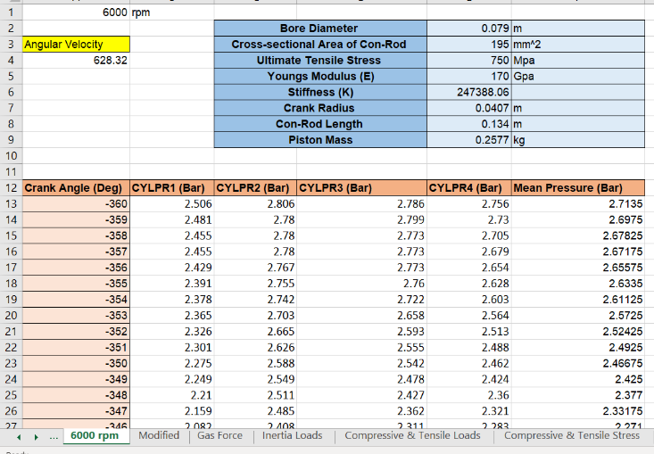
Figure 7- Cylinder pressure data for 6000rpm


Figure 8- Excel calculations for 6000rpm

Appendix B

Figure 9- Modified engine pressure for 10000rpm

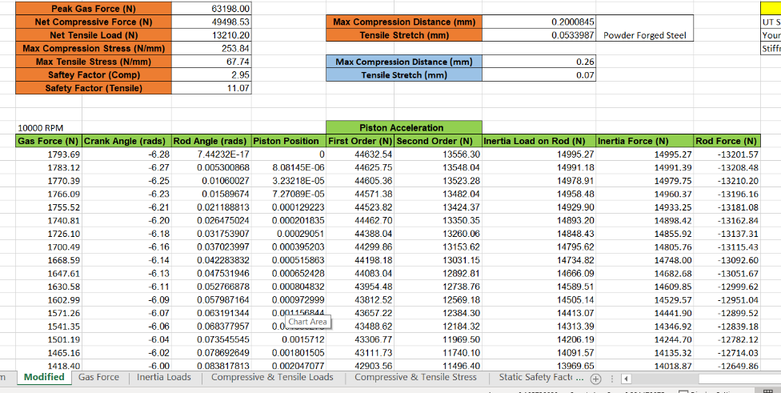
Figure 10- calculations for 10000rpm (modified)

Appendix C Further Work

Methodology

Table 9- Piston ring
Piston Ring Height | 0.0012 | m
Piston Ring Inner Diameter | 0.076 | m
Piston Ring Thickness | 0.0015 | m
Coefficient of Friction | 0.1
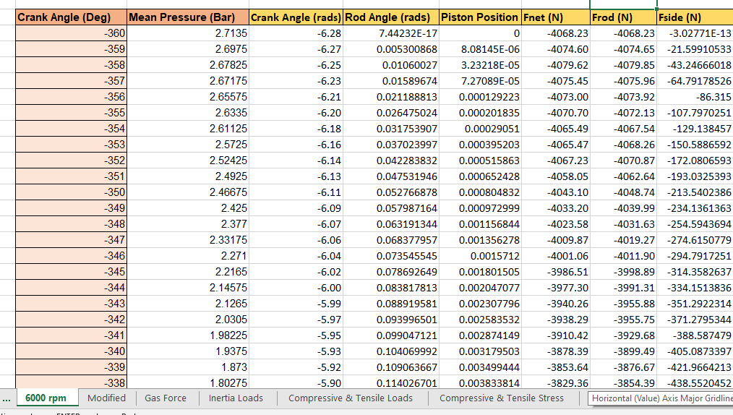
Figure 11- Work done calculations - Part 1
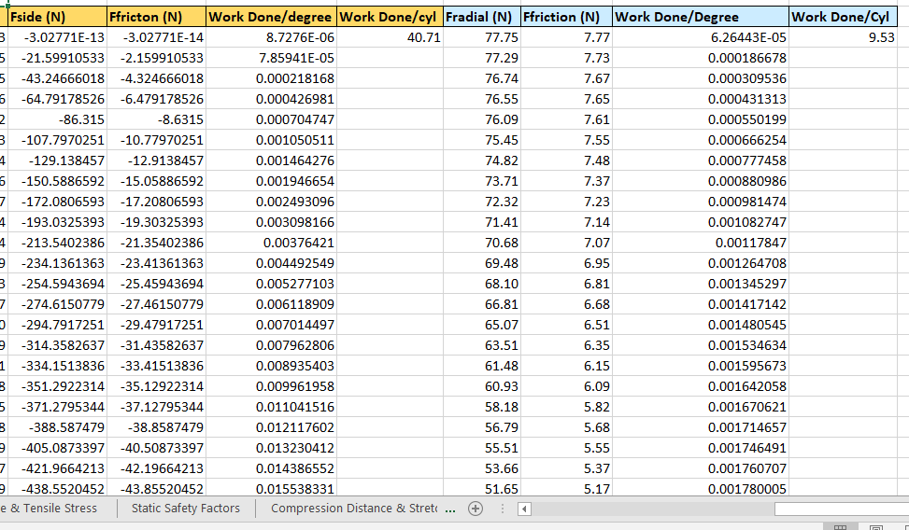
Figure 12- Work done calculations - Part 2
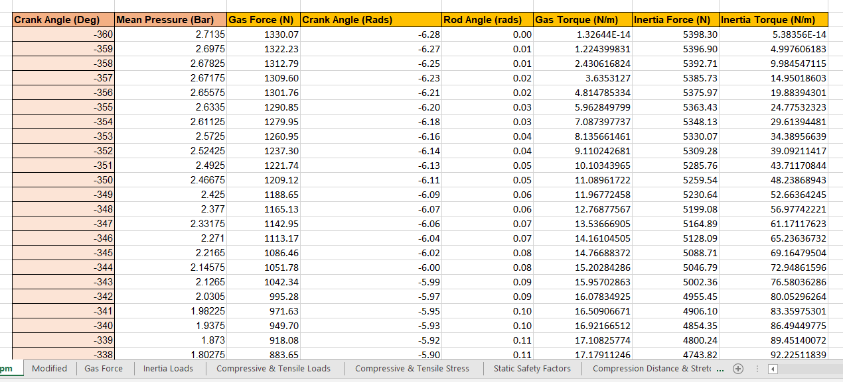
Figure 13- Torque calculations

Results & Analysis
Table 10 below shows the results calculated for the total work done per cylinder and the power loss per cylinder at 6,000rpm.
Table 10- Work done & power loss
Total Work Done/Cylinder | 50.25 | Joules/Cylinder
Power Loss/Cylinder | 2512.37 | Joules/second/Cylinder

Figure 14 is a graph showing the results for side force at 6,000rpm. From analysing the graph, the maximum side force calculated will be approximately 30 degrees after the piston hits top dead centre (TDC).
Figure 14- Side force @ 6000rpm

Table 11 shows the results calculated for gas and inertia torque at 6,000rpm. The average gas torque is per cylinder with the mean gas torque is all cylinders in the engine.
Table 11- Torque
Average Gas Torque (N/m) | 56.06
Mean Gas Torque (N/m) | 224.26
Average Inertia Torque (N/m) | 0.00

Figure 15- Gas torque at 6000 rpm
Figure 15 shows what happens to the gas torque over a full cycle.

