Sustainability in coca cola: A Critical Analysis

Emma-Lisa Beaumont
P1804423

Contents
1. Introduction 2
2. Corporate Social Responsibility in Business 2
3. Sustainability 3
4. Triple Bottom Line 3
5. Sustainability in Coca Cola 4
5.1 Economic Sustainability 4
5.2 Environmental Sustainability 4
5.3 Social Sustainability 4
6. The Sustainability Challenges for Coca Cola Company 5
6.1 Water Stewardship and Pollution Issues 5
6.2 Greenwashing and Water Neutrality Claims 6
7. Conclusion 6
8. Recommendations for Coca Cola 6
References 7

Introduction
This report has been commissioned to critically analyse the role of corporate social responsibility and the triple bottom line in business from a sustainability perspective. The report will then review the challenges faced by an organisation in relation to these issues. The chosen business for this analysis is The Coca Cola Company.

2. Corporate Social Responsibility in Business
Corporate Social Responsibility (CSR) is defined by the Financial Times as ‘a business approach that contributes to sustainable development by delivering economic, social and environmental benefits for all stakeholders’ (FT, 2019).
Milton Friedman’s position on CSR is that businesses should have no outside responsibility – only the responsibility to its stockholders to generate profit (Friedman, 1970). However, CSR features prominently in Edward Freeman’s stakeholder theory and opposes Friedman’s stance. Freeman denotes that businesses should consider all the outside groups (See Fig. 2) which a business could affect – whether positively or negatively (Crane, Matten, 2010).
Carroll’s Model of Corporate Social Responsibility outlines the CSR expectations which are placed on a business by society. These are outlined as economic, legal, ethical and philanthropic expectations. The model states that for a company to be fully meeting its ethical and CSR responsibilities, it must meet all four expectations (See Fig. 1). This model compliments Freeman’s stakeholder theory.
Figure 1: Carroll’s Model of Corporate Social Responsibility
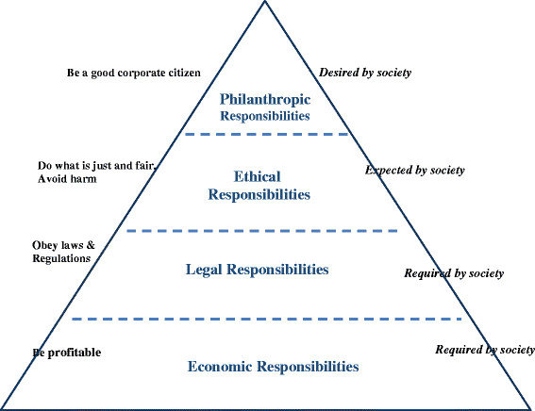
(Source: Carroll, 2016)
The Coca Cola Company is a global beverage company, which manufactures and distributes non-alcoholic beverages and syrups to almost every country in the world (Torres et al, 2012 p53). In 2017 its revenue was over $35 billion (Coca Cola, 2019).
Coca Cola has many sustainability issues to face. There have been controversies over its water use within its manufacturing processes, and in several areas the company has been deemed to contribute to decline in supply and quality of water for poor rural communities (O’Brien, 2018).

3. Sustainability
Although there are many perspectives on sustainability, in business the definition of sustainable development is best expressed by Brundtland as, “meeting the needs of the present generation without compromising the ability of future generations to meet their own needs” (Brundtland Commission, 1987). As seen previously in Carroll’s Model of Corporate Social Responsibility (Fig 1.), sustainability can be applied to both a company’s legal and ethical responsibilities.
The Coca Cola Company has a clear sustainability report for 2017 and as part of the report has set several sustainability goals for 2020. These sustainability goals include women’s empowerment, water conservation and waste management. These goals include increasing the number of female entrepreneurs within their supply chain from 1.2 million to 5 million, recycling or reusing 75% of packaging and a 25% water efficiency (Coca Cola Company, 2019).

4. Triple Bottom Line
Originally an accounting model, the theory of triple bottom line sustainability was first introduced by Elkington in 1994. The triple bottom line is closely associated with CSR reporting and sustainability. This framework allows businesses to take environmental and social performance into account, alongside financial performance, to give a more holistic overview of how a company works and behaves (Elkington, 2018).
Figure 2: Stakeholder Theory Diagram
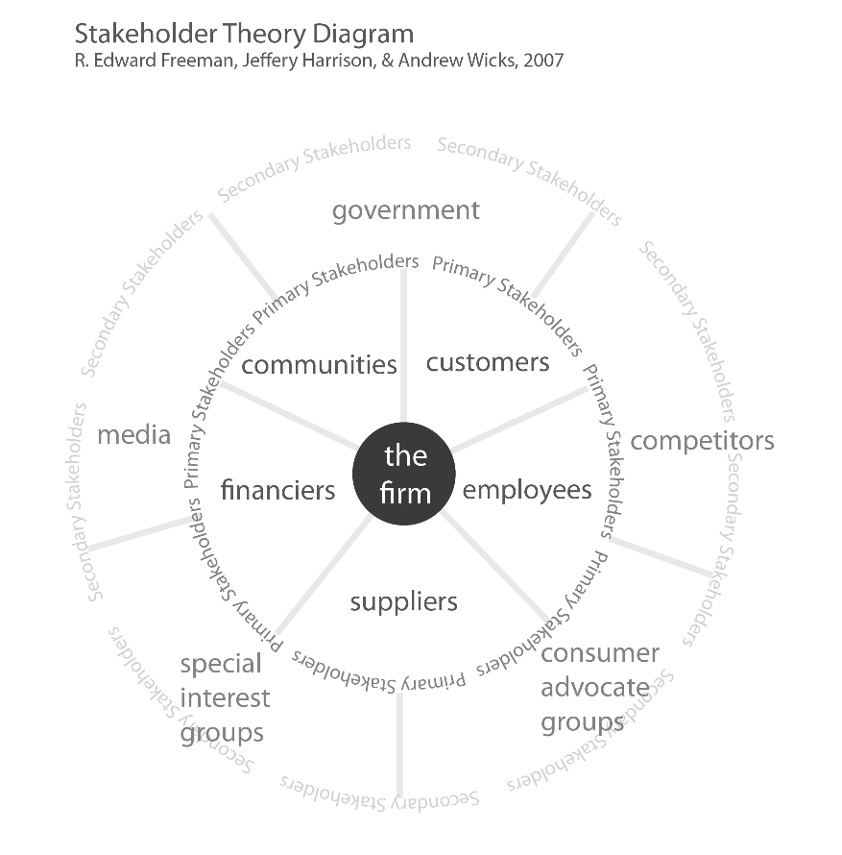
(Source: The Society Pages)
Operating in a sustainable manner is important for businesses in the modern global market. It fulfils the expectations and needs of consumers and demands that responsibility for the stakeholders lies with the business; in line with Freeman’s theory. According to Freeman’s theory, the triple bottom line for Coca Cola would affect not only their shareholders and customers, but a much wider group of stakeholders (see fig. 2) and the environment.
There are many advantages of implementing the triple bottom line, which includes the positive brand impact to a company. It does this by meeting customer expectations that the brand cares about particular socio-economic and environmental issues. It can also work as a cost-saving exercise as the company aims to reduce environmental impact (Stephens, 2015).
With these key issues in mind, the Global Reporting Initiative (GRI) was created to develop guidelines to help businesses develop their sustainability reports using economic, environmental and social indicators. These issues include human rights, environmental sustainability and equality (Torres et al, 2012 p.52). Coca Cola has chosen to adopt this framework and formats its sustainability reporting using GRI G3.1 guidelines (Torres, et al p.68).

5. Sustainability in Coca Cola

5.1 Economic Sustainability
Coca Cola was met with a challenge in 2018 in the UK, when the UK Government introduced a sugar tax. The “Soft Drinks Industry Levy” was put in place at the point of production or importation of the beverage. Drinks with more than 5g per 100ml of sugar are taxed at 18p per litre, and drinks with more than 8g per 100ml at 24p per litre (Gander, 2016). Coca Cola responded to this by introducing new varieties of sugar free or low sugar options, and by decreasing bottle sizes for a more premium price (Wood, 2018). By doing this, Coca Cola are working towards maintaining their market share and their economic sustainability.

5.2 Environmental Sustainability
Water stewardship is one of the main environmental challenges facing the Coca Cola Company. In 2002 Coca Cola was criticised for overusing the water of the village of Plachimada, India, after a factory built in the area used up water from the wells and left drinking water toxic and contaminated (Raman, 2005). In January 2017, Tamil Nadu Vanigar Sangangalin Peramaipu – a Southern Indian trade association – called for all members to cease selling both Coca Cola Company and PepsiCo products in order to support local farmers who had been suffering from groundwater depletion caused by the companies (Bhushan, 2017). The Coca Cola Company maintains that it has a “special interest in protecting local water sources” (Coca Cola, 2019) and claim that for every drop of water used in Coca Cola products, one is given back. This, however, does not include the water used in the production process (Coca Cola, 2019).

5.3 Social Sustainability
Coca Cola has received much criticism for the health effects of its beverages, as many – especially it’s flagship Coke brand – are high in sugar. According to a study by the Harvard School of Public Health, “people who drink 1-2 cans of sugary beverages daily are 26% more likely to develop type 2 diabetes” (Harvard School of Public Health, 2015). The Coca Cola company mitigates this issue by marketing reduced or no sugar options of their drinks (Coca Cola, 2018).

6. The Sustainability Challenges for Coca Cola Company

6.1 Water Stewardship and Pollution Issues
In India, several demonstrations were held and campaigns raised against the company, following the publication of a report by the Indian NGO Centre for Science and Environment in 2003. The report exposed levels of pesticides in their Coca Cola beverages many times higher than any acceptable limit in European standards. The report also revealed that the company had polluted local water sources with their operations (Ramesh, Jha, 2006). The Indian government investigated these claims but found The Coca Cola Company had not broken any national standards legislation. Despite public concern, attempts to introduce tougher national standards were blocked by powerful interests in the Indian government (Torres et al. 2012).
The Coca-Cola processing plant in Plachimada, Kerala were discovered to be a source of water pollution for the local area. Waste water from the plant was being discharged into local fields and rivers. The pollution of soil and groundwater made water from wells and handpumps unfit for human consumption (Torres et al. 2012). Following water stewardship issues in Kerala, the local High Court of Kerala banned the company from over extracting groundwater. Coca Cola were forced to close their operations and the brand’s reputation in the area suffered and sales dropped by 40% (Mahjumder, 2006). In 2000, the community living in the vicinity of the plant in Kerala complained of water scarcity. However, Coca-Cola blamed natural drought conditions and low rainfall in the area. Despite a suspension of operations for two years for these issues, Coca-Cola was successful in renewing it’s licence to operate in 2006. In March 2010, the state government recommending fining Coca-Cola for the damage to groundwater and soil in the Kerala area. Coca-Cola denied all allegations (Torres et al. 2012).
To counteract these issues, Coca Cola formed a partnership with the World Wildlife Fund in 2007. It also became a member of the CEO Water Mandate, as the company aimed to address its water use (WWF, 2018). In addition The Coca Cola Company annually publish a Sustainability Report, which lists goals and sustainability development issues identified by the company. This includes statistics of their annual water usage and details of their goals to decrease this (Coca Cola, 2018).
Although following this controversy Cola Cola made efforts to improve the situation in India, in 2017 the company was accused of the same issues in Mexico. Their manufacturing plant in the indigenous area of San Felipe Ecatepec, Chiapas has reportedly been running natural water resources dry – forcing residents to walk over two hours away to buy bottled water. The factory was reported to have used over 1.08 million litres of water a day in 2016 (Agerholm, 2017).

6.2 Greenwashing and Water Neutrality Claims
The company now claims that “For every drop we use, we give one back” (Coca Cola, 2016). However, the company’s claims of becoming water neutral are disputed by critics. Coca Cola explains that the claim is related to the production and contents of each beverage but does not include it’s supply chain – including the sugar crop which is heavily water intensive (MacDonald, 2018). This has led to the company being accused of greenwashing – providing potentially misleading or ‘disinformation’ to appear more environmentally or socially responsible in their public image (Pearce, 2008).
Despite the company’s efforts to set sustainable goals and move towards water neutrality, it does not include locality in its water neutral goals (Phillips, 2016). Although they aim to replenish the water that they use this does not mean they have to replace the water where it was sourced, which does not benefit areas like Kerala (Pearce, 2008).

7. Conclusion
The Coca Cola Company does appear to be embarking on an ambitious CSR and sustainability policies following the conflict in India. However, the determination to mitigate its impact on the environment, especially water, may be driven to improve its image for the customer and not out of legitimate concern for the consequences of its corporate actions. The conflict in India was a driving force for change for Coca Cola and their decision to adopt such a complex CSR policy on water stewardship in its operations around the globe, and their partnerships with charities such as WWF.
This CSR policy appears to function as a tool to appease stakeholders, as required in Carroll’s Pyramid. This aims to avoid further boycotts and loss of product sales and is important for brand reputation management.

8. Recommendations for Coca Cola
In order to become a more sustainable business, the following recommendations should be considered by Coca Cola:
- To replenish water within the locality it has been removed from in order to achieve true water neutrality. This would negate the accusations of greenwashing and would significantly improve the quality of life for residents surrounding Coca Cola plants.
- To identify areas of improvement within the supply chain to increase water efficiency. This should include all aspects of the manufacturing process including creation of product, cleaning, and manufacturing of bottles etc.
- To include total water usage in statistics including supply chain, crop growth etc. This should be readily available to all consumers, suppliers and stakeholders.
- To increase transparency in statistics. The company should aim for statistics to be easy to understand and clearly labelled to include all aspects of manufacturing and business.

References
Agerholm, H. (2017). Coca-Cola sucking wells dry in indigenous Mexican town - forcing residents to buy bottled water. Available: https://www.independent.co.uk/news/world/americas/coca-cola-mexico-wells-dry-bottled-water-sucking-san-felipe-ecatepec-chiapas-a7953026.html. Last accessed 11th March 2019.
Bhushan, R. (2017). Rs 1,400 crore may fizz out of Coca-Cola, PepsiCo coffers as Tamil Nadu traders mulling to ban products. Available: https://economictimes.indiatimes.com/industry/cons-products/food/tamil-nadu-traders-to-boycott-coca-cola-pepsico-products-from-march-1/articleshow/56799928.cms. Last accessed 26th February 2018.
Carroll, A . (2016). Carroll’s pyramid of CSR. Available: https://www.researchgate.net/figure/Carrolls-pyramid-of-CSR_fig1_304662992. Last accessed 18th February 2019
Coca Cola Company. (2016). Ad: For Every Drop We Use, We Give One Back. Available: https://www.coca-colacompany.com/packages/ad-for-every-drop-we-use-we-give-one-back. Last accessed 28th February 2019.
Coca Cola Company. (2017). 2017 Sustainability Report . Available: https://www.coca-colacompany.com/packages/2017-sustainability-report. Last accessed 21st February 2019.
Coca Cola Company. (2018). Annual Sustainability Reports. Available: https://www.coca-colacompany.com/stories/sustainability-reports. Last accessed 28th February 2019.
Coca Cola Company. (2018). Does Coca-Cola contribute to obesity?. Available: https://www.coca-cola.co.uk/faq/do-your-drinks-contribute-to-obesity. Last accessed 26th February 2019.
Coca Cola Company. (2019). Our Approach to Water Stewardship. Available: https://www.coca-colacompany.com/stories/about-water-stewardship. Last accessed 26th February 2019.
Coca Cola Company. (2019). Water Replenish Report . Available: https://www.coca-colacompany.com/water-stewardship-replenish-report. Last accessed 26th February 2019.
Crane, A. & Matten, D. (2010) Business Ethics (3rd ed.). New York: Oxford University Press Inc.
Elkington, J. (2018). 25 Years Ago I Coined the Phrase “Triple Bottom Line.” Here’s Why It’s Time to Rethink It.. Available: https://hbr.org/2018/06/25-years-ago-i-coined-the-phrase-triple-bottom-line-heres-why-im-giving-up-on-it. Last accessed 5th March 2019.
Friedman, M. (1970, September 13). The Social Responsibility of a Business is to Increase its Profits. New York Times Magazine, p. 32.
FT. (2019). Definition of corporate social responsibility (CSR). Available: http://lexicon.ft.com/Term?term=corporate-social-responsibility--(CSR). Last accessed 18th February 2019.
Gander, K. (2016). Budget 2016: George Osborne announces sugar tax on soft drinks industry. Available: https://www.independent.co.uk/life-style/health-and-families/health-news/budget-2016-george-osborne-announces-sugar-tax-a6934206.html. Last accessed 26th February 2019.
Harvard School of Public Health. (2015). The Nutrition Source - Soft Drinks and Disease. Available: https://www.hsph.harvard.edu/nutritionsource/healthy-drinks/soft-drinks-and-disease/. Last accessed 26th February 2019.
MacDonald, C. (2018). Coke claims to give back as much water as it uses. An investigation shows it isn’t even close. Available: https://www.theverge.com/2018/5/31/17377964/coca-cola-water-sustainability-recycling-controversy-investigation. Last accessed 28th February 2019.
Majumder, S. (2006). Indian state bans Pepsi and Coke. Available: http://news.bbc.co.uk/1/hi/world/south_asia/4776623.stm. Last accessed 28th February 2019.
Pearce, F. (2008). Greenwash: Are Coke's green claims the real thing? . Available: https://www.theguardian.com/environment/2008/dec/04/coca-cola-coke-water-neutral. Last accessed 28th February 2019.
Phillips, R. (2016). Taking the fizz out of Coca-Cola’s water replenishment claims. Available: https://corporate-citizenship.com/2016/09/19/taking-fizz-coca-colas-water-replenishment-claims/. Last accessed 28th February 2019.
Raman, K. Ravi (18 June 2005). "Corporate Violence, Legal Nuances and Political Ecology: Cola War in Plachimada". Economic and Political Weekly. 40 (25): 2481–2486
Ramesh, R. and Jha, S. (2006). India bans soft drinks in pesticides row. Available: https://www.theguardian.com/environment/2006/aug/07/food.business. Last accessed 28th February 2019.
Stephens, R. (2015). Triple Bottom Line. Available: https://slideplayer.com/slide/5862597/. Last accessed 5th March 2019.
The Society Pages. (2018). Graphic Sociology. Available: https://thesocietypages.org/graphicsociology/2015/02/12/stakeholder-theory-diagram/. Last accessed 5th March 2019.
Torres, C, Garcia-French, M, Hordijk, R and Olup, L. (2012). Four Case Studies on Corporate Social Responsibility: Do Conflicts Affect a Company's Corporate Social Responsbility Policy?. Utrecht Law Review. 8 (3), 1-73.
Wood, Z. (2018). Coca-Cola to sell smaller bottles at higher prices in response to sugar tax. Available: https://www.theguardian.com/society/2018/jan/05/coca-cola-to-sell-smaller-bottles-at-higher-prices-in-response-to-sugar-tax. Last accessed 26th February 2019.
World Wildlife Fund. (2018). Partnerships - Coca Cola. Available: https://www.worldwildlife.org/partnerships/coca-cola. Last accessed 28th February 2019.

