
Bright Nyakamha 1804509
SMART & CONNECTED DEVICES 1

February 28, 2020
UWTSD
[Company address]

Table of Contents Page

Introduction 2

Text files Transfer 2

SQL 3

Forms 3

Checking Login 3

Home Page 3

Search 4

Data Visualation 5

Logout 6

Website weaknesses 6

Conclusion 7

Introduction

The document contains SQL,Php, and HTML extracts used in the development of a website interface that allows authenticated users access to monitor data from internet of things devices. The website utilises PHP to connect to the rainfall data database drawing raw data from 3 different Sensors. An insight into how and why specific codes were used to build the website will be discussed. A brief evaluation of the identified weaknesses that will be necessary to improve and enhance the responsive functionality of the Website shall also be discussed .

Data Transfer from Text Files
To populate the data base with readings from the sensors text files a PHP code was used, as a way of maintaining data integrity through automation efficiency. The creation of database is to formulate a structured format that allows data manipulation and visualisation for easiness in interpretation and presentation.

An extract of the code that was utilised in the transfer of rainfall data from the text files into SQL.

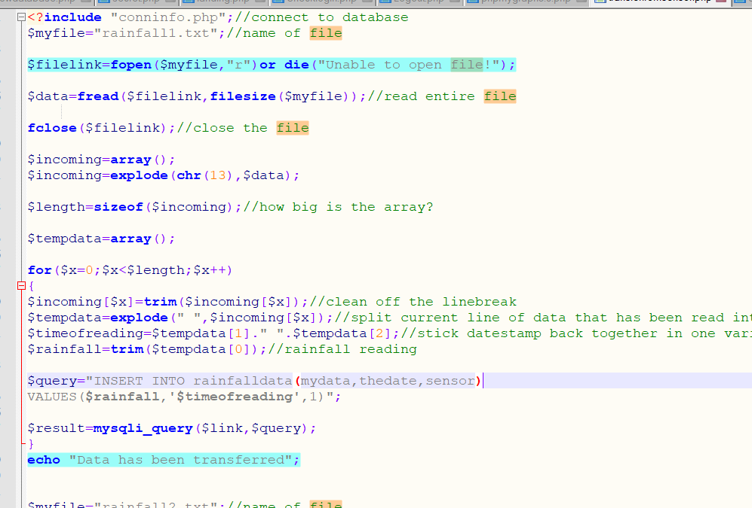

Highlighted in blue are extracts of the code that echoes “data has been transferred “ this informs the use the data has be populated. To guard against accidently repopulating the database with same data

SQL database
A screenshot of the parameters utilised in SQL to arrange and structure the transferred data. Auto increment was used for id to allow unique number to be generated if a new record was to be inserted into the table. To enable dates from the rainfall text files to be validated in SQL the function type timestamp(2) was used
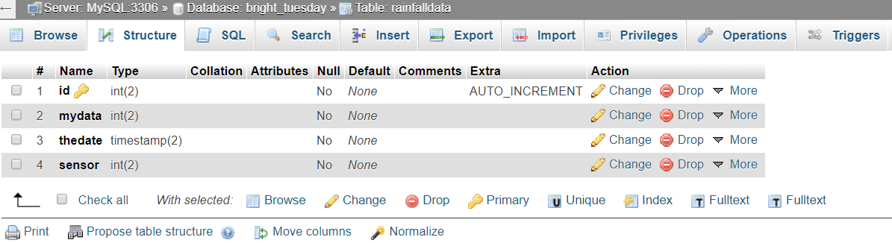

Forms
Forms were designed were in submission of data for processing, though primarily there 2 methods to send data POST and Get. POST was used as it is more secure to use a precaution against the unethical hackers. The security advantage of using Post over Get is that Post is deemed secure as request and browser history is not cached. There is no data length restriction with the post request.

Checklogin.php
The Website as one of the security features has a login portal where a verification of the user validation credentials is verified against the username and the password stored in the SQL database. As an extra security hardening feature password has be hashed .

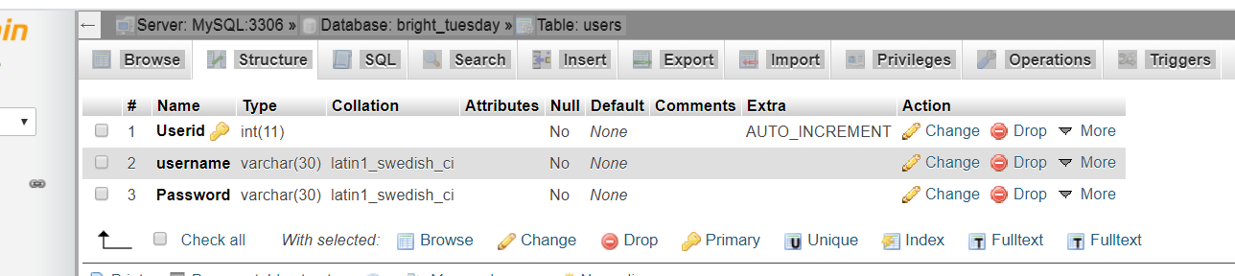

The login credentials on submission from checklogin.php is transferred using Post method as authentication and validation against records in the table.

Home Login portal (landing.php)
This denotes the landing page that allows the user to input their credentials to authenticate themselves before accessing the website. Inputting the wrong user details prompts the user to try again. If user successfully logs on, they have two navigation choices either to navigate to enter a search of the data they require or to a visual page populated with graphs of the 3 sensors +

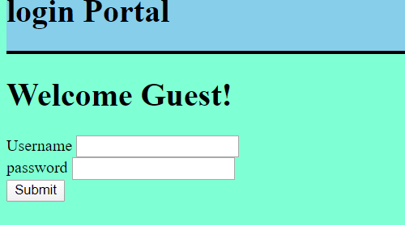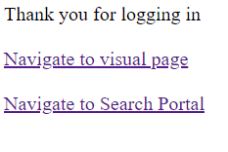
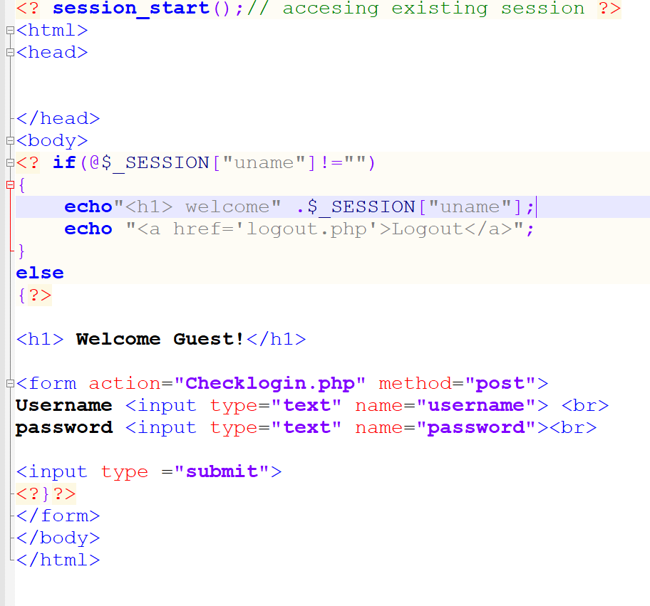

Search (entersearch.php)

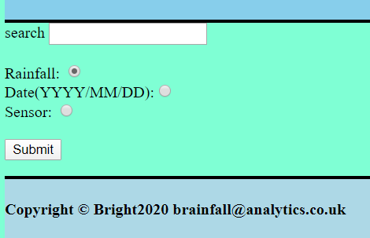
The search page allows the user to input the search of the desired data from the different sensors. It is imperative to avoid placing the search button at the button of the page. The submit button. The search allows the user to filter search by sensor, choice of sensor rainfall recorded specific day, date and year. The choice of search is managed by the use of a dial button .
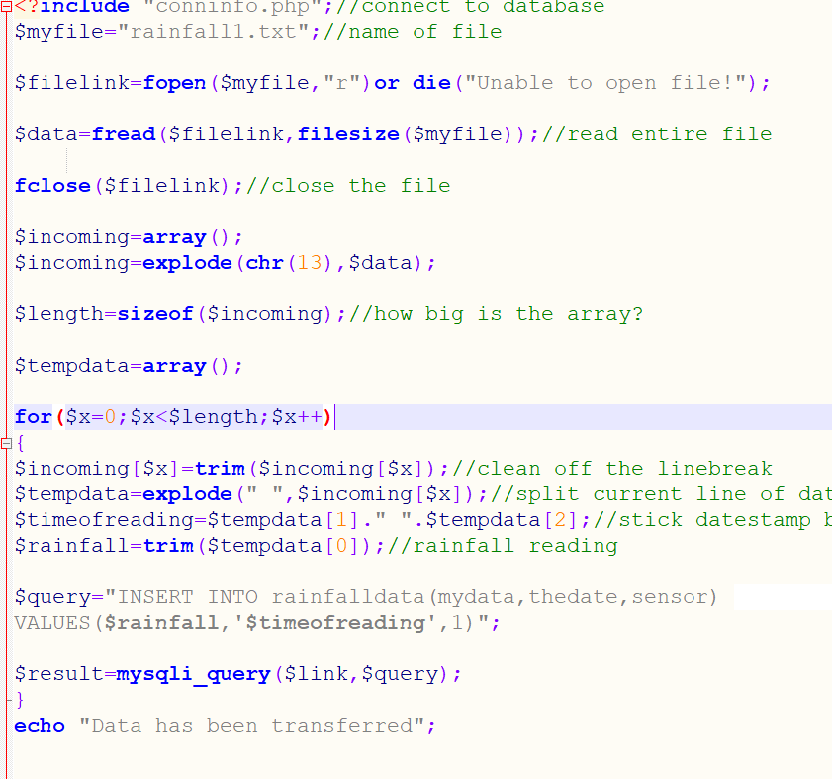

Data Visualisation (Makegraph,php)
For the purposes of Data presentation and visualisation a library 'phpMyGraph5.0.php' was utilised. Visualised data allows users to easily monitor trends and patters. It is ideal and easy do comparisons between different data sets. Interpretation of raw data would be time consuming for users and to reduce errors in interpretation visual presentation would be recommend.

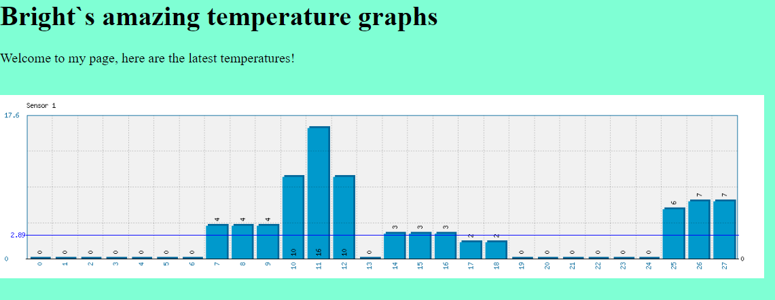
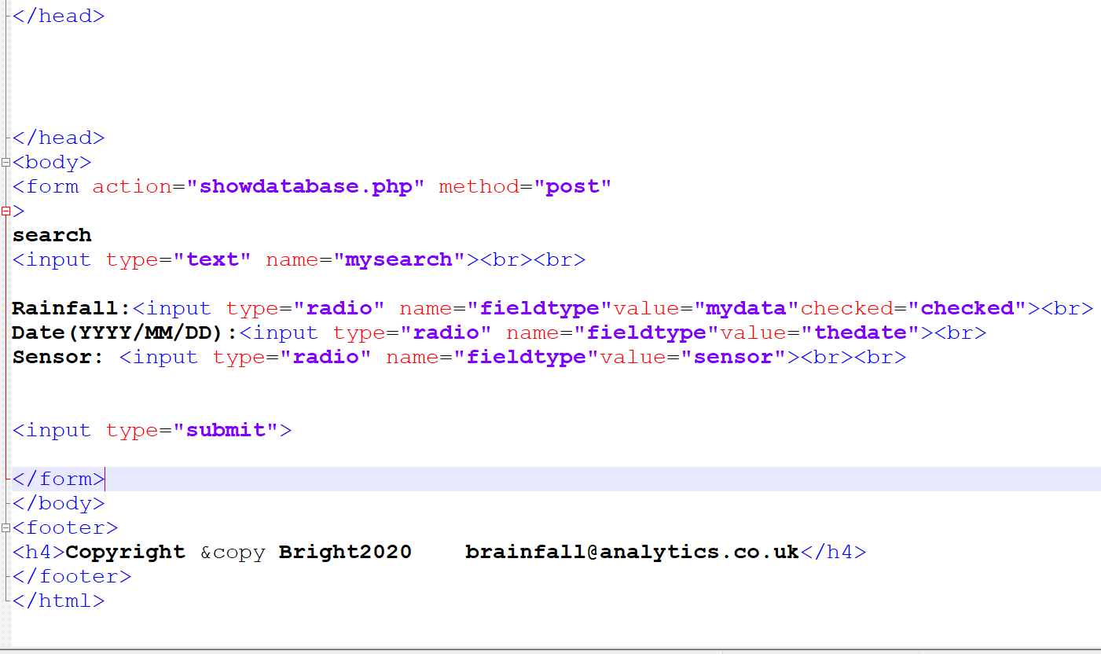

Logout (logout.php)

On session completion allows users to logout, with security features to guard against cross site forgery CSRF with trickery to makes users take involuntary action of logging out. The removal and session destruction guards against cookie and session token being hacked.
Token validation is of the query string and stored user session, if the token is valid the user session can be confidently destroyed user session using the PHP destroy session function. If the token invalid, then user will remain logged on as the request is likely to be a hoax.

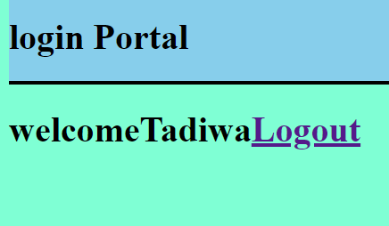
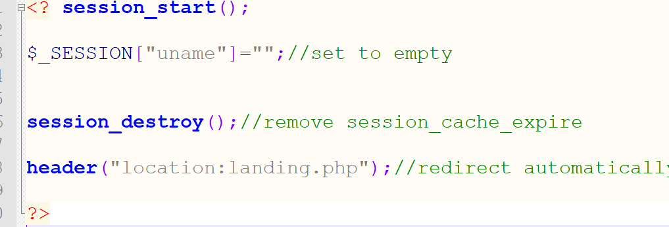

Noted Weaknesses of the Website
The website validation protocols were not secure as upon testing the code when user logs out they still had access to the data base without being logged on. It would have been ideal to input a code that allow users that may forgotten password to enable them to reset and new registrations as well. Password reset is another feature that could have been included to inclusive of new user registration. It would be professional to attach image source of weather icons.

Conclusion

The HMTL and Php does work well in wed designing but there is need to use external styling files such as CSS and bootstrap to enhance ambience and responsiveness.

References

[1] | "https://thisinterestsme.com/secure-php-logout/," [Online]. Available: https://thisinterestsme.com/secure-php-logout/.[Accessed 23 fFebruary 2020]
[2] | "Stage 5b. Quality assurance - Mobile and Web development process," [Online]. Available: http://www.thedroidsonroids.com/blog/quality-assurance-mobile-web-app-development-process. [Accessed 18 January 2020].
[3] | "https://www. w3schools,com," [Online]. Available: https://www.w3schools.com. [Accessed 23 02 2020].

