University of Wales Trinity Saint David

Wales Institute of Science and Art



Torsion of Shafts Report

ACHA4026 Mechanics and Dynamics

Darryl Diaz
2404983
Date (01/2026)
Contents
1. Introduction 1
2. Experimental Procedure 2
3. Results 3
4. Analysis 4
5. Conclusion 5
6. Evaluation 6
7. Further Work 7
8. References 8

Figure 1 - Experiment Equipment Setup 2
Figure 2 - Experiment with Brass Rod 4
Figure 3 - Experiment with Aluminium Rod 5
Figure 4 - Experiment with Steel Rod 6

Table 1 - Raw Data for Brass Rod Experiment 3
Table 2 - Raw Data for Aluminium Rod Experiment 3
Table 3 - Raw Data for Steel Rod Experiment 4
Table 4 - Data Given in Brief 4

Introduction
This report will look at an experiment investigating the torsion of shafts. 3 shafts made of different materials will be investigated. The measurements taken during these experiments will be used to calculate different values in order to ultimately obtain the G values for the 3 shafts. This will then be compared with results from research data, to see how accurate the values are.

Experimental Procedure
The experiment was carried out by setting up the equipment as seen in the picture below.
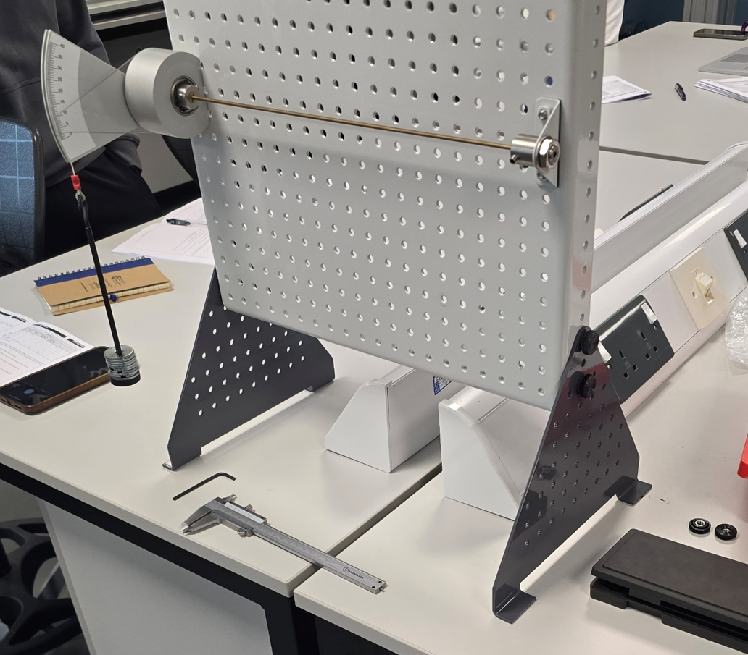
Figure 1 - Experiment Equipment Setup

The procedure for carrying out the experiment can be seen below.
- The rod should be fitted (initially the brass rod), ensuring that the grub screws are tightened properly, so that the rod cannot spin.
- The weight carrier can then be attached to the arm on the rotating chuck.
- Set the scale to zero and then add the weights in 100g intervals (each weight being 10g).
- Read the measurements before adding the next 100g.
- Continue like this up to 500g.

Now change the rod over to the aluminium rod. Repeat the above steps, stopping at 400g.
Finally, change the rod over again, to the steel rod. Repeat the steps above again, stopping at 500g this time.

Results
Below are the tables containing the raw data taken from the experiment. The highlighted numbers were given as part of the experiment, in the brief.
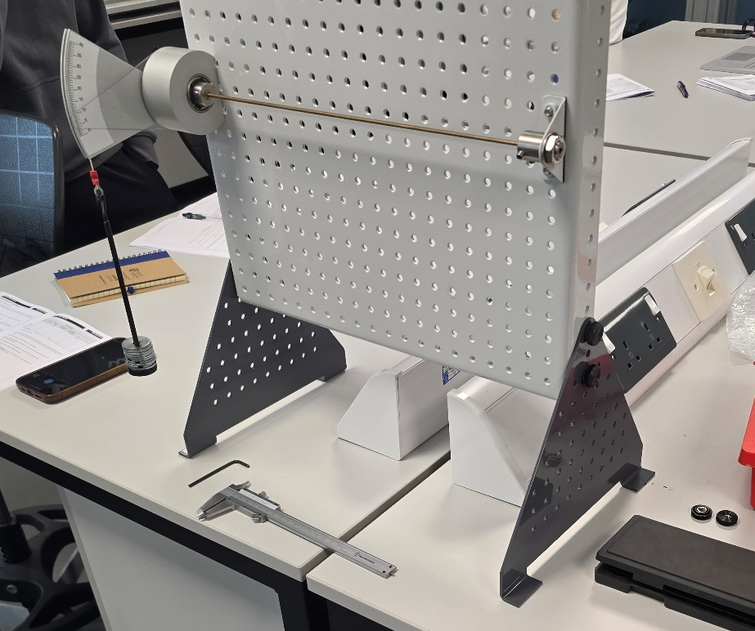
Figure 2 - Experiment with Brass Rod
Table 1 - Raw Data for Brass Rod Experiment
Load (g) | Load (N) | Torque [T] (Nm) | Twist Angle (degrees) | Twist Angle [Θ] (radians) | TL | JΘ
100 | 0.98 | 0.098 | 6.5 |  | 0.033
200 |  |  | 13.5
300 |  |  | 19.5
400 |  |  | 25.5
500 |  |  | 31.5
 | Material | Brass

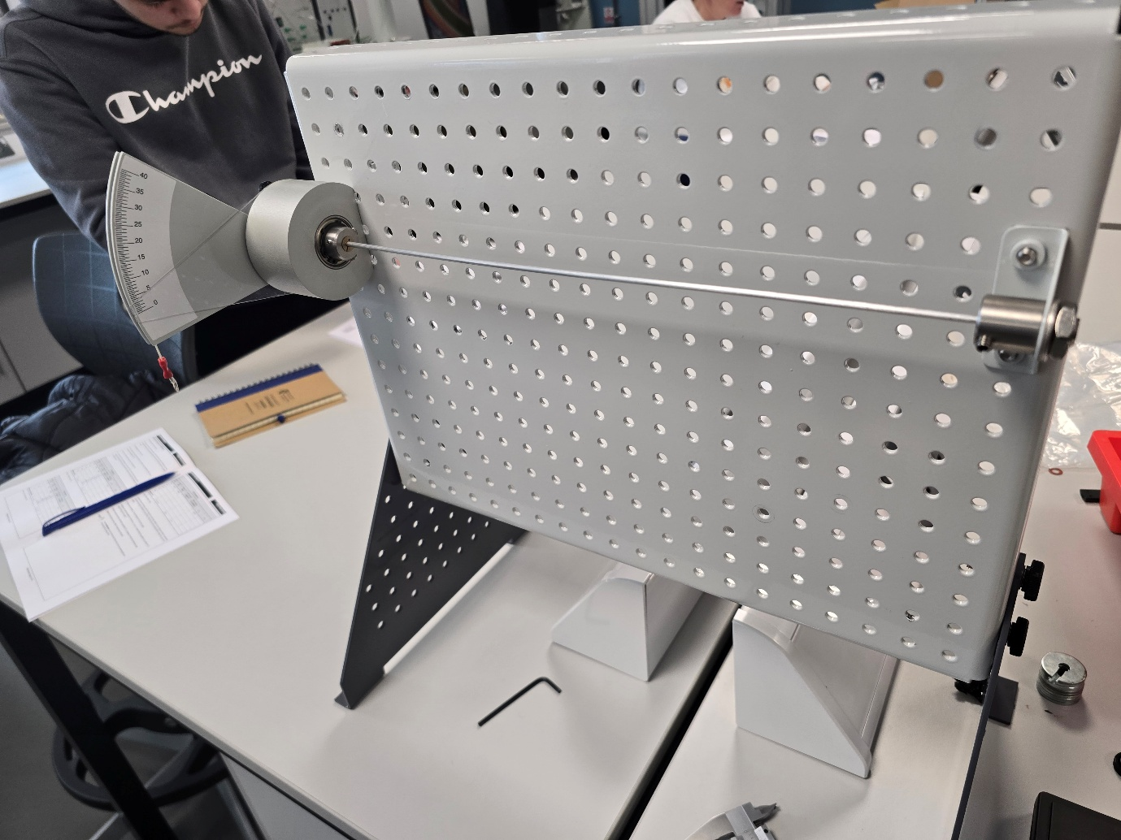
Figure 3 - Experiment with Aluminium Rod
Table 2 - Raw Data for Aluminium Rod Experiment
Load (g) | Load (N) | Torque [T] (Nm) | Twist Angle (degrees) | Twist Angle [Θ] (radians) | TL | JΘ
100 | 0.98 | 0.098 | 8.5 |  | 0.033
200 |  |  | 16.5
300 |  |  | 24
400 |  |  | 32
 | Material | Aluminium

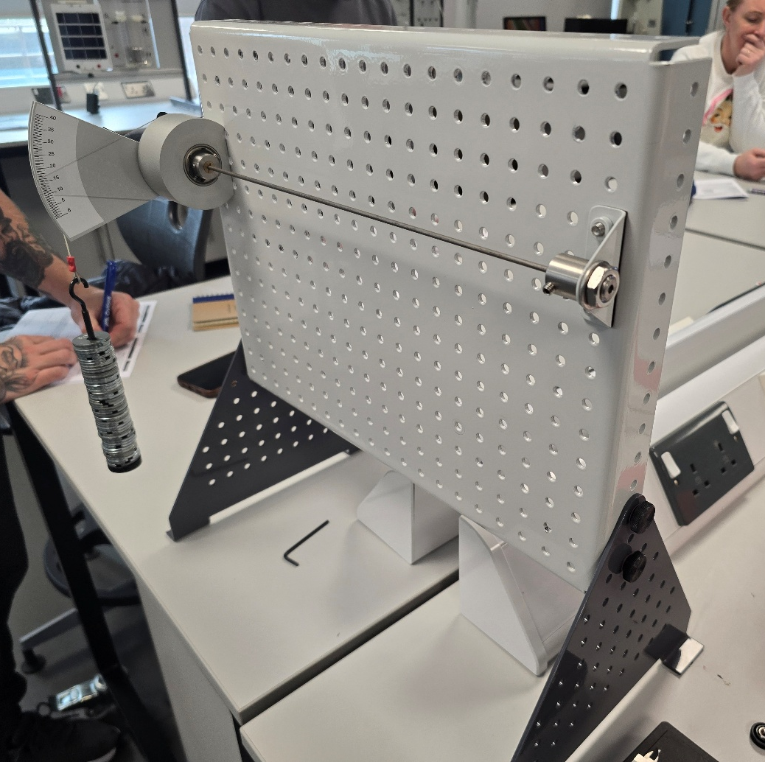
Figure 4 - Experiment with Steel Rod
Table 3 - Raw Data for Steel Rod Experiment
Load (g) | Load (N) | Torque [T] (Nm) | Twist Angle (degrees) | Twist Angle [Θ] (radians) | TL | JΘ
100 | 0.98 | 0.098 | 3.5 |  | 0.033
200 |  |  | 6
300 |  |  | 8
400 |  |  | 10.5
500 |  |  | 13.5
 | Material | Steel

The table below shows the data given in the brief which was used in the later calculations.
Table 4 - Data Given in Brief
Torque Arm Radius (m) | 0.1
L (m) | 0.34
D (mm) | 3.1
D (m) | 0.0031
π | 3.14

Analysis
The data tables could then be filled in by;
- First calculating the load in newtons by multiplying the load in grams by the acceleration due to gravity, 9.81m/s².
- The torque could then be calculated by multiplying load in newtons by the torque arm radius which was 0.1m.
- The twist angle could then be converted from degrees to radians by multiplying the figure in degrees by 2π/360.
- The TL column could then be calculated by multiplying the torque values by the length of the rod, which was 0.34m.
- The value for J was then calculated by multiplying π by the rod diameter to the power 4 all over 32.
- With the J value calculated, the JΘ values were calculated by multiplying the twist angle in radians by the J value.
All the equations used in the calculations can be seen below.
$Load(weight)=m×g$ (N) (cuemath, n.d.)
$T=Load(w)×Torque Arm Radius$ (NASA, 2015)
$θ=x°×\frac{2π}{360}=x°×\frac{π}{180}$ (Cuemath, n.d.)
$$TL=T×L$$
$J=\frac{π×D^{4}}{32}$ (Rosato and Rosato, 2003)
$$Jθ=J×θ$$
The completed tables for each rod material can be seen below with the associated graphs. The gradient equation on each graph, gives the G value for each rod. The polar second moment of area (J) was calculated and can be seen at the end of this section.

Table 5 - Completed Data Table for Brass Rod
Load (g) | Load (N) | Torque [T] (Nm) | Twist Angle (degrees) | Twist Angle [Θ] (radians) | TL | JΘ
100 | 0.98 | 0.098 | 6.5 | 0.113 | 0.033 | 1.028E-12
200 | 1.962 | 0.196 | 13.5 | 0.236 | 0.067 | 2.134E-12
300 | 2.943 | 0.294 | 19.5 | 0.340 | 0.100 | 3.083E-12
400 | 3.924 | 0.392 | 25.5 | 0.445 | 0.133 | 4.031E-12
500 | 4.905 | 0.491 | 31.5 | 0.550 | 0.167 | 4.980E-12
 | Material | Brass

The graph below shows an almost linear response between the torque applied and the twisting of the rod. The anomaly being at the second point on the graph.

Table 6 - Completed Data Table for Aluminium Rod
Load (g) | Load (N) | Torque [T] (Nm) | Twist Angle (degrees) | Twist Angle [Θ] (radians) | TL | JΘ
100 | 0.98 | 0.098 | 8.5 | 0.148 | 0.033 | 1.344E-12
200 | 1.962 | 0.196 | 16.5 | 0.288 | 0.067 | 2.608E-12
300 | 2.943 | 0.294 | 24 | 0.419 | 0.100 | 3.794E-12
400 | 3.924 | 0.392 | 32 | 0.558 | 0.133 | 5.059E-12
 | Material | Aluminium

The graph below, shows the aluminium very nearly gave a linear response between the twisting and the torque. This is what was expected, especially with the small weights being used in the experiment.

Table 7 - Completed Data Table for Steel Rod
Load (g) | Load (N) | Torque [T] (Nm) | Twist Angle (degrees) | Twist Angle [Θ] (radians) | TL | JΘ
100 | 0.98 | 0.098 | 3.5 | 0.061 | 0.033 | 5.533E-13
200 | 1.962 | 0.196 | 6 | 0.105 | 0.067 | 9.485E-13
300 | 2.943 | 0.294 | 8 | 0.140 | 0.100 | 1.265E-12
400 | 3.924 | 0.392 | 10.5 | 0.183 | 0.133 | 1.660E-12
500 | 4.905 | 0.491 | 13.5 | 0.236 | 0.167 | 2.134E-12
 | Material | Steel
Table 8 - Calculated J Value
J (m^4) | 9.062E-12

This graph shows the steel rod gave the least linear response. This was not expected as the steel was expected to give the most linear response due to steel being the strongest and least inclined to deformation of the three materials being used. The third and fourth points are slightly higher than expected, while the final point is lower than expected. This is probably due to human error when reading the gauge.

Conclusion
The rod materials used in the experiment were brass, aluminium and mild steel. The G value obtained for each material was close to the expected value for the given material. The value for mild steel was a little high though. Looking at the graph for the mild steel, its response is the least linear of the three, which may be a result of errors during the measuring stage. The other two graphs, for the brass and aluminium shows an almost linear response, again, this could be a result of errors when obtaining the measurements. The brass, according to the graph’s gradient had a G value of 3x10¹⁰ N/m² and the aluminium also had a G value of 3x10¹⁰N/m². These are around what would be expected, according to Engineering ToolBox (2005), as brass should have a G value of around 4.0x10¹⁰N/m², while aluminium should have a G value of around 2.4x10¹⁰N/m² to 2.8x10¹⁰N/m². While those values are around what is expected, the brass G value is a little below the expected value. The steel rod, according to the gradient of the graph, had a G value of 9x10¹⁰N/m². This is a little high for steel as it would ordinarily be expected, according to Engineering ToolBox (2005), to have a G value of between 7.5x10¹⁰N/m² and 8.0x10¹⁰N/m².

Evaluation
The potential errors were minimised as much as possible by minimising how much the equipment was touched during the experiment, to prevent the gauge being knocked out of calibration. At the start, the gauge was zeroed with the empty weight carrier mounted. When taking measurements, all parties were able to check the gauge and a figure was collectively agreed upon. When weight was added to the weight carrier, it was done so carefully and gently, again, to ensure the gauge wasn’t thrown out of calibration. It is possible that the equipment may not have been properly zeroed, which would have thrown off the figures being measured, either making them too high or too low, depending on the starting position of the gauge. The digital gauge would help to fix this issue too.

Further Work
To improve the experiment, the gauge could be replaced with a digital gauge, ensuring a reliable and accurate reading every time. The experiment could also be repeated several times over and an average value for each weight calculated to try lessen the effect of any anomalies. This could have corrected the issues seen in the results, particularly with the steel rod’s values, which in turn may have thrown off the G value, making it higher than expected. In addition, this may have caused the G value for the brass rod to be a little lower than the researched figures would suggest it should have been.

References
cuemath (n.d.). Weight Formula- What Is Formula To Find Weight? Examples. [online] Cuemath. Available at: https://www.cuemath.com/weight-formula/. [03 Jan. 26]
Cuemath. (n.d.). Degrees to Radians - Conversion, Formula, Examples | Converting Degrees to Radians. [online] Available at: https://www.cuemath.com/geometry/converting-degrees-to-radians/. [03 Jan. 26]
Engineering ToolBox (2005). Modulus of Rigidity. [online] Engineeringtoolbox.com. Available at: https://www.engineeringtoolbox.com/modulus-rigidity-d_946.html. [Accessed 03 Jan. 26]
NASA (2015). Torque (Moment). [online] Nasa.gov. Available at: https://www.grc.nasa.gov/www/k-12/airplane/torque.html. [03 Jan. 26]
Rosato, D. and Rosato, D. (2003). PRODUCT DESIGN. Plastics Engineered Product Design, pp.198–343. doi:https://doi.org/10.1016/b978-185617416-9/50005-3. [Accessed 03 Jan. 26]

‌
‌

‌
‌
‌

