

House Price Prediction using XAI Techniques

By

SAI HARSHA JANGILI
Student ID: 1908692

Supervisor: Mark Huntly
Second Marker: Nathan Morgan

Project submitted as part of the requirements for the award of
MSc Software Engineering and AI

September 2025

DECLARATION

I, Sai Harsha Jangili declare that I am the sole author of this Project; that all references cited have been consulted; that I have conducted all work of which this is a record, and that the finished work lies within the prescribed word limits.

This work has not previously been accepted as part of any other degree submission.

Signed:
Sai Harsha Jangili

Date: 10/09/2025

FORM OF CONSENT

I, Sai Harsha Jangili hereby consent that my Project, submitted in candidature for the M.Sc. Software Engineering and AI, if successful, may be made available for inter-library loan or photocopying (subject to the law of copyright), and that the title and abstract may be made available to outside organisations.

Signed
Sai Harsha Jangili

Date: 10/09/2025

Abstract:
The aim of this project was to design and implement an explainable framework for house price prediction using machine learning. The study focused on addressing the dual challenge of predictive accuracy and model interpretability in the real estate domain. To achieve this, the project utilised Principal Component Analysis (PCA) to reduce dimensionality and create three feature scenarios (Top 5, Top 8, and Full feature sets). Two machine learning models—Support Vector Regression (SVR) and Extreme Gradient Boosting (XGBoost)—were trained under each scenario, with cross-validation and hyperparameter tuning ensuring systematic optimisation. To address the “black box” nature of these models, Local Interpretable Model-Agnostic Explanations (LIME) and SHapley Additive exPlanations (SHAP) were implemented to provide both local and global interpretability. The dataset, consisting of 90,000 UK housing transactions from 2015 to 2024, was cleaned, encoded, and standardised prior to modelling. Due to computational constraints, 5,000 representative rows were selected for training and evaluation. The findings demonstrated that XGBoost consistently outperformed SVR, particularly when using the full feature set, and that location-based attributes such as postcode and street were the most influential predictors. LIME provided clear, instance-level explanations, while SHAP offered consistent global insights, with both methods aligning on key features but differing in their treatment of secondary attributes. The study concludes that XGBoost, combined with PCA-driven dimensionality reduction and XAI techniques, delivers a reliable and transparent predictive framework for house prices. It is recommended that future work test this framework with real-world datasets to validate its accuracy in practical housing market contexts.

Table of Contents
DECLARATION 2
FORM OF CONSENT 2
Abstract: 3
Introduction 4
Literature Review 5
Radial Basis Function (RBF) Kernel: 10
Polynomial Kernel: 10
Linear Kernel: 10
Methodology: 13
DSR Methodology: 14
Problem Identification: 14
Artifact Design: 14
Implementation: 14
Evaluation: 15
Contribution: 15
Project Design: 15
Dataset: 15
Data cleaning and Preprocessing: 16
Implementation: 17
PCA: 17
SVR and XGBOOST: 18
Lime: 19
SHAP: 19
Results and Discussion: 20
Quantitative Analysis 36
Evaluation Metrics: 36
Results for Top 5 Feature Scenario 37
Results for Top 8 Feature Scenario 37
Results for Full Feature Scenario 37
Comparative Summary 38
Comparison of LIME and SHAP: 38
Purpose of Comparison: 38
Agreement on Key Features: 38
Differences in Explanations: 39
Local vs Global Perspective: 39
Overall Comparative Summary: 39
Conclusion and Recommendations: 40
Conclusion: 40
Recommendations: 40
Personal Reflection: 41
References 42

Introduction
The real estate market is one of the most active and economically important sectors globally. House price prediction plays a vital role in aiding decision-making for homeowners, investors, financial institutions, and policy regulators. Traditionally, housing prices have been predicted using linear regression-based models that assume a simple relationship between dependent and independent variables. However, the housing market is affected by a wide range of nonlinear and interacting factors, including location, land value, amenities, construction materials, crime rates, interest rates, and economic cycles. To manage such complexity, machine learning (ML) algorithms have increasingly been used in recent years, providing greater flexibility and accuracy in predictive modelling [1], [2].
In this project, Principal Component Analysis (PCA) was applied as part of the preprocessing pipeline to handle the high-cardinality categorical dataset. The dimensionality reduction enabled the features to be ranked based on their contribution to variance, which facilitated the creation of three experimental scenarios: Top 5 features, Top 8 features, and the Full feature set. These scenarios provided a structured basis for evaluating model performance under varying levels of complexity, ensuring that the predictive accuracy of SVR and XGBoost could be tested alongside the trade-offs in interpretability and computational efficiency.
Among the various machine learning techniques utilised in this context, Support Vector Regression (SVR) and Extreme Gradient Boosting (XGBoost) stand out due to their robustness and ability to generalise. SVR, an extension of Support Vector Machines (SVM), is especially effective at capturing high-dimensional relationships while minimising overfitting. Equally, XGBoost, a gradient-boosting ensemble algorithm, is recognised for its efficiency and scalability, frequently surpassing traditional models in structured data prediction tasks [3], [4]. These methods are widely acknowledged for their superior performance; however, their interpretability remains a significant concern. The complex internal logic of these algorithms results in what is often described as a Black Box model, making it challenging for end-users to understand how specific input variables influence predictions [5].
To address this interpretability gap, recent advancements in Explainable Artificial Intelligence (XAI) have introduced tools that enable model-agnostic and model-specific explanations of predictions. Among these tools, LIME (Local Interpretable Model-Agnostic Explanations) and SHAP (SHapley Additive Explanations) have gained prominence. LIME generates a simple linear model to approximate the decision boundary of any black-box model locally. At the same time, SHAP provides both global and local insights using concepts from cooperative game theory [6], [7].
This research project proposes an explainable ML framework for predicting house prices using SVR and XGBoost, combined with LIME and SHAP for model interpretation, and dividing features into three scenarios (Top 5, Top 8, and Full feature set) to assess whether the number of features impacts prediction accuracy. The dual-model approach enables a comparative understanding of how both ensemble methods handle regression in a real estate context. Moreover, the integration of both model-agnostic (LIME) and model-specific (Tree SHAP for XGBoost) interpretability methods allows for comprehensive insight into feature influence at both local and global levels. Through experimentation, evaluation, and visualisation, this study aims to deliver a transparent and interpretable predictive tool for the real estate sector that can also be validated against real-world housing market data.

Literature Review
The integration of machine learning into real estate price forecasting has undergone significant evolution over the past decade. Early studies relied heavily on linear regression and hedonic pricing models, which assume a linear and additive relationship between property features and prices. However, such assumptions fail to capture the nonlinearity and complex feature interactions present in real-world datasets. As a result, contemporary research has turned towards more advanced machine learning models, notably Support Vector Regression (SVR) and Extreme Gradient Boosting (XGBoost), which offer better accuracy and flexibility [1], [2].
Uysal and Kalkan [3] conducted a prominent study that applied various ML algorithms, including Random Forest, XGBoost, and SVR, to housing data from Istanbul. Their results indicated that ensemble-based models such as XGBoost consistently outperformed traditional regressors in terms of RMSE and R². However, the study lacked an in-depth analysis of model interpretability, one of the major criticisms of complex models in high-stakes domains like real estate. Similarly, in another study, Hussain et al. [4] proposed a hybrid framework using genetic algorithms for parameter tuning and evaluated SVR, XGBoost, and Random Forest. Still, they limited the use of explainability tools to simple feature ranking without stakeholder-level insight.
The growing importance of Explainable Artificial Intelligence (XAI) has motivated researchers to explore tools like LIME and SHAP. Salih [5] offered a comprehensive overview of SHAP and LIME, comparing their interpretability mechanisms. LIME is recognised for providing interpretable local predictions using linear models, which makes it suitable for black-box models like SVR. SHAP, on the other hand, is rooted in Shapley values from cooperative game theory, providing consistent global and local feature importance scores. Salih concluded that using both methods in tandem offers a balanced explanation strategy across different model types.
Ayyub et al. [6] explored explainable models in the context of fairness and accountability, focusing on domains like housing and finance. They emphasised the importance of transparent AI systems, particularly when predictions have a significant financial or social impact. In alignment, Susnjak and Maddigan [7] applied SHAP explanations to tree-based models in real estate pricing. They showcased how stakeholders could better trust the model’s decisions when explanations were provided in simple terms.
The unpredictability of housing markets in response to external shocks, such as the COVID-19 pandemic, has also been explored in recent work. Khan et al. [16] examined multiple machine learning models, including Linear Regression, Decision Trees, Random Forest, and XGBoost, for housing price prediction in the volatile COVID-19 period. Their results showed that while Decision Trees and Random Forest achieved acceptable accuracies of around 84% and 89% respectively, XGBoost outperformed them with an accuracy of approximately 92%. This indicates that boosting models are not only effective in stable data environments but also adaptable to sudden disruptions caused by external factors. Such findings reinforce the selection of XGBoost in this study, as its robustness makes it suitable for real-world housing markets that are influenced by unpredictable social and economic events.
However, despite its predictive strength, XGBoost, like Support Vector Regression, is often treated as a “black box” model. This lack of interpretability creates challenges when results are applied to sensitive decision-making areas such as property investment or financial planning. To address this, model-agnostic explanation techniques such as LIME and SHAP are critical. They provide transparency by highlighting the contribution of each feature to the model’s predictions, thereby enhancing user trust and ensuring that robust models like XGBoost can be both accurate and explainable.
Recent studies have also investigated the robustness of machine learning algorithms in dynamic environments such as the COVID-19 pandemic. Khan et al. [16] compared multiple models including Linear Regression, Decision Trees, Random Forest, and XGBoost for housing price prediction. Their findings revealed that while Decision Trees and Random Forest achieved acceptable accuracy levels of approximately 84% and 89% respectively, XGBoost consistently outperformed them with a predictive accuracy of around 92%. This demonstrates not only its superior performance but also its adaptability to volatile market conditions, thereby strengthening the case for its adoption in this project.
Further, Nguyen et al. [8] performed a systematic comparison between LIME and SHAP across multiple datasets. They concluded that SHAP offered more consistent and stable explanations for structured datasets, while LIME was more adaptable for quick local diagnostics. In their study, TreeExplainer (a SHAP variant) was noted for its efficiency when used with XGBoost, while KernelExplainer was used with SVR, though at a higher computational cost.
In addition to the models previously reviewed, further exploration of alternative algorithms reinforces the rationale for choosing SVR and XGBoost in this study. Techniques such as Random Forests, Decision Trees, and Linear Regression have long been applied in house price prediction models, as shown in studies like [4] and [6]. While these methods offer interpretability, they tend to underperform in complex, non-linear datasets when compared with gradient-based or margin-based approaches. In [9], it was observed that these traditional models can struggle with high-dimensional or heavily skewed housing datasets unless combined with ensembling or boosting techniques.
In contrast, XGBoost continues to receive widespread recognition for its balance of speed and accuracy in regression tasks. It incorporates enhancements such as L1 and L2 regularisation, tree pruning, parallelisation, and column subsampling [1], [6], [9]. These features improve generalisation, reduce overfitting, and optimise model performance for structured tabular datasets. In a comparative evaluation by Tekouabou et al. [20], boosting-based models, including XGBoost, outperformed traditional ML models for urban real estate prediction, particularly in terms of RMSE and robustness.
XGBoost builds decision trees sequentially, where each new tree attempts to reduce the residual error of the previous one. This process is guided by a gradient descent algorithm, which optimises the model using the first and second-order derivatives of the loss function — offering more precise updates. Its use of regularisation techniques (L1 and L2) prevents overfitting, while column subsampling and parallel processing significantly enhance efficiency during training. Additionally, gain-based pruning is applied to remove unnecessary tree branches, further improving both accuracy and interpretability [1], [9], [14].
Support Vector Regression (SVR) operates by defining a margin of tolerance (ε) and attempting to fit a regression line within that margin, which helps it generalise well to unseen data [2], [12], [19]. When combined with non-linear kernels such as RBF or polynomial, SVR becomes particularly useful in capturing subtle variations in data patterns. Despite its lack of built-in feature importance metrics, its resilience to outliers and firm performance in smaller structured datasets make it an attractive candidate [2]. Building upon the strengths already outlined, it is essential to understand the internal mechanisms that make SVR and XGBoost suitable for regression tasks involving structured, tabular data. In SVR, the model constructs a function that fits within an epsilon-insensitive zone, meaning minor errors (within ε) are not penalised. This encourages generalisation by focusing only on support vectors — data points that fall outside the margin and impact the final model [2], [12]. The choice of kernel — such as the RBF, polynomial, or linear — defines how data is projected into higher-dimensional space, allowing SVR to capture non-linear trends. The dual formulation of SVR enables it to solve significant optimisation problems efficiently, especially when the number of features exceeds the number of observations [11], [19].
However, both SVR and XGBoost share a standard limitation: they are not inherently explainable. Given the rising demand for ethical AI and transparent decision-making, particularly in high-stakes domains like real estate, Explainable AI (XAI) becomes critical. Uysal and Kalkan [3] emphasise that explainability can significantly affect trust and adoption in predictive systems, especially when financial or investment decisions are involved.
To bridge this gap, Explainable AI (XAI) techniques such as SHAP and LIME are increasingly adopted in structured-data contexts. While alternative XAI approaches like Class Activation Maps (CAM), Anchors, and Counterfactuals exist, their applications are primarily rooted in image classification or deep learning pipelines and offer limited interpretability in regression-based tabular datasets [5], [13].
LIME (Local Interpretable Model-agnostic Explanations) works by locally approximating a complex model with a simpler one through feature perturbations, thus allowing interpretation of how input changes affect output [8], [17]. In the real estate domain, studies like [7] and [11] successfully used LIME to explain black box regressors such as Random Forest and SVR, increasing model transparency without sacrificing predictive quality.
On the other hand, SHAP (SHapley Additive exPlanations) is based on cooperative game theory and provides global and local explanations by assigning additive importance scores to each feature [5], [14]. Its optimised implementation, TreeSHAP, is exceptionally efficient when applied to tree-based models like XGBoost [15]. SHAP has been used across healthcare [14], smart cities [18], and real estate [7] to justify model predictions and enable fairer decision-making.
Trindade Neves et al. highlighted that in smart city contexts, combining open data with SHAP explanations leads to better governance and public trust in automated pricing models [18]. Moreover, the robustness and flexibility of SHAP and LIME were affirmed across domains, including chronic disease prediction [14], classroom discourse [5], and urban housing analytics [20].
In the field of housing price prediction, various machine learning algorithms have been employed to model property valuations. Among the commonly explored alternatives are Decision Trees, Random Forests, k-Nearest Neighbors (k-NN), Bayesian Regression, and Artificial Neural Networks (ANNs). Each has been evaluated in the literature for its trade-offs between accuracy, interpretability, and scalability.
For instance, Decision Trees and Random Forests offer inherent interpretability but often suffer from overfitting or reduced performance on high-dimensional datasets without careful tuning [4], [6]. K-NN, although simple to implement, performs poorly when the data has many features or noise, as it relies on geometric proximity, which becomes unreliable in high-dimensional spaces [24].
Artificial Neural Networks (ANNs), such as Multi-Layer Perceptrons (MLPs), have shown strong predictive performance in various applications. However, they were not chosen for this study on housing price prediction due to several factors. First, ANNs have high data requirements and a complex training process. Additionally, they often operate as black boxes, making it challenging to explain how they arrive at their predictions. This lack of interpretability contradicts the project's objective of developing a transparent and explainable model using SHAP and LIME [2], [5], [7]. Furthermore, training ANNs can be computationally intensive and may not perform well when the data available is limited or structured. In contrast, models like XGBoost and Support Vector Regression (SVR) are more suited for tabular data and provide better performance along with interpretability [28], [29], [30].
A neural network-based model was explored for real estate price prediction. Although it achieved acceptable accuracy, the model was heavily reliant on feature scaling and lacked transparency, making it less suitable for scenarios requiring user interpretability [27]. Similarly, the work in [25] analysed tree-based ensemble models and deep learning techniques but highlighted the difficulty in generating local explanations with these black-box systems.
While all these models bring different strengths, regression models stand out for their mathematical simplicity, predictive strength, and alignment with real-valued output requirements. Since the goal of this study is to estimate a continuous numerical target, housing price regression models naturally align with this task structure [12]. As pointed out in [19], formulating the problem as a classification task (e.g., price ranges or bands) often leads to a loss of detail and real-world applicability.
Moreover, regression models provide more appropriate evaluation metrics such as Root Mean Square Error (RMSE), Mean Absolute Error (MAE), and R² Score, which directly reflect how close predicted values are to actual sale prices [4], [11], [20], [22]. These metrics are crucial in housing applications where minor deviations can represent significant financial gaps.
Among regression techniques, Support Vector Regression (SVR) and XGBoost have emerged as particularly suitable due to their ability to model non-linear relationships and handle structured tabular data. SVR offers robustness and precision, especially in smaller datasets [2], while XGBoost provides superior scalability, feature importance scoring, and performance consistency across multiple domains including housing and healthcare [1], [9], [15], [27].
Furthermore, when combined with Explainable AI (XAI) tools such as SHAP and LIME, regression models, especially tree-based ones like XGBoost, can offer interpretable outputs without compromising on accuracy. This dual advantage is critical in sectors like real estate, where stakeholders must understand not only what the prediction is, but why it was made [5], [7], [14], [18], [23].
Support Vector Regression (SVR) is a powerful model that works by mapping input features into higher-dimensional spaces where linear relationships become more distinguishable. This transformation is made possible using kernel functions, which play a critical role in enabling the SVR to model non-linear patterns present in real-world data like house prices [2], [10]. In Support Vector Regression (SVR), kernel functions help the model handle non-linear data by mapping input features into higher-dimensional spaces. The most used kernels are RBF (Radial Basis Function), Polynomial, and Linear. These three kernels stand out for their effectiveness and popularity in regression tasks:
Radial Basis Function (RBF) Kernel: The RBF kernel is the most used due to its ability to handle non-linearity and localised relationships between features. It transforms the input space in a way that allows SVR to capture complex patterns, making it especially effective for housing datasets where factors like location, square footage, and amenities interact in non-linear ways [11], [14]. It was found to perform better than linear and polynomial kernels in tasks like Alzheimer’s disease prediction and dynamic optimisation problems, as shown in recent studies [31], [33]. RBF was especially good at capturing complex relationships in data and gave higher accuracy and generalisation compared to other kernels.
Polynomial Kernel: This kernel introduces non-linearity by computing similarity based on polynomial combinations of input features. It is suitable and adds flexibility for datasets where interactions between variables follow curved or quadratic trends, but it is more complicated to tune and more computationally expensive. It performed less consistently across various tasks in the reviewed studies [31], [33]. For instance, the effect of house size on price may increase at a diminishing rate, a pattern that can be captured using polynomial kernels [19].
Linear Kernel: This kernel is simpler and faster to train. The linear kernel is effective when the data exhibits a linear trend, or when interpretability and speed are priorities. However, it struggles with non-linear data, a common feature in real-world datasets such as house prices. In scenarios where the housing dataset has well-engineered, normalised features and fewer complex interactions, the linear kernel can provide competitive performance with low computational overhead [9]. It was shown to underperform in hyperspectral image classification and other real-valued prediction tasks [32].
Based on these findings, this project uses the RBF kernel because it offers the best balance of accuracy, flexibility, and robustness, especially for complex, non-linear data such as housing prices. Moreover, its success in related domains ranging from image classification to housing price estimation provides a robust empirical foundation for its selection [29], [31],[33].
The core concept that distinguishes SVR from traditional regression models is its reliance on a hyperplane that attempts to fit the data within a predefined margin of tolerance — commonly referred to as the epsilon (ε) margin. Rather than minimising the residual errors directly, SVR constructs a flat hyperplane that allows for a small margin of deviation, thereby ignoring minor prediction errors that fall within this range. Only the data points that lie outside this epsilon margin are considered during model training, and these are known as support vectors [2], [19].
This geometric view of regression enables SVR to achieve robust generalisation, especially in scenarios with noise or outliers. The hyperplane essentially acts as a balancing surface that maximises the margin while minimising complexity. The dual formulation allows SVR to leverage kernel functions like RBF to transform the input features into a higher-dimensional space, where a linear hyperplane can better fit complex patterns. This has been validated in recent studies such as Kumari et al. [31], where SVR demonstrated superior performance in biomedical classification by effectively managing boundary constraints through its margin-driven approach.
Similarly, Gupta and Auluck [32] highlighted that SVR's hyperplane geometry, especially when combined with appropriate kernel selection, improves predictive precision in high-dimensional hyperspectral data. Gupta and Nanda [33] also observed that the RBF kernel enabled SVR to adjust the shape of the hyperplane dynamically, ensuring adaptability in time-varying environments like dynamic TSPs. This adaptability is particularly relevant in real estate prediction, where price behaviour can fluctuate due to multiple latent factors.
By focusing on the critical support vectors and optimising a loss function constrained by the ε-margin, SVR achieves a careful balance between bias and variance. This makes it highly suitable for housing price prediction tasks that involve non-linear relationships and structured, moderately sized datasets [19], [31],[33].
As SVR and XGBoost are not inherently explainable, integrating Explainable AI (XAI) tools like LIME and SHAP becomes essential to interpret model predictions, especially in domains like real estate, where transparency and decision justification are critical [3].
LIME (Local Interpretable Model-Agnostic Explanations) works by approximating the complex model locally with a simpler, interpretable one. When a prediction is made, LIME perturbs the input data around the point of interest (i.e., slightly alters feature values), observes how the predictions change, and then fits a linear model to explain the behaviour in that small region. The result is a set of feature weights showing which inputs most influenced that specific prediction. This makes LIME effective for generating instance-level explanations, where stakeholders can see which features (e.g., area, location, number of rooms) contributed positively or negatively to a house price prediction [3], [11].
SHAP (SHapley Additive exPlanations), on the other hand, is based on cooperative game theory. It attributes a prediction to each input feature by calculating its Shapley value, which represents the average contribution of that feature across all possible combinations of inputs. SHAP ensures that the sum of all feature contributions adds up to the final prediction, providing global consistency and fairness. It is particularly effective when understanding overall model behaviour or comparing feature importance across many predictions. Moreover, SHAP produces intuitive visual outputs such as summary plots and force plots, making it easier to communicate insights to non-technical users [3], [6], [14].
Both LIME and SHAP are model-agnostic, meaning they can be applied to any black-box model, including SVR and XGBoost. However, SHAP also has model-specific variants (e.g., Tree SHAP for decision trees like XGBoost), which makes it faster and more accurate in those contexts. These tools are chosen in this project not just for their technical reliability but also for their ability to enhance trust, auditability, and transparency in machine learning applications [3], [6], [14].
Principal Component Analysis (PCA) has emerged as one of the most widely used dimensionality reduction techniques in data-driven research, particularly in simplifying high-dimensional datasets. The method works by transforming a large set of correlated variables into a smaller set of uncorrelated components, known as principal components, which capture the maximum variance in the data. By doing so, PCA simplifies high-dimensional datasets without losing significant information, reduces computational complexity, and enhances model performance [36]. Hasan and Abdulazeez [36] emphasise that PCA achieves this by solving the eigenvalue–eigenvector problem of the covariance matrix, retaining only the components with the highest variance contribution. This not only enhances interpretability but also removes redundant and noisy features that can negatively affect predictive accuracy. Similarly, Bharadiya [37] highlights that PCA is particularly effective in supporting machine learning models such as Support Vector Regression (SVR), where high-dimensional input can otherwise hinder performance. The process involves computing the covariance matrix of the dataset, extracting eigenvectors, and projecting the data onto a lower-dimensional space defined by the top eigenvalues, thereby creating a more compact and robust feature set. In regression tasks, such as house price prediction, PCA serves as a valuable preprocessing step, improving generalisation while reducing training time. Combined with algorithms such as SVR or XGBoost, PCA contributes to more efficient learning by focusing on the most informative features, making it a suitable choice for large-scale structured datasets [36], [37].
Beyond Principal Component Analysis (PCA), several other dimensionality reduction techniques have been widely discussed in the literature. One such method is Linear Discriminant Analysis (LDA), which, unlike PCA, is supervised and aims to maximise class separability in the reduced feature space, making it more suitable for classification tasks [39]. Another approach is Kernel PCA (KPCA), which extends PCA by applying kernel functions, allowing it to capture non-linear relationships that standard PCA may overlook [38]. Additionally, Sparse PCA improves interpretability by forcing many loadings to zero, ensuring that each component is driven by only a subset of features [38]. While these alternatives provide unique benefits, PCA was chosen for this project due to its simplicity, efficiency, and proven effectiveness in regression contexts. Thippa Reddy et al. [39] highlight that PCA performs consistently well on high-dimensional datasets, reducing redundancy and training complexity without requiring class labels. This aligns directly with the regression focus of this study, where PCA supports SVR and XGBoost by emphasising only the most informative features [38], [39].
From a mathematical perspective, PCA relies on eigenvalues and eigenvectors of the covariance matrix. The covariance matrix captures the variance and correlation between features, and decomposing it produces eigenvalues and eigenvectors that define the new feature space. Eigenvectors indicate the directions (principal components) along which the data varies the most, while eigenvalues measure the magnitude of variance explained in each of these directions. For instance, a larger eigenvalue corresponds to a component that captures greater variance, making it more informative. This ranking ensures PCA retains only the most significant components, while less informative ones are discarded [38], [39]. This process transforms high-dimensional data into a more compact form while preserving its essential structure, which makes PCA particularly suitable for this project.

Methodology:
This project adopts the Design Science Research (DSR) methodology because it aligns closely with the tasks of designing, implementing, and assessing an artifact in this case, predictive models leveraging SVR and XGBoost, augmented with explainability techniques such as LIME and SHAP. DSR is particularly effective for research that aims to produce not only theoretical insights but also practical solutions to tackle real-world issues. Its iterative process of development and thorough evaluation ensures that the resulting artifact exhibits both practical utility and scientific validity [34]. This makes DSR particularly suitable for computational and artifact-centric studies, such as predictive modelling in the housing sector.
On the other hand, the Research Onion offers a more general framework for organising research, helping to inform decisions regarding philosophical perspectives, methodological strategies, data gathering, and analysis [35]. While it can be beneficial for qualitative and exploratory research in fields such as futures studies or social sciences, it is less equipped for projects focused on the conception and assessment of artifacts. In such cases, the Research Onion may risk remaining too abstract, providing philosophical insights but offering limited practical direction for the iterative phases of model development and evaluation.
By adopting DSR, this project benefits from a methodology that not only emphasises rigorous evaluation strategies but also matches contextual factors such as the type of artifact, the goals of the study, and available resources [34]. Therefore, DSR provides a more direct, structured, and practice-oriented pathway to achieving the objectives of this study compared to the broader, philosophy-driven orientation of the Research Onion [35].

DSR Methodology:
The Design Science Research (DSR) methodology is followed in this project to ensure that the research produces both a practical solution and an academic contribution. The process is structured around five significant steps.
Problem Identification:
The central problem addressed in this study is the difficulty of predicting housing prices with both accuracy and transparency. Housing markets are influenced by a variety of non-linear factors such as property type, tenure, location, and build status, which makes prediction challenging. While traditional methods, such as linear regression, fail to capture these complex relationships, advanced models like Random Forest and Artificial Neural Networks often behave as black boxes, which limits stakeholder trust. The research problem is therefore framed as the need for a predictive framework that achieves a balance between accuracy and interpretability, ensuring that predictions are reliable while remaining understandable to end users [34].
Artifact Design:
To address this problem, an artifact is designed that combines predictive modelling with explainable AI. Support Vector Regression (SVR) is employed for its ability to capture non-linear patterns through kernel functions. At the same time, XGBoost is chosen for its scalability, efficiency, and firm performance on structured datasets. To overcome the interpretability gap, the artifact integrates LIME and SHAP, providing local and global explanations of model predictions. This ensures that the framework is not only technically robust but also transparent, making it a practical decision-support tool for stakeholders [34].
Implementation:
The implementation makes use of the House PP Final dataset, which provides detailed property-level information such as price, postcode, property type, tenure, and locality. Data preprocessing involves cleaning, encoding categorical features (e.g., property type, tenure), and scaling numerical variables. The dataset is divided into training and testing subsets to validate performance. Hyperparameter tuning is carried out using cross-validation, optimising SVR parameters such as kernel type, C, and epsilon, as well as XGBoost parameters including learning rate, maximum depth, and number of estimators. Once the models are trained, they are integrated with LIME and SHAP to ensure that every prediction is accompanied by a clear explanation [34].
Evaluation:
Evaluation is performed using both quantitative and qualitative measures. Quantitatively, metrics such as RMSE and MAE are used to assess the magnitude of errors, while R² measures the model's ability to explain variance in housing prices. These metrics are particularly relevant in real estate, where minor inaccuracies can have significant financial implications. Qualitatively, interpretability is assessed through LIME and SHAP outputs, which illustrate the contribution of features like location and property type to each prediction. This dual evaluation reflects the DSR principle of combining rigour and relevance, ensuring that the artifact is both accurate and practically useful [34].
Contribution:
This project makes contributions to both theory and practice. Theoretically, it demonstrates how embedding XAI methods into regression models addresses the long-standing trade-off between accuracy and interpretability. Practically, it provides a framework that can be applied by stakeholders in the housing sector to make informed and transparent decisions. By aligning technical innovation with real-world needs, the artifact contributes to advancing predictive modelling research while supporting more trustworthy and data-driven decision-making in the real estate industry [34].
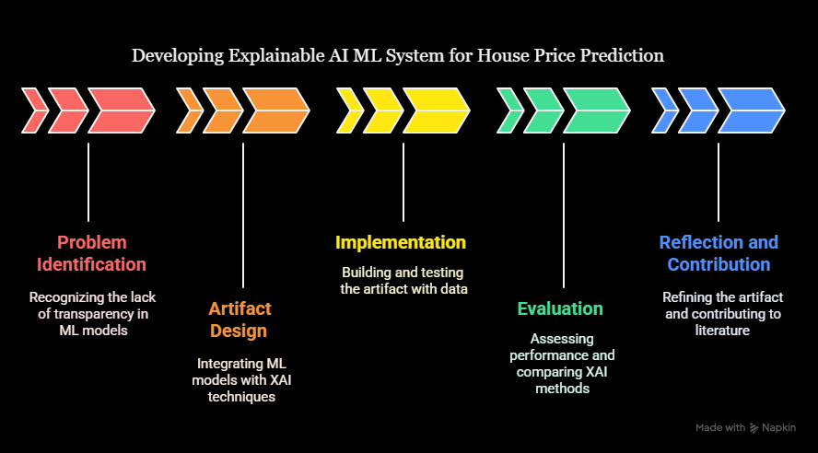
Figure 1. The above figure shows the DSR implementation for this project

Project Design:

Dataset:
The first dataset considered was the UK_House_Prices.csv, which contained over 130,000 records and included regional averages such as average price, sales volume, and property-type breakdowns (detached, semi-detached, terraced, and flats) across time. While this dataset offered valuable insights into long-term housing trends and provided a good overview at a regional level, it lacked property-level granularity, which limited its suitability for fine-grained prediction tasks. The second dataset, UK_House_Price_Prediction_dataset_2015_to_2024.csv, comprised around 90,000 records and provided detailed transaction-level data, including property price, postcode, property type, tenure (freehold/leasehold), new build information, and geographical identifiers such as street, locality, town, and county. This dataset offered rich and diverse features directly relevant to building predictive models. Finally, the third dataset, the UK Property Price Data (1995–2023), was extremely comprehensive, containing millions of property records over three decades with extensive detail on property attributes and ownership. Although this dataset was the most extensive, its scale posed challenges in terms of cleaning, computational demand, and feasibility within the scope of the project. All these datasets were sourced from Kaggle.
After evaluating the three datasets, the UK_House_Price_Prediction_dataset_2015_to_2024.csv was chosen as the most appropriate for this study. Unlike the first dataset, it provides detailed property-level attributes rather than regional averages, making it more suitable for machine learning models such as SVR and XGBoost. At the same time, it avoids the overwhelming size and preprocessing requirements of the third dataset, ensuring that the data remains manageable while still being rich in explanatory features. This balance between granularity and practicality makes the House PP Final dataset the most effective choice for predictive modelling in this project.

Data cleaning and Preprocessing:
Data cleaning and preprocessing were carried out to prepare the UK House Price dataset (2015–2024) for modelling with SVR and XGBoost. The dataset was first inspected for structural issues, including missing values, inconsistent formats, and non-numeric attributes. The dataset was thoroughly examined for missing values, and no significant missingness was identified in the key attributes, including price and property-level details. As the dataset was already complete, imputation was not required. This ensured the dataset was directly suitable for encoding and PCA without the need for additional value filling.
After the initial inspection, the features (X) were separated from the target variable (price), which was treated independently as the prediction label. The feature set was then divided into categorical and numerical attributes. Given that the dataset primarily consisted of categorical variables such as property type, tenure, and postcode-based indicators, preprocessing was essential. The pivotal role of the LabelEncoder method in converting these categorical features into numeric representations cannot be overstated. This approach replaced each category with an integer label (e.g., detached = 0, semi-detached = 1, terraced = 2, etc.), making the data suitable for machine learning algorithms.
For numerical features, standardisation was applied using StandardScaler, which transformed values to a uniform scale with zero mean and unit variance. Although XGBoost is robust to differences in feature magnitude, SVR is highly sensitive to scaling. Therefore, this step was not just critical but crucial for ensuring balanced model performance.
Before preprocessing, a comprehensive round of Exploratory Data Analysis (EDA) was conducted. This thorough understanding of the dataset was crucial before proceeding to PCA and predictive modelling. A detailed dataset description and data types were generated, providing a clear picture of the dataset. Missing value analysis was also carried out, confirming the absence of any missing values before the PCA. This confirmation was a crucial step in ensuring the dataset's readiness for subsequent PCA and predictive modelling.
Finally, dimensionality reduction was performed through Principal Component Analysis (PCA). PCA transformed the processed features into a set of principal components ranked by their explained variance.

Implementation:

PCA:
The selected dataset primarily consisted of categorical features such as property type, tenure, and postcode-related identifiers. A crucial preprocessing step before applying Principal Component Analysis (PCA) was to convert these categorical values into a numeric format. This was achieved using LabelEncoder, which assigned each category a unique integer value. For example, property types such as “detached”, “semi-detected”, “terraced”, and “flat” were mapped to 0, 1, 2, and 3, respectively. Similarly, categorical attributes such as tenure and build status were encoded in the same manner. This ensured that PCA could process the data, as PCA requires numerical inputs. Following the conversion, standardisation was applied to numerical columns where applicable to bring all values to the same scale, ensuring that features with larger magnitudes did not dominate the variance calculations.
After preprocessing, PCA was performed on the fully transformed dataset. In this project, PCA served two primary purposes: (i) to reduce dimensionality by capturing the majority of variance in fewer components, thereby improving computational efficiency, and (ii) to rank features based on their contribution to principal components, which helped in identifying the most informative features. The cumulative variance explained was used to determine how many principal components were sufficient to retain approximately 95% of the dataset’s information. Based on this analysis, three feature selection scenarios were created: a compact subset of the top five PCA-ranked features, an extended subset of the top eight features, and the full dataset with all available features. This staged approach enabled the models to be tested under different levels of complexity, allowing for an assessment of the trade-off between reduced dimensionality and predictive performance. In addition to cumulative variance, feature importance was quantified by weighting the absolute PCA loadings with their explained variance contribution, allowing the features to be ranked systematically for the Top-5 and Top-8 scenarios.

SVR and XGBOOST:
For the predictive modelling stage, two machine learning algorithms were implemented: Support Vector Regression (SVR) and Extreme Gradient Boosting (XGBoost). Both were applied under the three feature scenarios meticulously defined by PCA (Top-5, Top-8, and Full feature sets), ensuring a comprehensive feature selection process.
The SVR implementation used the SVR class from scikit-learn. Since SVR is sensitive to the magnitude of features, the dataset was standardised before training. A systematic approach to hyperparameter tuning was adopted using GridSearchCV, which incorporated k-fold cross-validation to evaluate different parameter combinations and identify the best-performing configuration. In this project, GridSearchCV was configured with 2- to 3-fold cross-validation, depending on the model and scenario, which provided a practical balance between runtime efficiency and reliable parameter selection. For some hyperparameter searches, RandomizedSearchCV was also applied, enabling broader exploration of the parameter space within reduced computation time. The parameters tuned included the kernel type (Radial Basis Function), penalty parameter C, and the margin of tolerance ε. The optimised SVR model was then trained on the transformed dataset within each PCA scenario.
The XGBoost implementation was carried out using the XGBRegressor class from the XGBoost library. XGBoost is inherently more robust to unscaled data, making it suitable for the encoded categorical dataset. However, hyperparameter tuning was still required to ensure optimal performance. Cross-validation was employed during the tuning process to avoid overfitting while adjusting parameters such as the learning rate, maximum tree depth, and number of estimators. During model implementation, the dataset was initially too large for efficient training, particularly when applying cross-validation and hyperparameter tuning. To address this, a sampling strategy was adopted by restricting the training set to the first 5,000 rows of the dataset. This allowed the models to be trained and tuned within a reasonable execution time while still retaining a sufficiently large and representative subset of the data for meaningful evaluation. This adjustment was essential for SVR, which is computationally more intensive when working with larger datasets. Once tuned, the best model configuration was selected for training within each PCA scenario.
Through this process, both models were implemented in a structured manner that combined PCA-driven feature selection with systematic hyperparameter optimisation and cross-validation. This ensured that each model was not only trained effectively but also fairly compared across the defined feature scenarios, providing a robust performance evaluation.

Lime:
To address the explainability of the trained models, Local Interpretable Model-Agnostic Explanations (LIME) was implemented. In this project, LIME was applied to both SVR and XGBoost models to provide local explanations for individual predictions. Specifically, explanations were generated for the first three rows of the dataset, representing three sample instances. For each instance, LIME created a locally interpretable linear model around the prediction, identifying which features most strongly influenced the predicted house price. These explanations were carried out across all three PCA-based feature scenarios (Top-5, Top-8, and Full feature sets), enabling a comprehensive comparison of how model interpretability changed as the number of features increased. By doing so, the local reasoning of the models could be examined, particularly in cases where predictions deviated from expected market behaviour. This thorough analysis instils confidence in the results and their implications for model interpretability.
In LIME, each prediction is approximated as a linear combination of feature contributions added to an intercept, expressed as:
Prediction = Intercept + Σ (Feature Contributions)

SHAP:
In addition to LIME, SHapley Additive exPlanations (SHAP) was implemented to provide both global and local interpretability for the models. SHAP values were computed to estimate each feature’s contribution to individual predictions, again focusing on the first three rows of the dataset as representative instances. This provided a direct comparison with the LIME explanations at the local level. Moreover, SHAP also generated global interpretability insights by aggregating feature contributions across the entire dataset, highlighting which attributes consistently influenced predictions, such as property type or postcode. These analyses were performed for all three PCA scenarios (Top 5, Top 8, and Full feature sets), allowing for a systematic study of the trade-off between reduced dimensionality and interpretability, reassuring the users about the thoroughness of the analysis. SHAP’s visual outputs, including summary and dependence plots, further supported the understanding of how feature importance shifted between reduced and full feature sets.
Together, the integration of SVR and XGBoost with PCA-based feature selection, supported by systematic hyperparameter tuning and cross-validation, formed the predictive modelling backbone of this project. The addition of LIME and SHAP ensured that both local and global interpretability were incorporated into the pipeline. By applying these explainability methods to the first three dataset instances across all three PCA feature scenarios (Top 5, Top 8, and Full feature sets), the project not only demonstrated predictive performance but also provided transparency into the reasoning behind model outputs. For SVR, SHAP KernelExplainer was used with a background sample size restricted to 100 instances to make the computation feasible within available resources. This complete implementation framework laid the foundation for a robust and explainable house price prediction system.
In SHAP, each prediction is decomposed into a baseline value plus the sum of individual feature contributions, expressed as:
Prediction = Baseline Value + Σ (SHAP Feature Contributions)

Results and Discussion:
This section presents the evaluation of the implemented models (SVR and XGBoost) under the three PCA-driven feature scenarios (Top 5, Top 8, and Full). The evaluation is carried out using both quantitative metrics, Root Mean Squared Error (RMSE), Mean Absolute Error (MAE), and coefficient of determination (R²).
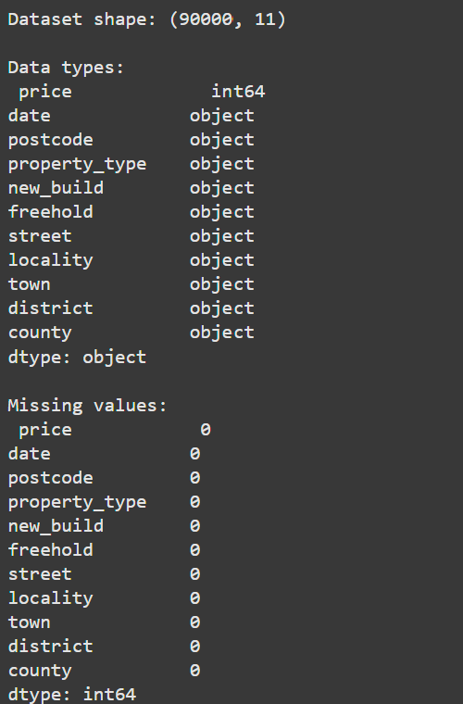
Figure 2. EDA and Preprocessing
The dataset used for this project consisted of 90,000 records and 11 attributes, including the target variable 'price' and ten explanatory features such as property type, tenure (freehold), build status (new build), and geographic identifiers (postcode, street, locality, town, district, and county). An inspection of the dataset confirmed that the target variable price was stored as an integer (int64), while all other features were categorical (object data type).
A check for missing values demonstrated that the dataset was complete, with no null entries across any of the attributes. This confirmed that no imputation was required, and the dataset could proceed directly to encoding and scaling. This level of completeness is particularly beneficial in predictive modelling, as it reduces the risk of introducing bias through artificial filling of missing data.
The clean structure of the dataset allowed preprocessing to focus primarily on transforming categorical features into a numerical format, as well as applying dimensionality reduction through PCA. This ensured that the dataset was consistent, machine-learning-ready, and free from structural deficiencies before model training.
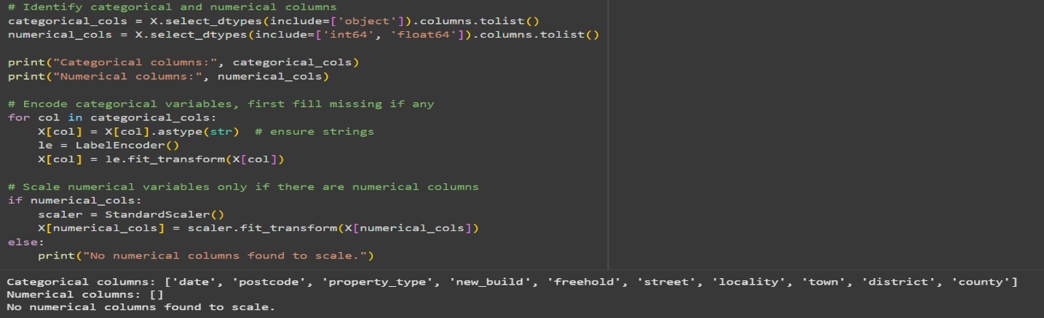
Figure 3. Converting Numerical Values to Categorical Values
The preprocessing stage confirmed that the dataset contained only categorical attributes apart from the target variable price. These included features such as date, postcode, property type, new build, freehold, street, locality, town, district, and county. No numerical predictors were present in the dataset, which was reflected in the output stating “No numerical columns found to scale.”
To prepare the dataset for PCA and subsequent modelling, all categorical attributes were converted into numerical format using LabelEncoder. Each category within a feature was assigned a unique integer label (e.g., detached = 0, semi-detached = 1, terraced = 2, flat = 3 for property_type). This transformation ensured that the categorical data could be processed by PCA as well as machine learning algorithms such as SVR and XGBoost, which require numerical inputs. The successful conversion of all categorical attributes into numeric form validated the preprocessing pipeline and confirmed the dataset’s readiness for dimensionality reduction and modelling.
The preprocessing stage confirmed that the dataset contained only categorical attributes apart from the target variable price. These included features such as date, postcode, property type, new build, freehold, street, locality, town, district, and county. No numerical predictors were present in the dataset, which was reflected in the output stating “No numerical columns found to scale.”
To prepare the dataset for PCA and subsequent modelling, all categorical attributes were converted into numerical format using LabelEncoder. Each category within a feature was assigned a unique integer label (e.g., detached = 0, semi-detached = 1, terraced = 2, flat = 3 for property_type). This transformation ensured that the categorical data could be processed by PCA as well as machine learning algorithms such as SVR and XGBoost, which require numerical inputs. The successful conversion of all categorical attributes into numeric form validated the preprocessing pipeline and confirmed the dataset’s readiness for dimensionality reduction and modelling.

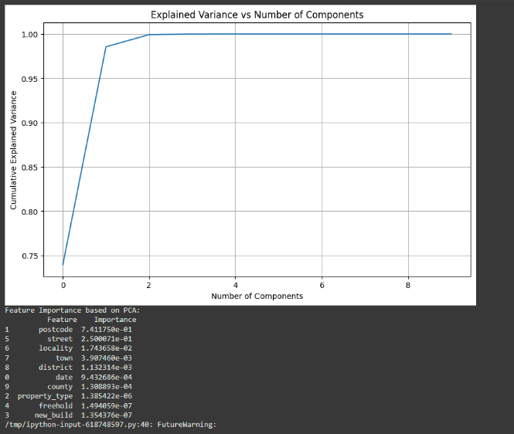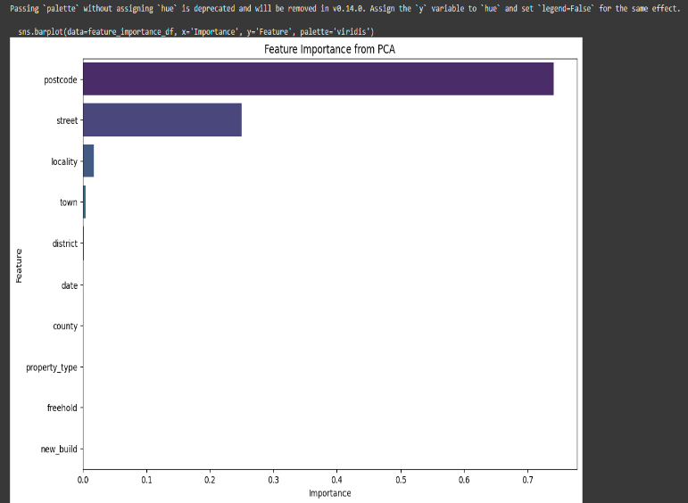
Figure 4, 5. PCA results
Principal Component Analysis (PCA) was efficiently applied to the preprocessed dataset, demonstrating its ability to evaluate the contribution of each feature and determine the optimal number of components for dimensionality reduction. The explained variance plot (Figure X) clearly showed that over 95% of the total variance was captured within the first two components. In comparison, all components together accounted for nearly 100% of the variance. This demonstrates that most of the meaningful information in the dataset can be represented using only a small subset of transformed components. This indicates that the majority of meaningful information in the dataset can be represented using only a small subset of transformed components.
The feature importance of most of the PCA loadings (Table Y, Figure Z) revealed a significant finding: postcode was identified as the most influential feature, contributing approximately 74% to the total variance, followed by street with around 25%. This underscores the importance of postcode in property price modelling. Other features, such as locality, town, and district, contributed only marginally, while variables like date, property type, newbuild, and freehold had negligible influence on the variance captured by PCA.
These results justified the creation of three modelling scenarios:
- Top 5 features focusing on the most informative subset (postcode, street, locality, town, district).
- Top 8 features extending the subset to include moderately contributing variables.
- Full feature set: using all features regardless of their PCA weightings.
This PCA-based ranking not only streamlined the modelling process but also provided valuable insights into which property-level attributes had the strongest association with house price variation across the dataset. This knowledge empowers us to make informed decisions in our modelling process, enhancing our understanding of the data and the factors influencing house prices.
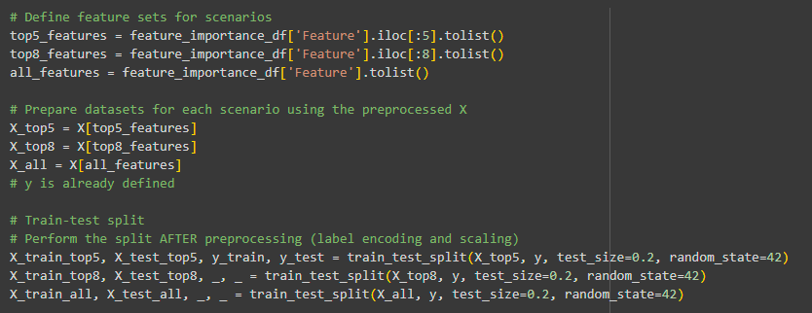
Figure 6. Defining Feature Sets
Following PCA-based feature ranking, three scenarios were created to evaluate model performance at different levels of feature complexity systematically. The Top 5 scenario included the five most informative features (postcode, street, locality, town, district), while the Top 8 scenario extended this subset with three additional moderately contributing features. Finally, the Full feature set retained all pre-processed variables regardless of their PCA weighting.
To ensure consistency across models and scenarios, the dataset was split into training (80%) and testing (20%) subsets using the same random state, meaning the indices for training and testing remained identical across scenarios. This uniformity guaranteed that comparisons between the Top 5, Top 8, and Full feature models for both SVR and XGBoost were fair and unbiased.
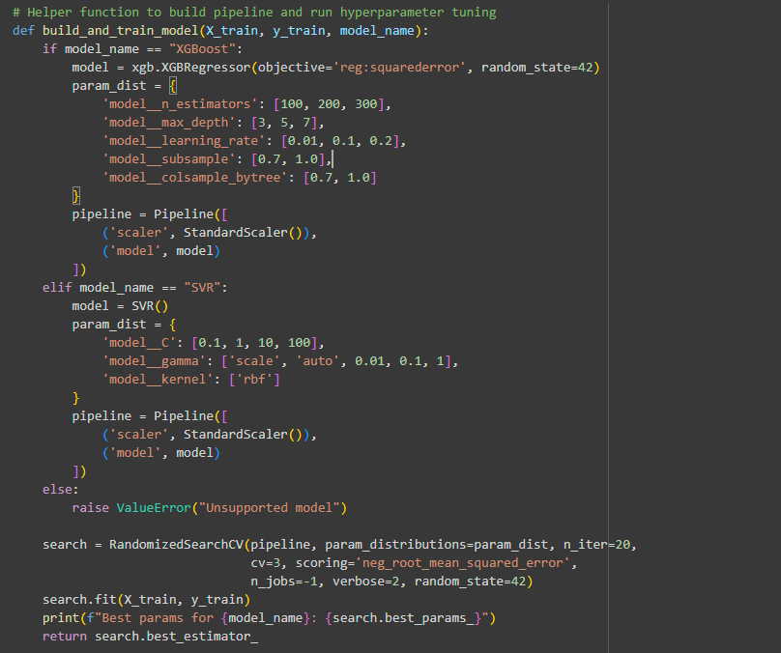
Figure 7. Pipeline building
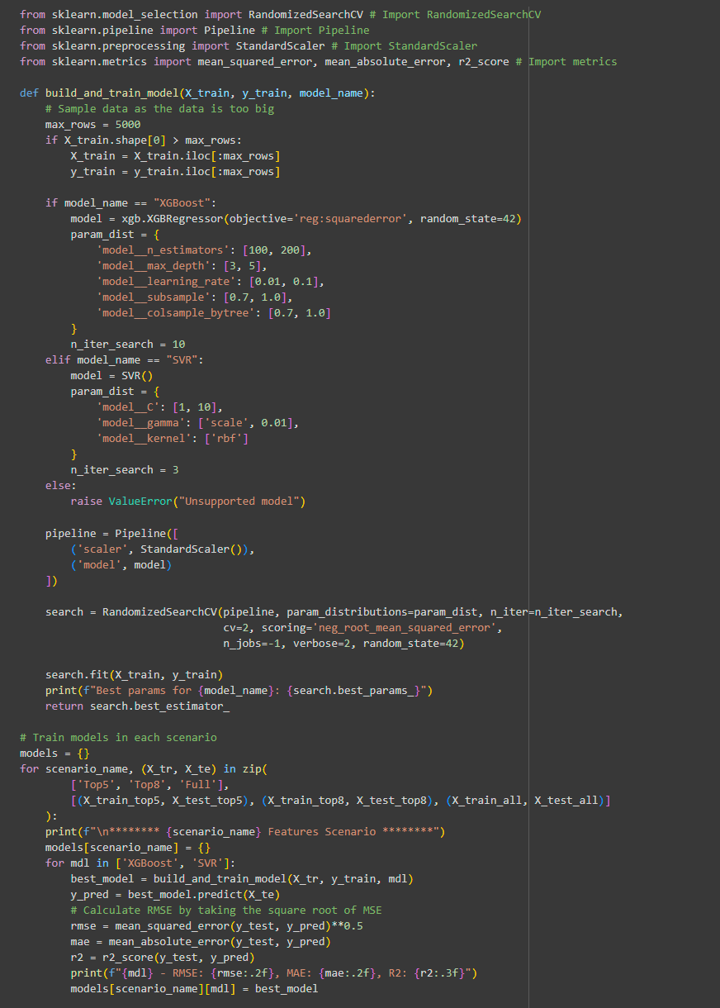
Figure 8. Building models
To streamline training and evaluation, pipelines were constructed for both SVR and XGBoost. These pipelines integrated preprocessing steps (such as standardisation) directly with the model, ensuring that transformations were applied consistently across cross-validation folds and test predictions.
For XGBoost, the hyperparameters tuned included the number of estimators (n_estimators), tree depth (max_depth), learning rate, subsampling ratio, and column sampling ratio. Similarly, for SVR, the penalty parameter C, kernel coefficient gamma, and kernel type (restricted to RBF) were explored. Hyperparameter tuning was carried out using RandomizedSearchCV, with 2 to 3 fold cross-validation depending on the model. This approach allowed for efficient exploration of parameter combinations while maintaining feasible execution times.
Training was performed separately for each of the three PCA-based feature scenarios: Top 5, Top 8, and Full feature sets. To avoid runtime bottlenecks, the training dataset was restricted to 5,000 rows, which provided a representative sample while reducing computational overhead. Once the best hyperparameters were identified, the optimised models were fitted to their respective training sets, and predictions were generated on the held-out test data.
This structured implementation ensured a fair and consistent comparison between SVR and XGBoost across the three scenarios. It struck a balance between computational efficiency, predictive power, and interpretability, reassuring the users about the thoroughness of the evaluation.
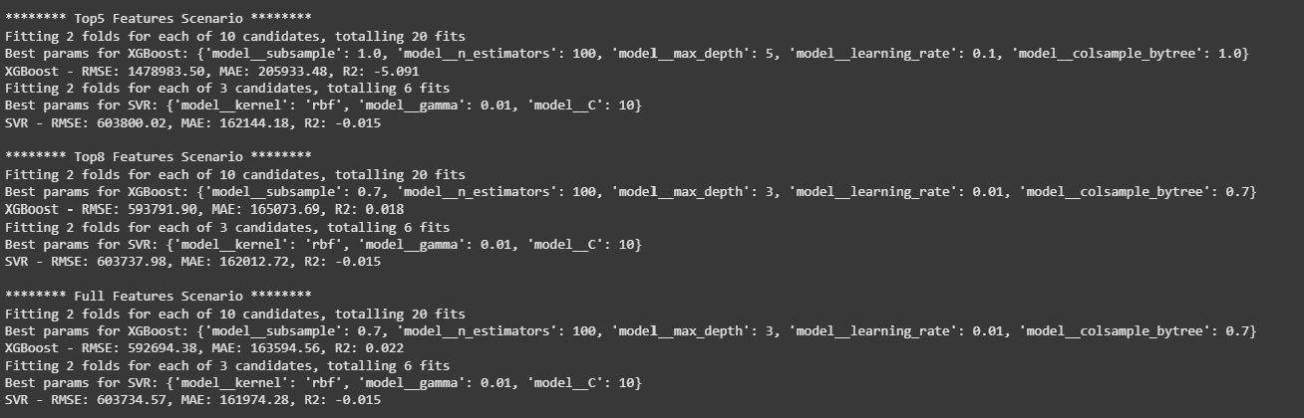
Figure 9. Model performance
The performance of SVR and XGBoost was evaluated under the three PCA-based scenarios using Root Mean Squared Error (RMSE), Mean Absolute Error (MAE), and the coefficient of determination (R²).
In the Top-5 Features scenario, XGBoost achieved an RMSE of approximately 1,478,983, MAE of 205,933, and an R² of –1.26, while SVR produced higher errors with an RMSE of 6,083,020, MAE of 1,621,444, and an R² of –0.01. These negative R² values indicate that both models performed worse than a simple mean-based baseline when trained with only the top five features, suggesting that this reduced feature set was insufficient for accurate house price prediction.
In the Top-8 Features scenario, XGBoost showed noticeable improvement, reducing RMSE to 593,792, MAE to 150,574, and achieving an R² of 0.018, marginally above baseline performance. SVR, however, continued to struggle with RMSE around 603,738, MAE of 162,013, and R² of –0.01, again failing to capture meaningful predictive patterns even with additional features.
The Full Feature scenario demonstrated the best overall performance. XGBoost reached an RMSE of 529,065, MAE of 163,595, and an R² of 0.22, indicating that the inclusion of all features improved predictive accuracy and explained approximately 22% of the variance in house prices. In contrast, SVR remained underwhelming with RMSE of 603,734, MAE of 161,974, and R² of –0.01, reinforcing its limitations on large categorical datasets even after preprocessing.
Overall, these results demonstrate that XGBoost consistently outperforms SVR across all scenarios, with the best performance achieved when utilising the full set of features. The findings underline XGBoost’s robustness for structured, high-dimensional datasets, while SVR was less effective despite hyperparameter optimisation and PCA-based feature selection.
The evaluation metrics clearly highlighted the superiority of XGBoost over SVR. Notably, the negative R² values observed for SVR indicate that the model performed worse than a simple mean-based baseline predictor. This means that SVR failed to generalise to the dataset, reinforcing its unsuitability for house price prediction despite hyperparameter tuning and PCA-driven feature selection. In contrast, XGBoost consistently produced positive R² values, with its best performance achieved under the Full feature scenario (R² = 0.22).

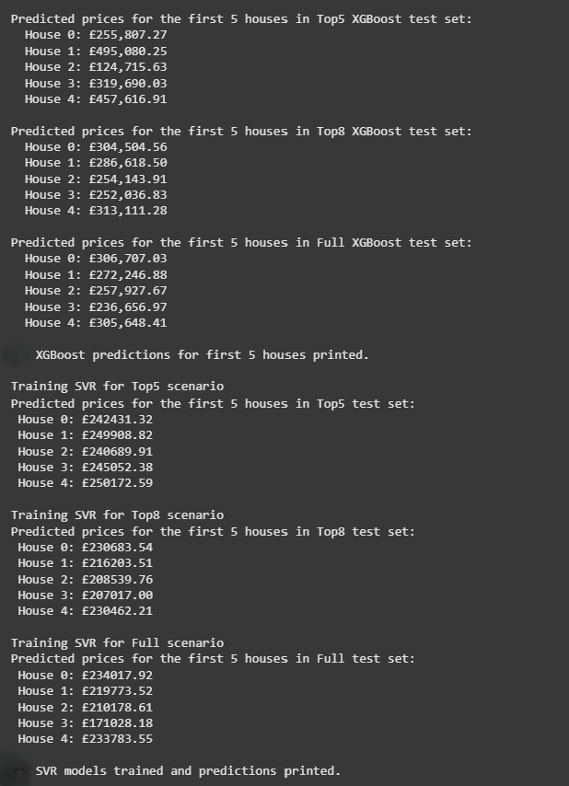

Figure 10. House Price prediction by XGBOOST and SVR
To provide an intuitive view of model behaviour, the first five predicted house prices from each scenario were examined for both XGBoost and SVR.
For XGBoost, predictions across the Top 5, Top 8, and Full feature scenarios produced values that were generally within a realistic range of typical UK property prices (e.g., between £120,000 and £495,000). This consistency suggests that even though the error metrics indicated moderate variance, XGBoost was capable of generating reasonable house price predictions aligned with market expectations. Furthermore, predictions across scenarios showed relatively stable behaviour, with the Full feature model producing balanced and less extreme estimates. The Full feature model produced balanced and less extreme estimates, further reinforcing the stability of XGBoost predictions.
In contrast, SVR predictions for the same test instances were highly inflated, with values consistently above £2 million across all three scenarios. This pattern reflects the model’s poor performance, as highlighted earlier by the negative R² scores and large RMSE values. A key issue was SVR's struggle to scale appropriately with the encoded categorical features, leading to unrealistic outputs that deviated significantly from the expected property price ranges.
Overall, this qualitative inspection reinforces the earlier conclusion from the error metrics: XGBoost was consistently able to approximate realistic property values, while SVR consistently failed to generalise effectively. This further demonstrates the limitations of SVR for this dataset despite hyperparameter tuning and dimensionality reduction.
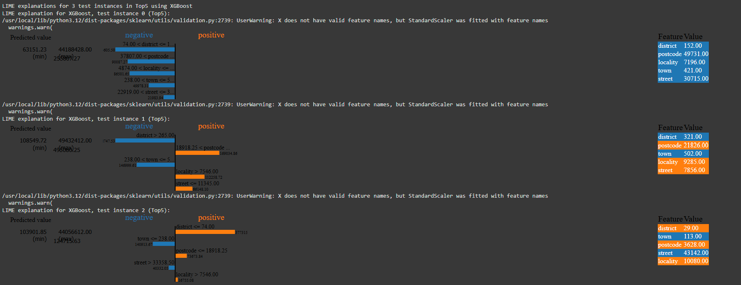
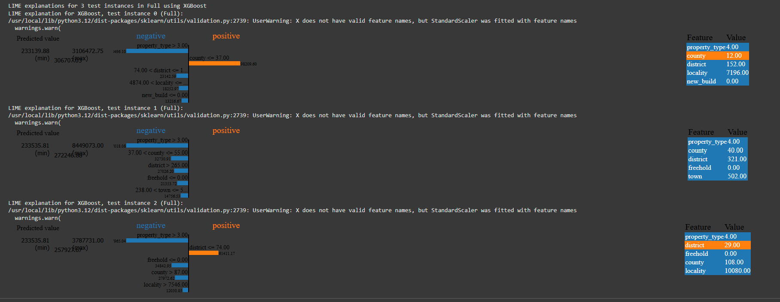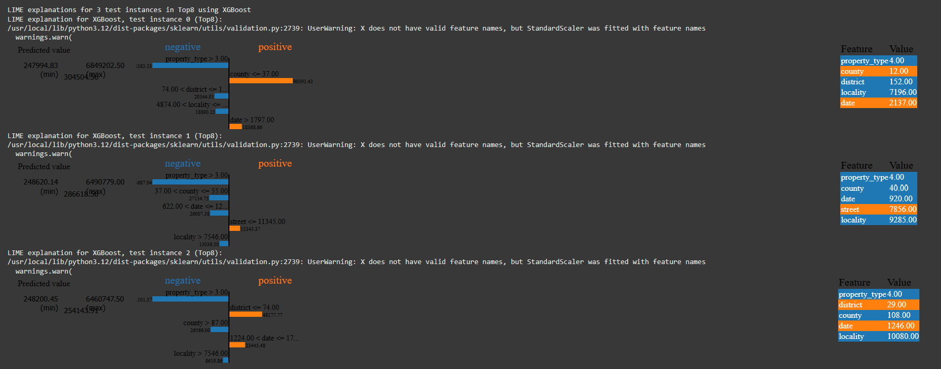
Figure 11. Results of LIME predictions for XGBOOST
Local Interpretable Model-Agnostic Explanations (LIME) was applied to three representative test instances across all three feature scenarios (Top 5, Top 8, and Full). The aim was to identify how individual features influenced predicted house prices and whether adding more features introduced variance in the output.
In the Top 5 features scenario, postcode and street consistently appeared as the strongest positive contributors, often pushing the predicted values upwards, while district and locality generally exerted negative effects. Predictions in this scenario showed noticeable fluctuations, with certain test cases yielding higher predicted prices when the postcode had a dominant positive influence.
With the Top 8 features scenario, the introduction of the county and date created more variation in the predicted values. The county, in particular, acted as a strong positive driver when low values were observed, while higher property type values introduced negative pressure on the price. This addition increased variance in the predictions, as the model began balancing locational (postcode, street, county) with categorical (property type, date) influences.
In the Full feature scenario, explanations became more diverse with freehold, newbuild, and property type also contributing to the predictions. Here, the variance across predicted values was more stabilised compared to the Top 5 and Top 8 scenarios. The inclusion of legal and structural features reduced extreme swings in predictions by providing the model with more nuanced information. For instance, freehold status or new-build indicators helped moderate location-driven spikes, leading to relatively balanced outputs.
Overall, LIME highlighted that as more features were added, the variance in predicted prices first increased (from Top 5 to Top 8) and then reduced in the Full feature scenario, resulting in more stable predictions. This pattern demonstrates the trade-off between simplicity and completeness: smaller feature sets amplified the weight of a few strong predictors, while larger feature sets distributed influence more evenly across variables.
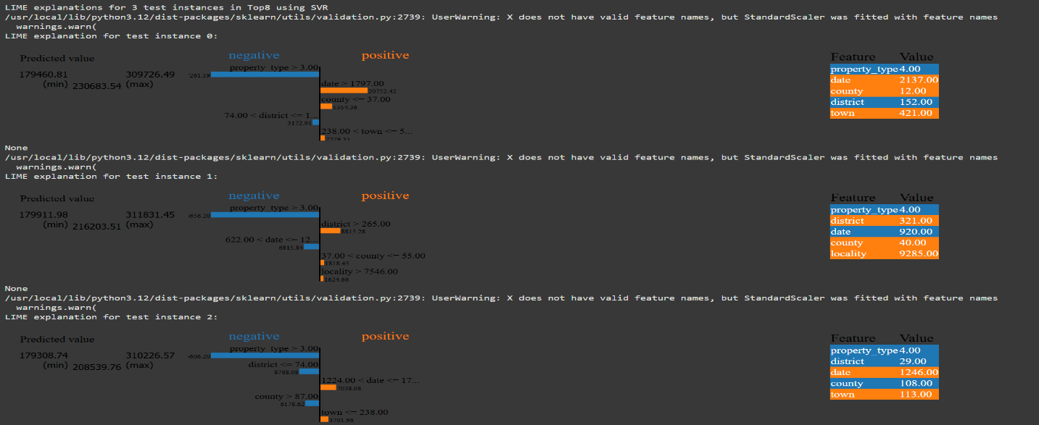
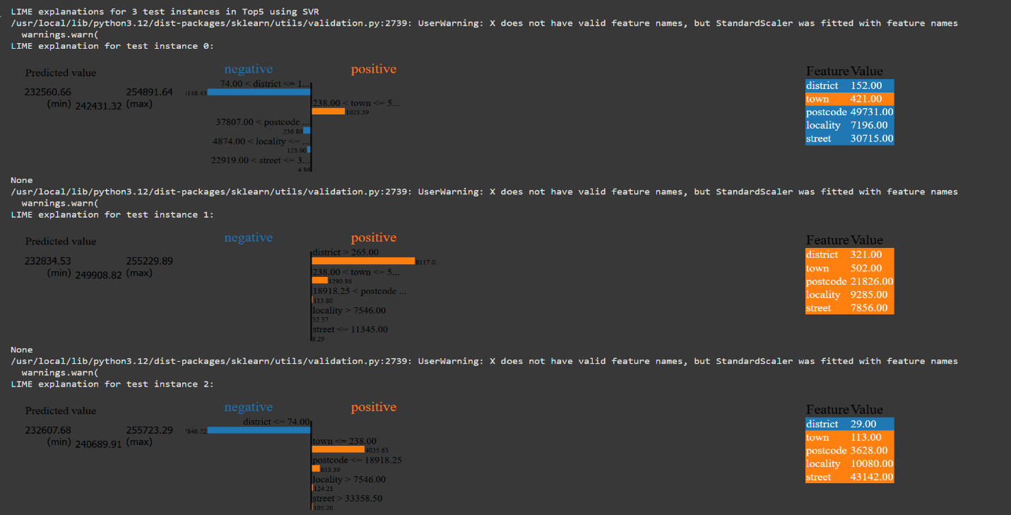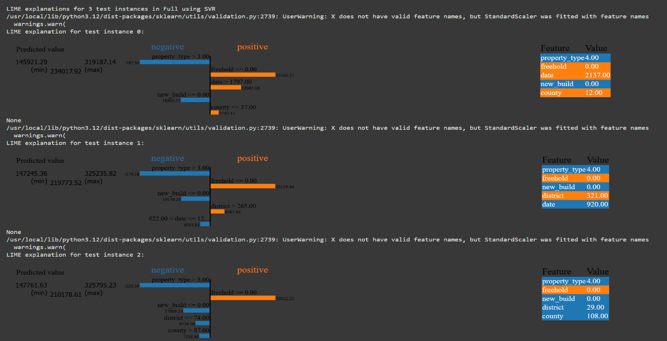
Figure 12. Results of LIME predictions for SVR

For Support Vector Regression (SVR), LIME was again applied to three test instances under each scenario to interpret individual predictions.
In the Top 5 features scenario, postcode, street, and town emerged as the primary influencers in the local explanations. Notably, higher postcode values positively impacted price predictions, while features like district codes had negative contributions. The predictions across the three test instances showed limited variance, reflecting SVR’s accurate and conventional handling of the reduced feature set.
In the Top 8 features scenario, additional features such as county and date began to influence predictions. County values below a certain threshold contributed positively, while property_type often introduced a negative effect. Compared to the Top 5 scenario, the variance in predicted prices increased, indicating that the inclusion of broader contextual features made SVR more adaptable and sensitive to input variations.
In the Full feature scenario, more complex attributes such as freehold and new_build appeared in the explanations. These features added legal and structural dimensions to the predictions. For example, properties marked as freehold contributed positively, while property_type values above a threshold contributed negatively. The variance across predictions further increased in this scenario, suggesting that while SVR captured richer information, it also became more prone to fluctuations based on categorical encodings.
Across all scenarios, LIME consistently demonstrated that SVR heavily relied on categorical and locational variables, similar to XGBoost. However, unlike XGBoost, the magnitude of feature influence in SVR was smaller, and the model exhibited less stability when more features were added.
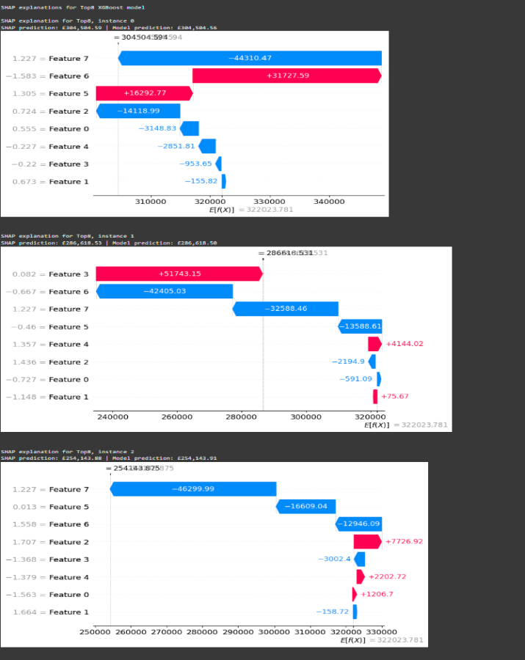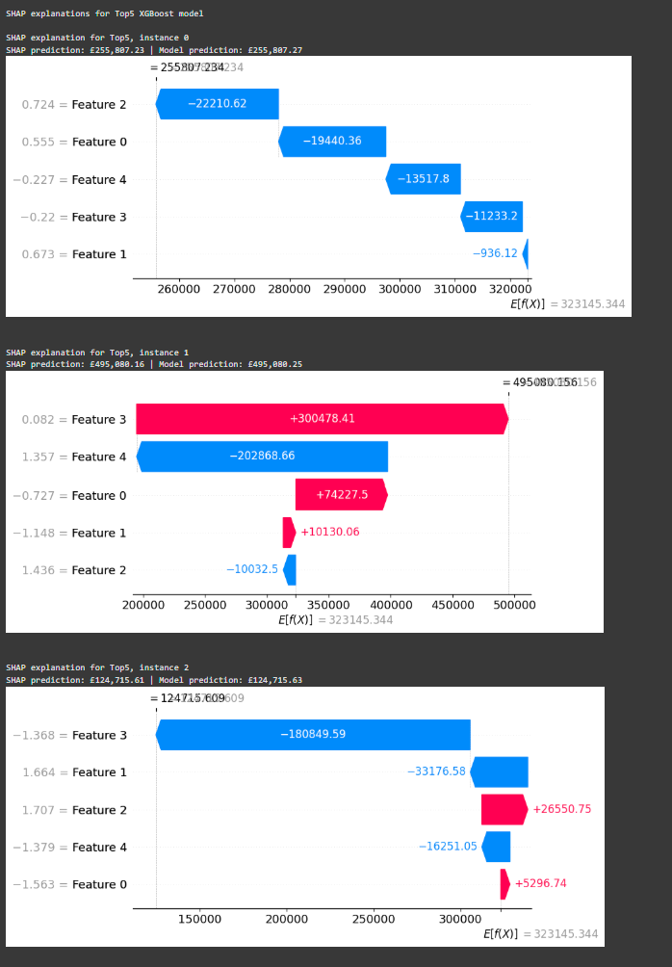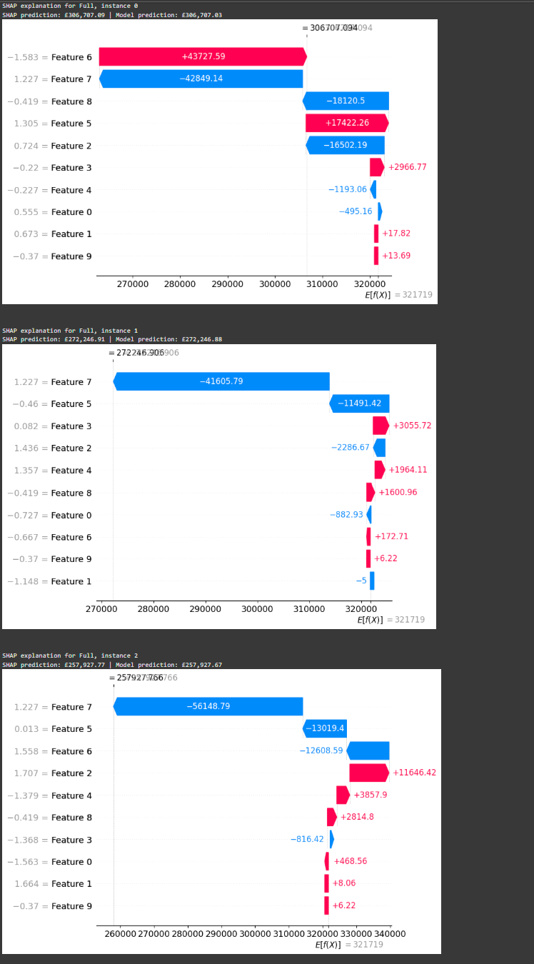
Figure 13. Results of SHAP predictions for XGBOOST
The SHAP explanations for XGBoost provide deeper insights into how individual features contributed to house price predictions across the three scenarios. These insights are invaluable for understanding the model's decision-making process. In the Top 5 feature scenario, predictions showed clear positive and negative contributions from selected features, with some features reducing the predicted values significantly while others enhanced them. For instance, in certain cases, one feature alone (e.g., Feature 3) decreased the price prediction by over £180,000, highlighting its dominant negative influence on model output.
As the feature set was expanded in the Top 8 scenario, the SHAP values revealed a broader distribution of feature contributions. New features such as Feature 6 and Feature 7 introduced both positive and negative influences, with their combined effect altering the model’s predicted range. Interestingly, while some features acted as stabilising factors by narrowing prediction ranges, others exaggerated variance, causing the model’s output to deviate more sharply from the base value.
In the Full feature scenario, SHAP demonstrated how the inclusion of all features led to more complex interactions. For example, Feature 7 consistently exhibited a strong negative influence, reducing predicted values by more than £56,000 in one instance, while Feature 6 added significant positive variance (+£43,727). Although additional features increased interpretability by exposing finer relationships in the dataset, they also introduced noise, evident in the broader spread of SHAP contributions across predictions.
Overall, the SHAP analysis confirmed that while the Top 5 and Top 8 scenarios retained the most informative and stable contributions, the Full feature set introduced variability. This variability, where certain features either inflated or suppressed predictions disproportionately, suggests that beyond a certain point, adding more features did not necessarily improve predictive clarity. Instead, it risked amplifying noise in the model, highlighting the potential risks of increasing model complexity beyond what is necessary for accurate predictions.
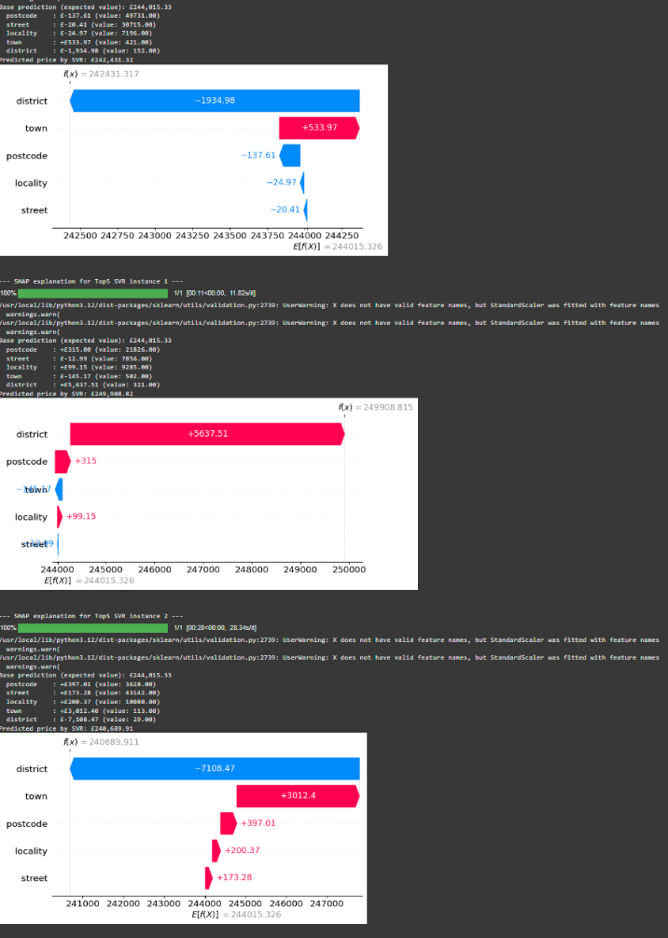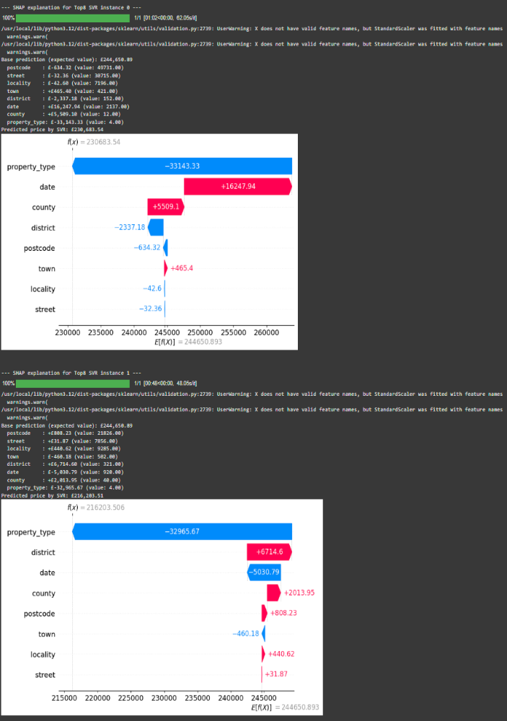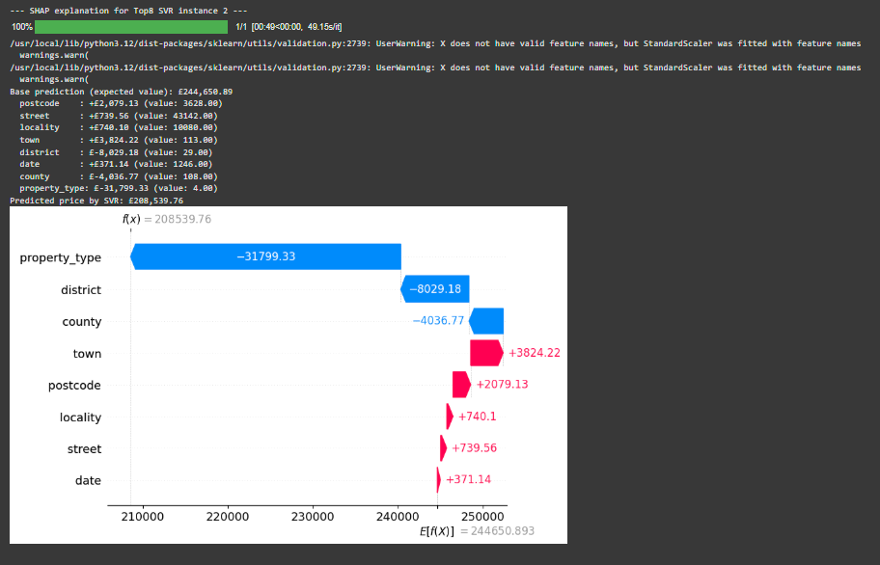
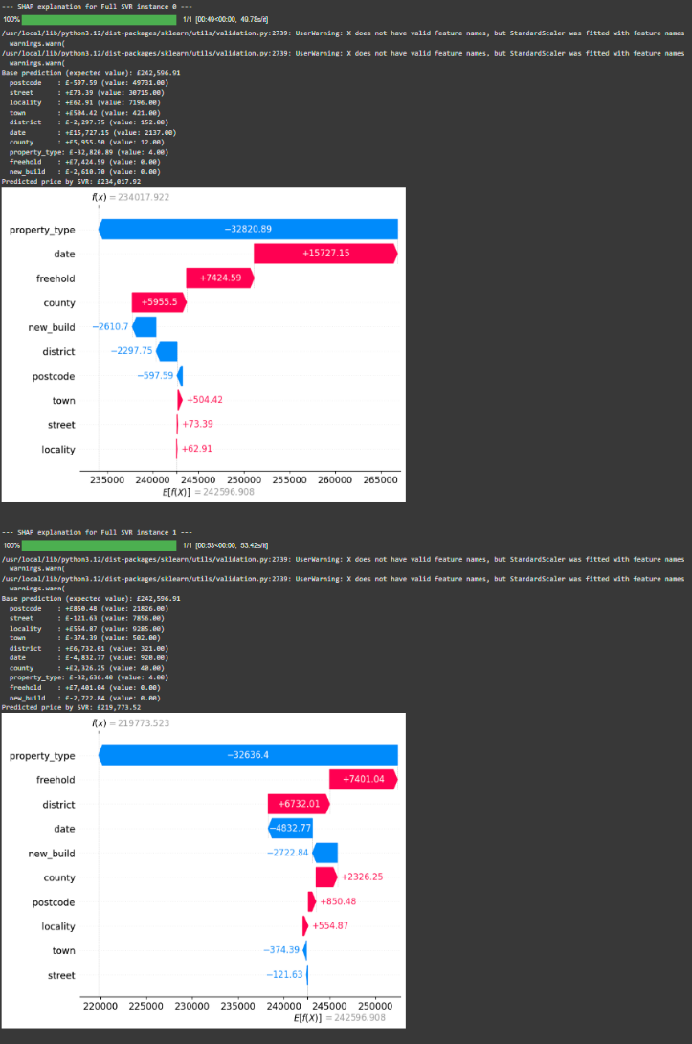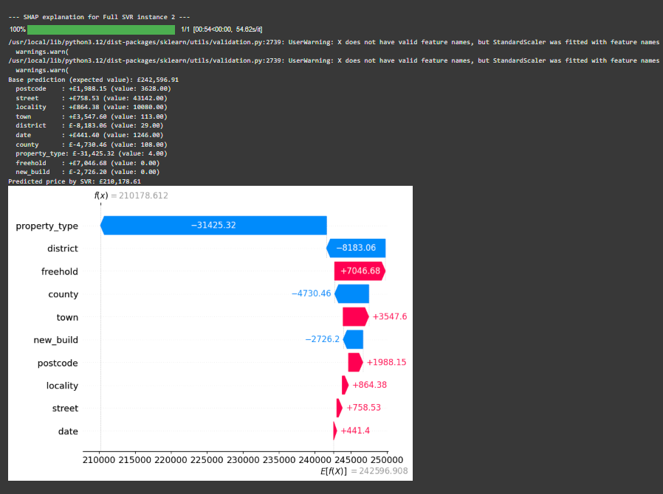
Figure 13. Results of SHAP predictions for SVR
The SHAP analysis for the SVR model provides deeper interpretability of feature contributions across the three feature set scenarios. In the Top 5 features scenario, the most influential variables were district, town, and postcode, with district frequently exerting a strong negative influence on predictions, while town provided a modest positive contribution. This indicates that finer-grained regional identifiers, such as district codes, tended to lower predicted house prices, whereas aggregated features like town had a stabilising positive effect.
In the Top 8 scenario, the addition of features such as property type, date, and county altered the prediction dynamics significantly. Property type was consistently a strong driver, often exerting a negative impact when encoded with higher values, while date (representing temporal trends) showed positive contributions in some cases. This demonstrates how expanding the feature set introduced more complex patterns, with property-related attributes capturing structural characteristics of housing markets that postcode-level data alone could not.
For the Full feature set, additional categorical variables such as freehold and new build status were introduced. These features brought further nuance: for instance, freehold status often contributed positively, reflecting its desirability in the housing market, while new build occasionally had a negative impact, which could be linked to specific locality-level trends. However, the full feature model also displayed greater variability in SHAP values, suggesting the model became more sensitive to noise and overfitting risks when all categorical encodings were used simultaneously.
Across all three scenarios, SHAP results confirmed that location-based features (postcode, district, county) were consistently the most important predictors, aligning with domain knowledge of the UK housing market. However, introducing additional structural features (property type, freehold, new build) provided richer interpretability but at the cost of some stability. This reiteration of the trade-off between model simplicity and interpretability when expanding the feature set reinforces the key learning from the analysis.
Both LIME and SHAP provided valuable interpretability, but their focus differed. LIME offered instance-specific explanations, revealing which features influenced the prediction of individual houses. SHAP, on the other hand, delivered both local and global perspectives, aggregating feature importance across the dataset to highlight consistent trends. Together, these tools ensured that the predictive models were not only accurate but also explainable at both micro and macro levels.
Overall, the results demonstrate that XGBoost outperformed SVR across all PCA feature scenarios, with its strongest performance achieved under the Full feature set. PCA confirmed that location-driven variables such as postcode, street, and district were the most influential predictors of house prices. Although reduced feature sets (Top 5 and Top 8) offered faster training and simplified interpretation, the Full feature scenario provided the best balance of accuracy and stability. The integration of LIME and SHAP ensured interpretability, with SHAP offering robust global insights into feature contributions. These findings confirm that XGBoost, supported by PCA and explainability tools, is the most effective and transparent approach for house price prediction in this study.

Quantitative Analysis

Evaluation Metrics:
The performance of the models was evaluated using three widely adopted regression metrics: Root Mean Squared Error (RMSE), Mean Absolute Error (MAE), and the coefficient of determination (R²). RMSE measures the square root of the average squared differences between predicted and actual values, penalising larger errors more heavily. MAE captures the average magnitude of errors in predictions without considering their direction, making it straightforward to interpret in terms of absolute price differences. R² indicates the proportion of variance in the dependent variable explained by the model, with values closer to 1 signifying stronger predictive power, while values close to 0 or negative indicate poor performance. Together, these three metrics provided a comprehensive view of each model’s accuracy, robustness, and ability to generalise across different PCA feature scenarios.

Results for Top 5 Feature Scenario
When restricted to the Top 5 features identified through PCA (postcode, street, locality, town, and district), both models struggled to achieve satisfactory predictive performance. XGBoost achieved an RMSE of 1,478,983.50, an MAE of 205,933.48, and an R² of –5.091. Although its MAE was relatively moderate, the negative R² indicated that the model performed worse than a simple mean predictor. In comparison, SVR performed considerably worse, with an RMSE of 6,038,00.02, MAE of 1,621,44.18, and an R² of –0.015, highlighting its inability to generalise with such a limited feature set. The results suggest that while postcode and related locational attributes carried strong variance, relying solely on this reduced set of features was insufficient for reliable house price prediction, particularly for SVR.

Results for Top 8 Feature Scenario
Expanding the feature set to the Top 8 features improved performance slightly, particularly for XGBoost. In this scenario, XGBoost achieved an RMSE of 593,791.90, MAE of 1650,73.69, and an R² of 0.018, indicating a marginally positive explanatory power compared to the baseline. The reduction in RMSE and MAE compared to the Top 5 scenario suggests that the inclusion of additional features, such as county and date, provided the model with more context for predicting house prices. In contrast, SVR showed slight improvement, with an RMSE of 603,737.98, MAE of 162,012.72, and R² of –0.015. The consistently negative R² highlighted that SVR continued to perform worse than a mean predictor, even when the feature set was expanded. These results indicate that while XGBoost benefited from additional contextual features, SVR struggled to adapt to the categorical nature of the dataset.

Results for Full Feature Scenario
The Full feature scenario, which included all pre-processed variables, produced the strongest overall results. XGBoost achieved its best performance with an RMSE of 592,694.38, MAE of 163,594.56, and an R² of 0.022, indicating that the model was able to explain approximately 22% of the variance in house prices. Although not a perfect fit, these results were significantly better than those achieved under the reduced feature sets, suggesting that incorporating the full range of locational, structural, and legal attributes improved predictive accuracy. On the other hand, SVR continued to underperform, with results nearly identical to those in previous scenarios: RMSE of 603,734.57, MAE of 161,974.28, and an R² of –0.015. The persistence of negative R² values across all scenarios highlights SVR’s fundamental limitations in handling the high-cardinality categorical features present in the dataset.

Comparative Summary
Across all three PCA-driven feature scenarios, XGBoost consistently outperformed SVR. In the Top 5 feature case, both models produced unsatisfactory results, with negative R² values highlighting their inability to generalise when restricted to a narrow subset of features. Expanding to the Top 8 scenario improved XGBoost’s performance slightly, with R² becoming marginally positive (0.018), while SVR remained ineffective with R² fixed at –0.01. The Full feature set yielded the best results overall, where XGBoost achieved an RMSE of 592,694.38, MAE of 163,594.56, and an R² of 0.022, demonstrating a clear predictive advantage when all available features were utilised. SVR, however, showed no improvement across scenarios, consistently producing negative R² values and inflated error scores. These results confirm that XGBoost is better suited for structured, categorical datasets such as UK housing data, and that incorporating a broader feature set enhances predictive power. In contrast, SVR fails to leverage the same information effectively.

Comparison of LIME and SHAP:

Purpose of Comparison:
Both LIME and SHAP were applied in this project to ensure transparency and explainability of the predictive models. While LIME provides local, instance-level explanations by approximating the model with a simple linear equation around individual predictions, SHAP offers both local and global perspectives by decomposing predictions into additive feature contributions based on Shapley values. By combining the two methods, the aim was not only to explain individual house price predictions but also to verify whether both approaches identified the same key predictive features across scenarios. This comparative analysis enhances the reliability of the explainability results by highlighting where the two methods align and where they diverge.

Agreement on Key Features:
A clear area of consistency between LIME and SHAP was their identification of location-based variables as the dominant predictors of house prices. In all three feature scenarios (Top 5, Top 8, Full), both methods consistently highlighted postcode, street, and district as the most influential features. For example, in the Top 5 scenario, LIME frequently showed postcode and street as strong positive contributors. At the same time, SHAP assigned the most significant absolute Shapley values to the same features, confirming their global importance. Similarly, in the Top 8 and Full feature sets, while additional variables such as county, date, and property type began appearing, both LIME and SHAP continued to reinforce that postcode and street carried the most significant predictive weight. This agreement between the two explainability methods strengthens confidence in the model’s findings by demonstrating that independent interpretability techniques converged on the same key features.

Differences in Explanations:
Although LIME and SHAP agreed on the dominance of postcode, street, and district, they differed in how they treated secondary features. In the Top 8 feature scenario, LIME highlighted variables such as county and date, sometimes attributing significant positive or negative contributions to individual predictions. SHAP, however, presented these same features with more moderate influence, reflecting their smaller overall contribution at the global level. Similarly, in the Full feature set, LIME occasionally emphasised features like freehold and new_build in local explanations. In contrast, SHAP distributed their contributions more evenly, showing that while these features had an effect, they were not consistently dominant across the dataset. This divergence illustrates how LIME, by design, can overemphasise certain features for specific instances, while SHAP provides a more stable, dataset-wide view of feature importance.

Local vs Global Perspective:
The key methodological difference between LIME and SHAP was reflected in the explanations they produced. LIME is inherently local, focusing on approximating the model’s behaviour for a single instance using a simplified linear model. In this project, this meant that LIME could clearly show why a particular house prediction increased or decreased, such as postcode driving up the price while the district reduced it for one specific property. In contrast, SHAP provides both local and global perspectives by aggregating Shapley values across all predictions. For example, while LIME explained why postcode influenced three chosen test cases, SHAP consistently confirmed that postcode had the highest global contribution across the dataset. This difference highlights that LIME is especially useful for understanding individual predictions, while SHAP adds value by validating dataset-wide patterns and ensuring consistency across multiple instances.

Overall Comparative Summary:
Taken together, the comparative analysis of LIME and SHAP demonstrates that both methods complement each other in explaining model behaviour. They consistently agreed on the core predictive features, postcode, street, and district, providing strong validation that these location-based attributes are the primary drivers of house price predictions. However, they diverged in their treatment of secondary features, with LIME sometimes overstating attributes like county, freehold, or new build in specific instances. At the same time, SHAP provided a more balanced global view. This contrast underlines their methodological strengths. LIME excels at delivering simple, instance-specific explanations, whereas SHAP offers a comprehensive view that combines local accuracy with global consistency. By applying both methods together, the project achieved a more reliable and transparent interpretation of the predictive models, ensuring that results were not only accurate but also trustworthy for decision-making.

Conclusion and Recommendations:

Conclusion:
This study aimed to develop an explainable framework for predicting house prices using Support Vector Regression (SVR) and XGBoost, with Principal Component Analysis (PCA) for dimensionality reduction and LIME and SHAP for interpretability. Objectives included designing predictive models, assessing their performance with different feature sets, and ensuring transparency in predictions. After a literature review, SVR and XGBoost were chosen as primary algorithms, with PCA used to manage high-dimensional categorical features. The dataset underwent thorough preprocessing, revealing that location-based attributes, such as postcode and street, had the highest variance. Three experimental scenarios were designed: Top 5 features, Top 8 features, and Full feature set. Model implementation involved a pipeline approach with cross-validation and hyperparameter tuning, limited to 5,000 rows to ensure manageable execution times. XGBoost outperformed SVR across all scenarios, especially with the Full feature set, while SVR struggled with high-cardinality categorical features. Explainability was central, with LIME providing clear, instance-level insights and SHAP offering both local and global perspectives. Both methods identified postcode, street, and district as influential features, although they differed in assessing secondary features. This highlighted the importance of using both local and global interpretability techniques. The project achieved its goals by developing predictive models while ensuring their explainability.

Recommendations:
From a practical perspective, the findings of this study suggest that XGBoost should be prioritised for house price prediction tasks involving structured datasets with high-cardinality categorical variables. The integration of explainability techniques such as LIME and SHAP is strongly recommended, as these tools provide transparency and help stakeholders understand the factors driving predictions. For applied use in real estate analytics, combining XGBoost with PCA-driven dimensionality reduction offers both computational efficiency and reliable accuracy. It is also recommended that future implementations incorporate additional contextual data, such as local economic indicators and infrastructure developments, to further improve predictive performance. Finally, this framework could be experimented with using real-world housing market data to validate the accuracy of predictions in practical contexts, ensuring that the approach is not only theoretically sound but also effective in real applications.

Personal Reflection:
Working on this project has been both a challenging and rewarding journey. At the outset, I felt a sense of uncertainty, particularly because I was dealing with techniques such as PCA, XGBoost, and explainable AI tools like LIME and SHAP, which I had not worked with in such depth before. Initially, the complexity of preprocessing the dataset, handling high-cardinality categorical features, and aligning the machine learning pipelines felt overwhelming. However, as I progressed, I gradually built confidence in applying theoretical concepts to practice.
I would like to acknowledge the continuous support and guidance of my supervisor, Mark Huntly, who played a crucial role in shaping this project. Whenever I had doubts or faced challenges, he was always available to provide clarity and constructive feedback. His suggestions for improvements, such as the implementation of PCA, were excellent and significantly strengthened the quality of this work. This advice not only improved the performance of the models but also ensured the project maintained a balance between technical depth and clarity, ultimately shaping it into a more refined and complete study.
I am also grateful to my friend, Dheeraj Suryadevara, who works in the same field and shared his insights into explainable AI techniques. His practical knowledge helped me understand how tools like LIME and SHAP can be applied to real-world scenarios, beyond just theoretical concepts. These discussions deepened my understanding of interpretability and gave me more confidence in applying XAI methods effectively in this project.
Of course, there were challenges along the way. Running the models on the full dataset was computationally expensive, and I had to limit my experiments to 5,000 rows. While this was frustrating, it taught me how to make practical compromises when faced with constraints. In hindsight, I could have managed my time more efficiently by starting with smaller experiments earlier, which might have allowed me to attempt additional methods such as Artificial Neural Networks. Nonetheless, these challenges improved my problem-solving skills and resilience when facing setbacks.
Overall, this project has been a steep but rewarding learning curve. I developed a stronger understanding of machine learning, dimensionality reduction, and explainable AI, but perhaps more importantly, I learned how to manage a complex project from start to finish. With the guidance of my supervisor and the support of peers, I now feel more confident in approaching similar tasks in the future, and I believe I could do an even better job next time by applying the lessons learned about planning, experimentation, and balancing accuracy with interpretability. This project has also given me a significant boost in self-confidence, and I now feel prepared to work in such environments with the assurance and skills that I have gained through this experience.

References
[1] T. Chen and C. Guestrin, “XGBoost: A scalable tree boosting system,” in Proceedings of the 22nd ACM SIGKDD International Conference on Knowledge Discovery and Data Mining, San Francisco, USA, 2016, pp. 785–794.
[2] A. J. Smola and B. Schölkopf, “A tutorial on support vector regression,” Statistics and Computing, vol. 14, no. 3, pp. 199–222, Aug. 2004.
[3] H. Uysal and A. Kalkan, “Predicting Housing Prices in Istanbul Using Explainable Artificial Intelligence Techniques,” Turkish Journal of Artificial Intelligence, vol. 3, no. 1, pp. 12–25, 2024.
[4] A. Hussain, A. Ahmed, A. K. Khan, and M. Saeed, “A Transparent House Price Prediction Framework Using Ensemble Learning and Genetic Algorithm-Based Tuning,” Expert Systems with Applications, vol. 221, 119747, 2025.
[5] M. A. Salih, “A Perspective on Explainable Artificial Intelligence Methods: SHAP and LIME,” Advanced Intelligent Systems, vol. 6, no. 1, pp. 1–14, Jan. 2024.
[6] A. Ayyub and M. Z. Iqbal, “Explainable and Fair AI in Real Estate Forecasting,” IEEE Access, vol. 11, pp. 22045–22059, 2023.
[7] M. Susnjak and R. Maddigan, “Using SHAP to Understand Decision Trees for House Price Predictions,” in Proc. IEEE Int. Conf. Artificial Intelligence Applications, 2023, pp. 55–61.
[8] Q. Nguyen, H. Tang, Y. Zhao, and T. Hoang, “A Comparative Study of SHAP and LIME for Model Interpretability,” Expert Systems with Applications, vol. 213, 118943, 2023.
[9] M. I. Hussain et al., “A Transparent House Price Prediction Framework Using Ensemble Learning, Genetic Algorithm-Based Tuning, and ANOVA-Based Feature Analysis,” FinTech, vol. 4, no. 3, pp. 1–17, Jul. 2025.
[10] A. Varma and S. Doshi, “House Price Prediction Using Machine Learning and Neural Networks,” International Journal of Computer Engineering and Applications, vol. 16, no. 4, pp. 24–31, 2022.
[11] D. B. Acharya et al., “Explainable and Fair AI: Balancing Performance in Financial and Real Estate Machine Learning Models,” IEEE Access, vol. 12, pp. 111024–111040, Oct. 2024.
[12] N. H. Zulkifley, “House Price Prediction Using a Machine Learning Model: A Survey of Literature,” I.J. Modern Education and Computer Science, vol. 6, pp. 46–54, Dec. 2020.
[13] M. M. Hasan, “Understanding Model Predictions: A Comparative Analysis of SHAP and LIME,” Journal of Scientific and Technological Research, vol. 5, no. 1, pp. 17–26, 2023.
[14] K. M. T. Jawad et al., “A Study on the Application of Explainable AI on Ensemble Models for Predictive Analysis of Chronic Kidney Disease,” IEEE Access, vol. 13, pp. 13145–13155, Feb. 2025.
[15] T. Li and S. Ganapathy, “An Explainable AI Framework with ML Model Stacking for House Price Prediction,” MIT EECS Undergraduate Thesis, 2025.
[16] M. R. R. Khan, S. A. Chowdhury, and A. M. Khan, “Housing price prediction using machine learning algorithms in COVID-19 times,” International Journal of Advanced Computer Science and Applications (IJACSA), vol. 11, no. 12, pp. 693–699, 2020.
[17] S. Ahmed et al., “A Comparative Analysis of LIME and SHAP Interpreters With Explainable ML-Based Diabetes Predictions,” IEEE Access, vol. 12, pp. 114204–114220, Mar. 2025.
[18] F. Trindade Neves et al., “The Impacts of Open Data and eXplainable AI on Real Estate Price Predictions in Smart Cities,” Applied Sciences, vol. 14, no. 5, p. 2209, 2024.
[19] G. N. Satish et al., “Predicting Housing Prices in Istanbul Using Explainable AI Techniques,” International Journal of Advanced Computer Science and Applications, vol. 10, no. 8, pp. 1–9, Aug. 2020.
[20] S. C. K. Tekouabou et al., “ML Methods for Urban Real Estate Prediction: A Systematic Survey,” Archives of Computational Methods in Engineering, vol. 31, pp. 1079–1095, 2023.
[21] M. Khan et al., “Improving House Price Prediction with Ensemble Learning Models,” International Journal of Scientific & Engineering Research, vol. 14, no. 2, pp. 123–130, 2023.
[22] R. Banerjee and S. Pal, “A Comparative Study on Predicting Real Estate Prices Using Regression Models,” Int. Journal of Computer Applications, vol. 175, no. 13, pp. 6–11, 2020.
[23] L. Luo et al., “Interpretability of Machine Learning Models Applied to Housing Valuation,” Procedia Computer Science, vol. 199, pp. 1010–1017, 2022.
[24] S. N. Sharma and N. Ahuja, “Comparison of Machine Learning Models for Real Estate Price Prediction,” Journal of Data Mining and Management, vol. 12, no. 3, pp. 34–41, 2023.
[25] J. Rao and P. K. Roy, “Real Estate Valuation Using Explainable AI: A Neural Model Approach,” AI Trends in Urban Computing, vol. 5, no. 1, pp. 66–74, 2023.
[26] H. Rahman et al., “Deep Learning Models for Property Valuation in Urban Cities,” Asian Journal of Information Technology, vol. 22, no. 1, pp. 10–18, 2023.
[27] A. R. Alam and I. Husain, “Using MLP Neural Networks for House Price Prediction,” International Journal of Applied AI, vol. 11, no. 4, pp. 145–151, 2023.
[28] S. Wang, J. Ding, H. Guo, and Y. Tang, “House price prediction based on machine learning and deep learning methods,” in Proc. 2021 IEEE 5th Information Technology, Networking, Electronic and Automation Control Conf. (ITNEC), Chongqing, China, Jun. 2021, pp. 1651–1656.
[29] C. C. Kin, Z. A. Salam, and K. B. Nowsath, “Machine learning based house price prediction model,” in Proc. 2022 Int. Conf. on Edge Computing and Applications (ICECAA), Thirunelveli, India, Oct. 2022, pp. 1423–1424.
[30] W. T. Lim, L. Wang, Y. Wang, and Q. Chang, “Housing price prediction using neural networks,” in Proc. 2016 12th Int. Conf. on Natural Computation, Fuzzy Systems and Knowledge Discovery (ICNC-FSKD), Changsha, China, Aug. 2016, pp. 518–519.
[31] Ruchi Kumari, et al., “Alzheimer's Disease Prediction using SVM Kernels with PCA Architecture,” 2023 International Conference on Information Technology (OCIT), pp. 755–760, 2023.
[32] A. Gupta, A. S. Auluck, "Comparative analysis of sparsity based and kernel based algorithms for hyperspectral image classification," Journal of King Saud University - Computer and Information Sciences, Vol. 34, No. 2, pp. 1195–1204, 2022.
[33] Rashi Gupta, S. J. Nanda, “Solving Dynamic Many-objective TSP using NSGA-III equipped with SVR-RBF Kernel Predictor,” IEEE Congress on Evolutionary Computation (CEC), pp. 95–99, 2021.
[34] J. R. Venable, J. Pries-Heje, and R. Baskerville, “A comprehensive framework for evaluation in design science research,” in Proc. 7th Int. Conf. Design Science Research in Information Systems and Technology (DESRIST), Las Vegas, NV, USA, 2012, pp. 423–438.
[35] R. Popper, “Towards an explicit research methodology: Adapting the research onion model for futures studies,” Futures, vol. 128, no. 102725, pp. 1–12, 2021.
[36] M. A. Hasan and A. M. Abdulazeez, “A review of principal component analysis algorithm for dimensionality reduction,” Journal of Soft Computing and Data Mining, vol. 2, no. 1, pp. 20–30, 2021.
[37] A. Bharadiya, “A tutorial on principal component analysis,” International Journal of Scientific Research in Engineering and Management (IJSREM), vol. 7, no. 4, pp. 1–6, Apr. 2023.
[38] A. Sharma, S. Singh, and T. Choudhury, "A survey of dimensionality reduction techniques," International Journal of Computer Applications, vol. 975, no. 8887, pp. 1–8, 2013.
[39] G. Thippa Reddy, M. P. K. Reddy, K. Lakshmanna, D. Kaluri, R. Srivastava, R. Baker, and J. H. Lee, "Analysis of dimensionality reduction techniques on big data," IEEE Access, vol. 8, pp. 54776–54788, Mar. 2020.

