Financial Management for the Hotel Industry
Assignment Title: Business Report: Comparison of Two Hospitality Organisation

Student Name: Cristina Maria Silva Pita
Student id: 2228861
Module Name: BMIH5007
Tutor Name: Tristan Hawkins

Executive Summary
The report has discussed the operation of Travelodge and Shangri-La in the United Kingdom. There has been a discussion regarding the services which they provide to the customers. Furthermore, there has also been a comparison of the profit which both the businesses have earned. In addition, the areas of growth have been identified for the enterprises. On the other hand, there has also been a discussion regarding the strategies which would help the businesses to increase their position in the market. Moreover, the CSR policies which both businesses have has been identified in the report. Based on the analysis, a set of recommendations has been provided to the businesses.
Table of Contents
Introduction 1
Overview of the Businesses 1
Revenue Comparison 1
Market Position 3
Potential Areas of Growth of the Businesses 7
Financial Commitment to CSR 8
Recommendations 9
Conclusion 9
References 10

Introduction
The report will compare the operation of two hotel businesses. The hotels which have been selected are Travelodge and Shangri-La. There would be a comparison of the revenue that both the hotels have earned. Furthermore, there would also be a comparison of the positions that the businesses hold in the market. Also, the potential areas of growth would be identified.

Overview of the Businesses
Travelodge is one of the biggest hotel chains operating in the United Kingdom. The business has been operating in the country for over 40 years. This has helped the enterprise to get hold of a huge place in the industry (Travelodge, 2024). Furthermore, the business has also expanded its empire to different parts of the country. It has been identified that the organisation has approximately 600 franchises in the UK. With this, the business has further increased the number of customers. Moreover, they have ensured to provide the customers with the best facilities. This has helped the enterprise to expand its operational efficiency as well. The high-end facilities and proper resources which have been provided to the employees have been beneficial (Page and Connell, 2020). With this, the employees have ensured that the customers have a comfortable stay in the hotel. Moreover, the enterprise has also ensured that better facilities are provided to the employees. This has helped in increasing their satisfaction level as well.
Shangri-La Hotels is one of the most luxurious hotels in the United Kingdom. The business has been new to the tourism of the United Kingdom. However, the short span of service of the organisation has been highly impactful on the market (Shangri-La, 2024). The efficiency of the strategies which they have considered has been beneficial. With this, there has been a considerable enhancement in the possibility for the business to enhance its operational perimeter. Furthermore, the best-quality services and other amenities provided to the customers have been their plus point. In this way, there has been considerable enhancement in the possibility for the business to increase its brand image as well. Moreover, the efficiency of the employees and their service quality has been another plus point. With this, the business has been able to ensure comfort to the customers during their stay.

Revenue Comparison
Both businesses have been efficient concerning their operational procedure. This has helped them to meet the immense competition in the market. Furthermore, the revenue structure which they have created has also been efficient (Walker, 2021). In the case of Travelodge, the business has been able to ensure that a proper analysis of the market condition is done. In this way, the enterprise has been able to make necessary changes in its performance strategies. With this, the business has ensured an upgrade in its revenue structure.
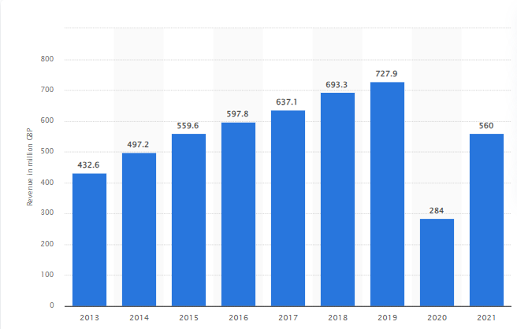
Figure 1: Revenue of Travelodge in the United Kingdom in 2021
(Source: Statista, 2022)
The figure discusses the revenue the business has generated from its operation in the United Kingdom. It has been identified that the business has been successfully earning immense revenue till 2019. That year was notified to be the most profitable for the enterprise. This is so because the enterprise has earned a total of £727.9 million (Statista, 2022). However, the year 2020 has led to an immense downfall because of the Covid-19 pandemic. Yet, the business has been striving hard to stand up. Therefore, it has been recorded that the enterprise earned a total of £560 million in 2021 (Statista, 2022).
Shangri-La on the other hand has also ensured that they focus on their strategic operations. Such procedures have benefitted the business to enter the market of the UK efficiently. Moreover, the enterprise has also been able to generate a huge amount of money from its operation (Shinzo, 2023).
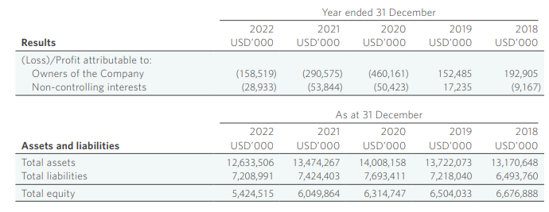
Figure 2: Financial Comparison of Shangri-La Hotels from 2018 to 2022
(Source:
The diagram depicts the comparison in revenue of the business for five years. It has been identified that the business has been able to generate an immense amount of revenue. However, the diagram depicts that there has been a gradual reduction in revenue in the year 2022. The revenue which the business has been able to generate is only over £4 million (Shangri-La, 2024). Therefore, there needs to be the presence of proper strategies. These strategies would help in increasing the revenue of the business.

Market Position
The operation of both businesses has been efficient. This has helped the business to gain an immense amount of revenue. Furthermore, there has also been a considerable increment in the customers which the businesses have been able to serve.
Regarding Travelodge, the operation of the business has been highly efficient. With this, the business has been able to increase its position in the market as well. Furthermore, the organisation has been able to ensure that the customers are provided with the best comfort. In this way, there has been an immense increment in the brand image of the business as well (Guilding, 2014). Moreover, the business has also been efficient in identifying the type of customers which would be beneficial for the business. For this, the use of the customer persona can be considered beneficial.

Customer Persona
Name: Alice Rodricks
Address: London
Demographics | Location | Oxford Street, London, United Kingdom.
Demographics | Age | 38
Demographics | Education | Bachelors in Business Management
Demographics | Annual Income | £ 30,000
Demographics | Language | English and Spanish
Demographics | Family | Medium-income family
Profession | Industry | Retail Industry
Profession | Job Title | Cashier
Profession | Goals | Increase in income
Profession | Challenges | Medium yearly income
Table 1: Customer Persona for Travelodge
(Source: Developed by the Student)
As per the analysis, it has been identified that such types of customers would be beneficial for Travelodge. Therefore, the business has ensured to make necessary changes in its promotional strategies. Furthermore, there have also been changes in the pricing strategy of the business (Haynes and Egan, 2020). The use of a reasonable pricing strategy has been beneficial for the business. With this, the enterprise has been able to attract such customers.
As discussed, Shangri-La is one of the most luxurious hotels in the United Kingdom. Therefore, it is obvious that the hotels’s prices would be high. In light of this, it has been identified that the business has ensured to target such customers with an immense annual income (Tranter et al., 2014). In this way, the business has been able to gain an immense attraction. Therefore, the customer persona created below would be beneficial in identifying the targeted customers of Shangri-La.

Customer Persona
Name: Jenny Gomes
Address: London
Demographics | Location | London, United Kingdom.
Demographics | Age | 38
Demographics | Education | Diploma in Business Management
Demographics | Annual Income | £ 10 million
Demographics | Language | English and Italian
Demographics | Family status | High-standard family
Profession | Industry | Retail Industry
Profession | Job Title | CEO of a retail business
Profession | Goals | Enter the market of new countries
Profession | Challenges | None
Table 2: Customer Persona for Travelodge
(Source: Self-created)
As per the table, it has been identified that the business targets customers with an immense annual income. Therefore, there needs to be a proper identification of those customers. It has been this strategy which has helped the business to increase its position in the market as well. Furthermore, there has also been a considerable enhancement in the possibility for the business to meet the competition of the other elite-class hotels in the market (JIN, 2022). In light of this, a comparison regarding the position of the businesses as per the prices and quality of services has been created.
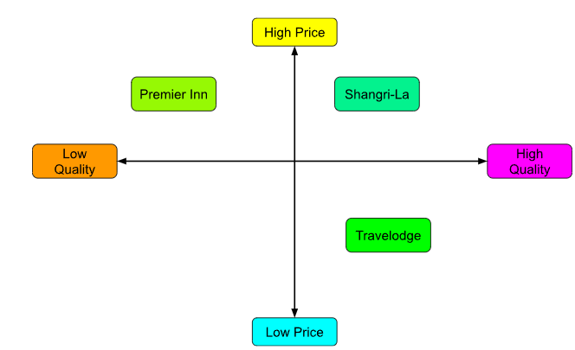
Figure 3: Positioning Map
(Source: Self-Created)

Potential Areas of Growth of the Businesses
The strategies which both businesses have used have helped them to increase their position in the market. Moreover, there has also been an immense increment in the brand image which the businesses have been able to generate. However, there are various areas where growth can be initiated. This would help the enterprises reach the peak of the competition (Guix and Font, 2020). For this, the use of the Ansoff Matrix would be efficient.
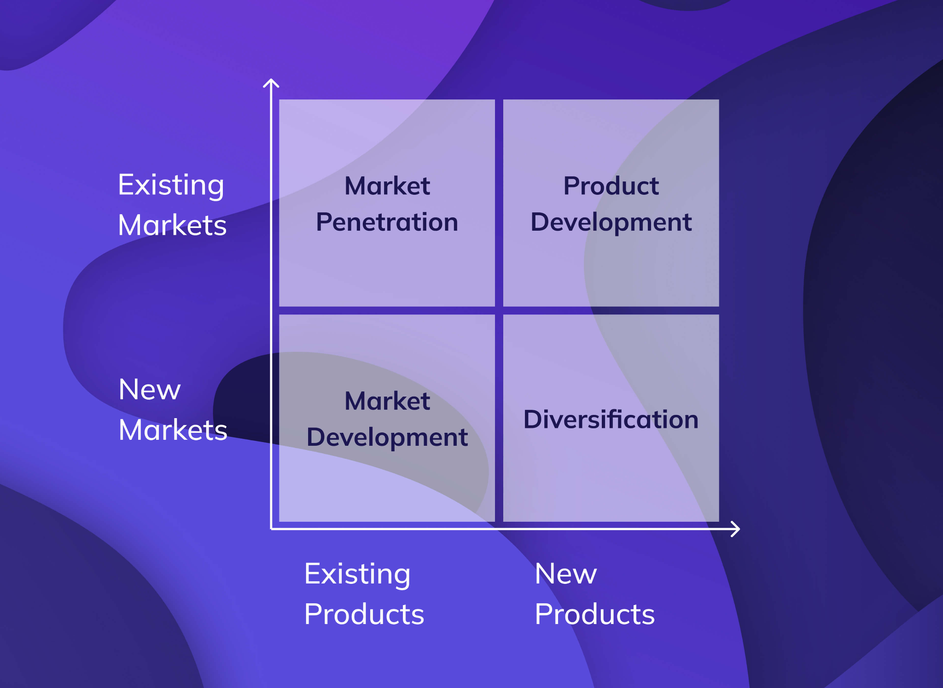
Figure 4: Ansoff Matrix
(Source: Grünig et al., 2022)
This model helps in identifying areas where there is the potential for growth of a business. In this way, the enterprises would be able to have an immense competitive advantage. Furthermore, there would also be a considerable increment in their potential to dominate the market condition (Clarissia, 2020).
For Travelodge, the business has been operating in the market of the United Kingdom for decades. Therefore, there is no doubt that the business has an immense hold over the market condition. Furthermore, the long period of operation has helped the business by providing immense growth in the market. Therefore, there is the potential for the business to enter a new market segment. Therefore, the use of a Market Penetration Strategy would be beneficial for the enterprise. The use of this strategy would require the business to have an efficient analysis of the products and services provided to the customers in another market. In this way, there would be the creation of a different department (Ali and Anwar, 2021). Such procedures would help Travelodge in meeting the demand of the other market as well. Therefore, there would also be an efficient hold which the business would have over there.
Shangri-La on the other hand, has been new to the travel industry of the United Kingdom. Therefore, there is a long procedure in which the business has to continue to dominate the market. For this, the marketing team needs to ensure that there is an efficient analysis of the market condition. In this way, there would be efficient countermeasures which would be considered by the business. Based on the Ansoff Matrix, the use of a Product Development Strategy would be efficient. This would help the business to produce new types of products or services that would be provided to the customers in the hotels. In this way, there would be an enhancement in the attraction level of the customers (Granato et al., 2020). Furthermore, the business also would be able to get hold of the market condition efficiently. Moreover, there would also be an enhancement in the position that the business would have in the market.

Financial Commitment to CSR
A vital element which a business entity needs to emphasise is its CSR policies. The use of such policies helps a business to ensure that society benefits from their operations. In this way, the organisations would further be able to gain the trust of the people (Siregar, 2021). Furthermore, there would also be an enhancement in the competitive advantage which they would have.
Regarding Travelodge, the seniors of the business have ensured that there is a proper identification of the CSR policies. In this way, they have been able to ensure that society is also benefitted (Jones and Comfort, 2021). For instance, they have ensured to make use of sustainable procedures. The use of solar panels for the use of green energy has been beneficial. This has been a cost-saving procedure which the business has considered (Filimonau and Magklaropoulou, 2020). With this, there has been a considerable reduction in the expenditure of the business.
Shangri-La on the other hand, has ensured to understand the CSR policies which would be beneficial for them to enter the market of the UK. It has been identified that the business has been able to reduce single-use plastic by 41%. On the other hand, there has been an immense reduction in carbon emissions as well. Therefore, 24% less carbon has been emitted through the operation of the hotel in 2023 (Shangri-La, 2024). These strategies have helped in increasing their inventory as well. This is so because the sustainable procedures have helped in reducing the financial expenditure borne by the business.

Recommendations
The strategies which both businesses have considered using have been beneficial. This has helped them to grab an immense position in the market. For Travelodge, the business can be recommended to identify strategies for entering the market of other countries. This would help in increasing their market hold as well. On the other hand, Shangri-La can be recommended to reduce the prices of the hotels. This would help them to increase the number of customers in the UK. Furthermore, they also have the potential to increase their brand image as well (Jooss, S., McDonnell and Burbach, 2021). Moreover, there would also be a hike in the position that the business would hold in the tourism industry.

Conclusion
In conclusion, it can be stated that both businesses have been performing efficiently. Their strategies have helped in gain an immense position in the market. The comparison has helped in identifying the competition between both businesses. Furthermore, there needs to be a proper understanding of the areas where there is a potential for the businesses to grow.

References
Ali, B.J. and Anwar, G., 2021. Marketing Strategy: Pricing strategies and its influence on consumer purchasing decision. Ali, BJ, & Anwar, G.(2021). Marketing Strategy: Pricing strategies and its influence on consumer purchasing decision. International journal of Rural Development, Environment and Health Research, 5(2), pp.26-39.
Clarissia, S.M.S., 2020. A study on Ansoff Matrix Technique: As a growth strategy and an adaptive learning technique adopted in the leading brand of products. BIMS Journal of Management, 18.
Filimonau, V. and Magklaropoulou, A., 2020. Exploring the viability of a new ‘pay-as-you-use’energy management model in budget hotels. International journal of hospitality management, 89, p.102538.
Granato, D., Barba, F.J., Bursać Kovačević, D., Lorenzo, J.M., Cruz, A.G. and Putnik, P., 2020. Functional foods: Product development, technological trends, efficacy testing, and safety. Annual review of food science and technology, 11, pp.93-118.
Grünig, R., Kühn, R. and Morschett, D., 2022. Developing and Assessing Strategic Options for the Company. In The Strategy Planning Process: Strategic Analyses, Objectives, Options and Projects (pp. 111-122). Cham: Springer International Publishing.
Guilding, C.2014 (3rd Edition) Accounting Essentials for Hospitality Managers, London, Routledge
Guix, M. and Font, X., 2020. The Materiality Balanced Scorecard: A framework for stakeholder-led integration of sustainable hospitality management and reporting. International Journal of Hospitality Management, 91, p.102634.
Haynes, N. and Egan, D., 2020. The perceptions of frontline employees towards hotel overbooking practices: exploring ethical challenges. Journal of Revenue and Pricing Management, 19, pp.119-128.
JIN, H., 2022. The Myth of Shangri-La and Its Counter-discourses:(Anti-) Utopian Representations of China’s Southwest Frontier in the Twenty-First Century. Modern Chinese Literature and Culture, 34(1), pp.202-237.
Jones, P. and Comfort, D., 2021. Modern slavery statements and leading UK hotel companies. Athens Journal of Tourism, 8(3), pp.147-162.
Jooss, S., McDonnell, A. and Burbach, R., 2021. Talent designation in practice: An equation of high potential, performance and mobility. The international journal of human resource management, 32(21), pp.4551-4577.
Page, S.J. and Connell, J., 2020. Tourism accommodation and hospitality services. In Tourism (pp. 216-241). Routledge.
Shangri-La 2024. Luxury Hotel in London | Shangri-La Hotel, At The Shard, London. [online] Shangri-la.com. Available at: https://www.shangri-la.com/en/london/shangrila/ [Accessed 8 May 2024].
Shangri-La 2024. Shangri-La Annual Report 2023. [online] Available at: https://sitecore-cd.shangri-la.com/-/media/Project/Shangri-La-Group/Investor/Files/Public-Disclosures/Latest-Top-Publications/e0069_230418_AR.pdf [Accessed 8 May 2024].
Shangri-La 2024. SHANGRI-LA Sustainability Report 2023. [online] Available at: https://sitecore-cd.shangri-la.com/-/media/Project/Shangri-La-Group/Sustainability/Images/Sustainability-Report/2023_SustainabilityReport.pdf [Accessed 8 May 2024].
Shinzo, A., 2023. The 13th IISS Asia Security Summit–the Shangri-La Dialogue: keynote address. In Japan and the IISS (pp. 521-532). Routledge.
Siregar, I., 2021. CSR-based corporate environmental policy implementation. British Journal of Environmental Studies, 1(1), pp.51-57.
Statista 2022. Travelodge UK revenue 2021. [online] Statista. Available at: https://www.statista.com/statistics/429089/travelodge-total-revenue-united-kingdom-uk/#:~:text=Travelodge%20UK%20generated%20revenues%20of [Accessed 8 May 2024].
Tranter, K. Stuart-Hill, T. Parker, J. 2014 Introduction to Revenue Management for the Hospitality Industry, London, Pearson
Travelodge 2024. Travelodge | Great value hotels throughout the UK & Ireland. [online] Travelodge. Available at: https://www.travelodge.co.uk/ [Accessed 8 May 2024].
Walker J 2021 Introduction to Hospitality, Harlow, Pearson

