University of Wales Trinity Saint David
Wales Institute of Science and Art


Electronic Circuits Testing and Applications

Electrical Control Systems – ACHA4010

Ross Burnside
2110614
2nd April 2023
Contents
1 Task 1 1
1.1 A 1
1.2 B 1
1.3 c (i) 1
1.4 c (ii) 2
1.5 c (iii) 2
1.6 c (iv) 2
1.7 d 2
1.8 e 2
1.9 f 2
1.10 g 2
2 Task 2 3
2.1 Scope Time Division Calculations 3
2.2 Function Generator output sine wave 3
2.3 Unsmoothed Rectifier Wave 4
2.4 Smoothed Rectifier Wave 5
2.5 Drop in Voltage Question 5
2.6 Rectifiers use in Automotive applications Question. 6
2.7 Probing Question 6
3 Task 3 7
3.1 Scope Time Division Calculations 7
3.2 Function Generator output square wave 7
3.3 Capacitor charge and discharge wave marked at correct points. 7
3.4 Basic Capacitor Calculations 8
3.5 Capacitor discharge table 8
3.6 Gradient Plot and calculations 8
3.7 Inaccuracies Question 9
4 References 9

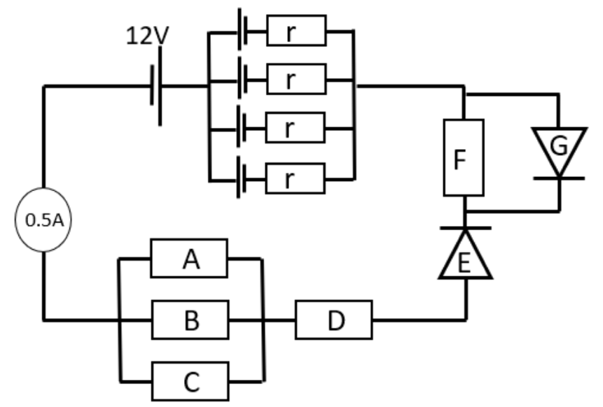
Task 1
(Diodes are assumed to be ideal with a 0.6V potential barrier).

A
Calculate the resistance of E.
Diodes have a 0.6V potential barrier.
Current = 0.5A
$$\frac{V}{I}=R$$
$$\frac{0.6}{0.5}=1.2Ω$$

B
Calculate the current passing through B and C.
Current passing through resistor A = 0.3A
$$P=IV ∴ \frac{P}{I}=V$$
$$\frac{(0.5-0.3)}{2}=0.1Ω per resistor$$

c (i)
The Resistance of A, given that it dissipates 0.9J of energy per/sec.
$$\left(\frac{0.9}{0.3}\right)=3V drop across resitor A$$
$$\frac{V}{I}=R$$
$$\frac{3}{0.3}=10Ω$$

c (ii)
The resistance of B and C.

c (iii)
The potential difference across A, B, and C.

c (iv)
The potential difference across D, and its resistance.
$$Total V_{drop} from resistor A to diode E=5V$$
$$V_{drop} across resistor D=2V$$
$$D=0.5A∴\frac{2}{0.5}=4Ω$$

d
Calculate the resistance, and total resistance of the parallel combination of cells.
$$V_{drop} across 1 parallel battery cell=2V$$
$$\frac{V}{I}=R$$
$$\frac{2}{0.5}=4Ω$$
$$\frac{1}{R_{T}}=\left(\frac{1}{4}+\frac{1}{4}+\frac{1}{4}+\frac{1}{4}\right)=\frac{1}{0.25+0.25+0.25+0.25}=\frac{1}{1}=1Ω$$

e
Calculate the voltage drop across F.
$$Potential Difference=5V∴7V is left$$
$$6Ω resistance \\ 0.5A current \\ 6×0.5=3V_{drop} across F$$

f
Calculate the total resistance of the circuit, including total internal R, and R caused by the reverse polarity battery (ignoring G).

g
Calculate the EMF of each of the cells in the parallel combination.

Task 2

Scope Time Division Calculations
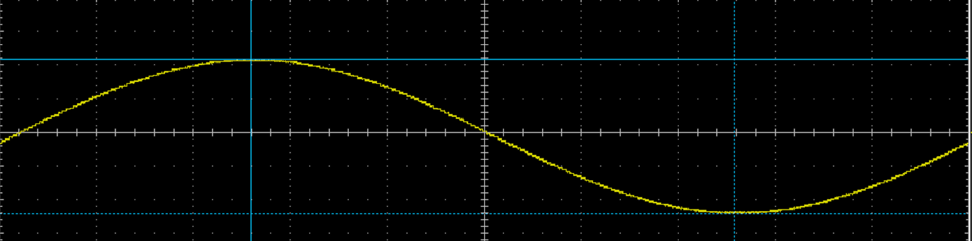
10.01 cycles per second = 10.01Hz
$f=\frac{1}{period}$ $period= \frac{1}{f}$
$period=\frac{1}{10.01}=0.0999=99.9mS$

Function Generator output sine wave
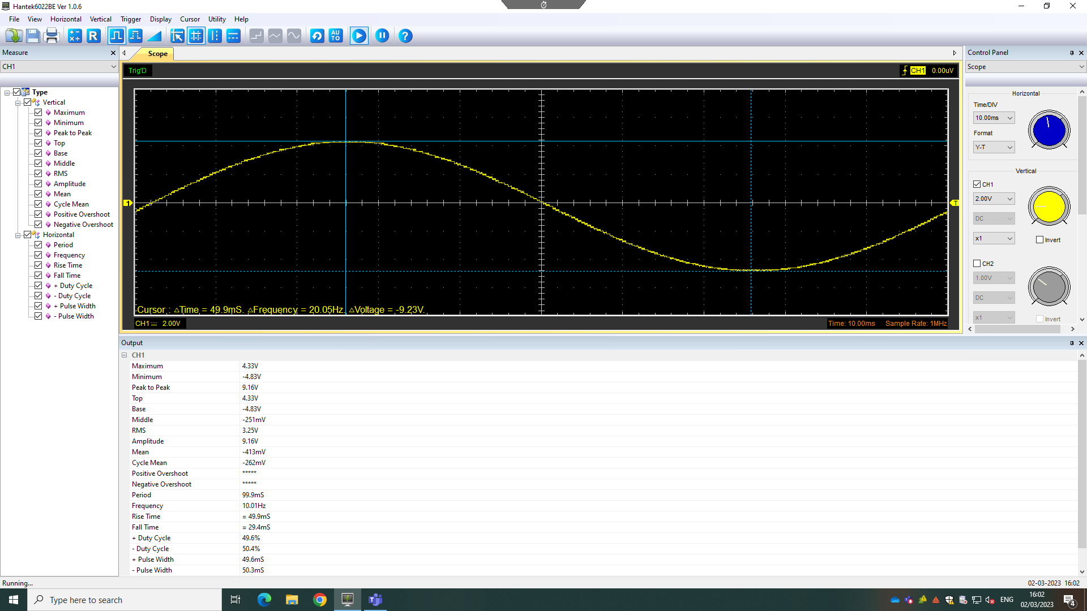
This is the “standard waveform that oscillates between two levels with a standard sinusoidal shape […] widely used in testing applications” (electronics-notes.com – 2023).
Peak to Peak: 9.16V
Period: 99.9mS
Frequency: 10.01Hz

Unsmoothed Rectifier Wave
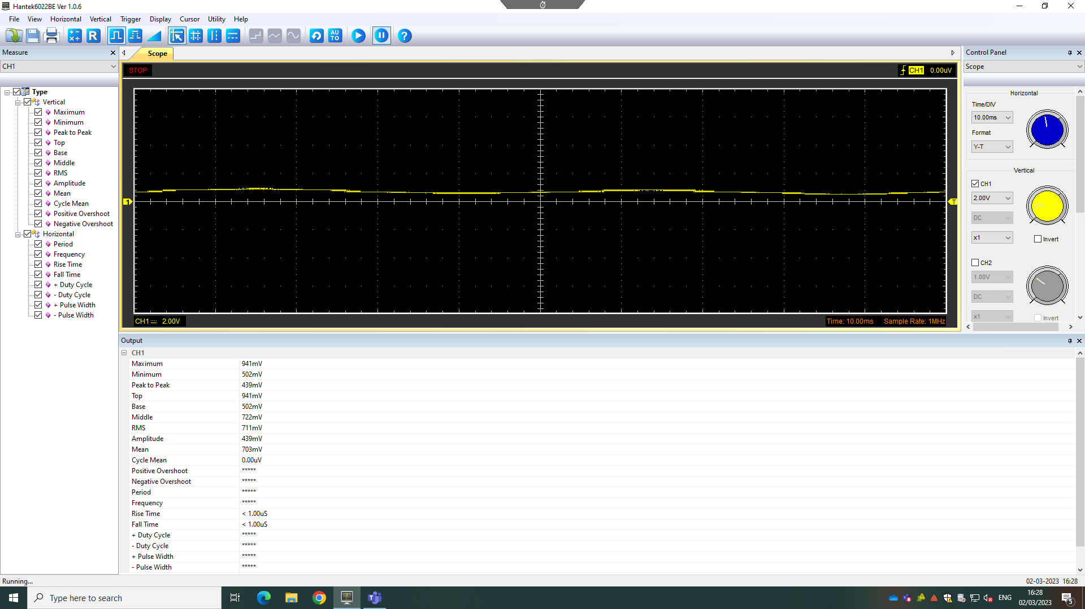
A rectifier is a “special type of diode that converts alternating current (AC) into direct current (DC)” allowing control of the current flow (Granath, E. – 2020). The type used was a ‘Full Bridge/Wave’ rectifier, converting the current from the function generator from alternating to pulsating direct current using the full signal, as opposed to a ‘Half-Bridge rectifier’ only allowing half of the AC signal to pass from input to output.
Peak to Peak: 439mV = 0.439V
Period: n/a
Frequency: n/a

Smoothed Rectifier Wave
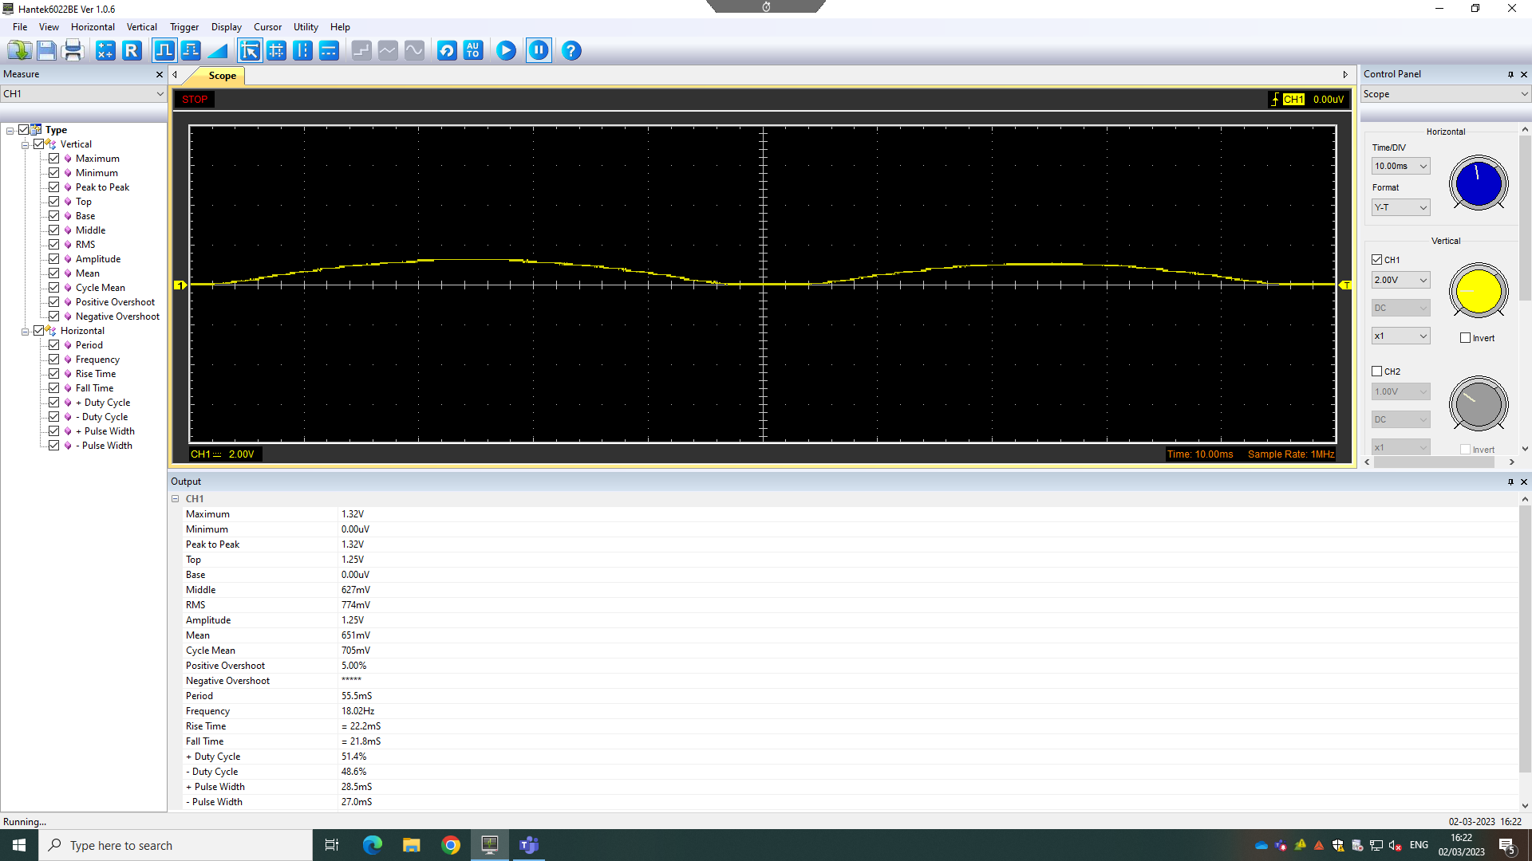
The rectifier wave was then smoothed enabling a more accurate visual representation of the pulsating DC over a complete cycle, including the second half. Full wave rectification is more efficient, and “enables better smoothing to be achieved” due to the decreased gaps between waveform peaks. Using full wave rectification creates basic waveform frequency double the amount of input frequency, due to the inclusion of the second half of the waveform, making the peak “occur at twice the frequency of the input” (electronics-notes.com – 2023).
Peak to Peak: 1.32V
Period: 55.5mS
Frequency: 18.02Hz

Drop in Voltage Question
Energy is dissipated throughout the circuit through heat and other factors, affecting the output whilst current is travelling through circuit featured components. There is a drop in voltage due also to the AC input measuring the RMS (root means squared). The potential barrier of the diode stops it from functioning until the voltage barrier has been overcome. In this case, if the input is 5V, and the voltage barrier is 0.6V, the output will measure 4.4V, despite capacitors charging to peak voltage.

Rectifiers use in Automotive applications Question.
Rectifiers are utilised when electricity is required to flow in one direction and blocking the flow in the opposite. An example of this used in an automotive environment is “the electricity flow from the alternator towards the rest of the vehicle electrical system”, where the AC current generated by the alternator’s pulley is converted to DC through use of a rectifier, due to the current control required in the electrical system as the “alternator’s polarity reverses per revolution” (Persistence Market Research – 2023).
A further example of rectifiers used in automotive environments is their use in Electric Motorsport applications. Formula E, following a “single-make chassis and battery format”, encourages competitor development in both software and hardware.
The cars need to be able to “switch the electric from AC to DC between motor and battery respectively”, using a rectifier (commonly referred to as an ‘inverter’) situated after the battery, to then power the motor that drives “the rear wheels through a reduction gearbox and differential”. Under braking, the rectifier switches, allowing the motor to generate electricity and “creating a drag on the drivetrain” to aid braking of the rear wheels. This electricity goes back to the battery, increasing the “remaining charge available to the driver through the race” (Scarborough, C. – 2020).

Probing Question
Using the experiment supplied HANTEK Oscilloscope and operating software, it should be noted that the oscilloscope features 2 inputs. This creates issue with simultaneously probing the input of the function generator alongside probing the rectifiers due to the oscilloscope’s ‘zero connection’ common to both channels. The lack of node, linking both input and output, disallows reading either feature at the same time, alongside running the risk of ‘grounding out’ the circuit, creating no readings whatsoever.
In future experiments, using a 1-1 isolating transformer on the measurement of the AC input, whilst connecting one side of the secondary probe to the negative of the output could allow for the measurement/reading of both. Alternatively, an ‘isolated input’ scope channel could be used to achieve the same.

Task 3

Scope Time Division Calculations
10.01 cycles per second = 10.01Hz
$f=\frac{1}{period}$ $period= \frac{1}{f}$
$period=\frac{1}{10.01}=0.0999=99.9mS$

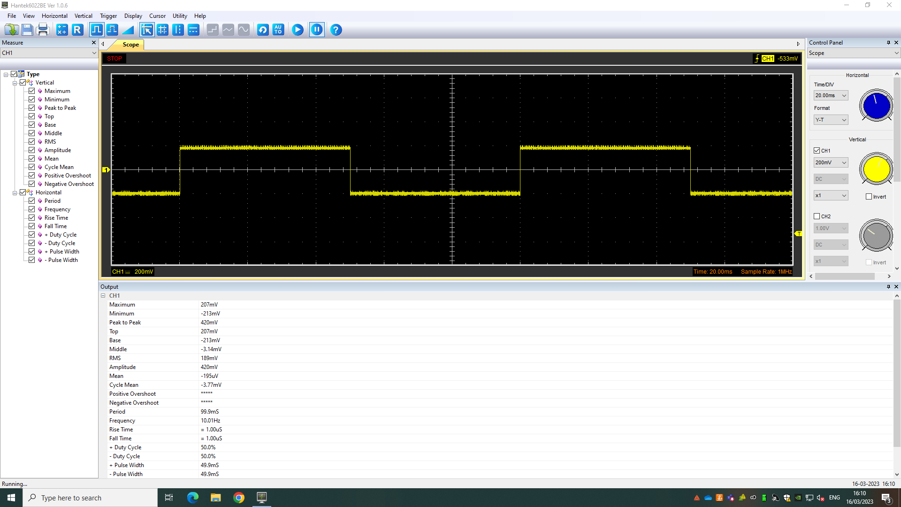
Function Generator output square wave
Peak to Peak: 420mV
Period: 99.9mS
Frequency: 10.01Hz

Capacitor charge and discharge wave marked at correct points.
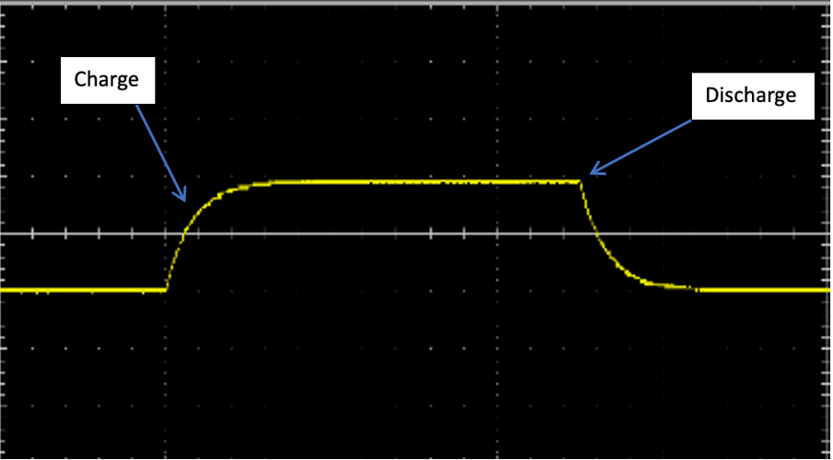

Basic Capacitor Calculations
Chosen Resistor $\left(Ω\right)=10R$
Capacitor $\left(F\right)=10μ$
Cap Marking $=106$
$f=\frac{1}{period}$ $period= \frac{1}{f}$ $\frac{1}{12T}≥f_{function generator}$
Frequency of function generator = 10Hz
$T=\left(R×C\right)=\left(10×10\right)=100$
$\frac{1}{12×100}=833.33×{10}^{-6}$
$\frac{1}{833.33×{10}^{-6}}=1200.0048$

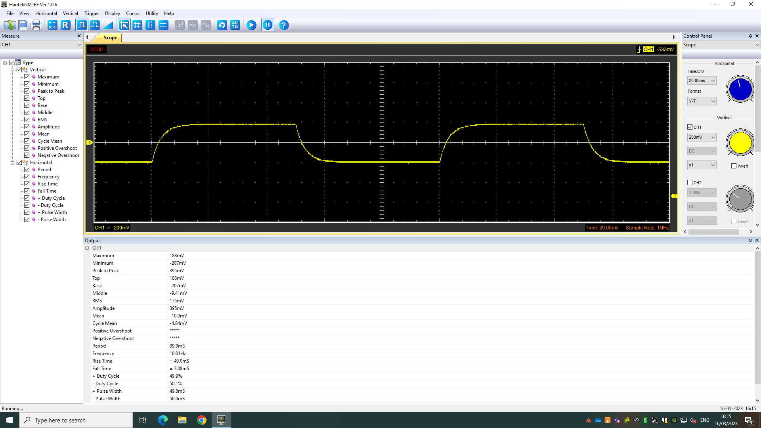
Capacitor discharge table
Peak to Peak: 395mV
Period: 99.9mS
Frequency: 10.01Hz

Gradient Plot and calculations

Inaccuracies Question
The true measurement could differ from that of the experiment-recorded, due to test inaccuracies.
These inaccuracies could be caused by faulty equipment; as they have been repeatedly accessed by students creating the same experiment. This could cause component damage/faults over excessive and repetitive use, altering the recorded results during the test. In addition to this, component degradation is also a factor that should be considered. Even without inflicted damage, the component’s repeated use can cause internal material degradation within things like the capacitor/resistors, showing outliers/inaccuracies in results.

References

Granath, E. – 2020.
What are diodes and rectifiers?
https://www.power-and-beyond.com/what-are-diodes-and-rectifiers-a-909411/
Accessed 29th March 2023.

Electronics-notes.com – 2023.
Signal Generators: Function Generator.
https://www.electronics-notes.com/articles/test-methods/signal-generators/function-generator.php
https://www.electronics-notes.com/articles/analogue_circuits/power-supply-electronics/capacitor-smoothing-circuits.php
Accessed 30th March 2023.

Persistencemarketresearch.com – 2023.
Automotive Rectifier Diode Market: Global Industry Analysis.
https://www.persistencemarketresearch.com/market-research/automotive-rectifier-diode-market.asp
Accessed 30th March 2023.

Scarborough, C. – 2020.
Carmagazine.co.uk: the Formula E powertrain explained.
https://www.carmagazine.co.uk/electric/formula-e-powertrain/
Accessed 30th March 2023.

