Effective Team Working and Communication

Name of the Student-Aisha Bibi
Student’s ID- 2122694
Module code-BMSW4002
Lecturer-Obinna Nkwocha
Assignment title-Effective team working for team success

Summary
Steve Brookes has recently been hired as Pelsall Hall Care Home manager in Birmingham, England. The care facility has experienced positive outcomes with a proactive team development approach. The staff at the facility, like many others, was committed and industrious. Still, Steve saw that they did not always appear to pull together, which led to misunderstandings and instances where employees did not necessarily have the whole picture when dealing with a problem. These conditions might influence the home's capacity to provide high-quality care services to its residents. Due to this dependence on each employee working together as an effective team to deliver better outcomes, Steve, the manager, is looking for solutions that would enable him to build a high-performance care home team.

Table of Contents
Introduction 3
Model of teamwork 3
Overview of Team working 3
Models of team development 4
The role of creating effective teams 6
Impact of effective teamwork on team success 8
Conclusion/Recommendation 11
Reference List 12

Introduction
Teams are commonplace in today's workplace, with employees collaborating to accomplish various objectives. Throughout our childhood, our parents and instructors use a variety of approaches to urge us to work as part of a team. Children learn the importance of teamwork from their parents, teachers, and other authority figures as early as possible, whether through sports, the classroom, or extracurricular activities. People's need to communicate persists as they move through life's phases. Everyday existence revolves around communication (Eisenberg et al., 2019). Communication is critical in a team setting, even if it is disregarded in other contexts. An official work group of people collaborating extensively to accomplish the same goal is called a team. To form a team, the members must display strong loyalty to one another to achieve a shared purpose. A team has a strong sense of camaraderie and a history of success. Two heads are generally better than one, to put it simply. In many ways, teamwork may improve our ability to communicate. Employee communication is enhanced when they work in groups. Working in a group requires coordinated effort based on words and deeds.

Model of teamwork

Overview of Team working.
A company's productivity and cost-efficiency may be increased by utilizing teams as essential building elements in its structure. In addition to driving change and innovation, high-performing teams give their members various benefits, including the chance to learn and grow as a team. To be a team, you must have individuals with complementary abilities who trust one another and are devoted to a single purpose, shared objectives, and the same strategy (Blackburn et al., 2019). Productive production, member satisfaction, and long-term commitment are requirements for a successful team. A company can construct effective units, hire the most influential leaders, and establish optimal communication channels using several methods.
An external challenge allows the Team to define a shared goal and build successful performance methods, such as the distribution of responsibilities and the proper communication channels for the Team to communicate with. Second, you should think about connecting rewards to team achievement. Team members learn to take responsibility for their productivity when supervisors use financial incentives to incentivize them. In the case of Nucor, employees are energized and driven to work more because of significant incentives. When recruiting new team members, managers need to ensure that they have the correct mix of technical, functional, and interpersonal abilities. As a team member, it is essential to prioritize some capabilities above others based on the level of competence or the nature of the social interactions necessary.

Models of team development
Tuckman’s Theory
Bruce Tuckman, a psychologist, for the first time discovered Tuckman's hypothesis in the year 1965. There were five stages of team growth that were mentioned in the article: forming, storming, norming and adjourning.
1. Forming
The first stage is to put together a team. However, the group has been given a task to complete while they get to know each other. Individualism is typical at this point, and it's a fascinating psychological phenomenon.
2. Storming
It's time to start storming after the early glee, and good cheer has worn off. Weighing and realism may have begun to sink in as the project nears completion.
3. Norming
In this phase, things tend to calm down a bit. Your group can establish a rhythm of cooperation in pursuit of a common objective (Chimruang and Yampinij, 2021).
4. Performing
It is possible to determine your rhythm at the performance stage. Team members can add to each other because they know each other's strengths and weaknesses.
5. Adjourning
Since the introduction of the fifth and final element in 1977, Tuckman's technique has continued to evolve. The Team will be dispersed as soon as the job is done.
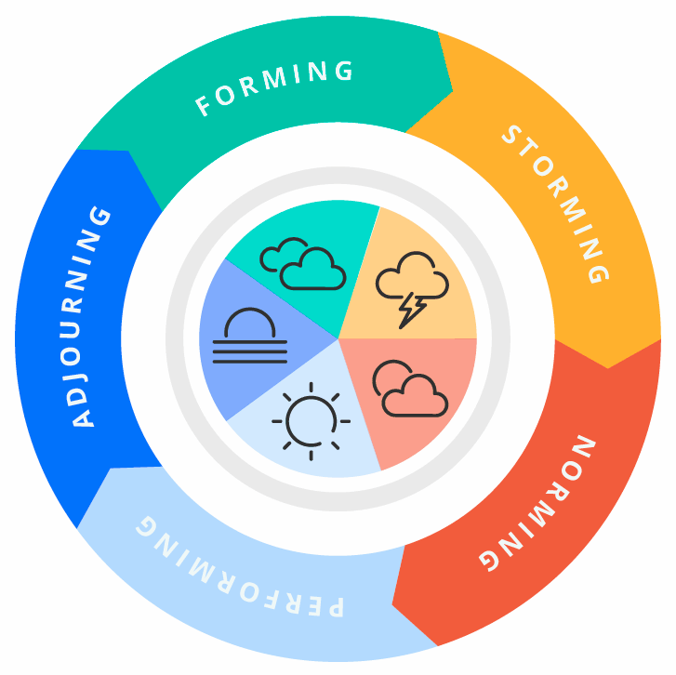
Figure 1- Tuckman’s Theory
Sources- (Chimruang and Yampinij, 2021)
The Lencioni Model
There is a lot of focus on what you should do while leading a team. The Lencioni model turns this typical method on its head, which details the traps that successful teams must avoid. The Five Dysfunctions of a Team. According to Lencioni, these five reasons can all contribute to a team's demise:
Absence of trust: Team members don't trust each other to be open, honest, and vulnerable with them.
Fear of conflict: Team members keep their mouths shut because they don't want to upset the status quo (Clutterbuck, 2019).
Lack of commitment: Participants aren't committed to the Team's mission or their collective effort as a team.
Avoidance of accountability: The team members do not acknowledge, respect, or appreciate each other's contributions to the group.
Inattention to results: Team members lose sight of what they're trying to accomplish as a group.
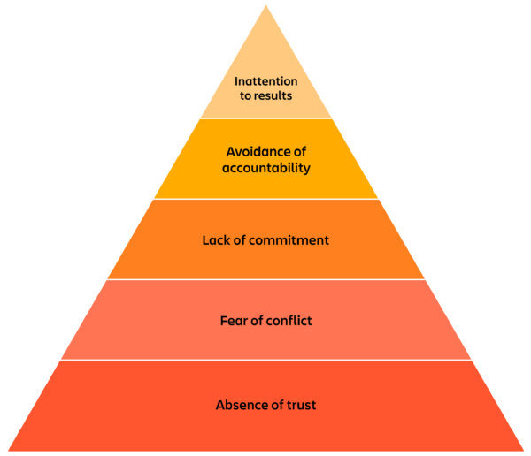
Figure 2- The Lencioni Model
Sources- (Pane et al., 2018)

The role of creating effective teams
Roles are needed to create a cohesive and effective team
When attempting to increase team cohesion at work, take into account the following steps:
1. Encourage communication
Open communication plays a vital role in a successful collaboration. Use proper communication techniques if you would like a team to be more cohesive. Online messaging services and software for online meetings like zoom and team meetings are two ways of communication platforms which encourage team involvement.
2. Practice team-building activities
The Team must accomplish the connections supporting those objectives (Aranzabal et al., 2022). The Team's success is aided by team-building exercises that increase members' self-worth and general morale and encourage them to build links with each other.
3. Structure goals
Team members will clearly understand their duties and responsibilities if the plans are laid out in an easy-to-follow manner. A typical way to organize goals is to create a goal pyramid that sets each group of objectives in ascending order of importance. For example, you can make individual plans for the company, the Team, and the person.
Belbin’s Team roles
Belbin claims that a team with members whom all share the same style of conduct or position might become imbalanced. Teams with comparable talents, for example, could vie for tasks and responsibilities that complement one other's inherent abilities. A group with similar limitations can demonstrate that weakness as a whole.
The nine jobs in the Belbin team are divided into three general categories: roles that focus on ideas, parts that focus on action, and features that focus on people. “Understanding the many roles each member of your Team may perform will help you function more effectively as a team:
- Monitor Evaluator (thought-oriented)
- Specialist (TO)
- Plant (TO)
- Shaper (action-oriented)
- Implementer (AO)
- Completer/Finisher (AO)
- Coordinator (people-oriented)
- Team Worker (PO)
- Resource Investigator (PO)
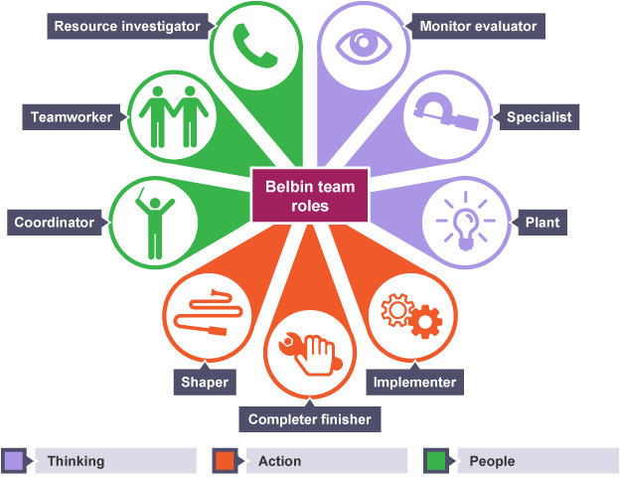
Figure 3- Belbin’s Team roles
Sources- (Rahmani et al., 2021)
Importance
Many distinct personalities are needed to make up a successful team. Team responsibilities can be assigned based on an employee's skills and shortcomings, which helps build a good team because employees work better when assigned tasks that utilize their talents.” With the aid of the Belbin Team Inventory exam, you may determine the motivations and objectives of team members.

Impact of effective teamwork on team success
Advantages of having an effective team
"teamwork" refers to the practice of two or more individuals working together toward a common goal. Everything, from a professional assignment to marriage to locating the fitting movie theatre instructions, may be stressful. For those around them, it's about helping others achieve by exchanging knowledge and skills. Individuals will feel excluded even though the work is still collaborative if there aren't any chances to present these alternatives.
Promoting Unity
One advantage of cooperation is that it promotes togetherness in the workplace. People from a variety of different departments work together on several cross-functional teams. Many teams also contain people with varying levels of seniority and power, which may occur even when there isn't a formal hierarchy. As a result of such collaboration, an organization's members may work together more successfully on future initiatives and foster a sense of belonging.
Teams create brainstorming opportunities.
When people are given a chance to collaborate, they can come at issues with a project or assignment from various angles. New ideas can be generated through collaborating with others who bring a variety of backgrounds, views, and viewpoints to the table. In the event of a problem, this advantage makes it easier to determine the appropriate course of action to ensure the best potential outcome.
Promoting Diverse Thinking
Insight and innovation are often fostered by teams that draw on diverse skills, experience, and cultural perspectives. The Team's diverse backgrounds and experiences can lead to new ideas and cutting-edge solutions that would not have been conceivable without them.
More Work in Less Time
A team of five people working together is more efficient than five people working alone, which is why many firms employ them.
Barriers to teamwork in the case study
Loss of Efficiency
In addition, many firms have discovered that teams do not always perform as well as expected. The decision-making process within a group can often be so slow that immediate action isn't taken. On the other hand, several teams of Pelsall Hall Care Home fall into the trap of over-planning and under-executing their plans.
Lack of Effective Communication
Sometimes it's challenging to communicate effectively with other team members. Inexperienced teams may be more susceptible to this phenomenon. Due to misinterpretations of tasks, general objectives, and feedback given to groups, the results of their labour often diverge significantly from the original intentions of those involved.
Personality Conflict
While bringing together personnel from different departments and viewpoints might help foster a sense of unity, it can also lead to a decrease in morale and impede a team's ability to carry out its assigned work at Pelsall Hall Care Home.
Teams can divide labour unequally in some situations.
It is possible to increase productivity significantly if each employee can focus on tasks most relevant to the abilities of Pelsall Hall Care Home (Ravindran et al., 2020. Unequal labour allocation within a team might give the impression that the person performing more work is being treated on an equal footing with that person who is putting in less effort. When only a few people handle all of the tasks, the Team's sense of purpose and cohesiveness may be compromised if everyone gets equal credit for their work.
The Culture Code – by Coyle (2018)
Coyle (2018) find out successful groups' secrets and explained how these can be developed into effective teams.
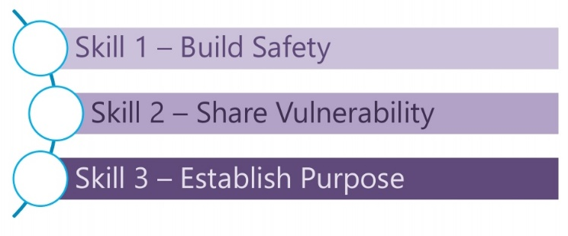
Skill 1 – Build Safety
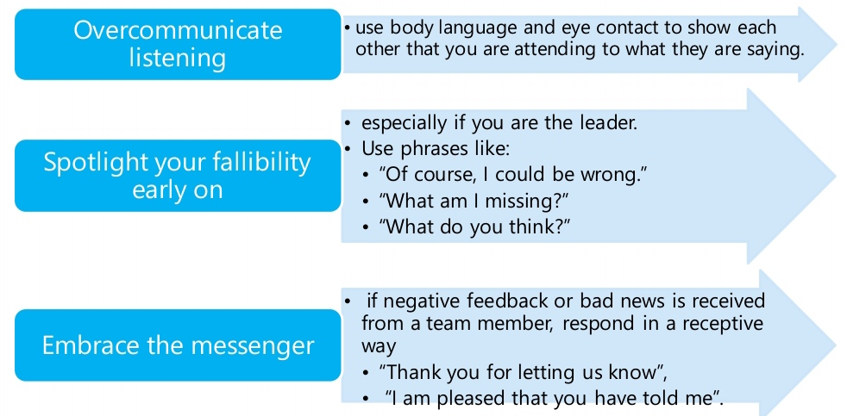
Skill 2 – Share Vulnerability
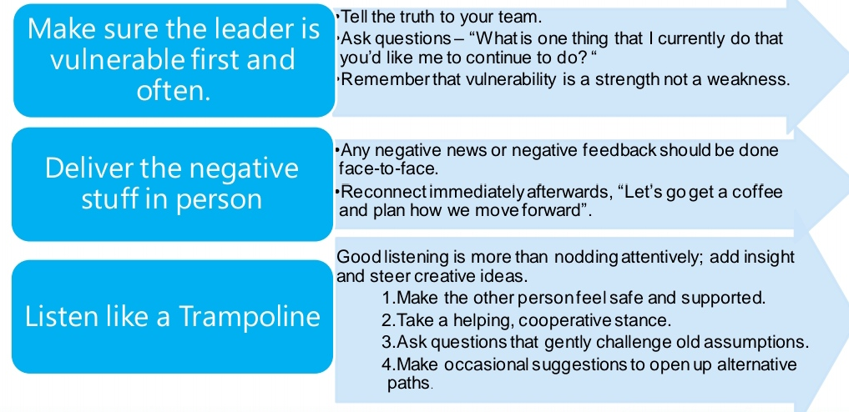
Skill 3 – Establish Purpose
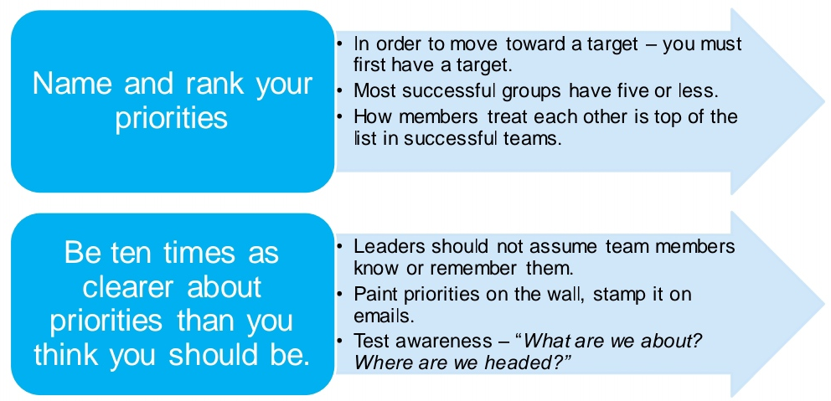

Conclusion/Recommendation
According to the research conducted at Pelsall Hall Care Home, most people would communicate vocally rather than in writing. Talking is more effective communication than writing, typing, rewriting, copying, or spreading it around since none of those things is required. Oral communication, whether it be business-related or personal, does have some drawbacks, and this is a fact that cannot be denied. When compared to the written word, the potential to make changes to anything that has been verbally communicated is far more limited. Effective communication at all levels of an organization, from the lowest to the highest, makes it easier for a business to react rapidly to events that were not foreseen.
On the other side, the purpose of informal communication is to cultivate employee loyalty and improve employees' professional and personal ties with the organization. In most businesses, unofficial communication channels are far more prevalent than the official chain of command. Telephone conversations, email queries, and even social gatherings, to provide just a few examples, can be either formal or informal, depending on how the sender of the communication handles it and the message that it conveys.

Reference List
Aranzabal, A., Epelde, E. and Artetxe, M., 2022. Team formation based on Belbin's roles enhances students' performance in project-based learning. Education for Chemical Engineers, 38, pp.22-37.
Blackburn, J., Ousey, K. and Goodwin, E., 2019. Information and communication in the emergency department. International emergency nursing, 42, pp.30-35.
Chimruang, S. and Yampinij, S., 2021. Constructionist learning using teamwork and social networks for information-technology students in higher education. Journal of Management Information and Decision Sciences, 24, pp.1-9.
Clutterbuck, D., 2019. Towards a pragmatic model of team function and dysfunction. The practitioner’s handbook of team coaching (pp. 150-160). Routledge.
Eisenberg, J., Post, C. and DiTomaso, N., 2019. Team dispersion and performance: The role of team communication and transformational leadership. Small-Group Research, 50(3), pp.348-380.
Pane, M.M., Siregar, C., Ruman, Y.S. and Rumeser, J.A., 2018, May. The Application of the Lencioni Model in Online Learning: A Case Study in Higher Education. In Proceedings of the 2018 International Conference on Distance Education and Learning (pp. 49-53).
Rahmani, F., Scott-Young, C., Tadayon, A. and van der Walt, J.D., 2021. Team composition in relational contracting (RC) in large infrastructure projects: a Belbin’s team roles model approach. Engineering, Construction and Architectural Management.
Ravindran, S., Matharoo, M., Coleman, M., Marshall, S., Healey, C., Penman, I. and Thomas-Gibson, S., 2020. Teamworking in endoscopy: a human factors toolkit for the COVID-19 era. Endoscopy, 52(10), pp.879-883.

