Introduction:
A problem is a gap between the existing and the expected, it is a difficulty that must be resolved. To establish the solution for a particular problem, we must follow the process of problem-solving and decision-making, where that two methods go hand in hand.
“Problem solving is a process in which we perceive and resolve a gap between a present situation and a desired goal, with the path to the goal blocked by known or unknown obstacle.”
(Huitt W., 1992, p.33)
“Decision making is a selection process where one of two or more possible solutions is chosen to reach a desired goal.”
(Huitt W., 1992, p.34)
This report discusses TM Lewin's case study where the main company's problem is profit decline. By applying the process and logic of problem-solving and decision-making (Figure 1), are defined the potential causes and their impact on the problem, and also are determined possible solutions, which could contribute to the problem being solved.

Figure 1. Process of problem solving and decision making
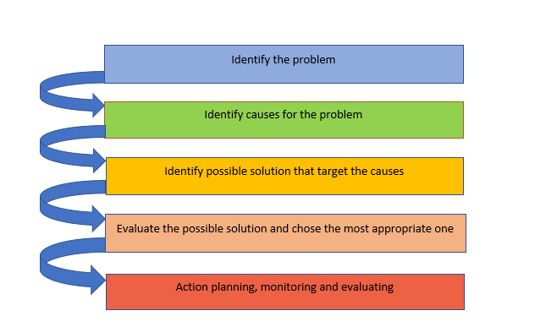

- Nature of the problem
"Identifying the problem means describing as precisely as possible the gap between one's perception of present circumstances and what one would like to happen.”
(Huitt, 1992, p.37)
“The COVID-19 epidemic has affected global markets because of government restrictions on social life and economic activities “(Koch et al., 2020). In addition, supply chain issues, and in addition, increasing inflation rate, lead to massive economic jolts in the retail business, and simultaneously prognosticate another difficult year for them.
This particularly affects retailers of non-essential goods, as many major sellers collapse and go into administration and numerous businesses go to bankruptcy (according to the Guardian, 1400 firms only in September).
TM Lewin is one of the most affected companies by the created economic situation, and although it is a long-standing branded manufacturer of British-styled clothing (120 years old business), it also faces a lot of challenges the main being declining profitability.

- Scope and Impact of the problem
The pandemic influences all aspects of life and businesses, but one of the most affected sectors is the fashion retail industry. According to the Office for National Statistics, the sales of clothes slump 25% (the biggest drop in 23 years, when records began) and because of the financial difficulty, numerous clothes retailers, even the top ones, such as Debenhams, Edinburgh Woollen Mill, go into an insolvency process.
TM Lewin is one of the biggest retail losers, which is affected by the government guidance to work from home, restriction of events, and all non-essential stores to be closed. Social distancing and other imposed rules on retailers, such as a limited number of consumers in stores and not being allowed to try the clothes, complicate the distressful situation, and the company should find a way to mollify their influence.
The decline in sales and profitability of the company is a long-term problem because although the previous reconstructions in TM Lewin, the company goes two times in administration and insolvency process for the last two years. Moreover, they are forced to close all 66 of their physical stores, which result in 600 job losses, and another part of the employees with reduced work schedules.
- Analysis of the organization and problem
The next step of the problem-solving and decision-making process is to explore what has caused a decline in the profitability of TM Lewin, and for this purpose are used the framework PESTEL and Fishbone diagram.
  - PESTEL analysis
"PESTEL analysis, as it stands, mainly provides general idea about the macro environmental conditions and situation of a company” (Yüksel, 2012, p.52). Seiyawati (2021, p.569) states, that PESTEL “is used to measure the value of competitive forces” and “determine opportunity and threats”, which are often external.
Figure 2. PESTEL analysis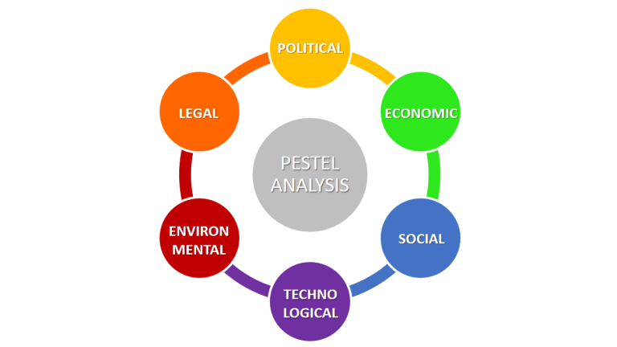
Source: https://www.business-to-you.com/scanning-the-environment-pestel-analysis/)

Applying PESTEL (Figure 2), are identified the following external factors, that have an impact on profit declining in TM Lewin:
- Political factors:
- Government policy (COVID) - “This pandemic has altered people's lives and wreaked havoc on the global economy.” (Roggeveen & Sethuraman, 2020, p.169), as considerably more impacted by government Covid restrictions, is a retail business.

“Retailers of non-essential goods, such as apparel and footwear, are facing a significant drop in sales and are having to adopt new ways to reach and engage customers”.
(Roggeveen & Sethuraman, 2020, p.169)

- Foreign trade policy - TM Lewin manufacture is positioned in the EU, and the higher border taxes and tariffs after Brexit lead to an increase in company expenses.

- Economic factors:
- Inflation rate - inflation leads to a cost-of-living squeeze but on the other hand, the production costs increase, and to make some profit the company should increase prices. Aryani & Maupula (2021) note that “when inflation is high, the price of goods increases, influencing the company's profit”.
- Reduced disposable income – “a lower disposable income would mean lower expenditures” (Horáková, 2015), and that reflects in decreasing sales of TM Lewin. Ciobanu et al. (2021) state that “People have reduced the share of expenditures for clothing and footwear; while the share of food expenditures has increased for them.”
- Unemployment rate – it results in decreasing income, reducing in purchasing power of consumers, declining demand, and therefore reducing sales.

- Sosial factors:
- Lifestyle attitude – "the pandemic affected the thinking, lifestyle, and behaviour of each individual through their experiences with the COVID-19 virus” (Kita et al., 2022, p.76); due to living styles changes and spending habits, “during this pandemic period, people have been more inclined towards buying necessary household items rather than engaging into impulse and fad buying” (Chakraborty, 2023).
  - Fishbone diagram
To solve any problem, the main(root) cause of the issue needs to be defined, targeted and addressed, and for that purpose additionally to PESTEL analysis, is used the Fishbone (Ishikawa) diagram.
“Fishbone diagram (the shape is similar to a fish skeleton) is a common tool used for a cause-and-effect analysis to identify a complex interplay of causes for a specific problem or event.”
(Coccia, 2018)
Figure 3. Fishbone diagram (Ishikawa diagram)
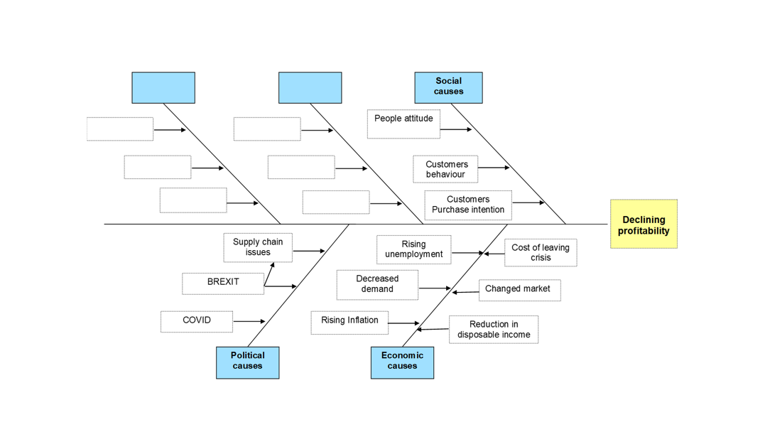
By applying the Fishbone diagram, are determined the underlying causes that could lead to declining profitability in TM Lewin, and are sorted into three categories: (Figure 3)
- Political causes:
- COVID restriction - work from home, the shutdown of non-essential shops, restriction for events, consumers do not need formal wear
- BREXIT - higher taxes and border tariffs
- Supply chain issues - port congestions and untimely deliveries due to the employment gap in the haulage industry

- Economic causes:
- Rising inflation - the highest in The UK for the last 30 years
- Decreased demand - 25% decline in sales of clothes
- Rising unemployment - decreased purchasing power due to reduced level of income
- Cost of leaving crisis the cost of essentials increases faster than household income, they reduce their spending, and fashion and clothing do not at the top of the priority list
- Changed market - due to closed physical stores and increased health care, customers are turning to online shopping
- Reduction in disposable income - according to the Office for National Statistics because of the drops in income, “UK households reduced their spending during the coronavirus (COVID-19) pandemic by an average of £109.10 (or 19%) a week”.
- Social causes:
- People attitude - shirts are defined as “non-essential things”
“Clothing consumption is discretionary, and consumers cut or postpone spending on clothing to reserve resources and gain control in an uncertain time.” (Liu et al., 2021, p.327)

- Customers behaviour - rising conscious consumption with preferences for more sustainable goods, with less loyalty to brands, and with an ever-increasing focus on health.
“Consumers simply cut down spending on fashion clothing and started recycling whatever was in the wardrobe to avoid going to stores and trying on clothes.” (Liu et al., 2021, p.324)

- Customer purchase intention - “Furthermore, when a crisis occurs, consumers did not want to spend money on high-quality or high-value products even when they could afford such items.”(Ferrell &Hartline, 2002)

By applying PESTEL analysis and Fishbone diagram, are defined three main(root) causes that could contribute to declining profitability in TM Lewin:
- COVID restriction
- Rising inflation
- Consumers behaviour
- Alternative solutions:
According to Huitt (1992),” brainstorming is an excellent technique to begin the problem-solving process” and come up with a possible solution to a particular problem. In consideration of the identified factors and potential causes that have an impact on the profitability decline in TM Lewin, are defined the following possible solutions:

- Selling the business of TM Lewin – this solution is applicable because it is directed to one of the main causes of the problem (Covid) - the company is deeply affected by Covid restrictions and although it is reconstructed as a principally online brand, fails to recover after the pandemic. This solution will help TM Lewin stop losing a lot of money, it could be able to complete payments to its lenders and may rescue the long-state brand.

- Repositioning as an online-only company (with a new strategy)– this solution is very relevant because it addresses one of the main causes of the problem (consumer behaviour). People no longer want to go into the shops because they prefer to buy clothes online, and additionally, they do not need formal wear because their lifestyle is changed (they must stay at home and work from home). The solution could help to increase TM Lewin's profit, but they must find a new way to attract online customers.
- Evaluation of alternatives:
In this step of the problem-solving and decision-making process, using GRID analysis, are evaluated the defined possible solutions. Using GRID, as a decision-making tool is preferable when making a choice between more than one solution, and key factors (criteria definition), that influence the problem and are important for the decision, need to be taken into consideration. As related to the problem of TM Lewin are chosen the following factors:
- Cost of implementation
- Implementation time
- Expertise
- Uncertainly and risk

Figure 4. GRID analysis
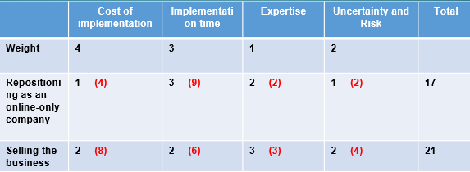
Based on the GRID analysis made, selling the business is the most appropriate solution to TM Lewin’s problem.

- Plan for implementing the solution, monitoring and evaluation:

Planning is a process of selecting a course of action, it “is the ability to control the future by current acts” and “the more consequences we control, the more we have succeeded in planning”. (Wildavsky,1973, p.128)

  - Action planning
Action  (What?) | Description  (How?) | Timeframe  (When?) | Staff responsible  (Who?)
Finding a sales expert | Enlisting the trusted expert who will help the company through the sales process | 20/11/2022-  23/11/2022 | Corporate finance adviser
Valuation of the business | Speaking to a professional adviser about how the company's value could be increased | 24/11/2022-  31/11/2022 | Business sales adviser
Preparation for sale | Doing an information memorandum and attracting potential buyers | 1/12/2022-  10/12/2022 | Corporate finance adviser
Marketing | Finding referral partners that may be engaged with potential purchasers | 11/12/2022-  20/12/2022 | Corporate finance adviser
Selection | Choosing the most appropriate buyer for the company( or the best offer) | 21/12/2022-  25/12/2022 | Corporate finance adviser
Negotiation | Agreement to terms and completing required documentation | 26/12/2022-  06/01/2023 | Corporate lawyer

  - Monitoring

Monitoring is a process between planning and evaluating and it is the collection and analysis of information during the process being monitored.
“Formal systems to measure and monitor results are essential to guide and assess implementation” (Bisbe & Barrubes, 2012, p.919)., and help to identify and correct the potential problems during the process, in order to increase the efficiency of the process and achieving maximum results.
Action | Description | Timeframe | Staff
Marketing | Checking that used marketing channels are relevant and make the business more attractive for buyers | Daily | Marketing adviser
Competition | Checking for the presence of more potential buyers, that meet the requirements, to aim for a better deal | Daily | Marketing adviser
Schedule | Ensuring all steps of the selling go within the established deadlines | Daily | Sales advisor
Finance | Verifying the financial ability of the potential buyers (Finance check) | Weekly | Corporate finance adviser
Negotiation | Ensuring that negotiations are aimed at securing a satisfactory price and acceptable terms | Every other day | Sales adviser

  - Evaluation
“KPIs are quantifiable metrics which reflect the performance of an organization in achieving its goals and objectives.” (Bauer, 2004, p.63) and they indicate how successful an organization is in terms of achieving its outcomes, how well it has performed.
KPI | Description of KPI | Timeframe | Staff responsible
The best possible deal for TM Lewin | The profit of the sale allows the company to deal with its insolvency and keep its trademark | Daily | Sales adviser

- Conclusion
The purpose of this report was to explain the main steps and the logic of the problem-solving and decision-making process. Based on TM Lewin's case study, we went through all stages of this process, as at the beginning identified TM Lewin’s problem, its scope, and its impact on the company and its employees. By using the framework PESTEL and Fishbone (Ishikawa) diagram we defined the external factors and possible causes, and their impact on the company’s problem. The alternative solutions to the problem were evaluated by GRID analysis, and the most appropriate solution was chosen. The report was completed with a plan for the implementation and monitoring of the chosen solution.

