

Sustainable Hospitality & Tourism Management (BMIH 5006)

Report: Destination Management: WWT London Wetland Centre

Lecturer Name: Dr Huw Thomas
Student Name: Ramona Mihaela Deca (2022132)

Table of Contents
Introduction 3
About the destination 3
Principles of sustainable tourism 3
Three pillars of sustainability 5
The extent to which general principles are closely associated with the general principles of development 8
General principles of development 8
Evaluation of connection between principles of sustainable tourism with the generable principles of development 9
Conclusion 10
References 11

Introduction
The development of tourism and hospitality entails the growth of the organization in terms of its earnings and resources development process. In the tourism and hospitality sector, growth and development are attained with effective sustainability in the tourism organization. Proper utilization of the sustainable principles for the tourism organization means to balance the economic, social, and environmental issues properly with the improvement of the community (Jones and Allen, 2016). The development of sustainability relates all the aspects with proper equilibrium. In this report, the management of destination has been demonstrated with application of sustainability in the destination. The destination management of WWT London Wetland Centre has been selected as its destination in this report.

About the destination
The destination WWT London Wetland Centre is a natural sight in Greater London located at the London Borough of Richmond upon Thames, southwest London, England. It consists of a wetland reserve which is managed by Wildfowl and Wetlands Trust. The destination was first opened in 2000 with more than 100 acres consisting of several small reservoirs. Before starting, the reservoir has been turned into a wide range of wetland. It was the first urban project of its kind. The wildlife is protected at the reservoir like many birds can now make their living here in this land.

Principles of sustainable tourism
The term sustainable tourism is a process of improving the tourism experience with the development of economic, social, and environmental solutions seeking for best match with the tourism experience. According to Sharpley and Telfer (2015), sustainability in tourism is a concept that deals with the issues in environment, economy and society along with giving the tourists proper satisfaction with the service making them excited for the tourists. It is a new concept that is developed to align the environmental development and reduction of pollution in the atmosphere (Awomeso, 2010).
The use of tourism and its sustainability has been demonstrated using Butler's (1980) Tourism Area Life Cycle (TALC). This model gives an explanation of the development of destination with six major practicable stages. The stages can be presented with the use of graph below:
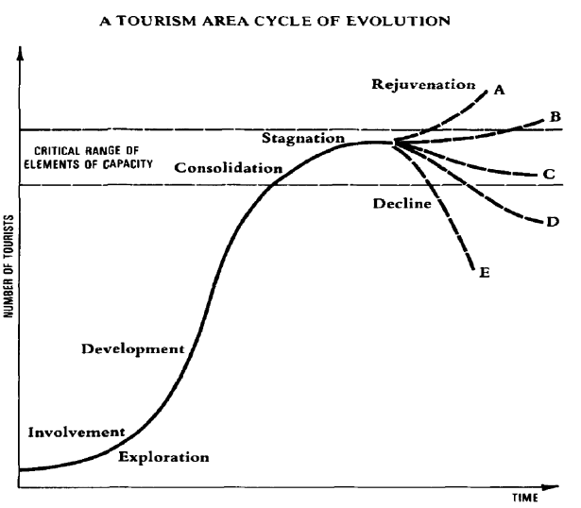
Among all these the destination WWT London Wetland Centre went through its life cycle and is currently staying at the stagnation stage where it still running with attraction of the tourists and travelers. Mostly nature-loving people attracted to this destination.
The practice of sustainability is crucial for this generation since global warming has emerged in its extreme form that can be harmful for the future generation. Sustainability in tourism and other sectors can prevent such warming through pollution and toxic things in the planet. The destination WWT London Wetland Centre was introduced with the motive to attain such sustainability in the tourism sector. This destination is a perfect example of involving in sustainability since it is involved in such activities that foster the organizational needs with environmental balance and maintenance along with maintaining social and economic balance. The motive is to reduce pollution rather use the natural resources in a way that reduce the pollution as well as reduce the use of artificial things that are harmful for nature for example the use of plastic in the wetland is prohibited.

Three pillars of sustainability
Setting the principles of sustainability can relate to three main pillars of sustainability. The basic pillars and their factors are presented with the graph below:
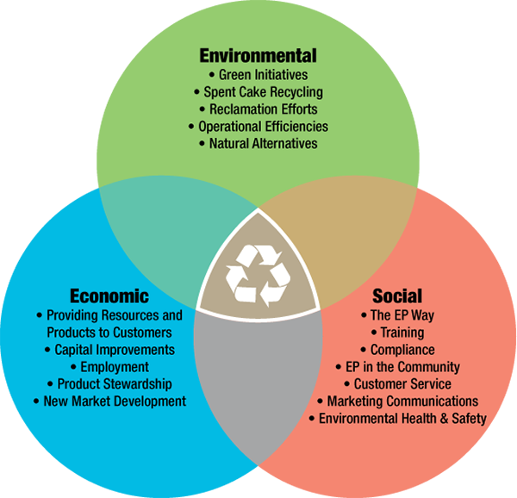
Environmental sustainability
The first pillar is environmental sustainability which suggests the development of environmental pollution and damage. With the name it can be understood that the environmental balance is greatly maintained with environmental sustainability. The development of sustainability requires the following principles for most organizations.
- Stating the model of travel: Travelling with private jet or other air ways create more carbon footprint on the atmosphere. The damage to the environment is greater while people fly from one place to other. The principle of travelling media states that the people should use the public transport which emits less carbon consumption on average (Bricker, Black and Cottrell, 2013). While every people would have their own transport, the consumption of the energy along with the emission of toxic from the use of such vehicles will be more. With this moto the destination managed under some circumstances to motivate the travellers are tourists at the destination about the maintenance of natural resources. They are motivated not to waste any resource, rather visit the destination with care.
- Managing the waste properly: The waste is the main reason for pollution. The organizations involved in tourism and hospitality produces much waste from their service, but not all the organizations are aware how they are dumping their waste in the atmosphere and polluting them (Chakraborty, 2010). This principle calls for managing the waste produced from service in a way that is recycled properly without hampering the natural atmosphere. In the destination there are staffs and volunteer who look after the management of waste. The disposal and waste are recycled in a way that produces zero carbon or toxic to the nature.
- Caring the animal lives: All lives matter in sustainability whether they are wild or ferocious. Every animal is part of the environmental ecosystem. The animals in the way of tourism should be cared properly in a way that no travelling should cause any harm to animal lives (Durbar, 2015). In the destination WWT London Wetland Centre the travelling guide is provided in a way that presents the animal as an important part of nature. The destination uses animals for amusing the travellers so that the travellers are demotivated to kill or make harm to such animals.
Social sustainability
Social sustainability is a process of combining the social elements properly in terms of using them to guide forming efficient society. The framework of society is created with the investment in social elements to accommodate a larger view of the world. The development of the social relationship among communities to create effective collaboration would foster globalized and standard culture. The adoption of the culture is suggested by the social and cultural development (Abakerli, 2001). The social sustainability can be attained with the utilization of varied factors presented in the graph below:
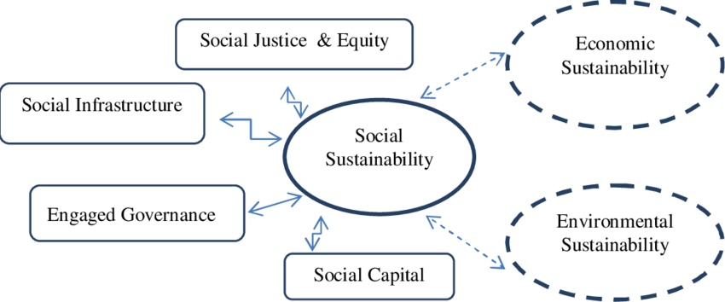
Sustainability through social balance can be attained with proper diversification of culture. The standard and diversified culture in the local area can attain higher value in terms of the tourism sector. For the destination WWT London Wetland Centre the involvement of the social sustainability works with the development of the social values among the people travel in this destination. The social principles that are promoted by the destination are as follows:
Equality and diversity: Equality and diversity is a measure of society which entails that every human being should be treated equally and they should be provided with similar opportunities in terms of developing their living standard. The tourism destination WWT London Wetland Centre depicts such development in terms of the development of the local community. The travelers and staff of the organization are related with the development of social balance and equality.
Standard culture: Standard culture is another sustainability to bring equilibrium to different social elements. Standard culture is promoted where adaptability of change is high for the people (Briassoulis, 2002). The beliefs of culture which welcome every person in society from any background is known as standard culture. Proper standard of culture is promoted by managing the destination to raise awareness among local people.
Respecting local people and culture: There are incidents where it shows that the tourists do not respect the local people and their culture. Sustainability in tourism brings proper respect to local people and their norms and values. The motive of this principle is that no one should disrespect any norms or people in any local area.
Improvement of local community: the improvement of the local community is attained with higher effectiveness of the involvement of the people (Forstner, 2004). In the consideration of the organizational balance the local people contribute an effective role where the local community by the organization should be given priority in terms of customer service as well as employing people for service.
Economic sustainability
The term economic sustainability is the way of improving the standard of living and resources allocation. The maintenance of the balance of economy with limited damage to environment is the main motive of sustainable economy. There are several conflicts about sustainable economy such that production in factory creates pollution in the atmosphere, but if the production is stopped the economy will fall down (Chouinard, Ellison and Ridgeway, 2016). So effective ways of economic production are employed which produce less damage to the environment as well as maintain profitability of the organizations within the economy.
The growth and development of the economy is not with quality but also with quantity where the reduction of the economic waste is reduced rather than utilizing the natural resources and processes to involve more people in production. The company attains the activities through efficient tolerance to the economic profit by the company but focuses more on the living standard of the people and their expectations. The development of the environmental balance is managed with the consideration of the economic balance of the destination.

The extent to which general principles are closely associated with the general principles of development

General principles of development
Bringing change: A change to the organization, its process and structure can foster development and growth for an organization promptly.
Technological development: The technologies are bringing rapid changes to organizations or nations which are also responsible for the development of the organization and the nation. The research and utilization of technological research can help attain faster growth (Hardy and Beeton, 2001).
Respect: Proper respect for the people and progress are to be derived by an organization or community to develop their status. The norms and values are used for developing the actualization with experience and making the growth and development to the organization or nation.
Collaboration: collaboration among people, team or organization helps in attaining better outcomes of performance. Proper collaboration also creates effective guidance to each other for effective performance (Hardy, Beeton and Pearson, 2002).
Empowerment: Empowerment of the people who deserve better positions can make the people believe in their contribution. This helps in better performance contributed by the people involved in the nation building and organizational development.
Self-awareness: Awareness among the people can help them to develop in terms of their contribution to the organization or the nation they are linked to.

Evaluation of connection between principles of sustainable tourism with the generable principles of development
The connection between the principles of sustainable tourism and general development principles can be identical in some portions. The development is similar way presented in the sustainability, rather the sustainable development focuses more on the environmental factors rather than earning profit from the consideration of the organizational development (Hewlett, Moffitt and Marshall, 2016).

From the graph, a balance in the different elements of society, economy and environment is focused on sustainable tourism. All these principles focus on the development of individual or organizational growth in the sector in which they are involved.
There are some common measurement and identical factors that are associated with the general development principles including:
Economic growth: The sustainable economic growth motives the development of the economic factors including the growth and development of living standard. Economic growth has potential for general development (Liu, 2003). Development requires growth of economy so that the economic resources are used to attain development goals.
Utilization of the resources: The use of the resources for development is attained with economic development. The utilization of the resources in the economy is processed with the use of resources within the economy.
Generating less waste: Both the sustainable and general development principle attains better management of waste which is believed to be profitable with less waste generation rather than using them properly (Ruhanen, 2008).
Equality and diversity: Equality and diversity are the common terms that are followed in both sustainable development as well as the general principles of development. The development of the process takes place by ensuring every person participates in the process of development and contributes to the organization or nation.
Improvement of local community: The local community provides both the customers and staff for production (Serafeim, 2016). The improvement of local community develops the idea of sustainability along with the growth potentiality of the organization or community.

Conclusion
The involvement in sustainable development in the modern world has turned out to be a common requirement for organizations since the maintenance of environmental balance is a major requirement in this era of global warming. The tourism and hospitality sector can attain proper contribution to the maintenance of sustainability through sustainable development principles. In this report the principles of sustainable development and the attainment of the organizational process have been fostered using examples about the destination WWT London Wetland Centre.

References
Abakerli, S., 2001. A critique of development and conservation policies in environmentally sensitive regions in Brazil. Geoforum, 32(4), pp.551-565.
Awomeso, 2010. Waste Disposal and Pollution Management in Urban Areas: A Workable Remedy for the Environment in Developing Countries. American Journal of Environmental Sciences, 6(1), pp.26-32.
Briassoulis, H., 2002. Sustainable tourism and the question of the commons. Annals of Tourism Research, 29(4), pp.1065-1085.
Bricker, K., Black, R. and Cottrell, S., 2013. Sustainable tourism & the millennium development goals. 1st ed. Burlington, MA: Jones & Bartlett Learning, pp.3-10.
Chakraborty, S., 2010. Sustainable and Value Based Tourism in Nepal – Travel Writer’s Perspective. International Journal of Hospitality & Tourism Systems, 3(1), pp.1-8.
Chouinard, Y., Ellison, J. and Ridgeway, R., 2016. The Sustainable Economy. Harvard Business Review.
Durbar, S., 2015. Nepal and the Millennium Development Goals Final Status Report 2000-2015. National Planning Commission, pp.7-11.
Forstner, K., 2004. Community Ventures and Access to Markets: The Role of Intermediaries in Marketing Rural Tourism Products. Development Policy Review, 22(5), pp.497-514.
Hardy, A. and Beeton, R., 2001. Sustainable Tourism or Maintainable Tourism: Managing Resources for More Than Average Outcomes. Journal of Sustainable Tourism, 9(3), pp.168-192.
Hardy, A., Beeton, R. and Pearson, L., 2002. Sustainable Tourism: An Overview of the Concept and its Position in Relation to Conceptualisations of Tourism. Journal of Sustainable Tourism, 10(6), pp.475-496.
Hewlett, S., Moffitt, A. and Marshall, M., 2016. Harnessing the Power of the Purse: Female Investors and Global Opportunities for Growth. Sisters Capital.
Jones, C. and Allen, S., 2016. Sustainability and Sustainable Development. Circular Ecology.
Liu, Z., 2003. Sustainable Tourism Development: A Critique. Journal of Sustainable Tourism, 11(6), pp.459-475.
Ruhanen, L., 2008. Progressing the Sustainability Debate: A Knowledge Management Approach to Sustainable Tourism Planning. Current Issues in Tourism, 11(5), pp.429-455.
Serafeim, G., 2016. Turning a Profit While Doing Good: Aligning Sustainability with Corporate Performance. Brookings.
Sharpley, R. and Telfer, D., 2015. Tourism and development. Bristol: Channel View Pulications.

