Student name: Alina-Ionela Scoipan
Student number: 1816722
Module title: Psychology for Health and Social Care
Module code: BMPH4003
Assignment title: Applying Psychology perspectives in Health and Social Care
Lecturer’s name: Dr. Gulnar Ali
University of Wales Trinity Saint David
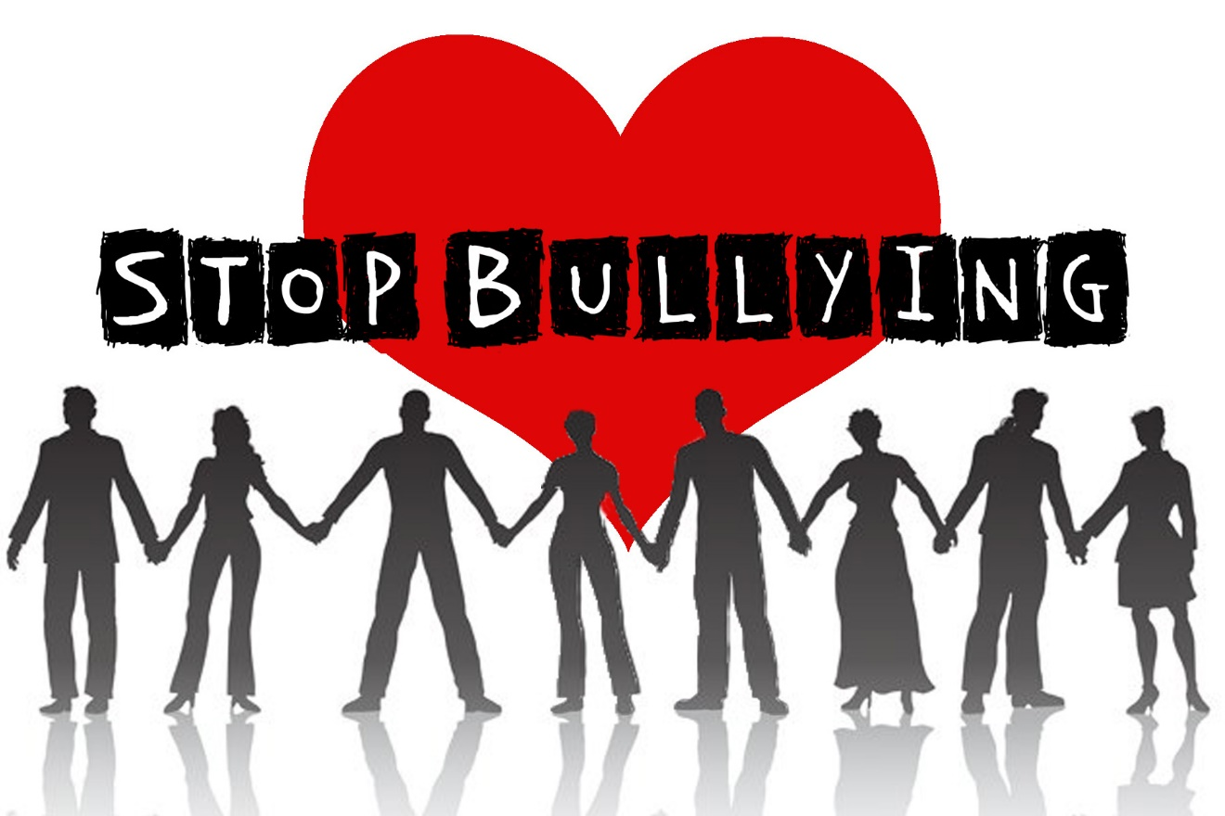

Content pages

Page 3 …………………………. Introduction
Page 4 …………………………. Theories of lifespan
Page 12 ………………………… Conclusion
Page 13 ……………………….. References
Introduction

The purpose of this assignment is to create comprehension of psychological factors which impacts human conduct throughout lifespan and how can it use in health and social care.
In this report will present the life-stage of adolescence ( mental health issues ) presented by Erikson’s theory stage 12-20: identify vs role confusion and Kohlberg’s theory of moral development as stage 4 Responsibility to the system( 15-20) supported by researches and trying to show that there is a connection between being bullied and self-harming

What is psychology? Psychology is a scientific study of mind and how it dictates and influence our behaviour ,from communication and memory to thought and emotion . The word comes from two Greek words: psyche =soul/mind and logos= the study of ( the study of mind/soul).
What is behaviour? Behaviour is any response or activity of an organism . it can be either simple or complex, overt or covert, conscious or unconscious, voluntary or involuntary, rational or irrational.
Sigmund Freud, know as father of psychoanalysis, said that the psychoanalysis much of our behaviour is governed by unconscious motive and primitive biological instincts. It consider all humans basically would like to gain pleasure and avoid pain.
What is human cognition? Is the capacity to process information through perception, knowledge acquired through experience and our personal characteristics that allow us to integrate all of this information to evaluate and interpret our world.
Theories of lifespan
- Psychosexual theory of development, by Sigmund Freud -1905- which is formed by 5 stages:

Stage 1: Oral Stage ( birth to 1 year)
Stage 2: The Anal Stage ( 1 to 3 years old) Erogenous zone: Bowell and Bladder control- the child learn to control his body needs.
Stage 3: The Phallic Stage (3 to 6 years old) Erogenous zone: genitals: the child discovers the differences between male and female.
Stage 4: The latent period ( 6 years to puberty) Erogenous zone : Sexual feelings are inactive . the time for ,,ego” and ,, superego”.
Stage 5: The genital stage( puberty to death) Erogenous zone : Maturing sexual interest : developing a strong interest in the opposite sex; this life stage starts in puberty and last through a person life.
- Theory of Psychosocial Development by Eric Erikson -1958/1963- formed by 8 stages
Stage 1: 0-1years Trust vs. Mistrust
Stage 2: 1-3years Autonomy vs. Shame
Stage 3: 3-6years Initiative vs. Guilt
Stage 4: 7-11years Industry vs. Inferiority
Stage 5: 12-18years Identity vs. Confusion
Stage 6: 19-29years Intimacy vs. Isolation
Stage 7: 30-64 Generativity vs. Stagnation
Stage 8: 65+ Integrity vs. Despair
- Cognitive theory of development by Jean Piaget -1936- formed by 4 stages:
Stage 1 : 0-2years : sensorimotor: world is experienced by senses and action
Stage 2 : 2-6years: preoperational: use words and images to represent things, but lack of logical reasoning
Stage 3 : 7-11years: concrete operational: understand concrete events and analogies logically, perform arithmetical operations
Stage 4: 12+ : formal operational : utilize abstract reasoning.
- The theory of moral development by Lawrence Kohlberg -1958-formed by 3 moral reasoning
Pre conventional : morality formed by obedience and individual interest
Conventional : formed by personal and authority
Post conventional: formed by social contact and universal ethics.

In stage 5:Adolescence, age 12-18, Identity vs. Confusion , by Erikson adolescence are looking for their personality which will transform them into adult. One of the most common question is ,, Who Am I?”. If I child was obedient until adolescence now they may change totally their attitude, they may start hanging out with all sort of trouble teenagers which will lead to being a problematic person as well. A important part of adolescence is exploring the two parts of the word ,,psychosocial”, one side we can have the parent which will not accept that their child had grown up and will try to dress up and act with their children as babies and pressure them to do certain things, and the society represent the external forces which will lead to the future grown up. After Erikson’s theory the diffusion of identity or the feeling of insecurity practised by teenagers can be characterized by four components:
- Intimacy : the adolescent is afraid to trust anyone as it may be a loss of personality
- Diffusion of time : the fear that something might happen and would change the present
- Diffusion of personal effort: is the incapacity to focus
- Negative Identity :,,a hostile, contemptuous and snubber attitude to the role deemed appropriate and desirable in the family or in the community nearby”.
What is morality? Morality is a system of beliefs about right or wrong. Moral development refers at changes of moral beliefs as a person grows older and achieve maturity. Moral stage according to Kohlberg regarding adolescence is stage 4 , age 15 to 20 years, responsibility to the system when a teenager must learn to obey the community customs and laws.
It is known that adolescents are usually victims of others adolescence if they are week or different. Bullying is one of the form they use to make the other teenagers to feel low, this is a unique but complex form of interpersonal aggression, this form isn’t just a personal form of manifesting but it can be influenced by multiple relationship. The victims are at greater risk for anxiety, depression, low self-esteem, self-harm, suicidal thoughts. Unfortunately most of the bullying happens in school, where children are picking other just to gain respect, fear from the others. Victim of bullying are either the smartest kids into their classroom either the one who come from different countries or different background. The worst part is that those children who are victims prefer to keep it as a secret at home so their family would not know about their stressful day at school; would not expose the conflict at school in front of the teachers. This children will either start bullying others just to revenge or they will start to self-harm themselves, refuse to have contact with their friends and family and won’t trust anyone around them. They will start looking for way how to produce pain to them either on online platforms, which will make them hide everything from they family.
I can give an example my own daughter, 17 years old, which she was only 9 years old when I brought her to Great Britain and her English level was 0, she started year 5 in primary school where she had all the support from teachers to accommodate and learn the language. Unfortunately she wasn’t welcome by the others children, which they start making fun of her accent, of her background, of the fact that she was rise just by her mother and her father always missing from her life. She tried to ignore them and start to focus more on learning and preferred to spend her break time in classroom around the teachers so she won’t have to face her bullies. The same problem was happening in year 6; but her attitude changed regarding me, she started to see me as her main enemy as I brought her to live with me; when she stared year 7, she started to look on line ways how to self-harm herself, she started to loose more her confidence and her only friend was her mobile and laptop which had password so I won’t have access to her ,, privacy”. When she begin to cut herself she started wearing long sleeves all day long either it was a hot day or a cold one. After a while she confessed that she is bullied at school but she never complain to the teachers as they won’t take any measures. We made complaints to the headteacher but still they won’t take any measures; they were replying all the time that they spoke with the girl who was making fun always and they will punish her if she continuous but never happened. By the age of 15 I discovered that she was cutting herself on her hand and tights just to make her feel better to forget about school, she was using blades from razors or sharpener; which I had to destroy them just to make sure she doesn’t have access to all these. I wasn’t able to make her understand never that I’m her best friend not her enemy and never convinced herself that she needs to get therapy . her only help was speaking once a week in school with the psychologist. In this moment she is on the waiting list for Child & Adolescent Mental Health service but she still denies that she needs help.
In concordance with Erikson’s and Kohlberg’s theory she is looking for her identity but she is still confused by everything what is happening around her. There is a long way till she will see that she doesn’t have to please her friends but she has to focus more on herself.
I can say that there is a strong connexion between bullying and self-harming in relation with what happened to my own child, and these adolescents will become very usury on them self and not trusting others when they will reach their maturity.
Case studies on teenagers who committed self-harming showed that it have a relation with their childhood, or the relationship which they have with one or bought parents. Most of them stop producing pain or punishing themselves but they prefer not to have a family not to have children of their own to make sure they will not act like their own parents with their children.

Conclusion

In this assignment it was made an analyse of the lifespan of adolescents in concordance with the theory of Erikson and Kohlberg; regarding their mental health.
All the case studies done indicates that these teenagers who experience bulling and self-harming need to get professional help as they need to pass these hard times and not become unsure adults or commit suicide. Prevention of non-suicidal self injury in young adolescents should focus on helping bullied children to cope more appropriately with their distress. Programmes should help those who have mental health or family history or tried to commit suicide or been abused as adults. In United Kingdom at least 25% of children are exposed or are victims of bullying( frequently those children who been bullied by the age of 10 years old they committed self-harm by the age of 12 years old) (Fisher HL, 2012).

References

Leena Kurki-Kangas, M. M.-H. (2018, jun 28). Retrieved from https://doi.org/10.1080/15388220.2018.1488136.
Lynn, V. (2019). Retrieved from https://scholarworks.waldenu.edu/dissertation.

Sigurdson, J. F. (2018, apr). Retrieved from doi: 10.1111/sltb. 12358. Epub 2017 Jun 5.

Fisher HL, M. T. (2012). Retrieved from NHS website.

