Marketing assignment 2

Introduction- what is marketing?
‘Marketing is the process of interesting of potential new customers and clients in your product or services’ (ward, 2017). Marketing centres on building relationship with the consumer or clients. They achieve this by delivering the right product or service to the right customer. Marketers try and convey the value of the product to the customer and thus attract more customers. Showing the customers the value of the product or service can also increase customer satisfaction. Marketing requires a lot of research, promoting and selling.
Processing and stages of marketing
In the process of marketing it is essential for those implementing this process to understand the needs and wants of the consumers. Organisations have to able to meet the demands, needs and wants of the consumers and marketers have to understand those demands. Wants are things that the customer desires and could go without as opposed to needs, which are basic requirement that the customer needs to be able to function within that environment. In order to understand their customer’s wants and need, organisations have to undertake an in depth study into their consumer data and understand their typical customer, and in today’s market this process may include social media research. ‘Social media has been useful to organisation to increase market share’ (demers, 2015) social media helps organisation have a better understanding of their customers. Gary Armstrong and Philip Kotler described social media in an interesting way, ‘your computer is your backup brain, it is your life, it’s your astonishing strategy and dazzling calculating it is your autobiography written daily’ (kotler, 2011) McDonalds have created their own mobile app, this helps them gain consumer data, by possessing this data they have a better understanding of the customer, the products they like, what they purchase the most and they can use this information to cater their specific requirements. Customers requirement are not met by the actual product but the experience as well, hence McDonalds have tried to make their mobile app user friendly. Marketers understand the importance of a good experience, that’s why Theodore Levitt coined the term ‘marketing myopia is the term deals with organisations assessing their product strictly from the stand point of selling the product’ (levitt, 2004).
There are different methods for marketers to use in order to form marketing strategies. These would be production, product, selling, and marketing as well social media concept. Organisation would use one of these concepts or a combination of these concepts, depending on the organisation’s goals. These concepts have their advantages as well as disadvantages. The selling concept would be predominately be used by companies that offer services such as accounting firms, these type of companies are focused on selling the product and not as much on satisfaction. Whereas organisations that use marketing concept focuses on finding the appropriate customer for the right product and also shows the customer the value of the product on offer. The product concept operates primarily on improving the product and continuous making the right product. The concept of production is the oldest of these concepts, this concept focuses on investigated the products available on the market and trying to compete by making the product affordable to the customer. The production concept is described as ‘the emphasis on low production cost, high production efficiency and mass production’ (bhasin, 2017) .

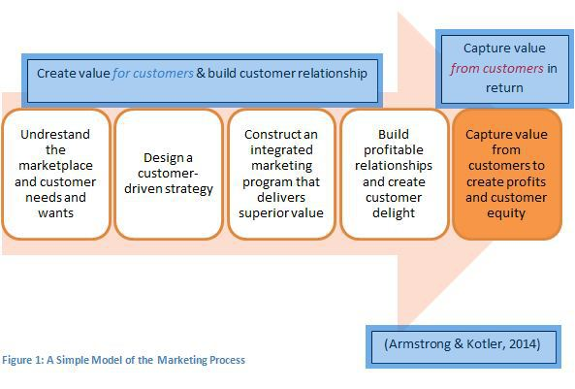
Marketing mix
This concept is designed from the decision making aspect of marketing. Marketing is usually referred to as the 4P’s, this in anagram for product, price, promotion and place. These are tools that are used by marketers. E Jerome McCarthy is credited with this concept, prior to that marketers used a concept known as functional approach. McCarthy defined the 4P’s conceptual framework for decision making marketing, which used product, price and promotion in the marketing mix. Later booms and Bitner added another 3P’s which were ‘people, process and physical evidence’ (bitner, 2001).thus the concept now is known as the 7P’s. The product is the goods the seller provides to the customer. Products go through stages of growth, mature phase and the end phase. The second part of the concept pricing, the price has to satisfy the customer and it’s important that the price is right. When pricing you have to also understand your competitors’ pricing and thus maintain value. Placing is also an important part of the concept, placing has a big impact on decision making as far as marketing is concerned. It’s important that the product is visible and accessible to the consumer. Promotion is also an important aspect of marketing, this part of the concept is essential to building relationships with the customers as well as increasing market share by also promoting the brand. In the process of marketing branding is important ‘‘Branding is the marketing process of creating a name, symbol that differentiate a product from others’ (thomas, 2017) companies use social media to promote and many companies have created mobile apps to help them engage more with their customers as well as promoting directly to their customers. McDonalds, they also use public relations to promote the business to their target audience and they also use ‘bundle pricing. ‘Companies selling a package of goods or services for lower price than when the customer would pay for buying them separately’ (merrit, 2017) another tactic McDonalds employees is not rounding off prices i.e. 99p instead of £1. SWOT analysis is important to organisations as this helps them understand their strengths, weaknesses, opportunities and their threats. This methods is used to analyse the organisation’s position within that environment they operating. When organisation use this concept they are able to look at their strength and look at what works for them and how they utilise their core strengths. When an organisation is not aware of their competition’s activities in the market that could be considered a weakness while their competitor would consider that a strength. Opportunity could arise with new benefit from new technology, if a company can utilise new technology i.e social media such as Instagram or Facebook they could increase their market share by reaching more potential customers.

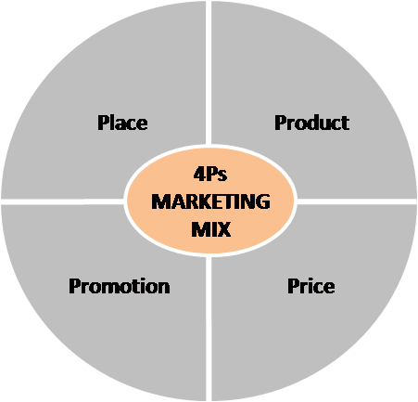

Creating value for customers
Customer value and satisfaction are imperative to organisations in order to build relationship with the customers. Organisation understand customers can be survey and will be looking for value on the products they purchased. According to Kotler ‘customer buyer behaviour refers to the buying behaviour of individuals and household that buy goods and services for personal consumption’ (kotler, 2011). Organisation understand the importance of understanding of understanding the market to be able to provide the right service. By understanding the market they can design the appropriate strategy to engage with the consumer. Market segmentation for company to provide value and satisfaction for the customer, companies need to focus on their target audience. McDonalds uses their mobile app to keep data on what their customers consume in their restaurant, they will send their customer new menu which is similar to what they ordered before as well telling them about any promotions they might have available. This keeps the client updated as well McDonalds concentrating their efforts to the right consumer. This helps give the customer greater value and helps strengthen the relationship with the customer.

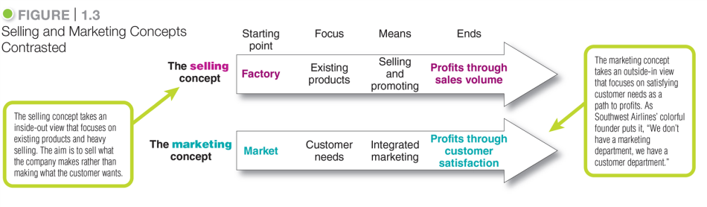
The mobile app helps mcdonald as it gives them the information about what the customer actually wants and makes it easier for them to understand that customers requirement thus making it easier to cater to them. Customers are always looking for alternative products so pricing is important, hence organisations need to understand the pricing of their competitors. McDonalds use ‘bundle pricing. ‘Companies selling a package of goods or services for lower price than when the customer would pay for buying them separately’ (merrit, 2017) another tactic McDonalds employees is not rounding off prices i.e. 99p instead of £1.

Stakeholder’s engagement and their impact on the marketing activities
Stakeholders can be defined as ‘people, groups and organisations that have a vested interest in an organisation because it can affect or be affected by the actions of the organisation’ (paul, 2018) anyone or organisation who could affect the operation of the business is considered a stake holder. There different levels of stakeholders, internal stakeholders as well as external stakeholders. In an organisation staff members could be considered stakeholders as they may not have much power in the way the organisation is run but none the less can be impacted by how the organisation is run i.e. management decision they might not have power over but could still see them lose their jobs through no fault of their own. External stakeholders might be people or organisations operating within the same industry or people living within the organisation i.e. if the company was extending their grounds that would impact the environment around them.
Mcdonalds’ stakeholders might in

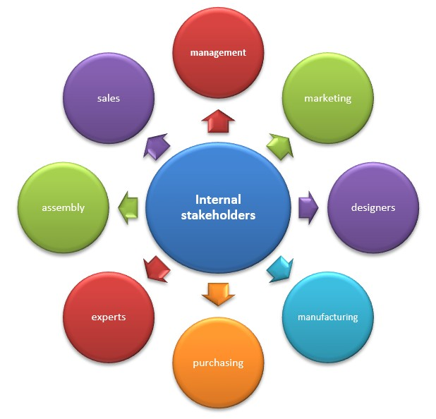

Conclusion
Cyfle I Dyfu is a social enterprise that is based in Swansea. The term social enterprise is defined as ‘business with primarily social objectives who’s surpluses are principally reinvested for the purpose of the business or in the community, rather than being driven the need to maximise profit for shareholders and owners’ (kerry, 2017) the organisation focuses on helping people that are marginalised in society and the aim is to try and help people back into work and be functioning members of society. The team wanted to raise awareness about Cyfle I Dyfu and what they did. They sell the chairs and tables they make in their workshop. We used blogs and social media such as Facebook and Instagram to raise awareness. The team also produced leaflets to hand out around Swansea and Cardiff. By using social media this allowed the team to reach a wider audience and different demographics. Using Instagram the team was able to provide a visual of the products they had on sale.

Bibliography
bhasin, h., 2017. marketing91. [Online]
Available at: https://www.marketing91.com/production-concept/
[Accessed 27 march 2018].
bitner, b. a., 2001. extended markerting mix . In: s.l.:s.n., pp. 55-58.
demers, j., 2015. forbs. [Online]
Available at: https://www.forbes.com/sites/jaysondemers/2014/08/11/the-top-10-benefits-of-social-media-marketing/#487b07b01f80
[Accessed 25 march 2018].
kerry, 2017. upholding social enterpises. [Online]
Available at: https://www.socialenterprisemark.org.uk/what-is-social-enterprise/
[Accessed 28 march 2018].
kotler, g. a. &. p., 2011. marketing principal. In: kotler, ed. marketing . s.l.:s.n., pp. 33-35.
levitt, t., 2004. havard business review. [Online]
Available at: https://hbr.org/2004/07/marketing-myopia
[Accessed 25 march 2018].
merrit, c., 2017. pricing strategies. [Online]
Available at: http://smallbusiness.chron.com/bundle-pricing-strategy-67049.html
[Accessed 25 march 2018].
paul, 2018. investopedia. [Online]
Available at: https://www.investopedia.com/terms/s/stakeholder.asp
[Accessed 28 march 2018].
thomas, j., 2017. entrepeniuer. [Online]
Available at: https://www.entrepreneur.com/encyclopedia/branding
[Accessed 25 march 2018].
ward, s., 2017. the balance. [Online]
Available at: https://www.thebalance.com/marketing-in-business-2948349
[Accessed 25 march 2018].

