Student Name:
Saira Zaeed
Student Number:
2332216
Module Code:
BMHP5019
Module Title:
Introduction to independent skills
Lecturer Name:
Rizwan Nadeem

Mind Map

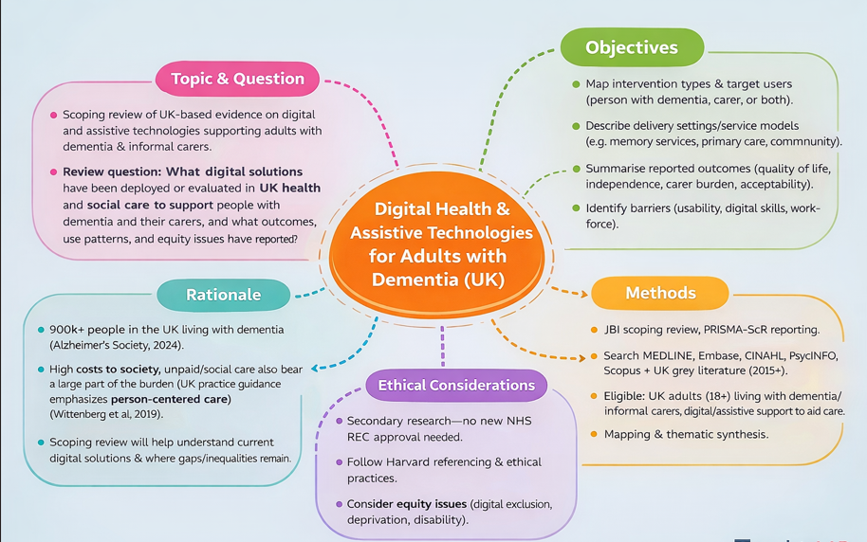

Dementia

This is a proposal for a scoping review of UK-based evidence on digital health and assistive technology provision for adults with dementia (including Alzheimer’s disease) and their informal care within health and social care settings. Digital support may be in the form of remote consultations, digital carer education, cognitively focused applications, medication reminders, remote monitoring and assistive devices that enhance safety and independence.

Rationale
Dementia is a big challenge in UK health and social care. Alzheimer’s Society reckons there are over 900,000 people in the UK living with dementia and that prevalence and costs will rise significantly over the coming decades (Alzheimer’s Society, 2024). The cost data suggests that a substantial proportion of the burden is borne by social care and unpaid care as well as healthcare (Wittenberg et al., 2019). UK practice guidance promotes person-centered support and carer involvement (NICE, 2018), so it is relevant to learn how digital solutions are implemented, who gains from them, and where deficits may persist.

Review question

Which digital solutions have been deployed or evaluated in UK health and social care to enable people with dementia and their careers, and what outcomes, use patterns and equity issues are reported?

Objectives
- Intervention types and target users (person with dementia, carer, or both) are mapped.
- Describe the mode of delivery (e.g., memory services, primary care, community).
- Summaries reported outcomes (e.g., quality of life, independence, carer burden, acceptability).
- Find barriers in the evidence (e.g., usability, digital skills, workforce) to underpin the later research report.

Methods for data collection and analysis
Methods will be conducted according to JBI method for scoping reviews (Peters et al., 2020) and reported following the PRISMA-SCRA statement (Trico et al., 2018). The searches will be conducted in MEDLINE, Embase, CINAHL, PsycINFO and Scopus, as well as UK grey literature (e.g., NICE, NHS England, ONS, Alzheimer’s Society). The inclusion criteria are that the source must be UK-based (2015–present), focus on adults (18+) with dementia and informal carers, and describe a digital intervention aimed at either supporting care.

Ethical considerations
As this is secondary research from publicly available sources, NRES approval is not being looked for. Ethical standards will be upheld by transparent reporting, right referencing, and prudent discussion. Equity considerations will be foregrounded throughout to guard against generalization and to support fair recommendations.

References
- Alzheimer’s Society (2024) Dementia UK: overview, prevalence, and cost estimates. Available at: Alzheimer’s Society website (Accessed: 28 January 2026).
- NICE (2018) Dementia: assessment, management and support for people living with dementia and their carers (NG97). Available at: NICE website (Accessed: 28 January 2026).
- Peters, M.D.J. et al. (2020) ‘Updated methodological guidance for the conduct of scoping reviews’, JBI Evidence Synthesis, 18(10), pp. 2119–2126. Doi: 10.11124/JBIES-20-00167.
- Trico, A.C. et al. (2018) ‘PRISMA Extension for Scoping Reviews (PRISMA-SCRA): Checklist and Explanation’, Annals of Internal Medicine, 169(7), pp. 467–473. Doi: 10.7326/M18-0850.
- Wittenberg, R. et al. (2019) ‘The costs of dementia in England’, International Journal of Geriatric Psychiatry, 34(7), pp. 1095–1103.

