Name: Neelam Liaquat
Student Number: 1605018
Module Title: Management Accounting(LCBB5002)
Module’s Lecturer’s Name: Isaiah Oino

Table of content:
Introduction of various budgets………………2
Why companies need budgets…………………3
Process of budgeting……………………………...4
Balanced of score card…………………….……..5
Activity based budgeting………………….….…6
Conclusion……………………………………….…….6
References………………………………………..…..7

Introduction
Despite various criticisms from different authors regarding budgeting, budgeting is still necessary and an essential part of planning.
Budgeting has been criticized by various authors due to the time and resources required for its preparation as well as the ability of managers to put slack in the budgets to ensure favorable variances are achieved. Other aspects regarding budgeting criticism include that of it being solely driven by financial aspects as well as the aim of the managers remain focused on achieving budgets whereas they may lose focus of the change in market conditions and trends.
(Bragg, 2018)
Even after all these criticisms, budgeting is still done by companies and is a basic requirement for planning as the management of the company need to know the amount of resources they have and how they should be allocated to get the maximum possible efficiency.
Literature Review
According to (Ahmad et.al., 2003) even after much criticism by so many authors according to their research almost all the major companies operating within the Malaysia used budgeting process and they argued that budgeting was not only a need but kind of a necessity and despite the change of doing business and rapid growth in technology budgets need to part of the strategic planning phase of a company.
(Libby and Lindsay 2010) also suggest in their research that they don’t find any conclusive evidence as to the fact that companies may stop using budgeting, on the contrary companies are trying to improve their budgeting processes which entails that budgeting is here to stay. (Libby and Lindsay 2010) also suggested that the work done by (Hope and Fraser, 2003) though has great value for management awareness but the assumptions used in their research are too overly generalized.
All in all the researches as well as results have suggested that the need of budgeting in planning is required and despite it cons it provides more benefits to an organization and is therefore readily used in companies around the world.

Need of Budgeting
The use of budgeting is not a factor which may provide the company with the surety to success but the use of this technique helps immensely in reducing the risk of failure for companies. Budget is used as an actionable application of plans which are converted into goals and objectives.
Large companies have various departments as well as many different parts and functions so budgets are required to ensure efficiency and that resources are allocated properly so that all departments, functions and people work in collaboration and with specific deadlines collaboratively.
Budgets act as benchmarks for achievement of goals and objectives especially financial ones and are often used to determine the performance of a department.
Budgets are usually departmentalized with each manager responsible for their own department which helps in inacting “responsibility accounting.” where different managers are responsible to meet the deadlines and objectives of their own department and the control for transaction is delegated to the manager level.
Budgets are also necessary to be made keeping the requirements of each department and bifurcated up to the level where each individual of the department is catered for so as to ensure that there is no blame game at the end. Deviations from budget both favorable and unfavorable variances need to be justified by the managers.
Budgets are used as resource allocators at the start of a business year and managers have to argue and fight over resource allocation to their department and the resource requirement is usually always more than the funding available so it provides the company with a greater understanding about the managers and how they align themselves with the goals of the company in view of limited resources to get the job done.
Budget is also required in the planning area as it helps identify the bottlenecks and the limitations faced by the company. The identification of bottle necks in turn allow the company to find alternative methods or plan for catering for that bottle neck.
(Principlesofaccounting.com, n.d.)
Process of Budgeting

The budgeting process consists of the following five major steps.
1. CALCULATE EXPENSES
The first process consists of determining the overall expenses that the company incurs during a specific period of time. This can be done using historic data as well as incorporating present information such as bank statements, cash books as well as receipts and payments. Some of these expenses can be calculated with accuracy for the future as they are known beforehand. The list of expenses can be accumulated, inflated for certain factors and averaged out to determine the average expenses of a company over the next period.
The accuracy of the budget depends upon the factor that the expenses of the company are well identified and no expense or receipt is forgotten while preparing the budget as it can have a significant impact on the performance, saving and profit of a company.

2. DETERMINE YOUR INCOME
The second part of the budgeting process consists of determining the income that the company has. The current amounts of sales as well as market conditions are analyzed to determine projected sales that the company may have in the future. All other aspects such as product launches and other revenues expected from investments are also incorporated in the budget. This ensures that proper availability of funds is determined so that it allows for the company to cover its expenses.

3. SET SAVINGS AND DEBT PAYOFF GOALS
Targeted profits are to be determined while making such budgets so as to ensure that the expected income is appropriately utilized to cover expected expenses thereby allowing the company to achieve its desired profits which may then be utilized to cover other aspects such as pay off loans or interest costs or payment of dividends to shareholders.

4. RECORD SPENDING AND TRACK PROGRESS
Another major process that needs to be done constantly is that of monitoring and reporting the whole process it not only provides with the opportunity to control the expenses but also helps in keeping track the actual performance of the company in and its departments in real time which helps ensure that the operations are being conducted out efficiently.

5. BE REALISTIC
The major backbone of the whole budgeting process is that the budgets as well as the assumptions on which the budgets is based are both realistic and attainable otherwise the whole activity of budgeting becomes useless and a waste of time and resources.
(Payoff, 2018)
Balanced Score Card
Balance Score Card is a technique which is used in the planning stage to ascertain that the following objectives are met and aligned with one another:
- The key goals and objectives are to be determined and established
- Aligning the operational work of all individuals with company strategy to ensure efficiency
- Rank products, services and projects according to priority
- And measure the performance according to goals set

The technique uses various functions through different tiers and interlink it so that all the factors such as the mission, purpose and values of the companies are followed in such a manner that they are fulfilled as a result of operational effectiveness due to fulfillment of KPI’s and other goals, objectives and targets. The inter linkage of all aspects is made possible by the BSC model which allows proper budgeting according to the priority of a project, product and service keeping in view all other aspects to ensure that the financial goals as well as operational objectives and company values are adhered and achieved.
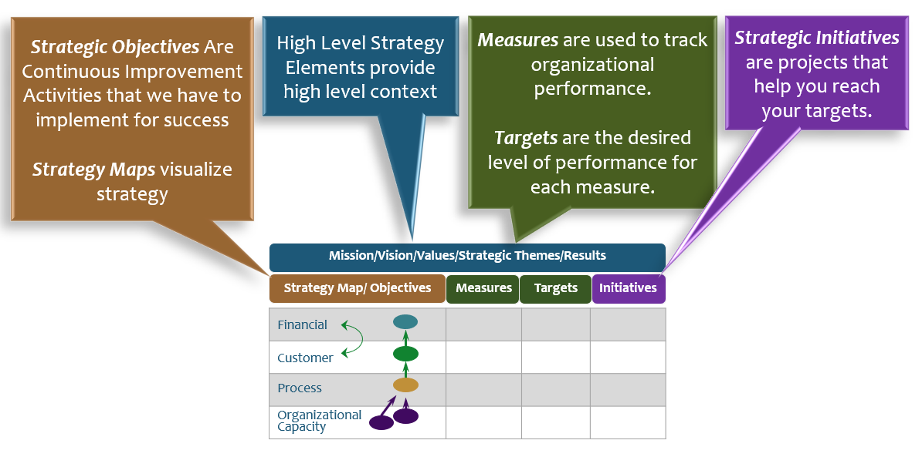
(Balance Scorecard Institute, 2017)
Activity Based Costing
Activity based costing is a technique used for cost calculation and budgeting in which the overhead cost of manufacturing is calculated using the activity of each department in terms of their production rather than using the age old method of allocating overheads by machine hours. Through activity based costing, the overhead cost associated with any product is first allocated to that product after which it is further allocated to any other product demanding the same activities thereby ensuring actual cost calculation of manufacturing a product which allows to make budgeting process more meaningful and effective.
(Averkamp, n.d.)
Conclusion
Despite all the criticism the benefits of budgeting is far more than the cons it brings with it and it helps the company to plan its cash flows and identify weaknesses as well as emphasize use of control measures. Many authors have criticized budgeting but other have researched and refuted their criticism and while the way of doing business is changing so is the way of making budgeting and the use of newer techniques such as balance scorecard and activity based counting have allowed the budgeting process to become more integrated and more accurate.
References
- Averkamp, H. (n.d.). Activity Based Costing | Explanation | AccountingCoach. [online] AccountingCoach.com. Available at: https://www.accountingcoach.com/activity-based-costing/explanation [Accessed 14 Apr. 2019].
- Balance Scorecard Institute (2017). What is the Balanced Scorecard?. [online] Balancedscorecard.org. Available at: https://www.balancedscorecard.org/BSC-Basics/About-the-Balanced-Scorecard [Accessed 14 Apr. 2019].
- Bragg, S. (2018). The disadvantages of budgeting. [online] AccountingTools. Available at: https://www.accountingtools.com/articles/what-are-the-disadvantages-of-budgeting.html [Accessed 14 Apr. 2019].
- Hope, J. and Fraser, R. (2003). Who Needs Budgets?. [online] Harvard Business Review. Available at: https://hbr.org/2003/02/who-needs-budgets [Accessed 14 Apr. 2019].
- Libby, T. and Lindsay, M. (2010). [online] https://www.journals.elsevier.com/management-accounting-research. Available at: https://cpb-us-west-2-juc1ugur1qwqqqo4.stackpathdns.com/u.osu.edu/dist/8/36875/files/2016/12/Libby-Lindsay_budgeting_survey-17bvsph.pdf [Accessed 14 Apr. 2019].
- Nik Nazli Nik Ahmad Maliah Sulaiman Norhayati Mohd. Alwi, (2003),"Are budgets useful? A survey of Malaysian companies", Managerial Auditing Journal, Vol. 18 Iss 9 pp. 717 – 724 Available at: https://s3.amazonaws.com/academia.edu.documents/34958060/Ahmad_et_al_2003_Budgets_in_MAJ.pdf?AWSAccessKeyId=AKIAIWOWYYGZ2Y53UL3A&Expires=1555474238&Signature=5ni4I0PXtHVsJJZHTDAEYH0vIMQ%3D&response-content-disposition=inline%3B%20filename%3DAre_budgets_useful_A_survey_of_Malaysian.pdf
- Payoff (2018). 5 Simple Steps to Create a Successful Budget | Payoff Life. [online] Payoff Life. Available at: https://www.payoff.com/life/money/5-simple-steps-to-create-a-successful-budget/ [Accessed 14 Apr. 2019].
- Principlesofaccounting.com (n.d.). Importance Of Budgets - principlesofaccounting.com. [online] principlesofaccounting.com. Available at: https://www.principlesofaccounting.com/chapter-21/budgets/ [Accessed 14 Apr. 2019].

