
Managing a project “Recruit Students for skills for the work place programme”
Submitted : UWTSD, Swansea
Laba Maharjan (1705167) | 8/5/19 | BMSK-5004 SWAN

Executive summary.

This report is highlighted on the base of a managing a project to ‘recruit potential capable students for the skills for the workplace programme in UWTSD Swansea’. As a team member of a project, the candidate and his team applied various tools such as quad chart, stakeholder analysis, Gantt chart, risk analysis, and evaluation tools for the complete the project following a project cycle which was divided into four phases. The project plan was started with the statement of work (SOW) then another hand the project was divided works work breakdown instruction(WBS), the applied tools and the individual and collective responsibility within the team members which helped to ply significant role to successfully complete the project.

Contents page:
Executive summary. 1
Introduction: 4
Project:
Iron triangle:
Skills for the workplace programme:
Project Management:
Main body (findings): 5
An analysis of various tools applied in the project:
Project Cycle:
Project initiation:
  - Quad chart;
  - Stakeholder analysis:
Project Plan:
  - Gannt chart
Project execution:
Risk analysis:
Project completion:
  - Evaluation
Recommendations:

Conclusion: 9
References: 10
Appendix1 11

Introduction:

Managing a project ‘recruit potential students in the skills for the workplace programme’ the main scope of the project, it looks so simple task but in reality, the process of staring the project and complete it was quite complicated and tough job. The researcher and his team applied series of tasks with various project management tools following the project cycle to complete the project described as below.

Project:
A project can be defined in several ways, according to Buchman and Boddy(1992), “A project is a unique venture with a beginning and end conducted by people to meet established goals within parameters of cost, schedule and quality.”(Field, M. and Keller, L. 2007).

“A unique set of co-ordinated activities, with definite starting and finishing points, undertaken by an individual or organisation to meet specific performance objectives within defined schedule, cost and performance parameters”(Maylor, H.”005).

  - Iron triangle:
  - Iron triangle is the simplest tool to explain and understand a project, time, cost and quality are three basic requirements for a project which helps to assume and helps to fix the objectives of project in advance which is one of the easy tool to understand and apply Iron triangle. .(Watson, M. 2002)
As in Iron triangle in this project, the total time of the project was five weeks starting from o8 May 2019 to 17 June 2019. It also helped for to manage approximate cost or resources needs so that it helped to arrange all the resources on time and quality of project was the meet the aims of the project was completed on time within the limit resources of the project, recruit students for skills for the workplace.

Skills for the workplace programme:
Skills for the workplace programme in UWTSD, Swansea is a special programme designed for those people aged between 21 to 60 who never has had opportunity to study higher education in their life, such as young unemployed living with mum, mid 40s fulltime worker, no dependents, 28 years married with two young children are the potential students for this programme. The UWTSD was officially formed on 1st August 2013 The Mission of University, Transforming education; transforming lives. The Lerner in central to the University and the wider group and the education delivery, underpinned by high-quality research, distinctive; develop mind and skills of students, and also be inclusive, professional and employment focused. The main aim of this program is 1) innovative course to get back into employment or move up the career ladder. 2) helps in improving skills, confidence and restart students career development. (www.uwtsd.ac.uk).

Project Management:
project management emphasises the strategic role of project, it is a process which helps to the project manager to deliver the end objective of the project and satisfy the needs of all its stakeholders. In modern project, managers become integrators and could uses various management tools to successfully run the projects. .(Watson, M. 2002).

The management tools such as iron triangle, quad chart, gnat chart, stakeholder analysis and risk analysis tools are applied in this project cycle.

Main body (findings):

An analysis of various tools applied in the project:

This project was started with a meeting in between team members and programme coordinator. In the beginning, the scope of the project was identified and also designed the project plan applying the various tools like Quad chart, Gantt chart, stakeholder analysis, risk analysis, evaluating the project cycle with the recommendation the project was completed.

  - Project Cycle:
There are four main phases of project cycle, conception, definition, implementation and handover or closeout. (Billingham, V.2008).
Weiss and Wysocki(1994) project cycle divided it, five phases, definition phase, planning phase, organisation phase, execution or implementation phase and closure phase. (Keller, L. and Field, M. 2007).

Project initiation:
First of all the project was started with the initial phase with a meeting with forming a team of four project team members, then the determine the team role, divided into team leadership role and team management and administrator role within the team asking the keys the giving things done, who was responsible for plan execution monitor control and moving things forward. Applying Quad chart and stakeholder analysis.

  - Quad chart;
It is a very simple and effective tool helps overall idea before starting any project and explain what a project about, it is just a page summary of a project, includes project scoping, stakeholders, desired outcomes and measures of success.

The quad chart was applied for to identify the project scope as “Recruit students for skills for workplace program ” was the project title, the project was the main aims/objectives of the project then, it also applied for to identify the main stakeholders/audience of the project they are University of Wales Trinity Saint David. University staffs, students, local community people, Swansea council, project team members as main stakeholders, The measures of success were measured by completion the project on time fulfilling the required numbers of students attending in the interview program was by program coordinator Shehla. Desired end result(critical success factors) of the project was positive and successfully completed by attendance in interview of the potential students for the program was held on 17th June, it was successfully completed the project. Quad chart is referred to Appendix 1.

  - Stakeholder analysis:
A stakeholder is anyone upon whom the project can have effect and anyone who can be affect the project. (Watson, M. 2002).
In this projects are the UWTSD Swansea, Wales Government, Government of UK, Swansea council, Local communities, University staffs, including lecturers, academic staffs, local business organisations, and researchers, specially the people aged between 21 to 60 who never has opportunity to study higher education in their life such as young unemployed living with mum, mid 40s with fulltime work, no dependents, 28 years married with two young children are the main stakeholders and one of the main part of the programme.

Project Plan:
The Project plan was started with three piece of work has done, Statement of work SOW, is the description of the work/project, where team decided what will be done? what are the goals and objective of the team? What are the milestones? There are monitoring for commitments? What are the measures of success? Measures of success is important it helps to team to determine that how successful will there in complete there in the project. The measures are important that indicates what improvements are needed to next time based on what achievement has got today. Quad chart and stakeholder analysis, Gantt chart tools were applied for planning the project as useful tools,

  - Gannt chart
It is a chart with a timescale in which a bar represents the period over which each activity is scheduled to be performed. (Keller, L. and Field, M. 2007).

In this project, the Gantt chart was applied to divide the different project task and gave the responsibility for each team members individually and collectively so the project became much more easier to start and completed on finish time and as following the scheduled task as on Gantt chat helped to complete all the project task smoothly on time. In this project Gantt chart it consist project tasks like information and resources collections, identify potential areas, stakeholder analysis, organise meeting in different local communities, prepare Gantt chart and QUAD chart, Risk analysis, organise the interview program, preparation for presentation all this tasks were divided as the individual base or team base responsibility. The Gantt chart of the is referred to Appendix 2.

Project execution:

Another part of project plan is work breakdown instruction(WBS). This is a task giving arrangement a product project pacific tasks. Together they represent all activities needed to complete the project. It is useful to managing the budget, also in terms of managing resources of staffs. The third items of project plan is work package, is assignment of pacific task and responsibilities. Work packages are very detailed and collection of work packages are used to create the various levels of the work break down instructions and together these three items forms the project plan. Work package is used to determine the project schedule. Where Gantt chart was applied as a project tool. (Project-Management.com. 2019).

In implementation phase as project plan the researcher organised meeting with the different groups of the people in different local areas like spring terrace road, Saint James church, where there 23 and 75 people were participated it was a enthusiastically communicated to the participant giving the all information about the project, then the public places like in Swansea market and city centre areas also distributed the bruisers and gave information to people walking on that areas and also visited door to door in local residential area to convey the message about our project, respectively other team members of this project also organised and conducted public meetings in various areas individually and collectively according to the project plan. To provide message all candidates used bruisers and verbally with mass communications in meetings to give information and motivate people.

In terms of project execution, the key items are interest here monitor and control functions. monitors the project to seen how the things are going, against the plan, and control the project by making sure that where is the project and actions taking on the deviating the plan to various regions and also getting everything back and schedule, so at the end of the project with completion satisfied the quality requirements, within budget completed everything on time. here it guides the activities, to successful project completion. In this stage, all the tools applied were monitored and evaluated by team.

Risk analysis:
Risk is uncertainty, it represents the chance of adverse consequences or loss occurring. Risk management is process that lays out the key steps of managing risks that the project manager has better control over project. There are five steps of risk management 1, identify risk. 2 evaluate risk. 3. Identify risk actions. 4. Select risk actions. Ans 5. Manage risk through project. where the first four steps are known as risk analysis. (Billingham, V.2008).

The various risk were analysed by team in the project, Such as group work, finish time, Language and communication, student loan, interview, changing Government rules and policies such as Brexit matter, these issues are mentioned as H/M/L Impacts, Likelihood, Risk, warnings and maintaining actions are analyse and the risk assessment is referred to appendix.

There was some issues with the high risk of the project because of the different personal barriers high chances of unable to attend in the interview of candidate was the one of the high risk of the project, so the interview was arranged for two days. During the teamwork there was few communication gaps seen between the team members were seen it was also another risk for the project, time also became another factors could effect on the project the time duration of the project, working and studying time of the individual team members and personal time availability of probable candidates was also high risk for the project. Most of the candidates were scared from the interview and also level of language also appeared as a barrier for to success of the project. Indirectly the team was also became a high risk because of the bit passiveness of the leadership role.

Project completion:
Project completion is normally has a project debriefing session, analyse, strength and weaknesses of plan and execution this is done continue on improvement on next project. The main strength of project was our the good teamwork, the scope of the project, and the main support from University and the teacher, community people. During this project cycle, there are some weaknesses are seen such as the team leader and managers role was bit weak and inactive and Poor communications between team members. Even the project was succeeded organising the different activities with final interview program. As a researcher want to recommend for the future project plan, it should be seriously need to give priority to form a good team in order to successfully effectively, manage and complete the project.

  - Evaluation:
It is one of the complex process but essential because evaluation is the only the way to measure the success of a project’s implementation(Kerzner, 2013).

As following the evaluation phases in the first phase the project was assessed and defined clear objectives, in next phase following the objectives to accomplishment to achieve the goal and results different kinds of plans were implemented. Final evaluation came at the end of the project that comparing with the objectives to recruit 20 potential students were successfully completed the number of candidates attended in the interview programme proved the measures of success of the project.

The success of the project is depends on the main stakeholders or the potential students for this program, but during the communicating with people it was noticed that still there are so many participants were unknown about the skills for the work placement program and also about the UWTSD, so it is one of the risk factor for this program.

In fact, to organising public meetings and convince about the project to people was a complicated task, so researcher used familiar local public and community areas so it became more easier to him to meet with the familiar locale people and gave the message about the project

There was few more issues like the communication or level of English language for those people whose English is as a second language also noticed one main barrier among the probable candidates.

The personal and family issues with the individuals with different people with different problems such as job, business, children, health are also other types barriers for the programme.

Time and financial issues are also seen as barrier there are so many people who dislike to get student loan and other supports and also impossible to lose their job or business too but to complete the study they need to arrange time and money in the same time for the mature student, so these factors are also creating confusing for the candidates.

There are few legal barriers are also seen among the migrant and refugees living in Swansea,(UK) since past few years and they wanted to join this course it is hard to meet all the minimum requirements and also to get support and join this course because of lack essential documents.

There are some communication gaps seen in the teamwork.

There are some leadership problems seen in the time management during the teamwork.

Recommendations:

To provide more information to potential local areas and communities the advertisement about the programme need to emphasise and need to develop public information system.

The personal, financial, legal and other issues raised by the candidates can be addressed and motivate them giving correct information.

communication gap to be improve using good communication methods and networking between team members.

The level of English Language of the candidates can be improved providing special classes.

At the initial stage of the forming, a leadership and managerial role needed to be seriously considered in different angles of the personal matters.

Conclusion:

The project management tools and techniques are mostly became useful in other to complete project successfully according to scope of the project. In modern age, these tools became most popular and useful to apply any micro or mega projects to successfully complete project tasks. The tools applied to recruit student in skills program was also useful and effective to help the project successfully complete. Even there was some errors and confusions seen during the implementation of tools within the teamwork because of lack of experience and communication gaps. The team learnt more lessons from those mistakes and from those weaknesses, so from these lessons from mistake can apply these knowledge to improve and effectively use in future project work.

References:

Bakers &k, and Campbell G. M.(2003). ‘Project Management’ (Third edition), ALPHA, New York.

Billingham, V.(2008). Project Management, Study matters Limited; UK.

Billingham, V. (2008). ’ Project Management, How to plan and deliver a successful project’. Study mates: UK.

Field, M. and Keller, L. (2007). ‘Project Management’` THOMSON The open university, London, UK.

Kerzner, H. (2013). Project management workbook to accompany Project management - a systems approach to planning, scheduling and controlling.. 11th ed. New York: Wiley
- Project-Management.com. (2019). Types of Risk in Project Management. [online] Available at: https://project-management.com/types-of-risk-in-project-management/. [Accessed 24 Jun. 2019].

sunny, et. Al, (2014). Project Management, (third, edition), ALPHA; USA

uwtsd. ac, UK.,(2019). ‘History and Timeline’ [Online] Available HTTP://uwtsd.ac.uk/history/ : (04, June 2019).

Uwtsd. ac. UK.( 20019), Online, [Available]: https://moodle.uwtsd.ac.uk/mod/turnitintooltwo/view.php?id=186105. (05. July 2019).

- You tube.com (2019). Online, Available: https://www.youtube.com/watch?v=CSGYIT1HuYw. (04. July 2019).

Appendix1

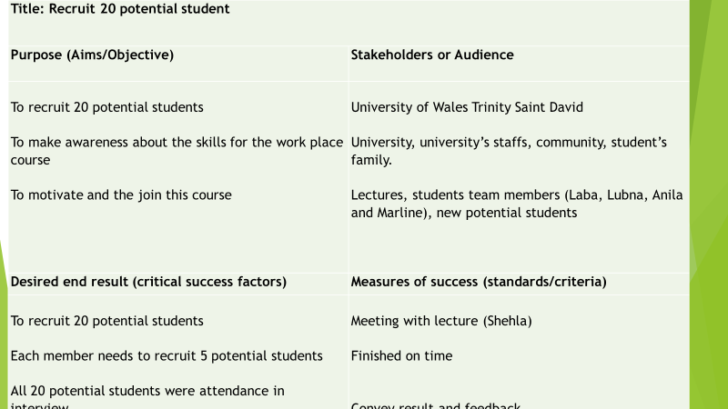

Appendix 2

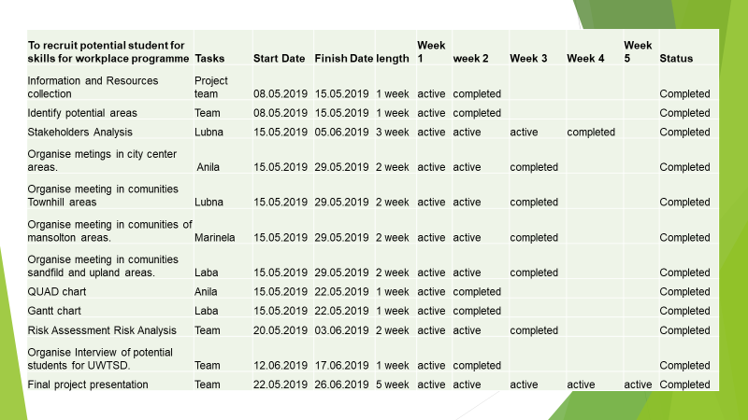

Appendix 3
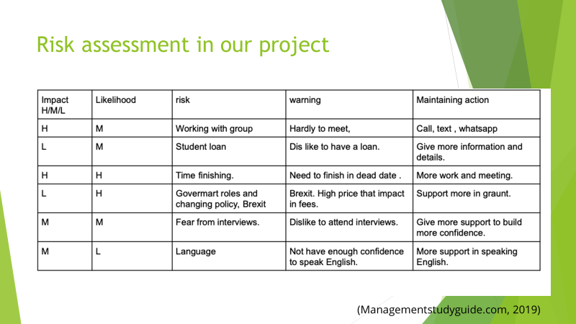

Project cycle:

Risk analysis:

 | Likelihood  H/M/L | Risk | Warning Mechanism | Mitigating Action
H | M | Working group of people | Try to meet convenient time | Text or call
H | H | Age group of the people | Identify the age group between 21-60.
H | M | Family problem | Identify the problem | Try to find out right way.
M | L | Financial | Analyse the financial condition a | Inform about supports
M | L | Student loan | Dislike to get loan | Give proper information about it
M | L | Documents | Passport and other essential documents | Ask clearly about it.
H | M | Language | communication | Evaluate simply about English language.
M | L | Time management | Need to finish at time | Follow the project plan
M | L | provide information and convince the people. | Prepare sufficient materials and information’s. | Use them according to needs,
M | L | Resources | Identify the resources needed | Prepare the essential resources.

