University of Wales Trinity Saint David
Wales Institute of Science and Art


Electrical Control Systems

Electronic Circuits Testing and Applications (ACHA4010)

Charlie Wint
2305014
24/03/2024
Contents
1 Task 2 1
1.1 Scope Time Division Calculations (4) 1
1.2 Function Generator output sine wave (3) 2
1.3 Unsmoothed Rectifier Wave (3) 3
1.4 Smoothed Rectifier Wave with capacitor (3) 4
1.5 Drop in Voltage Question (4) 5
1.6 Different Voltage Readings Question (5) 6
1.7 Rectifiers use in Automotive applications Question. (4) 7
1.8 Probing Question (4) 8
2 Task 3 9
2.1 Scope Time Division Calculations (4) 9
2.2 Function Generator output square wave (3) 10
2.3 Capacitor charge and discharge wave marked at correct points. (3) 11
2.4 Basic Capacitor Calculations (3) 12
2.5 Capacitor discharge table (4) 13
2.6 Gradient Plot and calculations (4) 14
2.7 Capacitor Uses (5) 15
2.8 Inaccuracies Question (4) 16
3 References 17

Task 2

Scope Time Division Calculations (4)

Period = 1 ÷ Frequency
The frequency is 10 hertz which means the equation is 1 ÷ 10 which equals 0.1 time periods.

Function Generator output sine wave (3)
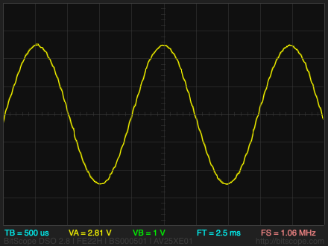
(Technblogy.com, 2018)

Unsmoothed Rectifier Wave (3)

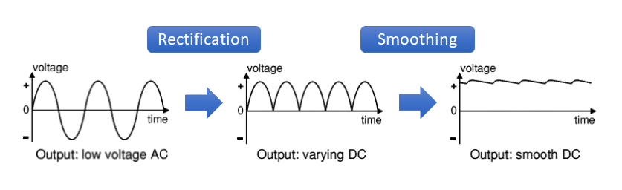
(Knowlescapacitors.com, 2022)

Smoothed Rectifier Wave with capacitor (3)
(Knowlescapacitors.com, 2022)

Drop in Voltage Question (4)

The drop in voltage could most likely be cause by the diodes used in the circuit as diodes create a voltage drop. During my time in Level 3 education, I was taught that silicone diodes typically create a 0.7 volt drop when a current passes through them whereas germanium diodes usually have a 0.5 volt drop. This makes it the most likely reason why the voltage drops lower than the peak.

Different Voltage Readings Question (5)
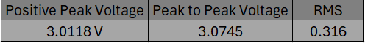
RMS, or Root Mean Squared is the changing function of values that occur in cycles. It’s a way of calculating the average in a set of values however it is an arithmetic average instead of the standard regular average such as mean, median and mode. Essentially, RMS is taking all the values, squaring them, then calculating the mean average of those squared values, and then taking the average and finding the square root of it.
(Wallstreetmojo.com, 2024)

Rectifiers use in Automotive applications Question. (4)

They are used in an automotive application to take the AC current from the cars alternator and turn it into a DC current for the rest of the car as the alternator polarity reverse after every rotation as well as preventing cross-feeding so that your high-beam signalling switch doesn’t feed voltage bac into the system. It just converts the alternators alternating current into a more practical direct current for the rest of the car’s electronic components.
(Gonzalez, 2014)

Probing Question (4)

Oscilloscopes usually have a limited number of input ports which limits how many input probes can be used as well as only so much data can be displayed by the software. Vector Network Analyser magnitude measuring devices and they can be wired up to a rectifier for simultaneous probing and analysing networks.

Task 3

Scope Time Division Calculations (4)

Period = 1 ÷ Frequency
Frequency = 1 ÷ Period
Frequency = 1 ÷ 20
Frequency = 0.05 Hertz

Function Generator output square wave (3)
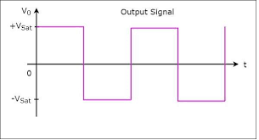
(TutorialsPoint, n.d.)

Capacitor charge and discharge wave marked at correct points. (3)

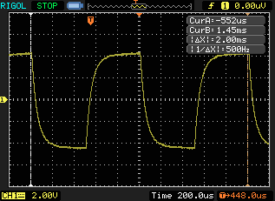
The darker box, on the left highlights the Capacitor Charge curve and the lighter box, on the right highlights the Capacitor discharge curve.

(Grisales, 2016)

Basic Capacitor Calculations (3)

C = Q/V
C represents capacitance measured in Farads.
Q represents the value of charge in the capacitor, measured in coulombs.
V represents the voltage, measured in volts.

Capacitor discharge table (4)

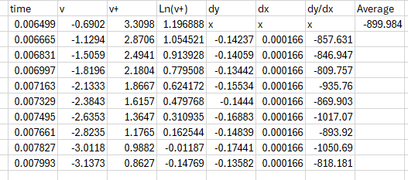

Gradient Plot and calculations (4)

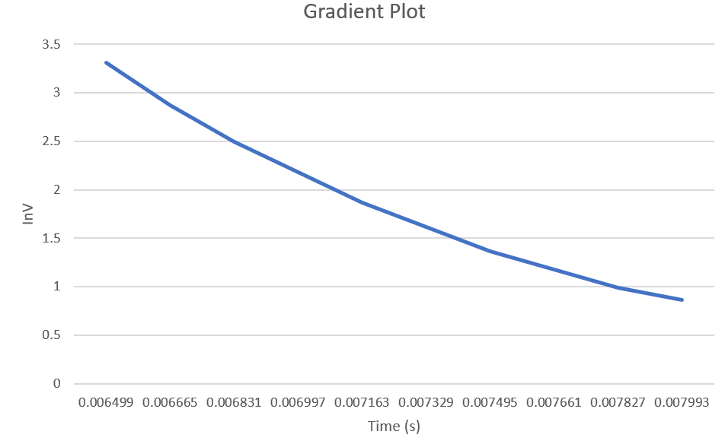

ΔY / ΔX
Delta Y refers to the Logarithm Voltage
Delta X refers to the Time

Capacitor Uses (5)

Capacitors can be used in an electrical application as form of a small energy storage device and releases it when it is needed. It can also be used to start engines.
Capacitors can be often used in circuits around power supply to filter and smooth the direct current waveform to make sure the output is smooth.
Capacitors help to prevent unwanted connections between components and make sure the signal’s integrity remains in check.
Electric motors receive a small boost of power by the capacitor from the stored energy inside it and it improves efficiency in the motor too.
Capacitors have a controlled release of energy to create a spark from a high voltage to ignite fuel in the engine and get it started.
Capacitors help control the voltage in the circuit as well as also protecting vital components within the circuit.
Capacitors improve the electrical system efficiency in the automotive sector as it reduces the reactive power and optimises the available power.
Capacitors are critical in creating precision functions regarding timings such as ECU units and controls how long an electronic pulse lasts for.
In the automotive and motorcycle sector, capacitors stop the light bulbs from going too dim or too bright and is especially effective with an inconsistent supply.
Capacitors are a valuable in electronic speakers as they act as a frequency filter, it only allows certain frequencies to pass through to the speakers without and direct current offset blocking.

Inaccuracies Question (4)

Inaccuracies may occur due to poor reading skills with an individual or an individuals lapse of concentration. These could have severe impacts on the later work carried out due to a small mistake which could have seemed nearly harmless at the time but turned out to be disastrously wrong after a short while of working with the mistaken data. Another thing that could cause potential inaccuracies is the quality of the equipment used. Older equipment would be far more inaccurate in readings than more modern equipment. Even with the modern equipment, there could still be terrible inaccuracies due to individual mistakes or misreading with any calculation or reading required to progress.

References
Gonzalez, G., 2014. What is an Automotive Rectifier and why do I need one?. [Online]
Available at: https://www.quora.com/What-is-an-automotive-rectifier-and-why-would-I-need-one#:~:text=A%20rectifier%20converts%20alternating%20current,is%20performed%20by%20the%20inverter.
[Accessed 21 03 2024].
Grisales, C. L., 2016. ResearchGate. [Online]
Available at: https://www.researchgate.net/figure/Measurement-of-the-charge-and-discharge-cycles-in-a-cardboard-capacitor-through-the-paint_fig6_305800602
[Accessed 24 03 2024].
Knowlescapacitors.com, 2022. Looking Closer at Smoothing Capacitors in Electric Vehicles. [Online]
Available at: https://blog.knowlescapacitors.com/blog/looking-closer-at-smoothing-capacitors-in-electric-vehicles
[Accessed 21 03 2024].
Technblogy.com, 2018. Tiny Function Generator Sine Wave. [Online]
Available at: http://www.technoblogy.com/show?22HF
[Accessed 21 03 2024].
TutorialsPoint, n.d. Waveform Generators. [Online]
Available at: https://www.tutorialspoint.com/linear_integrated_circuits_applications/linear_integrated_circuits_applications_waveform_generators.htm
[Accessed 24 03 2024].
Wallstreetmojo.com, 2024. Root Mean Square. [Online]
Available at: https://www.wallstreetmojo.com/root-mean-square/
[Accessed 21 03 2024].

