Title: A written assignment critically evaluating how Assessment for Learning can be utilised in a series of learning opportunities to aid progression across chosen areas of learning and experience.

This assignment will be a critical evaluation of how Assessment for Learning can be used in a series of learning opportunities to help progression across chosen areas of learning and experience. Assessment for learning is the impact of feedback on pupils in the classroom and it can enhance pupil learning through formative assessment (William, 2011). Using assessment for learning in classrooms, may improve pupil progression which is significant to child’s learning. It is important to promote good progress to allow pupils to understand any learning objectives required and to create appropriate reflections on their educational journey. Crucially, it enables pupil to receive quality time to review their own and peers work to begin self-reflection. This process provides relevant and appropriate targets to the pupils in a learning environment (Bishop Grosseteste University).

During my experience in a school, I observed and taught a year 6 class. The topic for the term was expressive arts through the world cup 2022. During my experience I explored many different assessments for learning strategies throughout different areas of learning experiences. The three areas of learning that I will be analysing through this assignment are expressive arts, humanities and mathematics. Throughout these learning experiences I used various assessment for learning strategies such as; secret squirrel, consensograms, pit stops, snowballing and secret notes. By implementing these assessments for learning strategies, I was able to meet the individual needs of my pupils appropriately and accurately. This is because assessment for learning provides quality of teacher and pupil feedback. It was vital that I met the needs of each individual pupil as there were a group of learners who had additional learning needs (ALN). These pupils had a learning difficulty or disability which called for additional learning provision (ALP), which is of greater difficulty in the learning than the majority of the class (Welsh Government, 2019). Therefore, I ensured that my lessons were clearly differentiated at their appropriate level. The pupils in my class varied across progression steps 2 and 3. The majority of learners were at step 3 with the small group of additional learners at progression step 2. The progression steps clearly indicate how skills and knowledge are developed throughout each year in education. I used these to support the pupils in my class, making no difference to what level they are working at (Fleetvile Junior school, 2023). There were many challenges that I faced in my class, with one pupil having an individual development plan (IDP), which required them to have a 1:1 teacher in the class at all times. Due to this, I ensured that I planned appropriately for them at progression step 1, and forwarded my planning to the individual development plan teachers so I was able to meet their needs appropriately in the classroom. However, this pupil only attended the class on a Monday. Furthermore, there was no teacher assistant situated in the year 6 class to use in my planning. Therefore, I was able to create all planning appropriately, ensuring I used differentiation throughout to support during my teaching time. While undergoing my teaching the pupils were required to build on previous knowledge. Building on prior knowledge and content may improve the pupils conceptual understanding and foster a positive attitude. This is by building their confidence in their knowledge foundation from the previous lesson in this specific area of learning experience (YUP Technologies, 2021).

Assessment for learning allows teachers to gather feedback in learning areas which may be used to improve pupil’s performance and progress. There are many strategies involved with assessment for learning, which may enable pupils to become more active in their learning. The five main processes involved in assessment for learning are; quality questioning, providing feedback, understanding successful work, peer assessment and self-assessment and summative assessment (Cambridge International Assessment, 2023). Teachers implement assessment for learning in to their classrooms to motivate and engage learners. The processes involved allow pupils to have a deep understanding of their own learning, increasing their confidence in the classroom. This is because it largely emphasises progress, achievement and promotes quality learning, rather than focusing on failure and defeat (Stiggings, 1999; 2001). Assessment for learning is vital for pupil progression to enable pupils to improve in their learning within the classroom. The elements within assessment for learning are used by teachers to provide the best opportunities for pupils in their learning progression. This is because it allows pupils to recognise their achievements while teachers are able to adapt and implement their teaching to the individual needs and abilities of the pupils (Qualifications and Curriculum Development Agency, 2010).

The learning progression is fundamental to the Curriculum for Wales and assessment is central in ensuring progress at an appropriate pace, where learners are supported and challenged accordingly to their individual needs. (Welsh Government, 2022). Donaldson suggested that the Welsh Government recognised weaknesses in the assessment framework. Therefore, it needs to provide high quality feedback that comes from formative assessment. Donaldson suggested that assessment should be aligned with what matters, engage students in their own assessment and be clear about the reasons for the assessments. The curriculum structure and the associated assessment arrangements should show links and expression to the four purposes by using the six areas of learning and experiences. (Donaldson, 2015). The four purposes of the Welsh curriculum are to be ambitious capable learners, enterprising, creative contributors, ethical informed citizens and healthy, confident individuals. The six areas of learning and experiences are humanities, mathematics and numeracy, expressive arts, health and wellbeing, language, literacy and communication and science and technology (Welsh Government, 2022).

Assessment is essential when improving learning and the high standard of education (Black and William, 1998; OECD, 2008). Therefore, teaching and learning must be interactive so teachers are able to adapt their own work to support their pupils appropriately. Teachers are able to do this in a variety of different ways; observations, discussions in the classroom, reading pupils’ written work and assessment for learning. When the assessment of pupils is implemented to provide feedback to modify teaching and learning activities, it becomes formative assessment. This is when the evidence is used to support the adaptation of teaching to meet pupils needs (Black and William, 1998). Formative assessment monitors and tracks pupils learning which provides practitioners with ongoing feedback on their learners’ progression. This may enable pupils to recognise their strengths and weaknesses in their work (Carnegie Mellon University, 2023). Pupil progression is when pupils understand the fundamental knowledge of academic skills in the classroom (Structural Learning, 2022). Assessment for learning may allow teachers to track pupil progression as it provides quality feedback. This may be due to the different strategies used by practitioners in the classroom. These may be sharing the criteria with the learners, the quality of questioning, formative assessment and peer and self-assessment which are they four key elements of assessment for learning.

D. Royce Sadler believed that quality of feedback is a key element in formative assessment. Feedback may provide information on how successful something has been or being done. This can benefit both teachers and learners in the classroom, to help progression, as it allows pupils to analyse their success and targets. Sadler discussed that if the learners generate relevant information then the procedure of learning is a part of self-monitoring. This suggests the importance of self-assessment and taking responsibility and control of own learning (Sadler, 1989).

Within the new Curriculum for Wales 2022, there are 12 pedagogical principles which were developed by Professor Graham Donaldson as part of his review of the curriculum and Assessment arrangements. The 12 principles are focusing on the 4 purposes of the curriculum, challenges pupils to reach high but achievable targets, broad teaching approaches, promotes problem solving, creative and critical thinking, builds on previous knowledge to engage pupils’ interest, creates authentic contexts, employs assessment for learning principles, connections across areas of learning and experience, cross-curriculum responsibilities, encourages pupils to take ownership of their own learning, supports positive relationships and encourages collaboration (Impact school improvement, 2022). The pedagogical principles may improve the overall quality of teaching as it can allow pupils to become more receptive during lessons which may improve their level of participation and contribution during the learning process (Learning Journals, 2023).

Bloom’s taxonomy is a classification system that was developed to provide common knowledge for teachers to exchange and discuss assessment and learning methods (University of Central Florida, 2023). This framework allows teachers and practitioners to assess their pupils learning on an ongoing basis. It also encourages learners to reflect and analyse their own progress. There are six stages within this classification system; remember, understand, apply, analyse, evaluate and create (Vanderbuilt University, 2010). Bloom’s taxonomy provides learners with the opportunities to ask more detailed questions to improve critical thinking as they aim to reach the top of the classification system (London school of management education, 2019). This system is beneficial for student’s progression as it identifies achievable learning goals and develops how to meet them.

Thinking time is also crucial in the classroom to help maintain a positive learning environment and to build pupil contribution and confidence. The waiting time may provide pupils with time to evaluate and think about any questions that may be asked. This allows them time to think of a response from a teacher or from a peer. This is beneficial in the classroom as it may allow pupils to give a more thoughtful and detailed answer, with more confidence and willingness (Kent State University, 2023).

However, there may be some disadvantages and challenges with using assessment for learning in the classroom. Firstly, assessment for learning may not always be an accurate reflection on the progress made by the pupils and it can force teachers to take accountability for the lack of progress, putting pressure on them. Also, it may decrease confidence for the pupils who become anxious in assessment environments, which can decrease their working progress.

During my time in PTE2, I was placed in a year 6 class. During my term in the school, the topic was ‘Expressive arts through the World Cup 2022’. Throughout my time I had various opportunities to explore different areas of learning and experiences, and implement assessment for learning strategies. The three areas of learning and experiences (AOLE’s) that I will be discussing are expressive arts, humanities and language, literacy and communication. These lessons required pupils to build on their previous knowledge to create work at an appropriate, good standard suitable to their individual progression step.

Lesson 1: See appendix 1

Learning objectives: Where are the countries from the World cup on a map and how to pinpoint them using google maps and paper form. Use previous knowledge on continents to predict where the countries would be on a map.

The first lesson that I will be discussing and analysing is a humanities topic lesson. This lesson was based on geography and looking at the countries competing in the world cup. The aim of this lesson was for the pupils to estimate a guess on where they believed the countries were placed on a world map. To do this, they had to build on their prior knowledge from a previous lesson about the continents in the world. After this, they would have used a world map from google maps or on paper form to pin point the correct location of each country. This led to the pupils using their mathematical skills to work out how far wrong or correct their estimations were. When planning this lesson, I focused on two ‘What matters statements.’ These were ‘I can use appropriate methods to gather information related to my enquiries and I am able to interpret the information obtained in the context of the enquiry question’ and ‘I can present my findings in a variety of ways, drawing conclusions and making judgements based on the evidence used’. It was important for me to include the ‘what matters statements’ in my planning as they underline the importance within each area of learning. I implemented these statements in support of each other to help with my curricular planning. Furthermore, this lesson provided me with the opportunity to use differentiation for the group of pupils who were ALN. I ensured I met the individual needs of the pupils by giving extra support when appropriate. I implemented this in my lesson plan; Pupil A was to be given a laptop to themselves as they were unable to work in a pair, this was to minimise any disruptions to the lesson, and I encouraged the pupils to be sat in mixed ability groups. The pupils benefited from being in mixed ability groups, as it allowed the higher ability to support the lower ability by being a ‘more knowledgeable other’ (MKO). This is linked to Vygotsky’s concept, which he explains is when the MKO is anyone who has a larger understanding or higher ability than the learner they are providing help to. The more knowledgeable other may be a teacher or a peer in the classroom (McLeod, 2019). Also, I closely supported the pupils under ALN when pin pointing the correct location of the countries by providing them with a correct map and drawing their lines of correction from the estimation marks.

There were many assessments for learning strategies that I placed within my lesson plan. The first method I used was ‘pit stop’ to stop the lesson during their estimation process. This was extremely beneficial to the class as it was important to remind them that an estimation doesn’t always have to be correct. I predicted that the class would become frustrated when realising their estimations were incorrect, therefore, this strategy worked well. The pit stop method is quality of pupil feedback as I was able to direct them into the correct path. Another assessment for learning method was ‘Exit cards.’ Exit cards are a plenary activity where the pupils will have to complete information or a task before leaving the classroom. This allows the teachers to gain relevant feedback from what the pupils have learnt (Twinkl). In my lesson, I used exit cards at the end of the session to provide me with quality feedback on the pupils understanding of the world map. I asked each learner to individually come to the board and chose a country they wanted to correctly pinpoint on the map before leaving for breaktime. I ensured that the pupils chose different countries and were supported when incorrect, so that their confidence wasn’t knocked or decreased, to maintain a positive learning environment.

Lesson 2: See appendix 2

Learning objectives: To write a detailed match report on the Wales vs Iran game using planning sheets from previous lesson

The second lesson is a language, literacy and communication-based session. This lesson gave the opportunity for pupils to write a match report from the Wales vs Iran game that they had watched during school time the week before. The aim of the lesson was for pupils to use various writing techniques to create a detailed match report, that was non-biased. In the previous lessons during this week of writing, the pupils had planned their reports on a planning template. They had analysed a match report from the Wales vs USA game to provide some key information and knowledge that would be useful when creating their own match report. Therefore, they called upon their previous knowledge when completing their report. When planning this lesson, I focused on two ‘What matters statements’ from the literacy area of learning experience. These were ‘expressing ourselves through languages is key to communication’ and ‘literature fires imagination and inspires creativity’. These statements were significant for this particular lesson as I allowed the pupils to use their creativity skills throughout the process of writing to use their own techniques in their report.

The group of ALN pupils required extra support when writing as they are unable to read and write independently. Therefore, I encouraged the group to focus on the whiteboard so I was able to scribe for them. During this process, I asked the pupils what they had written in their planning template and asked them to feed their ideas to me. By doing this, it allowed me to scribe on the whiteboard for them to copy on the laptops in the assignment tab. This was extremely beneficial to the ALN group as they were able to communicate effectively to me and to their peers to create a good piece of written work.

This lesson had two assessment for learning strategies; Pit stop and secret squirrel. The pit stop method was used differently in this lesson, as it was used to stop the lesson and check the pupils progress and gather information on if they were on the right track for writing their reports. This gave me critical and quality feedback from the pupils which allowed me to redirect and support those pupils who were struggling. Having meaningful feedback supports pupil progress, builds on learning and addresses any misunderstandings (Education, endowment foundation, 2021). Another method I implemented was ‘secret squirrel’. Secret squirrel helps promote pupil confidence as they are able to give answers ‘secretly’ without their peers seeing. During the lesson, I asked the pupils to write an arrow up, side or down on their mini whiteboards, to show their understanding of the work provided. This is a scheme they used throughout the school when giving a comment at the end of the work. Using mini whiteboards in the classroom help students become more willing to put their arrows honestly as it is easily-erasable. Also, it helped me as a teacher because I was able to get quick overview from the whole class within a minute as I scanned the class reading their answers (Durrington Research School, 2021). Therefore, I implemented it into a secret squirrel strategy to check their progress. This worked extremely well for the class, as they were able to be honest with their answers, and I was able to gather quality feedback from the learners. This enabled me to give extra support to those pupils who had written an arrow to the side or an arrow down.

Lesson 3: see appendix 3

Learning Objectives: To design a football kit for the Welsh team. To design a new world cup trophy and label correctly. To create a ‘ball about me’ using hobbies and favourite things to design it. To create an anthem to sing at a football game for any country of choice.

The final lesson that I will be discussing in this assignment is an expressive arts lesson. I approached and planned this lesson differently. I decided that the expressive arts lesson would be a carousel of four different activities linked to the world cup. These activities were designing a football kit, designing a world cup trophy, creating an anthem and creating ‘ball about me’. After 25 minutes, the pupils were instructed to change activities in their group tables. Each different activity had different instructions and materials to be used, such as felt tip pens, crayons and pencils. When creating the football anthems, the pupils were able to decide on a country of choice in their groups, that the song would be based on. This was a pupil led activity and they were given free range when completing this. Pupil led learning empathises self-directed education, which promotes creativity for the learners. The pupils are able to incorporate their own skills and interests when completing activities with broad guidelines given by the teachers (Jones 2021). The three ‘what matters’ statements that I focused on when planning this lesson were ‘exploring the expressive arts is essential to developing artistic skills and knowledge and it enables learners to become curious and creative individuals’, ‘creating combines skills and knowledge, drawing on the senses, inspiration and imagination’ and ‘responding and reflecting, both as artists and audience is a fundamental part of learning in expressive arts.’ These what matter statements intertwine with the four purposes in the Welsh curriculum 2022, ensuring pupils are creative contributors. Sir Ken Robinson suggested that creativity is a crucial skill to have in the 21st century. He believes that creativity involves critical thinking and fresh ideas which requires continual evaluation. Also, he suggests that schools should teach creatively and teach for creativity (Azzam, Amy M, 2009).

However, when planning this expressive arts lesson, I recognised that I was unable to differentiate for the pupils with extra learning difficulties as the activities were the same for every pupil. Although, I ensured to walk around the class during this lesson, and provide support when appropriate. This was essential when enabling ‘pupil A’ to have easy access around the class, due to being on crutches. This was a disadvantage to this lesson; however, I believe that the addition learning needs pupils coped extremely well with the activities, and used their peers for support and advice.

Throughout this lesson plan, I implemented one assessment for learning strategy; ‘traffic lights.’ This strategy was used at the end of the lesson, after each pupil had completed all four of the activities. I asked them to create a traffic light key for each of the activities separately, rating them green, orange or red. These symbolise how well the pupils understood and enjoyed the activities with green being ‘very well’, orange was ‘in the middle’ and red ‘not very well’. This gave me evidence from the pupils, to give me quality feedback that enabled me to check their understanding. By doing this, I discovered that the majority of learners struggled with designing a trophy the most. Therefore, I would use this strategy in the middle of the lesson, during a pit stop so that changes can be made during the lesson in the future. When doing this I would have green as ‘I understand’, orange as ‘I need a little help’ and red as ‘I do not understand’. Using the traffic light system is beneficial for myself as an educator and the pupils because it allows pupils to be supported quickly when needed. This strategy may be easier for a pupil to provide an honest answer as it is less embarrassing and obvious way of asking for help (Thompson, 2019). Also, using traffic lights is a way for pupils to self-assess their work and progress. Pupils are able to take responsibility of their learning and identify their next step to recognise their strengths and areas for improvement (Sparling in The English classroom).

To conclude, after trialling and evaluating various assessment for learning strategies during my placement in a year six class, I have discovered the importance of sharing criteria with learners, use and quality of questioning, use and quality of feedback and peer and self-assessment. I recognised that these are of high significance to pupil progression as they provide practitioners with the opportunity to adapt their teaching and learning to meet the individual needs of each pupil appropriately. By implementing assessment for learning strategies within my lesson plans, I was able to provide pupils with the best opportunities to progress in their learning. Student’s learning is supported through the use of assessment for learning strategies which enables pupils to take responsibility of their own progress and learning, using the ‘what matters’ statements and the four purposes from the Welsh curriculum 2022 to succeed at a good standard. It has become clear to me that it is important to plan appropriately for every individual in the classroom, regarding the progression step they are working on. Crucially, I ensured that I supported the pupils in the year six class, to meet their needs accordingly. I was able to do this through assessment for learning strategies and planning for differentiation. On the whole, assessment for learning is beneficial and works towards providing a successful future for learners.
Reference list

Cambridge International education (2023) ‘Getting started with Assessment for learning’
https://cambridge-community.org.uk/professional-development/gswafl/index.html

Chappuis, S and Stiggings, J (2002) Classroom assessment for learning. Volume 60 pages 40-43
http://hssdnewteachers.pbworks.com/w/file/fetch/50394085/classroom.assessment.for.learning.chappuis.pdf

Qualifications and Curriculum development agency (2010) Assessing pupils’ progress: learners at the heart of assessment
https://dera.ioe.ac.uk/2620/7/Assessing_pupils_progress_guidance_tcm8-18779_Redacted.pdf

Welsh Government (2022) Supporting learner progression: assessment guidance
https://hwb.gov.wales/curriculum-for-wales/assessment-arrangements/supporting-learner-progression-assessment-guidance

Black, P and William, D (1998) Inside the black box: raising standards through classroom assessment
https://electronicportfolios.org/afl/InsideBlackBox.pdf

Carnegie Mellon University (2023) Teaching excellence and education innovation. What is the difference between formative and summative assessment?
https://www.cmu.edu/teaching/assessment/basics/formative-summative.html

Main, P (2022) Rethinking pupil progress
https://www.structural-learning.com/post/rethinking-pupil-progress

University of central Florida (2023) Bloom’s taxonomy
https://fctl.ucf.edu/teaching-resources/course-design/blooms-taxonomy/

Armstrong, P (2018) Blooms taxonomy
https://cft.vanderbilt.edu/guides-sub-pages/blooms-taxonomy/

London school of management education (2019) Blooms taxonomy – what is it and how it can be applied effectively to develop critical thinking skills
https://lsme.ac.uk/blogs/blooms-taxonomy-what-is-it-and-how-it-can-be-applied-effectively-to-develop-critical-thinking-skills/#:~:text=BENEFITS%20OF%20BLOOM'S%20TAXONOMY%20TO%20STUDENTS&text=It%20also%20helps%20the%20students,ready%20to%20reach%20such%20levels.

William, D (2011) what is assessment for learning? Volume 37 page 3
https://www.sciencedirect.com/science/article/pii/S0191491X11000149

Welsh Government (2019) The additional learning needs transformation programme
https://www.gov.wales/sites/default/files/publications/2019-02/aln-frequently-asked-questions-2_0.pdf

Fleetville Junior school (2023) Progression documents
https://www.fleetvillejm.herts.sch.uk/progression-documents/

Impact school improvement (2022) What are the 12 pedagogical principles?
https://www.impact.wales/news/12-pedagogical-principles/

Learning Journals (2023) What are the different pedagogical approaches to learning?
https://learningjournals.co.uk/what-are-the-different-pedagogical-approaches-to-learning/

D. Royce Sadler (1989) Formative assessment and the design of instructional systems
http://michiganassessmentconsortium.org/wp-content/uploads/Formative-Assessment-and-Design-of-Instructional-Systems.pdf

Twinkl, (unknown date) What are exit cards?
https://www.twinkl.co.uk/teaching-wiki/exit-cards#:~:text=Exit%20cards%20consist%20of%20a,be%20provided%20for%20this%20purpose.

Kent State University, (Unknown date) Wait time: making space for authentic learning
https://www.kent.edu/ctl/wait-time-making-space-authentic-learning#:~:text=This%20time%20provides%20students%20with,responses%20may%20be%20more%20thoughtful.

Bishop Grossesteste University (Unknown date) Teacher standard 2: promote good progress and outcomes by pupils document

Jones, O, (2021) 4 ways educators can lean into student-led learning
https://www.unrulysplats.com/blog/four-ways-educators-can-lean-into-student-led-learning

Sir Ken Robinson in Azzam, Amy M (2009) Why creativity now? A conversation with Sir Ken Robinson. Volume 67 n1 pages 22-26
https://eric.ed.gov/?id=EJ855080

Thompson, A in North Lanarkshire council (2019) What happens in the classroom when traffic lights are used as a self-assessment tool?
https://www.nlprobationers.co.uk/wp-content/uploads/2019/05/Groub-4B-Thompson-A.pdf

Sparling, R in the English classroom No date Self-assessment with the traffic light system
https://the-english-classroom.com/blog/self-assessment-with-the-traffic-light-system/

Education, Endowment foundation (2021) Teacher feedback to improve pupil learning
https://educationendowmentfoundation.org.uk/education-evidence/guidance-reports/feedback#:~:text=All%20school%20leaders%20understand%20the,teacher%20wants%20them%20to%20be.

Durrington Research School (2021) The use of mini whiteboards in the classroom
https://researchschool.org.uk/durrington/news/the-use-of-mini-whiteboards-in-the-classrom#:~:text=Mini%20whiteboards%20are%20an%20excellent,able%20to%20take%20a%20risk.

Dr. Saul McLeod, in Simply Psychology (2019) The Zone of Proximal Development and Scaffolding
https://www.simplypsychology.org/Zone-of-Proximal-Development.html

Yup technologies (2021) The importance of building on students prior knowledge
https://yup.com/blog/importance-building-on-prior-knowledge/#:~:text=Not%20only%20does%20building%20on,foundation%20from%20the%20previous%20study.

Appendix

(1)
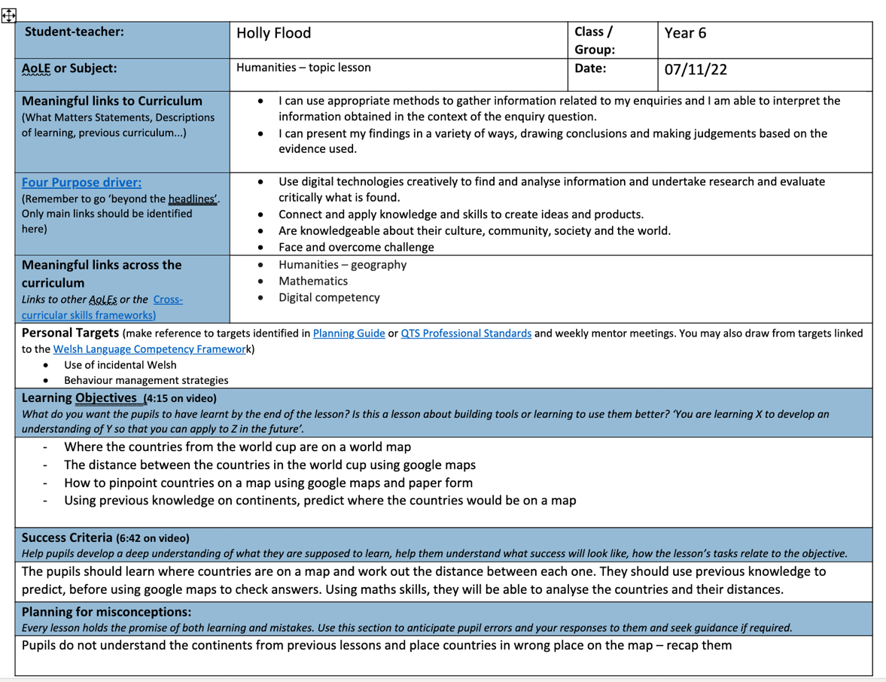
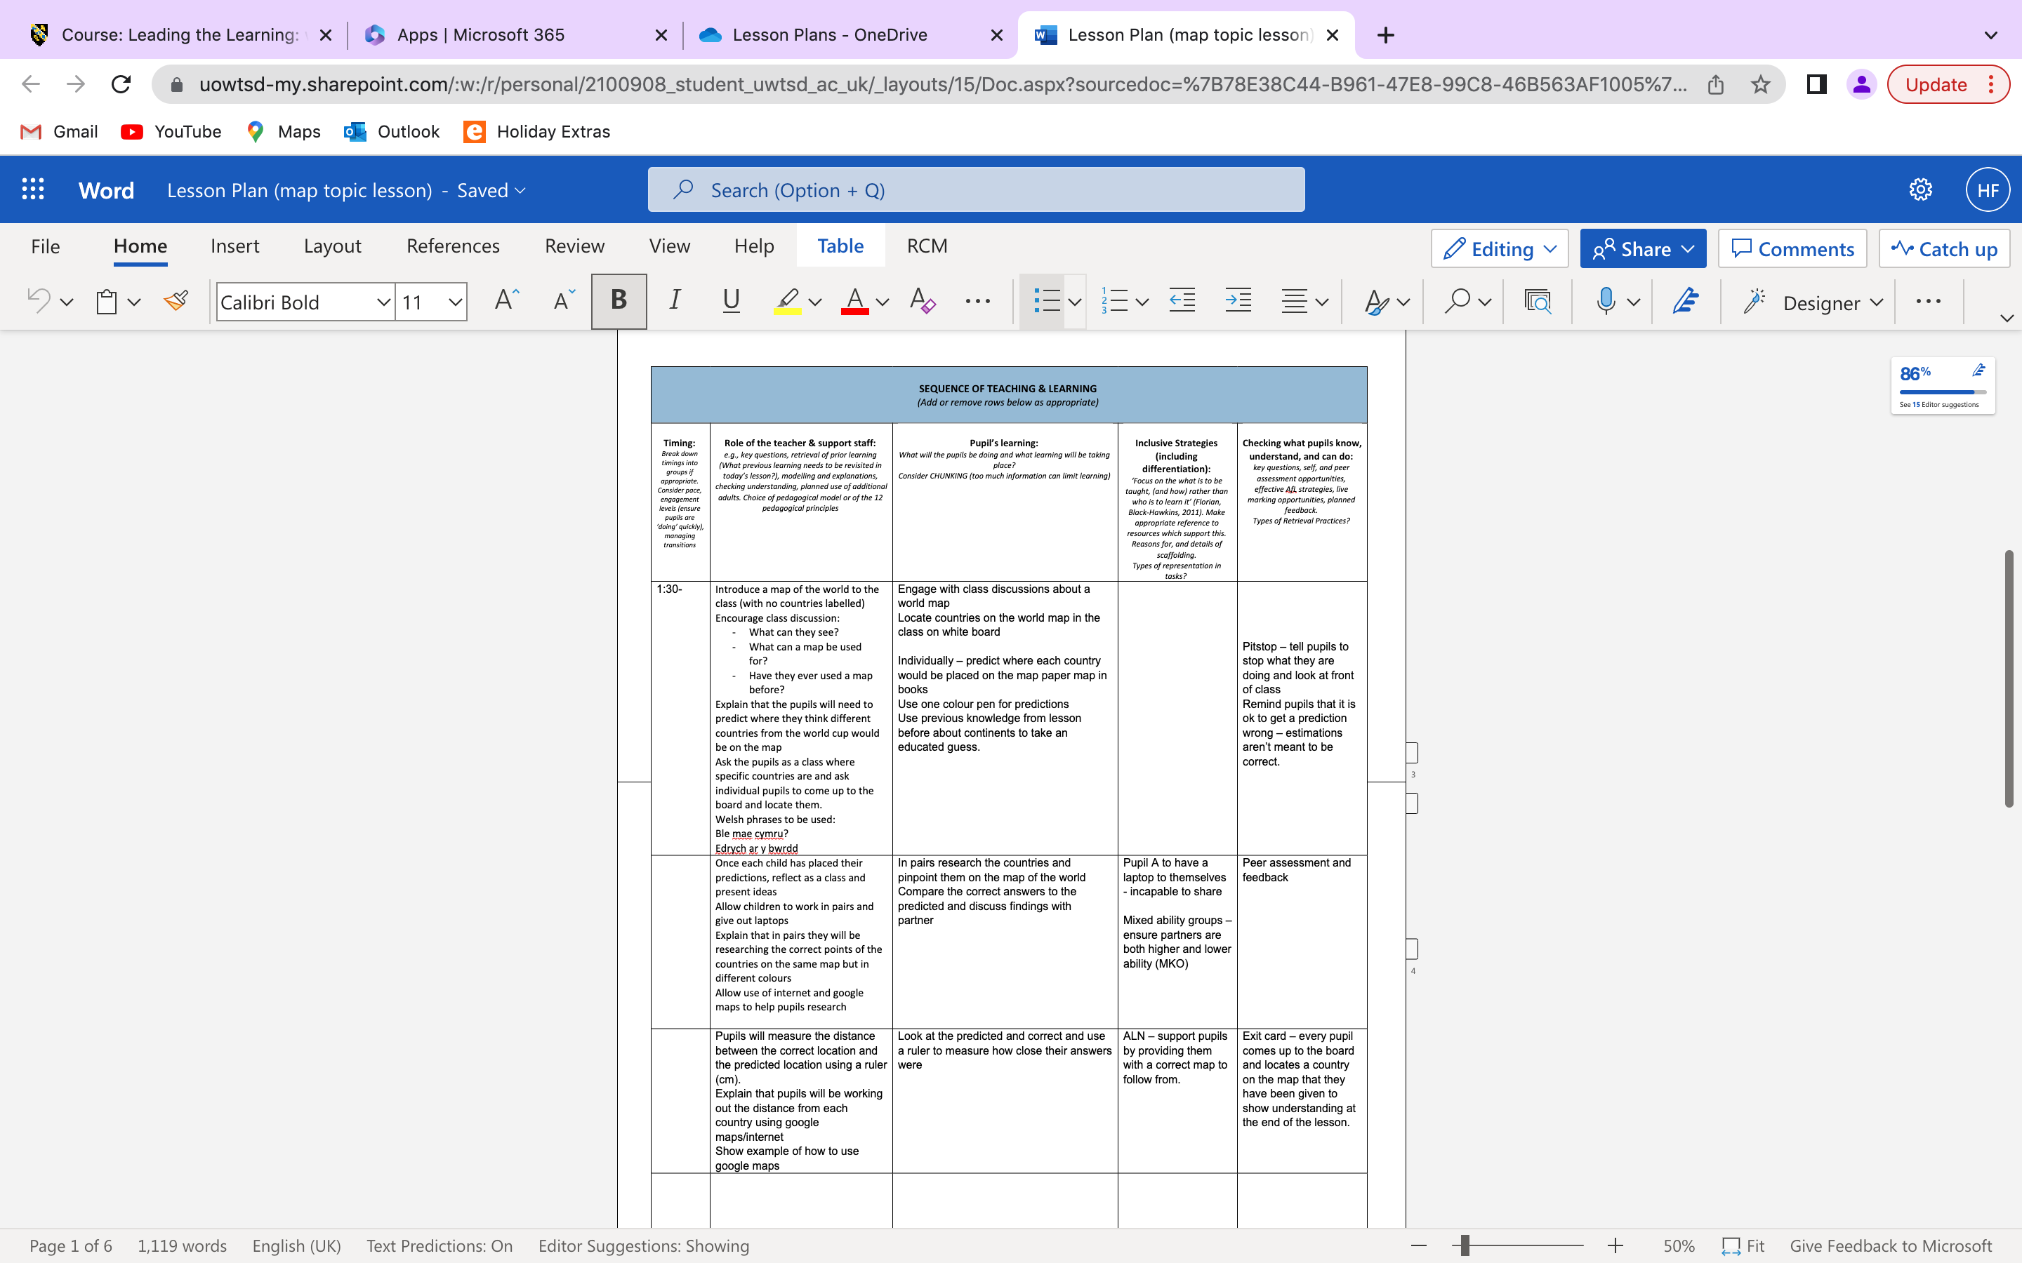

(2)
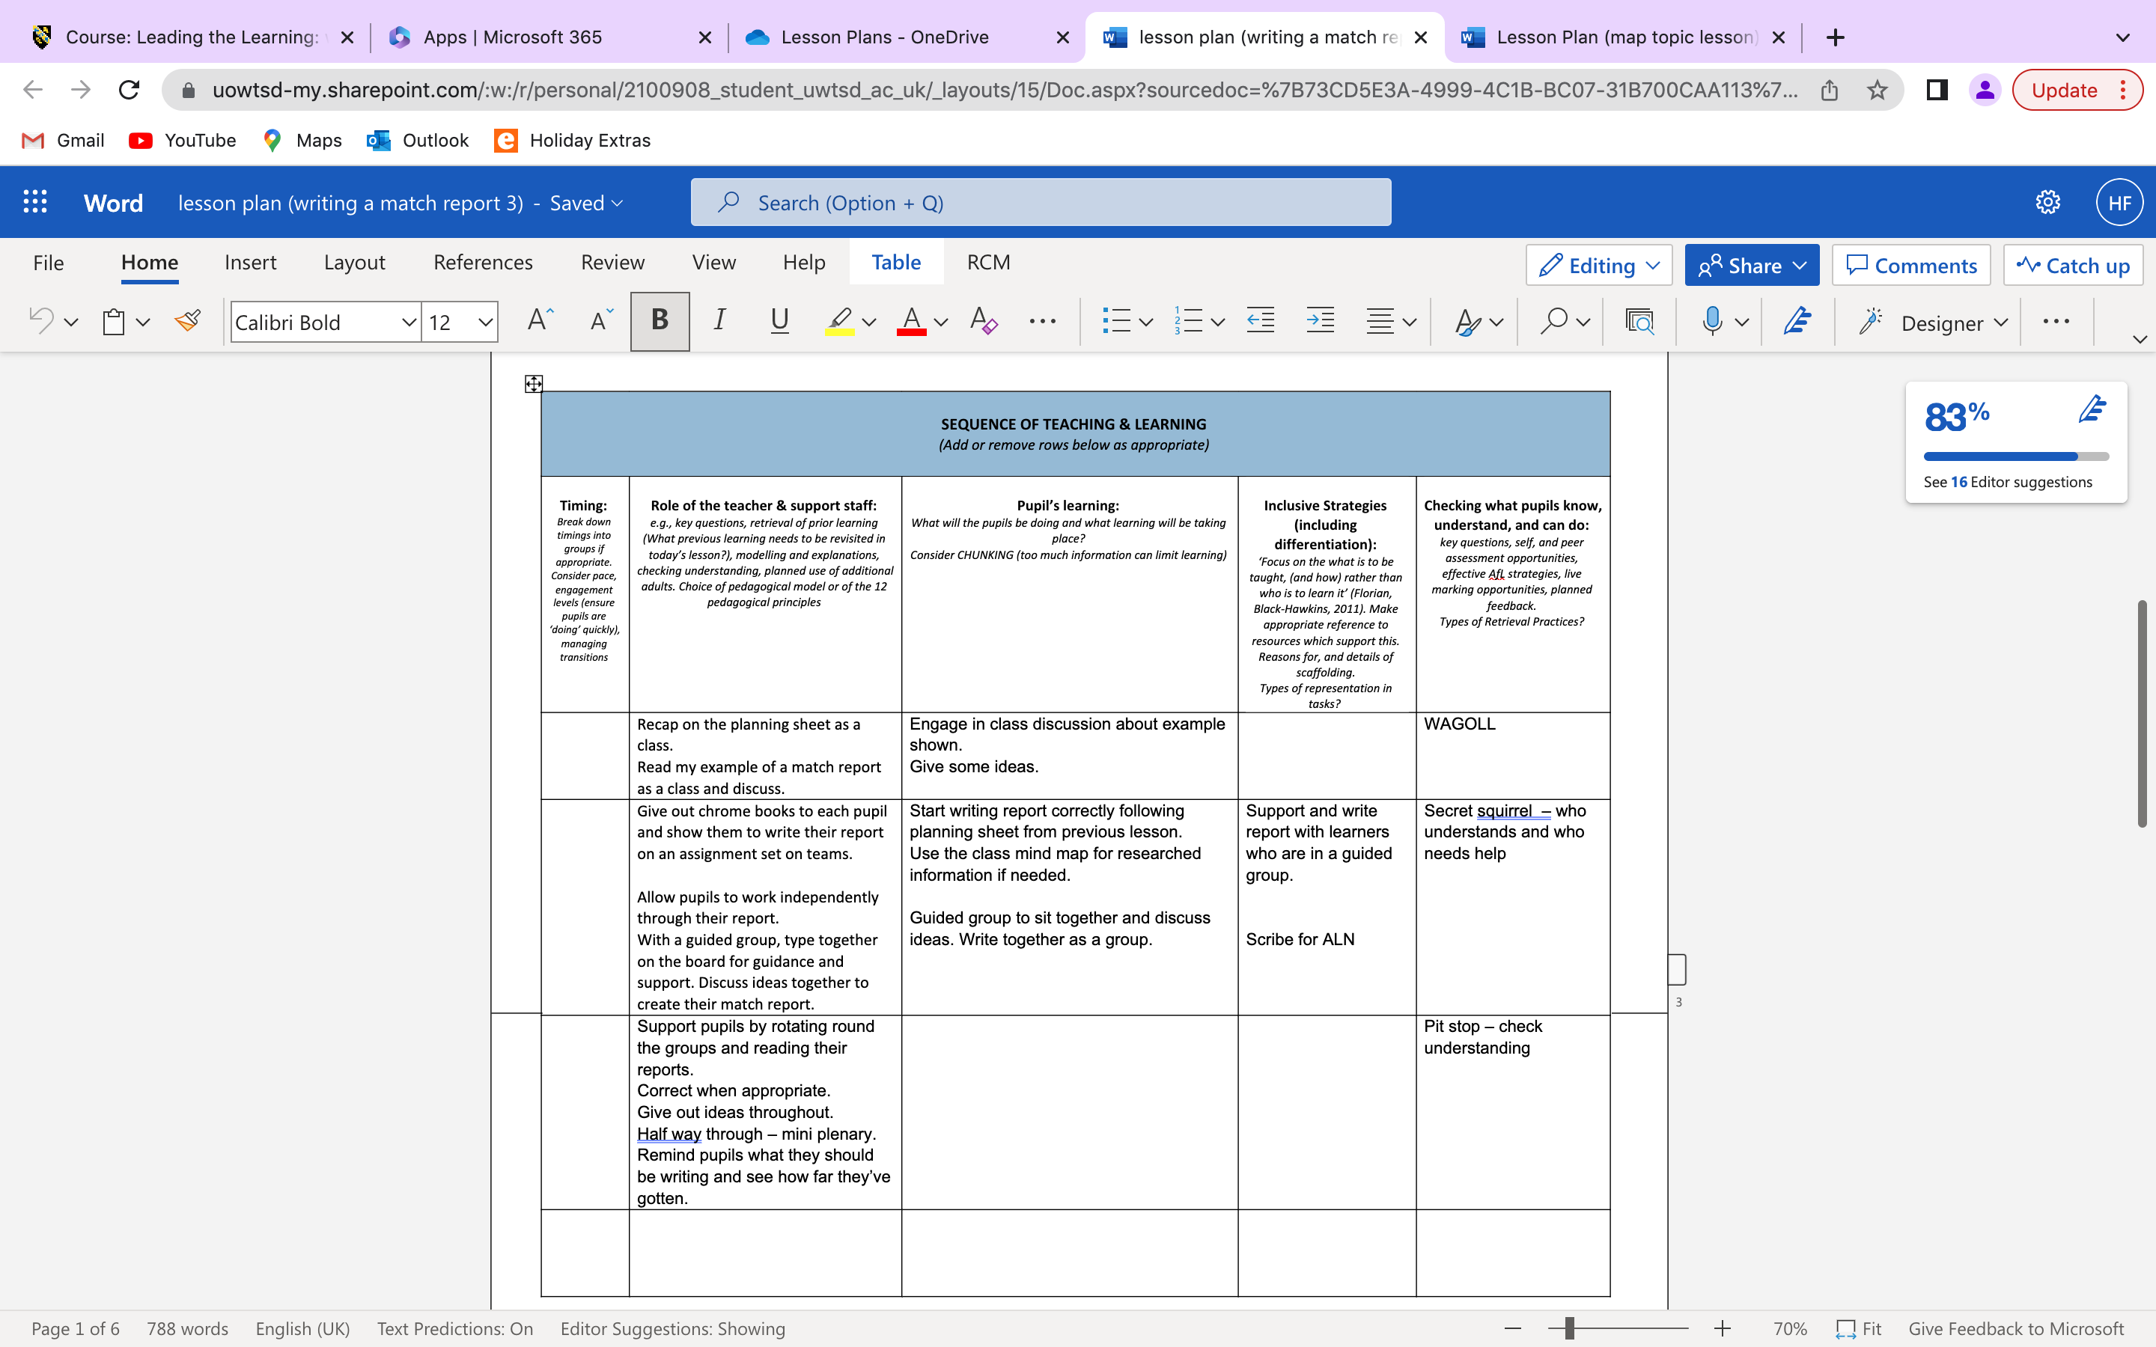
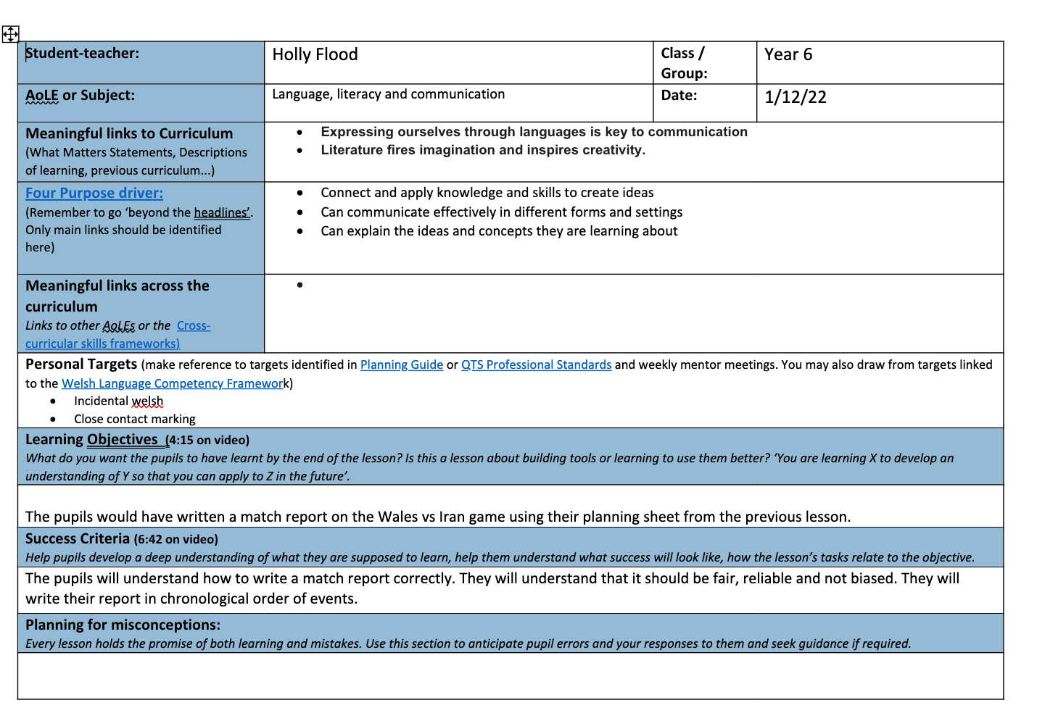
(3)


