BMMB7007
Human Resource Management
Name
Jiale Tong
Student Number
2217120
Improvement of an HR priority area: Managing equality, diversity, and equity at Tesla

Executive Summary
This report provides an analysis of the human resource management (HRM) priority area of equality, diversity, and equity in Tesla, a leading electric vehicle and clean energy company. The report identifies the current shortfalls of Tesla's HRM approach in this area, and examines the impact on the organization, its employees, and other stakeholders. The benefits of improving the management of equality, diversity, and equity are also discussed.
The analysis shows that Tesla's HRM approach to equality, diversity, and equity falls short in various ways, leading to negative impacts on the organization and its employees. The lack of diversity in leadership and the workforce can lead to groupthink and reduced innovation. The report highlights the importance of effective HRM in ensuring a diverse, inclusive, and equitable workplace, with benefits such as improved performance, enhanced reputation, and increased employee engagement and retention.
Based on the analysis, the report provides several feasible recommendations for Tesla's HR function to improve its approach to equality, diversity, and equity. These include implementing unconscious bias training, adopting a diverse candidate slate approach for recruitment, establishing employee resource groups, and conducting regular diversity audits. The report highlights potential risks and ethical issues associated with these recommendations and emphasizes the need for a comprehensive and sustained approach to HRM in this area.
Overall, this report recommends that Tesla takes proactive steps to improve its HRM approach to equality, diversity, and equity to ensure a more inclusive and equitable workplace, enhance its performance and reputation, and meet the needs and expectations of its stakeholders.

Contents

Executive Summary 2
Table of Figures 4
- Introduction 5
- Organizational structure 5
- Main Discussion 6
3.1 HRM Priority Area: Managing Equality, Diversity, and Equity 6
3.2 Current Shortfalls 7
3.3 Impact on the Organization 9
3.4 Benefits of Improving Equality, Diversity, and Equity 11
- Conclusion 12
- Recommendations 13
References 15
Appendices 18

Table of Figures
Figure 1: Tesla Diversity, Equity and Inclusion data (Tesla, 2020) 17
Figure 2: Diversity management impact on Employees and Organizational Performance (Nguyen et al., 2022) 18
Figure 3: Likelihood of financial outperfomance from diversity (Dixon-Fyle et al., 2020) 18
Figure 4: Workplace Gender Gaps (Sault 2020) 19
Figure 5: Gender pay gaps by race (Sault 2020) 19
Figure 6: Impact Of Diversity on perfomance (Sault 2020) 20

- Introduction
Organizations now recognize the importance of their employees in achieving strategic goals, which has given the field of human resource management (HRM) a great deal of importance in today's business environment. To make sure that organizations are inclusive and diverse, managing diversity, equality, and equity is a top priority for HRM. The purpose of this report is to examine Tesla Inc.'s (a well-known automotive and energy company) HRM priorities. The report will go over the organization's current practices for managing diversity, equality, and equity, as well as the consequences of any shortcomings and the advantages of making improvements. In addition, while taking into account the organization's resources and challenges, the report will offer suggestions for how to improve these areas within the organization.
- Organizational structure
Tesla Inc. was selected as the subject of this report. Tesla is a U.S.-based electric vehicle and clean energy manufacturer and retailer of electric vehicles, solar panels, energy storage systems, and related goods. The business has operations all over the world and was established in 2003. Its headquarters are in Palo Alto, California. Tesla has over 99,000 employees. The business has production facilities in California, Nevada, New York, and China, as well as sales and service offices in numerous nations worldwide (Zippia, 2022). In terms of size, Tesla is a sizable business with a sizable global footprint. At Tesla, Chris Winton, a former chief people officer at FedEx, is in charge of HRM. He is responsible for all facets of HR, including hiring new employees, training and development, compensation and benefits, HR systems, and employee relations. Tesla's Chief Executive Officer (CEO) is Elon Musk, who holds a key executive position in the company's HRM division (Khan, 2021). The HR department at Tesla is in charge of overseeing a diverse workforce with a range of backgrounds, abilities, and experiences while also making sure that every employee is treated equally.
- Main Discussion

3.1 HRM Priority Area: Managing Equality, Diversity, and Equity
Tesla's HRM priority area that requires improvement is managing equality, diversity, and equity. Equality and diversity are critical aspects of workplace culture that not only help a company's image but also improve its performance. It is critical to foster an inclusive workplace culture that values diversity and promotes equal opportunity (Shore et al., 2018). According to proponents of diversity management theory, the key to successful diversity management is fostering a welcoming and supportive work environment where all employees are respected and valued for their unique contributions (Yadav & Lenka 2020). Companies must be sensitive to the diverse cultural backgrounds of their employees, customers, and stakeholders as awareness of diversity and inclusion grows.
Tesla, a leading electric vehicle and clean energy company, has a diverse workforce that includes people from various cultural backgrounds. However, the company's diversity and inclusion policies need to be improved further. HR policies and practices at the company must be more comprehensive and inclusive. Previously, the company was accused of racial and gender discrimination. For example, in 2017, a former African American employee filed a lawsuit against Tesla, alleging racial harassment and discrimination at the company's California factory (Kari 2022). According to reports, since 2014, 145 discrimination related complaints against Tesla have been filed with California Department of Fair Employment and Housing (Bloomberg, 2022).
This shortcoming has had a negative impact on the company. First and foremost, the company's image has suffered as there has been several lawsuits due to the same. Tesla is a company that takes pride in being innovative and forward-thinking. Any negative publicity about the company's work culture can severely harm its reputation. Second, there is a risk of valuable talent being attracted by competitors. If a company does not foster an inclusive workplace culture, it risks losing valuable employees to competitors (Dolan et al., 2020). Finally, it may result in legal and financial consequences. Tesla has been the subject of several lawsuits which can harm the company's reputation as well as incur significant financial costs.
Improving diversity, equity, and inclusion can benefit the organization as a whole, as well as its employees and other stakeholders. Companies that value diversity and inclusion have higher levels of innovation, employee engagement, and customer satisfaction, according to research. A McKinsey & Company study, for example, discovered that companies in the top quartile for gender diversity were 21% more likely to have financial returns above their national industry medians (Dolan et al., 2018). Overall, it is critical for Tesla to improve its diversity and inclusion policies in order to improve its image and employee engagement and performance. To create a more inclusive workplace, the company must take proactive steps to address flaws in its policies and practices.

3.2 Current Shortfalls
Despite Tesla's commitment to diversity and inclusion, the company still has several gaps in its management of equality, diversity, and equity. Underrepresentation of certain groups in the workforce, particularly women and minorities, is one of the current shortfalls. Tesla's U.S. workforce is 60% White, 20% Asian, 7% Hispanic/Latinx, 5% Black/African American, and less than 1% Native Hawaiian/Pacific Islander and American Indian/Alaska Native, according to the company's 2020 diversity report (Tesla, 2020). Although the company has made some progress in diversifying its workforce, these statistics show that certain groups are still underrepresented.
Furthermore, Tesla's diversity and inclusion policies have not been fully implemented across the organization. The Harvard model states that HRM policies must take stakeholder interests and situational considerations into account, which would help improve diversity and inclusivity. Such implementations would help the company towards meeting its diversity and inclusivity goals.
Another current shortcoming at Tesla is the lack of diversity in leadership positions. According to the company's 2020 proxy statement, the executive team is predominantly White and male, with just 4% of people of color holding executive positions (Bloomberg. 2022). This lack of diversity in leadership positions can stymie women's and minorities' career advancement and perpetuate systemic inequalities within the organization.
These shortcomings in managing equality, diversity, and equity may have serious consequences for Tesla. According to research, companies with diverse workforces are more innovative, have better problem-solving abilities, and are better equipped to meet the needs of diverse customers (Dolan et al., 2020)). Organizations that lack diversity, on the other hand, are more likely to experience groupthink and may struggle to adapt to changing market demands. Furthermore, workplace discrimination and harassment can lead to lower employee morale, lower productivity, and higher turnover rates, all of which can be costly to the organization (Sims, 2022). As a result, it is critical for Tesla to address these current gaps in managing equality, diversity, and equity in order to ensure the company's long-term success.

3.3 Impact on the Organization
The current deficiency in managing equality, diversity and equity within Tesla has a significant impact on the organization. One of the most immediate consequences is the possibility of legal action being taken against the company. Discrimination lawsuits can be costly, both financially and in terms of reputational damage. Tesla has already faced multiple lawsuits alleging employee discrimination based on race, gender, and age. In 2018, a former African American employee sued Tesla, alleging that he was subjected to racial harassment and discrimination while working at one of the company's facilities (Kari 2022). In 2021, the company was fined $137 million to pay a former contractor over discrimination claim (Hernandez, 2021). These lawsuits emphasizes the importance of Tesla prioritizing workforce diversity and equity in order to avoid further legal issues and negative public perception.
A possible loss of talent is another consequence of Tesla's existing weaknesses in managing equality, diversity, and equity. Companies that value diversity and inclusion have a more engaged and pleased staff, which may contribute to higher productivity and retention, according to research (Nguyen et al., 2022). Businesses that fail to encourage diversity and inclusion risk losing top talent, particularly from underrepresented groups, who are more likely to quit owing to a lack of chances and a perception of undervaluation (Carden 2023). Given that Tesla works in a highly competitive and continuously expanding business, retaining top staff is vital to its success. As a result, prioritising diversity and inclusion is crucial for keeping a varied and high-performing staff.
Apart from legal and talent problems, Tesla's present lack of equality, diversity, and equity management may have a detrimental impact on staff morale and motivation. According to social identity theory, people at work will feel a sense of belong when they can identify with a specific social group (Raskovic, M. and Takacs-Haynes, 2021. Workers who do not feel appreciated or encouraged may become disengaged, which leads to lower productivity and creativity. A lack of diversity and inclusion may also lead to a toxic workplace culture in which harassment and discrimination are tolerated, further eroding employee morale and motivation (Kirton and Greene, 2021). With Tesla's reputation for promoting an inventive and high-performance culture, a hostile work environment may have a substantial impact on the company's capacity to attract and retain top employees, as well as innovate.
Furthermore, Tesla's present lack of equality, diversity, and equity management may harm the company's reputation and brand image. In recent years, there has been a rising realization in society and industry of the importance of diversity and inclusion. Businesses that fail to emphasize diversity and inclusion run the danger of being viewed as disconnected from society and uncaring about social responsibility (Kirton and Greene, 2021). As a result, they may acquire unwanted exposure, endangering their reputation and brand image. With Tesla's commitment to sustainability and social responsibility, failure to promote diversity and inclusion may contradict the company's ideals and hurt the company's brand image.
Overall, Tesla's current lack of management of equality, diversity, and equity has significant negative consequences for the organization, including legal risks, talent loss, a negative impact on employee morale and motivation, and harm to the company's reputation and brand image. To mitigate these risks and ensure its long-term success, Tesla must prioritize diversity and inclusion.

3.4 Benefits of Improving Equality, Diversity, and Equity
Improving equality, diversity, and equity management can help Tesla in a variety of ways. Firstly, it has the potential to improve organizational performance. The incorporation of various perspectives, ideas, and ways of thinking has the potential to drive innovation and creativity, resulting in a market competitive advantage (Bernstein et al., 2020). From figure 6, there is a positive relationship between diversity and employee performance. The human capital theory investing in employees' growth and well-being may boost performance and productivity (Islam and Amin 2021). This is especially true for Tesla, which works in the technology industry, where innovation and continuous improvement are critical to success.
Second, it can result in a more engaged workforce. A diverse workforce that feels valued and respected is more likely to be engaged and motivated at work (SHRM, 2021). This may lead to increased productivity and employee retention. According to the social identity theory, employees get self-esteem when they can be able to freely identify with specific social groups (Raskovic and Takacs-Haynes 2021). Tesla has faced several employee turnover and retention issues, particularly in its manufacturing plants. Improving diversity and inclusion management can assist in addressing some of these issues.
Third, improving management of equality, diversity, and equity can help Tesla's employer reputation. Due to increased complaints, particularly in California, the company has received negative publicity in recent years, particularly regarding its treatment of female employees and people of color (Kari, 2022). Improving diversity and inclusion can aid in addressing these issues and making Tesla a more appealing employer to a broader range of candidates. This can assist the company in attracting and retaining top talent, as well as in establishing a more positive public image.
Finally, better managing equality, diversity, and equity can have a societal impact. Tesla is a multinational corporation with the potential to shape the culture and norms of the communities in which it operates. By promoting diversity and inclusion, the company can serve as a model for others to follow, thereby contributing to the creation of a more inclusive and equitable society (Bernstein et al., 2020). Long-term social and economic benefits may result from this.
Overall, improving management of equality, diversity, and equity can benefit Tesla in a variety of ways, including improved organizational performance, a more engaged workforce, enhanced employer reputation, and a positive social impact. Tesla can position itself for long-term success in an increasingly competitive and socially conscious business environment by addressing current shortfalls and promoting a more diverse and inclusive workplace.
- Conclusion
In conclusion, this report has evaluated the HRM priority area of managing equality, diversity, and equity in Tesla. It has been established that there are current shortfalls in the organization that need improvement, including the lack of diversity among the workforce, gender pay gap, and lack of diversity in leadership positions. These shortcomings have negatively impacted the organization by limiting innovation, creativity, and overall growth. However, if these issues are addressed, it will result in benefits for the organization, employees, and other organizational stakeholders. This includes increased creativity, innovation, better decision-making, higher employee morale, enhanced company reputation, and increased profitability.

- Recommendations
Based on the analysis above, the following recommendations are made to improve Tesla's priority area of managing equality, diversity, and equity:
- Develop and implement a clear and comprehensive diversity and inclusion strategy: Tesla should create and implement a diversity and inclusion strategy that outlines specific goals, objectives, and actions to improve the representation and inclusion of underrepresented groups within the organization. All relevant parties should be used to come up with a solid inclusivity strategy. The Ulrich and Brockbank model recommends our HRM roles that could be important in this task; employee champions, administrative experts, change agents, and strategic partners (Francis, H. and Keegan, 2006)
- Provide regular diversity and inclusion training and education: Tesla should provide regular diversity and inclusion training and education to all employees, including senior leadership. According to the human capital theory, investing in employees' growth and well-being may boost performance and productivity (Islam and Amin 2021). The trainings can include topics such as unconscious bias, cultural competence, and macroaggressions. Training should be mandatory for all employees and integrated into the onboarding process for new hires.
- Increase transparency and accountability: Tesla should increase transparency and accountability around diversity and inclusion by publicly reporting on progress toward diversity and inclusion goals and sharing diversity and inclusion metrics with employees. This will help to ensure that the organization is held accountable for progress and will provide a clear picture of how the organization is doing.
- Improve underrepresented group recruitment and retention: Tesla should prioritize underrepresented group recruitment and retention in the organization by actively seeking out diverse candidates for open positions, reviewing job descriptions and requirements to ensure they do not create barriers for underrepresented groups, and creating an inclusive work environment that values and supports all employees. Diversity management theory argues that effective diversity management involves creating an inclusive workplace culture that values differences and promotes equal opportunities for all employees (Yadav & Lenka 2020).
- Conduct regular diversity and inclusion assessments: Tesla should conduct regular diversity and inclusion assessments to identify areas for improvement, measure progress, and make necessary changes to ensure a diverse and inclusive work environment. To ensure impartiality and objectivity, the assessments should be carried out by an independent third party.

References
Bernstein, R.S., Bulger, M., Salipante, P. and Weisinger, J.Y., 2020. From diversity to inclusion to equity: A theory of generative interactions. Journal of Business Ethics, 167, pp.395-410.
Bloomberg 2022. Tesla shares first diversity report: Here is what it says. https://tech.hindustantimes.com/tech/news/tesla-shares-first-diversity-report-here-s-what-it-says-71607256317506.html
Carden, L.L., 2023. Diversity and inclusion: Multilevel recommendations. Journal of Management & Organization, pp.1-13.
Dixon-Fyle, S., Dolan, K., Hunt, V. and Prince, S. (2020). Diversity wins: How inclusion matters. [online] McKinsey & Company. Available at: https://www.mckinsey.com/featured-insights/diversity-and-inclusion/diversity-wins-how-inclusion-matters.
Dolan, K., Hunt, V., Prince, S. and Sancier-Sultan, S., 2020. Diversity still matters. McKinsey Quarterly, 19.
Hernandez, J. (2021). Tesla must pay $137 million to a Black employee who sued for racial discrimination. NPR. [online] 5 Oct. Available at: https://www.npr.org/2021/10/05/1043336212/tesla-racial-discrimination-lawsuit.
Islam, M.S. and Amin, M., 2021. A systematic review of human capital and employee well-being: putting human capital back on the track. European Journal of Training and Development, 46(5/6), pp.504-534.
Kari, P., 2022. The Guardian. Black workers accused Tesla of racism for years. Now California is stepping in. Available at: https://www.theguardian.com/technology/2022/feb/18/tesla-california-racial-harassment-discrimination-lawsuit. Accessed: 18 February 2023
Khan, M. R. (2021). A critical analysis of Elon Musk’s leadership in Tesla motors. Journal of Global Entrepreneurship Research, 1-10.
Kirton, G. and Greene, A.M., 2021. The dynamics of managing diversity and inclusion: A critical approach. Routledge.
Nguyen, N.T., Yadav, M., Pande, S., Bhanot, A. and Hasan, M.F., 2022. Impact of diversity management on organizational performance in hotel organizations: a conceptual framework. International Journal of System Assurance Engineering and Management, pp.1-11.
Raskovic, M. and Takacs-Haynes, K., 2021. (Re) discovering social identity theory: An agenda for multinational enterprise internalization theory. Multinational Business Review, 29(2), pp.145-165.
Sault, S. (2020). What you need to know about equity, inclusion and social justice in the workplace. [online] World Economic Forum. Available at: https://www.weforum.org/agenda/2020/10/equity-inclusion-and-social-justice-in-the-workplace/.
Shore, L.M., Cleveland, J.N. and Sanchez, D., 2018. Inclusive workplaces: A review and model. Human Resource Management Review, 28(2), pp.176-189.
Sims, C.S., 2022. Harassment and Discrimination on the Basis of Gender and Race/Ethnicity in the Federal Emergency Management Agency Workforce. RAND.
Society for Human Resource Management (SHRM). (2018). Diversity, Inclusion, and Equity: Overview. Available at: https://www.shrm.org/resourcesandtools/hr-topics/pages/diversity-equity-and-inclusion.aspx Accessed: 18 February 2023
Tesla (2020). U.S. Diversity, Equity and Inclusion Report. Available at: https://www.tesla.com/blog/us-diversity-equity-and-inclusion-report Accessed: 18 February 2023
Yadav, S., & Lenka, U. (2020). Diversity management: a systematic review. Equality, Diversity and Inclusion: An International Journal, 39(8), 901-929.
Zippia (2022). TESLA STATISTICS AND DEMOGRAPHICS. Available at: https://www.zippia.com/tesla-careers-11363/demographics/ Accessed: 18 February 2023

Appendices

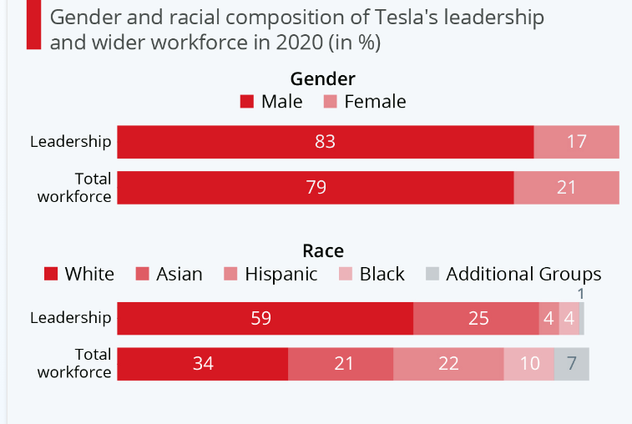
Figure 1: Tesla Diversity, Equity and Inclusion data (Tesla, 2020)
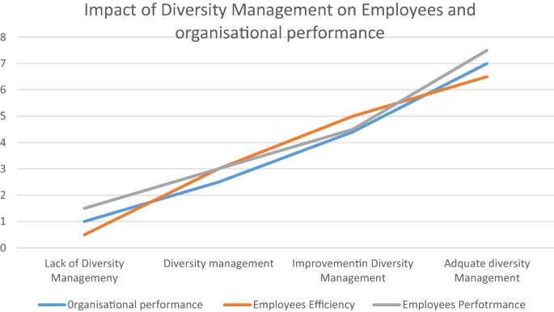
Figure 2: Diversity management impact on Employees and Organizational Performance (Nguyen et al., 2022)
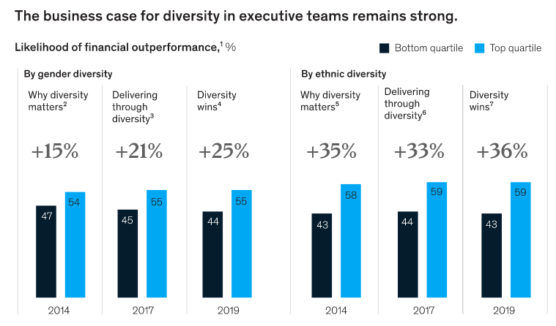
Figure 3: Likelihood of financial outperfomance from diversity (Dixon-Fyle et al., 2020)
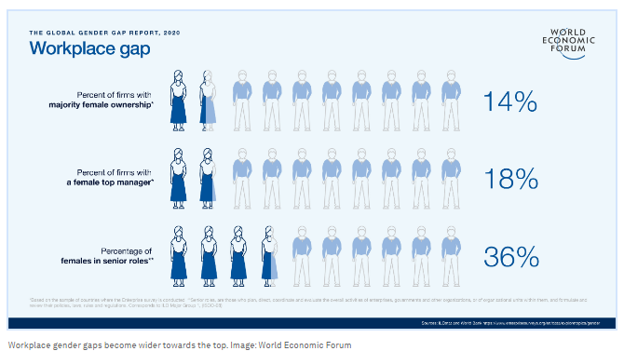
Figure 4: Workplace Gender Gaps (Sault 2020)
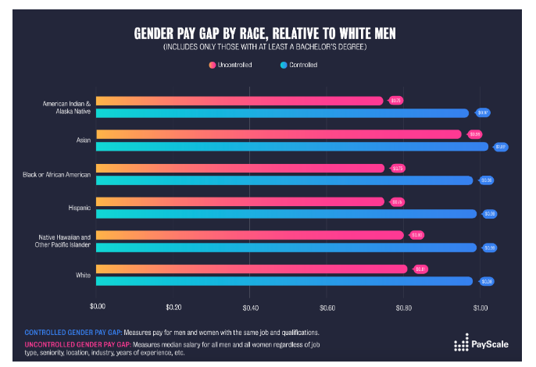
Figure 5: Gender pay gaps by race (Sault 2020)
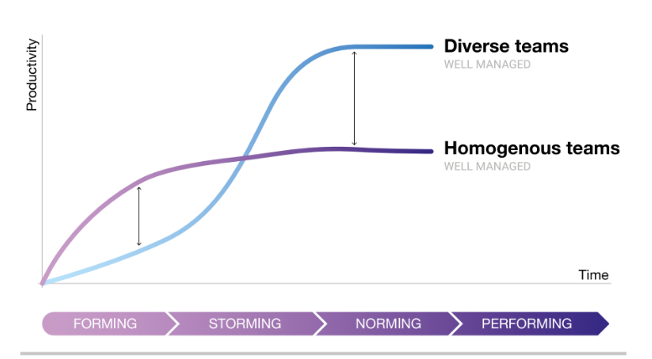
Figure 6: Impact Of Diversity on perfomance (Sault 2020)

