
Assignment
Portfolio – Two Tasks
- Task 1: Pharmacy Services
- Task 2: Community Mental Health Services

Student Names: Sadia Batool (2512945)
Module Code: LCHS4003
Module Title: Introduction to Health and Social Care
Lecturer's Name: Farah Islam

Submitted on: 28/06/2026

What is a Pharmacy Service?
A community pharmacy is run by a qualified pharmacist and sits at the heart of local healthcare. People can walk in for medicines, clinical advice, or public health support without booking an appointment in advance. Pharmacies are found throughout local communities, which makes them one of the most accessible points of entry into the NHS. Their work covers a wide range of tasks: supplying medication, carrying out health checks, giving self-care guidance, promoting healthier behaviours, and referring patients onwards when a problem needs more specialist attention.
Task 1: Pharmacy Services

Challenges Facing Pharmacy Services?

Medicine Shortages
Getting hold of certain medicines has become an increasingly serious problem for pharmacies across England, driven by global supply chain disruptions, manufacturing issues, and currency fluctuations that affect the cost of importing drugs. According to Healthwatch, 2025, medicine shortages were among the most raised concerns among pharmacy patients, with some waiting for days or weeks for essential medication. The knock-on effects go beyond inconvenience: for patients managing chronic conditions such as diabetes or epilepsy, a gap in medication supply can have direct consequences for their health and safety. Pharmacists dealing with shortages must spend time they do not always have contacting prescribers, sourcing alternatives, and counselling worried patients
Impact: Beyond the individual patient, medicine shortages place added administrative pressure on an already stretched pharmacy workforce, according to the Nuffield Trust (2023).

Lack of Public Awareness of Pharmacy Services
Many people still do not know that pharmacists are qualified to assess and treat a wide range of common conditions without a GP referral. A Healthwatch report found that awareness of the Pharmacy First scheme, which allows pharmacists to treat seven specific conditions, including sinusitis and urinary tract infections, remained patchy a year after its launch, with many patients still defaulting to GP visits or A&E for these conditions out of habit or unfamiliarity, according to Healthwatch, 2025. This imposes a real cost on the health system: unnecessary GP appointments consume clinical time that could be directed to more complex cases, while patients wait longer than necessary for straightforward conditions that a pharmacist could resolve on the spot
Impact: Each avoidable GP visit carries both a financial and an opportunity cost. NHS England estimates that the average GP appointment costs around £30–40, meaning even modest shifts in patient behaviors towards pharmacies could generate significant system-wide savings — as well as faster care for patients.

Somerset Gardens Family Health Centre, n.d

What Community Pharmacies Offer?
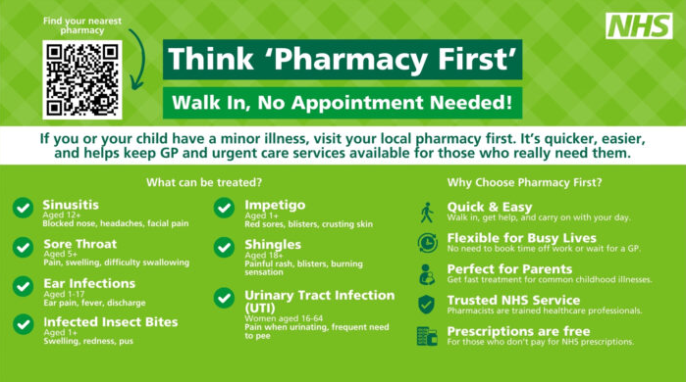
Medicines Optimization
New Medicine Service (NMS), inhaler technique checks
Community pharmacies provide people with quick access to advice, medicines, and basic treatment. If a condition turns out to be more serious than first thought, the pharmacist can refer the patient to a GP or, if urgent, to A&E.
Preventative Care
Flu Vaccines, Blood Pressure Checks, and Smoking Cessation

Dispensing Prescription
NHS electronic prescription from GPs or hospitals
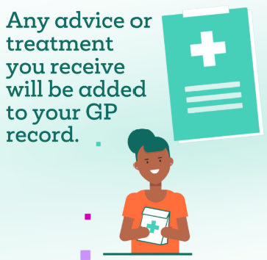
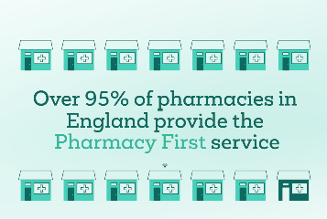
Minor Ailments Treatment
Sore Throat, Hay Fever, Acne, Cystitis, Thrush

Pharmacy First Service
Provides assessment, advice, and treatment for common conditions without needing a GP

(Somerset Gardens Family Health Cenre, n.d)
What Happens at a Pharmacy

STEP 2:
The pharmacist decides what to do
Threat or refer to GP / A&E
STEP 1:
The patient goes to the pharmacy

The pharmacist checks the problem

STEP 3:
Prescription is sent online
The pharmacy received it safely
STEP 4:
Medicine is checked
Patient gets medicine and advice
(Custom Compounding Pharmacy, n.d)

What can a pharmacy help with?

Why it matters:
Patients can get help quickly for common health problems without waiting for a GP appointment. The pharmacist checks that medicines are safe and can refer patients for more urgent care if needed.

Where pharmacies are
On high streets, in supermarkets, and in health centres
When they are open
Many are open in the evenings and at weekends

Pharmacy History Lesson
Community pharmacy has a history stretching back centuries, but its modern role is very different from its origins. Early pharmacists, known as apothecaries, compounded medicines by hand and operated largely independently from formal healthcare structures. The creation of the NHS in 1948 brought pharmacy formally into the public health system, establishing the dispensing contract that still underpins community pharmacy today. Over subsequent decades, the profession expanded steadily beyond dispensing: the introduction of the New Medicine Service in 2011 and the Pharmacy First scheme in 2024 are among the most significant recent policy steps, each reflecting a political and professional consensus that pharmacists should be doing more clinical work. This shift matters because it repositions pharmacists not simply as suppliers of medication but as the first point of clinical contact for millions of people — a role that carries both opportunity and responsibility

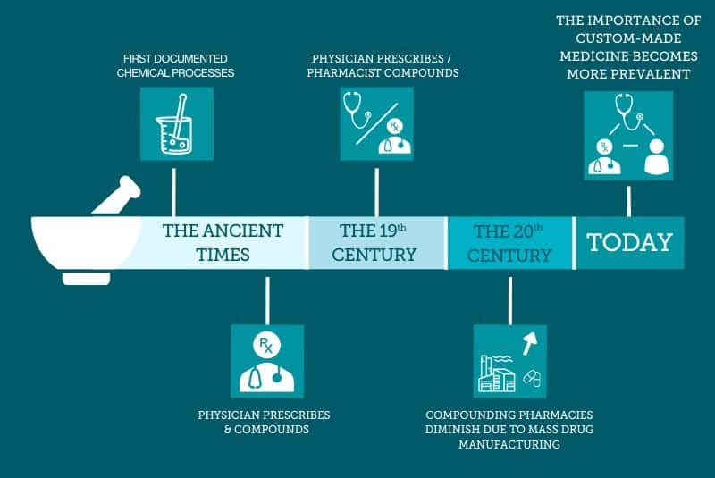

(Custom Compounding Pharmacy, n.d)
Task 2: Community Mental Health Services
Introduction
Community Mental Health Services (CMHS) provide support to help people with mental health needs and remain part of their communities. Rather than relying on long hospital stays, these services supply assessment, treatment, and ongoing support close to home. In England, CMHS aim to promote recovery, independence, and dignity. This essay examines the origins of these services, their current functioning, and their impact on quality of life.

History of Service
Until the mid-20th century, most mental health care in Britain was delivered in large psychiatric hospitals. Hospitals were meant to provide safety and treatment, but many became overcrowded and isolated people from society. Patients were separated from family, friends, and daily life, increasing isolation and reducing independence. This shift reflected a growing belief that people with mental health needs should be supported in less restrictive settings and remain part of society.

Key developments shifted mental health care into the community. The Mental Health Act 1959 encouraged a more therapeutic approach and gave local authorities more responsibility for aftercare (Legislation.gov.uk, 1959). The 1962 Hospital Plan supported the reduction of hospital-based services (UK Parliament Hansard, 1962). New psychiatric medications reduced the need for long hospital stays. Later, Care in the Community promoted links between mental health services, housing, social care, employment, and primary care.
Community care was seen as a more humane way to help people live as normal a life as possible, challenging the idea of isolating those with mental health needs. However, the transition was uneven. Some hospitals closed before local services were ready, and underfunding remains a problem—CMHS still needs more trained staff, clear pathways, and reliable funding.

How CMHS Functions Today
In England, CMHS are delivered by multidisciplinary teams, including psychiatrists, nurses, psychologists, occupational therapists, social workers, peer support workers, and others. This mix is vital because mental health often overlaps with housing, unemployment, social isolation, and physical health. Integrated teams can address these challenges more effectively. NHS England encourages integrated, tailored care close to home for each person (NHS England, 2019; NHS England, 2026b).

A key benefit of CMHS is helping people avoid hospital admission. Crisis and home treatment teams support people through difficult times in less disruptive ways (NHS England, 2026c). CMHS also aid recovery by supporting choice, confidence, and community connections (NHS England, 2019).

However, CMHS do not always meet people’s needs. Services vary greatly depending on location. Many report feeling unsupported during crises and unsure who to contact (Care Quality Commission, 2021). Long waiting times are a serious problem; people may get worse while waiting for help (Mind, 2024). Staff shortages make these problems worse (Care Quality Commission, 2021; 2026).

Significance for Quality of Life
When CMHS work well, it can greatly improve the quality of life. Community support helps people stay close to family, friends, work, and local activities. Good services help people keep housing, cope with difficulties, and maintain daily routines. Recovery is not only about managing symptoms.

CMHS can do even more by linking mental health care with job advice, peer support, physical health, and help with social problems (NHS England, 2026a; 2026b). People receiving coordinated support feel better and are less likely to be readmitted to the hospitals (NHS England, 2019). This benefits both patients and the health system, as hospital care is expensive and frequently signals that earlier support failed. Investing in CMHS makes economic sense and supports recovery.

Conclusion
Community Mental Health Services emerged as attitudes toward mental illness shifted—moving from containment to focusing on recovery, inclusion, and self-determination. This change is ongoing. Today, CMHS seek to help people live well, maintain relationships, and have control over their care. NHS policy supports these goals, promoting integrated and person-centred care (NHS England, 2019). However, a gap remains between policy and people’s experiences. Closing this gap demands sustained investment in staff, facilities, and support to enable recovery.

References
- Care Quality Commission (2021) Community Mental Health Survey 2021. Available at: www.nhssurveys.org/surveys/survey/05-community-mental-health/ (Accessed: 9 June 2026).
- Care Quality Commission (2026) Surveys. Available at: www.cqc.org.uk/publications/surveys (Accessed: 9 June 2026).
- Custom Compounding Pharmacy (n.d.) The evolution of pharmacy. Available at: https://customcompounding.com.au/the-evolution-of-pharmacy/ (Accessed: 27 June 2026).
- Healthwatch. (2025) One year on: How is Pharmacy First working for patients? Available at: https://www.healthwatch.co.uk/report/2025-06-30/one-year-how-pharmacy-first-working-patients (Accessed: 20 June 2026).
- Legislation.gov.uk (1959) Mental Health Act 1959. Available at: www.legislation.gov.uk/ukpga/Eliz2/7-8/72/contents (Accessed: 9 June 2026).
- Mind (2024). We still can’t get the help we need: Mind’s report on mental health crisis care. Available at: https://www.mind.org.uk/media/a11jdkuz/we-still-can-t-get-the-help-we-need.pdf (Accessed: 15 June 2026).
- Nuffield Trust (2023). The pharmacy workforce: pressures and challenges. Available at: https://www.nuffieldtrust.org.uk/research/the-pharmacy-workforce (Accessed: 15 June 2026).
- NHS England (2019). The Community Mental Health Framework for Adults and Older Adults. Available at: www.england.nhs.uk/publication/the-community-mental-health-framework-for-adults-and-older-adults/ (Accessed: 9 June 2026).
- NHS England (2026a). Adult and Older Adult Mental Health. Available at: www.england.nhs.uk/mental-health/adults/ (Accessed: 9 June 2026).
- NHS England (2026b). Community Mental Health Services. Available at: www.england.nhs.uk/mental-health/adults/cmhs/ (Accessed: 9 June 2026).
- NHS England (2026c). Crisis and Acute Mental Health Services. Available at: www.england.nhs.uk/mental-health/adults/crisis-and-acute-care/ (Accessed: 9 June 2026).
- Somerset Gardens Family Health Centre (n.d.) Visit your Pharmacy First. Available at: https://www.somersetgardensfhcc.nhs.uk/visit-your-pharmacy-first (Accessed: 27 June 2026).
- UK Parliament Hansard (1962). The Hospital Plan. Available at: api.parliament.uk/historic-hansard/lords/1962/feb/14/the-hospital-plan (Accessed: 9 June 2026).

