

Are Industry 4.0 Capabilities, Using Legacy Equipment and a Shoestring Budget, a Viable Option for SMEs?
University of Wales Trinity Saint David
Wales Institute for Science and Art
Paul Michael Williams
P151245
01/06/2020
Major Project M6X00417
BEng Mechanical Engineering
Richard Morgan

‘This thesis is the result of the author’s original research. It has been composed by the author and has not been previously submitted for examination which has led to the award of a degree.’

Signed: P Williams Date: 01/06/2020

Acknowledgements
Firstly, I would like to thank my supervisor Richard Morgan, for his constant and invaluable guidance during the practical and literary aspects of this dissertation. Whose expertise initially pointed me in the direction of this subject area and sparked my imagination.
I would also like to thank Andy Tibbott and Dave Cooper for their supervision within the robotics laboratory and also their patience with my unending requests for tools and their valuable expertise.
Lastly, I would like to thank my wife for her valued support and patience during my entire university experience, without which, I would not have made it to this point.

Abstract
This project proposes an interesting premise, “Are Industry 4.0 Capabilities, Using Legacy Equipment and a Shoestring Budget, a Viable Option for SME’s?”. The introduction answers questions as to the relevance of the project. The literature review seeks to back up any work and or opinions expressed later in the report. The research completed includes, all relevant components of the project such as, industry 4.0, all the required parts for the actual implementation, the software that will be used, and any existing examples in industry to support the premise. The methodology shows all works carried out to complete the project. The analysis section shows how the results and data were to be analysed.
The findings of this report are, legacy equipment can certainly be brought into modern industry 4.0 uses, yes, this can be achieved with low cost and the skills to achieve these goals are available to the driven and enthusiastic people working towards these goals.

Covid-19 Statement
During 2020, there has been massive disruption on a global scale, across all walks of life. That disruption came in the form of the Covid-19 global pandemic. The lives lost is in the hundreds of thousands worldwide. The effect has been felt by all industries whether in education or large enterprises, businesses and enterprises of every kind has had a period of shutdown. UWTSD has also been affected and was closed on 20th March, this was to maintain the safety of staff and students and the wider community.
The closure meant that all remaining studies went to an online format for the foreseeable future. In the case of this project, the closure meant the project could not be completed as planned. The project stopped at an important juncture, the CNC machine was fully functioning, the appropriate sensors were programmed, but the sensors were not installed as planned. Furthermore, the data collection and analysis section went incomplete, this leaves certain sections in the following report woefully inadequate. The main sections affected are the analysis and conclusions. In place of true analysis, there is an explanation of the planned analysis, with as much detail as possible. Some of the code and expected results used here are for illustrative purposes, though the code shown is the base code for the sensors, and as such would have undergone some fine tuning for the purposes of this project. The actual code was saved on the Arduino and the computer in the Robotics Lab. As the lockdown happened quite suddenly, the code was not copied for use in this report, also at the time it was not known when the lockdown would be lifted. The conclusions drawn are purely conjecture, though some common sense and real-world examples have been used to make the conclusion as relevant as can be, in the circumstances.
Another affect the closure of the university has had upon this project is the closure of the library, this has led the author to use fewer books for the research. Purely because most of the books needed would only be available as a physical commodity at the library. The author has tried to use as many peer-reviewed articles and journal entries from the online library, in place of books that were not available. The technical information used in the literature review has come directly from the manufacturer’s websites, where it has been possible as this was deemed to be a credible source in relation to their own products.

Abbreviations
OEM – Original Equipment Manufacturer
SME – Small to Medium Enterprise
LE – Large Enterprise
CPS – Cyber Physical System
IOT – Internet of Things
B2B – Busines to Business
CNC – Computer Numerical Control
Grbl – Open source CNC software
PCB – Printed Circuit Board
MHZ – Mega Hertz
ATX – Advanced Technology eXtended
PSU – Power Supply Unit
USB – Universal Serial Bus
VFD – Variable Frequency Drive
LED – Light Emitting Diode
DIP – Dual In-line Package
HTTP – Hypertext Transfer Protocol
PWM – Pulse Width Modulation
UART – Universal Asynchronous Receiver/Transmitter
ICSP – In Circuit Serial Programming
RPM – Revolutions per Minute
N – Newtons
kW – Kilowatts
Nm – Newton metre
AI – Artificial Intelligence
VFD – Variable Frequency Drive
V – Volts
PC – Personal Computer.
LED – Light Emitting Diode
I2C – Serial Communication Bus
MEMS - Micro Electro-Mechanical Systems
ADC – Analogue to Digital Converter
A – Amps
μ – Micro (x10⁻⁶)
AMRC – Advanced Manufacturing Research Centre for Sheffield University
OEE – Overall Equipment Effectiveness
ABS – Assisted Braking System
IDT – Industrial Digitalisation Technologies
MAE – Mean Absolute Error

Table of Contents
Acknowledgements iii
Abstract iv
Covid-19 Statement v
Abbreviations vi
1 Introduction 1
1.1 Barriers to Entry for SME’s 1
1.2 Aims 3
1.3 Objectives 3
2 Literature Review 5
2.1 Industry 4.0 5
2.2 EMCO PC Mill 50 11
2.2.1 CNC xPro Controller V4 13
2.2.2 CNCjs 15
2.3 Arduino 16
2.3.1 Arduino Mega 2560 17
2.3.2 Arduino IDE 18
2.4 Sensors 18
2.4.1 InvenSense MPU6050 Accelerometer 18
2.4.2 KY-038 Sound Sensor 20
2.5 Machine Learning 20
2.5.1 MATLAB 21
2.6 Industry Examples 22
2.6.1 AMRC Digitalisation of Legacy Tools 22
2.6.2 Bosch Smart Factory 24
3 Methodology 26
3.1 CNC Machine 26
3.2 Arduino/Sensors 31
3.3 Data Acquisition 34
4 Analysis 36
5 Discussion & Conclusion 39
5.1 Discussions 39
5.2 Conclusions 39
6 Recommended Further Work 41
7 References 42

Figure 1 Statistical analysis of barriers to Industrie 4.0 (Glass, et al., 2018) 2
Figure 2 Industrial Revolutions (Kagermann, et al., 2013) 6
Figure 3 Vision of the Smart Factory of the Future as per (Kagermann, et al., 2013) 8
Figure 4 Industry 4.0 key enabling technologies (Made Smarter Commission, 2017) 10
Figure 5 EMCO PC Mill 50 11
Figure 6 Concept Turn 55 (EMCO, 2020) 12
Figure 7 Spark Concepts CNC xPro V4 Controller (Spark Concepts, 2019) 13
Figure 8 CNCjs Interface (CNCjs, 2018) 16
Figure 9 Arduino Mega 2560 (Arduino, 2020) 17
Figure 10 Arduino IDE Interface (Arduino, 2020) 18
Figure 11 Piezo Accelerometer (Sanjeev, 2016) 19
Figure 12 Sensors selected for lathe (Lockwood, et al., 2018) 23
Figure 13 Digital dashboard showing lathe metrics (Lockwood, et al., 2018) 24
Figure 14 Original Control System 26
Figure 15 CNC xPro V4 (Spark Concepts, 2020) 27
Figure 16 CNC xPro V4 Hook-up Guide (Spark Concepts, 2020) 27
Figure 17 Mounting plate 28
Figure 18 Axes limit switches 28
Figure 19 Location of door limit switch 29
Figure 20 Relay module 30
Figure 21 Fully wired and functional control system, further tidying up of the wiring pathways was planned but for obvious reasons incomplete 31
Figure 22 MPU6050 Wiring Diagram (Admin, 2019) 31
Figure 23 Base Code for KY-038 (Joy IT, 2017) 34
Figure 24 Serial Plotter Example (Arduino, 2020) 35
Figure 25 Part to be used for future analysis (HelmanCNC, 2016) 36
Figure 26 Mean Absolute Error (Santos, et al., 2009) 37

Introduction
The manufacturing world and wider world in general is currently experiencing the fourth industrial revolution or Industry 4.0 as it has come to be known. Industry 4.0 simply put, is the digitisation of manufacturing. As with any evolution of technologies or processes, there are leaders and followers. The leaders being the top manufacturers in the world that have adopted these principles early on and have heavily invested to become the cutting edge, ofttimes spending in the millions. The followers are the small to medium enterprises that do not possess the budget nor the skillset to employ these new manufacturing concepts. This report will investigate whether these companies can achieve any semblance of industry 4.0 capabilities using legacy equipment and a small budget. There are existing examples of this principle, such as AMRC, who added industry 4.0 capabilities to a 1956 Colchester Bantam Lathe and a 1980’s Bridgeport Turret Mill. In the case of this project, it is intended to take things a step further by adding machine learning to the industry 4.0 capabilities. (Lockwood, et al., 2018)

Barriers to Entry for SME’s
There are several barriers to entry for businesses of all types, small and large enterprises. Research shows that SME’s do not implement Industrie 4.0 applications despite the many advantages the technologies offer. Company stakeholders, along with experts in the fields of science, engineering, politics, and economics believe that supporting these advancements will sustain these companies within the current economies. The goal of the study was to find the challenges preventing implementation of the Industrie 4.0 ideals and then identify the most important factors that need attention. In order to conduct the survey, the authors prepared a comprehensive literature review, containing hundreds of superficially scanned and 44 detailed analysed sources. There were three main areas of concern, technological factors, economical and legal factors, and social factors. The technological factors are comprised of, Internet of things, cyber-physical systems, big data, visual computing, cloud computing and standardisation. The economic and legal factors are concepts of finance, new business models and legal preconditions. The social factors will address toe changes top qualifications, working environments focusing on employees and also the rising flexibility of the companies. These fields were analysed through the literature review and fifteen hypotheses were selected, each with four sub hypotheses. The answers to the survey are quantified into five answers, -2 totally disagree to 2 totally agree. The answers to the subcategories feeding into the main categories as shown in the figure below. (Glass, et al., 2018)
The following figure shows the main constraints for German SME’s and LE’s as ascertained via two online surveys, that was distributed to 253 companies. A review of German companies seemed appropriate as many of the industry 4.0 ideas originated within Industrie 4.0 ideals, conceived of, in Germany. (Glass, et al., 2018)
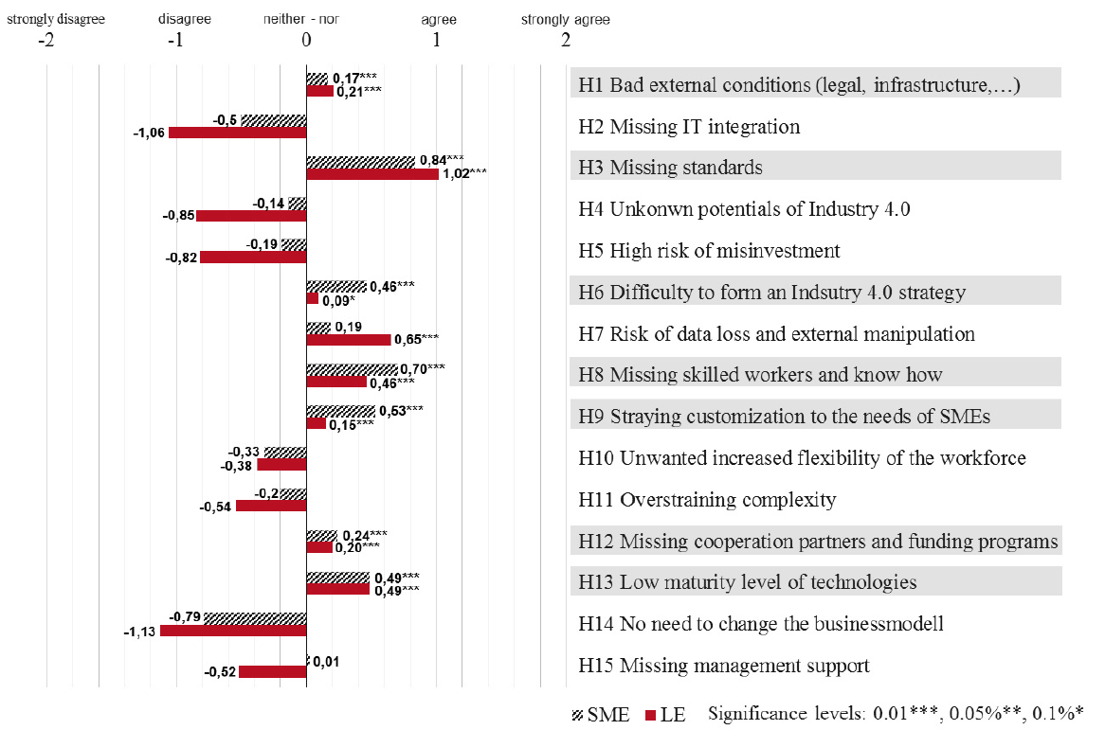
Figure 1 Statistical analysis of barriers to Industrie 4.0 (Glass, et al., 2018)
As you can see above, the results of the survey highlighted seven problem areas as perceived by companies as barriers to entry to Industrie 4.0. The analysis verified that out of the fifteen identified barriers, seven were shared by companies. In order of importance, H3 missing standards was the biggest challenge. This consists of several sub hypotheses, with the most significant being: absence of international norms, incompatibility of ports and interfaces and missing standardised data formats. Next H8 missing skilled workers and know how, with the significant factors of missing training concepts, not enough interdisciplinary courses, and a shortage of young scientists/engineers. This is more acute in terms of SME’s, the LE’s seems to be less affected and their answers show such. H9 shows that the focus for the customization of solutions are primarily being rolled out to LE’s, while SME’s are being left behind. SME’s have requested specific solutions to their adaption as most solutions are only geared for LE’s smaller operation will have unique setups that need particular attention. H12, missing cooperation partners and funding programs, such as university research teams and government funding. These again would hit SME’s harder than LE’s, but both have shown similar results and their answers to the survey. Finally, H13 implies that infrastructure is hindering implementation such as adequate broadband connections and the amount of data involved and its implications such as data security. The conclusion seems to point towards a need for a new skillset to be trained, such as mechanical engineering degrees with information technology. Also, that governments need to step in to help with either funding programs or with the standards needed. (Glass, et al., 2018)
Overall, the findings of this survey support in part the premise laid out in this report, that skills and cost are major barriers to entry in Industrie 4.0 for SME’s. In addition, it also lays out that the problems facing SME’s are wider and more nuanced than previously thought.

Aims
This report will ascertain whether it is possible to add industry 4.0 capabilities to a piece of legacy equipment. The aim being to take a non-functioning EMCO PC Mill 50, retro fit an updated control system and add a variety of sensors that will output relevant industry 4.0 data. Then use that data within a machine learning algorithm to improve the manufacturing process. Also, to do all this on a minimal budget and a self-taught update to skills, as per necessary. The budget for this project was £250, this came from a university bursary, that enables students to purchase anything that would enhance their learning.

Objectives
- Conduct quality research
- Create and submit a project proposal
- Strip and inspect the hardware
- Control system research
- Research Industry 4.0
- Prepare and give interim presentation
- Implement and fit control system
- Code new control system
- Test and troubleshoot the control system
- Code and test sensors
- Fit Sensors
- Create G-code to run a process
- Run data through machine learning
- Test and observe for any suggested parameter changes via the machine learning algorithm
- Dissertation Preparation
- Complete dissertation
- Prepare poster to accompany dissertation
- Submit dissertation

Literature Review

Industry 4.0
The concept of industry 4.0 lies with the origins of Industrie 4.0, a term coined by at the Hannover Messe industrial trade fair in 2011. Pfeifer states that Industrie 4.0 was invented and marketed by three engineers: Henning Kagermann, Wolfgang Wahlster and Wolf-Dieter Lukas. These engineers managed to put industrial production in the limelight, a topic that had been dead for many years. After the trade fair the term Industrie 4.0 became a catch word not just in Germany but worldwide, the idea became the centre of a strategy to revolutionise industry and struggling economies. Industrie 4.0 is the fourth industrial revolution, the first three being mechanisation, electricity, and IT. (As seen in Figure 2 below) A large driving force towards Industrie 4.0 was the introduction of the Internet of Things. This enables businesses to create interconnected networks that incorporate production, warehousing, and machinery seamlessly, in the shape of Cyber Physical Systems (CPS). As the titles suggest, CPS and IOT are about digitally networking the maximum number of elements within the production process, support services, and logistics. The material melds with the digital, from local production lines to global supply chains will network globally while being regulated locally. An example of this would be highly customizable products. All products will be fitted with sensors that communicate its position and status at all stages of manufacture directly to the machines carrying out the work. Smart factories of the future built on these principles, will overcome the restrictions of traditional manufacture, and enable custom manufacturing to individual needs and demands. On a complex supply a production chain, there will be numerous sensors and data transponders all transmitting an unending stream of data, this then truly becomes big data. As CPS evolves the amount of data will increase exponentially alongside it. One day this data stream can be used as an end to end manufacturing solution with little or no human interaction between order and delivery. A customer could create the order online and a ‘smart factory’ could theoretically manufacture and deliver said product to the customers door, with the exact specifications requested per customer. (Pfeiffer, 2017)
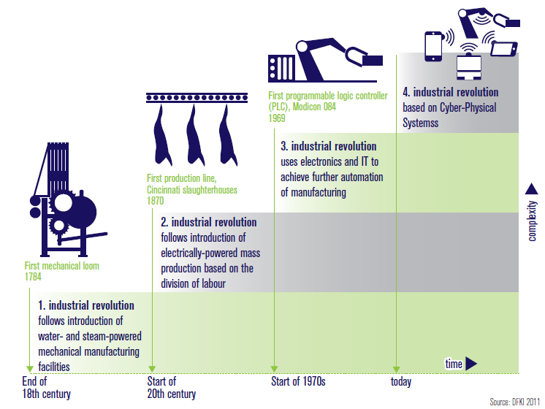
Figure 2 Industrial Revolutions (Kagermann, et al., 2013)
According to Kagermann et al., the introduction of the IOT came about when the internet protocol IPv6 was introduced in 2012. The new protocol produced enough network addresses that smart objects could direct network with each other via the internet. So, for the first time all resources involved in manufacturing could be networked together, whether that be people, information, network resources or objects. (Kagermann, et al., 2013)
Kagermann et al. suggests several ways that Industrie 4.0 will have a positive effect on manufacturing:
- Meeting Individual Customer Requirements
Customer driven data and input can be put into the design, configuration, ordering, planning, manufacture, and operation processes and also include any last second adjustments. Industrie 4.0 should also allow one off manufacturing to be possible while maintaining profitability.

- Flexibility
CPS ad hoc networking enables businesses to take control of their processes and reconfigure them as needed, this would affect such aspects as quality, time, risk, robustness, price, and eco-friendliness. Another benefit would be the trimming of materials and supply chain. Engineering processes will also improve and become agile, manufacturing can be changed, temporary shortages can be compensated for and massive increases in output can be achieved over the short term.

- Optimised Decision-Making
In the global marketplace it is critical to make the correct decisions, sometimes at short notice. Industrie 4.0 provides complete clarity from end-to-end, allowing early verification of engineering designs and more flexible responses to global events or disruptions, throughout all aspects of the business.

- Resource Productivity and Efficiency
The current strategic goals for manufacturing still apply to Industrie 4.0: Producing the highest output of product from a given volume of materials and using the lowest amount of resources to deliver said output. These make up the resource goals of productivity and efficiency, respectively. CPS allows for the manufacturing processes to be optimised across the entire value network, on a case to case basis. Also, the optimisation can happen mid flow of production without the need for shut down, therefore reducing energy consumption.

- Creating Value Opportunities through New Services
Industrie 4.0 has the potential to add new ways of creating value and new forms of employment opportunities, especially downstream. Smart algorithms can be applied to big data, recorded by the smart devices and sensors throughout the value chain. This will provide innovative and invaluable services not previously thought of. In particular, there will be opportunities for SME’s, and start-ups to develop B2B services in relation to Industrie 4.0.

- Responding to Demographic Change in the Workplace
In conjunction with work organisations and work competency programmes, collaboration between the workforce and technology will provide ways to turn the demographic change within the workplace to their advantage. In the face of a shortage of skills relating to Industrie 4.0, and the diversifying workforce, Industrie 4.0 will offer a diverse and flexible career pathway. All so that the workforce will have longer more productive working lives.

- Work Life Balance
The companies that employ CPS also enjoy a more flexible company organisation, this places them to meet the growing needs of the workforce to strike a happy balance between their work lives and home lives. Smart assistance systems as an example, will provide opportunity to reorganise work in a way that offers flexibility that meets the company’s goals while also serving the personal needs of the employees. Also, as the current workforce size declines, adopters of CPS will be at an advantage when it comes to recruiting the best employees.
(Kagermann, et al., 2013)
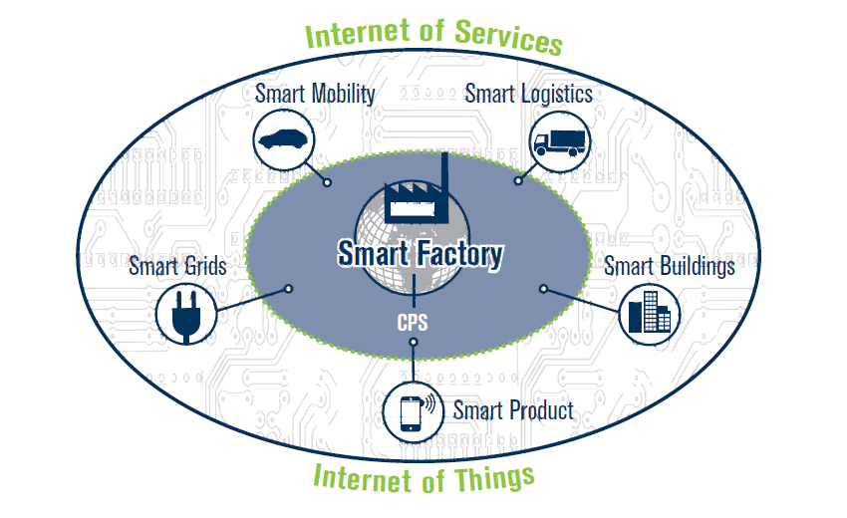
Figure 3 Vision of the Smart Factory of the Future as per (Kagermann, et al., 2013)

As you can see in the above Figure, this is the smart factory as Kagermann et al. envisioned it, and at the centre of the vision is the IOT. The effect of IOT will be felt in all the key areas of the smart connected world. The effect is expected to touch all parts of the world, from education to medical and environmental to business.
The smart factory that embraces the Industrie 4.0 principles, will manage complexity, be less prone to disruption and able manufacture more efficiently. Within the smart factory all machines, people and resources will communicate with each other as naturally as in social networking. Where smart products know how they were built, and how they are intended to be used. They will support the manufacturing process by answering such questions as, “where am I to be delivered?”, “when was I made?” or “what parameters are needed to process me?” and many more besides. How the smart factory interacts with smart mobility, smart logistics and smart grids, will transform conventional value chains, and create new business models. Therefore Industrie 4.0 needs to be treated on a wider scale and not in isolation, there are several key areas that will need to work in cooperation. (Kagermann, et al., 2013)
Kagermann et al. sets out several areas that need to be prioritised in order to achieve the goal of an interconnected and smart value chain. Standardisation and an open standard reference, the value chain will inevitably be made up of different businesses, with different business models and different standards of communication. In order for a value chain to communicate freely, a standardisation of communication protocols would be needed. The management of the complex systems would also need attention. There is an ever-increasing complexity of systems across different businesses, due to an increase in functionality, customisation, dynamic delivery requirements, integration, and cooperation between companies. (Kagermann, et al., 2013)
Modelling can be used to manage these requirements; they will only take into account the important factors to the problem. These simulations would calculate the value added and predict potential weaknesses in the systems, in the context of Industrie 4.0 this tool would smooth out the planning stages. Even after implementation models could be used to troubleshoot problems that arise. In particular, within SME’s it is not standard procedure to use model-based simulation to configure and optimise manufacturing procedures. This is a tool that would ease the SME’s into Industrie 4.0. (Kagermann, et al., 2013)
Infrastructure is another problem, with a widespread CPS rollout, then broadband would need serious investment. The existing infrastructure would need to cope with a much higher throughput of data as well as improved quality of delivery, of said data.

Since Kagermann et al. revealed their vision of the fourth industrial revolution, Industrie 4.0, the international manufacturing community has picked up their vision fervently and Industrie 4.0 has evolved into a wider and deeper discipline. Hereafter Industrie 4.0 will be referred to as Industry 4.0, as this is the more evolved and refined version of a nonetheless innovative original idea. A wider view of the original vision can be seen below.
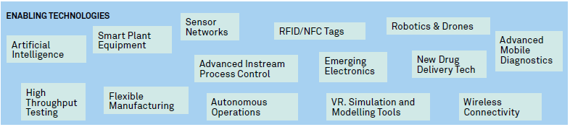
Figure 4 Industry 4.0 key enabling technologies (Made Smarter Commission, 2017)
As you can see, the idea has come on from the original, Kagermann et al. talked about CPS, big data and IOT but four years later this is the vision that the Made Smarter Commission has for industry 4.0. The commission has focused on three main areas that need to be addressed for the UK to become a leader in industry 4.0. Firstly, leadership, more ambitious, informed, and focused. Secondly, adoption, more widespread adoption of technologies across supply chains, especially among SMEs. Lastly, innovation, faster innovation and creation of new tech, new companies, value streams to sustain the UK competitive advantage. (Made Smarter Commission, 2017)
Industrial digitalisation as per the Smarter Commission’s definition, is the application of digital tools and technologies to the value chains of businesses that create things, whether products or services, such as power grids. These enable the physical and digital worlds to merge, bringing about enhanced productivity and performance. These technologies are industrial digitalisation technologies (IDT). In this enhanced version of Kagermann et al’s. ideas, there are several additions that should be mentioned, artificial intelligence, robotics, VR and AR and analytics. These are the driving forces behind industry 4.0 together with Kagermann et al’s. original ideas.

EMCO PC Mill 50
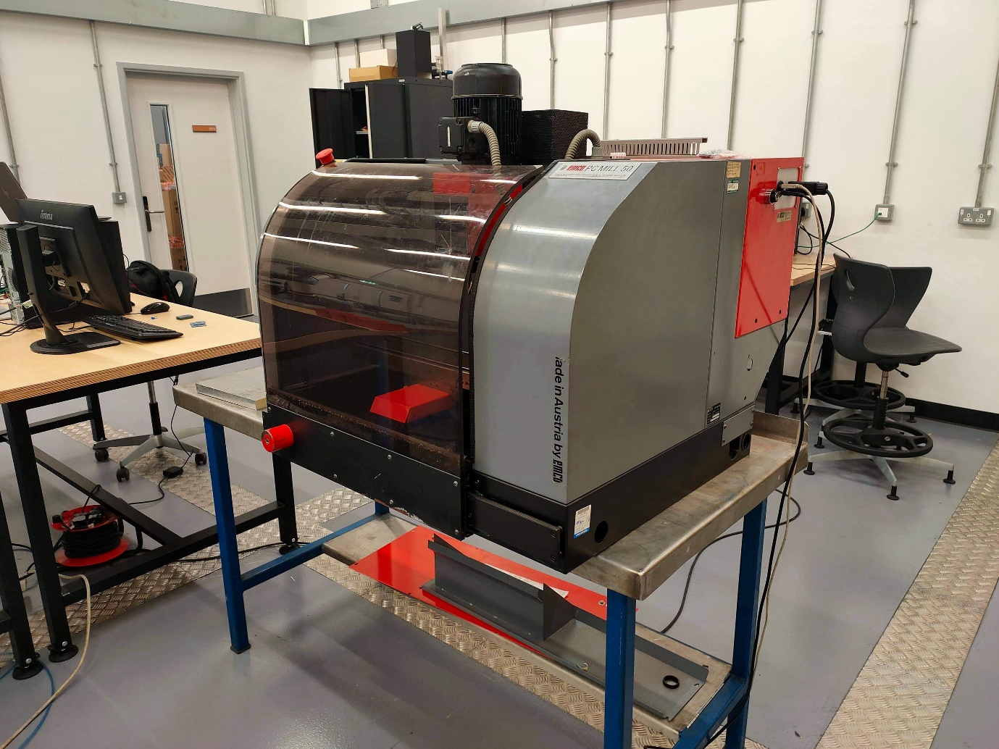
Figure 5 EMCO PC Mill 50
The EMCO PC Mill 50 used for this project was built around 1996 and as such there is scant information online, relating to the machine. The one piece of official information is a software manual relating to the PC Mill 50 and its operation using the software package of WinNC. This largely means the information contained within the document is irrelevant as the control system and software is completely updated.
At the start of the project the machine was not in working order, though it had been modified from its original state. The control system was updated but would only run from a parallel printing port, a connection only available on Windows 7 or previous. Thus, the control system needed to be updated to current protocols.
As previously stated, not much information about the technical specifications of the machine can be found, but on a retrofit blog it was gleaned that the spindle speed max RPM is 2500. So, to get an idea of the specifications, a comparable model with similar applications was used for the product line-up from EMCO. The Concept Turn 55 was used for comparison as it had a similar model number and similar applications, i.e. for educational purposes.
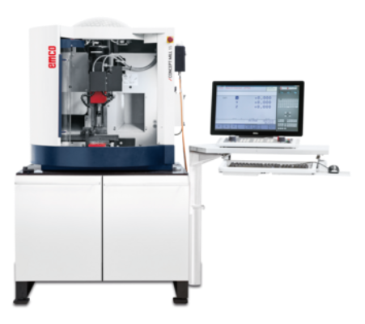
Figure 6 Concept Turn 55 (EMCO, 2020)
Specifications:
- Travel in X/Y/Z 190/140/260mm
- Distance spindle nose 77 – 377mm
- Number of axes 3rd, optional 4th
- Rapid motion speed in X/Y/Z 2m/min
- Work feed X/Y/Z 0 – 2m/min
- Feed force in X/Y/Z 800/800/1000N
- Clamping are 420 x 125mm
- Max table load 10kg
- Tool holder EMCO similar SK30
- Number of tools 8
- Max spindle speed 3500 RPM
- Max drive power 0.75kW
- Max torque 3.7 Nm
- Dimensions L x W x H 980 x 960 x 1000mm
- Weight 220kg
- Fully covered work area
- Infinitely variable main and feed drives
- Clockwise and anticlockwise spindle directions
- Compact desktop design
(EMCO, 2020)
The EMCO PC Mill 50 in question is assumed to have similar attributes to the above stated specifications, these specifications can be verified with the addition of the sensors, later in the project.

CNC xPro Controller V4
The CNC xPro V4 was initially selected as it came well within the £250 budget at £151.27 and also met all the specifications needed to run the EMCO PC Mill 50. The board connects via USB and as such will be able to be run from any modern computer, a prerequisite considering the machine’s previous connectivity. Another bonus is that the board can be upgraded to have WIFI connectivity and so can be brought further into modern machinery with little effort at a later date.
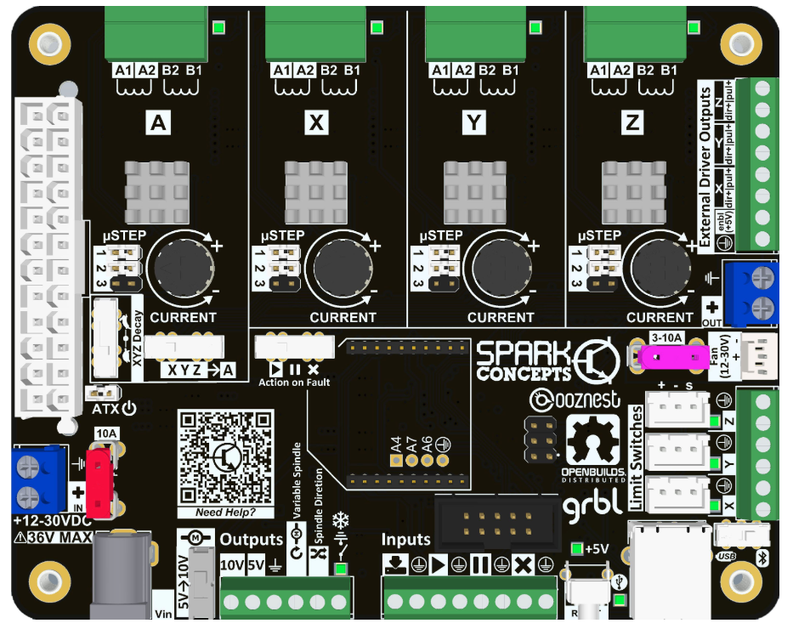
Figure 7 Spark Concepts CNC xPro V4 Controller (Spark Concepts, 2019)
The CNC xPro V4 is an all-in-on multi axis CNC controller, it is specifically designed for CNC applications and is pre-loaded with Grbl. The CNC xPro V4 is equipped with four DRV8825 motor drivers that allow for dual motors configurations on the X, Y and Z axis. The circuit also features isolated analogue and digital inputs to prevent false triggers and greatly reduce noise. (Spark Concepts, 2019) Electronic noise on a PCB can adversely affect the correct operation of the circuit. This is especially so when it comes to circuits that operate in the MHZ region. This is because at the higher frequencies, electromagnetic waves are created around the traces and inside components can be picked up by other components and therefore cause unwanted triggers. (Lin, 2014)
The V4 features a new logic, DriverMinder, that constantly monitors the drivers and will notify you if there is a fault, there are three pre-set responses; pause, stop, and play. The pre-sets are fairly self-explanatory, pause will wait for you to restart or troubleshoot the problem, stop will immediately stop all actions and reboot the system and play will carry on regardless of faults. (Spark Concepts, 2019)

Specifications and Features
- Pre-loaded with a stable version of Grbl
- Powered by ATX PSU, a 12V/24V dedicated two wire supply or a laptop power supply
- 4 DRV8825 stepper drivers – 2.5A peak with 1.75A and up to 1/32 micro stepping
- 1 driver capable of cloning X, Y or Z axis
- Connectivity for USB of WIFI, with the addition of a WIFI unit
- Emergency stop to cut all motor power
- 12V and 5V outputs to power peripherals (fans, pumps etc)
- 3.5mm screw terminals for quick connection of stepper motors and limit switches
- Expansion port for future upgrades
- Quick install with plug and play motor headers, limit switches and power supplies
- 4-layer design with isolated motor and logic power buses
- All smd parts moved to back of board for protection
- Selectable spindle output voltage, can use 0-5V or 0-10V using a VFD or direct to the spindle
- Coolant output is an open drain via a 3V connection
- Robust power management system, overvoltage/reverse voltage protection with replaceable mini blade fuses
- Motor driver step and fault LED’s for easier troubleshooting
- DIP switches for easier reconfiguration
(Spark Concepts, 2019)
There are several software packages that are compatible with the xPro V4, including Fusion 360, CNCjs, and Vetric Vcarve, CNCjs was selected for this project as it was opensource and therefore free.

CNCjs
CNCjs is a highly versatile web-based CNC machine controller that operates using Grbl, TinyG or Smoothieware. It can run off a laptop, phone, raspberry pi, or Arduino using USB or WIFI connections. The specifications are as follows:
- Supported CNC controllers
Grbl and Grbl Mega
TinyG
Smoothieware
- Desktop app for Windows, Linux and MacOS
- 3D visualiser
- Multiple HTTP connections via the same serial port
- Responsive view for small screen support of less than 720p, i.e. phones
- Customisable workspace
- My account
- Commands
- Events
- Keyboard shortcuts
- Contour ShuttleXpress
- Multi-language support
- Watch directory
- Z probe
(CNCjs, 2018)
Grbl is an opensource CNC control software that sends g-code to your machine.
CNCjs and the CNC xPro V4 are highly popular among the hobbyist/enthusiast communities and as such there is a lot of extra info and support available via blogs, vlogs, and YouTube. For this reason, they also made a good choice for this project as the author is new to this field and skillset. Also, as it was compatible with Arduino, this was advantageous.
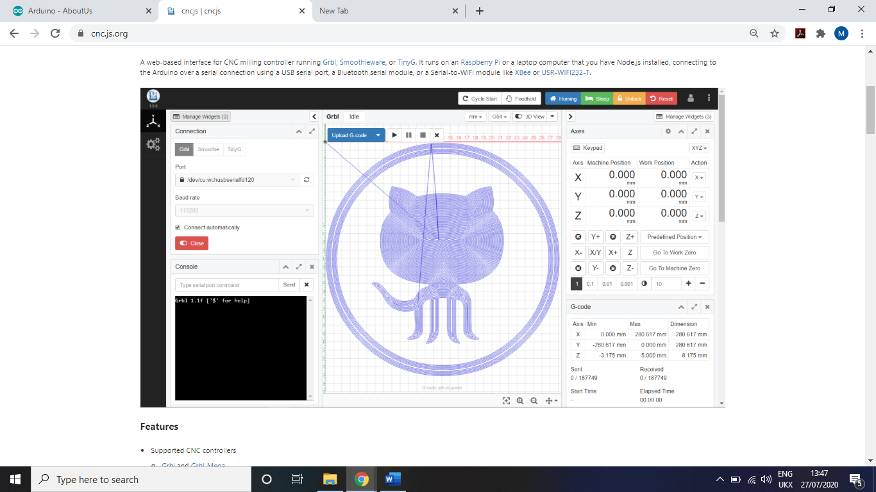
Figure 8 CNCjs Interface (CNCjs, 2018)

Arduino
Arduino is the world’s largest open source hardware and software ecosystem. The company offers a range of software tools, hardware platforms and enough learning resources that anyone can create using the Arduino system. Arduino is a tool popularly used within the IOT community, as well as a hugely popular teaching tool for STEM students from primary through to university. Hundreds of thousands of people, students, engineers, and creators are using Arduino to innovate in the music, toys, games, smart homes, farming, and autonomous car industries, all around the world. (Arduino, 2020)
Originally, Arduino was started as a research project by Massimo Banzi, David Cuartielles, Tom Igoe, Gianluca Martino, and David Mellis at the Interaction Design Institute of Ivrea in the early 2000s. The research builds upon a Processing project by Casey Reas and Ben Fry that teaches programming language using visual arts and also draws from a thesis project by Hernando Barragan about the Wiring Board. (Arduino, 2020)
The first Arduino board was introduced in 2005 to aid design students, with little to no experience with electronics or microcontroller programming. The original concept was to link the physical world with the digital one using prototypes designed with Arduino. Since then it has become the most popular electronics prototyping tool amongst engineers and even large corporations. (Arduino, 2020)
Arduino is the world’s first open source hardware project and was set up to build a community that will spread the use of the tools as well as providing support across an interconnected community in the way of example codes, debugging, project contributions, tutorials and an active forum. Since Arduino’s foundation, countless new development boards and software libraries have been added to an ever-increasing range of possibilities available to Arduino creators. After a decade, Arduino still provides an open sources tool to provide creators the chance to realise any and all of their ideas, whether small or big. Arduino has become the number one choice for electronics companies, especially in relation to IOT concepts, IOT is set to be a $6 trillion industry by 2021. (Arduino, 2020)

Arduino Mega 2560
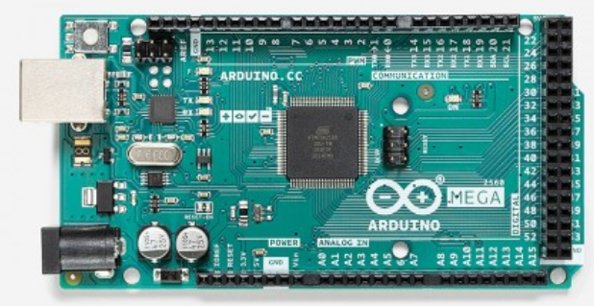
Figure 9 Arduino Mega 2560 (Arduino, 2020)
The Arduino Mega 2560 is a microcontroller board based on the ATMega2560, it has 54 digital input/output pins, of which 15 can be used as PWM outputs, 16 analogue inputs, 4 UART’s, a 16MHz crystal oscillator, a USB connection, a power jack, an ISCP header, and a reset button. It contains everything needed to support the microcontroller, just plug in the USB and a power source and you are ready to start. (Arduino, 2020)
As you can see above, the Arduino Mega 2560 has the maximum amount of connectivity, of all the Arduino boards available the Mega was most suited to a project with multiple sensors being connected simultaneously. Within the context of this project, this board was selected due to the low price, around £25 and the option to add numerous sensors, whether that be now or in future or possible expansions to the project.

Arduino IDE
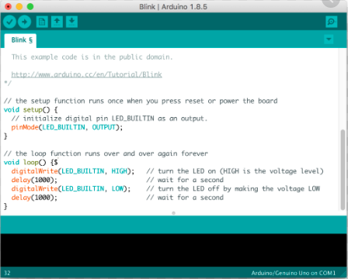
Figure 10 Arduino IDE Interface (Arduino, 2020)
Arduino IDE is the software suite used in conjunction with any Arduino hardware. IDE lets you write programs and upload them to your Arduino board. There are two options for IDE, a desktop app that is downloaded to your computer or the web editor that you can use online. The desktop app can be used offline and the web editor can be used from any device with a web browser, such as a phone.

Sensors

InvenSense MPU6050 Accelerometer
The MPU6050 is an integrated 6-axis motion tracking device that combines a 3-axis gyroscope with a 3-axis accelerometer and a digital motion processor. Motion based features are becoming a must have in all modern electronics, especially smart phones, and tablets. The MPU6050 enables smart devices to use gesture commands for phone control, enhanced gaming capabilities, augmented reality uses, panoramic photo capture and viewing, and pedestrian and vehicle navigation. In essence, this chip will convert a smart phone into a powerful 3D intelligent device that will track health and fitness or enable any location-based services. (InvenSense, 2013)
The MPU6050 is a MEMS based device, the accelerometer uses piezo electric material to calculate the acceleration along three axes. As you can see in the Figure below, there is a ‘ball’ inside a cuboid and as the accelerometer moves the ball will collide the piezo walls, when the ball collides the magnitude and direction of the force can be calculated. This all happens at a microscopic level and as such, is able to pick up tiny movements.
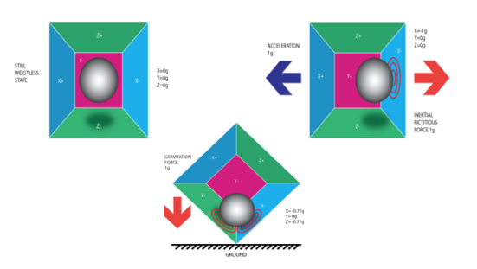
Figure 11 Piezo Accelerometer (Sanjeev, 2016)
For the technical specifications, only the accelerometer specifications are listed as this is the relevant part for this project.
Specifications
- Digital-output 3-axis accelerometer with programmable sensitivity of +-2g, +-4g, +-8g and +-16g
- Integrated 16-bit ADCs enable simultaneous sampling of the accelerometer without any external calculation
- Accelerometer operating current 500μA
- Low power accelerometer mode; 10μA at 1.25Hz, 20μA at 5Hz, 60μA at 20Hz, 110μA at 40Hz
- Orientation detection and signalling
- Tap detection
- User programmable interrupts
- High-G interrupt
- User self-test
(InvenSense, 2013)

KY-038 Sound Sensor
The KY-038 has three main components, the sensor unit at the front, which measures the physical area and sends an analogue signal to the second unit, the amplifier. The amplifier does what its name suggests and amplifies the signal according to the value of the potentiometer and sends the signal to the analogue out pin. The third component is digital comparator that switches the digital out and LED if the value falls below a certain amount. The sensitivity can be adjusted using the potentiometer. (Joy IT, 2017)
This type of sensor is usually used for a different use than intended for this project but as a cheap and readily available product, it was selected to use in this instance. Usually the detector would be used to send a signal when a noise of a selected level is heard, such as a clap used to turn on a light. The detector can be used in the context of this report with some minor tweaks to the code.

Machine Learning
Machine learning is the technology that allows computers to learn directly from data, experience, or examples. Whereas the field of AI is the science of making machines smarter, machine learning allows computers to perform specific tasks more intelligently, by learning from past examples. Therefore, these types of systems can perform complex tasks by learning without following pre-programmed rules. Recent advances in technology, computing power and the availability of data, has seen a surge in the field of machine learning. This has resulted in systems that only a few years ago could not get accurate results, now outperform their human counterparts in certain tasks. There are voice recognition and object detection systems that clearly perform better than humans. (The Royal Society, 2017) One such example would be, in 2015 researchers created a machine learning system that vastly surpassed human capabilities, when recognising individually handwritten digits. (Markoff, 2015)
Machine learning algorithms interact with people on a global scale every day, such as image recognition in photo tagging on social media platforms, product placement recommenders used by online retailers and, voice recognition used by virtual assistants. In addition to the current uses for machine learning there are several significant areas that have the potential to benefit from this technology and are already being developed. The accuracy of healthcare diagnostics could be improved or personalised treatments, classroom activities tailored to a child’s needs, and intelligent transport systems. Scientifically speaking, machine learning could provide insights from large data sets that a human could not see, driving scientific advances or efficiencies within the industrial sector. (The Royal Society, 2017)
The origins of machine learning lay with several prominent scientists, Alan Turing asked whether computers could think in a 1950 paper published in the journal, Mind. (Marr, 2016) Whilst famously creating the Turing Test, a test that proves whether a computer’s answers are distinguishable from human answers. To this day the UK is a leading research environment for the machine learning community, with UK start-ups being acquired by some of the world’s largest companies, such as Microsoft, Google, Twitter and, Apple. (The Royal Society, 2017) In 1952, Arthur Samuel wrote the first learning computer program. An IBM computer played a game of checkers and improved, the more it played. The computer would incorporate winning strategies from past examples into its future play. (Marr, 2016) In the 1990’s scientists shift from using a knowledge driven approach to machine learning towards a data driven one, this was when modern machine learning techniques get their origin. (Marr, 2016)
Machine learning differs from traditional programming, traditional programming solves a problem sequentially using hard coded rules, whereas machine learning is given a large data set showing how a task can be completed, and then detects and predicts patterns. The system then learns how to best achieve the desired outcome. Machine learning lies between data science, statistics, and computer science, using elements of these disciplines to detect and learn patterns, predict future activity, and make decisions. (The Royal Society, 2017)
There are two types of machine learning deployments, online and offline. An offline set up consists of training and learning in an offline setting with the training model being frozen before becoming live. Any subsequent training and testing of the model would also happen in an offline setting before redeployment to the live system. This is a common method of machine learning as there is an element of human verification before deployment. An online learning model would also be initially trained offline but then once deployed the training algorithms are continuously applied. This way the system’s performance will improve in real-time and in response to real-world data. It also means there is no human checking of system decisions and consequences. (The Royal Society, 2017)

MATLAB
The origins of MATLAB lie with a series of research papers by J. H. Wilkinson, and 18 of his colleagues, published between 1965 and 1970. They were late collected in Handbook for Automatic Computation, Volume II, Linear algebra, edited by Wilkinson and C. Reinsch. These papers presented algorithms that solved matrix linear equations and eigenvalue problems. (Moler, 2018)
MATLAB is a programming environment designed specifically for engineers and scientists. The heart of MATLAB is the MATLAB programming language, a matrix-based language allowing for the most natural expression of computational mathematics possible. Millions of scientists, engineers and students use MATLAB around the world, whether in industry or for study and research. MATLAB can be used for a wide range of applications, including deep learning and machine learning, signal processing and communication, video and image processing, control systems, test and measurement, computational finance, and computational biology. (The Mathworks Inc, n.d.)
The fact that MATLAB was readily available to students and that the previously mentioned capabilities, taken directly from the Mathworks website, were extremely apt to this project. MATLAB was selected as the machine learning component for this project.
In order to complete this project, the machine learning on ramp course and the full machine learning course were both completed by the author. These courses were offered for zero cost to students and as such, fit the parameters of the project. The courses were extremely useful and needed to complete the project, though it must be mentioned that the courses are designed to teach the student to use the machine learning toolbox within MATLAB. However useful that is, the courses offered little insight into how the machine learning algorithms worked, possibly due to proprietary reasons. The K-means clustering algorithm was selected for this project as it is a supervised learning algorithm.

Industry Examples

AMRC Digitalisation of Legacy Tools
The AMRC detected a familiar problem with the deployment of industry 4.0 within the SME community. Basically, SME’s are worried about, high investment costs, skills gaps within their business and a lack of technology knowledge. Also fuelling theses worries is the need to improve services and cut costs simultaneously, to maintain competitiveness. In general, SME’s do not have the budget to improve digital skills and end up staying in their comfort zones. (Lockwood, et al., 2018)
There are several metrics that SME’s have shown interest in and deem to be useful to their ability to increase production or add value to their current production.
- Overall Equipment Effectiveness (OEE)
The measurement of productivity, for instance the percentage of production time that is truly productive. 100% OEE means, 100% quality, 100% performance and 100% availability.
- Operating Cost
The cost of producing a component, purely based on machine operation time.
- Machine Condition
Sensor data that monitors the machine’s operating parameters and indicates whether the machine is in need of maintenance. A spindle with too much vibration may need new bearings.
- Process Control
Production parameters within a machine need to be monitored and if they fall out of the normal running parameters then it could indicate that the part is out of manufacturers tolerance. Higher vibration could show that the tool is worn.
(Lockwood, et al., 2018)
The plan was to install a few simple sensors to a Colchester Bantam Lathe from 1956 and a Bridgeport Turret Mill from 1980. Only the lathe will be considered for this examination, this is due to the fact that the type of sensors used are comparable to the project. Another factor is that an Arduino was used to gather the data, whereas on the mill side of things more expensive sensors were used and an online IOT was used to collect the data.
Next is a table of the sensors used in the retrofit of the lathe.
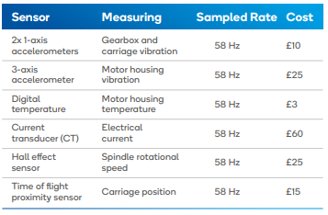
Figure 12 Sensors selected for lathe (Lockwood, et al., 2018)
These sensors were fitted as suggested in the table above, the Arduino collects the data and sends the data to a raspberry pi. The raspberry pi acts as a network gateway in this instance, sending the data to an IOT web service and then displaying the metrics on a dashboard at the machine. Some such results can be shown in the following Figure.
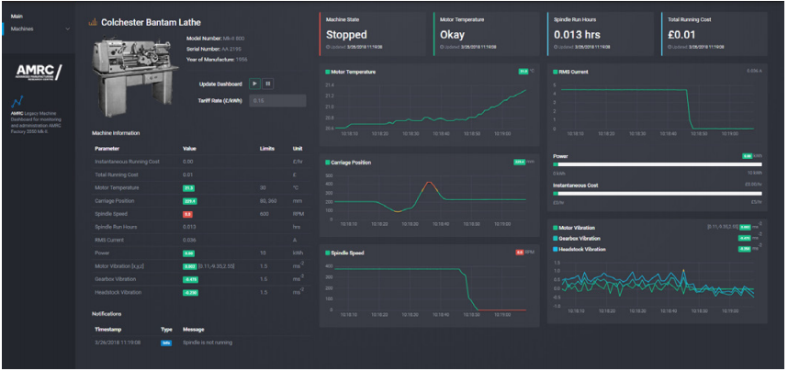
Figure 13 Digital dashboard showing lathe metrics (Lockwood, et al., 2018)
The AMRC clearly met their goal of digitising legacy equipment on a tight budget, this clearly demonstrates to SMEs that digitalisation is within their grasp.

Bosch Smart Factory
The Blaichach Bosch plant is the leading manufacturer of ABS systems, it also leads the way when it comes to connected industry. Always sounding out new ways to connect their manufacturing processes and value chains. Where a production team would check parts and inspect machines, tablets have now become the norm when it comes to checking processes and intervene where necessary. This is the world of industry 4.0, by connecting its operations to the latest in IT and by digitising its processes. This plant is the lead location for an international network, it was the ideal location to showcase all the possibilities of industry 4.0. (Bosch, 2020)
Industry 4.0 offers plenty of opportunity to improve efficiencies within production, the wealth of data produced needs to be leveraged to gain a competitive edge. When analysis is done correctly, quality can be assured, and the monitoring processes sped up significantly. Another advantage of an interconnected global system, the shared database can reveal error patterns in production. (Bosch, 2020)
In 2015, Bosch pooled all its interconnected industry 4.0 resources into a “connected industry” cluster. This is a pool of over 100 experts in the field that work together to further enhance Bosch’s industry 4.0 capabilities and open up new areas of business. They also offer external industry 4.0 services and solutions. This makes Bosch both a leading user and provider of industry 4.0 solutions. (Bosch, 2020)

Methodology

CNC Machine
Th first step to completing this project is to strip and inspect the machinery involved. The back plate of the CNC machine was removed via screws along the bottom and top edges of the machine. As you can see below, this was the condition of the machine at the start of the project. The control system interface was a parallel printer port, a dated interface that is not supported in Windows 8 or later.
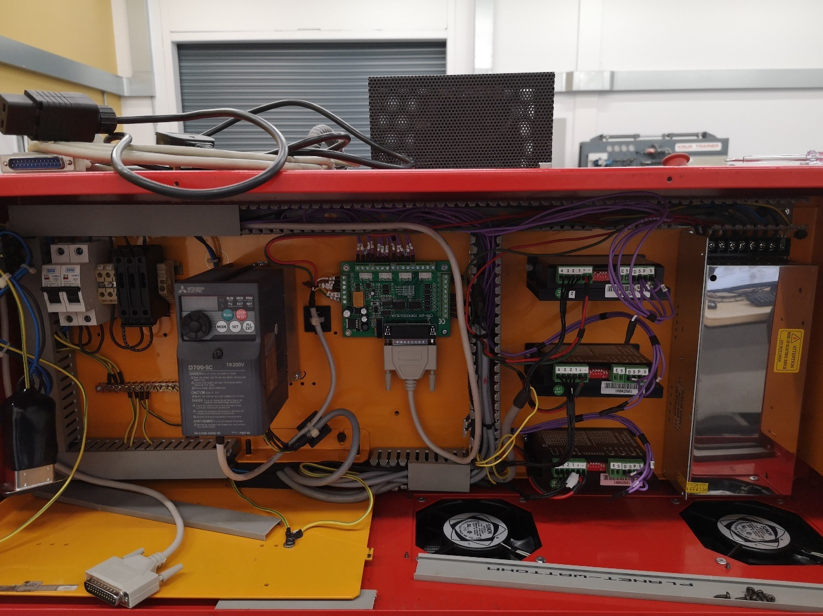
Figure 14 Original Control System
As per the research, the CNC xPro controller V4 was selected as a suitable replacement control system as it had all the capabilities of the previous system while also providing a more modern method of connection. The xPro V4 can be connected to external stepper drivers but has inbuilt stepper drivers, it was therefore decided to remove the external stepper drivers towards the right of the picture above. This was to facilitate the fitting of the sensors and Arduino board. This part of the fit was relatively smooth, though not without a few small issues. The previous owner was very diligent when labelling all the wiring to and from the control board and as such the control system was almost plug and play, especially when combined with the wiring diagrams shown in Figures 11 and 12.
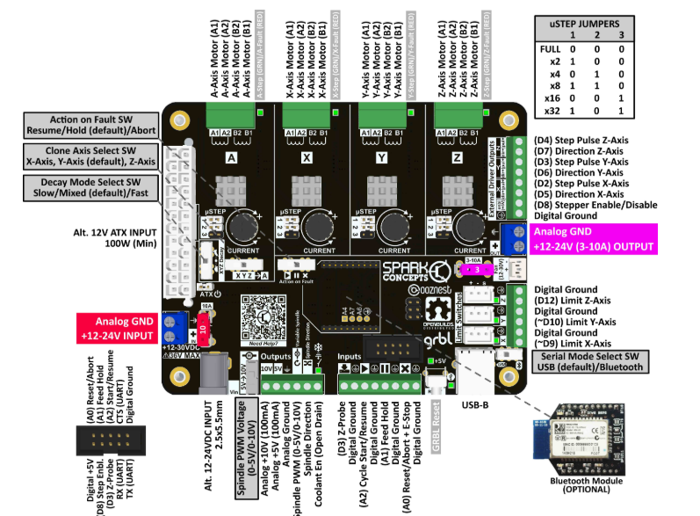
Figure 15 CNC xPro V4 (Spark Concepts, 2020)
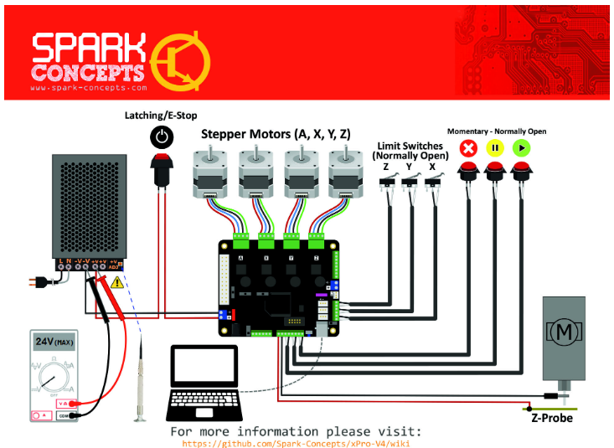
Figure 16 CNC xPro V4 Hook-up Guide (Spark Concepts, 2020)
There is a mounting plate on the side of the machine that was designed for the parallel port connection and the power input, a new one was designed and made around the USB interface that was installed. The double USB connection was chosen, one for the Arduino and sensors and one for the control system. The plate was made from plastic and cur using a laser cutter, the plate is shown in the below Figure.
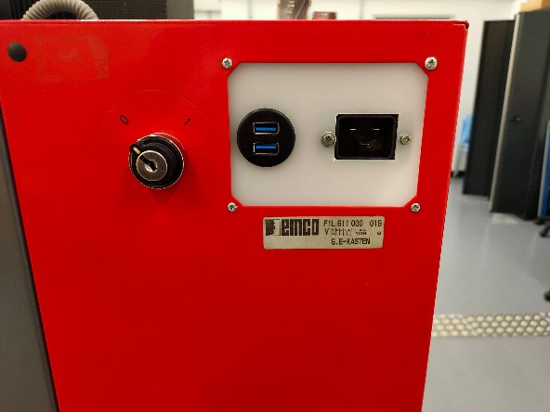
Figure 17 Mounting plate
There were two notable snags, first the limit switch wires were not labelled as limit switches but just as their designated axes, i.e. X/Y/Z. This was easily remedied by downloading a copy of the original control system’s wiring diagram to ascertain they were the limit switch wires. Next the wires were chased to the limit switches to find which wire was the ground and which was the live. The locations of the three axes limit switches are shown below.
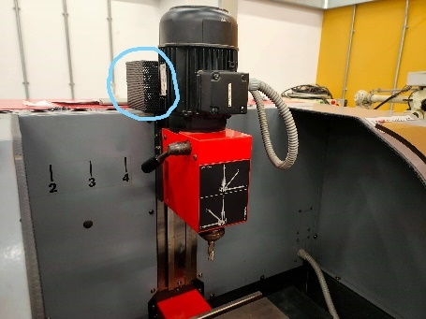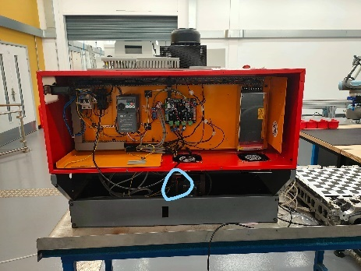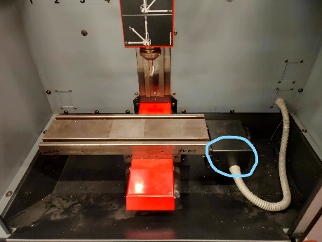
Figure 18 Axes limit switches
After the board was connected and tests were conducted, it was found that the limit switches acted abnormally. At first it was assumed to be circuit board noise but upon further investigation, it was found that two out of the three switches were set to normally closed, this control system requires limit switches to be set at normally open. So consequently, they were removed and set as so. The X axis switch shown in the right picture, the black casing was removed to access the switch. The Y switch in the middle was a case of removing the lower back panel. Finally, the Z switch shown on the left, the metal caging was removed to gain access.
The next problem was the E-stop and the door safety switch, the door switch was also set to normally closed and had to be set to normally open. The location of the door switch is illustrated below. The door switch was located underneath the bottom door runner, to access this the door was removed and the CNC machine had to be moved slightly over the edge of the table as the switch was accessible from beneath the machine.
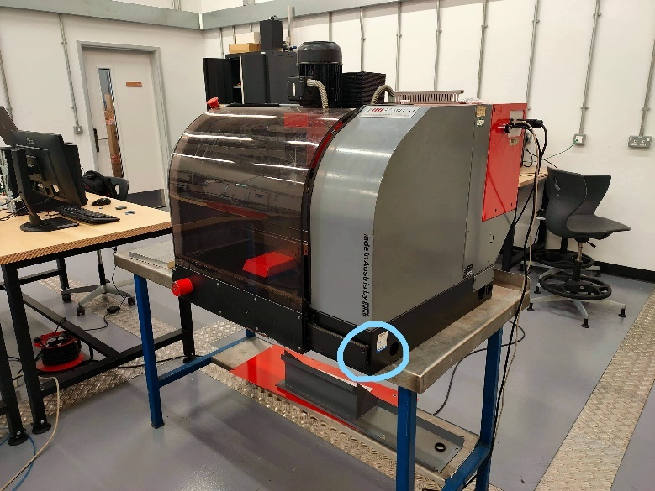
Figure 19 Location of door limit switch

The final snag at this point was a particularly, time consuming one, when the spindle direction cable from the VFD was connected to the control board, it did not work. When testing the spindle, it would only spin in one direction whether clockwise or anticlockwise commands were sent. First, the xPro V4 documentation was investigated to find out how the signal to change spindle directions was sent. The signal works as a high low voltage, less than 1V for one direction and 5V for the other direction. The suspected problem was the VFD and considerable time was spent scouring the manual for the parameters that would change the spindle direction based on a high low signal. After a week of trying several hundred different parameter changes on the VFD without success, it was time to go down another route before any more valuable project was taken up. A closer inspection of the previous control board revealed the necessary information. That system also worked from a high low signal but with a slight difference, there was a relay module, high low trigger in between the VFD and control system. Once this was realised, the fix for the spindle direction was fairly simple. A relay module with high low trigger was purchased and was wired as a go-between the VFD and control system. The module switches a live circuit between two output wires, those wires are connected to the start forward spindle and start reverse signal on the VFD. I t must be said that the parameters of the VFD were changed for this set up to work.
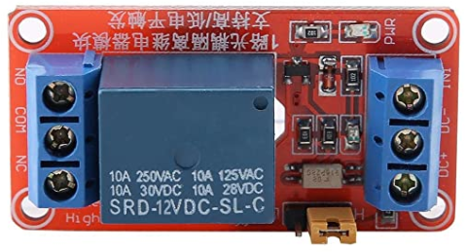
Figure 20 Relay module

The next part of the project was to download CNCjs and test the functionality of the machine. At first all seemed very good, all commands were being followed as expected. The E-stop, door limit, and axes limit switches all functioned as they should. When observing the movement of the bed, the movement distance entered did not seem to match the actual distance travelled by the bed. This was a calibration problem, the steps per mm setting within Grbl did not match the physical attributes of the machine. As there are no specifications to be found about the EMCO machine, this became a manual task. After a conversation with the workshop manager, he said to measure the thread of the lead screw. The most accessible lead screw was the X axis screw but upon inspection the lead screws of all axes were the same. Also, each axis had the same motor powering them. Therefore, the same step/mm could be used on all axes once the correct measurement was procured. First, the thread pitch of the lead screw was measured, then this was put into a calculator online that converts to steps/mm. The first answer was a rough estimate as not all variables were known from the machine, the first estimate was 2000 steps/mm. This was tested, a sharpie was used to mark the bed against the stationary part of the bed. The command was sent to the axis to move 10mm and then that distance was measured from mark to mark. After some fine tuning, the steps/mm ended as around 2100 steps/mm and this was verified as mentioned.
At this point, the CNC machine is fully functioning as per its intended functionality. After some use of the CNCjs software, a homing cycle was set up. A homing cycle sends the tool and bed back to a designated point in the workspace, usually top left or right. This facilitates an easier process later in the project. Once a process has been set as the base for the analysis section, then the homing cycle will be added to the end of every component so that a continuous flow of components can be processed in a timely manner. In the below Figure, the completed wiring of the control system can be seen.
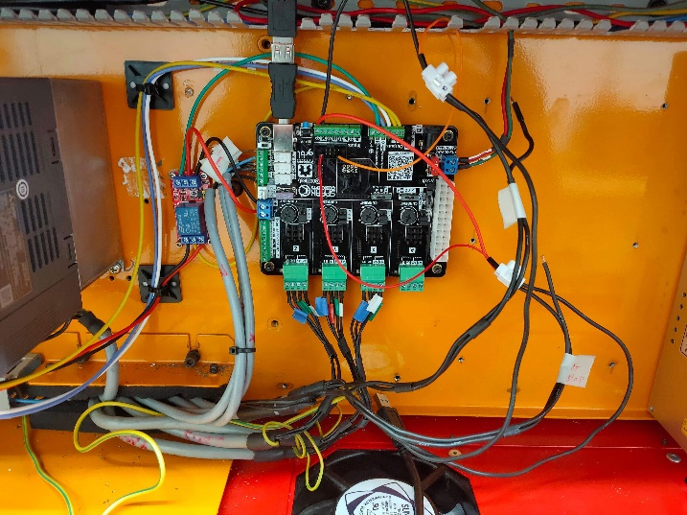
Figure 21 Fully wired and functional control system, further tidying up of the wiring pathways was planned but for obvious reasons incomplete

Arduino/Sensors
The Arduino was connected to the PC via a USB cable, then Arduino IDE was opened to ensure all was connected and working between board and software. Within the IDE environment, under the tools tab, you can select the model of the board you are connecting. The correct baud rate also needs to be selected to ensure connectivity.
The first sensor to be programmed was the MPU6050 accelerometer and gyroscope, after finding the wiring diagram, shown below. The sensor was connected and shown to be communicating with the Arduino Mega via an LED on the sensor. At this point there is not any data being transmitted by the sensor.
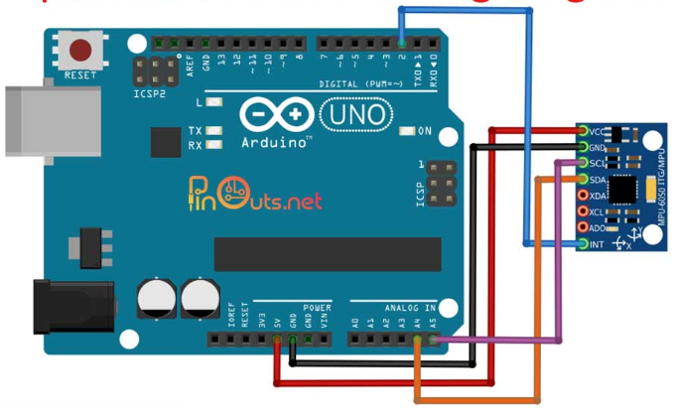
Figure 22 MPU6050 Wiring Diagram (Admin, 2019)
There are several steps before the sensor is ready for operation. Firstly, IDE needs to know the sensor, this requires you to add a library to the sources available in IDE. The library is just a zip file available from github. Next another library was needed, called wire, this allows communication from the sensor to the I2C pins on the Arduino. Next a sketch is needed to inform Arduino to read the data transmission and present the data as needed. A base code relating to the MPU6050 is shown next, this was used as a starting point for the code used with this project. The actual code was unavailable. Most notably the gyroscope readings were removed as unnecessary and the sensitivity setting were adjusted to maximum sensitivity. The code below is a short base code, there are more complicated and longer versions but the short one was more customisable to the project’s needs.
- // MPU-6050 Short Example Sketch
- // By Arduino User JohnChi
- // August 17, 2014
- // Public Domain
- #include<Wire.h>
- const int MPU_addr=0x68; // I2C address of the MPU-6050
- int16_t AcX,AcY,AcZ,Tmp,GyX,GyY,GyZ;
- void setup(){
- Wire.begin();
- Wire.beginTransmission(MPU_addr);
- Wire.write(0x6B); // PWR_MGMT_1 register
- Wire.write(0); // set to zero (wakes up the MPU-6050)
- Wire.endTransmission(true);
- Serial.begin(9600);
- }
- void loop(){
- Wire.beginTransmission(MPU_addr);
- Wire.write(0x3B); // starting with register 0x3B (ACCEL_XOUT_H)
- Wire.endTransmission(false);
- Wire.requestFrom(MPU_addr,14,true); // request a total of 14 registers
- AcX=Wire.read()<<8|Wire.read(); // 0x3B (ACCEL_XOUT_H) & 0x3C (ACCEL_XOUT_L)
- AcY=Wire.read()<<8|Wire.read(); // 0x3D (ACCEL_YOUT_H) & 0x3E (ACCEL_YOUT_L)
- AcZ=Wire.read()<<8|Wire.read(); // 0x3F (ACCEL_ZOUT_H) & 0x40 (ACCEL_ZOUT_L)
- Tmp=Wire.read()<<8|Wire.read(); // 0x41 (TEMP_OUT_H) & 0x42 (TEMP_OUT_L)
- GyX=Wire.read()<<8|Wire.read(); // 0x43 (GYRO_XOUT_H) & 0x44 (GYRO_XOUT_L)
- GyY=Wire.read()<<8|Wire.read(); // 0x45 (GYRO_YOUT_H) & 0x46 (GYRO_YOUT_L)
- GyZ=Wire.read()<<8|Wire.read(); // 0x47 (GYRO_ZOUT_H) & 0x48 (GYRO_ZOUT_L)
- Serial.print("AcX = "); Serial.print(AcX);
- Serial.print(" | AcY = "); Serial.print(AcY);
- Serial.print(" | AcZ = "); Serial.print(AcZ);
- Serial.print(" | Tmp = "); Serial.print(Tmp/340.00+36.53); //equation for temperature in degrees C from datasheet
- Serial.print(" | GyX = "); Serial.print(GyX);
- Serial.print(" | GyY = "); Serial.print(GyY);
- Serial.print(" | GyZ = "); Serial.println(GyZ);
- delay(333);
- }
(Chi, 2014)
The plan for the project was to use three MPU6050 sensors, one for each axis, fitted as close to the motors as possible. This is to gauge the vibration of the axis but also to detect any wear within the motors. After initial training, the motor vibrations picked up by the sensors should just become the normal operating noise, then any excess vibration made by the motors should highlight a maintenance alarm. The MPU6050 also features a digital temperature sensor, as the sensors are placed at the motors, an increase in temperature could indicate increased wear or other anomalies of the motors.
There are four possible ways to mount a vibration sensor, drilled mount, adhesive mount, magnetic mount, and a probe mount. The drilled mount gives the best dynamic range for measurement but would cause permanent damage to the machinery. The adhesive method would yield a slightly less dynamic range but not by much, the only downside is that the sensor would be destroyed if ever removed. The magnetic mount is a possibility as the sensor would not be affected by the magnetism, but the dynamic range is vastly reduced compared to the aforementioned methods. The probe mount would mean causing damage to the machine and also the dynamic range would not compare to the drilled or adhesive methods. The plan was to mount the sensors using adhesive, this would limit any damage to the machine at the cost of the sensor should it need replacing or removing. These sensors cost around £2 to £3 and as such their destruction would not cause huge costs. (Wilcoxon Sensing Technologies, 2016)

The KY-038 sound sensor was to be placed inside the workspace of the CNC machine, at the top left. This is so that the sensor can pick up all sounds that are made while a component undergoes processing.
// Declaration and initialization of the input pin
int Analog_Eingang = A0; // X-axis-signal
int Digital_Eingang = 3; // Button
void setup ()
{
pinMode (Analog_Eingang, INPUT);
pinMode (Digital_Eingang, INPUT);
Serial.begin (9600); // Serial output with 9600 bps
}
// The program reads the current value of the input pins
// and outputs it via serial out
void loop ()
{
float Analog;
int Digital;
// Current value will be read and converted to voltage
Analog = analogRead (Analog_Eingang) * (5.0 / 1023.0);
Digital = digitalRead (Digital_Eingang);
//... and outputted here
Serial.print ("Analog voltage value:"); Serial.print (Analog, 4); Serial.print ("V, ");
Serial.print ("Extreme value:");
if(Digital==1)
{
Serial.println (" reached");
}
else
{
Serial.println (" not reached yet");
}
Serial.println ("----------------------------------------------------------------");
delay (200);
}
Figure 23 Base Code for KY-038 (Joy IT, 2017)
The Figure above shows the base code for the KY-038 sound sensor, though not designed for this project’s intended use, it can be adjusted to reflect so. This code is designed to send a signal whenever a pre-set minimum sound level is reached. The plan was to set the minimum level to zero, making every sound recorded. Then change the output from a message saying reached, but to a voltage value from the potentiometer. This would assign a value to the output, i.e. a louder noise would illicit a stronger response and the sounds are quantified.

Data Acquisition
The data acquisition was going to be handled by MATLAB, as it has the capability to read a serial wire from Arduino and then record the data in either Excel or Database. An initial set of data was to be collected from the processing of ten components, this dataset was then to be used as the training data for the machine learning algorithm. Then the machine learning would predict any outliers for the next one hundred components and suggest the best running parameters for the machine.
The machine learning algorithm used for this would K-means clustering, this is a supervised algorithm, the initial data set would be clustered by the human. This method was selected to ensure maximum value, especially as this is a relatively small dataset. The data collected could be significant, if the data collection were to be every second then big data can be achieved in this case. That would mean 1 bit of data per second per sensor, the accelerometers pick up 4 bits of data per second, in total 13 bits of data per second would mean that 46800 bits of data per hour would be collected. The data collection interval could be changed to every millisecond but that would mean the data is 1000 times that of per second. The plan was to see how the machine learning coped with the smaller set first, as the machine learning was going to be run on a local PC and not a cloud based IOT.
The resulting data was going to be presented locally and live as an analytics-based solution, within the Arduino IDE software package there is a function called the serial plotter. The serial plotter plots live data from whatever program is running at the time, this was ideal to showcase the sensor data. IOT cloud computing has significant costs involved, one solution charges around £500 per annum for 1 bit of data per minute. An example of the serial plotter at work is below, similar results were achieved in the sensor tests.
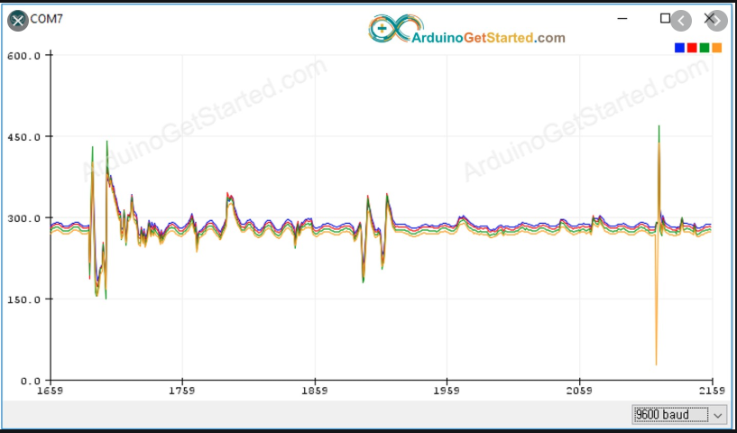
Figure 24 Serial Plotter Example (Arduino, 2020)

Analysis
The analysis of machine learning in industry, happens as real-world results, reduced defects, improved quality, reduced direct production costs and reduced need of quality assurance. These are indicators that a business will see improvements upon, these types of improvements would be hard to prove for this project. As such another method has been devised. (Santos, et al., 2009)
The plan for analysis would be to run the below G-code cycle and create the illustrated components a total of ten times. Then train the machine learning algorithm, using the recorded data.

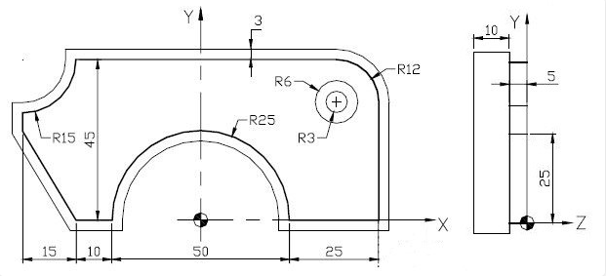
Figure 25 Part to be used for future analysis (HelmanCNC, 2016)
N1 (BRIDE)
N10 G90 G71 G80 G40
N20 G0 G52 Z0
(Contour)
N30 T4 D4 M6
N40 G97 S345
N50 G94 F110
N60 G0 X62 Y-18
N70 Z-5 M3 M41
N80 G1 G42 X50 M8
N85 G1 Y33
N90 G3 X38 Y45 R12
N100 G1 X-35 Y45
N110 G2 X-50 Y 30 R15
N120 G1 X-50 Y25
N130 G1 X-35 Y0
N140 G1 X-25 Y0
N150 G2 X25 Y0 R25
N155 G1 X50
N160 G1 G40 X68 Y-12 M9
N170 G0 G52 Z0 M5
(Drilling)
N180 T6 D6 M6
N190 G97 S1061
N200 G94 F74
N210 G0 X38 Y33
N220 Z3 M3 M42
N230 G1 Z-18 M8 (5+10+3)
N240 G0 Z3 M9
N250 G0 G52 Z0 M5
(Counterbore)
N260 T7 D7 M6
N270 G97 S530
N280 G94 F106
N290 G0 X38 Y33
N300 Z3 M3 M40
N310 G1 Z-5 M8
N320 G0 Z3 M9
N330 G0 G52 Z0 M5
N340 M2
(HelmanCNC, 2016)
Next a machine learning prediction algorithm would be used to predict future data points and this dataset can be tested using a mean absolute error equation.
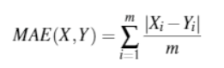
Figure 26 Mean Absolute Error (Santos, et al., 2009)
The MAE would give an accuracy to the prediction model in the form of a percentage, as more data enters the system this percentage should improve. As a traditional business type analysis would be near impossible for the scope of this project, an improvement of the machine learning predictions seems a worthy substitute. Another way to visualise this improvement would be the cluster graphs associated with the machine learning, over time the predicted groupings should show improved accuracy. Also, these groupings would have MAE analysis and a given accuracy.
The information received from the machine learning algorithms was finally going to be used to set parameters on the CNC machine, to improve the quality of future components and reduce possible defects. For instance, if an undue vibration was detected on the spindle, then the analytics would highlight an out of ordinary event and a machine operator could act on that premise.

Discussion & Conclusion

Discussions
The sections for methodology and analysis are as detailed as possible, every effort was made to show a plan where the actual work could not be carried out due to the Covid-19 pandemic. Though had the project been completed as intended, then a far greater detail of events would have been captured in these sections. The project stalled after a couple of days of programming the sound sensor and as such the detail after this reflects the situation. Much greater detail can be gleaned from experiences lived rather than experiences intended to be lived.
In particular, the analysis section should have greater detail, the analysis planned was to test the machine learning algorithms, as no machine learning was carried out, then no results exist to analyse. There is a swathe of missing information and this will lead to a conclusion based on conjecture rather than fact.

Conclusions
This project shares a number of similarities with the AMRC legacy project, a hugely successful demonstration of some of the ideals this project wished to achieve. This project was to take a further step into the industry 4.0 world though, to test machine learning on the data collected from the legacy part of the project. This may have been a bit over ambitious, from the work completed and experience gained throughout the project. Would the initial aims have been met? There would certainly have been a degree of success, the disparate parts of the project would have been successful. The non-functioning machine was brought to life with a new control system. The sensors would undoubtedly have been installed and collected some data. In the case of the sensors, another point should be raised, originally more sensors were planned for installation. A rotary encoder would have been top of that list as a vital piece of information, but as the snags early on affected the timing of the project, it was decided that only the sound and vibration sensors would go ahead. This was an informed decision, during research it was found that Bosch had a development industry 4.0 app for phones. This app is used by academia and researchers around the world to aid in their industry 4.0 applications. The app only features a vibration and sound sensor, and if one of the world’s leading industry 4.0 providers, finds that information important then it probably is. Lastly, the machine learning would also have been able to be carried out with some success, to which degree is unknown.
The part of the project that felt unsuccessful, was the integration of the separate pieces of the puzzle. The point of the project was to demonstrate industry 4.0, and the core belief of industry 4.0 is for interconnected system communicating with each other seamlessly. The control system would not communicate directly with the sensor suites or the machine learning software. All the interfacing, if any were achieved, would have been crowbarred into place and would not feel like interconnected system of the future.
In hindsight, if the project was to be carried out with utmost success, then the systems selected for each part, control system, sensor suite, and machine learning would have been selected with more care. That care would have been to select systems with the same standards, whether they are data or communication, and that would have led to a seamlessly integrated system. The reason behind this failing becomes clear at the end of the project, the project had a tight deadline for a single researcher and that meant that the research and physical implementation of the project happened concurrently. This meant that not enough insight into industry 4.0 and its implementation was known before selecting the relevant components to complete the project.
The final part of the project that was a definite success was the cost of the project, in total the spend came to around £250. This clearly demonstrates to SMEs that low-cost solutions are available and able to implement. The skills gap can also be addressed, every skill learnt through this project was self-taught or from online free courses. Again, this is a concern for SME’s but with the right policies and drive these issues can be overcome.
To answer the question, “Are Industry 4.0 Capabilities, Using Legacy Equipment and a Shoestring Budget, a Viable Option for SME’s?”, then yes there are ways that SMEs can gain access to industry 4.0 and this report has proven to some extent how that goal can be achieved.

Recommended Further Work
This project would be ideal to be picked up and furthered for post graduate study, the next step in the project’s evolution, would be the demonstration of in process machine learning informed adjustments. The improvement of the systems integration would also be a worthy goal. Just with a precursory search, Arduino has a machine learning add in, python can interface with the control system and Arduino. This would make integration seamless with Arduino and python as the core of the system.

References
Admin, 2019. MPU6050 pinout- wiring diagram and sample projects. [Online]
Available at: https://pinouts.net/mpu6050-pinouts-and-wiring-diagrams/
[Accessed 5 February 2020].
Arduino, 2020. About Us. [Online]
Available at: https://www.arduino.cc/en/Main/AboutUs
[Accessed 20 October 2019].
Bosch, 2020. The Connected Factory. [Online]
Available at: https://www.bosch.com/stories/the-connected-factory/
[Accessed 10 January 2020].
Chi, J., 2014. MPU-6050 Accelerometer + Gyro. [Online]
Available at: https://playground.arduino.cc/Main/MPU-6050/#sketch
[Accessed 6 February 2020].
CNCjs, 2018. CNCjs. [Online]
Available at: https://cnc.js.org/
[Accessed 15 October 2019].
EMCO, 2020. CONCEPT TURN 55. [Online]
Available at: https://emco.co.uk/products/concept-mill-55-2/
[Accessed 3 January 2020].
Glass, R. et al., 2018. Identifying the Barriers to Industrie 4.0. Darmstadt, Elsevier B.V..
HelmanCNC, 2016. NUM CNC Mill Program Outer Contour Cutting with Drilling and Counterbore, s.l.: Helman CNC.
InvenSense, 2013. MPU-6000 and MPU-6050 Product Specification. [Online]
Available at: https://invensense.tdk.com/products/motion-tracking/6-axis/mpu-6050/
[Accessed 7 February 2020].
Joy IT, 2017. KY-038 Microphone sound sensor module. [Online]
Available at: https://datasheetspdf.com/datasheet/KY-038.html
[Accessed 10 February 2020].
Kagermann, P. D. H., Wahlster, P. D. W. & Helbig, D. J., 2013. Recommendations for Implementing the Strategic Initiative Industrie 4.0, Frankfurt: acatech – National Academy of Science and Engineering.
Lin, K., 2014. How to Reduce Noise in a PCB Board. [Online]
Available at: https://www.pcbway.com/blog/Engineering_Technical/How_to_Reduce_Noise_in_a_PCB_Board.html
[Accessed 20 March 2020].
Lockwood, A. J. et al., 2018. Digitilisation Of Legacy Machine Tools, Sheffield: AMRC .
Made Smarter Commission, 2017. Made Smarter Review, Manchester: Made Smarter Review.
Markoff, J., 2015. A learning advance in artificial intelligence rivals human abilities. New York Times, 10 December.
Marr, B., 2016. A Short History of Machine Learning -- Every Manager Should Read. Forbes Magazine, 19 February.
Moler, C., 2018. A Brief History of Matlab, s.l.: Mathworks.
Pfeiffer, S., 2017. The Vision of Industrie 4.0 in the Making—a Case of Future Told, Tamed and Traded. Nanoethics, Volume 11, pp. 107-121.
Sanjeev, A., 2016. Arduino MPU 6050 - Best IMU Sensor Tutorial. [Online]
Available at: http://www-robotics.cs.umass.edu/~grupen/503/Projects/ArduinoMPU6050-Tutorial.pdf
[Accessed 9 February 2020].
Santos, I., Nieves, J., Bringas, P. G. & Penya, Y. K., 2009. Machine Learning based Defect Prediction in High Precision Foundry Production. In: L. M. Becker, ed. Structural Steel and Castings: Shapes and Standards.. Bilbao: Nova Science Publishers Inc., p. Chapter 9.
Spark Concepts, 2019. Welcome to the CNC xPRO V4. [Online]
Available at: https://github.com/Spark-Concepts/xPro-V4/wiki
[Accessed 1 October 2019].
Spark Concepts, 2020. CNC xPRO V4 Controller. [Online]
Available at: http://www.spark-concepts.com/cnc-xpro-v4-controller/
[Accessed 3 October 2019].
The Mathworks Inc, n.d. Matlab Help and Support. [Online]
Available at: https://uk.mathworks.com/help/index.html
The Royal Society, 2017. Machine learning: The Power and Promise of Computers that Learn by Example, London: The Royal Society.
Wilcoxon Sensing Technologies, 2016. Installation of vibration sensors, Germantown: Wilcoxon Sensing Technologies.
Yao, B. & Feng, T., 2018. Machine learning in automotive industry. Advances in Mechanical Engineering, 10(10), pp. 1-2.

