L4 LDE Assignment 1
Student Number: 2533410
E-Portfolio Link: https://sites.google.com/view/digitaleraassignmentportfolio/task-1

Task 1


Task 2
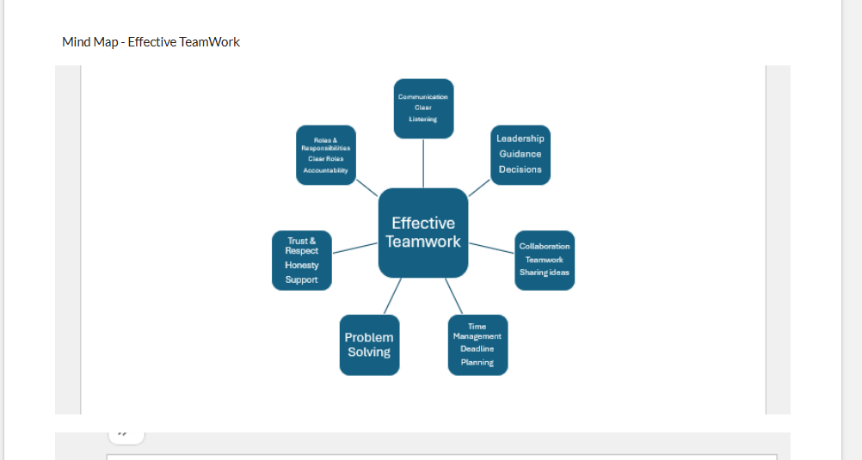


Task 3


Task 4 

