Student Name: Seren Davies
Student Number: 2404613
Photography in the Arts

Key words: Time, landscape, trace
Photographers: Michael Wesely, Sophie Ristelhueber, Hiroshi Sugimoto, Sally Mann

Within this essay I am going to explore the relationship between time, landscape and trace which eventually leads up to a question that revolves around these key words.
Time is generally conceived of as abstract, chronological, and invisible. Landscape is conceived more as a material, present but looking more closely, landscape is deeply affected by temporal factors, such growth, decay, construction, and memory, all of which make time visible in a landscape, and at the same time it makes time material in the presence and marks left in a landscape. By examining visual representation and theoretical perspectives, this essay will investigate the concept of how landscape becomes a temporal field, and how time becomes connected, recorded, or made visible.
The idea of ‘traces’ is crucial in understanding the relationship, as traces function as evidence of what has passed. Traces serve as evidence of what has already happened, whether through ruins, traces in nature, remnants of buildings, or even changes in the landscape. Landscape, in this case, landscape should not be considered a constant or something that remains the same but rather as something that is always changing and containing the memory of all the events that have happened.

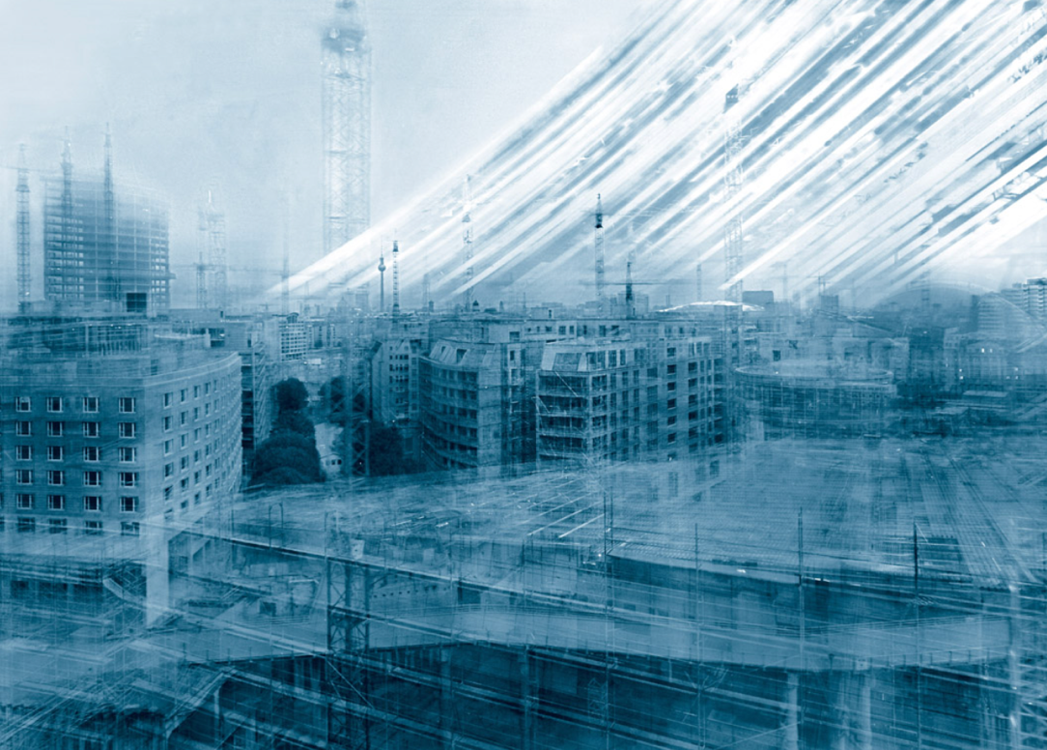

Fig 1 Potsdamer Platz (Wesely, 2000)

In this work Potsdamer Platz 27.3.1997-13.12.1998, 2000 by Michael Wesely. Wesely recorded the construction work at the Potsdamer Platz using long exposure time up to 26 months (Mercedes Benz art collection, n.d.). Using this method allowed Wesely to create a photograph to see how a city is built by recording many small moments and bringing them into one view. The buildings in the photograph (see fig 1) make the view look almost see-through because they are in different states of construction at the same time. It also shows how people move, how light changes, and how weather changes from season to season. This photograph (see fig 1) I find to be quite interesting as it displays many different moments in time, rather than the traditional singular shot such as in the image the buildings, cranes, railway, and the lights display the changes in the city over time. This image looks to be layered and transparent which makes the building appear to be faint and look ghostly.
The main colours are light greys, faded blues, whites, and dull browns. These soft colours create the atmosphere of a dreamy and hushed photograph, but at the same time, the choice of such shades reminds the viewer of a construction site. Since the colours are rather dim and pale, the image looks aged and somewhat nostalgic. Colour plays an important role in illustrating the opposition of static architectural elements to dynamic ones, when buildings appear dark and sharp while the dynamic elements look faded, blurring, and even transparent. Such contrast highlights the evolution process of Berlin's cityscape. The faded colours also make the image look like an old photograph, which links to ideas of memory and time passing.
What stands out in the image (see fig 1) is the set of bright diagonal streaks running through the upper right corner of the photograph.
This effect can be explained by the prolonged exposure during which the sun’s rays penetrate the lens multiple times. In contrast to the steady flow of natural light, its physical displacement through time is registered in the photograph.
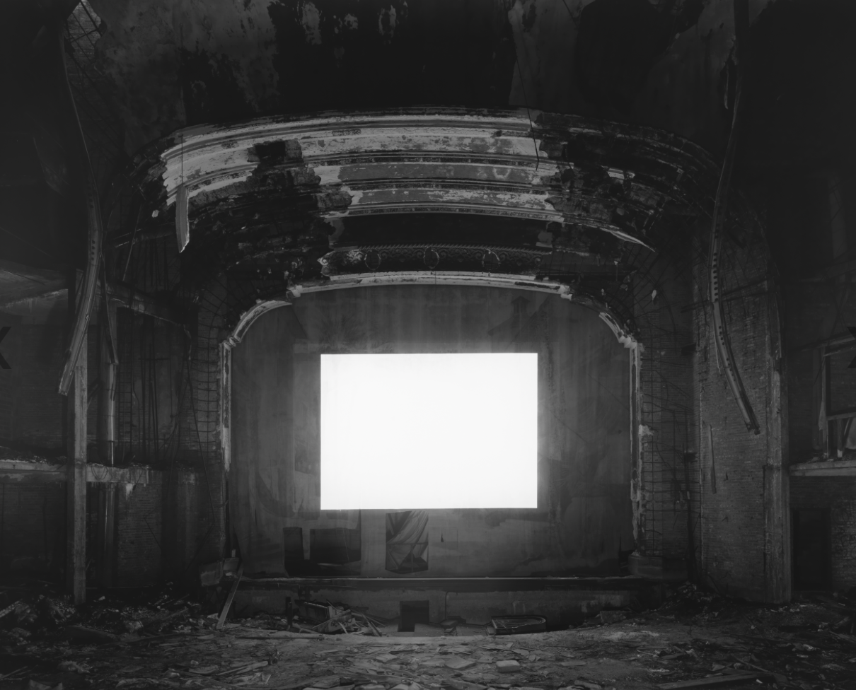

Fig 2 Abandoned Theaters (Sugimoto, 1970)

Abandoned Theaters by Hiroshi Sugimoto 1970. The series depicts the deterioration of the artist’s longstanding subjects. Time being the theme, each image is created through the use of a long exposure depending on the duration of film that the artist decides to show in the movie theatre (Fraenkel Gallery, n.d.).
His choice of movies was also linked with these cinemas. One such cinema theatre, located at Boston known as Franklin Park Theatre, has a very wet interior because there is a leak from the ceiling (Genova, 2016).
Sugimoto shoots the images in such a way that the whole composition is captured with a high level of focus and sharpness. Even the most intricate features of the theatres be they decorative balconies, ripped and worn-out seats are shot in such a way as to resemble architecture in their precision and clarity.
The viewer can easily notice all the details of the deserted buildings. They are mostly symmetrical compositions with centred structures, adding to the precise and peaceful nature of the image. Sugimoto always shoots in a fixed position for an extended period of time. The white rectangle that appears in many photographs of theaters by Sugimoto is not empty. Instead, it houses all of a movie captured in one single shot. The photograph does not depict a film but instead it captures the act of viewing it. It could be argued that Sugimoto’s theatre photographs are ultimately about the impossibility of preserving experience. Even though the camera records an entire film, none of the movie’s actual images remain visible in the image but everything turns to white light. For this reason, the photographs themselves carry a sense of beauty tinged with melancholy. They remind us that memory condenses experience just like photography condenses film.

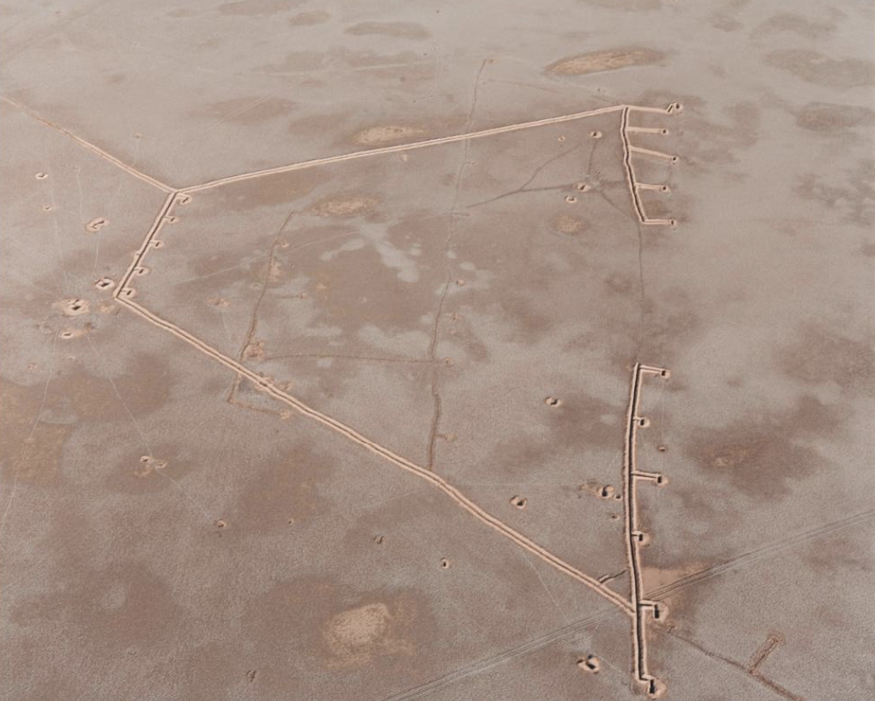

Fig 3 Fait (Ristelhueber, 1992)

At the end of the Gulf War, Ristelhueber travelled to Kuwait to record the physical traces of conflict on the landscape. The series of photographs Ristelhueber produces portrays trenches and tank tracks, bomb craters, smoke billowing from burning oil wells, and battle waste strewn on the sands from both above and below. At first glance, her photographs seem abstract, however, closer examination shows how an environment has been changed by war (Buffalo AKG Art Museum, 2025).
The focus in Fait is typically very sharp and controlled. Ristelhueber often uses deep focus so that textures of sand, tire marks, trenches, oil residue, and craters remain clearly visible across the frame. This gives the images documentary quality. It is not just the subject matter that Ristelhueber brings into focus, but it is the entire surface of the image, as if examining evidence.
The dust, grains and the surface textures are key to the ambiance of the project. As expected in a desert-like setting, there are plenty of hazy textures and dull surfaces, all of which are preserved by Ristelhueber, as opposed to being cleaned up. The images lack the smooth surface but appear rough instead.
As far as the development and production processes. The use of tones is quite limited. In keeping with the ruined and devastated nature of the landscape, earth tones mainly brown, black, grey, and faded yellow predominate the palette. Visual vibrancy does not feature prominently at all in the series. Currie-Williams (2021) discusses the meaning of afterimage in photography. Afterimage has been defined as the experience of perceiving images even after looking away from them. This is created as a form of memory or impression of something that is no longer present. What is left behind is not an entire image of the thing; rather, it is just the remnant or a fraction of it. Therefore, through the concept of afterimage, one can learn about the link between vision, memory, and absence. In photography, afterimages may be considered as an essential component of the photographic experience. They stay in our memory because they resist being forgotten. The afterimages contribute to the way in which we remember the photograph not only through its visual content but also through the lingering emotions and sensations that follow after viewing. Doane (2002, cited in Currie-Williams, 2021) defines afterimage as a “temporal aberration, an incessant invasion of the present moment by the past.”

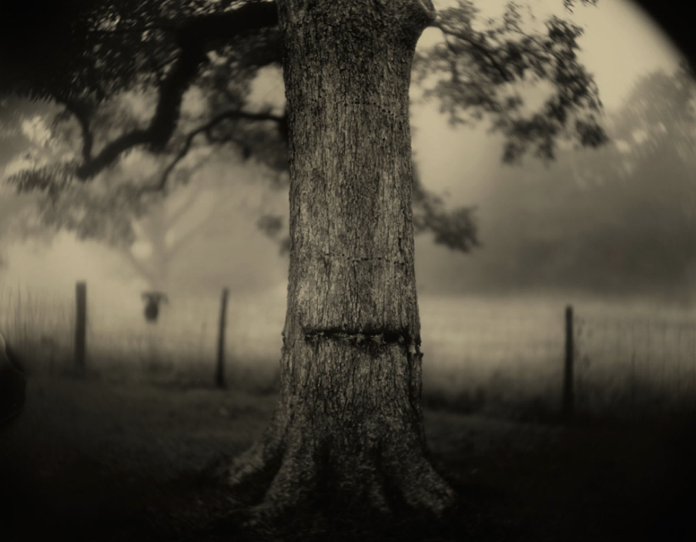
Fig 4 Deep South, Untitled (Scarred Tree) (Mann, 1998)
Sally Mann work explores the southern landscapes that are haunted by history, decay, death and memory. The tree in this image (see fig 4) is set in the deep South of the United States. The broken bark looks like a wound inflicted on the tree and one that seems to have become part of its being. Despite being alive, the tree carries scars of the past that are painful and still very much evident. The tree in the image represents the past that still exists in the collective memory of the land (Peck, 2021). While the scar on the tree is the focal visual element that needs interpretation, the overall mood created in the image adds to the significance of the image. Mann’s use of a large-format camera and antique lens produces a blurred, atmospheric quality. The overall effect is one of an eerie, nightmarish scene that seems haunting and full of emotion. There are feelings of sadness, remorse, and guilt invoked by the image. Mann uses old photography techniques that perfectly fit into her works context.
Both the photos and memories are temporary but still physical things. Her work carefully captures moments in time before they disappear. The images become physical reminders of memories, preserving something that can never happen in the same way again. However, memories are dynamic and changeable and cannot be depicted in one photograph entirely.

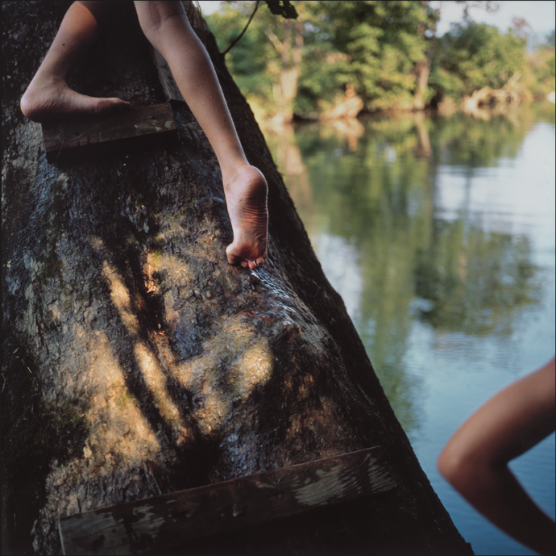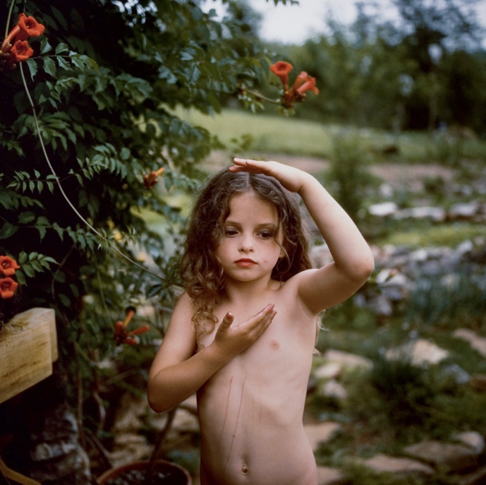
Fig 5 Fig 6
Bean’s Bottom (Mann, 1991) Trumpet Flowers (Mann, 1991)
Gilliams (2020) provides an overview of Mann’s process and approach to photography. Mann has expressed how looking at her photographs has not helped her to remember moments in her life but how they can weaken or change memories. Mann calls this the “treachery of memory” (Gilliams, 2020). Her work has often shown people growing older and the reality of death, reminding us that time passes, and nothing stays the same forever. Mann started her career by taking photographs of her children at home and outdoors in nature. Her photographs reveal her children in their purest form, including having black eyes and bug bites for playing, swimming, blowing bubbles, and pretending to dress up. Mann adopted old techniques of photography such as the collodion method, which is an old technology before the American Civil War and is mostly used during this period to capture images of the war. Sally used an old big camera and took her own glass plates as negatives through coating clean glass with a combination of chemicals. The coated glass would dry for 15 minutes within which she would have to place it in her camera and take the photo.

Wesely, Sugimoto, Ristelhueber, and Mann all explore themes of landscape, time, memory, and trace, but they approach these ideas in very different ways. Each photographer transforms the landscape into something more than a physical place however each photographer interprets these ideas in his or her own way. It becomes a record of human presence, history, or emotional experience. Each artist also applies completely different techniques in the interpretation of these ideas and their effect on emotions.
For Wesely, landscape is an evolving scene that is marked by change and temporality. For example, in his Potsdamer Platz 27.3.1997–13.12.1998 series, he employs long exposure times to create a scene of a month or even years packed into one photo. The landscape becomes ephemeral and multilayered, full of ghostly images of buildings being constructed, movements, and changes. For him, the subject is not the actual event, but the temporality associated with the event itself. In the photograph (see fig 1), we get an image of the city as an ever changing entity, which is a reality in modern landscapes.
Meanwhile, the work by Sugimoto is more composed and reflective in nature. Sugimoto’s Theaters series (see fig 2) reduces a whole film down to a shining white screen. Sugimoto’s technique involves stripping down details to achieve an image that is timeless. While Wesely depicts disordered cityscapes, Sugimoto’s photographs are quiet and timeless. The presence is achieved through lack. In Sugimoto’s photographs of theatres, there are no longer any spectators, films disappear into the whiteness of light, and all that remain is the architecture.
In her photography, Ristelhueber creates landscape through signs of destruction and violence. Her photographs tend to capture the signs of damage to the land, ruined paths, marks on the land, and signs of warfare without showing any human forms. For instance, in the project Fait, the landscape becomes a damaged site where signs of political and military activities are captured in a physical manner. Her work differs from that of Wesely and Sugimoto because she uses a confrontational style that is more forensic in nature.
In the same way, Mann also employs landscape to evoke memory and history, even death, especially in the case of her pictures of the American South. Her pictures are usually atmospheric, blurry, and imperfect because she works with traditional techniques of photography such as wet plate collodion process. While Ristelhueber's style is starkly documentary, Mann's landscapes have an intensely personal and emotional quality. She combines landscape with family history, death, race, and Civil War heritage. Traces found in her photos are historical and emotional rather than architectural or political. Through mist, decay, stains, and blurring, she creates a sense that the landscape itself holds the memories of the past.
While all the four photographers employ ideas of trace and memory, each has a different way of working. Wesely makes an impression of the passage of time using long exposure and urban development. Sugimoto eliminates any details that would make a photograph temporal, making it eternal. Ristelhueber focuses on the physical marks made by violence and warfare. Mann makes photographs of haunted, poetic landscapes based on the forces of memory, history, and death.
Based on this research I am interested in learning about how photographers use analogue photographic techniques to explore the theme of trace, especially how it relates to memory. My question for further research is:
How can photographers use analogue photographic techniques to explore the themes of trace and memory in their work?

Bibliography

Buffalo AKG Art Museum (2025). Untitled from the series FAIT | Buffalo AKG Art Museum. [online] Buffaloakg.org. Available at: https://buffaloakg.org/artworks/p199794-untitled-series-fait. [Accessed 8 Mar. 2026].
Currie-Williams, K. (2021) “Afterimages and the synaesthesia of photography,” Philosophy of photography (Print), 12(1–2), pp. 111–127. Available at: https://doi.org/10.1386/pop_00050_1.
Fraenkel Gallery (n.d.). Abandoned Theaters. [online] Fraenkel Gallery. Available at: https://fraenkelgallery.com/portfolios/hiroshi-sugimoto-abandoned-theaters. [Accessed 8 Mar. 2026].
Gilliams, A. (2020). Sally Mann: The Treachery of Memory • XIBT Contemporary Art Magazine. [online] XIBT. Available at: https://www.xibtmagazine.com/2020/04/sally-mann-the-treachery-of-memory/.
Mercedes Benz art collection (n.d.). Mercedes-Benz Art Collection. [online] Mercedes-Benz Art Collection. Available at: https://www.mercedes-benz.art/en/artwork/michael-wesely-potsdamer-platz-27-3-1997-13-12-1998-2000/ [Accessed 20 Mar. 2026].
Peck , T. (2021). Darkness in the Deep South | Sally Mann | On Landscape. [online] www.onlandscape.co.uk. Available at: https://www.onlandscape.co.uk/2021/07/darkness-in-the-deep-south/ [Accessed 14 May 2026].

