ASSIGNMENT 1
STUDENT NAME: Mohamed Diallo
STUDENT NUMBER: 2532267
GROUP: 2
LECTURER’S NAME: Anum Paracha
Software Solutions for Business (ACCA4026_LON)
Table of Contents
Introduction 1
Task 1. e-Commerce Website builders or software solutions 1
1.1 WooCommerce 1
1.2 Wix 1
Task 2. Mind-map of contemporary software applications 1
a. Mind mapping and explain the benefits of using mind mapping in business operations 1
b. Create a mind map of contemporary software applications 1
Task 3. Office Applications 1
a. Four office software solutions for business operations 1
MS Word 1
MS PowerPoint 1
MS Excel 1
MS Access 2
b. Practical demonstration of Two Office Features 2
Mail Merge 2
If Statement 2
Task 4. Communication and Collaboration applications 2
a. One contemporary Communication and one Online Collaboration applications/tools 2
MS Outlook 2
MS Teams 2
b. One feature of a freely available Communication (1) and one feature of a Collaboration (1) application 2
MS Outlook 2
Ms Teams 2
Conclusion 2
References 3

Introduction
This is my assignment 1 for software solutions for business in this assignment I will be talking about the reason software is important or business and explain why these software are good for running a business and the benefits.

Task 1. e-Commerce Website builders or software solutions

Shopify
Shopify is a website builder that focuses on e-commerce this focuses on bugger companies that have a lot of stock because Shopify offers applications and gives businesses the opportunity to handle inventory. This make the difference between Wix and Shopify obvious choices when deciding what kind of website, you need to run a business online. Shopify cost more then Wix because it has a basic plan that cost money to run but Wix is free and is for small businesses or to create e portfolios[1]. Wix has a drag and drop feature that makes it easy to use and is good for beginners because it does not require extensive computer knowledge to create. Because Wix has a lot of templates if makes the creation of a website easier then having to create a website from scratch, the templates help the person building the website create a unique looking website. This because you can add a lot of pictures and Wix has hundred of picture that you can choose from to personalise a website and you can also insert you own pictures from your device to give it an even more personalized look. Wix also allows you to change the text on the website and has hundreds of different fonts to choose from this will help to give your website a unique look. Shopify also was these options but does not have as many templates as Wix[2][3]. Shopify offers more applications and is more focused on selling products so if you are a business that want to make sales you should choose wix but If you are a small business Wix can also help you make sales because it does offer some applications that will allow you to take payments online for product you would like to sell. Wix is a good website to offers a service because it gives you a platform to present your skills and to be seen if you are for example a painter Wix will be a good website or helping you to show some of your are and is has application that can help you sell it. Shopify is good for people that may already have a business for example if you are a business owner and you sell cleaning products and business it doing well[4]. But the business you own is a physical shop and you get the idea that you would like to open a digital shop and sell online as well and you also have some money to invest. Then Shopify will be a better option because it offers application that are for selling and handling stock and can handle a lot more traffic for its websites. So even doe Shopify and Wix are both website builders they serve two different function in their software operation and focuses on different type of business platforms. So for small business you should use wix and if you would like to create an e portfolio or a digital CV you should use wix but if you are an business that may already be selling product and you have a product that customers want then shopify is the best option between the two.

Task 2. Mind-map of contemporary software applications

Mind mapping and explain the benefits of using mind[5] mapping in business operations[6]
Mind mapping is a way of organizing to remember things it also helps you to create a plan because of its structure when you create a mind map people can see your plan clearly because it is simple to follow. When people are following a mind map the thing that stands out the most is the colour branches you may use the give it visibility and helps people to remember steps with the use of colour. When creating a mind map its important to keep it a easy and straight forward as possible because the point of a mind map is to give ideas a visual and step-by-step plan or structure of an idea. So if I have a business and I want to show how my business is structured and there are four important parts of my business for example 1)HR, 2)WORKERS, 3)SUPPLIER, 4)CUSTOMERS I create a mind map show my business in the middle then four different lines each line will have a different colour. These colour lines not only look better but it uses the colour to separate and organise the four main section of my business. So now if I was to hang this mind map on a wall anyone looking at my mind map will see the four main part of how my business runs and I have been able to share information or demonstrate by not using to many words. This mean I can share the same information more quickly because I am organising my words visually using colour to highlight the different section[7]s. Mind map is good for business because it is easy to use and multiple people can add to it this means that a team of people can collaborate it is a great tool for multiple people to add knowledge towards a certain goal. So if you have a project and you have a team everyone in the team can add an idea and when its put into a mind map that idea is now visual, therefore now each person on this project can visually see each other’s ideas. This is good for creating an environment where people start to talk and communicate their ideas because when we speak and communicate and see others ideas, it helps create more ideas and we can speak about the problems a business project may have and how we can solve these problems as a team[8]. Mind map is a great way to start building this type of communication and openly store ideas and information as a team. Its is also a good way to remember things because of the way the mind map is structured I can also use it to remember how to do things such as using application or anything that requires me to do something in an order I can also use it to see information of for example if I was using Microsoft word I can map out the options menu then list the option menu and have the information in a mind map with out having to open the application for guidance.

Create a mind map of contemporary software applications
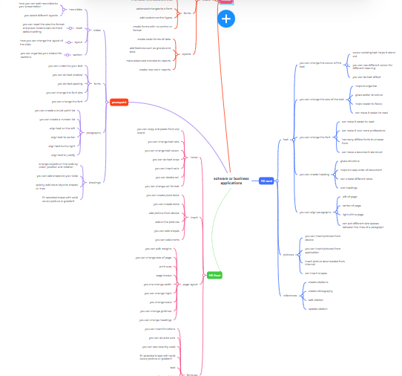
This a screenshot of my mind map https://www.mindmeister.com/app/map/3982456479

Task 3. Office Applications

Four office software solutions for business operations

MS Word
Microsoft word is an application that helps people write thing like document and other things like contracts this means that I wanted to write a letter digitally I can use this application to do it. When using this application, I can write different styles o word these different styles are called fonts and I can change the size o the letters and the colour. I am able to create essays and but my ideas in words to explain what I am doing or thinking to other people. Then I am able to send the information I have written down and save it in my computer or I can save it in my cloud. This gives me the ability to have my word document on other devices and means I it is in the cloud then I will not lose the word document If I lose my device so the fact, I can save the word document in the cloud is very good[9] . I am also able to add picture or images to my document this will help people that are reading my document see what I am writing and give better visual o what I am talking about on a certain subject and can make the document look better. There is also text box that allows me to add a box and lets me write in the box if I wanted to add notes on the side or create more of visual text and makes it stand out. I can add shapes to my document like squares, arrows or circles so I am able to separate certain parts of the text or create my own diagram. Microsoft word is good for business because it means that other people can add to the document if you want them to and allows you to collaborate with other people to create a document. You can add charts and make and information from the internet and you can add information from other Microsoft applications such as MS PowerPoint and MS Excel so a person that is creating a document for a business can add information from different application that the company uses and create a report of the information. This means that employees can create a document of information to send to people and make if more understandable for people who may to be able to use the applications or be able to find the information. So, Microsoft word is good for sharing information with other employees and employers within a business because it has the ability to add different types of information inside one document and can be designed to make information easier to understand. You can also add references to a document that allows you to reference sources where you got the information from so that if someone wanted to find more information or research it can use citation to point them in the right direction. This good because if I wanted to add information about my business inside a document and compare it to a competitor of my business the I can share the information using citation or a direct online website link.

MS PowerPoint
Microsoft PowerPoint is good for creating demonstrations this means someone can demonstrate something in the or of presentation slideshow this give people a visual of somebody’s and make it more understandable. If I wanted to show a company a new plan that I have then this will be a good software to use because it helps you to show your ideas and present them using simple bullet points and diagrams and images and tables. This is important because not everyone is going to understand or have time to read a long document so when you use PowerPoint it help you to share information and plans more quickly and because you use slides inside the presentation it means you can talk in-between each point you are trying to make. This allow you to share information visually and gives time for people to ask questions and gives you time to answer questions. Depending on how much time you have for your presentation it allows you to share information at you own pace to explain your idea inside a visual presentation. A user of this application and also add videos so it gives even more visual and give the presentation more of a feel of entertainment to the presentation by adding video can mean the presenter the ability to prepare a informative video in advance[10]. When using PowerPoint, you can also add tables but it is important to keep it fairly simple if possible because the whole point o using this software application is to share information or a idea in a simple format so people can follow along with you. If using a table, you can add colours this make the table stand out and allows you to make it look good and you can use colour to separate information. When using colour, it helps people understand it better or to remember it better because colour makes it stand out. You can also add pictures to the presentation because when you create a new slide you can add different table options for different types of slide or you can just add a image from stock images and you and add images from your computer and you can also download images from the internet and ad them to you presentation there are many way to add images. When you add images, it makes the presentation easier to look at and give a visual understanding of the point you are trying to make. This software application is very good for a business because people can make plans or rules and share it with everyone and people can have meeting and use this for answering questions or to guide people to understanding a business policy or how to do things inside the business. This can be shared and made available for employees to read in their own time and can be sent to a employee if they have missed a meeting and will keep them informed. The slide show can be edited in animations to that each picture and bullet point shows one at a time this will give more control and better pace when presenting.

MS Excel
Microsoft Excel is good for creation spreadsheet and tables for business if a business has a lot of staff and information you can save the information on a spreadsheet to make it easier to understand. This is good for calculation of a large spreadsheet with a lot of different types of in information such as salary or hours staff has works. It can also be use to show how much money a business makes and can show visually a breakdown of how much the business has made in a day a month or a year and so on. A spreadsheet uses columns and rows and cells the cells is where you can input data to show the information of the spreadsheet. You can use the information on the spreadsheet to create a chart and the chart will show the same information from the spreadsheet and give it a different look this is good for showing people in a simpler way. You can also use certain parts of the spreadsheet and create a chart by doing this will allow you to create a chart with the information that you want to show. When using calculating a feature you can use insert function this will give you the option to create a to calculate the information on the spreadsheet like add this will add all the numbers on a spreadsheet of your choice. You can you average this will give you the average of the numbers[11]. And the count will tell you how much cells do not have data inside of them. This is important when you have a large table that has a lot of numbers because it saves time and calculates as you are putting in data and updates in real-time as you do it. This means you do not need to calculate it yourself and that it will save time when running your business and because it is being calculated by your computer there is no mistakes this means there is no human error. You are able to share spreadsheet with other employees and they can also have access to a spreadsheet this means u can create a timetable for staff you can create a spreadsheet to manage budgets and expenses. This is a good way to save and share information to a large group of people. The pivot table is good because use can create a table from a spreadsheet and choose only the information that you want from a spreadsheet this allows you to look at or present the information that you want to see. When you create a pivot table it will show on the other worksheet. This software application is important to run a business because information is available to you and can hold different types of information ad create charts for better visual understanding o the information. You can add contact numbers and email addresses and website links this will allow you to access information or website just by clicking on the spreadsheet. You can change the colour o the text and you can change the colour of the spreadsheet to give it a better visual and make it easier to follow.

MS Access
Microsoft Access is a software application that allows you to create a data base this is important when running a business because I your business ass a lot of staff and If your business has a lot of customers or a lot of information in general. This is a great software to have because you can make a data base that has thousands of cells of data and will be able to store this data securely. When using this data base software, you can use SQL to find the data that you are looking for by using SQL Query it allows you to use certain command so talk to the software and ask its to provide you with information from the table. This is important because you can ask for certain information and you are looking for and you do not have to spend a long-time gathering information. This software is important for business because instead of using paper it put all the information in your computer and is digital and make it easier to find. Because you don’t have to go through a lot of paperwork you can ask the software to find it using SQL query and it will give you what you are looking for. You and also delete information rom a data base quickly by using SQL and you can update your data base as well[12]. You can also use different colour text to make information standout and you can change the function of a cell so that you can input number or text. When doing this you add phone numbers email addresses and other valuable information that you may need inside your database using this system allows you to have full control and access to a lot of information instantly because you are able to request data by using SQL. It is important to create a table that has all the information needed because of how much information that can be added and depending of the size of your business and how many table you may have then moving and transferring information will be a long process and data could be lost when you are transferring data to a new table. You can also filter data if you have a lot of information like for example 5000 customer and you would like know now many customers have purchased to most to the least. You can use filter option for a column and re arrange the order doing this allows you full control over how you view the information. This is giving you the option to prioritise information that is important for you. You can also add information rom MS word and MS excel this give a business a lot of flexibility to add data and will be very useful when creation a data base if your business is using other software applications that have information you will like to add to the data base. This software application is also allowing other people that you may allow access to, to update and to edit and even delete data.

Practical demonstration of Two Office Features

VLOOKUP

*write the name you are looking for
*highlight the cell next to it

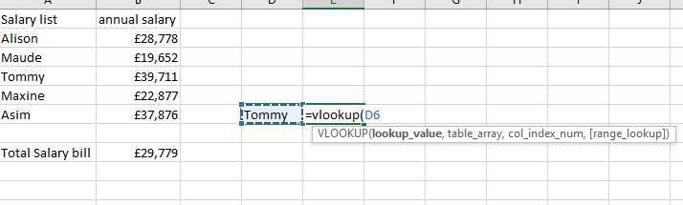
*in the empty cell type =vlookup(
*then click name of the value that you are looking for this will be the “lookup_value”

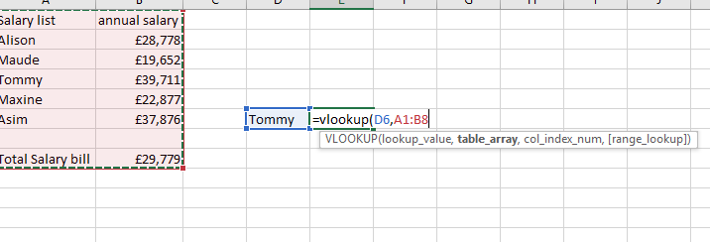
* then highlight the table or columns you want the information from this will confirm the “table_array”

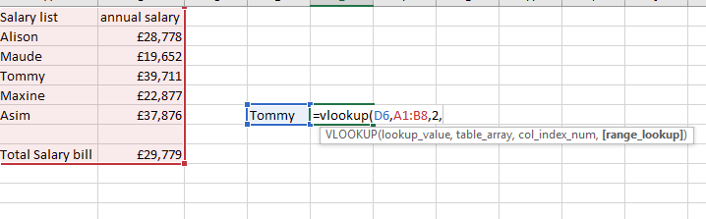
*chose that columns you want the information from because I want information from two columns I type “2” for “col_index_num”
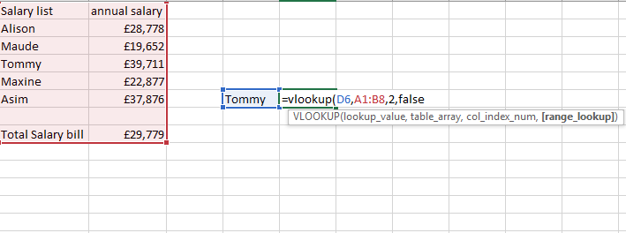
*then type “FALSE” to get the exact value

As you can see the exact value is the result inside the cell and information is found

If Statement

In this formula I would like to know who I have paid more then 20,00
“=” is to start a calculation
“B2” is the cell I would like to the if statement from
“>” means greater/ more than
Then the amount in this case £20,000 therefore or I’m asking is b2 more then 20,000 if so say “true” if not say false


It is true so the if formula is correct

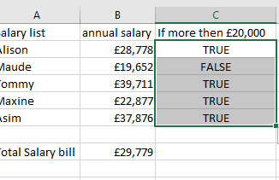
If I want the full column to show this if statement just hold the square on the highlighted box and drag down

Task 4. Communication and Collaboration applications

One contemporary Communication and one Online Collaboration applications/tools

MS Outlook
Outlook is an emailing software that allows you to send emails this is a very useful application because it allows you so communicate to people anywhere around. This form of communication is a safe way to send messages and is private If someone give an email address as a business there are multiple things you can do to help a customer and for a customer to get information about your business. This can be to promote products and to help people communicate with customer service. This communication is called asynchronous because it is not instant communication like video calling. This is because when you send an email to somebody you have to wait or a response. This for of communication is important because you can send website links and documents like Microsoft word documents and you can send MS excel documents. This can save you a lot of time I you are running a business and need to pass information to somebody. When using this software application, you have many options and can also schedule meeting by email. When you do this, you can notify other people and let them know in advance that a meeting will be taking place. This is a great way to save time and to get a understanding in advance on who will be attending. To open an account is free so having this for of communication is very affective when you want to start a business because you can use this application for free and you are not losing money or paying a monthly expense to keep it running. This is a very good software because the application is stored in a cloud and can be accessed on any device that uses the internet because of this you can use this application on the go and is vey flexible when you need to communicate with somebody. You can also attach PDF documents and pictures and videos and send them to multiple accounts at one time so you don’t have to keep repeating sending a email. CC option means if you send an email to multiple people then it will show all the people who received the email to the receiver. But if you would like to send an email to multiple but you don’t want nobody to know who else has received the email because you only want the one who received to not see who else got it then use BCC. Because BCC gives all the people you’ve sent the email to privacy and nobody can see who else has received the email. This is a good way to communicate to business and to customers because it also has the time and the date the message was sent and can be used as proof that you have communicated with somebody or it can be used as proof got communication from somebody or a business. This is good for if a customer buys something and then they get an email to confirm that they have bought something and if they want to return something, they can get links to take them to a webpage that can instruct them on how to return something they bought online.

MS Teams
MS teams is a good way to communicate and collaborate with people because it helps you to start group chats and you can also to video what conference calls because when you do video call you get a instant response rom the person that you are communicating with. This means that this form of communication is asynchronous and is very important if you are not in the same building and far away. Because you can use this app as long as you have a internet connection and you can create a profile for free. This application allows you to create groups withing the app so you can add different people for different things and you can start a group chat. This is a great way to collaborate when doing a project or whether you have multiple project because you can add different people to different groups. When in a video call you can add people to a call and you can send information and you can even show a PowerPoint in real time. This is very good for if you want to provide information in real-time and get feedback from work colleagues because multiple people are watching and everyone and have a input in the video call meeting. You can also use other software application inside the application like Microsoft 365 and can share document in this makes the work you do on other application be able to be accessed inside and you can also get help and feedback on a document or a project. This application can be used online and means it can be flexible with your lifestyle because if you are somebody that is always on the move and if you work from home you can see and speak to people and get an instant response. This also allows you to not miss meeting because if you have internet and an account this is all you need. The application looks nice and simple and is easy to use and because it is popular you can also go on the internet and search up how to use it and get a lot of information and instruction on how to use it. This is a great application or communication because it has many applications inside it that work with it and you can get third party application inside it that can help you make it easier to communicate. You can also send picture and videos to users it is like a private social media account messenger so it is east to use. So if you use this application to communicate in your business you will find that it will save you a lot of time and money because you can attend meeting and you can see people as you communicate with them. Because it is online you can have meetings with people and business in other countries this means you are able to save money and it saves time because you attend a presentation in another country and not even leave your home or office.
<Insert information appr 500 words>

One feature of a freely available Communication (1) and one feature of a Collaboration (1) application

MS Outlook
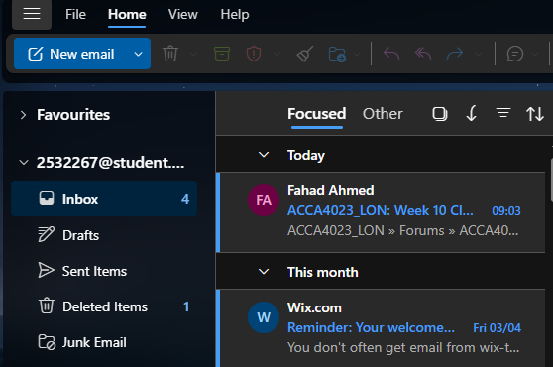
*click new message to send a message
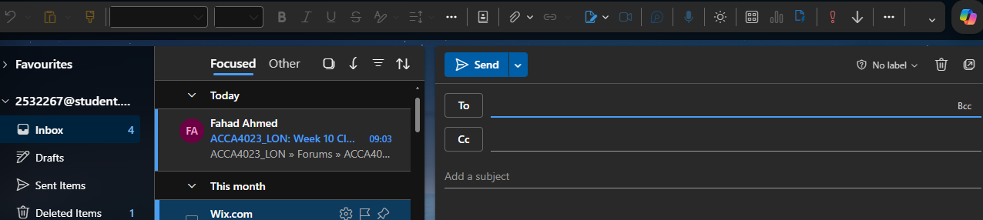
*this page will be a template for form a email

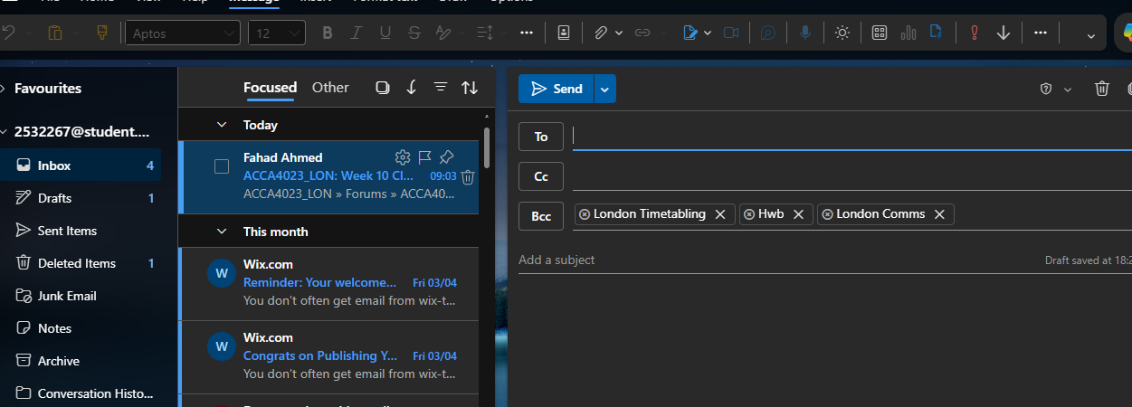
*”TO” is to send the email
*”CC” is to send a email to multiple and they will see everyone who received the email
*”BCC” Is to send a email and the receivers of the email will not see who else revived the email

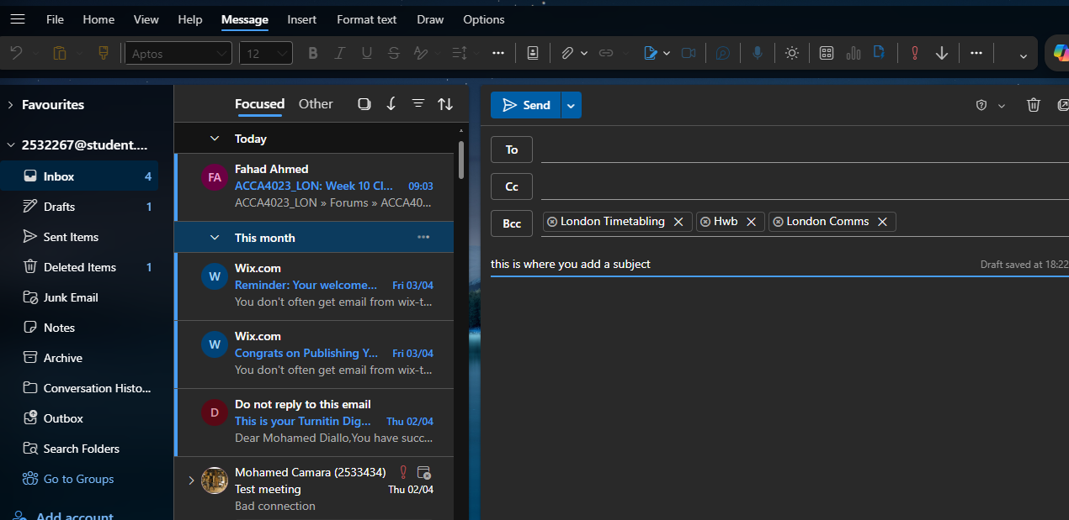
*add the subject on what the email is about

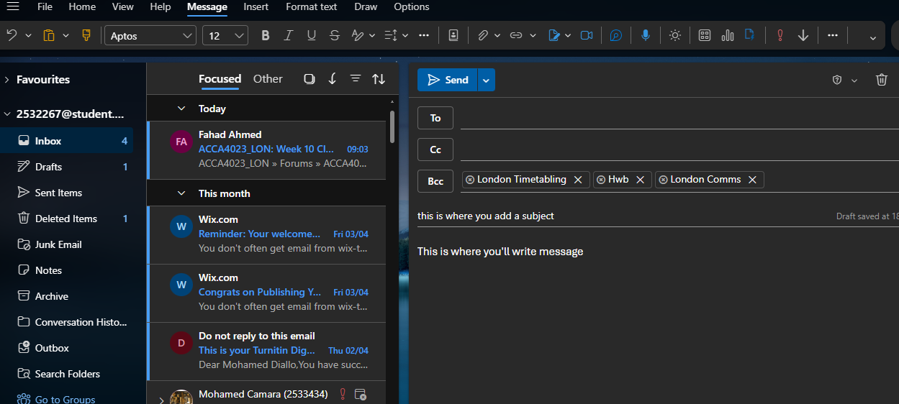
This is where you will put information of the email


*click send to send the email

Ms Teams

Conclusion
<Insert information>

ReferencesReferences
Task1
References
[1] J. DeRosa, Building DIY Websites For Dummies, John Wiley & Sons, 2024.
[2] B. A. Dharma and A. Septiana, "The Use of WIX as a Learning Media to Support Self-regulated Learning and Learning Activity", BISTIC Business Innovation Sustainability and Technology International Conference (BISTIC 2022), pp. 347–356.
[3] P. Waddy, Shopify for Dummies, John Wiley & Sons, 2022.
[4] L. MacDonald, The Shopify Story: How a Startup Rocketed to E-commerce Giant by Empowering Millions of Entrepreneurs, ECW Press, 2024.
Task 2
References
[1] T. Buzan and C. Griffiths,Mind Maps for Business: Using the ultimate thinking tool to revolutionise how you work, Pearson UK, 2013.
[2] F. Rustler, Mind mapping for dummies, John Wiley & Sons, 2012.
Task 3
References
[3] M. A. Cusumano, The business of software: What every manager, programmer, and entrepreneur must know to thrive and survive in good times and bad, Simon and Schuster, 2004.
[4] J. Bozarth, Better than bullet points: Creating engaging e-learning with PowerPoint, John Wiley & Sons, 2013.
[5] S. Bullen, R. Bovey and J. Green,Professional Excel development: the definitive guide to developing applications using Microsoft Excel and VBA, Addison-Wesley Professional, 2005.
[6] J. Eckstein and B. R. Schultz,Introductory relational database design for business, with Microsoft Access, John Wiley & Sons, 2018.

