Esther Anderson
1803142
Construction Management
ACBA5009
16/01/2020
Work Based Project

The purpose of this 1000 assignment is to identify a number of topics relevant to the construction project being discussed. A company description will be given, relevant health and safety will be discussed, roles within the company will be outlined, and the hardware and software used included within the project, the materials and processes the company use, and how the project affects and wider links such as marketing. This will be a weekly placement that can vary in hours from one/two days due to being a full time student. This will allow theory to be put into practice and gain on site experience. The duration of the placement can be made more beneficial by allocating time with a range of professionals.

As mentioned in the learning contract Jehu are a fairly large construction company that are familiar in this types of work. This project involves the demolition of a former police station built of reinforced concrete, containing asbestos. The new building will be a commercial building of a well-known supermarket Lidl. This will contribute greatly to the community; it will create jobs, boost economy, help local surrounding businesses, and give recognition to Jehu. The supermarket will be constructed on a raft foundation with a steel frame, with cladded walls and roof. Any existing bulwarks are to be protected with heras fencing. Prior to the site starting works and prior to starting the demolition of the building, an ecological survey is to be carried out to survey the roof of the building for bats; following this a competent sub contractor will remove the asbestos.

When on placement there are objectives that need to be obtained. Prior to starting placement lists of objectives were made, by having an insight into the project the objectives set may have been a bit ambitious. However there is still the duration to meet the criteria for the majority of the objectives. While on placement a number of jobs have been delegated and by the end of this project being able to check, rationalize and evaluate documentation should be a competent task. A major task is understanding health and safety which will give the opportunity to work alongside the Health and Safety Advisors on Site who carry out Daily Checks on Package works along with all Administration, the following will be looked at which cover a vast topic area: -

  - Understanding the Induction Process and Carrying out an Visitors Induction
  - Reviewing Method Statements and Risk Assessments for Work Packages
  - Controlling Site Access and Egress along With Security
  - Attend Internal and Sub Contractors Health and safety Meetings
  - Review documentation on Site Trades to ensure that they are carrying out works to meet all RA/MS
  - Build relationships with External Party’s also another opportunity to gain experience and knowledge

Following health and safety the allocated mentor has suggested that a development of an understanding in Supervision of Structural Steel Works, Internal Floor Slabs and Masonry Packages would be beneficial this would include:-
  - Monitoring Sort Term Programmes
  - Health & Safety
  - Controlling Work Packages, quality and Progress
  - Attend Sub Contract Meetings
  - Supervise Materials, Plant, and Equipment on Site
  - Maintain Working Relationship
Due to the project being a fairly non-complex build there are a limited number of professionals working on the project, there are a number of subcontractors involved to for various activities. However there is great importance in the roles of the professionals that are included.

Client – Lidl –Lyn McComas

Principle designer –SDS limited – Danny Groake
and architect

Civil and structural – SDS- Danny Groake
Engineer

Principle contractor – Jehu – Will Pugh

Client H&S advisor – Alumus HSE – Gerald Black

It is vital that a specialist contractor carries out the removal and disposal of asbestos in the most appropriate way in accordance to the control of asbestos regulations 2012 (Hse.gov.uk, 2020). The demolition and refurbishment survey will be available at all times on site for reference.

As part of health and safety it is key that a traffic management plan is established the following illustration displays this

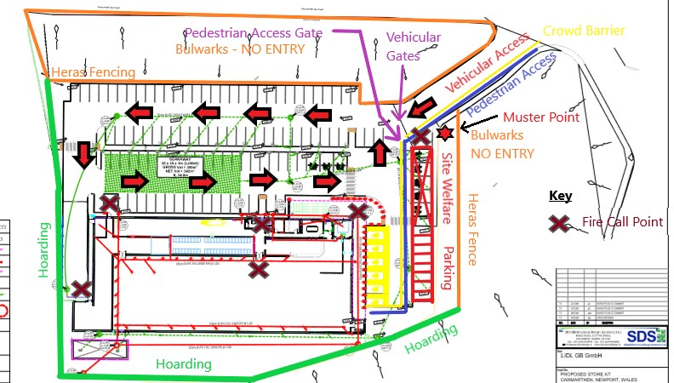
Access to the construction site will be made via Morfa Lane. Suitable vehicles will be selected to take account of the access route. Banksmen will be used to oversee the movement of construction vehicles into and out of the site the standards signal can be found within the health and safety regulation 1964 (Hse.gov.uk, 2020). Deliveries of materials and plant for use on site will be controlled according to the nature of items to be delivered, the type of delivery vehicle and the location of the proposed works. All suppliers/sub contractors will be advised of the access and delivery arrangements and restrictions.

A role in which has been adapted on a personal level is waste management; it is key that waste will be collected and placed into suitable receptacles. There is limited space for delivery and siting of skips, so where possible, waste material will be removed off site daily (Focus Logistics, 2020). From a gained interest in this topic, instructions and guidance have been taken from the site manager; it is the role of the Site Manager to ensure regular collections of waste materials. Licensed waste carriers will be used as required. Waste collections will be planned in line with our traffic management arrangements and be timed to minimize disruption and risk to non-construction personnel.

Health and safety covers a huge topic area therefore not all aspects will be address within the assignment, other areas that have been looked at include: -
- Noise and vibration
- Plant maintence and inspections
- Manual handling
- Avoiding dust generations – road, plant and vehicle, material handling and storage and cutting, grinding, grouting and packing.
- Water damping
- Dust screening
- Working near services including high voltage power lines
- Chemical and biological hazards
- Falling from height
- Excavation work and groundwork
- Protection of occupied or neighbored areas
- Management of temporary works
Prior to the commencement of steelworks erection operations, risk assessments and method statements will be prepared. The Lifting Contractor, Contracts Manager, Site Manager or a competent appointed person, will prepare a lifting plan. Documents will be produced and arranged for the following lifting operations, (Hse.gov.uk, 2020). Site Welfare Installation, Steel Frame Erection , and roof Installation this would be relevant to the materials and processes that are included within site procedures.
Health and safety is a massive topic area within construction therefore there is a major focus on this as previously stated within the objectives. From having an insight to the reality of on site experience further learning and knowledge will be gained in health and safety with guidance from the professional mentor. Other objectives will be addressed within the placement, however not all will be focused on in as much depth.
There are a number of software’s used within the company these include all Microsoft 360programme- (as pictured below), Microsoft project, BIM, Revit, Asta for planning, Activ Absence (a management software) and Codel software (Engworks, 2020). All documents produced and developed are kept on an electronic back up, as well as some being filed and updated by hand.
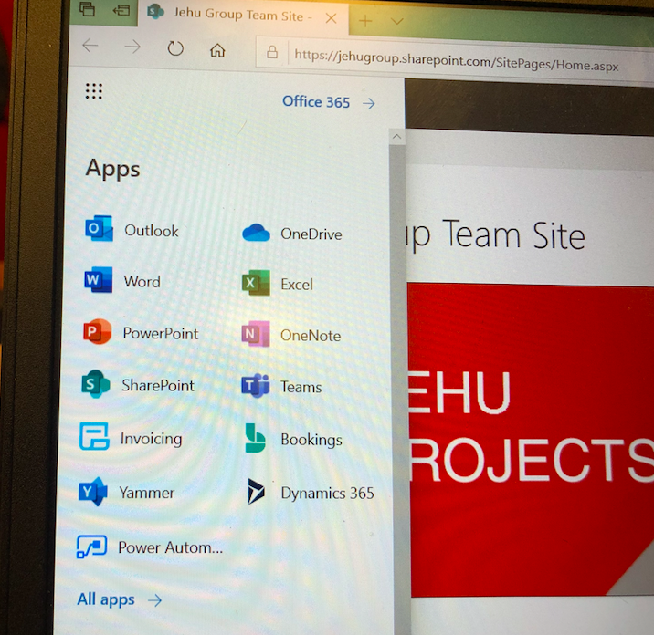
Due to work-based project being an ongoing learning goal, the following log will include any updates and gained learning objectives. This will be discussed further, and in the mean time further learning will be focused on to meet any deadlines and progression in the topic area.

References
Engworks. (2020). BIM Modeling Services - Leaders in Industry - ENGworks®. [online] Available at: https://engworks.com/bim-modeling-services/ [Accessed 16 Jan. 2020].

Focus Logistics. (2020). Construction Site Waste Management | Focus Logistics. [online] Available at: https://www.focuslogistics.co.uk/what-we-do/waste-management/ [Accessed 14 Jan. 2020].

Hse.gov.uk. (2020). Control of Asbestos Regulations 2012. [online] Available at: https://www.hse.gov.uk/asbestos/regulations.htm [Accessed 14 Jan. 2020].

Hse.gov.uk. (2020). Construction - FAQ’s about Banksmen and Signallers. [online] Available at: https://www.hse.gov.uk/construction/faq-banksmen.htm [Accessed 14 Jan. 2020].

Hse.gov.uk. (2020). Planning and organising lifting operations - Work equipment and machinery. [online] Available at: https://www.hse.gov.uk/work-equipment-machinery/planning-organising-lifting-operations.htm [Accessed 14 Jan. 2020].

