

Name: Shazea Perween
Student ID: 2325347
Module Code: LCHS 4008
Module: Introduction To Public Health – Report On A Health Issue
Lecturer: Mumtaz Goolam

Submitted on: 19/07/2026

Table of Contents

Introduction 3
Main Body 4
Approaches used to measure and monitor depression 4
How depression is controlled 5
Consequences of depression and health and social care support services required 6
Conclusion 8
Reference List 9

Table of Figures

Figure 1. Cases of depressive order (millions) by WHO region (World Health Organisation, 2017) 3
Figure 2. Percentage of adults reporting moderate to severe depressive symptoms in Great Britain (ONS, 2023) 5
Figure 3. Correlation between depression severity and the risk of chronic diseases (Click2Pro, n.d.). 7
Figure 4. Comparison of different depression treatment methods (Click2Pro, n.d.). 8

Introduction
Depression is a common mental health disorder that involves ongoing feelings of sadness, a loss of interest in things that used to bring joy, and difficulties managing day-to-day life. It can influence how a person thinks, feels, and behaves, and it affects physical health too. People may experience low mood, tiredness, changes in sleep or appetite, feelings of worthlessness, and trouble concentrating (World Health Organization, 2023). Depression is recognised as a major public health issue worldwide, with around 280 million people affected and the condition contributing heavily to the global burden of disease (World Health Organization, 2023). In the United Kingdom, depression remains widespread, with roughly one in six adults experiencing a common mental health problem such as depression or anxiety (Office for National Statistics, 2023). Because it affects so many people, it is important that depression is properly monitored, that prevention strategies are in place, and that individuals can access the right health and social care support. These steps are essential for reducing the impact and long-term consequences associated with depression.
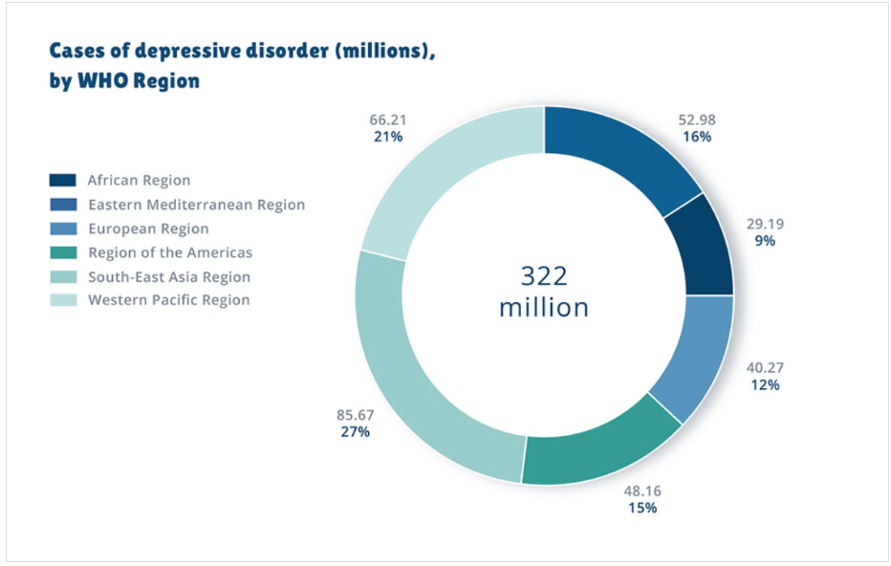
Figure 1. Cases of depressive order (millions) by WHO region (World Health Organisation, 2017)

Main Body

Approaches used to measure and monitor depression
Measuring and monitoring depression is important for understanding how common the condition is, spotting changes over time, and making sure the right health and social care services are available. This is done through a mix of population level monitoring, clinical assessments, and recognised screening tools. At both national and international levels, organisations such as the World Health Organization (WHO) and the Office for National Statistics (ONS) collect data to track depression rates and wider mental health trends. These methods help show how depression affects different communities and highlight groups who may be more vulnerable.
One widely used approach is mental health screening questionnaires. The Patient Health Questionnaire-9 (PHQ-9) is one of the most common tools for measuring the severity of depressive symptoms. It asks people about experiences such as low mood, sleep changes, tiredness, and feelings of hopelessness over the previous two weeks (Kroenke, Spitzer and Williams, 2001). Although screening tools cannot diagnose depression on their own, they help healthcare professionals identify individuals who may need further assessment. Using standardised tools also makes it easier to monitor symptoms consistently and evaluate whether treatments are working.
Clinical assessment is another key method for measuring depression. Healthcare professionals, including GPs and mental health specialists, look at symptoms, how long they have lasted, how severe they are, and how they affect daily life. The Diagnostic and Statistical Manual of Mental Disorders (DSM-5-TR) sets out recognised criteria for diagnosing depressive disorders, including persistent low mood, reduced interest in activities, changes in appetite or sleep, and thoughts of death or self-harm (American Psychiatric Association, 2022). These assessments help professionals recognise between temporary emotional difficulties and a clinical mental health condition that requires intervention.
Monitoring depression also involves looking at wider population data, such as hospital admissions, antidepressant prescription rates, and use of mental health services. This information helps healthcare planners identify patterns and allocate resources where they are most needed. However, measuring depression can be challenging because stigma, lack of awareness, and barriers to accessing healthcare often lead to underreporting. For this reason, combining statistical data with individual assessments gives a more accurate picture of depression within communities (World Health Organization, 2023; NHS England, 2019).
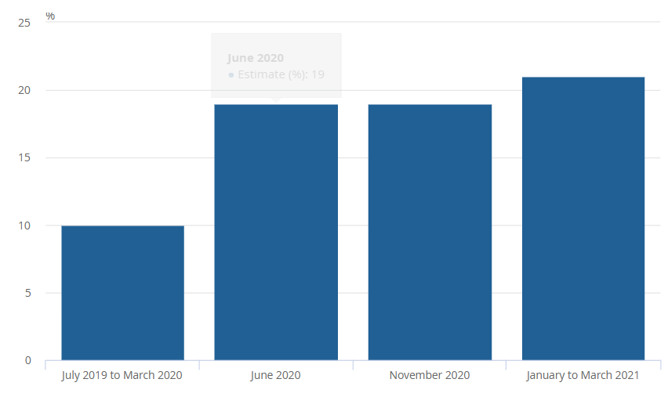
Figure 2. Percentage of adults reporting moderate to severe depressive symptoms in Great Britain (ONS, 2023)

How depression is controlled
Depression is managed through a mix of prevention, early intervention, psychological therapies, medication, and broader public health strategies. Because depression is complex, effective management usually requires an overall approach that considers biological, psychological, and social factors. Engel’s (1977) biopsychosocial model is particularly useful here, as it shows how health problems develop through the combined effects of physical health, emotional wellbeing, and social circumstances.
Early identification and support are essential because they help stop symptoms from becoming more severe. Healthcare professionals play a key role in recognising signs of depression and making sure people get the right support. The National Institute for Health and Care Excellence (NICE, 2022) recommends evidence-based treatments depending on how severe the symptoms are, including psychological therapies and medication. Cognitive behavioural therapy (CBT) is one of the most commonly recommended psychological treatments. CBT helps individuals recognise negative thought patterns and develop healthier coping strategies, based on the idea that thoughts, emotions, and behaviours are closely linked (Beck, 1976).
Medication is another important option, especially for people with moderate to severe depression. Antidepressants, such as selective serotonin reuptake inhibitors (SSRIs), can help regulate chemical processes in the brain that affect mood. However, medication decisions should be personalised, as people respond differently and may experience side effects. NICE (2022) highlights that treatment choices should take into account individual preferences, past treatment experiences, and symptom severity.
Lifestyle changes can also support the management of depression. Regular physical activity, staying socially connected, improving sleep routines, and reducing alcohol intake can all help improve mental wellbeing. Exercise, in particular, has been shown to support mood regulation and reduce stress. However, lifestyle changes should complement professional treatment rather than replace it, especially when depression is more severe.
At a wider level, depression can be addressed through public health strategies aimed at challenging negative attitudes and improving access to support. Mental health awareness campaigns encourage people to recognise symptoms and seek help sooner. Workplace and community initiatives can also create supportive environments where individuals feel comfortable discussing mental health. The NHS Long Term Plan (NHS England, 2019) highlights the importance of improving access to mental health services and integrating mental and physical healthcare.

Consequences of depression and health and social care support services required
Depression can have serious consequences for individuals, families, and communities. It affects emotional wellbeing, physical health, relationships, education, and employment. People experiencing depression may struggle with motivation, concentration, and everyday tasks, which can reduce independence and overall quality of life. In work settings, depression can lead to increased absence, reduced productivity, and difficulties maintaining employment, which may also create financial pressures for individuals and their families (World Health Organisation, 2023; Mental Health Foundation, 2024).
Depression can also affect communities more broadly. Social withdrawal is common, and individuals may become isolated from friends, family, and community networks. This isolation can worsen symptoms and reduce opportunities for informal support. In severe cases, depression is linked to an increased risk of self-harm and suicide, making early intervention and accessible support services essential (National Institute for Health and Care Excellence (NICE), 2022; World Health Organization, 2023).
Physical health can also be impacted. People with depression may experience disrupted sleep, reduced physical activity, changes in appetite, and a higher risk of developing other health conditions. This connection between mental and physical health highlights the importance of integrated healthcare that supports the whole person rather than focusing only on psychological symptoms (American Psychiatric Association, 2022; World Health Organization, 2023).
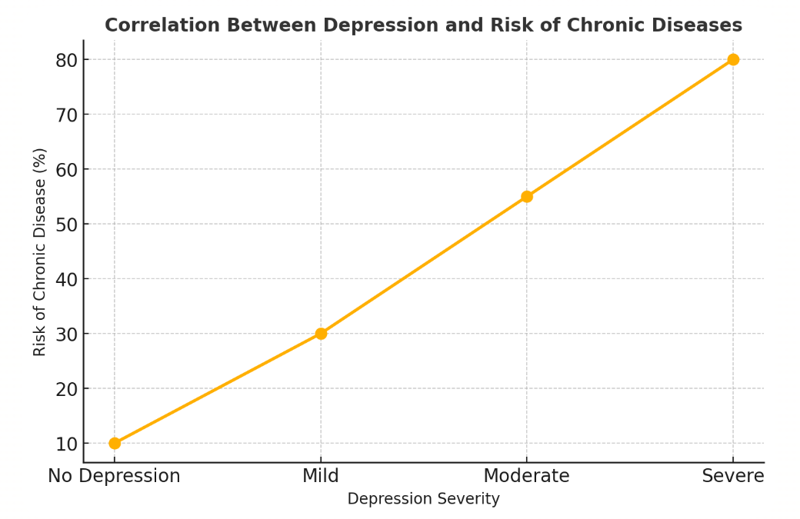
Figure 3. Correlation between depression severity and the risk of chronic diseases (Click2Pro, n.d.).
Health and social care services play a crucial role in supporting people affected by depression. GPs are often the first point of contact, providing initial assessments, prescribing medication when appropriate, and referring individuals to specialist services. NHS Talking Therapies offer access to psychological treatments, including CBT, for people experiencing anxiety and depression. For those with more complex or severe needs, community mental health teams provide specialist assessment, treatment, and ongoing support (National Institute for Health and Care Excellence (NICE), 2022; NHS England, 2019).
Social care services and community organisations also help by addressing social factors that contribute to depression. Social prescribing allows healthcare professionals to connect individuals with community activities, volunteering opportunities, exercise groups, and support networks. This approach recognises that improving mental health often involves addressing loneliness, isolation, and wider social determinants of health (NHS England, 2019; World Health Organization, 2023).
Charitable organisations provide additional support through information, counselling, peer support, and crisis services. Mental health helplines can offer immediate assistance to individuals in distress. A coordinated approach between healthcare providers, social services, voluntary organisations, and communities is essential to meet the diverse needs of people living with depression (Mind, 2024; Rethink Mental Illness, 2024).
Overall, depression requires ongoing monitoring, effective management strategies, and accessible support services. Measuring depression helps healthcare systems understand the scale of the issue, while treatment and prevention approaches reduce its impact. Providing appropriate health and social care support ensures that individuals receive person-centred care that improves wellbeing and quality of life (World Health Organization, 2023; National Institute for Health and Care Excellence (NICE), 2022).
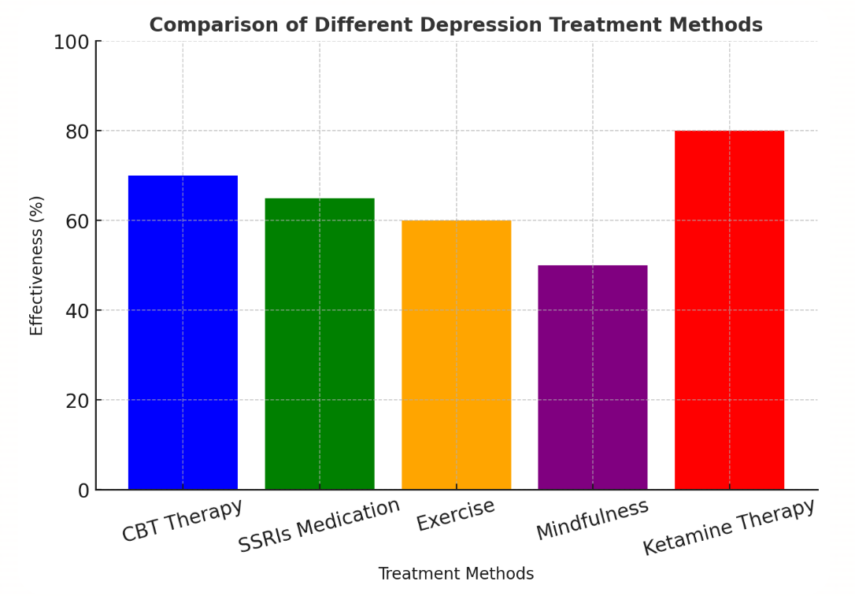
Figure 4. Comparison of different depression treatment methods (Click2Pro, n.d.).

Conclusion
Depression is a major public health issue that affects millions of people worldwide and has serious impacts on individuals, families, and communities. This report has demonstrated that a range of methods are used to measure and monitor depression, including screening tools, clinical assessments, and national health data, enabling healthcare professionals to identify trends and provide appropriate interventions. Effective control of depression requires a holistic approach involving early identification, evidence-based psychological therapies, medication where appropriate, lifestyle modifications, and public health efforts that reduce stigma and encourage help-seeking. The report has also highlighted how depression can influence many areas of life including physical health, relationships, education, employment, and overall quality of life. Access to integrated health and social care services, including GPs, NHS Talking Therapies, community mental health teams, and voluntary organisations, is essential in meeting the needs of those affected. Continued investment in prevention, early intervention, and accessible mental health services will help reduce the burden of depression and improve outcomes for individuals and society.

Reference List
American Psychiatric Association (2022) Diagnostic and Statistical Manual of Mental Disorders: DSM-5-TR. Washington, DC: American Psychiatric Association.
Beck, A.T. (1976) Cognitive Therapy and the Emotional Disorders. New York: International Universities Press.
Click2Pro (n.d.) Clinical depression symptoms, causes and treatment. Available at: https://click2pro.com/blog/clinical-depression-symptoms-causes-treatment (Accessed: 20 July 2026).
Engel, G.L. (1977) ‘The need for a new medical model: A challenge for biomedicine’, Science, 196(4286), pp. 129–136.
Kroenke, K., Spitzer, R.L. and Williams, J.B.W. (2001) ‘The PHQ-9: Validity of a brief depression severity measure’, Journal of General Internal Medicine, 16(9), pp. 606–613.
Mental Health Foundation (2024) Depression. Available at: https://www.mentalhealth.org.uk⁠ (Accessed: 18 July 2026).
National Institute for Health and Care Excellence (2022) Depression in adults: treatment and management (NG222). Available at: https://www.nice.org.uk/guidance/ng222⁠ (Accessed: 15 July 2026).
NHS England (2019) The NHS Long Term Plan. Available at: https://www.longtermplan.nhs.uk/⁠ (Accessed: 15 July 2026).
Office for National Statistics (2023) Personal well-being and depressive symptoms in adults in Great Britain. Available at: Coronavirus and depression in adults, Great Britain - Office for National Statistics /⁠ (Accessed: 18 July 2026).
Rethink Mental Illness (2024) Depression. Available at: https://www.rethink.org/advice-and-information/about-mental-illness/learn-more-about-conditions/depression/⁠ (Accessed: 19 July 2026).
World Health Organization (2023) Depressive disorder (depression). Available at: https://www.who.int/news-room/fact-sheets/detail/depression⁠ (Accessed: 16 July 2026).
World Health Organization (2017) Depression and other common mental disorders: Global health estimates. Geneva: World Health Organization. Available at: https://www.who.int/publications/i/item/depression-global-health-estimates (Accessed: 19 July 2026).

