Name: Nimra Ali
Student id: 2507537
Module: introduction to physiology
Module code: BMHP5023
Assignment title: component 1
Lecturer name: Robert Nartowski
Words count: 2446
Submission date: 23/10/2026

Table of content
Introduction …………………………………………………………………….
Anatomy & physiology………………………….……………………………
Pathophysiology……………………………………………………………….
Monitoring & data use…………………………….………………………….
Evidence-based lifestyle recommendations…………….……………
Conclusion……………………………………………………..………………
References……………………………………………………..……………….

Introduction
Type 2 diabetes mellitus is a persistent metabolic disease involving impaired blood glucose regulation and the development of hyperglycaemia. The condition is primarily associated with insulin resistance and an inadequate insulin response from the pancreas. Insulin, which is secreted by pancreatic beta cells, is essential for maintaining glucose balance by helping the body’s cells take up and utilise glucose for energy (NIDDKD, 2026).
The condition is growing concern for public health due to its gradual onset and the possibility of delayed diagnosis. Clinical features may include polydipsia (increased thirst), polyuria (frequent urination), fatigue and visual disturbances, including blurred vision. However, the early stages may be asymptotic, meaning that some individuals remain unaware of their condition until it is identified through health assessments or blood tests (NHS, n.d.a).
The risk of developing type 2 diabetes is influenced by a combination of genetic, biological and lifestyle factors. These include a family history of diabetes, increasing age, physical inactivity, dietary patterns and excess body fat. Nevertheless, the condition is multifactorial and should not be attributed solely to body weight or personal lifestyle choices, as it can also develop in people who are not overweight (diabetes UK, n.d.a).
This report will examine the normal anatomical structures and physiological mechanisms responsible for blood glucose regulation before exploring how these functions become impaired in type 2 diabetes. In addition, it will consider the role of health monitoring and discuss evidence-based lifestyle interventions that may support disease control. Understanding the underlying physiological changes is essential for healthcare professionals to deliver appropriate care, promote patient understanding and reduce the likelihood of long-term complications (NICE, 2026).
Anatomy and physiology
  - anatomy of the pancreas
The pancreas is an organ found in the upper part of the abdomen, positioned behind the stomach. This theory has two main roles: exocrine function involves producing enzymes that assist digestion, while its endocrine function is carried out by groups of cells called the islets of Langerhans. These calls release hormones that help control blood glucose levels. Pancreatic cells secrete insulin, which reduces blood glucose concentrations, while alpha cells release glucagon, which increases glucose levels when they become low. The interaction between these hormones helps maintain glucose homeostasis and supports normal bodily function (Hall and Hall, 2021).
  - Normal regulation of blood glucose
When a person eats, carbohydrates are broken down into simpler sugars, glucose. This glucose is absorbed through the small intestine into the bloodstream, causing blood glucose levels to increase. The pancreas responds by releasing insulin from its beta cells. Insulin helps glucose enter different tissues. In skeletal muscle and adipose tissue, it stimulates GLUT4 transporter proteins to move towards the cell’s membrane, enabling glucose to enter cells. Muscles use glucose to generate energy or store it as glycogen. Adipose tissue uses glucose in energy storage and fat-related processes. Insulin also affects the liver by encouraging glycogen storage and reducing glucose release through glycogen breakdown and gluconeogenesis. Consequently, blood glucose levels gradually decrease. When a person has not eaten for several hours, blood glucose may decrease. Insulin release becomes lower, while glucagon secretion increases. Glucagon signals the liver to break down stored glycogen and produce more glucose. This response helps maintain the supply of glucose required by the brain and other tissues. Negative feedback keeps this system balanced. High blood glucose stimulates insulin release, whereas decreasing glucose reduces the needs for insulin. Glucagon helps prevent glucose levels from becoming too low (Hall and Hall, 2021).
  - Cellular metabolism and ATP production
Glucose supplies energy for cellular activities. During cellular respiration, glucose undergoes glycolysis, the citric acid cycle and oxidative phosphorylation to produce adenosine triphosphate (ATP). ATP provides energy for processes such as muscle contraction, active transport, and cellular substance synthesis. In type 2 diabetes, insulin resistance reduces the effectiveness of glucose regulation. Muscle and other insulin-sensitive tissues respond inadequately to insulin, reducing glucose uptake, while the liver may continue releasing excessive glucose. Consequently, blood glucose remains elevated and normal metabolic processes become disrupted. These mechanisms demonstrate how insulin resistance and impaired insulin secretion contribute to the development of type 2 diabetes (Hall and Hall, 2021).

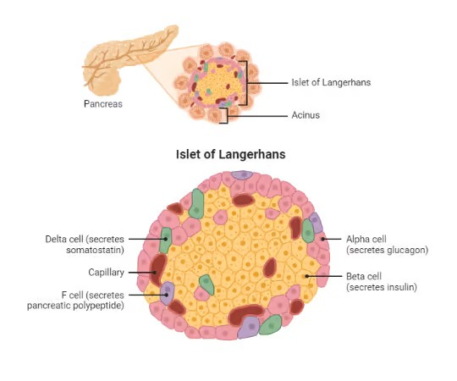
(Biorender, 2026)
Pathophysiology and impact
2.1 what happens when glucose regulation fails
Type 2 diabetes occurs when the body cannot use insulin effectively and the pancreas gradually struggles to produce enough insulin to control blood glucose. At first, the pancreas may try to overcome insulin resistances by releasing more insulin. However, as the insulin-producing beta cells become less effective, the body can no longer maintain normal glucose levels, resulting in hyperglycaemia (National institute of diabetes and digestive and kidney diseases, n.d.). insulin resistance affects different organs in different ways. The muscles become less able to take glucose from the blood, while the liver continues releasing glucose instead of reducing its production in response to insulin. Fat issue also becomes less effective at regulating the breakdown of stored fat. These problems combine to keep blood glucose levels higher than normal. Overtime, uncontrolled blood glucose can damage the body’s nerves and blood vessels. This may lead to heart disease, stroke, kidney problem, diabetic retinopathy, and peripheral neuropathy. Damage to the nerves in the feet can reduce a person’s ability to feel pain or notice injuries. If these injuries are not treated, they may develop into ulcers or infections (NHS, n.d.b).

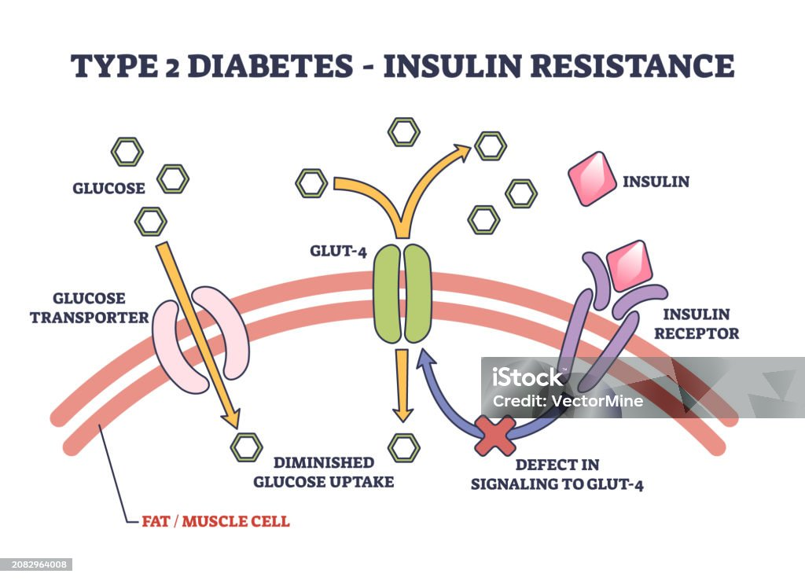
(Istockphoto, 2026)

2.2 influence of lifestyle factors
Life factors can influence metabolic health and the management of type 2 diabetes, although they interact with genetic and environmental influence. Diet is particularly relevant because the amount and type of carbohydrate consumed, as well as portion sizes, affect postprandial blood glucose. Frequent intake of sugary drinks and highly processed foods may complicate glucose management, whereas fibre-containing foods, including pluses, vegetables and wholegrains, can from part of a balanced eating pattern (Diabetes UK, n.d.b). Physical activity supports glucose regulation by increasing muscular glucose utilisation and improving insulin sensitivity. In contrast, physical inactivity and prolonged sitting limit opportunities for these beneficial effects. Smoking presents an additional concern because it increases cardiovascular and vascular risks. Since diabetes itself is associated with an increased risk of this complication, smoking cessation is an important preventive measure. However, the condition is multifactorial. Genetic predisposition, family history and age may contribute independently of personal lifestyle choices. A balanced understanding should therefore avoid presenting diabetes as simply the consequence of individual decision (Diabetes UK, n.d.).
2.3 effects on everyday life
Managing type 2 diabetes can affect daily routines, physical health and emotional wellbeing. People may need to take medication, attend appointments, monitor their health and make ongoing changes to their diet and activity. These responsibilities can be difficult when individuals face financial problems, demanding work schedules, cultural food preferences or limited support. Healthcare professionals should understand these challenges and help patients find manageable solutions. Overall, diabetes management should focus not only on controlling blood glucose but also on supporting emotional health, maintaining quality of life and helping individuals sustain realistic lifestyle changes (NHS, n.d.; NICE 2026).
Monitoring and data use
Monitoring helps people with type 2 diabetes receive appropriate care by allowing healthcare professional to review treatment progress and identify potential problems before they become more serious.
3.1 HbA1c testing
HbA1c is used to assess longer-term blood glucose control by measuring the proportion of haemoglobin with glucose attached. As it reflects average glucose levels over approximately two to three months, it offers a more comprehensive assessment than an isolated blood glucose measurement. NICE (2026) recommends testing at intervals of three to six months until treatment and glucose levels have stabilised. Thereafter, six-monthly testing may be suitable. Nevertheless, HbA1c goals should be agreed individually, taking account of treatment options, hypoglycaemia risk and the patient’s circumstances (NICE, 2026).
3.2 blood glucose and other health measurements
Checking blood glucose can help certain patients identify how food, physical activity, illness and medication affect their results. However, finger-prick testing is not routinely needed by all adults with type 2 diabetes. This particularly useful in circumstances such as insulin use or when hypoglycaemia is a concern (NICE, 2026). Healthcare professionals also monitor blood pressure, cholesterol, kidney health, weight where suitable, and food and eye health. These checks are important because diabetes can affect several parts of the body (NICE, 2026),
3.3 using health data to improve care
Maintaining reliable health records makes it easier to identify patterns and decide whether care needs to change. For example, an increase in HbA1c may indicate that the existing treatment is no longer providing sufficient control. Blood pressure and cholesterol results also help professionals evaluate heart and circulatory health risks. However, clinical decisions should be based on the overall patient picture, including symptoms, medical history, medication and personal goals. Clear communication of results encourages patient involvement and informed choices. Consequently, the value of monitoring lies in translating reliable data into appropriate clinical action, continued review and shared decision-making (NICE, 2026).
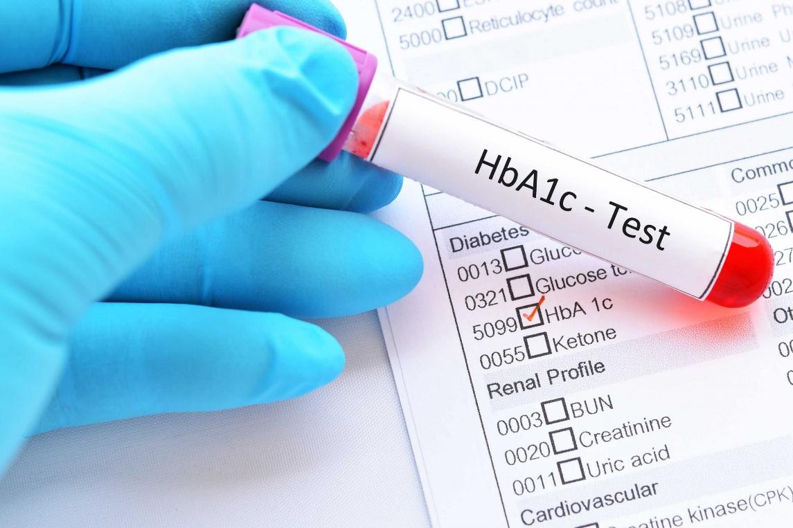

(Seery, 2019)

Evidence-based lifestyle recommendations
Making healthy lifestyle choice is an important part of controlling type 2 diabetes. Advice should be practical, realistic and appropriate for the person’s health, daily routine and personal circumstances.
4.1 balanced dietary choices
A healthy diet should include a variety of vegetables, fruit, wholegrains, pluses and appropriate protein sources. Foods such as beans, lentils, chickpeas and wholemeal products provide fibre and contribute to nutritious, balanced meals. Reducing sugary drinks and limiting foods high in sugar, salt and saturated fat can benefit overall health and help manage blood glucose. Another consideration of how much food a person eats and the quantity of carbohydrates in their meals can be inferred by their caloric and carbohydrate intake. Dietary advice needs to respect individual preferences and cultural eating habits while considering food costs. For example, people who regularly eat rice or roti can be encouraged to choose suitable portions, use higher-fibre alternatives when possible and include vegetables and protein in their meals. Completely avoiding familiar foods is not always necessary (Diabetes UK, n.d.b).
4.2 regular physical activity
Physical activity improves glucose uptake by muscles and increases insulin sensitivity. Adults should generally undertake at least 150 minutes of moderate-intensity activity per week when medically appropriate. Options include brisk walking, cycling and swimming, with shorter sessions used to accommodate individual schedules and abilities (Diabetes UK, 2026). People who do little exercise should begin with simple activities, such as a short daily walk, and increase their activity gradually. Those with mobility problems or additional medical conditions may need professional advice before starting a new exercise routine (Diabetes UK, n.d.).
4.3 weight management and smoking cessation
People who are above their healthy weight may improve their glucose control through supported weight management. Goals should be realistic and focused on improving health rather than creating pressure or unrealistic expectations. Quitting smoking is also important because its lower exposure to a major cardiovascular risk factor. Healthcare professionals can provide advice and information about services that support smoking cessation.
4.4 medication adherence and patient education
Healthy lifestyle habits cannot replace medication for everyone. Patients should take prescribed medicines correctly and speak to their healthcare professional if they experience side effects or have difficulty following treatment. Education helps people understand diabetes, identify possible signs of high or low blood glucose and keep up with recommended health checks. Family encouragement can also help them maintain healthy habits. Overall, small changes that are introduced gradually may be easier to maintain than major changes made all at once. Regular reviews help patients and healthcare professionals monitor progress and adapt recommendations when needed (NICE, 2026).
Conclusion
Type 2 diabetes mellitus is a progressive metabolic condition associated with reduced insulin sensitivity and impaired insulin secretion. Normally, insulin and glucagon maintain glucose homeostasis through coordinated physiological processes. When these mechanisms become dysfunctional, chronic hyperglycaemia can develop, contributing to an increased risk of vascular, neurological and organ-related complications. The report highlighted the contribution of the pancreas, liver, skeletal muscle and adipose tissue to glycose regulation and energy balance. Disruptions in the normal functioning of these tissues help explain the underlying mechanisms responsible for type 2 diabetes and its progression over time. effective monitoring is fundamental to assessing disease control and identifying emerging health risks. HbA1c testing, blood pressure assessments and cholesterol measurements provide useful clinical information, although results must be evaluated in the context of each patient’s symptoms, medical history and personal circumstances. A comprehensive management strategy should combine evidence-based lifestyle interventions with appropriate medical treatment. Nutritional improvements, physical activity, supported weight management and smoking cessation can contribute to better health outcome. Medication adherence, patient education and consistent follow-up further support effective self-management. Importantly, interventions must be accessible and appropriate to patients’ cultural, financial and social needs. Ultimately, successful management requires a holistic and individualised approach rather than an exclusive focus on glucose levels. Knowledge of disease physiology, appropriate interpretation of health data and recognition of individual risk factors are essential components of care. Healthcare professionals support these objectives by promoting informed choices and collaborative decision-making. By integrating personalised lifestyle advice, clinical monitoring and appropriate treatment, it is possible to reduce the risk of complications and promote improved long-term health and quality of life (NICE, 2026; Diabetes UK, n.d.).

References
Created by Jerry Gu • BioRender Team (2026). Pancreas and Islet of Langerhans diagram. [Diagram] Biorender.com. Available at: https://www.biorender.com/template/pancreatic-islet-of-langerhans [Accessed 22 Oct. 2026].

Diabetes UK (n.d.a) Type 2 diabetes. Available at: https://www.diabetes.org.uk/about-diabetes/type-2-diabetes (Accessed: 19 October 2026).

Diabetes UK (n.d.) How to check your blood sugar levels. Available at: https://www.diabetes.org.uk/about-diabetes/looking-after-diabetes/blood-sugar-levels (Accessed: 16 October 2026).

Diabetes UK (n.d.b) I have type 2 diabetes – what can I eat? Available at: https://www.diabetes.org.uk/living-with-diabetes/eating/i-have-type-2-diabetes (Accessed: 19 October 2026).

Diabetes UK (2026) 10 tips for healthy eating with diabetes. Available at: https://www.diabetes.org.uk/living-with-diabetes/eating/10-ways-to-eat-well-with-diabetes (Accessed: 19 October 2026).

Hall, J.E. and Hall, M.E. (2021) Guyton and Hall Textbook of Medical Physiology. 14th edn. Philadelphia: Elsevier.

NHS England (2023) Healthbox: Diabetes care home guidelines. Available at:
https://www.england.nhs.uk/north-west/wp-content/uploads/sites/48/2023/03/Healthbox-Diabetes-Care-Home-Guidelines.pdf (Accessed: 16 October 2026).

National Institute for Health and Care Excellence (NICE) (2026) Type 2 diabetes in adults: management. NICE guideline NG28. Available at: https://www.nice.org.uk/guidance/ng28 (Accessed: 19 October 2026).

National Institute of Diabetes and Digestive and Kidney Diseases (n.d.) Symptoms and causes of diabetes. Available at: https://www.niddk.nih.gov/health-information/diabetes/overview/symptoms-causes (Accessed: 19 October 2026).

NHS (n.d.a) Symptoms of type 2 diabetes and how it is diagnosed. Available at: https://www.nhs.uk/conditions/type-2-diabetes/symptoms/ (Accessed: 19 October 2026).

NHS (n.d.b) Complications of type 2 diabetes. Available at: https://www.nhs.uk/conditions/type-2-diabetes/complications/ (Accessed: 19 October 2026).

NHS (n.d.c) Treatment for type 2 diabetes. Available at: https://www.nhs.uk/conditions/type-2-diabetes/treatment/ (Accessed: 19 October 2026).

NHS (n.d.) Diabetes. Available at: https://www.nhs.uk/conditions/diabetes/ (Accessed: 16 October 2026)

World Health Organization (WHO) (2023) Diabetes. Available at: https://www.who.int/news-room/fact-sheets/detail/diabetes (Accessed: 19 October 2026).

