Has the role of women changed throughout the history of Fairy Tales?

Samantha Gabriel
Submitted in partial fulfilment of the requirements for the degree of BA (Hons) University of Wales Trinity Saint David, Swansea.
Wednesday 12th December 2018

Contents
Word count : 5007

Chapter 1 : Introduction ………………………………………………………. Page 3-6
Chapter 2 : The Grimm Brothers Traditional Princess …………………….Page 6-11
Chapter 3 : Disney’s Classic Princess………………………………………..Page 11-17
Chapter 4 : The Modern Disney Princess…………………………………….Page 11-19
Chapter 5 : Conclusion…………………………………………………………Page 19-21
Bibliography :…………………………………………………………………….Page 22-25

List of illustrations:
Figure 1: Cruikshank, G. (1830) Aschenputtel [Ethching]. Available at: https://www.vox.com/2015/3/15/8214405/cinderella-fairy-tale-history (Accessed: 21st October 2018).

Figure 2: Unknown. (1950) Cinderella’s step sisters [Painting]. Available at: https://krystaldisney.wordpress.com/2014/12/14/what-is-beautiful-is-good-what-is-ugly-is-bad/ (Accessed: 22nd November 2018).

Figure 3: Unknown. (1950) Cinderella [Painting]. Available at: https://krystaldisney.wordpress.com/2014/12/14/what-is-beautiful-is-good-what-is-ugly-is-bad/ (Accessed: 22nd November 2018)

Has the role of females changed throughout the history of Fairy Tales?
Introduction
I want to explore how women, specifically Princesses, are represented in fairy tales. I will begin by looking at The Grimm Brothers and their collection of tales. Were strict gender roles and representations reflective of the society they were written in? I will look particularly at the stories of Snow White, Cinderella and Sleeping Beauty which still remain popular tales into the 21st century. I will then consider the feminist movement and the arguments posed by critics such as Jane Yolen and Andrea Dworkin, and examine what impact this social change has had on our understanding and enthusiasm for fairy tales. Finally I shall be looking at the modern fairy tale, using examples of animated feature films by Disney to analyse the changes they have made when representing gender roles to keep them relevant to modern society.
For hundreds of years children and adults have been fascinated by fairy tales. The power to transport us into magical worlds filled with enchantment and adventure has kept us sharing and adapting these tales year after year, and many stories are recognised all across the globe. Our love of storytelling started as soon as man could communicate. These ancient stories helped to explain the mysteries of the world: birth, death, the seasons, day and night. They helped humanity to progress. As communities developed, stories containing more every day and domestic matters were created, still filled with supernatural ideas and lessons, these folk tales captured the dreams and hopes of humanity. It is from these folk tales that we have developed the fairy tales that we recognise and love today. (Johnson, 2017)

It could be suggested that the allure of fairy tales has much to do with the ability to transform themselves to suit many different audiences. Folklorist Alun Dundes once wrote “folklore means something — to the tale teller, to the song singer, to the Riddler, and to the audiences….. folktales must appeal to the psyches of many, many individuals if they are to survive” (Dundes, 1980). They enable people to connect with a range of human experiences, such as greed, fear, love and grief and regularly demonstrate how determination and courage can be used to change a course of events even for the most misfortunate. These tales which offer hope at overcoming adversity can become a powerful tool for influencing and manipulating an audience. (Johnson, 2017)

The Authors of the earliest recorded versions were aware of the power these tales had, they transformed the content of early folktales to target children, teaching them lessons about morals, and society. Charles Perrault for example adapted folk tales to suit the aristocratic salon set of 17th century France. He customised stories making a point of tackling the challenges and difficulties of his time. (Abler, 2008) In the 19th century the Brothers Grimm published their collection of traditional folktales entitled Children’s and Household Tales this soon established fairy tales as a genre predominately aimed at children. The tales reflected the Grimm brothers political views and echoed the social and cultural values of nineteenth century Germany.

As the world developed and the social ideals changed, people began to question the messages that these traditional tales gave to children. American phycologist Bruno Bettelheim’s book “The Uses of Enchantment: The Meaning and Importance of Fairy Tales” contained extensive studies into the psychological effect that that fairy tales had on young people. Bettelheim believes that fairy tales provide a unique way for children to come to terms with hidden fears and they serve as a healthy outlet for feelings of aggression towards parents. (Bettelheim,1989) The release of this profound book came at a time of great change socially, particularly for women. The feminist movement was gaining true prominence during the 1970s and increasing numbers of women were asking questions about their place In society. Many female academics were beginning to question the passive female stereotypes portrayed in many traditional fairy tales. Feminist critic Marcia Lieberman argued that tales which depict such rigid roles for female and male characters could be damaging to the development of young people. (Lieberman, 1972)

There is no doubt that fairy tales over the last 200 years have often contained messages of the feminine beauty ideal. This is the notion that beauty is one of women’s most valuable assets and something that women should strive to achieve. (Baker-Sperry and Grauerholz, 2003) Tales such as Sleeping Beauty, Cinderella, and Snow white certainly promote this ideal, and yet in a Western world which is becoming increasingly more liberal, these continue to be some of our favourite tales. There have been many writers such as Robert Munsch, Babette Cole, Martin Waddell who have transformed the traditional tales to better suit the cultural values of today. With great developments in technology we have widened the mediums with which we enjoy Fairy tales, with Film corporations such as Disney becoming a name which you immediately associate with fairy tales. (Zipes, 1986) In the 21st century how are we representing gender women in fairy tales, furthermore how does this compare with the traditional tales of the 19th century.
The Grimm Brothers Traditional Princess
Many people consider the Grimm Brothers as the true fathers of fairy tales. In 1812 the first edition of ‘Nursery and Household Tales’ was published. It contained 86 stories. By 1857 the final standard edition contained 210 tales and was to become the most widely translated book in the world after the Bible and the Quran. (Ulmer, 1988)

Jacob Ludwig Carl Grimm was born in 1785 and his brother Wilhelm Carl Grimm was born in 1786. Both born in Hanau Germany, they went on to both study law at University of Marburg. Academics from an educated background, they set out to gather oral tales from unschooled peasants. The Grimm Brothers were living in a time of bloodshed and turmoil. The French Revolution had led to in the invasion and control of the City of Kassel where the brothers were working in the Library. Marina Warner suggests that in response to their humiliation they felt like they wanted to assert cultural riches and distinctiveness. They did this through a encyclopaedic account of German Myths, history, beliefs, customs and knowledge. (Warner, 2014)

The Brothers were very keen to make sure these stories were as accurate as possible. Jacob once wrote ‘’... these items should be gathered faithfully and truly, without decoration and addition…’’ (Tatar, 2003)
We know that this rule was not adhered too as they made many changes and alterations to their stories. This could be due to the fact that the Grimm Brothers never intended for their book to be for children, their intention was to preserve what they said were inherently German tales from industrialization.

All copies of ‘Nursery and Household Tales’ were sold quickly much to the brothers surprise. It could be argued that this was largely down to its title and that there was a developing market for fairy tale collections at that time. The book did not escape the critics and there were numerous scathing reviews, frequently criticising the tales content and their suitability for children. Such as Friedrich Ruhs who described their stories as likely to disturb children and lead to uncomfortable feelings. (Tatar, 2003) In view of the brothers hunger for commercial success, coupled with a need for recognition towards their literary efforts, it is reasonable to suggest that they felt the need to configure and alter these tales to better suit the commercial market and make them more suitable for children. We know that the Grimm Brothers also let their religious beliefs influence the changes that they made to the tales that they gathered. They minimized all references to sex and pregnancy, and eliminated the tales of any reference to incestuous desire. The ease at which the brothers, specifically Wilhelm edited the tales, strongly indicates the significance society and culture had on the Tales.

A common feature of numerous Grimms brothers tales is the role of leading female protagonists. Some of these female characters are good and some are bad, it is usually evident in the description of the characters physical appearance to which side the woman belongs. The heroine in the tales is invariably beautiful and fair, she possesses kind and caring character traits. If the heroine is beautiful and good, then the evil character must display the opposite physical attributes and this largely holds true.

The Grimm Brothers stories certainly portray all the characteristics feminists would describe as the feminine beauty ideal. The socially constructed notion that a women’s physical attractiveness is the greatest asset she has (Baker-Sperry and Grauerholz, 2003) The Grimm Brothers attributed attractiveness with success and goodness, very often for their lead protagonists, beauty is the most important attribute she can possess. (Neikirk, 2018) This beauty often leads to success by gaining themselves a handsome prince for a husband who will look after them forever. This is evident in stories such as Sleeping Beauty. In the Grimm’s version, the King’s beautiful daughter Rose is bestowed with beauty, a sweet voice, kindness, health, grace and other womanly qualities. The prince had never met the princess but heard stories about her great beauty and risks his life in order to fulfil his role as saviour, likewise in Snow White, the Prince encounters Snow White lying poisoned in her glass coffin, he is so taken by her beauty that he persuades the dwarfs to let him take her home so he can gaze upon her (Tatar, 2003). The heroines in these tales do not have to do anything to be chosen. They do not show resourcefulness, wit, they do not have an special talents they are simply chosen because they are beautiful. This enforces the idea of the feminine beauty idea. Grauerholz believes that reading fairy tales about princesses who achieve enormous riches simply because their beauty makes them special, can inhibit young women who feel they do not meet society's expectation of what it means to be attractive. (Grauerholz, 2003)

Beauty can often lead to Jealousy in many of the Tales. In stories where there are several daughters in a family, the most beautiful is singled out and designated for reward. Often the beautiful are persecuted and oppressed to begin with as is the case with the Snow white and the evil Queen, who’s jealousy drives her to attempt to murder Snow White. Similarly in Cinderella with the bad tempered, ugly, older sisters who oppress and persecute the younger more beautiful Cinderella, ultimately because they are jealous of her beauty. Eventually the passive, oppressed heroine defies the odds and they are chosen for reward.

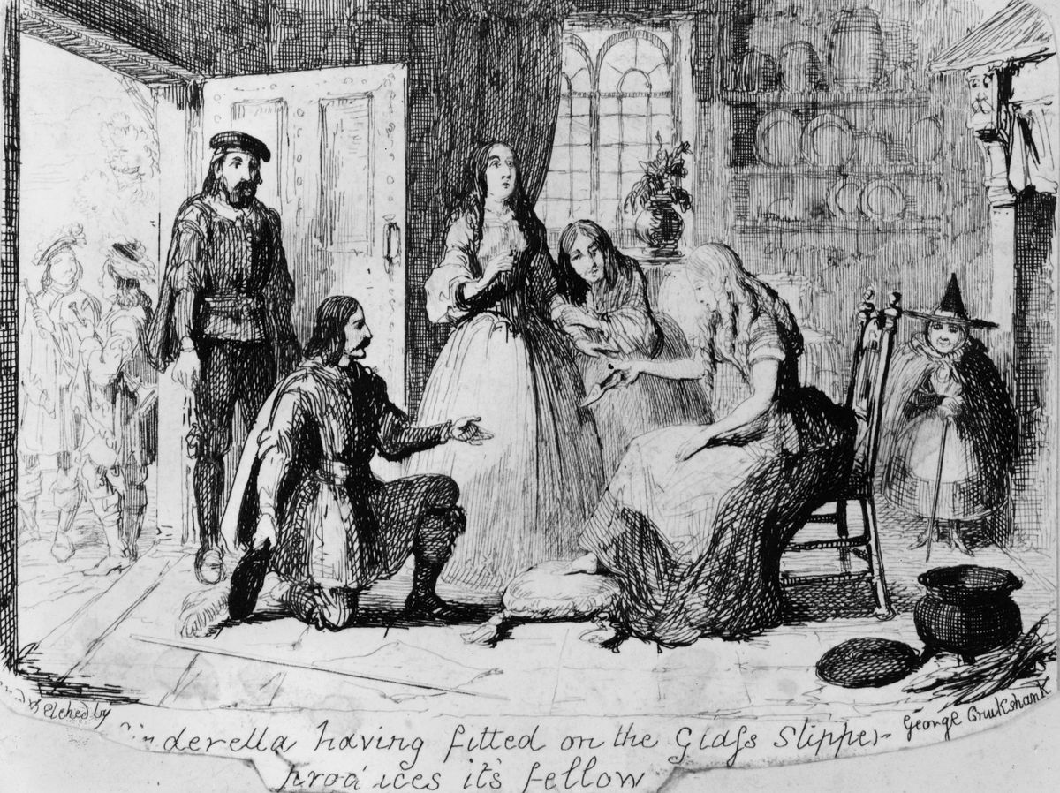 Fig. 1: Aschenputtel

These stories are often competitive, where there can only be one winner, and in The Grimm’s Tales this winner is always the fairest of them all. Liberman (1972) believes that these ideas could possibly promote jealousy and divisiveness between girls. If a child identifies with the beauty she may feel suspicious of people they consider ugly who are portrayed as cruel and evil in these stories. Likewise for a child who identifies with the plain characters, who may become suspicious and jealous of pretty girls. The common pattern of the heroine being a victim could also have a profound effect on the way children develop social ideas. Characters like Cinderella who are treated so cruelly by her family and bears the ill-treatment meekly, she becomes an object of pity. It is the sound of her crying that results in the Fairy Godmother helping her to the ball. Her suffering and loneliness are romanticised and become an fundamental part of her glamour. Critics believe stories like Cinderella can lead children to believe that girls who are rejected, bullied, and treated badly are destined for rewards if they submit to their ill treatment wait for rescue.

The Grimm Brothers Christian beliefs are clear in many tales. Nearly every fairy tale culminates in marriage. It is the ultimate reward for many of the heroines. Notably they also associate marriage with getting rich. The pretty, poor heroine always wins handsome and rich princes, never good but poor men.

In several instances, the prince and the heroine have never spoken but the females beauty is enough to ensure that their marriage will be happily ever after. Liebermann (1972) suggests that these narratives can lead children to infer that beauty leads to wealth and happiness , what’s more, Neikirk (2018) suggests that this sends the message to children that the cultural expectation that they settle down and marry is of upmost importance.

The treatment of women in the 1800’s is clearly reflected in the tales of The Grimm Brothers. Women in this period were commonly trapped in their homes and would only perform domestic chores and duties. This idea is reflected in tales such as Cinderella and Snow White. The woman’s role was to bear children, take care of the young ones as well as submitting to their husbands. Socially, women were considered weaker hence unequal to their men counterparts, they had very little control over their lives, they were controlled by their fathers in their youth and then their husbands in adulthood. (ukessays, 2013) Women were expected to accept their given roles without argument and were not expected to offer opinions, this notion of silent persecuted women is commonly reflected in traditional fairy tales.
The Grimm Brothers were like many storytellers adapting their tales to suit the audience. The drastic change from oral tales that were enjoyed by both the poor and the elite to literary tales that could only be accessed by the most educated and wealthy resulted in the tales having a different audience and it could be said a different purpose. If looking at the tales using todays social and cultural beliefs, it is accurate to say the tales are characteristically sexist. However at the time of collection and recording the concept of feminism and sexism was largely unheard of and the role of the dominant male and women as home makers was a accepted and normal part of society. The concept of women being beautiful but largely submissive was an accurate reflection of the way it was believed women should behave.

Disney’s Classic Princess

Fairy tales have remained a loved and popular genre into the 21st century. A century and a half has passed since the Grimm Brothers began collecting their tales, and although many tales have been changed and transfigured they still have a magical and alluring hold which keeps storytellers returning to them repeatedly. With vast changes in technology, the way an audience receives those tales has expanded from just the oral and literary tale. Through music, radio, theatre, television and film, fairy tales have been transformed for a new genre of audience. Animation is one of the largest forms of media today. It plays a part in many people’s lives in Western Civilization and has provided large audiences with laughter and tears over the last 80 years. (ukessays, 2016)
Disney is a name which many people immediately associate with fairy tales. Disney Studios is currently the biggest media conglomerate in the world. In 2016, the Walt Disney Company held assets worth a total of over 92 billion U.S. dollars, much of this is profits from its animated feature films, but also their theme parks, children’s’ books, websites, shops etc. They are arguably the biggest and most dominant storytellers of our time and therefore have a large influence over our generation. The Disney Princess phenomenon is embedded in young people today. Lieberman (1972) believes that characters such as Cinderella, Sleeping Beauty and Snow White are mystic figures who have replaced the old Greek and Norse Gods and are heroes for many children. Therefore observing the changing stereotypes and representations of women Disney have created over the last 80 years is crucial to understanding the changing role of women in fairy tales.

In 1937 Disney released Snow White. This was their first full length animated movie in colour and sound and was to be the start of a long and successful relationship with the Fairy Tale genre. Disney chose to use fairy tales not only because of the familiarity of the material but also the opportunities it offered for staging a visual spectacle and the potential to draw in a widespread audience. (Short, 2015) Walt Disney and his many animators made numerous changes to the Grimm Brothers version. The wicked queen is not only envious of her step daughters beauty but also that she has found a suitable suiter. The Dwarves are given names and personalities and play a much more important role than in the Grimm’s version in which they remain anonymous. Snow White appears to be an orphan in the Disney version as opposed to her father still being alive in the traditional version. Disney also took away much of the violence of the traditional version, leaving the queen to die in a tragic accident with a boulder rather than the more horrific traditional ending of the queen being made to dance in red-hot iron shoes. They also introduced the idea of the true loves kiss which is synonymous with Disney films.

As numerous as Disney’s changes were, the main protagonist Snow White, remained a passive, innocent, very beautiful heroine who waits patiently for her prince to rescue her.Disney retained key ideological features of the Grimms' fairy tale that support nineteenth century patriarchal notions. They preserve and carry on many of their benevolent attitudes towards women especially in their classical princess films. Snow White for instance in both versions, cleans and cooks and mends for the dwarves in order for her to stay in their house. In Disney’s Snow White the Heroine discovers the untidy Dwarves house, she is shocked at the uncleanliness and exclaims ‘Maybe they have no Mother?’ (UKEssays, 2016) This could imply that the house is untidy because there is no woman around. Both versions include the domestication of women. (Zipes, 2002) Feminist literary critics Gubar and Gilbert (2000) believed that the film follows the classic “sexist” narrative about the framing of women’s lives through a male discourse.

The culture of the 1930’s could have much to do with the way Disney represented Snow White. Disney drew on associations of traditional femininity, indicating the widespread encouragement of these traits within 1930’s American culture. The Great Depression had left many people jobless, along with catholic moral reform movements and a desperate need for jobs, there was a national desire for women to return to their home, this idea was encouraged by 1930’s commercial media. The success of Snow White could be down to the fact that the character fits the domestic expectations of Pre-World War 2 women. (Stover, 2003) It is difficult to critic the use of beauty in Snow White as for the character being beautiful is essential to the Tale.

In the decades following the successful release of Snow White, Disney continued to produce full length animated features, none of these however contained Princesses. There is evidence to suggest that the involvement of America in World War 2 had resulted in women having a more prominent position in businesses and households, meaning they were less likely to identify with the passive princess stereotype. It wasn’t until 1950 that Disney introduced their next Princess, Cinderella. Popularised by Charles Perrault in 1697 under the name Cendrillon, (Warner, 1995) then adapted by the Grimm Brothers, Disney had once again chosen a familiar and popular rags to riches tale. Once again Disney made relatively small changes to the traditional tale and its character representations, eliminating the violent end that the Grimms had written. However the themes of jealousy and beauty are still prominent. In Disney's Cinderella the differences between Cinderella and her stepsisters are highlighted in terms of beauty, grace, and charm.(Short, 2015) We can also see this in the visual images in which they depict the ‘Ugly Sisters’.
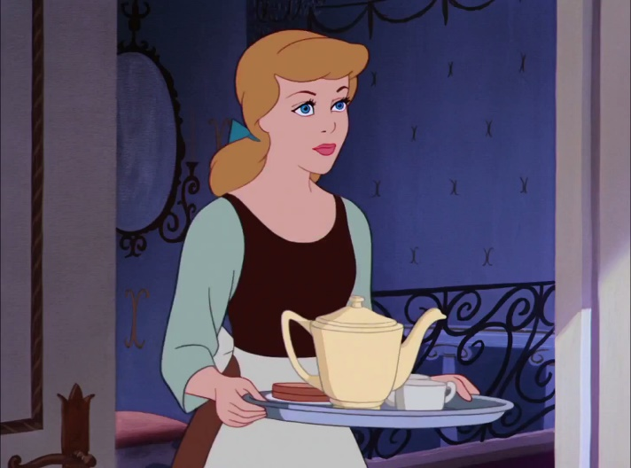
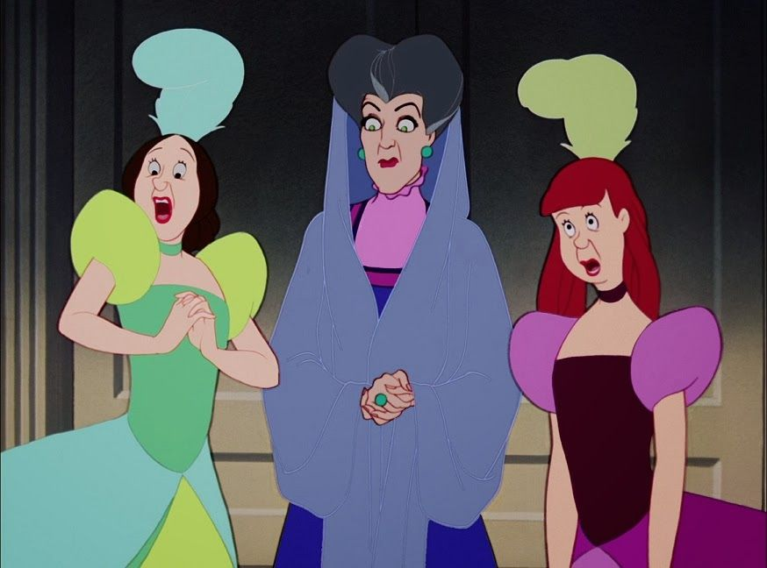
Fig. 2: Cinderella’s step sisters Fig. 3: Cinderella

Choosing to give the Sisters and Step Mother red, grey, and brown hair, with dumpy noses and garish outfits the animators were keen to highlight the contrasting beauty of the blonde, blue eyed Cinderella. This reinforces the Traditional tales idea that evil women are ugly and good women must be beautiful. They again domesticate Cinderella, she cooks and cleans and demonstrates the qualities that Disney believed a women should have if she wants to get married and therefore have a happy and fulfilled life. She is saved from her oppressed lifestyle by a handsome prince who is charmed mainly by her beauty and appearance, as he fails to recognise her in a more unattractive outfit. These stereotypes and themes mirror the Tales of the Grimm Brothers and again strongly represent the social views of 1950’s America. There was a strong desire after the war for women to return to family matters and allow men to again embody the ideals of hard work and ambition. (Stover, 2003)

In 1959, Disney released Sleeping Beauty it was their third depiction of a princess and she is often described as the last of the ‘Classic Disney Princesses’. Disney made more changes to the original tale of Sleeping Beauty than any of the other classic fairy tale films. This is largely due to the content of the traditional tales, in which Sleeping Beauty does very little but sleep. As passive as the other princesses were they did have a part in their own destiny’s, contrary to Sleeping Beauty who does nothing but sleep till she is rescued. (UKEssays, 2016) Instead they chose to make a large part of the story about the main antagonist Maleficent and the good fairies who help Sleeping Beauty. Leigh butler (2014) believes that there are moments in Sleeping Beauty that do demonstrate certain feminist ideas, such as the power and strength of the other main female protagonists, Maleficent and the Fairies. Similarly Mari Ness (2018) states that this is a direct result of adapting a story which has numerous versions featuring strong and powerful women.

However, there are definitely contrasting ideas in Sleeping Beauty in particular the need for the Fairies to give up their magic and take on domestic roles in order to provide Sleeping Beauty with protection. This message that women are safer doing domestic, housekeeping roles again mirrors the attitudes of traditional Tales. Sleeping Beauty is not as persecuted as the pervious princesses, although to hide away from Maleficent she must give up everything she knows, but she does this with the help and support of the good fairies. She does share certain assets with Snow White and Cinderella such as kindness and her beautiful appearance, which is the first gift the fairies bestow on her, signifying its importance. She also shares the ability to fall in love with a man at first sight, who luckily turns out to be her hero and saviour. It could be suggested that Disney were attempting change certain aspects for a changing audience but the films critical and popular failure suggests that people found the defined roles of Disney Princesses harder to associate with.

In the decades following Sleeping Beauty there were unprecedented changes for women in the Western world with the feminist movement bringing the issue of gender equality to the forefront of social and cultural politics. They began to question the otherwise previously unchallenged notions of gendered images. With feminist critics such as Liberman, Tatar, and Yolen questioning the suitability of the messages that fairy tales might encourage. Disney did not produce another Fairy Tale adaptation until 1989 when they returned with a rather different Princess.
The Modern Disney Princess
In 1989 Disney released their version of Hans Christian Andersons The Little Mermaid. She is presented as a far stronger and more headstrong Princess than any that had gone before her. She has a voice and a desire for adventure. There is a clear change from the previous protagonists who were happy to quietly wait until someone rescued them. She is unhappy with her life and wants something more so she takes it upon herself to try to change her destiny. (Stover, 2013) This change is reflective of women in the Western World at that time who feel liberated after the 1970’s feminist movement.

She is vast improvement on the passive princesses of the past but the film still has questionable themes and narratives that represent benevolent attitudes towards women. Ariel for example is happy to give up her family and her life for man that she has met once, believing that it will bring her happiness which is similar to the ideas of marriage in the traditional tales. It is also her father who enables her to live on land in the end by giving her the legs that she craves so badly, which could be reflective of fathers giving away their daughters to suiters. (Ebersol, 2014)

The Fairy Tale Princesses that follow are further examples of the many ways Disney have changed their stereotypes to suit a changing society. Belle, Jasmine, Pocahontas, Meg, Mulan, and Tiana are focused, ambitious, intelligent and often fiercely independent, and in the case of Pocahontas and Mulan, literally heroic as they perform the traditional prince role and save the day. Their emphasis of empowering culturally-diverse women such as Mulan, Pocahontas and Jasmin also show a changing attitude towards race. These changes in attitude could largely be down to Disney now commissioning women screen writers such as Linda Woolverton who wrote the scripts for Mulan, Aladdin and Beauty And The Beast. (Warner, 2014) This is further evidence of how Disney are transforming to suit a changing world. However Ebersol believes that with each of these stories ending in happy ever after relationship with the female heroines true love, Disney are still implying that women will only find complete happiness with a man. (Stover, 2013)

The two most recent Disney fairy tales depictions Brave (2012) and Frozen (2014) have moved further from this dated view of finding true love than ever before. They focus heavily on the relationships of the women and treat romance as a secondary consideration. In these films Disney has progressed from the traditional tales tendency to encourage jealousy among women and they have really focused on representing women who can work together to achieve their goals. Flynn describes Merida from Brave as Disney’s first feminist Princess thanks to her fierce independence, her courage and her refusal to conform to a stereotype which doesn’t suit her. (Flynn, 2015) Merida refuses to marry the suiter her parents have chosen claiming she will ‘fight for her own hand in marriage’. Flynn (2015) suggests that Brave successfully illustrates how arranged marriage and forced stereotypes can negatively affect a family.

Similarly it is the importance of family, specifically sisters that is encouraged in Disney’s Frozen. The idea of love at first sight is repeatedly questioned in Frozen. Anas engagement to someone she has met that day is repeatedly mocked by characters who question how she could love someone she’s only just met, and her sister refuses to give her blessing to the engagement for the same reasons. This clearly goes against the Disney films of the past which have repeatedly utilized the idea of love at first sight. Disney uses the audiences prior knowledge of characters and Disney tradition to lead you to believe that it is a romantic act of true love that will save the day for the sisters, when in fact it is the true love between them that saves them from danger. Michelle Law (2014) comments that Disney are showing that happily ever after is not prescriptive and that romantic love is not the only or the most valid type of love. This concept contradicts the previous representations of love in both the traditional and classic Disney films, and it reaffirms the belief that the Fairy tales Disney are producing are transforming with the changing times.

Conclusion
Fairy tales have transformed and developed over the last 200 years. That is the very nature of fairy tales they can be transformed and changed to suit whoever the audience might be. These changes can depend on many things, but they are largely dictated by the story teller and what message they are trying to send to the audience. These story tellers messages are largely influenced by the cultural and social ideas that surround them which is evident in the changing representations of women over the years.

Many people have criticised the values and morals that many fairy tales have communicated over the years but these stories especially the classic Disney versions have remained the favourite choice for many children despite their outdated views and representations. Furthermore who can say that it is not ok for children to relate to these type pf characters. There continued popularity would suggest that there are some children who feel that they do identify with these stereotypes and are drawn towards them. This could be down to the pretty dresses, crowns, the romance and the happy ever afters or a deeper connection but whatever the reason, it could be seen as discriminative to suggest that people shouldn’t identify with these representations. In the Western World our views of gender and stereotypes have become increasingly more liberal, and the stiff gender roles that we were expected to fit have become dated and unrealistic, with people free to choose what defines them without facing discrimination. This applies if an audience chooses to relate to the characters in older traditional tales or the new representations that have emerged over the last 20 years. Furthermore there is nothing to definitively say that children cannot separate themselves from the make believe world of fairy tales, and are more than able to realise It is not a reflection of true life. The largest transformation of women in fairy tales is that we now get to choose between the traditional protagonist and the modern protagonist and having the ability to choose is more liberating and inclusive than many of the actual changes made.

Bibliography
Books:
Bettelheim, B. (1989) The uses of enchantment : the meaning and importance of fairy tales. New York: Vintage Book Press.

Bottigheimer, R.B. (1987) Grimms’ Bad Girls and Bold Boys The Moral And Social Vision Of The Tales. USA: Yale University Press.

Byrne, E. and McQuillan, M. (1999) Deconstructing Disney. London: Pluto Press.
Dundes, A. (1980) Interpreting Folklore. USA: Indiana University Press.

Gilbert, S.M and Gubar, S. (2000) The Madwoman In The Attic, The Woman Writer And The Nineteenth-Century Literary Imagination 2nd Ed. USA: Yale University Press

Johnston, O. and Thomas, F. (1993) The Disney Villain. New York: Hyperion.
Short, S. (2015) Fairy tale And Film, Old Tales With A New Spin. UK: Palgrave Macmillan

Tatar, M. (1987). Grimm’s Fairy Tales 2nd Ed. New Jersey: Princeton University Press.

Warner, M. (2014). Once Upon A Time, A Short History Of Fairy Tale. New York: Oxford University Press.

Zipes, J. (2002) Breaking The Magic Spell, Radical Theories Of Folk And Fairy Tales. Kentucky: The University Press Of Kentucky.

Zipes, J. (1986) Don’t Bet On The Prince: Contemporary Feminist Fairy Tales In North America And England. Aldershot: Gower Publishing Company Limited.

Zipes, J. (2011) The Enchanted Screen, The Unknown History Of Fairy Tale Films. UK: Routledge.
Zipes, J. (2006) Why Fairy Tales Stick The Evolution And Relevance Of A Genre. UK: Routledge.

Online: Blogs, articles and websites:

Abler, A. (2008) Vision. [Online] Available at: http://www.vision.org/visionmedia/society-and-culture/moral-of-the-story/153.aspx (Accessed: 19th October 2018)

Baker-Sperry, L. and Grauerholz, L. (2003) ‘The Pervasiveness and Persistence of the Feminine Beauty Ideal in Children’s Fairy Tales’, Gender & Society, 17(5), pp. 711–726. doi: 10.1177/0891243203255605. (Accessed:12th October 2018)

Butler, L. (2014) ‘How Sleeping Beauty is Accidentally the Most Feminist Animated Movie Disney Ever Made’ tor.com. [Blog] Available at: https://www.tor.com/2014/11/06/how-sleeping-beauty-is-accidentally-the-most-feminist-animated-movie-disney-ever-made-and-how-maleficent-proves-it/ (Accessed: 24th November 2018).

Ebersol, K. (2018) ‘How Fourth-Wave Feminism is Changing Disney’s Princesses’ Highbrowmagazine.com [online] Available at: https://www.highbrowmagazine.com/4388-how-fourth-wave-feminism-changing-disney-s-princesses (Accessed: 1st December 2018).

Flynn, C. (2015) ‘Fact: Merida From 'Brave' Is Disney's Most Feminist Princess’ Bustle.com [Blog] Available at: https://www.bustle.com/articles/107099-fact-merida-from-brave-is-disneys-most-feminist-princess (Accessed: 24th November 2018).

Grauerholz, L. (2003). ‘Experts say fairy tales not so happy ever after’. News.uns.purdue.edu. [online] Available at: https://news.uns.purdue.edu/html4ever/031111.Grauerholz.tales.html (Accessed: 4 Nov. 2018).

Johnson, M. (2017) The Conversation .[Online] Available at: https://theconversation.com/friday-essay-why-grown-ups-still-need-fairy-tales-87078 (Accessed: 25th October 2018)

Law, M. (2014) ‘Sisters doin'it for themselves: Frozen and the evolution of the Disney heroine’ Screen Education, No. 74, Jun 2014: 16-25. [online] Available at: <https://search.informit.com.au/documentSummary;dn=436282205645360;res=IELHSS> ISSN: 1449-857X. (Accessed: 22nd November 2018).

Lieberman, M. (1972) ‘Some Day My Prince Will Come: Female Acculturation through the Fairy Tale.’ College English, vol. 34, no. 3, pp. 383–395. Available at: https://www.jstor.org/stable/375142?seq= (Accessed: 19th October 2018)

Neikirk, A. (2018). Hilo.hawaii.edu. [online] Available at: https://hilo.hawaii.edu/campuscenter/hohonu/volumes/documents/Vol07x07HappilyEverAfter.pdf (Accessed: 16th November 2018).

Ness, M. (2018) ‘When the Girl Rescues the Prince: Norwegian Fairy Tale’ “East of the Sun, West of the Moon” tor.com. [Blog] Available at: https://www.tor.com/2018/11/15/when-the-girl-rescues-the-prince-norwegian-fairy-tale-east-of-the-sun-west-of-the-moon/ (Accessed: 28th October 2018).

Stover, C. (2013) "Damsels and Heroines: The Conundrum of the Post-Feminist Disney Princess,"LUX: A Journal of Transdisciplinary Writing and Research from Claremont Graduate University: Vol. 2: Iss. 1, Article 29. Available at: http://scholarship.claremont.edu/lux/vol2/iss1/29 (Accessed: 19th November).

UKEssays, (2016). Female Stereotypes In Disney Films Film Studies Essay. [online]. Available at: https://www.ukessays.com/essays/film-studies/female-stereotypes-in-disney-films-film-studies-essay.php?vref=1 (Accessed: 23rd November 2018).

UKEssays. (2016) Womens Role In Society In The 1800s History Essay. [online]. Available at: https://www.ukessays.com/essays/history/womens-role-in-society-in-the-1800s-history-essay.php?vref=1 (Accessed: 26 November 2018)

Ulmer, A. (1988). Monatshefte, 80(4), 511-512. Available at: http://www.jstor.org.ezproxy.uwtsd.ac.uk/stable/30153121 (Accessed: 2nd November 2018).

