REMICHCHAELA SMITKOVA
STUDENT NUMBER:2234595
BMSW4009


INTRODUCTION:
Hi, My name is Michaela Smitkova, my student number is (2234595). Today I will talk about Belbin and Tuckman how the analysis team role and how they overcame strength and weaknesses.

OVERVIEW:
Belbin and Tuckman are two established models for understanding teamwork in a fictional setting. The Belbin model categorizes team members into nine different roles, including shaper, implementer, and teamworker, based on their strengths and weaknesses. This model helps teams better understand each member’s contributions to the group and how to optimize their strengths.
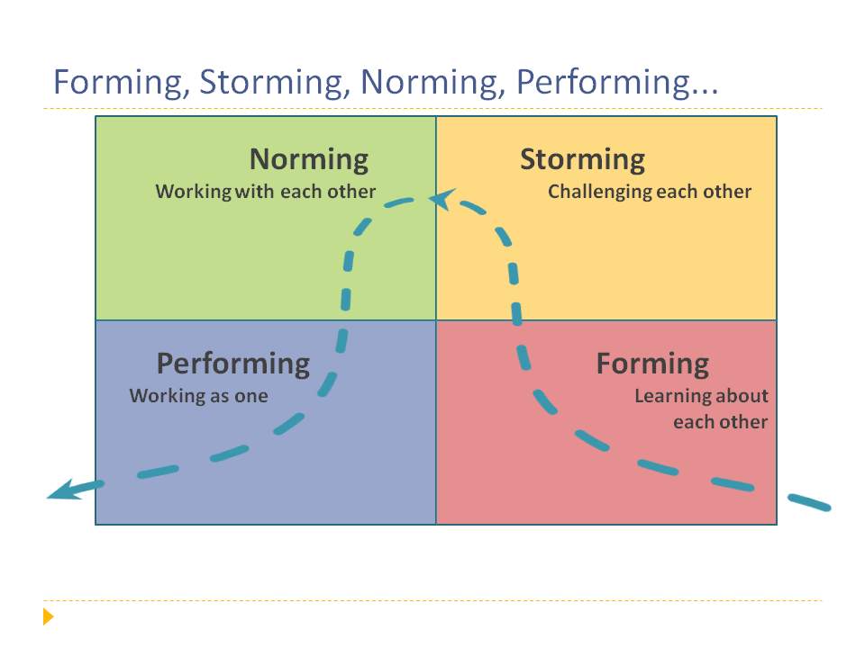

ANALYSIS:
The process of team development and each team member’s specific responsibility must be understood while forming a team. In order to guarantee that roles are assigned efficiently, the team can use the Belbin model to assess each member’s strengths and limitations. The Tuckman model then aids the team in comprehending( the phases of team development and the difficulties they can encounter when cooperating(Eyal,0. &Roth ,G 2011).

When opinions and ideas collide during the storming phase, for instance, a team made up of a shaper, a plant, a team worker, and a monitor evaluator may run into problems. The team can, however, get around this by making use of the shaper’s initiative and leadership, the plant’s inventiveness, the team member’s ability to mediate conflicts, and the monitor evaluator’s objective analysis of ideas.
The team can more effectively navigate the storming stage and advance to the norming and performing stages by using the Tuckman model. For instance, to avoid misunderstandings, the group can create ground rules, assign duties in accordance with individual strengths, and encourage open communication.

As a result, teams can more effectively create team compositions that také into consideration individual strengths and weaknesses by utilising the Belbin and Tuckman models.

BELBIN SRENGHTS AND WEEKNES CHALENGES:
A team’s individual strengths and weaknesses can be successfully described using the Belbin model. Strengths include the knowledge and abilities a person offers to the team, such as their capacity for initiative, leadership, and teamwork. The model also identifies personal flaws that must be managed jiby the team, such as defensiveness, a lack of attention to detail, or complacency(Furnham l.A.,&Steele,H(1993).

The effective assignment of duties to ensure that each team member is working in their area of strength may be a challenge for teams adopting the Belbin model. Role ov,Merlap presents a challenge since it might cause conflict or misunderstandings(Gregory ,J.B & West M.A.(2021).
Making sure that roles are successfully assigned, so that each team member is working in their area of strength, can be difficult for no employing the Belbin model. Role overlap can make things more difficult and increase the likelihood of misunderstandings.
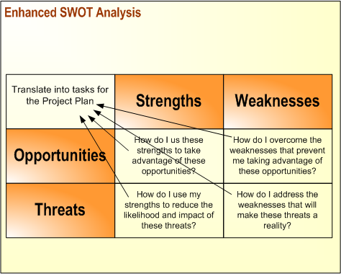

HOW BELBIN AND TUCMAN OVERCAME :
The team composition and development models developed by Belbin and Tuckman have been beneficial in fostering good teamwork by highlighting individual strengths and shortcomings and offering guidance on how to move through various developmental phases. The Belbin model encourages a thorough grasp of team dynamics and makes it possible for teams to function more successfully by recognising the roles of team members and how they might complement one another(Martin,R ., & Graik,K.H.(1986).On the other hand, the Tuckman model focuses on the many stages of team development and offers a framework for recognising possible difficulties and creating workable solutions. Teams can overcome obstacles and work towards attaining their goals more successfully by combining the two models and customising them to each team’s particular circumstances
MY EXPERIENCE:

My experience is from an environment where you worked as a cleaner. And to describe it best, no one did their job well or they didn’t ask for the right amount, so you had to clean for them and stay at work, so it wasn‘t good. You gained a lot from Belbin and Tuckman experience and enough information to help me learn more to communicate, work and agree with people and do the best work in the team.


REFERENCE LIST:

- Furnham, A., & Steele, H. (1993). Measuring Belbin’s team‐role self‐perception inventory: A reconsideration. Journal of Occupational and Organizational Psychology, 66(3), 245-251.

- Gregory, J. B., & West, M. A. (2001). Construct validity of the Belbin Broomhead team role self‐perception inventory. Journal of Occupational and Organizational Psychology, 74(4), 459-468.

- Martin, R., & Craik, K. H. (1986). Belbin’s team role theory: A conceptual and empirical critique. British Journal of Social Psychology, 25(3), 235-252.

- Prichard, C., & Stanton, E. (2006). Good grief, another personality test! A review of the efficacy of Belbin’s Team Role Self-Perception Inventory. Journal of Business and Psychology, 21(4), 541-554.

- Sun, J., Zhang, X., & Chen, Y. (2010). Comparison and analysis of team role theories. IEEE International Conference on Management and Service Science, 2010, 1-5.

