Environmental Storytelling

How important is it in video games?

Martyna Grek
P149796

University of Wales
Trinity Saint David
Computer Games Design

Abstract
The paper focus on environmental storytelling as a method of narrative in video games and how important it is. This paper will contain two case studies, Fallout Series and Bioshock - games that have rich meaning and can offer multiple narrative interpretations for the players. A video game can use narrative to create a fully immersive experience for the player, they are something more than an arcade story-based challenge. Telling stories through environment is much more powerful that telling it directly to a player, the paper points out that by using this method the player feels like he is part if the game’s world instead of just an observer.
The paper maintains that by using environmental storytelling in games, the designer can transform the player into an active participant in the virtual story.

Table of contents
Table of Contents
Abstract 2
Table of contents 3
List of Figures 4
What is Environmental Storytelling? 7
Why is Environmental Storytelling used in games? 9
Unique Experience 9
Guide and teach the player 10
Create mood and atmosphere 10
Warn the player 10
Imply a bigger world 11
Fallout Series 11
Fallout Series – Skeletons in Environment 12
Chapter 2. Bioshock 16
Story told through environment in Bioshock 17
Audio as narrative element 22
Chapter 3. The importance of narrative in video games 24
Is the narrative context important in video games? 24
Conclusion 26

List of Figures
Figure 1, page 12: Skeleton at breakfast with bear.
Figure taken from: https://www.eurogamer.net/articles/2015-11-26-why-i-love-fallout-4-skeletons
Figure 2, page 13: Two skeletons during a fight.
Figure taken from: https://www.eurogamer.net/articles/2015-11-26-why-i-love-fallout-4-skeletons
Figure 3, page 14: Skeletons in the fridge.
Figure taken from: https://www.gamesradar.com/uk/fallout-4-skeletons-have-story-tell/
Figure 4, page 15: Skeleton in the bath.
Figure taken from: https://www.reddit.com/r/Fallout/comments/3chc65/fallout_does_indeed_have_some_sad_untold_stories/
Figure 5, page 18: Values of the underwater city
Figure taken from: https://www.youtube.com/watch?v=iay9supw5uk
Figure 6, page 18: Sign ,,Ryan doesn’t own us’’.
Figure taken from: https://www.youtube.com/watch?v=tcMMgJytiL4
Figure 7, page 19: New Year party
Figure taken from: https://www.youtube.com/watch?v=JNWiJ39Nvmo
Figure 8, page 20: A hanged man, covered in blood
Image taken from: https://rowanmcnyland.wordpress.com/2015/03/30/environmental-storytelling-and-why-i-love-it/
Figure 9, page 21: Pictures of Rapture’s inhabitants
Image taken from: http://the-void.co.uk/games/game-bioshock-pt1-104/
Figure 10, page 22: Words on the floor
Image taken from: https://warwick.ac.uk/fac/arts/english/constellations/shoot_strafe_soliloquy/8/
Figure 11, page 22: Words on the wall
Image taken from: https://warwick.ac.uk/fac/arts/english/constellations/shoot_strafe_soliloquy/8/
Figure 12, page 23: Audio diary
Image taken from: http://bioshock.neoseeker.com/wiki/Audio_diaries

Introduction
,,Environmental storytelling is the art of arranging a careful selection of the objects available in a game world so that they suggest a story to the player who sees them.’’ (Stewart, 2015)

A method of environmental narrative in video games is a method in which information about events taking place in the game world are not transmitted directly - in dialogues or texts scattered around the game world. Instead, the player must be able to guess what happened in the location, carefully observing the elements of the environment. With the help of environmental narrative, both plot features and the situation in which a player character is at a given moment are presented. The narrative method described is realized both through the visual sphere of the game (for example, through the appearance of the location, the condition or arrangement of specific objects), and the sound layer. Due to its specificity and the fact that its application requires the development of specific environments, environmental storytelling has become more important as the entire video game industry develops. Currently, this form of narrative is used in all game genres.

The focus of this paper is to study the role of graphical elements in games in player navigation, showing the story and narrative progression through the game. Especially this paper will look at the role of environments in games and how the story can be shown by creating an environment in video games.
The research questions are the following:
1Q: What is environmental storytelling and why is it used in video games?
2Q: How the environmental storytelling is used in video games – Fallout Series and Bioshock?
3Q: Is the narrative context important in video games?
The goal of this paper is to analyse method of narrative environmental in video games and apply it to two case studies on narrative games. The general insight can be formed into the roles and functions of environmental storytelling by studying specific examples of narrative games, analysis how they are created and how important they are. This paper should also be useful for future research.
To study environmental storytelling in video games the paper will perform a textual analysis of examples of environmental narrative of two games to study the elements that play a role in narrative progression, and what effect they try to create in the context of that game. Data-collection phase will be used before the textual analysis. Here will be used observation as a method to gather examples of narratives in games.
The first chapter will focus on research the first question and go more in depth with the research on narrative elements in games, mainly on environments. The second chapter will research different examples on how the environmental storytelling is used in video games and will focus on specific games titles to explain how this method is applied to help the player with progression through game story. Next chapter - chapter three will discuss the importance of narrative context in video games. Chapter four will conclude analysis on environmental storytelling and if it is important in video games.

Chapter 1. Environmental Storytelling in games

What is Environmental Storytelling?

‘’Conveying narrative backstory and exposition by embedding it in the environment itself - without using a cutscene, character dialogue, or even UI text - is a highly efficient method of storytelling, and one of the best ways to create a player-pleasing amalgam of gameplay and narrative.’’ (Skolnick, 2015)

Environmental storytelling in video games is a method in which information about events taking place in the world of the game are not transmitted directly, such as dialogues or texts. Instead, the player must be able to discover what happened in the world, carefully observing the elements of the environment. With the help of environmental narrative, both plot features and the situation in which a player character is at a given moment are presented. The narrative method described is realized both through the visual sphere of the game (for example, through the appearance of the location, the condition or arrangement of specific objects), and the audio.
Not every video game has to tell the story, and if the game shows a story, then the developers have a lot of methods and styles at their disposal. Environmental Storytelling is the creation of a story in the world that the player travels through so that the player can learn and interpret the story on his own. By using this, the developers can show even more than by dialogues or texts. As Skolnick points out, ‘’visually communicate narrative information is not exclusive to games’’ (Skolnick, 2015) as there are other mediums that used it before games, such as cinema. However, games have the potential to use it more effectively than any other medium. Games can give the unique experience for a player to actively discover and examine stories told through the environments at his own pace. Evan Skolnick explains that games can offer unique experience for a player - he can feel like he is in the environment instead of just observing it;
‘’Video games’ ability to provide that experience to the player - to allow him to really feel like he is in the environment, as opposed to just observing it - is one of the unique and compelling storytelling elements that separate games from other entertainment forms’’ (Skolnick, 2015)

Matthias Worch and Harvey Smith in their presentation have determined what according to them can communicate the game environment:
‘’We're saying that the game environment, which has been derived from a fictional premise, can communicate
• the history of what has happened in a place
• who inhabits it
• their living conditions
• what might happen next
• the functional purpose of the place
• and the mood.’’ (Worch & Smith, 2010)
When the environment is arranged in the right way, nobody has to say anything. The world tells the story itself to the player who must just go through and watch it carefully.
Games have this advantage over other media, that the exploration is active. As Smith and Worch say - Activity means, above all, that history is not told directly by the player. It is the player who draws in the narratives and all his discoveries follow his own pace. This results in a world that seems more familiar to the player just because the player can participate in the process of learning about the world.
In getting to know history through observation, it is great that for a human as it is a completely natural thing. For example, one of theories of psychology - the Gestalt theory - that is, the principle of closing. According to this, the human perception always tries to fill in the gaps, and with smaller elements create a bigger whole even if this whole exists only in our head. As people, we try to give everything a sense and put it in a logical order, and the game developers can use it.
According to Smith and Watch, environmental storytelling should support the theme of the game, it works in such a way that the game triggers some events and these events remind the player of the theme. Even if the environment does not concern the main story, it can effectively support the theme of the game, but it can also effectively support the main story.

Why is Environmental Storytelling used in games?
Environmental storytelling is powerful way of telling a story to the player as it lets him or her to fill in the gaps in their own way, their own pace. However, it is not just a way of telling a story, it is a way to create a unique experience, teach the player about the game, create mood and atmosphere, warn the player or even to imply a bigger world.

Unique Experience
Environmental storytelling creates a unique experience for a player to discover the game world’s story on his own and become a part of it instead of just being an observer. The player can feel that he is in the game, he is a part of something and it can cause different feelings and emotions associated with a certain story. Emotions and feelings like that are much more powerful than these when the story will be told directly to a player, for example by an NPC or a cutscene.

Guide and teach the player
The environmental storytelling can guide the player to certain places in the game, for example by hiding clues in the environment such as maps to show any important locations, by leaving tips, such as footsteps on the floor or on the ground, to navigate the player. Environmental storytelling can also guide the player how to overcome their enemies, for example by leaving the murder weapon by an enemy dead body to show how to kill it.

Create mood and atmosphere
Environments can create a certain state of mind, by manipulating the atmosphere in the game it can influence the emotions and feelings of a player. A designer can create the atmosphere that will increase the reality of the story and emotions associated with it. For example, in the environment that shows a dramatic or horror story, the lighting in the environment will be dark, cloudy, gloomy and scary, in contrast to a calm and cheerful story where the lighting will be bright and warm. The atmosphere should contain elements that will effect on the emotions of a player, associated with the story. Other elements that can be used to create a certain mood in the environment are, colours and sounds.

Warn the player
The environment can be created in a way to warn the player. For example, the environment can be combined with a story from the past to help the player understand of upcoming danger. An abandoned environment can suggest a disaster that has occurred in this place and killed everyone that makes the player to feel unsafe, or a place that is war zone, everyone has been killed and only the enemy combatants remain in this location. The environment that is relevant to the game’s story also can show the challenges that he will need to face. The environment can also show the story and warn the player by small details, such as scratches on the walls created by a monster, lead towards a dark, hidden area showing that something bad happened here and still leaving gaps for the player to fill in with their story, for example – what kind of a monster was it? Warning the player by certain enemies can be also done by using different sounds, the combination of these sounds and other signs in the environment, for example leaking blood can create great immersion by way of tension.

Imply a bigger world
By telling the story through environment a designer can prompt players to infer the existence of places, people and even events that doesn’t exist in the game. If the player is provided with a few words or ideas he can fill in the story gaps with their powerful imagination. The clues can be made of notes, letters, pictures or graffiti in the world.

Case Studies

Fallout Series
Fallout series are a post-apocalyptic RPG open world video games developed by Bethesda Game Studio. The story shows the Earth that is destroyed as a result of a nuclear war, and the selected part of humanity manages to avoid the lethal effects of radiation by hiding in underground shelters, popularly known as Vaults Those who remain on the surface deal with changeable happiness. Some are bravely trying to create new communities, others are retreating to the Stone Age, others are mutating. The world is generally a destroyed place, and the main character in some circumstances is forced to leave the home and discover the secrets of the game world.
The Fallout is well-suited to an examination of environmental narrative as the environments created in these games are rich in meaning and they also can offer multiple narrative interpretations for the players. Looking closer at some areas, the player can find hidden stories: toys, skeletons, cars, all these parts can tell a story about game’s world. However, the stories hidden in environment have no narrative impact on as they can show events from the past. These objects suck the players into the game world by allowing him to discover stories by observation of the environment and by using player’s imagination instead of dialogue or texts.

Fallout Series – Skeletons in Environment
In Fallout series the developers used skeletons in the environment to show the story of the game. They are used to capture a moment in time and the player can imagine what happened in this place while the nuclear bombs fell. Some of the scenes showed by these skeletons can be very emotional and are doing a great job of showing the horror of post-nuclear world.
The skeletons can make a question for a player – ‘What happened here?’- they allow the player to stop and study them, using their imagination.
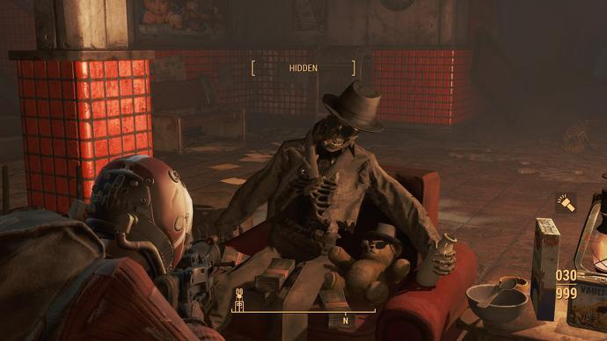
Figure 1: Skeleton at breakfast with bear.
Sometimes skeletons that can be found in game can represent a very sad and emotional situations, but some of them may look funny with the assets that are added around them – for example a skeleton sitting in the armchair in black glasses and a hat, holding a bottle of milk and the cereals on the table can show that he had a breakfast while the nuclear bombs fell, this can also show the time when the bombs feel (they could fell in the morning) and this can be emotional for the player imagining that, however the developers added a bear who also wear black glasses and a hat, sitting with the skeleton on the same armchair – this can be hilarious.
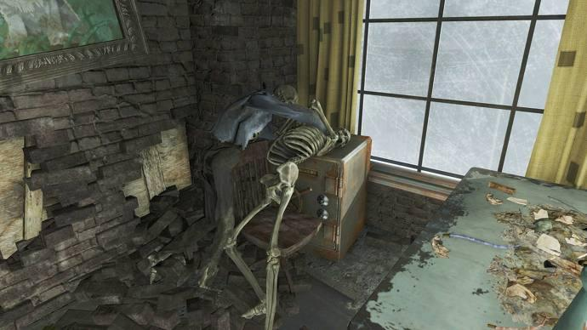
Figure 2 Two skeletons during a fight.

Sometimes the skeletons posed in the game can show some mysteries. For example, the picture above shows us two skeletons that were fighting while the nuclear bombs fell and player can have questions, such as – ‘Why one of them is naked?’ – or – ‘Why are they throttling each other?’. Also, as the skeletons were fighting on the safe it can make the player feel that something good is inside. Poses like this can help the player to imagine whole story in this room, why the fight started and how it could end if the bombs don’t fall.
Evan Skolnick points out that, ‘’An abandoned environment is one thing - but combining it with a calamity of the past can help add a sense of foreboding and dread to a single mission’s environment or even that of the entire game.’’ (Skolnick, 2015)
The environment created in Fallout series is post-apocalyptic, abandoned, however all the clues hidden in the environment can discover the past of the world. Skeletons can have the most impact on the player's imagination, however the assets placed around them also have a very important role in the environmental storytelling. All the dirty, broken walls, floor, scattered old papers - they all support the story by creating post-apocalyptic mood.

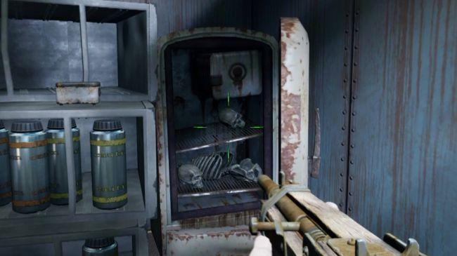
Figure 3 Skeletons in the fridge.

On this example the skeletons that can be found in the fridge can suggest a story about someone that lived in that house – a cannibal? A scientist?
‘’My first thought when I saw this was why would anyone store bones in a fridge? Then I realised it probably wasn’t bare bones when it went in. 200 years ago that was probably an innovative and exciting solution to the whole nuclear holocaust food shortage issue.’’ (Hurley, 2017)

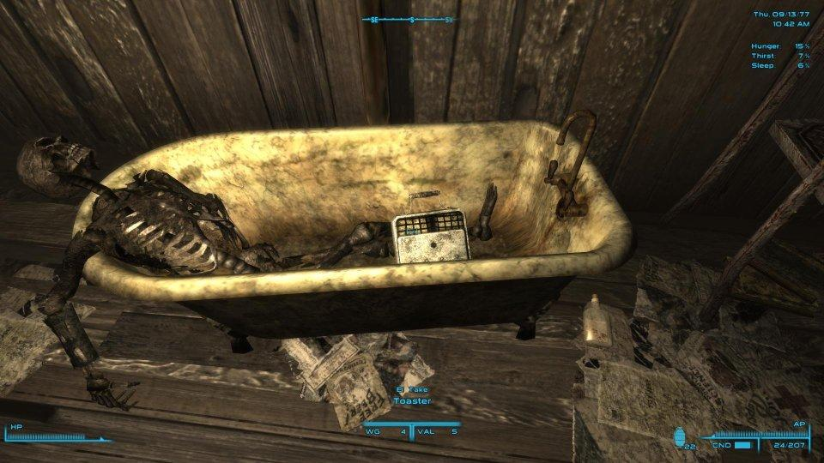
Figure 4 Skeleton in the bath.

Here is another example of posed skeleton that can show the player an untold story. The skeleton is posed in a bath that can suggest that he killed himself before the nuclear bombs fell, or he was just taking a bath in that time. There are some more details added to this scene such as toaster in the bath and some magazines under it, that says ‘FREE BEER!’. This scene can make different feelings for the players:
- ‘’ It's so sad how the great war stopped time for everybody. This guy just wanted a quiet bath and some fresh toast and now he's trapped.’’ (Vraleigh, 2015)
- ‘‘I wonder if he killed himself because the Great War meant he'd miss out on that free beer giveaway (see the paper on the floor)?’’ (Callous1970, 2015)
- ‘’And then I imagine toaster guy, who filled his bathtub with his remaining water while sobbing his eyes out. He lays down, closes his eyes and lets the toaster fall....and nothing happens so he lifts it and lets it fall again, again and again and again. Until he realises the thing doesn't use electricity anymore. No wires, no electricity. The thing uses some nuclear cell that is waterproof. So, he just sobs and lets the thing sink. Maybe if he gives up enough, he'll either drown after a while or he'll fall asleep and just won't wake up.’’ (Sunago, 2015)

These comments found under the image shows how powerful environmental storytelling in games is and how everyone can have different feelings about a single scene made with one posed skeleton and few assets around him. Environmental storytelling like this can help to suck players into the world, and instead of telling the story by dialogue – showing it through objects and places in game.

Chapter 2. Bioshock
‘’Bioshock is one of the games that most aggressively incorporates environmental storytelling, and to this day it stands as a shining example of doing it right.’’ (Skolnick, 2015)

Bioshock was developed by Irrational Games and released in North America in 2007. It is horror-themed, action-adventure first person shooter and its narrative is set in 1960 in the fictional city of Rapture that is built on the bottom of the Atlantic Ocean. The player takes control of the protagonist named Jack, survives in a plane crash, in which he lands in the water in the middle of the ocean. With no special choice, he flows to a nearby structure, resembling a lighthouse. There he finds a lift that takes him to the underwater city. Rapture created by a visionary and a madman at the same time. An ideal world in which science is not constrained by ethical standards. It turns out, however, that something is wrong. The city is controlled by psychopaths, destroyed, in slow agony under the pressure of the ocean. Having no special choice, the hero begins to follow the instructions of a man named Atlas, who is guiding the player via radio communication.

According to the interview with Lead Level Designer Bill Gardener the visual design and gameplay structure of Bioshock was influenced by environmental storytelling. He explained the creation of Rapture and how environmental storytelling became a key factor in many designs through this process and how it made the game to stand out of the games market, ‘’I think a big part of it was the storytelling on the narrative, the immersion level that the game had I think at the time most shooters were just run down a hall you blast a bunch of demons or monsters or aliens or whatever, and then you move on, you don’t care about it and to us that way those always… a tragedy it’s a waste you think about games what’s thing that what’s the one thing that games have over any other medium besides interactivity’’. (Gardner, 2017)
The design philosophy of games that are ‘corridor shooters’ have been considered ‘a waste’ as they do not use the game’s ability to show narrative information through the environment. Early design of Bioshock have been poor in guidance for the players and tis made the developers to take a step back and focus on the narrative.
“BioShock’s story is “loss, loss, loss.” Loss of dreams, loss of hope, loss of love. That’s what makes it horror. That’s why one of the first horror things you see is the woman with the baby carriage. There’s no baby in there. She’s lost her mind, and she’s lost the thing she loves.” – Ken Levine to Gamasutra.
Player can decide how much of the narrative in Bioshock he want to discover as he or she can go through the game as quickly as possible, concentrating on the game’s action or focus on the game’s story hidden in the environment’s elements.

Story told through environment in Bioshock
The Bioshock game is a great example of a game that contains stories told through the environment. In the first 15 minutes of the game, we learn the basic values ​​and ideas of an underwater city such as learning creativity and independence. The environment also shows the effects of genetic modifications that make life easier for the residents. The buildings tell us a lot about the local style of life - fashion, art galleries, theatres, casinos just a paradise for the elite. When we get to know the ideal visions of the city, it's time for what happened here, scattered signs on the ground are clearly associated with rebellion, for example 'Ryan does not own us'
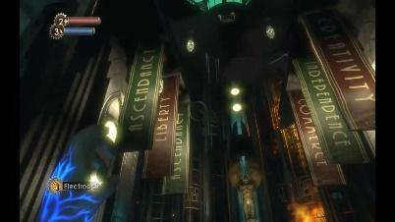
Figure 5 Values of the underwater city
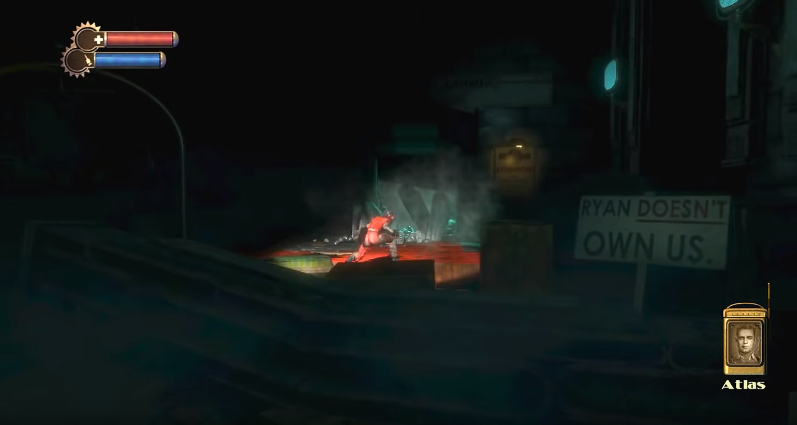
Figure 6 Sign ‘’Ryan doesn’t own us’’
One of the first rooms in the game is another great example of showing the history through the environment, on the place of a failed New Year party we learn not only about the year in which the city collapsed but also about how the local life looked like - a ball, masks, alcohol. On the one hand, you can see the fun and on the other hand, the decadent atmosphere that you can sense in this unsuccessful utopia. In the game world, the player can also encounter a lot of other things such as degenerated inhabitants, posters, dirt, ruins and dark lighting that leave no doubt as to the mood prevailing in Rapture.
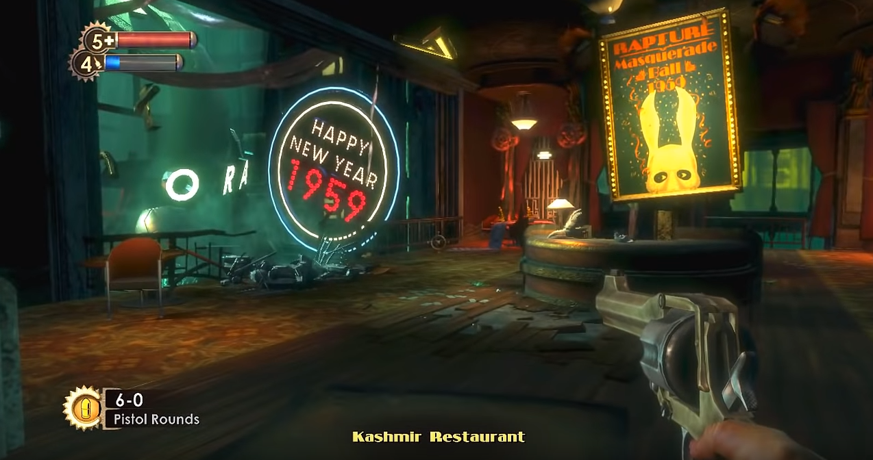
Figure 7 New Year party
In Bioshock there are several different stories - the history of the city, the history of different heroes and each of them has a specific series of events about which player must discover. In the surroundings, the player learns various tips, gradually can get to know the context and finally all the truth that impacts on the player is even bigger just because he came to it on his own. Finding out information by yourself is much stronger than the information we can get straight.
The player learns the story throughout the whole game, not only at the beginning. The game world shows various scenes that shows what happened in Rapture.

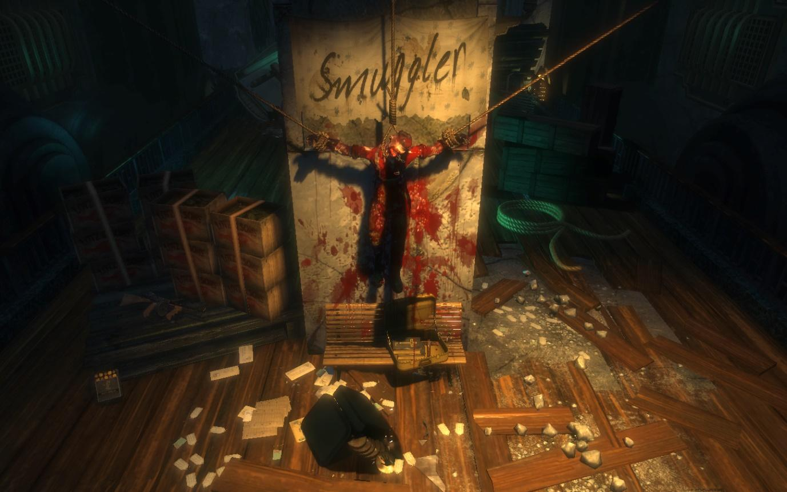
Figure 8 A hanged man, covered in blood
Here is example of an environmental scene created in Bioshock game world. The scene shows a figure who has been hanged and has been left on display for others to see and few assets around it, such as suitcase with bible and a Cristian cross, a gun and scrapped book’s pages. The text “Smuggler” on it behind the character directly illustrates the reason for his punishment. This can show the horror of living in Rapture and make the questions for the player, such as ‘Why is he hanging in a position remaining a cross? Who killed him? Why is there a bible and Christian’s cross under his body? The player intuitively can start connecting multiple elements into one story by looking at this scene.
In games, some passages are limited, or door closed. And all these things are kind of control of a player which can also encourage him to go somewhere. This can be controlled visually through the lights and appropriate colours. In this scene we can see example of this, the lights are focused on the dead body covered in blood that is positioned in the centre of the scene, making the player to stop and study what happened here.
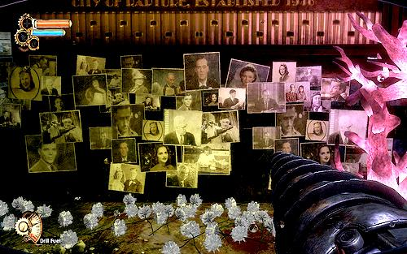
Figure 9 Pictures of Rapture’s inhabitants
Here is another example of story told by environment elements. This scene shows a wall covered by photographs of people that could live in this place. Small elements like that can show much more and can be much more powerful that words told by an NPC and work emotionally on a player’s imagination.
Hidden stories in environments can show the existence of events, people, and places that haven’t been created or presented to a player and they can prompt the player to infer their existence. The player will fill in the story gaps by using their imagination. Small things such as graffiti, pictures or notes added to the game’s environment can be effective to imply a bigger world, for example the above example of different pictures placed in the Bioshock environment are showing different people that haven’t been a part of the game however it can add much more content to game’s story. Environmental storytelling can also be effective for the players that are not interested in the story by not slowing down their pace.

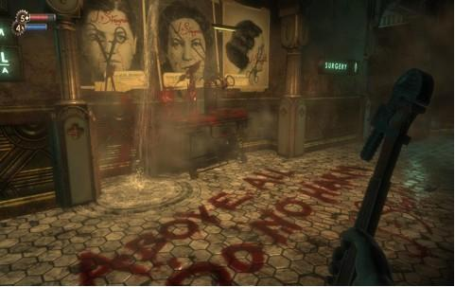
Figure 10 Words on the floor
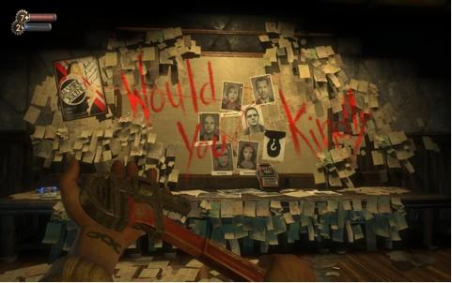
Figure 11 Words on the wall
There are also other, more specific narrative elements in environments, such as graffiti or direct words. For example, Dr Steinman’s patients’ morbid diagrams or words on the wall together with photographs in a room before the player’s encounter with an enemy. Even if they are a written word, they still can make questions such as, - What does it mean? Who did this? Messages in scenes like this usually containing warning of upcoming events or how to find a nearby secret. Combining environment warnings with audio can help to create great tension in the game and work on the player’s imagination.

Audio as narrative element
Audio is one of Bioshock’s greatest assets and makes the gameplay intellectually stimulating. According to William Gibbsons’ article, the music used in Bioshock is connected to narrative. The music reminds the player what period the story shows.
‘’The ironic quality of the popular music allows it to create and maintain the dystopian atmosphere that permeates Bioshock. The juxtaposition of mid-century aesthetic ideals, given voice through the period music, with the visual evidence of the corruption and collapse of those ideals taken to their ultimate extreme, provides a powerful experience for gamers.’’ (Gibbons, 2011)

Figure 12 Audio diary

Another very important audio element that is connected to game’s narrative is radio, that is the player’s primary way of interacting with an NPC. Others are contacting Jack to guide the player what to do next and the writer can use it as a tool to tell the story and control the space of the narrative.
There are also audio-diaries that can be found in the game’s environment that contains story elements. If a player finds an audio journal in the world, he can learn something from his content, but also from where it was found. This may increase the credibility of the game world and awaken our imagination. The diaries are part of the game’s narrative; however, player can choose to listen or ignore them, those who didn’t ignore them have been rewarded with a richer story experience and greater sense of characters, events and game’s world.

Chapter 3. The importance of narrative in video games

Is the narrative context important in video games?
‘’Storytelling isn’t idle leisure activity that humans developed to while away the hours: It evolved for serious purposes, as a necessary component in the development of human culture. Without storytelling, humans could never have communicated complex information. Storytelling isn’t merely characteristic or even definitive of the human condition – it’s absolutely necessary to the existence of human culture.’’ (Crawford, 2005)
Storytelling has been one of the most important elements in connecting human beings. Stories make people aware of their shared human experience, their unique characters. They make people think, feel, imagine and remember. In a book, the story is shown through the lines of text, the cinema transports the audience to a world of sight and sounds, in a game the player guides a character through an onscreen narrative. Nowadays, the age of technology can transform the player into an active participant through stories. In video games the player becomes the story, rather than simply being told the story through the words or observe through lens of a film director.
In today’s most successful video games, quality of the narrative has become one of the most critical features, ahead of graphics or even gameplay. Bioshock is example of the video game that owe its success to its story, a game with incredible story and story world, that shows the unique experience of playing a game.
A video game can use narrative to create a fully immersive experience for the player, tell a story, guide the player what they need to do next. Narrative in video games is important as it can make the player feel more immersed and involved in the game’s world. It can show the game’s meaning and help the player to understand it. The most unique feature of narrative in games is that it makes the player part of the story, the player lives the entire character’s experience.
Nowadays games are increasingly offering expansive world that let the player interact with the main narrative at their own pace. Designers place hints in the game world to show its story, leaving players a lot of freedom to creating their own stories that feel unique to them. For example, in the series Fallout, the player can discover skeletons placed around the game world that are posed in a certain way to work on player’s imagination and create a story of a character that doesn’t even exist.
The environment’s role is very important in telling a story. By hiding a story in the environments, designers can create locations in games that are more than just optimized play spaces. Skolnick points out, that ‘’A vibrantly realized fictional space will always help draw the player into the experience, contributing greatly to her immersion and that all-important suspension of disbelief.’’ (Skolnick, 2015). The attributes and appearance of environment will help define and elaborate on the imaginary world of the game. For example, returning to Bioshock, the important storytelling attributes are assets placed in the game world that shows its culture, for example words that tell us about the most important values of Rapture - Creativity and Independence – or, pictures of different people that lived in the city that the player can discover in the game. The environment in games is not a place that just contains things to do, it is a place to see, explore and learn from.
Telling a story through environment helps a writer tell weaker stories to greater effect than does telling or showing the same story explicitly. A story can be nothing special if it's narrated or portrayed explicitly, for example telling that – ‘’This man died while the nuclear bombs fell’’- but when the player uncover this story on his own, by finding clues in the environment will result in a greater emotions.

Conclusion
Video games now are something more than an arcade story-based challenge. More and more of them aspire to be called art, arouse emotions and become an authentic experience. The story is necessary for them, but it is not the end of the game and satisfaction with the victory that should keep the player in front of the screen, but things like - the possibility of discovering the underwater city, try your hand in the post-apocalyptic world, explore the recesses of the futuristic city. If the developers want the player to feel like a guest in their virtual world, they cannot separate him from this world.
The example of the above titles shows how unique experience a game can be for a player. The game world is no longer just an optimized play space with different things to do, a player can explore and learn from it. The one of the most important features of environmental storytelling in games is that it is much more powerful than any stories told directly to a player, for example by an NPC in the game, in an environmental narrative
the player can imagine his own stories related to the scenes in the game and discover the world in his own pace. Even the smallest details can stimulate player imagination, such as few pictures on the wall or a skeleton with toaster in the bath. Not only games can tell stories, but this paper pretends that only games can provide such experience as feeling of being part of history. Games can surprise anyone with the pace of their evolution, and the new technology, for example VR can offer a richer experience, and especially experience related to being in the environment, if the environmental narration in games is so powerful on the screen these days, what games can achieve in the future?

Bibliography

Online Sources
Steward, B. (2015). Environmental Storytelling. [online] Gamasutra.com. Available at: https://www.gamasutra.com/blogs/BartStewart/20151112/259159/Environmental_Storytelling.php [Accessed 27 Oct. 2018].
Tuck, M. (2010). Gestalt Principles | Design Strategy | Tips & Tricks. [online] WebFX Blog. Available at: https://www.webfx.com/blog/web-design/gestalt-principles-applied-in-design/ [Accessed 27 Oct. 2018].
Duclaux, A. (2017). I love environmental storytelling [online] Tay.kinja.com. Available at: https://tay.kinja.com/i-love-environmental-storytelling-1797910450 [Accessed 2 Nov. 2018].
Shepard, M. (2014). Interactive Storytelling - Narrative Techniques and Methods in Video Games: Environmental Storytelling. [online] Interactive Storytelling - Narrative Techniques and Methods in Video Games. Available at: http://scalar.usc.edu/works/interactive-storytelling-narrative-techniques-and-methods-in-video-games/environmental-storytelling [Accessed 2 Nov. 2018].
Gibbons W (2011), Wrap Your Troubles in Dreams: Popular Music, Narrative, and Dystopia in BioShock, Game Studies 11:3 (Online) http://gamestudies.org/1103/articles/gibbons [Accessed 3 Nov. 2018]
Smith, H. and Worch, M. (2010). What Happened Here? Environmental Storytelling. [online] Gdcvault.com. Available at: https://www.gdcvault.com/play/1012647/What-Happened-Here-Environmental [Accessed 6 Nov. 2018].
TV Tropes. (2015). Environmental Narrative Game - TV Tropes. [online] Available at: https://tvtropes.org/pmwiki/pmwiki.php/Main/EnvironmentalNarrativeGame?from=Main.EnvironmentalNarrativeGames [Accessed 12 Nov. 2018].
Eden, M. (2017). Environmental Storytelling: How I Learned to Write through Playing Video Games - Geek Girl Authority. [online] Geek Girl Authority. Available at: https://www.geekgirlauthority.com/environmental-storytelling-how-i-learned-to-write-through-playing-video-games/ [Accessed 12 Nov. 2018].
Farrell, D. (2015). Something Awful - Fallout 4 Takes Environmental Storytelling to the Next Level. [online] somethingawful.com. Available at: https://www.somethingawful.com/news/fallout-storytelling-skeleton/ [Accessed 16 Nov. 2018].
Yin-Poole, W. (2015). Why I love Fallout 4's skeletons. [online] Eurogamer.net. Available at: https://www.eurogamer.net/articles/2015-11-26-why-i-love-fallout-4-skeletons [Accessed 16 Nov. 2018].
Dane, P. (2015). Fallout 4 Director Talks Environmental Story Telling In New Video. [online] Bleeding Cool News And Rumors. Available at: https://www.bleedingcool.com/2015/07/24/fallout-4-director-talks-environmental-story-telling-in-new-video/ [Accessed 16 Nov. 2018].
Lawardorn, D. (2017). How Environmental Storytelling Shaped Bioshock - OnlySP. [online] Only Single Player. Available at: https://www.onlysp.com/environment-bioshock-design/ [Accessed 17 Nov. 2018].
Kreuch, M. (2011). GAME: Narrative Environment in BioShock, pt. 1. [online] The Void Magazine. Available at: http://the-void.co.uk/games/game-bioshock-pt1-104/ [Accessed 17 Nov. 2018].
Jongeneel, J. (2013). Environmental Storytelling in Games | Jethro. [online] Jethrojongeneel.com. Available at: http://www.jethrojongeneel.com/articles/T3.php [Accessed 19 Nov. 2018].
Hurley, L. (2017). Fallout 4's skeletons have a story to tell. [online] gamesradar. Available at: https://www.gamesradar.com/fallout-4-skeletons-have-story-tell/ [Accessed 19 Nov. 2018].
Suárez, J. (2017). The Importance Of Narrative In Video Games. [online] Wibbu. Available at: https://wibbu.com/importance-narrative-video-games/ [Accessed 1 Dec. 2018].
Ceros Originals. (2017). Narrative Design and the Future of Video Game Storytelling. [online] Available at: https://www.ceros.com/originals/narrative-design-video-game/ [Accessed 1 Dec. 2018].

Books
Skolnick, E. (2015). Video game storytelling. New York: Watson-Guptill, pp.148-162.
Crawford, C. (2005). Chris Crawford on interactive storytelling. Berkeley, CA: New Riders, p.3-4.

Videos
Gameumentary, (2017). Designing the Opening Level of BioShock with Bill Gardner. [online video] Available at: https://www.youtube.com/watch?time_continue=316&v=ztFCbnqSSuA [Accessed 17 Nov. 2018]].
TmarTm2, (2013). Bioshock - Part 1 - Welcome To Rapture (Let's Play/Playthrough/Walkthrough). [online video] Available at: https://www.youtube.com/watch?v=tcMMgJytiL4 [Accessed 19 Nov. 2018]].
TmarTm2, (2013). Bioshock - Part 2 - Big Daddy (Let's Play/Playthrough/Walkthrough). [online video] Available at: https://www.youtube.com/watch?v=JNWiJ39Nvmo [Accessed 19 Nov. 2018]].
TräshLetsPlay .TräshLetsPlay, (2013). Let's Play BIOSHOCK Part 2 Little sister's Big Daddy. [online video] Available at: https://www.youtube.com/watch?v=iay9supw5uk [Accessed 19 Nov. 2018]].

