Impact of current challenges on the human resource department relating to recruitment and retention

Caz study: Premier Inn

n

Student name: Maria Ana Iordache
Student ID number: 2126874
Personnel Resourcing and Development: BMIH 5005
Lecturer’s name: Helen Evans

Abstract

Due to the fierce competition in the labour market today, it is becoming more and more challenging for businesses to find and keep qualified employees. Lack of trained labour, high turnover rates, and shifting workplace cultures are all factors that contribute to this trend. The purpose of this report is to investigate how current difficulties affect employee recruitment and retention by the human resource department (Powell, Francis-Devine and Foley, 2022).

Table of Contents

Introduction.…………………………………………………………………………......2
Research Methodology..……………………………………………………………………………2
Expected Outcomes…….………………………………………………………………………….2
Discussion……………………………………………………………………………….2
SOWT………………………………………………………………..………………...3
PESTEL…………………....……….………………………………………………….3
Premier Inn…………………………………………………………………………….5
Conclusion…..………………………………………………………………………......9
Recommendations..………………………………………………………………….....9
References List…………………………………………………………………………11

Introduction.

This study project seeks to examine the current issues that the HR department faces in terms of employee recruitment and retention. It also aims to assess how these difficulties affect the organization's capacity to recruit and retain competent personnel, as well as what initiatives might be done to minimise them.

Research Methodology
A mixed-methods approach will be used to collect data, encompassing both qualitative and quantitative data collection approaches. Employees and HR staff will be polled to acquire data on current recruiting and retention practises, employee happiness, and organisational culture. In-depth interviews with HR managers and recruiters will also be undertaken to acquire a better understanding of the problems associated with recruiting and retention (Harvard Business Review, 2021).

Expected Outcomes:
The key obstacles that HR departments encounter in attracting and keeping people are expected to be identified by this study, along with information on how these challenges impact an organization's capacity to do so. The final report will provide suggestions for tactics to deal with the problems found and enhance the organization's retention and recruiting procedures (University, 2022).

Discussion:
The current challenges facing the HR department in the UK hospitality industry in terms of staff recruitment and retention include:
- increasing recruitment and retention costs,
- increasing competition between companies to hire and retain qualified personnel,
- changing employee preferences and expectations regarding benefits and working conditions,
- changing the way of working and the needs of employees in the context of BREXIT and the COVID-19 pandemic (Team, 2022).
The hospitality business is popular in the UK, but it used to have problems retaining employees due to high staff turnover rates. According to a recent YouGov research, the yearly worker retention rate in the UK hotel business is 70% (Blythe, 2021). Employee engagement is critical in order to keep employees for as long as feasible. Motivating and retaining employees necessitates the use of motivational strategies (Race, 2021).
The hotel industry is a branch of the hospitality industry that works with visitors and offers them long-term or temporary lodging. It has the potential to expand based on the global economy and may be divided into three categories: food service, hotel, and customer help. The industry's growth is also influenced by the kind, age group, and character of workers (cycles and Text, 2022).

A hotel SWOT analysis is a method used in hotel management to examine internal and external opportunities and threats. It aids in detecting opportunities and planning proactive approaches to bottlenecks. It aids in maximising internal resources, investing in opportunities, transforming weaknesses into strengths, and detecting and mitigating the effect of risks.

The analysis can include a variety of factors like this example:
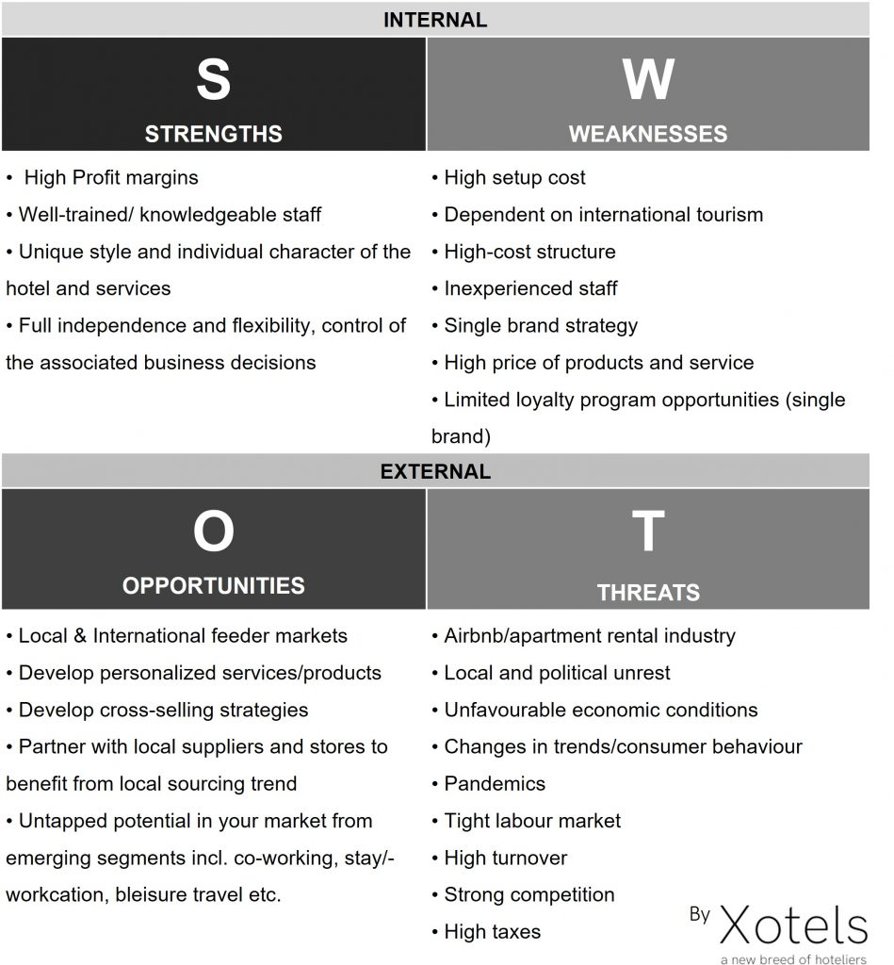(Landman, 2010)

PESTEL analysis is a management method that evaluates the impact of six elements on hotel sector growth: political, economic, social, technical, environmental, and legal. Elections and other forms of government change may have a substantial influence on the hotel sector. Inflation, unemployment, recession, and economic insecurity can all have a direct influence on the hotel business (Frue, 2019).
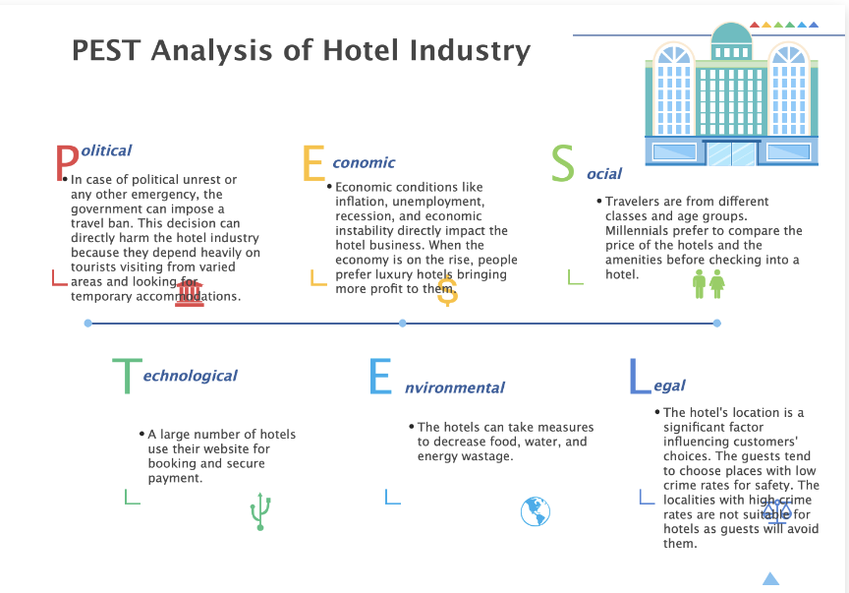(Edrawsoft, n.d.)

People's tastes and spending habits affect the community and culture to which they belong, making socio-cultural aspects an essential external element for the hotel sector. Before checking into a hotel, millennials want to analyse the pricing and amenities, but many travellers pick hotels primarily on available amenities such as bars, swimming pools, heating, valet, and so on (Venturini, 2022).

The hotel industry is a highly competitive market, with many guests reserving rooms based on evaluations or recommendations from family, friends, or peers. Technological considerations have ushered in a new age in the hospitality industry, enabling hotels to provide the greatest facilities and services to their customers, such as internet booking and safe payment, AI-based customer care systems, and secure apps. Hotels may reach more clients with marketing on social media, and travel websites allow travellers to give evaluations, keeping the hotels competitive (www.mews.com, n.d.).

Because environmental considerations can have an influence on the sector, hotels should implement sustainable practises to decrease food, water, and energy waste, convert to renewable energy sources, and employ eco-friendly cleaning products.

Legal considerations are vital in the growth of the hotel sector since there are laws and taxes regulations that must be obeyed, such as local laws with high crime rates and laws about the protection of the guest's data (Merli et al., 2019).

Due to global upheavals, the workplace is changing. Organizations and their leaders are undergoing radical transformations in the way they live and work, evaluating and pursuing new possibilities. This has led to a change in the way staffing is done, with the top 5 recruitment difficulties facing companies in 2023. To address these obstacles, companies need to reflect, reset and reform.
Recruitment problems arise when the hiring process is laborious and complicated, requiring consensus on the goals of all parties. As a result, finding and retaining the ideal candidate for a position can become a challenge.
Finding qualified employees and avoiding unwanted outcomes such as increased turnover and absenteeism are two of the major challenges of recruiting in 2023. To overcome these obstacles, strategies such as the following examples must be followed:
- Hiring managers need to be aware of their responsibilities in order to properly screen applicants.
- Creating a strong employer brand to engage with potential applicants and decrease turnover and recruiting expenses. A psychologically secure workplace and a pleasant workplace culture are critical for effective recruiting.
- Narrowing down the abilities necessary for the function and establishing prerequisites to build opportunities that fit employee talents and set precedents to acquire experience.
- Organisations should think about using a hybrid system to boost flexibility and combine remote training to keep staff.
- Social networking is a fantastic tool for finding new employees and establishing a brand. It's a fantastic approach to cast a wider net and find prospective talent (www.linkedin.com, n.d)

Premier Inn Hotel, is one of the major hotel chains in the UK, and this study tries to determine the reasons behind low staff retention and how to inspire them. It will also concentrate on the most effective techniques to encourage staff (Premier Inn, 2021).
Premier Inn ranks in the top 30 companies in terms of staff retention. 25% of employees would not quit if offered a higher-paying job, and 73% look forward to going to work every day. 75% of employees believe the employer is doing all possible to keep them, while 25% are considering changing jobs. Because good personnel are hard to come by, retention is even more vital.
Premier Inn's Retention score is awarded a "B" by 141 workers and has stayed stable at 73/100 over the last three months. It scores first vs one rival, Doubletree By Hilton, and is in the top 30% of 1341 similar-sized firms (10,000+ Employees) on comparable.
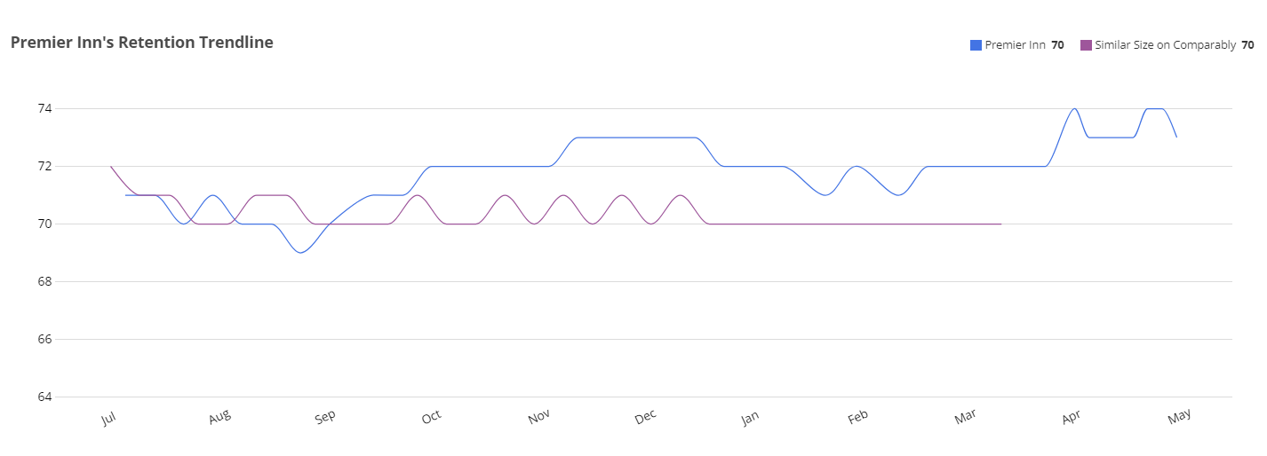

The research focused on the barriers to retaining employees and motivating them in a competitive market. The following are the results from 141 employees across all departments, genders, ethnicities, and years. Experience, the outcomes are as shown in the images:

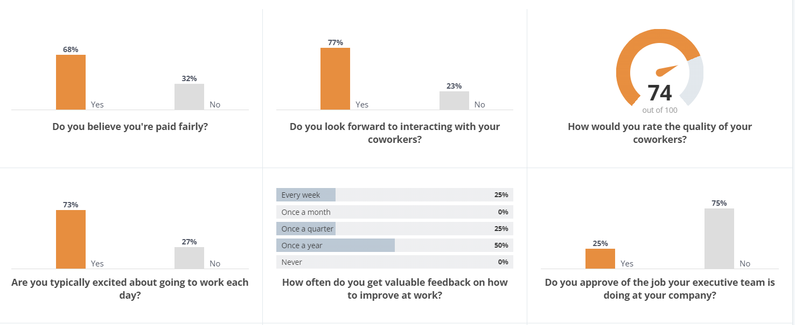
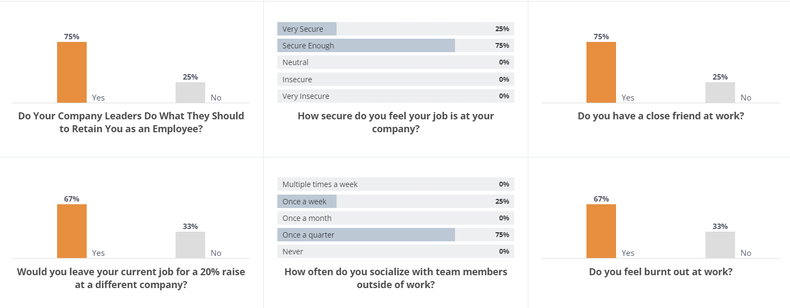

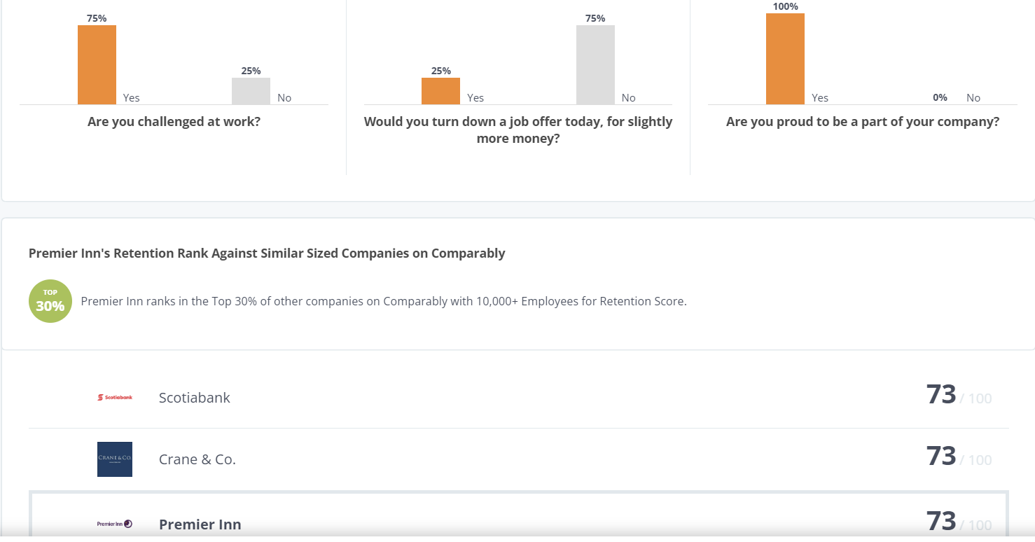
(Comparably -A, 2023)

Employees give Premier Inn's human resources department an A- and are highly delighted with it. According to one user, the diversity and background of the people with whom they work is a beneficial quality.

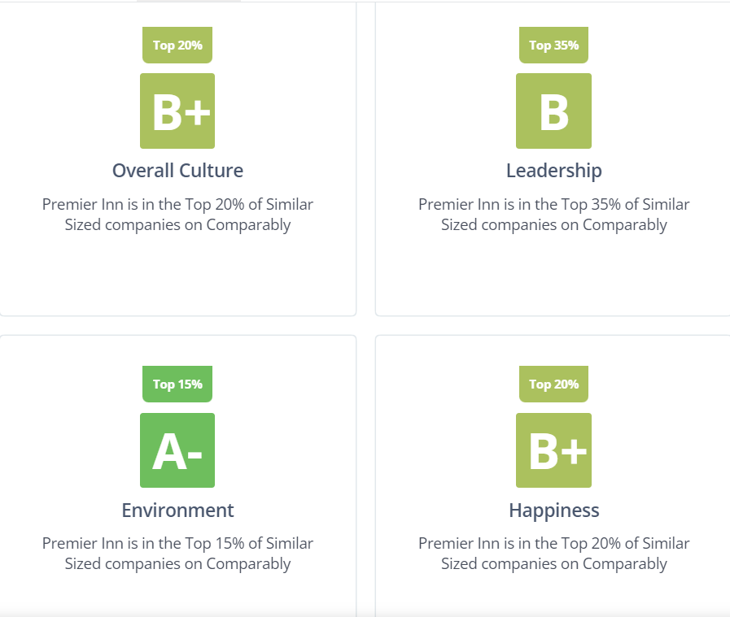(Comparably -B, 2023)

The pandemic and Brexit have both had a big influence on the hotel industry in the United Kingdom. Regulations, food costs, and changes in immigration legislation all offer challenges to businesses, including worker shortages, customer confidence, and staycations. To survive, businesses must alter to become more efficient (Hutton, Foley and Irvine, 2022).
Due to changes in the immigration system, non-UK employees earning less than £20,480 can no longer obtain employment in the UK, which is problematic because the hospitality sector mainly depended on EU immigrants. Due to the epidemic and tougher immigration regulations since March 2020, over 300,000 employees in the hotel sector have left their employment and gone back to their home countries. In addition, because of continued travel restrictions, fewer EU residents are likely to visit the UK for employment during the coming several years (GOV.UK, 2020) .

The hotel sector, especially Premier Inn, has had severe issues in hiring and keeping personnel as a result of Brexit and the COVID-19 epidemic. Some of the ways Premier Inn may deal with these difficulties according to Anon, 2022 into SWOT and PESTLE Analysis, are as follows:
1. Attracting local talent - With Brexit, the free movement of labour has been curtailed, limiting the capacity to attract talent from European nations. As a result, Premier Inn may focus on recruiting and enticing individuals from the local community to fill roles.
2. Competitive pay and perks - To retain employees, Premier Inn can offer competitive compensation and benefits such as employee discounts and health insurance, as well as incentivise employees through incentives.
3. Offering training and career development possibilities - Offering training and opportunity for promotion can help retain employees and generate new ones.
4. Implementing flexible working arrangements - Offering employees flexible hours and other work arrangements can help with retention, especially for those with care obligations.
5. Ensuring workplace safety - Given the problems posed by the pandemic, Premier Inn must prioritise staff safety by taking measures such as providing personal protective equipment, temperature testing, and instituting social distancing standards (uk.indeed.com, n.d.).
Despite the difficulties posed by Brexit and the pandemic, Premier Inn may succeed by putting these tactics into practise and attracting and keeping personnel (www.premierinn.com, n.d.).

Even at difficult times like Brexit and COVID-19, Premier Inn places a high priority on employee well-being and happiness in its recruiting and retention strategies. Listed here are a few causes:
1. Attracting and Retaining staff: Premier Inn is aware that it is essential to find and keep the greatest staff in order to offer clients high-quality services.
Talented individuals are motivated to join and stay with the organisation by variables such as employee welfare and pleasure.
2. A Positive Work Environment: A positive workplace boosts employee morale, which in turn influences performance and productivity. As employees may battle with uncertainty and job loss worry, it's critical to create a healthy work environment during trying times.
3. Increased Customer Satisfaction: Employee satisfaction has a direct impact on customer satisfaction. Employees that are happy and motivated go above and beyond to satisfy the demands of their customers, resulting in higher levels of customer satisfaction.
4. Cost-Effective: Recruiting and training new personnel is costly and time-consuming. Investing in the pleasure and well-being of current employees may minimise turnover rates and generate recommendations from current employees, saving time and money.
5. Ensure Business continuation: Retaining experienced and skilled workers is critical for business continuation during difficult times. It is critical to ensure that employees are pleased and motivated to continue working in order for operations to function properly.
These considerations are acknowledged by Premier Inn, which has taken efforts to safeguard the wellbeing and contentment of its staff. In order to entice and keep talent, the organisation provides competitive compensation, employee benefits, possibilities for growth and development, and flexible working schedules (peachyessay, 2019) (uk.indeed.com, n.d.).

Conclusions /Recommendations

The research project focuses on the challenges faced by human resource departments in relation to employee recruitment and retention, providing valuable insights into the labour market, which will be useful to organizations seeking to enhance their employee recruitment and retention efforts.
The issues that the HR department faces, such as talent shortages, skill gaps, and high turnover rates, have the potential to have a long-term influence on firms' recruiting and retention efforts. The following are some instances of how these difficulties might impact businesses:
- Increasing competition for top talent - As talent shortages worsen, firms will have to compete with one another to recruit the best applicants. This means that employers will have to design more appealing salary packages, better benefits, and more professional progression prospects to keep their employees.
- Focus on training and development - To solve skill shortages, firms will need to focus on providing more training and development opportunities to their employees. This will assist them in upskilling their employees and ensuring that they have the essential skills to fulfil the demands of the job.
- Emphasis on employee involvement - High turnover rates may be costly for firms, both in terms of revenue and productivity. Businesses will need to work on enhancing employee engagement in order to retain their staff. This may be accomplished by creating a happy work atmosphere, enabling more flexible scheduling, and providing employees with a feeling of purpose.
Overall, organisations will need to be proactive in solving the HR department's difficulties in order to recruit and retain top people in the long run.
Companies need a strong "employment value proposition" that includes competitive pay and benefits, career-development possibilities, and a track record of excellent management since candidates are becoming pickier about the companies they work for. Talented applicants are considering chances differently, especially at top levels, giving things like meaningful employment and closeness to family more weight. Employers must provide candidate-valued employee experiences, particularly during a time of high unemployment. Reengineering the Recruitment Process.

References List:

- Anon, (2022). Premier Inn Hotel SWOT and PESTLE Analysis | Free Essay Examples. [online] Available at: https://samples.freshessays.com/premier-inn-hotel-swot-and-pestle-analysis.html [Accessed 5 Jun. 2023].

- Blythe, T. (2021). Employee Retention | Strategies in the Hospitality Industry. [online] The Hub | High Speed Training. Available at: https://www.highspeedtraining.co.uk/hub/employee-retention-in-hospitality/ [Accessed 5 Jun. 2023].

- Comparably A. (2023). Premier Inn Retention Score. [online] Available at: https://www.comparably.com/companies/premier-inn/retention [Accessed 5 Jun. 2023].

- Comparably B. (2023). Premier Inn Retention Score. [online] Available at: https://www.comparably.com/companies/premier-inn/human-resources [Accessed 5 Jun. 2023].

- cycles, T. text provides general information S. assumes no liability for the information given being complete or correct D. to varying update and Text, S.C.D.M. up-to-Date D.T.R. in the (2022). Topic: Hotel industry worldwide. [online] Statista. Available at: https://www.statista.com/topics/1102/hotels/#topicOverview [Accessed 5 Jun. 2023].

- Edrawsoft. (n.d.). Detailed PESTEL Analysis of Hotel Industry | EdrawMax Online. [online] Available at: https://www.edrawmax.com/article/hotel-industry-pestel-analysis.html.

- Frue, K. (2019). PESTLE Analysis for Hotel Industry. [online] PESTLE Analysis. Available at: https://pestleanalysis.com/pestle-analysis-for-hotel-industry / [Accessed 5 Jun. 2023].

- GOV.UK (2020). New Immigration System: What You Need to Know. [online] GOV.UK. Available at: https://www.gov.uk/guidance/new-immigration-system-what-you-need-to-know [Accessed 5 Jun. 2023].

- Harvard Business Review. (2021). A Data-Driven Approach to Identifying — and Retaining — Top Employees. [online] Available at: https://hbr.org/2021/05/a-data-driven-approach-to-identifying-and-retaining-top-employees. [Accessed 5 Jun. 2023].

- Hutton, G., Foley, N. and Irvine, S. (2022). Hospitality Industry and Covid-19. commonslibrary. parliament.uk, [online] CBP 9111. Available at: https://commonslibrary.parliament.uk/research-briefings/cbp-9111/ [Accessed 5 Jun. 2023].

- Landman, P. (2010). Evaluate the Value Proposition of your Competitors. [online] Hotel Management Company - Hospitality Group - Xotels Ltd. Available at: https://www.xotels.com/en/revenue-management/revenue-management-book/competitor-analysis [Accessed 5 Jun. 2023].

- Merli, R., Preziosi, M., Acampora, A. and Ali, F. (2019). Why should hotels go green? Insights from guests’ experience in green hotels. International Journal of Hospitality Management, 81(0278-4319), pp.169–179. Doi https://doi.org/10.1016/j.ijhm.2019.04.022 [Accessed 5 Jun. 2023].

- Peachy Essay (2019). Employee Retain Barriers in Hospitality Industry; Premier Inn Case Study. [online] Peachy Essay. Available at: https://peachyessay.com/sample-essay/employee-retain-barriers-in-hospitality-industry-premier-inn [Accessed 5 Jun. 2023].

- Powell, A., Francis-Devine, B. and Foley, N. (2022). Coronavirus: Impact on the labour market. Commons library. parliament.uk, [online] 8898(CBP8898). Available at: https://commonslibrary.parliament.uk/research-briefings/cbp-8898/ [Accessed 5 Jun. 2023].

- Premier Inn (2021). Premier Inn Home. [online] Premier Inn. Available at: https://www.premierinn.com/gb/en/home.html [Accessed 5 Jun. 2023].

- Race, M. (2021). Is there a solution to the hospitality staff crisis? BBC News. [online] 20 Jul. Available at: https://www.bbc.co.uk/news/business-57817775 [Accessed 5 Jun. 2023].

- Team, E. (2022). HR Challenges In The Hospitality Industry And Possible Solutions. [online] HR News. Available at: https://hrnews.co.uk/hr-challenges-in-the-hospitality-industry-and-possible-solutions/ [Accessed 5 Jun. 2023].

- uk.indeed.com. (n.d.). Premier Inn Mission, Benefits, and Work Culture | Indeed.com. [online] Available at: https://uk.indeed.com/cmp/Premier-Inn/about [Accessed 5 Jun. 2023].

- University, N. (2022). The key HR challenges for 2023. [online] Public Sector Executive. Available at: https://www.publicsectorexecutive.com/articles/key-hr-challenges-2023 [Accessed 5 Jun. 2023].

- Venturini, B. (2022). Sustainability in Tourism: The socio-cultural lens. [online] hospitalityinsights.ehl.edu. Available at: https://hospitalityinsights.ehl.edu/sustainability-tourism [Accessed 5 Jun. 2023].

- www.linkedin.com. (n.d.). 5 BIGGEST RECRUITMENT CHALLENGES IN 2023 AND HOW TO OVERCOME THEM. [online] Available at: https://www.linkedin.com/pulse/5-biggest-recruitment-challenges-2023-how-overcome-them-/ [Accessed 5 Jun. 2023].

- www.mews.com. (n.d.). Hotel trends you’ll see in 2023 in the hospitality industry. [online] Available at: https://www.mews.com/en/blog/hotel-trends-hospitality-industry [Accessed 5 Jun. 2023].

- www.premierinn.com. (n.d.). Top employer. [online] Available at: https://www.premierinn.com/gb/en/news/2022/top-employer.html#/ [Accessed 5 Jun. 2023]. [Accessed 5 Jun. 2023].

