An investigation into British football fandom, fan behaviour, and the reasons why there are persistent relations to varying degrees of criminality.
By Kyle Evans.

MA Criminal Justice & Policing.
Student Number: 1706558. Official Word Count: 15,638.

Acknowledgements

To begin with, I would like to thank both my supervisor Peter Doyle and the overall dissertation project lead lecturer Jane Thomas for their consistent engagement and support throughout this Masters course, with added thanks to Peter for giving up valuable time and knowledge during this specific dissertation period. Additionally, I would also like to extend my gratitude to all my former lecturers at UWTSD for all you done for me during my time at undergraduate level whilst also at this University.

I would also like to extend a big thank you to all who took the time to participate in my research for this project, I understand the COVID-19 related difficulties resulted in a much more remote and personally disconnected experience during participation and so, I cannot thank you enough for still helping make this research possible.

Lastly and most importantly, I would like to thank all my family and friends for any inspiration, motivation, or support they may have provided me with over the entire duration of my time at university. With an added thanks to my late Grandad who passed away during my undergraduate degree, for all the love and support he gave me throughout my life and influencing this passion I have for sports and problem solving respectively, which has been combined in a sense within this project.

THANK YOU.

Declaration/Statements Page

Declaration:
This work has not been previously accepted in substance for any degree and is not being concurrently submitted in candidature for any degree.
Signed – K. Evans Date – 01/12/2021.

Statement 1:
This dissertation is being submitted in partial fulfilment of the requirements for the degree of MA.
Signed – K. Evans Date – 01/12/2021.

Statement 2:
This dissertation is the result of my own independent work/investigation, except where otherwise stated. Other sources are acknowledged by footnotes giving explicit references. A bibliography is appended.
Signed – K. Evans Date – 01/12/2021.

Statement 3:
I hereby give consent for my dissertation, if accepted, to be available for photocopying and for interlibrary loan, and for the title and summary to be made available to outside organisations.
Signed – K. Evans Date – 01/12/2021.

Statement 4:
I hereby give consent for my dissertation, if accepted, to be available on the university’s IT system to those who have consent to use the system.
Signed – K. Evans Date – 01/12/2021.

Abstract

The focus of this dissertation project is to critically analyse and investigate the reasonings as to why there is such a persistent and notorious relation between criminal/deviant behaviour and football fandom. The main aim of the study is to try and provide an in-depth and specific examination rather than a generalised response which has become somewhat normalised in regards to research on this subject matter, thanks to the influence and impact of the news, media, and social media respectively. The literature review offers a clear and concise evaluation of existing literature and research that is connected to the topic, whereas the methodology section outlines the proposed methods and reasonings for the primary research carried out.

As a result of the analysis of the results that followed, there were notable conclusions made that could help to improve the overall understanding of this topic, as well as the outlined issues relating to the subject matter if they are either directly acted upon, acknowledged and used as influence or, developed upon further to gain an even more critical and conclusive stance. In line with this, both recommendations and limitations were highlighted in the closing of this piece of work, to ensure that there was a clear transparency met regarding this research. With the main recommendation being that, those in decision making and power holding positions relating to the overall footballing landscape, must become more assertive and accountable in terms of providing those at the policing, preventing and prosecuting levels, with effective guidance and support that allows for them to become an actual deterrence and safeguarding factor in and around football grounds.

Table of Contents

Chapter One: Introduction 6
Chapter Two: Literature Review 10
Chapter Three: Methodology 31
Philosophy & Approach 32
Design of Research 33
Data Collection 34
Participants & Ethical Considerations 35
Remote Online Interviews 36
Online Questionnaire 37
Reliability & Validity 39
Analysis of Data 39
Method Limitations 41
Chapter Four: Analysis of Results 43
Introduction 44
Main Findings 45
The Beautiful Game 46
The Present-Day Predicament 48
Football Fandom Versus News & Media 50
The Perfect Camouflage 52
Fan or Foe 53
Policing, Policing & More… Policing? 55
Future of Football Fandom 57
Chapter Five: Conclusions & Recommendations 59
Conclusions 60
Limitations 66
Recommendations 68
Chapter Six: Bibliography & Appendices 72

Chapter 1: Introduction

A notorious but also still not fully understood critically, the topic of football fanhood and the controversial relations it has with matters such as criminality is very much still contemporary. As the studies by those such as Dwyer et al (2015) showcase, the understanding of football fan behaviour in general circumstances is still somewhat flawed or undetermined, meaning the matter of analysing complex links to criminality becomes that much harder. The reasoning for this, is due to just how difficult it can be to find and make use of a generally agreed upon scale for measuring football fandom/fan behaviour transnationally, with scholars and other academic research from various countries all using a variety of scales presenting an issue in terms of correlation.

However, Spaaij & Anderson (2010) do offer a differing but perhaps more relevant perspective which is, the best approach to studying football fan behaviour and criminality is one of a holistic nature because, trying to critically analyse such matters without incorporating the external factors such as macro-level influences on fandom, the importance of collective mind research, social identification theories and the impressionable environment of sporting and in particular football events, would be an ineffective task. In essence, this perspective effectively highlights the shift in researching within this subject matter over recent years, with there been a more evident focus on explanatory models generally first and foremost before delving into the more individual and diverse critical evaluating (ibid).

This is perhaps made evident with work such as that regarding the very much recently termed topic of ‘fangelism’, which can be connected to the studies by Dwyer et al (2015) referenced earlier in this section. This term and related topic – which is very much still in infancy – relates to the studying of football fandom and fan behaviour of differing dimensions and outcomes using certain variables such as age, gender, income, status, education, other self-interests and favourite team’s value or status (Page, 2020). In line with this, the work of Dixon (2013) also highlights the shift in researching and reviewing with this sociological focused approach to analysing the practice of football sporting. This analysis unlike many, displays a clear focus on recognising the true value and significance of individuals or small groups reasoning for maintaining an avid football fan status and overall outlook (ibid). Whereas, with the majority of now slowly antiquated but similar subject matter analysis, there has always been a more heavily objective social conditions and accrued experiences line of focus attached.

It could also be stated, that it is down to this constant sort of researching that is to blame for the lack of understanding, especially across Europe. As Redhead (2002) projected, with the ever-increasing effects of digitalisation and capitalism on the overall football environment, there could be no doubting that criminality related to football fan behaviour was although going to become fewer and farther between, also become more severe, segregated, signified, and showcased. Thus, football hooliganism as it was once viewed in regards to the connection it had towards the passion, atmosphere, and experience of a matchday, could perhaps be seen as fading.
Because, as Finn & Giulianotti (2013) explain, the dynamic at play now within the context of the business of football and football fandom is one of bend but not break. Meaning, the global vision for the footballing landscape is clearly to effectively outlaw as much traditional and expressive fandom as possible but, at the same time not breaking or eliminating this too greatly as it is part of the overall entertainment package and appeal of football as a sporting interest and social pastime (ibid). Therefore, this can be seen as to why from a more localised and micro level viewpoint, there are such issues relating to criminal fan behaviour and the difficulties in terms of policing and prevention, as this global vision has essentially paved the way for localised conflicts and chaos in regards to football and football fandom.

Despite this, there is still an obvious lack of critical research depth in terms of the links and relations to criminality. As the still very relevant work of Dunning (2000) suggests, there is still very much a need for more emphasised and localised research approaches towards deviant fan behaviour such as football hooliganism, due to the common yet flawed reasonings of commercial and cultural influences. The reasoning for the chosen topic has been alluded too, with there seemingly being a lack of understanding as for why there is such an obvious link to anti-social behaviour/criminality and football fandom. And so, if this is indeed the case, then it is possible to suggest that a critical but also concentrated research approach may provide specific findings and answers, that allow for a better understanding and knowledge for the broader issue at hand. In particular, findings and hopefully answers that either directly relate to the issue from a UK outlook and perspective or, that can be generally applied for football fan behaviour across the board.

Chapter 2: Literature Review

There can be no disputing that football fandom and fan behaviour are both far from being recently discovered topics of discussion, with Frosdick & Marsh (2013) providing details of how some of the first recorded instances and evidence of football fan anti-social behaviour/hooliganism as we know it, can be dated as far back as the late 19th - early 20th century and occurred in England. However, what can be identified as being more relevant recently is the matter of discrimination and notable acts of criminality in connection to football fandom, which has whether rightly or wrongly led to a growing trend in mass media coverage and debates on such issues.

As Groombridge (2015) suggests, the subject of fan behaviour and the connection it has to deviancy or criminality in a footballing context is very much a contested concept, with various instances highlighting that depending on the setting or timing it could perhaps be deemed both overplayed and wrongfully scrutinised or even overlooked and underemphasised. In relation to this, Spaaij (2006) provides the evaluation that this sort of contested mood surrounding football fandom is largely down to the perceiving by the likes of politicians, policymakers and the media that football fan behaviour or football hooliganism which it is almost always characterised as within the UK, is a disturbing and serious social problem in need of nullifying. In addition, the regular terming of anything football fan related as hooliganism –which can be understood as violent or affrontive behaviour typically by groups of males– perhaps plays in to this perceived narrative whilst also, further fuelling this belief that there is an exclusive issue within the UK when it comes to football fandom (Stott & Pearson, 2007).

In conjunction with this previous point about exclusivity, it should be noted that hooliganism has been and still very much is a dynamic and rather niche phenomenon and so, the social and historical context it is studied within is of importance. For example, up until the last two decades or so football within the UK particularly, was very much viewed as a working-class sporting interest and played a part in this sort of British class dividing, with different sports such as cricket or tennis for example being predominantly linked with the upper echelons of society (Spaaij, 2008). Therefore, if the social and historical context being looked at in regards to football fandom was within perhaps the 1970s/1980s and focussed on some of the major cities such as London, Liverpool, Manchester, and Birmingham, then this sort of well-mannered men with higher class status versus working class and hard masculinity characterised boys, would be very much apparent (ibid).

However, it is when looking at this subject matter within the context of around the last three decades or so (1990 – present day) where much more uncertainty can be found. This is because, despite the still somewhat residual belief of football hooliganism being an almost exclusively British/English social problem, this period has proven that the matter of football hooliganism is far from being antiquatedly conceptualised and generally explained as previously assumed (Poulton, 2007). Furthermore, with the ongoing growth and globalization of football culture, societies, and behaviours, it has enabled a clear transnational showcasing that, societal faults and cultural issues or trends cannot be deemed enough in regards to researching or reasoning this matter (ibid). Therefore, more detailed analysis and specific approaches towards understanding football fan/hooligan subcultural identities, underlaying interests or behaviours and social interactions is required, to help gain a more modernised accuracy in fully understanding the matter of football fan behaviour and the links to deviant/criminal acts (Spaaij, 2007).

Contrastingly, Frosdick & Newton (2006) contest this slightly with the viewpoint that there is not actually a legitimate need for this because, the coverage and perception regarding ‘football hooliganism’ often projects this enlarged significance on the matter. When in reality, statistics such as hooliganism only being associated with around one match in twenty across UK mainland football and also, over half of these reported incidents taking place away from the ground or the immediate proximity of it, could lead to the suggestion that there is no need for any greater emphasis being put towards football fandom over any other debatable cultural or social pastime (ibid). On the other hand, Poulton (2013) believes that it is for this exact reason as to why there is a need for much greater emphasis put on understanding fan behaviour, as this put off of it being just a sort of divisive type of pastime is what allows this constant production and re-production cycle of rather notorious but still solicitated behaviour amongst fans.

This can be seen with the example provided by Trost & Kovacevic (2013), which is concerning the issues regarding the crossover between football hooliganism, nationalism, and the extreme-right movement within Serbia. To add further context, the key concern relating to this crossover issue within Serbia is that, for some time these anti-social behaviour-based crimes were simply brushed off as just acts of football hooliganism and which then slowly led to the incorporating of acts and attitudes towards nationalism (ibid). But because of this, it then enabled this cycle of production and re-production (mentioned above) to begin and eventually, allowed for the blurring of what were acts of football hooliganism and what was nationalism or far-right extremism behaviour/criminality, with the events of the Serbian gay parade riots in 2010 displaying this (Poulton, 2013).

Furthermore, this specific event and setting holds even more significance, due to the particularly inextricable link in Serbia between governing politics and football. As Nielsen (2013) enlightens, since the collapse of Yugoslavia in 1991 football has held an uncommon level of importance alongside expected national state fundamentals such as a distinctly favoured religious perspective and a pro-European or patriotic allegiance, with the volatile mixture of these and some others still being embedded through the declaring of Serbia being an independent state in 2006. Essentially, what this implies is that the phenomenon of football and the level of support and dedication it provides, if given enough status and significance (which has been detailed to be the case in Serbia), could become stronger and more influential than the actual state (Mojet, 2005). Coincidentally, Mededovic & Kovacevic (2020) believe that it is due to the combining of this unique level of influence held alongside this research recognised Militant Extremist Mindset (MEM) amongst considerable amounts of Serbian football supporters, that has basically led to the unifying of football fandom and far-right extremism.

Ambivalently, Pearson & Stott (2016) are of the belief that although of course being completely plausible when being looked at through very peculiar circumstances like that of Serbia, this must be viewed as more of a one off rather than a reasonable benchmark or example for other instances which lead to questioning of football fandom and criminality. The reasoning for this, is due to how the growth in both globalization and commercialisation input and impact on the subject of football as a whole, has enabled a more passive attendance and matchday experience (Putra, 2019). Because, alterations such as ticket and pricing increases, restricted or prohibited alcohol consumption and modernised football stadiums as well as the surrounding settings, have ensured that the classic football fan assumptions and perceptions are becoming less and less of an accurate representation (ibid).

However, Bliesener (2009) disputes this sort of easy to accept reasoning with the viewpoint that even though this is evidently true to a certain extent, it does not profoundly counter the points made earlier by Mededovic & Kovacevic (2020) regarding MEM amongst fans, which despite mentioned specifically in regards to the example of Serbia is still applicable across other parts of Europe. In tandem with this, Kennedy (2013) provides the context that through extensive analysis it has been widely accepted that football can be used and manipulated in many cases quite easily, to provide a vehicle for certain extremist political or militant views and movements. As has been proven throughout Europe, if there is a considerable significance or influence given towards the ultra-football supporters of a team so to speak, then this MEM can be produced and spread easily throughout a fanbase and allow for the creation of an extremist movement/collective from just within the seemingly regular fandom of a football team (ibid). And so, this is why Ferdinand et al (2007) urge that football fandom must be considered through a different kind of ethic, in order to be able to truly understand why things such as football supporting and far-right extremism becoming unified are able to happen.

In regards to this call for a unique ethical approach, it perhaps provides direction to a more complex matter that is in desperate need of being understood for any issues regarding football fan behaviour to be effectively analysed. The complex matter in question is that of this notoriously captured football fan etiquette, which seems to beguile quite a large proportion of fans and sort of allows for this seamless social identity and behavioural change whilst within a football event or match setting (Fillis & Mackay, 2014). Interestingly, this can be linked to the social identity theory produced by Tajfel & Turner in 1979, which theorises that much of our social identification, experience, behaviour, and existence can be related back to a simple examination of in-groups and out-groups (McLeod, 2019).

In short, the in-groups are the social groups an individual identifies with, whereas the out-groups are not identified with and as a result might be discriminated against by the individual (ibid). Now, although being rather easy in terms of capturing and describing this social identity matter, Fillis & Mackay (2014) assure the complexity lays with trying to critically answer why this is the case, with a whole array of factors needing to be considered such as consumption behaviour, antecedents of loyalty in the communities around a club, specific club fanaticism, consistent exposure to overwhelmingly impressionable environments, and religion like influences relating to club affiliation and devotion.

Contrastingly, Williams (2013) disputes this last comment regarding similarities to religion and instead, offers the viewpoint that the major reasoning for the complexity is solely down to the consumer like role and environment fans are captured within. Strengthening this viewpoint, Richardson (2004) educates that this consumer like role embodied by football fans is actually a key influencing factor for the majority of fan thoughts and actions, including even hooliganism behaviour or intentions. This is thought to be because, whilst engaging and making connections to a particular social setting or group, the more consumption (such as purchasing club merchandise) or consumption behaviour (such as engaging with specific club events or going to a renowned fan hotspot pre- or post-match) that an individual yields, then the greater the likelihood of that person becoming deeply induced by the social habitus (ibid).

Conversely, the work by Bebber (2020) provides questioning to this with the highlighting that, this does not necessarily provide any understanding for deviant football fan behaviour or actions due to the fact that, in actuality consumer like supporters and hooligan related fandom have been made easily distinguishable for the lack of mainstream consumption recorded by the latter. Offering an overarching point of view, Numerato & Giulianotti (2018) believe that both perspectives hold worth as despite not fully applying to the normalised consumer type role described, the majority of football hooliganism is still very much prompted from a consumption behaviour stance. In continuation, what this means is although not aligning with the normalised and recognised as correct football fandom consumption, the more controversially aligned consumption behaviour (such as rioting, rival club abuse, alcohol, and drug use) still allows for specific social habitus embeddedness (Richardson, 2007). Therefore, irrespective of whether or not a fan is viewed more as a modern-day consumer like supporter or a diehard club ultra, the mere fact that they had an initial engagement with a particular football club fandom/social habitus means their whole outlook could be severely influenced (ibid).

Keeping the points made above in mind, it is perhaps important to address a follow up uncertainty from this which is in relation to trying to identify and explain how this connection between criminality and football fandom was enabled in the first place. As a starting point, Ahmed (2019) offers the explanation that the reason criminality particularly of a severe or prominent nature has become slightly synonymous with a certain type of football fandom, is due to the sort of platform and camouflage abilities that the deceptive use of football fandom can provide.

Expanding on this, Busset et al (2009) highlight that there is very much truth to be had in the suggesting that the modern construction of football in general, provides great opportunities for a wide scope of criminality. In particular, the current football stadium experiences without a doubt enable specifically serious and threatening criminality such as extremism to have notable exposure to mass numbers of people that can be either influenced and radicalised or even victimised in ways that aid the extremist synchronisation to the football stadium and fandom in question (ibid). Opposingly, Mangan (2013) argues that despite agreeing fully that stadiums hosting certain sporting events or teams provide a worryingly effective environment for threats such as radicalization and instances of extremism, does not align with the idea that there is a further unique and specific issue relating to football over any other largely followed and engaged with sport.

In disagreement with the previous statement, Mammone et al (2013) counter this with the stating that although from a victimisation and targeting perspective football may not hold any significance over other sports, in terms of infiltration, camouflaging and even recruitment or radicalisation, there is no disputing how influential the modern-day football supporting environment is for extremism. Additionally, specifically in terms of football across Europe there is a continuously increasing number of examples and evidence that showcase how football fandom in various parts of Europe is becoming an increasing factor in the rise of right-wing extremism (ibid). In regards to right-wing extremism, it can be understood as the term used to explain and identify those on the very right of the commonly followed political spectrum and of which, usually aligns with political beliefs such as anti-communism, authoritarian, ultranationalist and tendencies or ideologies that are very nativist/patriotic driven (Koehler, 2016).

In relation to this understanding of right-wing extremism and also the visible connection it has to football across Europe, Malatesta et al (2009) offer the conjecture that the reasoning for why this dangerously growing fusion is happening may actually be a result of the origins of some of the current European states/countries. This is because, for countries such as Serbia, Poland and Italy who have all witnessed these right-wing extremist behaviours within a football setting, the history of them all showcase examples of the exact opposite of the right-wing political perspectives (ibid). This is also alluded to by Giulianotti & Robertson (2007), with their highlighting of how due to globalization and transnationalism, in some cases football has been used as a tool for either over implementing transnational concepts or, the complete opposite with it being used for anti-transnational beliefs. In essence, this perspective is implying that due to the current outlooks of some European countries compared to their past structures or political stances, football fandom is providing the public of these places to either fully express the support or disapproval they have towards this within the current dynamic of globalization and transnationalism (Djordjevic & Pekic, 2018).

Interestingly, the perspective presented above can also be interpreted as suggesting that football fandom and matchday/other fan socialising experiences in the current state essentially, enables the coercing, cooperating, and complying similar to that of a localised and isolated community or society surrounding a terrorist organisation (ibid). As Aziz (2014) expands, although seeming completely unrelatable, both these instances at their core highlight the same influential fundamentals that allow them both to be just as impactful as each other in terms of aiding terrorism/extremism. In dispute of this, Silke (2014) suggests this is very much an over exaggeration, as unlike the matchday and football fandom socialising scenario, the impact of terrorism being coerced or even harboured within a community setting is very much more of a difficult and concerning problem to resolve.

However, Richards (2015) provides the argument that although within a community setting it may have more implications in terms of commitment and longevity, surely the large scale and mass attended environment presented by football related experiences provide equally as worrying opportunities for challenges such as extremism infiltration and involvement. On the other hand, Gelfand et al (2013) does push back on this with the perspective they provide which is, although both are equally as challenging to counter in terms of detecting and deterring, the matter of extremism being present within football fandom and football related events may be more explainable and resolvable due to the clear link present day right-wing extremism threats have to the current surrounding cultures.

Following on from this, it is perhaps important to highlight what this point regarding current cultures being heavily linked to the issue of increased right-wing extremism means and, if it does indeed hold the legitimacy the above perspective implied. Firstly, in terms of the increasing number of instances related to right-wing extremism, particularly across the Western world, there can be no denying that current cultures or current cultural trends such as cancel culture and anonymous social lifestyles through social media have had a huge part to play in this (Assoudeh & Weinberg, 2021).

Furthermore, the ability that both the internet and social media provides the generations of today with cannot be overemphasised. So, when these anonymous and instantaneous capabilities are coupled up with things like a cancel culture or the widely observed decrease in support for democracy and normalised politics by significant amounts of younger people, there is no wonder why issues such as increased right-wing extremism occur (Ashby, 2021). Although, as the earlier perspective of Gelfand et al (2013) suggested, could this high reliance and connection to social media/the internet and all that comes with that actually work in favour of this increased threat being countered or deterred in a social setting, unlike an issue such as embedded offline terrorism threats within a community.

Well, as Aly et al (2016) illustrate, there is no bigger evidence needed to deem this suggestion a fruitless answer than that of current actions and trends seen within current Islamic terrorism threats because, these strongly showcase in terms of the relation to social media and the internet that right-wing extremism is not an anomaly and that it applies to all extremism or terrorism threats. In reference to this, Awan (2017) explains that in terms of extremism/terrorism, there has never been a greater provider of power to these threats than that of the current social media landscape. For example, pre 2010s any Islamic terrorist organisation or movement trying to inflict any sort of damage on Western civilization, would have more than likely had to invest a significant amount of time, materials, finances, and local manpower into each required step of their overall aim. Whereas at present, many of these steps for an Islamic terrorist threat are either unnecessary or hugely simplified, with the obvious evidence being that of the ease of radicalisation and recruitment to external individuals through the use of social media platforms and services, that are then easily passed on in settings such as that of a full capacity professional football match (ibid).

Returning to the matter of football fandom, it must be evaluated whether this analysis of right-wing extremism and how it has become such an issue across the Western world in particular, also applies simultaneously in the context of football fan behaviour and experiences. Well, in the opinion of Bodin & Sempe (2011) there is no denying this is of course the case because, football and sports in general are simply reflections of the societies they take place within and so if right-wing extremism is on the rise across Europe, then inevitably it also will be in football. Although not disputing this statement, Rahmati et al (2014) strongly believe that the most underlaying and elusive problem of all in regards to football fandom and fan behaviour, is the factor of anonymity and the sense of freedom and opportunity this provides fans belonging to this sort of belief and behaviour with. Therefore, despite issues such as growing right-wing extremism across the western world clearly being cause for concern, in the context of football fandom, it is this anonymity factor that is truly the cause and allowance for all this deviancy to infiltrate/integrate (ibid).

In regards to anonymity, there is no questioning that for football fans it seems it has been an ever-present ally due to longstanding reasonings such as, the mass popularity the game of football holds as a sporting spectacle and how the framework of a matchday experience usually is. However, Knapton et al (2018) question how is it that if this has always been the case and has become expected and accepted with fan behaviour, that is seems to be a more distressing and captivating matter right now more than ever. Well as Cleland & Cashmore (2013) adamantly state, this is to be expected due to the impacts of the globalization of football and the influence of modern technology on society, which have both simultaneously brought this understanding of how embedded anonymity really is amongst football fans.

Essentially, what this has an enabled is an environment where the fans actually hold the most leverage and are empowered more than that perhaps of football players or regulators (ibid). Perhaps the most prominent example of this is seen with the increased influence of social media on football and fan behaviour alike, with the numerous recent issues regarding racism and discrimination behaviour from often unknown so called football fan individuals displaying this (Herbert, 2021). It offers the questioning then why or, how this has come to be the current case within the football and supporting landscape. Well as Cleland (2014) details, the social media aspect to all of this has added a new dimension to football supporter anonymity in regards to behaviour, rather than displace or alter the ways that were already embedded before the social media boom. What this is implying is that, the issue of deviancy of any nature from football supporters is now aided by having multiple ways of both engaging and executing whilst, the abilities in terms of preventing, countering, or deterring deviancy are still linear and limited (ibid).

Contrastingly, Atkinson (2021) is confident that the factor of social media is very much misinterpreted and misplaced because, like the rest of the majority of modern societies in which football is a big part of, the negative and unaccepted use of social media is very much a broader and overreaching issue. Although giving merit to the previous point, Kilvington & Price (2019) provide the information that there is a clear lack of action or effort that has been put into tackling the misuse of social media in a footballing context despite, clearly being acknowledged as one of the major areas in which it is most needed. On the other hand, there is scepticism by Bennett & Jonsson (2017) due to the factor of a football clubs’ organisational presence or engagement with the fandom digitally, perhaps actually being the best and most effective resource in terms of countering the issue.

However, in the case of countering this mentioned issue regarding anonymity there must also be effort given to truly analysing how it is people from all backgrounds and varying lifestyles, are able to essentially flip a switch and culminate into this pressing matter of football hooliganism and criminality. As Porat (2010) enlightens, what makes the factor of football fandom so unique in terms of being a part of someone’s identity or social composition, is how it can almost become a separate entity to the rest of an individual’s identity or even encapsulate a person’s complete identity. In continuation, what this is detailing is that although identity understood as a concept is always unstable and a continuing process, with other components such relationships/friendships, lifestyle choices and education/employment status factoring in, the component of football fandom is very much an outlier (ibid). Offering support to this perspective, Fulconis & Pache (2014) detail that the factor of football fandom regarding an individual’s identity is perhaps most similar and comparable to the presence of religion within someone’s living experience because much like religion, football fandom in the most normalised and understood format is very much tangible to religion with the four dimensions of the community, the law’s, the behavioural way and the experience, all being easily adaptable to both religion and football fandom.

On the other hand, Hinck (2018) is certain that as globalisation and transnational impacts continue within the context of football this will slowly become less of a factor. Additionally, in terms of modernisation it has in fact already proven to have substantial influence on shifting the patterns of embedded footballing norms with the likes of digital media (YouTube & Tiktok), videogames and fashion, all having an impact on how football fandom is expressed and also showcased (ibid). Furthermore, with these increasing influences of the digital age on the culture of football fandom in general, it is obvious that this comparison to being a religion like factor within someone’s identity is only going to become less and less apparent (Lawrence & Crawford, 2018). Although, much like most of the real-life actuality in the present day, the way in which this may be perceived or even believed will ultimately come down to how it is explained and displayed by the daily news and media outlets (ibid). Providing prime examples of this, Keegan (2018) & Prigg (2018) illustrate with their contrasting contributions to reporting for the same daily news outlet how volatile and non-committal they can be, with the reporting of Prigg (2018) detailing how football fans are socially bonding and growing past hooliganism but then being simultaneously countered with the reporting by Keegan (2018) that brutal hooliganism at rival games within England is rising significantly.

Despite not legitimising these daily news reporting’s in any way, Rivers & Ross (2021) does provide the outlook that although change is becoming more apparent as a result of digitalisation, there is definitely this sort of clashing environment currently within football fandom as a whole. For instance, the digital media channel of Arsenal Fan TV can be seen as a prime example because, despite hosting more support and subscriptions from rival fans over Arsenal fans, that is not down to social bonding or a lack of club affiliation but rather mocking and humiliating (ibid). Therefore, this is why Domeneghetti (2020) believes that this alluded to clashing environment for football fandom across the majority of Europe is only going to escalate, due to the toxic mix of continued globalisation and commercialisation by external presences such as American capitalists, the authorities/regulators of football and the concerned societies, opportunistic groups or organisations aligned with deviant intentions and of course, the traditionalist football supporters who are often seen at fault for problems relating to hooliganism.

Of course, this then leads to the questioning of what really does the future hold for football fandom and the contentious links made to criminality already discussed thoroughly. As Williams (2017) suggests, the future for football supporting, fan behaviour and affiliation to criminality are all very much unknown, as the current outlook for the subject of football in the present day is very much without any frontiers. Meaning, whereas in the past there has been inclinations on the outlook for near future football experiences such as, stricter governmental rules regarding smoking and drinking or increased American ownership of English clubs suggesting more commercialisation, at present this is not the case (ibid).

Conversely, Rookwood & Spaaij (2017) highlight why this is perhaps not the case because, although there may not be visible inclinations in a clear football sense or setting in broader terms, advancements in practices such as facial recognition, data collecting and storing and continuous legislation amendments, can all provide a sort of glimpse into what may be very influential and impactful in the near future. However, as Lawrence & Crawford (2021) conclude, this is why the subject of football fandom and the matter of fan behaviour and any relations to criminality is such a phenomenon because, there is still a lack of definitive understanding for the past and present state of football fan behaviour and so, trying to gauge or predict the future versions of football cultures and fandom is almost an impossible task.

As highlighted throughout, the subject of football fandom / fan behaviour is very much complex and endless in terms of trying to truly understand and evaluate. As Frosdick & Marsh (2013) mentioned early on, the dating of the first recorded instances of anti-social fan behaviour or hooliganism being around the late 19th – early 20th century highlights just how longstanding these matters are and after much analysing, it is very clear to see why this is the case. Perhaps the most concise reasoning was by Porat (2010) with the explanation that, football fandom holds a very influential position in terms of the purpose it has within an individual’s identity. And so, when that has been fully conceptualised and understood, it is easy to see just why the matter has stayed relevant for so long.

On the other hand, the emerging issue of varying degrees of notable criminality becoming affiliated or linked to football fandom, is considerably more of a nuance in regards to the subject. This is because, as Kennedy (2013) pointed out football fandom, mass supporting and behaviour of a hooligan nature, have all provided visible evidence that this sort of environment and belonging can easily be manipulated to be used as a vehicle for various external trends such as political and militant views or movements, extremist and terrorist threats and other deviant/criminal intentions. Additionally, examples such as those provided by both Fulconis & Pache (2014) & Nielsen (2013) regarding religious similarities and the case study of football’s impact in Serbia respectively, illustrate just how impactful and influential this sort of involvement can be and in particular, just how difficult it can be to rectify or truly nullify.

Despite this, Groombridge (2015) made clear that this matter of notable criminality having clear links to football fandom is very much still a contested concept, due to a lot of emphasis laying with time period, setting, factors regarding the football teams involved and perhaps most importantly, the reporting and educating on it by the news and media outlets. As Lawrence & Crawford (2018) provided support with their perspective, much of what is perceived or believed to be the case regarding football fandom and issues relating to it such as hooligan behaviour or links to other criminality, is often stemmed from what is reported or published about the matter in question. Therefore, if a perspective is driven from a populist or biased belief and is largely engaged with, then the actual deeper meaning and issue at hand regarding football fan behaviour and fandom can never truly be recognised (Spaaij, 2007).

Conversely, in recent years it has been made evident that the current level of digitalisation and the social media boom experienced at present, has enabled a more widespread and entangled outlook for this subject meaning it cannot just be categorised as poor reporting or educating of the issues (Rivers & Ross, 2021).

Ultimately, perhaps the best evaluation was provided by Lawrence & Crawford (2021) with the enlightening that, a subject matter like this can perhaps never be truly concluded or defined, with the contentions still visible regarding the past and present matters or issues relating to it highlighting this. However, this does not mean that there should not be an increased or continued desire to further evaluate or analyse the topics of football fandom, fan behaviour and the relations to criminality because, further research can only progress and improve the legitimate understanding of this complex and everchanging topic.

Chapter 3: Methodology

Philosophy & Approach
It is expected that the philosophical approach of this research study will be in keeping with an interpretivism style, as it enables the overall research to be much more humanistic and qualitative focussed meaning a more critical understanding on what is thought, felt, and experienced about the subject matter in question. As Chowdhury (2014) enlightens, the alignment with this philosophy particularly when the topic is that of a contemporary nature, ensures that there can be as much human interest as possible integrated into the research which is vital when studying something as volatile as football fan behaviour. Whereas, if a more positivism inclined stance had been taken, there may have been issues in relation to limiting or preventing unique and varied input from individuals, due to the prominent focus on statistical and mathematical proof or logic (Parrington, 2002).

In terms of the actual approach to the research, it is the deductive approach that has been chosen for this study as the overall aim is to try and analyse, evaluate, and conclude existing knowledge and theory that is already established regarding the issue of fan behaviour and the links to criminality (O’Reilly, 2009). This is because, as informed by Thomas (2006) unless there is a heavy focus on uncovering original or previously unbeknown knowledge by the research study, relating to a topic that is somewhat of a nuance or has a sparse amount of related information (inductive approach), then the deductive approach should always be the preference.

Design of Research
Following on from the selections outlined above, the preferred method for this study must be noted as that of a mixed method complex. The reasoning for this, is due to how this allows for both factual and tangible data to be collected to support the investigation of football fandom and fan behaviour as well as, providing a more internal and unfiltered understanding of the subject matter due to the parameters provided to the research participants (Morse, 2016). As a result of the quantitative data aspect of this research method, the engagement and experience by football fans, regular matchday goers and those working within the football industry/environment, on the issue of football fan behaviour and the relations it has to all types of criminality can be gathered, analysed, and evaluated (Axinn & Pearce, 2006).

Furthermore, the additional acknowledgement and identifying of what is the current outlook, what has changed or needs to change, are the links to notable criminality legitimate and any other first-hand experienced knowledge/opinions on the research topic can be obtained through the chosen qualitative data approach (ibid). Therefore, with the assistance of Taylor (2005) the mixed method research can be seen to best suit this study because, the use of a more singular or less integrated methodology approach would lead to a very tainted evaluation of the subject matter, with either an overly statistical and broad or unrelatable and too specific outcome being delivered.

Data Collection
Despite there being some implications caused by the current global pandemic difficulties, particularly for this area of the methodology, there is still a timescale in place of a two-week period from the week commencing 20th of September and running until the 3rd October. Meaning, this research will be classed as a cross sectional study as it will all take place within this selected period despite, some of the data collected relating to experiences or perspectives external to this period (Levin, 2006). In regards to this set time, it will allow for a timely collection and completion but whilst also, ensuring there is a long enough duration so that research gathering can be spread out effectively and not rushed or clustered (ibid). Additionally, with this study using both quantitative and qualitative methods the outlined time period is suitable for allowing the research findings to be relatable due to the fairly short time frame but, also not overly condensing the data collection to the point where the research becomes overly similar or undistinguishable (Baker, 2011).

The design preference to ensure the most effective and efficient data collection is set in two distinct sections of research, as seen below:
- Football supporters / avid matchday goers – Questionnaires & some more open-ended interview style questions depending on participant status/background.
- Matchday workers / operators / coordinators – Interviews and/or questionnaires with open-ended interview style questions depending on availability and accessibility.

This defined data collection structure will ensure there is a set contrast in the research methods and that it also, covers as much area as possible given the external parameters and implications regarding the subject matter. Because, although all research will be undertaken from the same scope geographically, it is hoped the digital and remote aspect permitted for researching at this current time will add value in terms of comparing and contrasting data collected from participants not necessarily localised. As Best (2014) explains, when concerned with researching in a humanistic, subcultural, and social interaction context, there is a vital need for both the specified number of participants to be relatable whilst also, being dilated enough to ensure differences are noted such as location, team supported, level of fandom, background characteristics and additional factors influencing perspective (E.g., drinking alcohol on matchdays).

Participants & Ethical Considerations
In regards to this research, those who participate will not be exclusively selected in terms of age, gender, ethnicity, or any other factors instead, it is hoped they will be a completely random and varied mixture of passionate, dedicated and matchday attending football fans that are willing to participate and acknowledge the research topic. Due to the nature of the research topic, the data collection will not be concerned with obtaining personal information related to one’s identity because, the purpose of the study is to focus on understanding the experiences, perceptions, perspectives, and engagement the participants have relating to the topic and is not concerned with researching identities of individuals involved.

As Liamputtong (2019) highlights, when engaged in any research concerned with social or cultural analysing and evaluating this is the most adequate approach because, it ensures that the research remains as ethically sound as possible and does not cause any ethical issues in any way for either the research participants or researcher but, whilst also still providing the desired research outcomes. Additionally, with the current global pandemic outlook still being experienced, it is also important to acknowledge how this can be insured to not cause any concerns in relation to the research. Therefore, the approach of this study being undertaken and completed on a completely remote and digital basis, should nullify any chance for any coronavirus related challenges impacting the research and thus not providing any cause for concern for either the researcher or the participants (Kara & Khoo, 2020).

Remote Online Interviews
The use of this selected research method will be primarily focused on trying to capture the bulk of the qualitative data for the study. The use of this research method allows for perhaps the best chance at accumulating legitimate and authentic personal perspectives and opinions, as even with the current external circumstances this method is still in essence, the freest flowing, unrigid and individual than any other methods (Roulston & Choi, 2018). As supported by King et al (2018), if pursuing a mixed methods approach to any study, the use of any format of interview must seriously be considered as it offers the most effective way of providing alternative findings to that of a statistical nature which will likely make up the other half.

This is due to how those in the researching position can simply provide outlines or influencing questions, which then allows for the participants to take this understanding along with their already acknowledged stance on the subject matter and then uniquely respond in the manner that they personally can or choose too (ibid). Furthermore, as touched upon, this technique should almost guarantee that upon findings and results, there is a much more well-rounded outcome as despite the quantitative aspect being larger in quantity, this method will ensure a critical amount of in-depth qualitative data is captured and can be compared effectively.

Online Questionnaire
This research method of questionnaires will be used to accumulate the quantitative aspect of the data collection. This method will be distributed to an array of passionate and committed football fans hopefully from a mixture of standpoints, in terms of fandom perspective/level and matchday attendance regularity for example. Moreover, the questionnaires will be centred around gathering as much information and insight as possible on what the outlook of football fan behaviour, hooliganism and what any links to criminality are from each fans point of view, which should then allow for a sort of framework build-up for the more macro-outlooks such as specific football club perspective from the responses of designated fans and segregation of fan types. In regards to the actual questions, these will be designed and displayed in a way that means they are easily relatable for all who participate, regardless of any external factors such as age, gender, occupation, location, or ethnicity.

Because in their nature, questionnaires should be seen as the most general researching concept and so particularly now with the coronavirus implications, it has never been more important to focus on creating a questionnaire that is inclusive and is easily relatable and accessible for all who remotely participate (Einola & Alvesson, 2021). However, despite this definitely being the focus for this research study also, there will still be an information box provided within the questionnaires for any participant who voluntary chooses to provide some description of their individual football fandom identity, as if provided it could just add a sort of bonus extra layer that would further the critical insight obtained from the research (ibid).

In relation to the distribution of questionnaires, as already noted the current external circumstances the study is being impacted by does mean that all participation will be undertaken remotely. Due to this, it can be confirmed that all questionnaires will be provided in digital format through the means of a regulated and respected digital survey providing platform such as ‘SurveyMonkey’ or ‘Survio’ for example, to make the accessibility by participants as easy and fair as possible. In addition, although the quantity of questionnaires that will be completed is more difficult to calculate in a purely digital format scenario, it is still hoped that around fifty to sixty questionnaires can be fully completed and submitted. This projected questionnaire completion size, would provide an adequate amount of data to fully understand and analyse the actual football fan provided information relating to the subject matter, whilst also limiting the risk of the quantity becoming so large that it leads to an excess of data and thus creates difficulties in trying to monitor or evaluate it (Humble, 2020).

Reliability & Validity
Within this segment, the goal is to provide more clarity on how the both types of methods outlined in the previous two titles above, will be understood and optimised within the research. Relating to the reliability aspect, there is no questioning that this can be gauged at a considerably high level for this study, due to the selected and outlined methods both being very consistent in their setup with zero chance of any alterations in terms of amount, duration, information, or personalisation for any participation. As Roberts & Priest (2006) inform, if a consistency is achieved across the board with the researching, then the validity of the methods and data collection is clearly well established as the consistencies of all the researching processes are as sound and variable free as possible. Moreover, despite the positioning of this chapter meaning it is very difficult to predict or evaluate the findings section, it could be suggested that this will be of a fruitful composition as all the possible outcomes would have had to come through this already well considered data collection procedure (ibid).

Analysis of Data
All data collected during this study is to be analysed and evaluated through the same format, with the use of only personal notepads, Microsoft office applications such as word or spreadsheet and also, the previously mentioned digital platform of a dedicated only survey provider, in order to guarantee the recording is as concise and confined as possible. As Bazley (2009) enlightened, to be able to ensure the chances of flawed findings being produced are as limited as possible, it is imperative that there is a clear focus on documentation from the moment of creation regarding the specific research methods, right through to the final analysis and concluding of the findings to ensure adequacy.

The structure that will be used for all analysis is as follows:
- Charts, spreadsheets, and any feedback documenting for the questionnaire section, as this will be primarily where the quantitative data is captured meaning the findings will be generally much shorter and straightforward in terms of analysing and comparing or contrasting.
- Paper format note taking, with the use of Microsoft word and possibly Microsoft teams for the interview section. This will provide the most suitable setup for the data collection as it enables an effective process of using the Microsoft team’s software to provide the best possible digital and remote interviewing as well as initial paper format note taking, followed by a further formalisation of these into a Microsoft word document to allow for more clear and critical analysis on all aspects provided by the answers of the participants.

Method Limitations
In an overall context regarding this study, it must be stated that there can never be any guarantees made on outcomes prior to the researching and data collection, meaning the quality and quantity of the findings and whether they will provide suitable comparing and contrasting for the analysis section cannot be known.

There could be a scenario, where many participants have either too similar or completely unrelatable perspectives and answers. However, it is this possibility that provides the clear reasoning for why there has been decisions made such as choosing a mixed method complex for researching, as this helps to ensure there is as much variation and multiple points of view as possible, whilst also being overarched with clear parameters to keep all the research concise. Despite these outlined precautionary measures being implemented, the researching of any subject matter that relates in some form or another to social, cultural, or other human studies must always be noted as unforeseeable, as each individual participant has their own unique and undetermined mindset that will impact the data they provide for the specific research (Pyne et al, 2009).

Furthermore, there can be no questioning that researching social related experiences through the means of both questionnaires and interviews can never be predicted, due to there being no prior knowledge or findings to go off before undertaking the actual data collection. As Shipman (2014) illustrates, although there can never be a fully assured outlook obtained before the researching methods are either handed out to participants or undertaken by the researcher, there can be as much clarity as possible achieved beforehand with the format, structure and language used for the questionnaires and interviews being as simply and clearly written as possible. Additionally, as touched upon numerously throughout this section, the external circumstances and difficulties provided by the coronavirus pandemic are fairly obvious.

Such as, all the researching having to be done remotely causing complications or deficiencies compared to the more commonly used in person alternatives or, the implications of the pandemic over the last eighteen months causing difficulties in terms of participants being unable to fully relate to the topic in a recent capacity. On the other hand, there can still be optimism acknowledged due to the fact all possible measures have been taken to not only ensure the study is as safe and secure as possible in line with the current guidelines but also, to still provide an overall approach that is as effective and efficient as it can be regardless of being remote based.

Chapter 4: Analysis of Results

Introduction
The aim and reasoning for this research was to provide an investigation into football fandom and why fan behaviour is often found to have relations or persistent links made to varying degrees of criminality, one of which that encompasses both the research and literature regarding the subject matter that is already embedded whilst also focussing heavily on authentic and primary findings.

This is important to note, as it provides clarity right away that there has been consistency and continuation kept throughout this research, which is what this chapter is aimed at providing and that is a determination of whether the research objectives set out prior to researching have been addressed or answered. The following objectives are:
- To research and analyse how football hooliganism is viewed and understood by general football fans and matchday attenders.
- To critically understand why there are these persistent links made between football supporting/fandom and deviant behaviour.
- Critically evaluate whether the perceptions held and presented by those such as the media actually holds legitimacy for current gameday experiences.
- To identify and tabulate the changes (if any) that have occurred regarding the matter of football hooliganism.
- To also identify and understand if any external influential factors (digitalisation or commercialisation) relating to football fans has played a part in any changes.
In accordance with these objectives and the overall aim for undertaking research related to this subject matter in the first place, it was committed to that all findings from the primary research were paired closely with any notable findings previously found within this area, that would have been outlined in the prior Literature Review Chapter. The reasoning for this is because, it was vital to analyse whether or not the findings being understood were new and unique or, information that would further support or counter any previous findings on the topic.

Main Findings
To begin with, although being a little obvious given the area of study and popularity it holds but still rather surprising and overwhelming, the data made available from researching was in abundance. With this in mind, it is perhaps necessary to state that exploring all the avenues made available and presenting every singular and individual finding is not quite possible within the limited word count for this dissertation project. However, this does not come at any detriment to the quality and depth of the analysis of these findings as it has been ensured that, all the data from both research methods that hold the required relevance to the objectives (stated above) has been prioritised.

This is why, throughout this chapter it has been decided that each subsection is directly referring and signposted to a particular field of data that has been collected and of which is seen has holding clear importance to the overall research.
The Beautiful Game
As expected given the parameters of both the study and the participants, the results showcased a considerable level of popularity and passion towards the sport of football but whilst also, providing a convincing majority acknowledgement for some of the effects this may have such as the creation of a hostile atmosphere in and around football grounds as well as, the overexaggerated importance for a variety of factors such as level of commitment and prioritisation of fandom, fandom comparing or contrasting, and masculinity related opinions / perspectives (E.g. toughest fan group), all of which is just in relation to at the core a simplistic sporting pastime.

Conversely, it could be suggested that what the findings present are a first-hand representation of just how enlightening and innovative the theorised concept by Fulconis & Pache (2014), regarding football fandom being more of a religion like passion and interest rather than a usual sporting interest is. This is because, as the two charts below highlight, there is clearly more of an all-encompassing feeling and approach to football supporting that goes further than just the concept of football being a ninety or so minute game that starts and stops just before and just after the game is played at the specified stadium/ground.
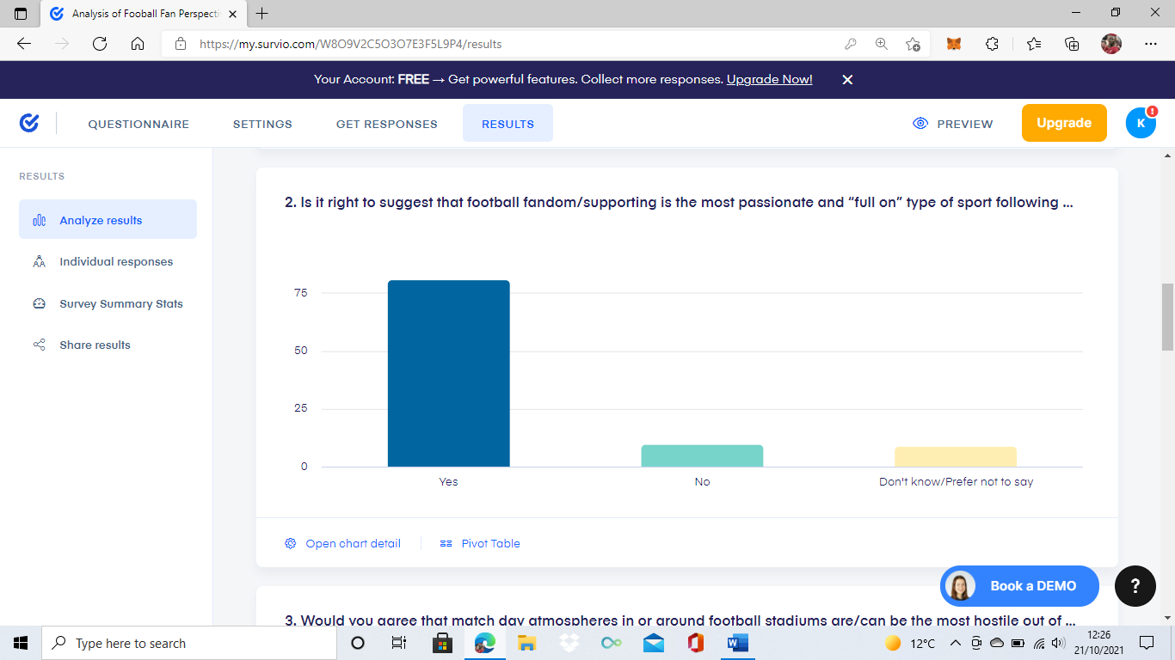
(Question – Is it right to suggest that football fandom/supporting is the most passionate and full on type of sport following experience). Appendix A.

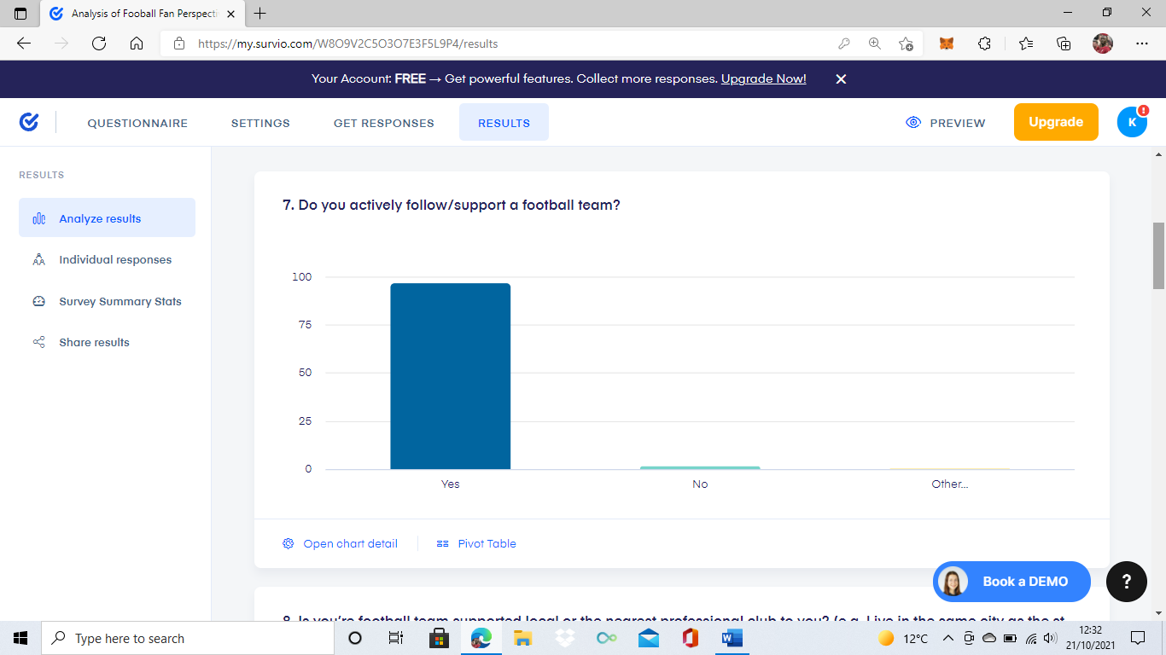
(Question – Do you actively follow/support a football team). Appendix B.

These show that football fandom can be viewed as much more of an everyday involvement and active interest for football supporters, supporting the multiple views throughout the literature review chapter acknowledging this.
As the latter of the two charts above (Appendix B) shows, out of a hundred responses, a staggering 97% of those said that they ‘actively follow/support’ a football team and thus overturn this concept of just a sporting pastime whereas, a mere 3% of all responses provide a backing to this idea. This finding, provides visible support for the in-place literature by Porat (2010) relating to the fandom connected to the sport of football being a particularly bounded identification, as even a decade or so on, the data collected aligns with this and provides evidence that there is very little change in importance to be noted from present day football supporting.

The Present-Day Predicament
Perhaps what was one of the most eye-opening discoveries from the data collected, was the finding that 98% of respondents expressed an understanding of the topic of football hooliganism and around 70% of them also believing it is still currently a significant problem in football today. But despite these results, a majority of 67 out of 100 respondents for the online questionnaires showed a belief, that over the last 5-8 years there has been monumental changes to the way football is supported, followed, and interacted with.

These findings, coupled with both the qualitative interview data collected and the previously touched upon literature by Fillis & Mackay (2014), demonstrate a consensus on the matter that current day football fandom has moved beyond fan typologies but, the impacts of this are still very much imbalanced depending on factors such as the level of social integration and influence of fanhood within a certain area or community. Therefore, there is a notion of a predicament currently facing football fandom within the UK and how it is perceived, policed, presented, and participated with, due to just how varied football supporting currently is with it ranging from one off attending fans treating it as a sort of entertainment/retail experience and playing the role of a consumer, to old school football diehards that never miss a game and plan their livelihoods around supporting their favourite club.

So, the predicament can be seen as this, how is it possible to handle all these variations effectively whilst also maintaining the status quo of the country’s most popular sport. Well as the response of one of the two interviewees alluded too with the answer:
“It does not make a difference if the football match goes ahead or not, the setting of football is an extension of the surroundings it has and so it has to be seen as a deeper societal problem”
(Quote from online interview one, participant is a current employee of a professional English Football League club).

There is clearly no current way of effectively and efficiently dealing with this matter and so, unless it is seen as and made a priority issue then like Hinck (2018) enlightens, it may just be the case of letting the issues continue and possibly even increase in the short term with the hope that this shift in football fandom washes out the sort of traditional football ultra-support in the future.

Football Fandom Versus News & Media
During the literature review chapter, the influence and impact of news and media involvement with football fandom was featured several times. For example, Poulton (2007) was adamant in his belief that for the most part, populist media and news reporting has a lot of influence on what is believed to be the truth regarding football fan behaviour but, it is often a more fantasy driven presenting of it and so it wrongly informs the many making it difficult for the truth to be highlighted by the few. Aligning this with the research, there was a definitive agreement with this belief as 69 out of 100 participants for the online questionnaires and both interviewees, believed the news/media often presents misleading or over exaggerated content regarding football fan behaviour.

However, it is only when the data just mentioned is analysed with the results from a couple of the other questionnaire questions can there be a contrasting case made for opposing this belief. The reasoning for this is because, the two questions (pictured below), provide a clear sense that hooliganism and other criminality at a football match is a regular occurrence and not just isolated to each of the individuals’ supported and attended football stadium/ground.
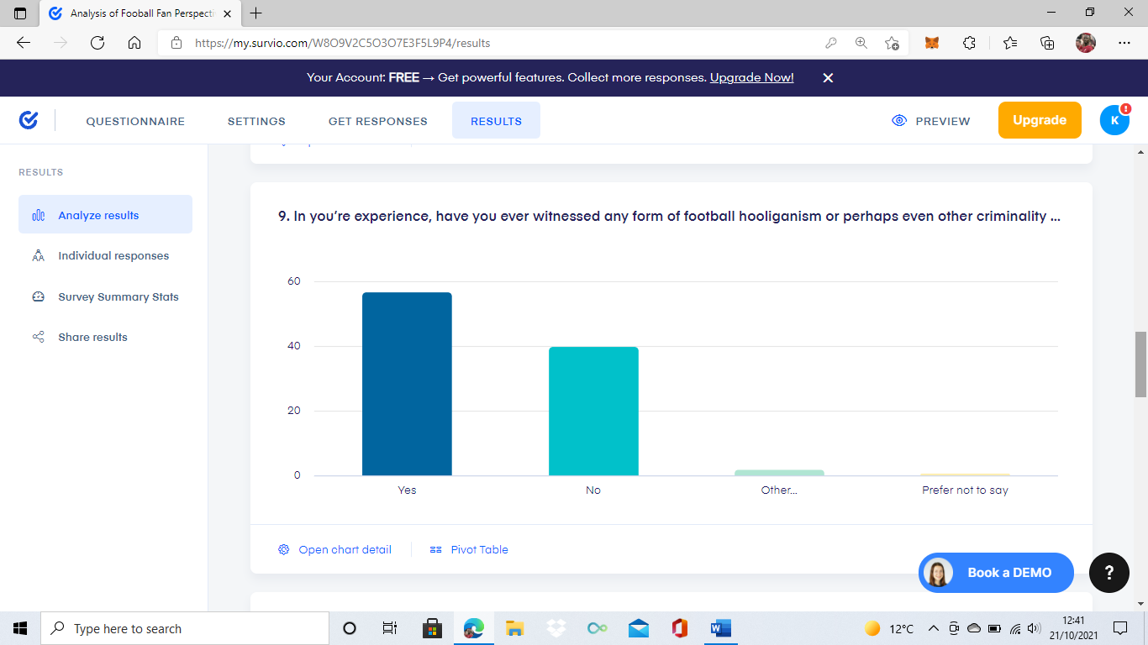
(Question – In you’re experience, have you ever witnessed any form of football hooliganism or other criminality whilst at a football match). Appendix C.

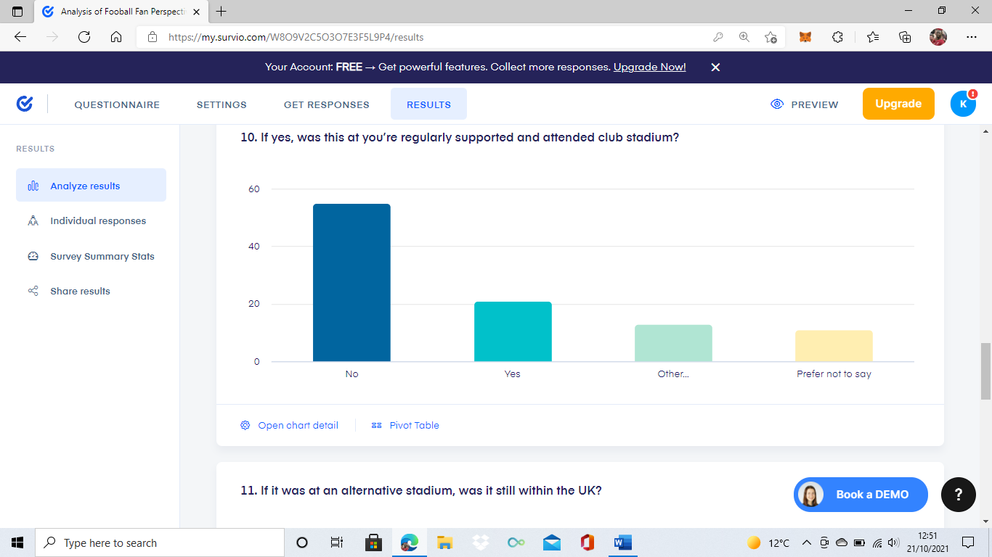
(Question – If yes, was this at you’re regularly supported and attended club stadium). Appendix D.

What this provides is possibly a correction to the sometimes often used excuse for deviant football fan behaviour being driven from exaggerated news/media coverage. Because, although not providing enough data to prove this, the high percentage of participants stating they have witnessed either hooliganism or other criminality whilst at a football match, from a relatively small sample size of 100 participants, is fairly concerning and somewhat proves it is not being fully mispresented by the media.
The Perfect Camouflage
Leading on from the identifying that many participants had witnessed some form of criminality or deviant behaviour at a football match, the research results also demonstrated a link between actively following/going to support a football team and this football team for the many, not being the local or nearest professional club. The statistics show that 97% of all participants actively follow or go to support their specific club but, a minority of 33% of this is relating to the nearest professional team in their personal area, which allows for the questioning of whether this should be viewed as problematic.

Well in accordance with this, the work of Brown (2013) provides a sort of explanation to these results with the viewpoint that, it does not really matter where a fan is based in a geographical sense but rather, where a fan is based in a fixation sense. For example, there could be a fan on the other side of the world to their beloved football team but, if this fan essentially lives and breathes supporting his team intensely then surely, they must be considered a fanatic and looked at in the same way as a season ticket holding traditional type of fan would.

On the other hand, it is literature such as that of Williams (2017) which perhaps provide the clear reasoning for this subsection title because, if fans are now being encouraged too and as the results showed already are travelling cities, regions or even countries to attend a football match then the game is now without frontiers. Meaning, what was once a more localised and possibly less diverse stadium environment providing ease in terms of policing or managing, is now so complex that a proactive or even an immediate reactive attempt at trying to nullify acts of criminality at a stadium on a matchday is an almost impossible task.

Additionally, one of the interviewees (who has current experience working for a professional football club) echoed Williams (2017), with the opinion that fans now hold the upper hand and the policing/security services are just playing catch up. What this research evidences then, is that in line with the perspective of Giulianotti & Robertson (2007), there may well be a critical need for trying to recover the social aspect surrounding football matchday environments due to just how unpredictable and varied they have become. For instance, pre-match there may be a traditional diehard club pub with an event on, a family-oriented attraction at the club shop, a gathering of supporters already queuing for entry into the stadium and unruly fans trying to intimidate and interact with the opposition fans as they arrive. So, the dangers and criminal threats could be coming from anywhere realistically but, there is only a finite amount of personnel and resources available to effectively deter or counter these possibilities.

Fan or Foe
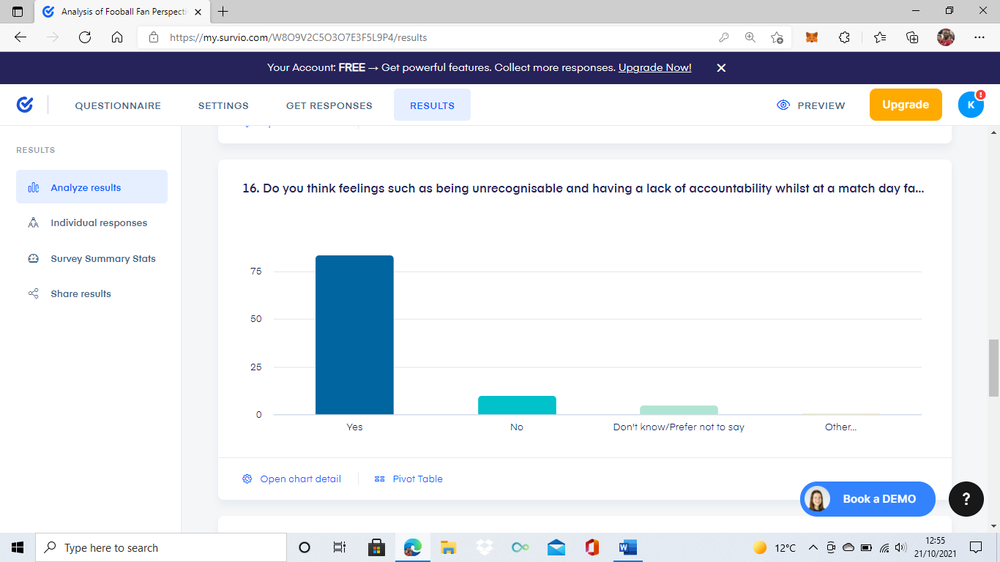
One of the benefits that did come out of strictly remote researching, is the notion that participants were able to be much more transparent and individual in their answering of questions. None more so perhaps, than with the responses provided for question sixteen of the online questionnaire (see below) which was relating to the concept that, a lot of the reasoning for deviant/criminal fan behaviour comes from the conscious and even subconscious feelings that can be tied to or triggered from the football matchday environment.
(Question – Do you think feelings such as being unrecogniseable and having a lack of accountability whilst at a match day setting factor into fans behaviour, E.g. Knowing there is less of a personal/professional sense and acknowledgement). Appendix E.

It may seem for someone oblivious to the footballing and football fandom world a rather bewildering chart of results. But nevertheless, this specific question was asked to gain an understading of the perspective an actual regular match attending fan may have regarding this concept as well as, if they acknowledge it to hold truth or not. On the whole, the results above show the fans who participated strongly agreed, with 84 out of 100 participants stating that feelings such as anonymous, unaccountable, detached and undeterred, without a doubt play a factor into the way some fans act, speak or think whilst at a football match.

Interestingly, this does slightly differ from the findings of both interviews and that of the embdedded literature by Poulton (2013), all of which is of the belief that for the most part, a lot of fan behaviour and emotion is reproduced due to this lack of acknowledgement that attending a football match is still an extension of society and should be treated no different than other social pastimes with their own unique set of principles such as going to the cinema or to a nightclub. What the chart above proves then, is that there is much more of an acknowledgment from matchday goers than is sometimes believed but unfortunately, this does not directly transfer to then preventing, countering or deterring hooliganism or other criminality from happening.

Policing, Policing & More… Policing?
Probably least surprising of all the data collected, was the majority verdict by both the quantitative and qualitative research that not enough is being done in and around football matches to prevent or deter instances of crime and hooliganism. As the questionnaire findings showed, an overwhelming 68 out of 100 participants believe that more needs doing as well as, both interviewees highlighting needs and areas for improvement when it comes to matchday policing and prevention. These results then, can be seen to further solidify the work of Rookwood (2016) which offers the suggestion that there can never be a complete nullyifing of criminality or deviancy at a football match and so, there must be a mindset shift to managaing football hooliganism rather than combating it.

Contrastingly, although providing a foundation for the concept by Rookwood (2016), further analysis of the data showcases that this is not actually the same perspective for a good proportion of the research particpants but rather, persepctvies that are more aligned to increased and innovated policing methods. For instance, one of the most frequently mentioned suggestions by participants was the use of facial recognition and individual identification at stadiums, in order to try and eliminate this sort of unrecogniseable and unaccountable atmosphere as much as possible. Addtionally, there was also a lot of alignment with the points made in the literature by Stott (2020), which is regarding the ever increasing difficulties for police forces in trying to ensure the effective policing of large crowd events, especially football matches due to their usually hostile and unpredictable nature.

As the results indicate, this is mainly seen to be because for many of the responses, the experiences they detail are ones that provide an insight into just how overrun and overpowered UK police officers are by the ratio of fans they are tasked with dealing with and also, how in some circumstances this has almost led to a fans policing themselves sort of environment. This is also supported statistically too, as over 68% of all responses demonstrated a belief that the policing of football matches is very much in a critical dilemma at this current moment, with urgent change and innovation needed to stop further escalation to a crisis sort of level. In conjunction with this, the findings from one of the interviews alluded to the issue of European football influence on UK football supporting, with an ever increasing display of criminality at matches being made evident but, a much more lacklustre policing and prevention approach.

Future of Football Fandom
There is perhaps no other way to conclude an analysis on a subject matter such as this, than to identify and present the key findings relating to the perceived future of football fandom, fan behaviour and how the acts of hooliganism/criminality are policed or prevented. In accordance with this, all participants were offered a qualitative response in order to gain the most individual and original perspectives on football fan behaviour and the period of the next five years. As was to be expected, there was a very mixed response to this, with around 20% of participants believing firmly that the worst of criminality and hooliganism at British football stadiums has been witnessed and thus, there is no way of it becoming worse in the near future.

However, this mere 20% offers the enlightenment that although not all being a singular and conclusive 80% opposing of the opinions of the 20%, there is a clear acknowledgement and support to the idea that, things could still escalate to a greater level if there is no seismic change. Undoubtedly the most referred to issue, was in relation to how reluctant some of the big footballing bodies and cooperations seem to be, in making monumental changes and choices one way or another to alter the current football matchday dynamic. For example, many responses highlighted how in some stadium settings or scenarios there can now be a very Americanised sort of feeling to football fandom, with much more emphasis on consumption and commercialisation rather than true football team following and supporting.

On the other hand, an array of participants detailed perspectives about just how unchanged some football environments are, with countless examples of unchallenged or unaccounted for acts of criminality before, during or after a football match being shared. Despite being a rather impossible matter to find an outcome for or conclude then, what this does provide is a visible research backing to the concept alluded to in the earlier literature review chapter. The concept being alluded to is that of Williams (2013) and it suggests that football fandom is ultimately the most difficult social identity, engagement and experience to effectively understand and deal with from a policing point of view because, there is no set way to properly deal with the various types of fandom that may be present at any giving matchday such as consumers, regular fan types, hooligans and activists. And so, at this point in time with no real input or innovation from those in the governing and decision making postions for professional football, trying to project or predict any sort of notable alteration to the current issues at hand almost seems a foolish endeavour.

Chapter 5: Conclusions & Recommendations

Conclusions
Hopefully it has been made clear, that the entirety of this document of work has been fully concerned with trying to obtain and provide a critical understanding of why football fandom is expressed and presented in some of the notorious ways it is and, how this allows for notable relations to criminality to just be regular and somewhat normalised. Furthermore, what this project has also focussed on is trying to provide authentic and insightful analysis on the related issues to the overall subject such as, the policing of football matches within the UK and the accuracy of how actual matchday stadium goers are presented / understood. In essence, there is a clear theme and purpose kept throughout the various chapters of this work, which is one that relates to providing realism and transparency in regards to the outlined subject matter which, has been consistently identified as something that is occasionally lacking in the mainstream coverage and literature on it.

First and foremost, what has been made clear is that there is without question either a lack of fundamental understanding to begin with for the matter of football fan behaviour and the ever-growing related issues or, there has been accidental or intentional breakdown in dealing with a visibly complex matter such as this. This is because, as both the qualitative and quantitative findings highlighted whilst also supporting the points made by both Atkinson (2012) & Spaaij (2007), there has never been enough of a subjective focus applied to understanding football fan behaviour and so, there is often a heavily objective nature applied to the knowledge and perspectives relating to issues such as hooliganism with no real purpose or committed interest / intention behind it.

However, this is not to say that all that has been concluded regarding this particular finding is, that all mainstream media or news presenting and reporting of football fan behaviour and the related criminality is flawed for being too objective, as this is certainly not the case. As was detailed in the prior analysis of results chapter, there is sometimes a vital need for objective researching and reasoning regarding individual behaviour at a football stadium because, it provides clear and concise identifying of rights and wrongs such as with instances of racism and discrimination. For example, the modern day setting for professional football matches allows for a somewhat escape like feeling from the lifestyle and laws of the rest of everyday life (Cleland & Cashmore, 2013) and so, without any objective input this would only become more intensified and lead to scenarios where things like acts of racism or discrimination by fans were unacknowledged, challenged, or policed.

In contrast, it could be argued whether this is not already the case, as one of the most seismic findings is in regards to just how embedded the link between fan behaviour and acts of criminality has become. As various sources such as Djordjevic & Pekic (2018) and Ferdinand et al (2007) all enlightened, this notion of there being a need for nervousness regarding suitable conformity by fans is for the most part too little too late. This is seen to be due to two major indicators, the first being just how widespread issues of deviant fan behaviour has become, with there being no pattern or trend to be found in terms of both geographic and demographic factors. Secondly, there is such an array of possibilities now in relation to how football fans can engage with criminality that when it comes to policing, there is no way of combating all these threats effectively and so dealing with the majority on a reactive basis is likely the only possible outcome.

Worryingly, as both Groombridge (2015) and the results of the online questionnaires identified, this in all likelihood is one of the main reasonings that criminality amongst fans is seemingly accumulating and escalating because as many questionnaire participants explained, for those that frequently attend the same stadium there is a visible sort of testing of the limits. Meaning, for those fans that are engaged or drawn to behaving defiantly towards the norms, laws, or guidelines, if there is not a sense of deterrence and risk to be felt to their behaviour from those in policing positions then a continuous cycle emerges albeit with usually more severe acts of deviancy.

This then, displays a rather obvious insight into just how much of a need there is within the UK for an increased and innovated response to policing and generally overseeing professional football matchdays, from those within the decision making and power holding positions. Nevertheless, it has already been depicted in both the literature review and analysis of results chapters, that this is not seen by those in such decision-making roles to hold any sort of urgency. But instead, as Williams (2017) points out for those with such viewpoints on the matter, it may just be viewed as an inevitable risk that comes with overseeing such dramatic alterations to football in the UK like commercialisation and digitalisation. However, it has been made evident that such risks should not be taken as lightly as they seemingly are within the UK at this present time, with the severe issues relating to football fan hooliganism merging with nationalism or even extremism in some Eastern European countries being a stark reminder (Mammone et al, 2013).

As Trost & Kovacevic (2013) alluded too, there can be no greater example that demonstrates just how important effective policing of football fandom is than that of Serbia, with the so-called simple sport being seen as a primary reason as to why there are currently large-scale nationalism and political extremism issues. Perhaps seen as the prime example, is the events of the gay parade riots on several occasions in Serbia, where regular acts of football fan hooliganism could be seen to merge with far-right extremist beliefs and actions leading to a disturbingly large anti LGBTQ movement (ibid). Therefore, what this is implying is that although this is without a doubt one of the worst possible outcomes, it still needs to be viewed as a necessity within the UK to prevent and combat football hooliganism more effectively because with how popular British football is, an emergence of something just the quarter of the size of the events just mentioned in Serbia could have unthinkable consequences (Nielsen, 2013).

On the other hand, the current literature in place on the subject matter alongside the research findings of this project, have allowed for a clear evaluation that notable changes have occurred in relation to football fandom over the last decade. As ‘The Present-Day Predicament’ section from the analysis of results chapter enlightened, there was an overwhelming majority in favour of the belief that over the last 5-8years there has been a monumental shift to the way football is both supported and interacted with. Additionally, because of these changes there has also been a sort of imbalance created within football fandom, with the new age consumer like supporting on one side and the traditional diehard type football fan on the other.

What this can be seen to have caused then is similar to the theorising presented by Brown (2013) which is that, a rift has been formed in terms of how each individual or even small group of fans engage and behave in the football matchday setting and so, the only way to fully counter the threats of criminality within football fandom in an effective manner now, is to essentially lean completely into the more passive and consumer like supporting that has emerged as a result of commercialisation and phase out the traditional fandom.

In conjunction with this last statement by Brown (2013), it must be mentioned that this is not something that has been critically investigated or even concluded through the outlined research although, is something that could be seen to hold relevancy if the policing, overseeing and general organising of football matchdays continues the current trajectory. Interestingly, this aligns well with the perspective that was outlined by Lawrence & Crawford (2021) who anticipate that, there is a growing digitalisation trend amongst the footballing world including football fandom, that is going to have a practically irreversible impact on the overall British football culture. As a result, matters such as unwelcome fan behaviour that may be of a criminal nature despite still occurring will also be impacted by this digitalisation and may take a different format, as has been found through the research to already be the case in some instances.

Therefore, linking this to the findings from the analysis of results section ‘Policing, Policing & More… Policing?’ it can be asserted that, this digital trend may allow those in the policing positions a chance at regaining considerable effectiveness when it comes to tackling the most current pressing issues such as racism, discrimination and harassment presented by some football fans. Because, combating, reducing, and eliminating the threats digitally should in theory require far less personnel to achieve as well as, improving the previously noted problematic workload of those policing in and around the stadiums on matchday.

Unfortunately, this is the exact problem enlightened by Herbert (2021) and also concluded by the ‘Future of Football Fandom’ analysis of results section which is this, in an environment and social setting which offers such anonymity and unaccountability such as the one in question, it is almost foolish to offer any sort of presumption that digitalisation within this context would provide any sort of improvements in terms of policing and prevention. In actuality, it has been found that the most likely outcomes for this current trending are ones that only provide more difficulty for dealing with fan behaviour and the links to criminality, as the finding of 80% of research participants believing without monumental change the issues will only escalate further displays.

Ultimately, it can be seen to come back to the verdict that has already been touched upon several times throughout this piece of work which is, football fandom is the most complex cultural pastime that incorporates and innovates social identity, engagement, and experience like nothing of a similar description such as other sports could even get close too (Williams, 2013). As a result, there can be no denying that it is a thankless and almost impossible task to try and adequately deal with but, it must be made clear that trying to provide effective prevention and intervention from a stance or approach unchanged, outdated and severely flawed, can only be expected to bring about similar if not more troublesome outcomes.

Limitations
In closing, it must be stated that despite being a rather extensive but also enclosing piece of work, this research has not been concluded without some shortcomings and limitations. Although most research projects are unable to claim complete perfection, highlighting any evident limitations should still be of high importance, specifically those that may have had a considerable impact and influence on overall outcomes, findings and ultimately, conclusions (Bloomberg & Volpe, 2018). Essentially, this is perhaps the exact case for the first limitation to be clarified, which is that of the COVID-19 pandemic and in particular, the restrictions and difficulties this caused for primary data researching. In terms of the research related to this writing, there is no denying that being limited and restricted to only digital / remote based researching played a factor in the research outcomes and findings. The reasoning for this, is due to how isolated and somewhat disconnected from the actual environment in question the completed research was and so, there is no adequate way of finding out whether each participant engaged with the research in the same manner they would have if it was within a football matchday setting.

Likewise, the same can also be said for the credibility of the perspectives provided by various participants because, without any in person and case study type research being carried out this cannot be speculated. For example, if any case study research had taken place in and around a variety of professional football club stadiums during matchdays, the observations and findings from these instances could have been analysed in tangent with the questionnaire findings of over 50% of participants, displaying a clear belief that deviancy and criminality amongst football fans is a regularity. Therefore, the outcomes of this study such as the one just mentioned cannot be linked to a certain fanbase for example or, even generalised to a certain geographical area(s). However, despite not being able to provide generalisation because of the findings and other information obtained through research participation, the study still provides an important overlook of the perspectives and experiences of the intended audience and does so, with great variation in terms of geographic, demographic and team affiliation or association factors.

Another limitation that must be mentioned, is in regards to the mixed methods approach to researching and the certain sense of imbalanced findings that this has resulted in. Although this was seemingly of great likelihood from commencement, due to the previously explained COVID-19 implications and digitally remote format, it still must be seen as a contributing factor to the overall project outcome.

This is noteworthy because, the nature of quantitative researching means it allows for much more ease in relation to being remotely undertaken whereas, qualitative methods are more heavily reliant on in person contributions such as positive introducing and informing, rapport building and, clear and concise formalities which, were obviously altered or completely nullified because of the researching constraints. Subsequently, even though the qualitative research was completed successfully it can be seen to be severely overshadowed by the quantitative aspect of the overall research, with exactly a hundred participants contributing to this and only two individuals having participated for the qualitative research. Because of this, it may be suggested that if there was less of a significant gap for the two research methods in terms of participation, then the very knowledgeable and informative findings from both, could have possibly been developed further and resulted in more absolute conclusions.

Recommendations
The first recommendation that can be made for the policing and prevention services relating to British professional football matchday environments, is to increase and focus the attention on limiting the feeling and factor of anonymity within this setting. As primary research conducted within this piece of work highlighted, the suggestions of this having some input are grossly underestimated, with this issue of anonymity perhaps being seen as the prime influencing factor for the allowance of such deviancy and criminality within football fan behaviour. By developing an understanding and counteractive approach for this from a policing stance, this may not only reduce the severity and regularity of deviancy at football matches but, may also increase the likelihood of identifying and prosecuting criminal behaviour within this environment.

Because, by combatting (through requiring valid identification proof or even facial recognition surveillance) the inability to have any knowledge or information on each fan entering football grounds, it would act as a sort of equalising factor to a certain extent in terms of the outnumbering of fans to policing and prevention personnel in these scenarios hopefully leading to more effective policing outcomes.

The specific policing services and decision-making authorities involved in football such as the English Football Association, should also ensure that the laws, policies, and prevention methods that are in place, are modified and modernised in a way that assures they are aligned with the current trends and threats presented by football fandom and most importantly stay up-to-date or if possible, ahead of the curve when it comes to these issues. An example of this could be seen with offender identifying or publicising whilst at a football matchday, as findings from both research methods identified the issue of the production and reproduction cycle of deviant fan behaviour whilst within football stadiums.

As supported by Poulton (2013), there is a constant cycle involved in the occurrence of deviancy within a football stadium, which is essentially caused by the fans ability to consistently push the limits of what they can get away with without being at risk of being identified, shamed, and shunned by the wider conforming crowd that is in attendance. Therefore, improving crowd knowledge on such instances as well as increasing general information and warnings published to the wider football fan community, could benefit such services and authorities in the long term by creating a sense of transparency and connectivity between them and general football fans.

Lastly, it is also recommended that a specific area of the findings produced by this study is subject to further research in some capacity, to gain a deeper and more critical understanding of the true impact this has on the outlined subject matter. The specific area in question is that of the comparability and relatability football fandom has received in relation to religion, as several instances throughout this study have highlighted how this is possibly the only thing that football ultra-fandom and the behaviour that comes with it can be compared too.

The reasoning for this advised further research is because, the concept by Fulconis & Pache (2014) which sets out the four distinct and required dimensions of community, law’s, the behavioural way, and the experience, that uphold religion and those who actively follow or have some sort of commitment to it, have been somewhat proven in the context of football fandom through the primary research undertaken. As displayed in the prior analysis of results chapter and the conclusion section just above, an array of participants from all different football fandom backgrounds and geographical locations has outlined a particular consistency, which is the voluntary devotion and affiliation to the same four mentioned dimensions of religion but instead in a footballing sense.

The proposition that is being suggested then is this, with further research and a clear focus on this outlined area of significance, it could perhaps be possible to investigate and conclude whether instances of notable criminality at a football ground such as hate crimes are in fact influenced and caused in similar ways to that of religiously motivated acts of violence. As Fillis & Mackay (2014) explained, the fact football fandom relates to a sport is a primary reason for the lack of acknowledgement and critical research to date this sort of specificity has received but, in order to make effective strides in tackling the issue of deviancy within football fan behaviour this urgently needs to change or, the problems are only going to continually rise and reach a level where the related criminality is far from just subtle acts of traditional football hooliganism.

Chapter 6: Bibliography & Appendices

Bibliography

Ahmed, M. (2019) FIFA-The Beautiful Game-The Ugly Organization. Published – Autumn, 2019. Published by Oxford University Press, Oxfordshire UK. (Accessed on – 23/07/2021).
Aly, A., Macdonald, S., Jarvis, L. & Chen, T. (2016) Violent Extremism Online: New Perspectives on Terrorism and the Internet. Published – May, 2016. Published by Routledge Publications, Milton Park, Abingdon, Oxfordshire UK. (Accessed on – 01/08/2021).
Ashby, H. (2021) ‘Far-Right Extremism is a Global Problem’ [Online] (Posted – 15/01/2021) Available at - https://foreignpolicy.com/2021/01/15/far-right-extremism-global-problem-worldwide-solutions/ (Accessed on – 01/08/2021).
Assoudeh, E. & Weinberg, L. (2021) ‘In Western Europe, Right-Wing Extremism is on the Rise’ [Online] (Posted – 07/01/2021) Available at - https://www.opendemocracy.net/en/countering-radical-right/western-europe-right-wing-terrorism-rise/ (Accessed on – 01/08/2021).
Atkinson, C. (2021) Football Fans are not thugs: Communication and the future of fan engagement in the policing of Scottish Football. Published – April, 2021. Published by Taylor & Francis Publications, Howick Place, London UK. (Accessed on – 12/08/2021).
Awan, I. (2017) Cyber Extremism: ISIS and the Power of social media. Published – March, 2017. Published by Springer Publishing Inc, Salmon Tower, Manhattan, New York USA. (Accessed on – 05/08/2021).
Axinn, W. & Pearce, L. (2006) Mixed Methods Data Collection Strategies. Published – September, 2006. Published by Cambridge University Press, Cambridgeshire UK. (Accessed on – 05/09/2021).
Aziz, S. (2014) Policing Terrorists in the Community. Published – Spring, 2014. Published by Harvard University Press, USA. (Accessed on – 30/07/2021).
Baker, L. (2011) Data Collection: Getting Started with Statistics. Published – Summer, 2011. Published by Chi-Squared Innovations Inc, Duke University Press, USA. (Accessed on – 05/09/2021).
Bazley, P. (2009) Analysing Mixed Methods Data. Published – September, 2009. Published by John Wiley & Sons Publishing Ltd, Oxford UK. (Accessed on – 10/09/2021).
Bebber, B. (2020) Unwanted Consumers: Violence and Consumption in British Football in the 1970s. Published – Summer, 2020. Published by Taylor & Francis Publications, Howick Place, London UK. (Accessed on – 23/07/2021).
Bennett. H. & Jonsson, A. (2017) Klick it out: Tackling Online Discrimination in Football. Published – Spring, 2017. Published by Taylor & Francis Publications, Howick Place, London UK. (Accessed on – 12/08/2021).
Best, S. (2014) Understanding and Doing Successful Research: Data Collection and Analysis for the Social Sciences. Published – May, 2014. Published by Routledge Publications, Milton Park, Abingdon, Oxfordshire UK. (Accessed on – 05/09/2021).
Biesta, G. (2010) Pragmatism and the Philosophical Foundations of Mixed Methods Research. Published – Autumn, 2010. Published by SAGE Publications, Thousand Oaks, California USA. (Accessed on – 28/06/2021).
Bliesener, T. (2009) Hooliganism and Right-wing Extremism: Findings from European research. Published – Spring, 2009. Published by NOMOS Publications, Zurich Switzerland. (Accessed on – 15/07/2021).
Bloomberg, L. & Volpe, M. (2018) Completing your Qualitative Dissertation: Road Map from Beginning to End. Published – October, 2018. Published by SAGE Publications, Thousand Oaks, California USA. (Accessed on – 20/10/2021).
Bodin, D. & Sempe, G. (2011) Ethics and Sport in Europe. Published – January, 2011. Published by Council of Europe Press and Publications, Zurich Switzerland. (Accessed on – 05/08/2021).
Brown, S. (2013) Football Fans Around the World: From Supporters to Fanatics. Published – September, 2013. Published by Routledge Publications, Abingdon, Oxfordshire UK. (Accessed on – 11/10/2021).
Bryman, A. (2008) Of Methods and Methodology. Published – August, 2008. Published by Emerald Insight Publishing, Bingley UK. (Accessed on – 28/06/2021).
Busset, T., Gander, T. & Pfiser, P. (2009) The Football Stadium – A Place where Right-Wing Extremists Recruit? Case Studies of Three Swiss Clubs. Published – Spring, 2009. Published by NOMOS Publications, Baden-Baden, Germany. (Accessed on – 27/07/2021).
Chowdhury, M.F. (2014) Interpretivism in Aiding our Understanding of the Contemporary Social World. Published – Autumn, 2014. Published by Scientific Research Publishing Inc, North South University Press, Dhaka, Bangladesh. (Accessed on – 03/09/2021).
Cleland, J. (2014) Racism, Football Fans and Online Message Boards: How social media has added a new dimension to racist discourse in English football. Published – January, 2014. Published by SAGE Journals, SAGE Publications, Thousand Oaks, California USA. (Accessed on – 12/08/2021).
Cleland, J. & Cashmore, E. (2013) Fans, Racism and British Football in the Twenty-First Century: The Existence of a Colour-Blind Ideology. Published – March, 2013. Published by Taylor & Francis Publications, Howick Place, London UK. (Accessed on – 09/08/2021).
Collis, J. & Hussey, R. (2009) Business Research: Practical Guide for Undergraduate and Postgraduate Students (3rd Edition). Published – February, 2009. Published by Palgrave Macmillan Publishing Ltd, Camden, London UK. (Accessed on – 29/06/2021).
Creswell, JW. (2011) Controversies in Mixed Methods Research. Published – Spring, 2011. Published by SAGE Publications, Thousand Oaks, California USA. (Accessed on – 28/06/2021).
Denscombe, M. (2008) Communities of Practice: A research paradigm for the mixed methods approach. Published – July, 2008. Published by SAGE Publications, Thousand Oaks, California USA. (Accessed on – 28/06/2021).
Dixon, K. (2013) Learning the game: Football fandom culture and the origins of practice. Published – July, 2013. Published by SAGE Publications, Thousand Oaks, California USA. (Accessed on – 15/11/2021).
Djordjevic, I. & Pekic, R. (2018) Is there space for the left? Football Fans and Political Positioning in Serbia. Published – June, 2018. Published by Taylor & Francis Publications, Howick Place, London UK. (Accessed on – 27/07/2021).
Domeneghetti, R. (2020) Football Hooliganism. Published – Summer, 2020. Published by Routledge Publications, Milton Park, Abingdon, Oxford UK. (Accessed on – 17/08/2021).
Dunning, E. (2000) Towards a sociological understanding of football hooliganism as a world phenomenon. Published – June, 2000. Published by European Journal on Criminal Policy and Research, Springer Publishing Inc, Salmon Tower building, New York City, USA. (Accessed on – 07/06/2021).
Dwyer, B., Greenhalgh, G. & LeCrom, C. (2015) Exploring Fan Behaviour: Developing a scale to measure sport fangelism. (Vol 29, Issue 6). Published – January, 2015. Published by Journal of Sport Management, North American Society for Sport Management, Washington DC, USA. (Accessed on – 07/06/2021).
Einola, K. & Alvesson, M. (2021) Behind the Numbers: Questioning Questionnaires. Published – February, 2021. Published by SAGE Publications, Thousand Oaks, California, USA. (Accessed on – 09/09/2021).
Ferdinand, J., Pearson, G. & Rowe, M. (2007) A Different Kind of Ethics. Published – December, 2007. Published by SAGE Publications, Thousand Oaks, California USA. (Accessed on – 15/07/2021).
Fillis, I. & Mackay, C. (2014) Moving Beyond Fan Typologies: The Impact of Social Integration on Team Loyalty in Football. Published – July, 2014. Published by Taylor & Francis Publications, Howick Place, London UK. (Accessed on – 16/07/2021).
Finn, G. & Giulianotti, R. (2013) Football Culture: Local Conflicts, Global Visions. Published – Autumn, 2013. Published by Taylor & Francis Publications, Howick Place, London UK. (Accessed on – 15/11/2021).
Frosdick, S. & Marsh, P. (2013) Football Hooliganism. Published – January 2013. Published by Routledge Publications, Milton Park, Abingdon, Oxford UK. (Accessed on – 14/06/2021).
Frosdick, S. & Newton, R. (2006) The Nature and Extent of Football Hooliganism in England and Wales. Published – November, 2006. Published by Taylor & Francis Publications, Howick Place, London UK. (Accessed on – 09/07/2021).
Fulconis, F. & Pache, G. (2014) Football Passion as a Religion: The Four Dimensions of a Sacred Experience. Published – July, 2014. Published by Emerald Insight Publishing Group, Bingley, UK. (Accessed on – 16/08/2021).
Gelfand, M., LaFree, G. & Fahey, S. (2013) Culture and Extremism. Published – September 2013. Published by Journal of Social Issues, US Army Research Institute, Washington D.C. USA. (Accessed on – 30/07/2021).
Giulianotti, R. & Robertson, R. (2007) Recovering the Social: Globalization, Football and Transnationalism. Published – May, 2007. Published by Wiley Publications, Hoboken, New Jersey USA. (Accessed on – 27/07/2021).
Groombridge, N. (2015) Football Hooliganism, Fan Behaviour and Crime: Contemporary Issues. Published – January, 2015. Published by Wiley Publications Inc, Hoboken, New Jersey USA. (Accessed on – 14/06/2021).
Herbert, I. (2021) ‘Online anonymity is breeding a new generation of racist football fans’ [Online] (Posted – 03/02/2021) (Web Last Updated – August, 2021) Available at - https://www.mailplus.co.uk/edition/sport/51329/online-anonymity-is-breeding-a-new-generation-of-racist-football-fans (Accessed on - 09/08/2021).
Hinck, A. (2018) Shifting Patterns of Football Fandom and Digital Media Cultures: YouTube, Fifa Videogames and AFC Wimbledon. Published – Autumn, 2018. Published by Routledge Publications, Milton Park, Abingdon, Oxford UK. (Accessed on – 16/08/2021).
Holliday, A. (2012) Doing and Writing Qualitative Research. (2nd Edition). SAGE Publications Inc, Thousand Oaks, California USA. (Accessed on – 28/06/2021).
Humble, S. (2020) Quantitative Analysis of Questionnaires: Techniques to Explore Structures and Relationships. Published – January, 2020. Published by Routledge Publications, Milton Park, Abingdon, Oxfordshire UK. (Accessed on – 09/09/2021).
Kara, H. & Khoo, S. (2020) Researching in the Age of COVID-19. Published – October, 2020. Published by Policy Press, Bristol University, Bristol UK. (Accessed on – 06/09/2021).
Keegan, M. (2018) ‘A grim new generation of football hooligans’ [Online] (Posted – 19/10/2018) (Web Last Updated – August, 2021) Available at - https://www.dailymail.co.uk/sport/football/article-6296059/A-grim-new-generation-football-hooligans-big-increase-disorder.html (Accessed on - 16/08/2021).
Kennedy, D. (2013) A Contextual Analysis of Europe’s Ultra Football Supporters Movement. Published – March, 2013. Published by Taylor & Francis Publications, Howick Place, London UK. (Accessed on – 15/07/2021).
Kilvington, D. & Price, J. (2018) From Backstage to frontstage: Exploring Football and the Growing Problem of Online Abuse. Published – October, 2018. Published by Routledge Publications, Milton Park, Abingdon, Oxfordshire UK. (Accessed on – 12/08/2021).
King, N., Horrocks, C. & Brooks, J. (2018) Interviews in Qualitative Research. Published – December, 2018. Published by SAGE Publications, Thousand Oaks, California, USA. (Accessed on – 09/09/2021).
Knapton, H., Espinosa, L., Meier, H. & Back, E. (2018) Belonging for Violence: Personality, Football Fandom, and Spectator Aggression. Published – February, 2018. Published by Taylor & Francis Publications, Howick Place, London UK. (Accessed on – 09/08/2021).
Koehler, D. (2016) Right-Wing Extremism and Terrorism in Europe. Published – June, 2016. Published by Institute for National Strategic Security, National Defence University, Washington D.C., USA. (Accessed on – 27/07/2021).
Lawrence, S. & Crawford, G. (2021) Towards a Digital Football Studies: Current Trends and Future Directions for Football Cultures. Published – June, 2021. Published by Taylor & Francis Publications, Howick Place, London UK. (Accessed on – 17/08/2021).
Lawrence, S. & Crawford, G. (2018) Digital Football Cultures: Fandom, Identities and Resistance. Published – September, 2018. Published by Routledge Publications, Milton Park, Abingdon, Oxford UK. (Accessed on – 16/08/2021).
Levin, K. (2006) Study Design: Cross-Sectional Studies. Published – March, 2006. Published by Springer Nature Publishing, The Campus, London UK. (Accessed on – 05/09/2021).
Liamputtong, P. (2019) Handbook of Research Methods in Health Social Sciences. Published – Spring, 2019. Published by Springer Publishing, Berlin Heidelberg, Germany. (Accessed on – 06/09/2021).
Malatesta, D., Jaccoud, C. & Dubey, JP. (2009) Violent Football Fans and Right-Wing Extremism: An analysis of the Socio-Juridical Aspects. Published – Autumn, 2009. Published by NOMOS Publications, Baden-Baden, Germany. (Accessed on – 27/07/2021).
Mammone, A., Godin, E. & Jenkins, B. (2013) Varieties of right-wing extremism in Europe. Published – May, 2013. Published by Routledge Publications, Abingdon, Oxfordshire UK. (Accessed on – 27/07/2021).
Mangan, JA. (2013) Europe, Sport, World: Shaping Global Societies. Published – September, 2013. Published by Routledge Publications, Abingdon, Oxfordshire UK. (Accessed on – 27/07/2021).
McLeod, S.A. (2019) Henri Tajfel and John Turner: Social Identity Theory. Published – October, 2019. Published by Division of Neuroscience & Experimental Psychology, University of Manchester, Manchester UK. (Accessed on – 10/10/2021).
Mededovic, J. & Kovacevic, U. (2020) Militant Extremist Mindset in Serbian Football Supporters: Relations with the adherence to extremist social movements. Published – December, 2020. Published by Taylor & Francis Publications, Howick Place, London UK. (Accessed on – 15/07/2021).
Mojet, H. (2005) The European Union and Football Hooliganism. Published – Quarter one, 2005. Published by The International Sports Law Journal, Griffith University Press, Queensland Australia. (Accessed on – 15/07/2021).
Morse, J. (2016) Mixed Methods Design: Principles and Procedures. Published – July, 2016. Published by Routledge Publications, Milton Park, Abingdon, Oxfordshire UK. (Accessed on – 05/09/2021).
Nielsen, C. (2013) Stronger than the state? Football hooliganism, political extremism, and the Gay Pride Parades in Serbia. Published – June, 2013. Published by Taylor & Francis Publications, Howick Place, London UK. (Accessed on – 15/07/2021).
Numerato, D. & Giulianotti, R. (2018) Citizen, Consumer, Citimer: The Interplay of market and political identities within contemporary football fan cultures. Published – January, 2018. Published by Journal of Consumer Culture, SAGE Journals, SAGE Publications, Thousand Oaks, California USA. (Accessed on – 23/07/2021).
O’Reilly, K. (2009) Inductive and Deductive. Published – Spring, 2009. Published by SAGE Publications, Thousand Oaks, California USA. (Accessed on – 03/09/2021).
Page, R. (2020) ‘The power of fangelism’ [Online] (Posted – 08/07/2020) (Website Last Updated – June, 2021) Available at - https://harro.com/2020/07/08/the-power-of-fangelism/ (Accessed on – 07/06/2021).
Parrington, D. (2002) Essential Skills for Management Research. Published – July, 2002. Published by SAGE Publications, Thousand Oaks, California USA. (Accessed on – 03/09/2021).
Pearson, G. & Stott, C. (2016) Farewell to the Hooligan?. Published – October, 2016. Published by Taylor & Francis Publications, Howick Place, London UK. (Accessed on – 15/07/2021).
Pole, K. (2007) Mixed Method Designs: Review of Strategies for Blending Quantitative and Qualitative Methodologies. Published – Fall, 2007. Published by Saint Louis University Press, Mid-Western Educational Researcher, Missouri USA. (Accessed on – 28/06/2021).
Porat, A. (2010) Football Fandom: A Bounded Identification. Published – April, 2010. Published by Taylor & Francis Publications, Howick Place, London UK. (Accessed on – 16/08/2021).
Poulton, E. (2007) ‘Fantasy’ Football Hooliganism in Popular Media. Published – January, 2007. Published by SAGE Publications, Thousand Oaks, California USA. (Accessed on – 24/06/2021).
Poulton, E. (2013) The Culture of Production Behind the (Re) Production of Football Hooligan Culture. Published – May, 2013. Published by Taylor & Francis Publications, Howick Place, London UK. (Accessed on – 09/07/2021).
Prigg, M. (2018) ‘The secret of football hooliganism: Violent fans are socially bonding’ [Online] (Posted – 25/06/2018) (Web Last Updated – August, 2021) Available at - https://www.dailymail.co.uk/sciencetech/article-5884647/The-secret-football-hooliganism-Violent-fans-socially-bonding-researchers-say.html (Accessed on - 16/08/2021).
Putra, L. (2019) Urban Regeneration and the Predicament of Being Local Fans in the Commercialized English Football League. Published – January, 2019. Published by SAGE Publications Inc, Thousand Oaks, California USA. (Accessed on – 15/07/2021).
Pyne, D., Mujika, I. & Reilly, T. (2009) Peaking for Optimal Performance: Research Limitations and Future Directions. Published – February, 2009. Published by Taylor & Francis Publications, Howick Place, London UK. (Accessed on – 12/09/2021).

Rahmati, M., Kabiri, S. & Masomeh, S. (2014) Team Identification, Sport Fandom Identity and Willingness to Verbal/Physical Aggressive Actions. Published – Autumn, 2014. Published by International Journal of Basic Sciences & Applied Research, New Delhi, India. (Accessed on – 09/08/2021).
Redhead, S. (2002) Post-fandom and the millennial blues: The transformation of soccer culture. Published – Spring, 2002. Published by Taylor & Francis Publications, Howick Place, London UK. (Accessed on – 15/11/2021).
Richards, A. (2015) From Terrorism to Radicalization to Extremism: Counterterrorism Imperative or loss of focus?. Published – March, 2015. Published by International Affairs Journal, Oxford University Press, England UK. (Accessed on – 30/07/2021).
Richardson, B. (2004) New Consumers and Football Fandom: The Role of Social Habitus in Consumer Behaviour. Published – August, 2004. Published by Irish Journal of Management, Dublin City University Press, Dublin Ireland. (Accessed on – 23/07/2021).
Richardson, B. (2007) Consumption Outside the Market: An Ethnography of Consumer Resistance Among Football Fans. Published – Spring, 2007. Published by Dublin City University Press, Dublin Ireland. (Accessed on – 23/07/2021).
Rivers, D. & Ross, A. (2021) Arsenal Fan TV, Football Fandom, and the Banter in the new Media era. Published – January, 2021. Published by Taylor & Francis Publications, Howick Place, London UK. (Accessed on – 16/08/2021).
Roberts, P. & Priest, H. (2006) Reliability and Validity in Research. Published – July, 2006. Published by Royal College of Nursing Publishing Company, Cardiff UK. (Accessed on – 10/09/2021).
Rookwood, J. (2016) Managing Football Hooliganism. Published – Spring, 2016. Published by Routledge Publications, Milton Park, Abingdon, Oxford UK. (Accessed on – 15/10/2021).
Rookwood, J. & Spaaij, R. (2017) Violence in Football: Overview, Prevalence and Risk Factors. Published – Spring, 2017. Published by Wiley Publishing Inc, Hoboken, New Jersey, USA. (Accessed on – 17/08/2021).
Roulston, K. & Choi, M. (2018) Qualitative Interviews. Published – January, 2018. Published by SAGE Publications, Thousand Oaks, California, USA. (Accessed on – 09/09/2021).
Saunders, M., Lewis, P. & Thornhill, A. (2012) ‘The Research Onion’ Research Methods for Business Students. Pearson Education Ltd, Harlow, England UK. (Accessed on – 28/06/2021).
Shipman, MD. (2014) The Limitations of Social Research. Published – June, 2014. Published by Routledge Publishing, Milton Park, Abingdon, Oxfordshire UK. (Accessed on – 12/09/2021).
Silke, A. (2014) Prisons, Terrorism and Extremism: Critical issues in management, radicalisation, and reform. Published – February, 2014. Published by Routledge Publications, Abingdon, Oxfordshire UK. (Accessed on – 30/07/2021).
Spaaij, R. & Anderson, A. (2010) Soccer Fan Violence: A holistic approach. Published – July, 2010. Published by SAGE Publications, Thousand Oaks, California USA. (Accessed on – 07/06/2021).
Spaaij, R. (2008) Men like us, Boys Like them: Violence, masculinity, and collective identity in football hooliganism. Published – November, 2008. Published by SAGE Publications, Thousand Oaks, California USA. (Accessed on – 24/06/2021).
Spaaij, R. (2007) Football Hooliganism as a transnational phenomenon: Past and Present Analysis. Published – April, 2007. Published by The International Journal of the History of Sport (Vol 24, Issue 4), Taylor & Francis Publications, Howick Place London UK. (Accessed on – 24/06/2021).
Spaaij, R. (2006) Understanding Football Hooliganism: A Comparison of six Western European football clubs. Published – January, 2006. Published by Amsterdam University Press, Netherlands. (Accessed on – 24/06/2021).
Stockemer, D. (2019) Quantitative Methods for the Social Sciences. Published – Spring, 2019. Published by Springer Link Publishing, Salmon Tower, New York USA. (Accessed on – 28/06/2021).
Stott, C. (2020) Policing Crowds. Published – Autumn, 2020. Published by Routledge Publications, Milton Park, Abingdon, Oxford UK. (Accessed on – 15/10/2021).
Stott, C. & Pearson, G. (2007) Football Hooliganism: Policing and the war on the ‘English Disease’. Published – Autumn, 2007. Published by University of Exeter Press, Pennant Books Publishing Group, London UK. (Accessed on – 24/06/2021).
Taylor, G. (2005) Integrating Quantitative and Qualitative Methods in Research. Published – Autumn, 2005. Published by University Press of America, Washington D.C., USA. (Accessed on – 05/09/2021).
Thomas, D.R. (2006) A General Inductive Approach for Analysing Qualitative Evaluation Data. Published – June, 2006. Published by SAGE Publications, Thousand Oaks, California USA. (Accessed on – 03/09/2021).
Trost, T.P. & Kovacevic, N. (2013) Football, Hooliganism and Nationalism: The Reaction to Serbia’s Gay Parade. Published – June, 2013. Published by Taylor & Francis Publications, Howick Place, London UK. (Accessed on – 09/07/2021).
Williams, JM. (2013) Fans: Consumers, Hooligans and Activists. Published – December, 2013. Published by University of Leicester Press, Leicestershire UK. (Accessed on – 23/07/2021).
Williams, J. (2017) Games Without Frontiers: Football, Identity and Modernity. Published – September, 2017. Published by Routledge Publications, Milton Park, Abingdon, Oxford UK. (Accessed on – 17/08/2021).

Appendices
Appendix A: Chart highlighting how participants responded to the question – Is it right to suggest that football fandom/supporting is the most passionate and “full on type” of sport following experience. A clear majority voted in agreement.

Appendix B: Chart Highlighting how participants responded to the question – Do you actively follow/support a football team. Participants provided an overwhelming ‘yes’ response.
Appendix C: Chart highlighting how participants responded to the question – have you ever witnessed any form of football hooliganism or other criminality whilst at a football match. Results were considerably more split than the two before but, showed a worrying result for a group size of a hundred participants.

Appendix D: Chart highlighting how participants responded to the question (directly following the question and results of Appendix C) – If yes, was this at you’re regularly supported and attended club stadium. The results show a convincing lean to the ‘No’ response meaning, their experiences of deviant fan behaviour have been in various locations rather than consistently at the grounds they attend regularly.

Appendix E: Chart highlighting how participants responded to the question – Do you think feelings such as being unrecognisable and having a lack of accountability whilst in the match day setting factor into fans behaviour. Very convincing result in agreement with the suggestions of the question being viewed as legitimate factors by matchday attenders and avid supporters.

Appendix F: Online Questionnaire completed by a hundred participants, that was used to provide the research data for the quantitative research aspect whilst also having some input on the qualitative. 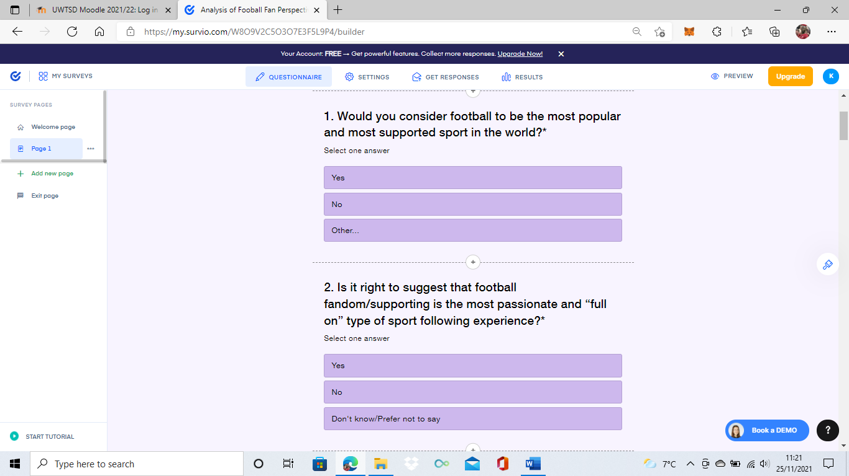
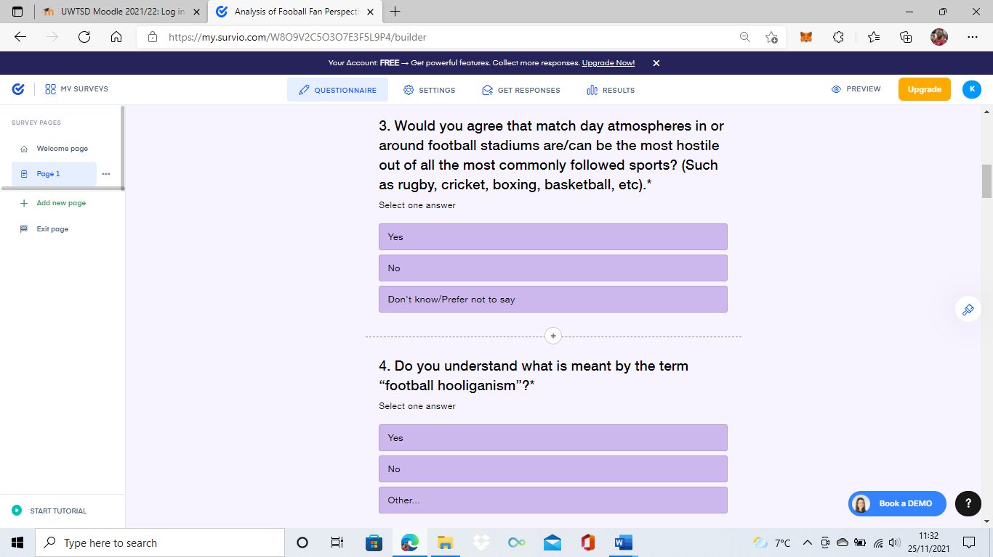
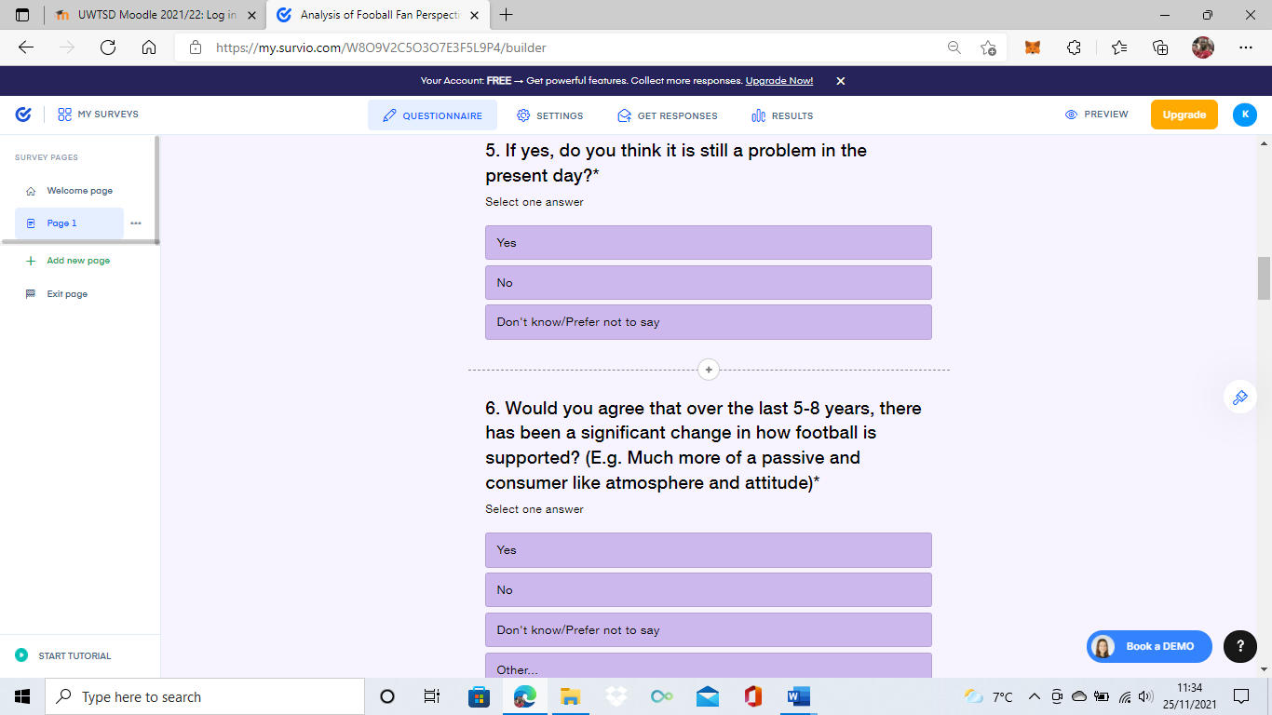
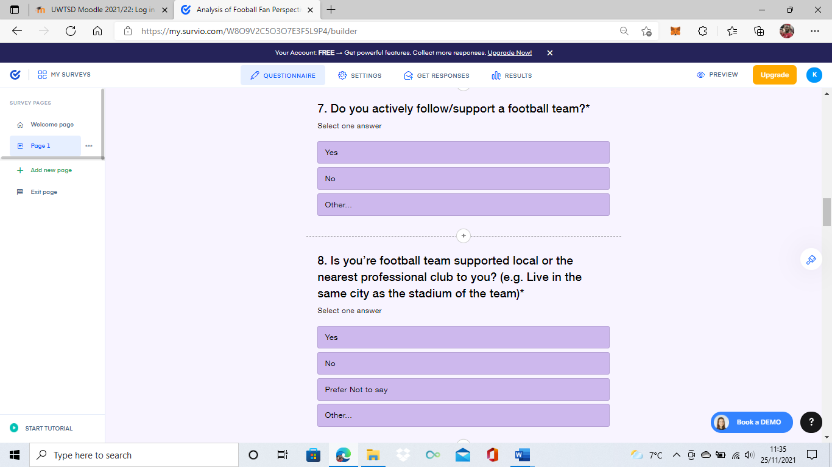
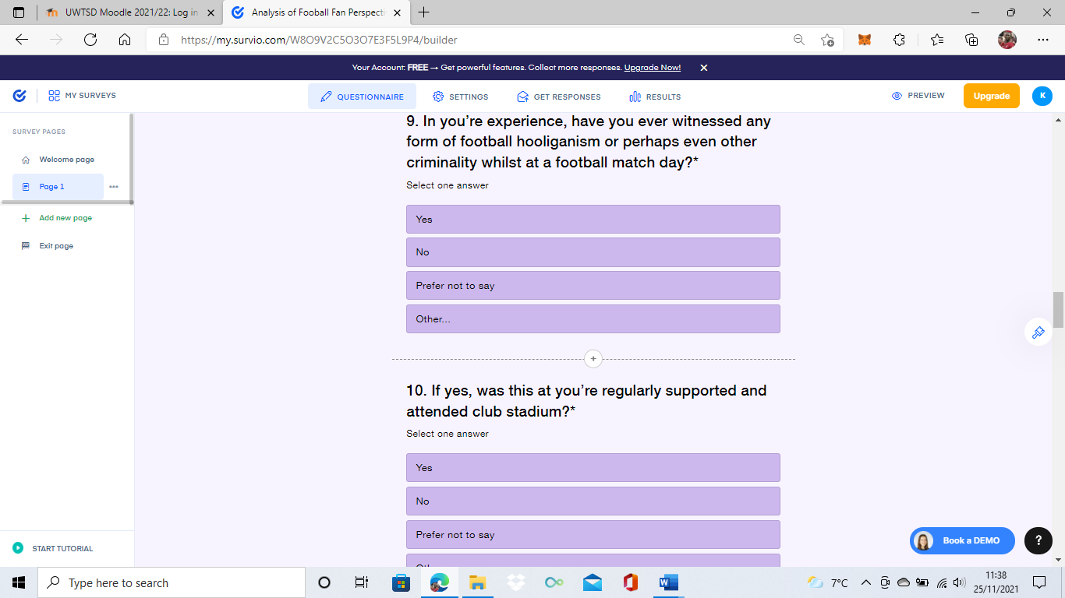
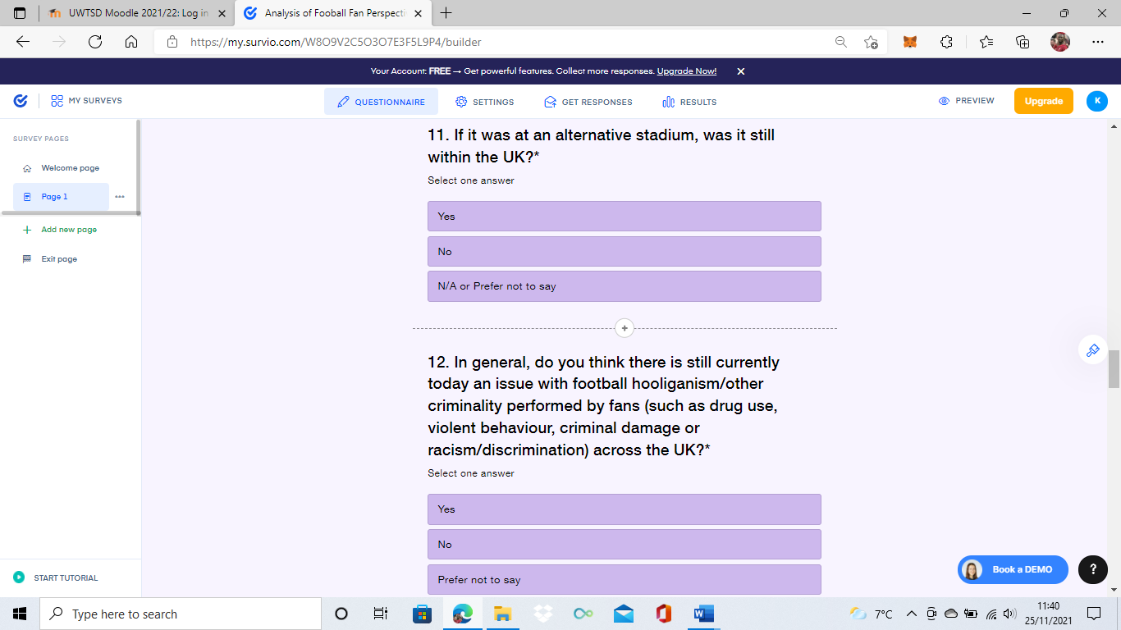
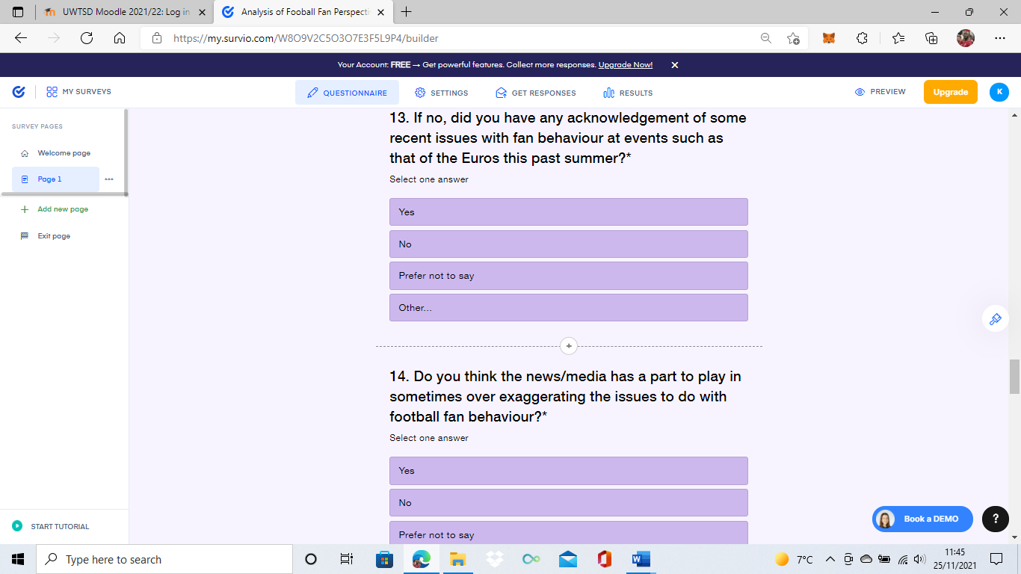
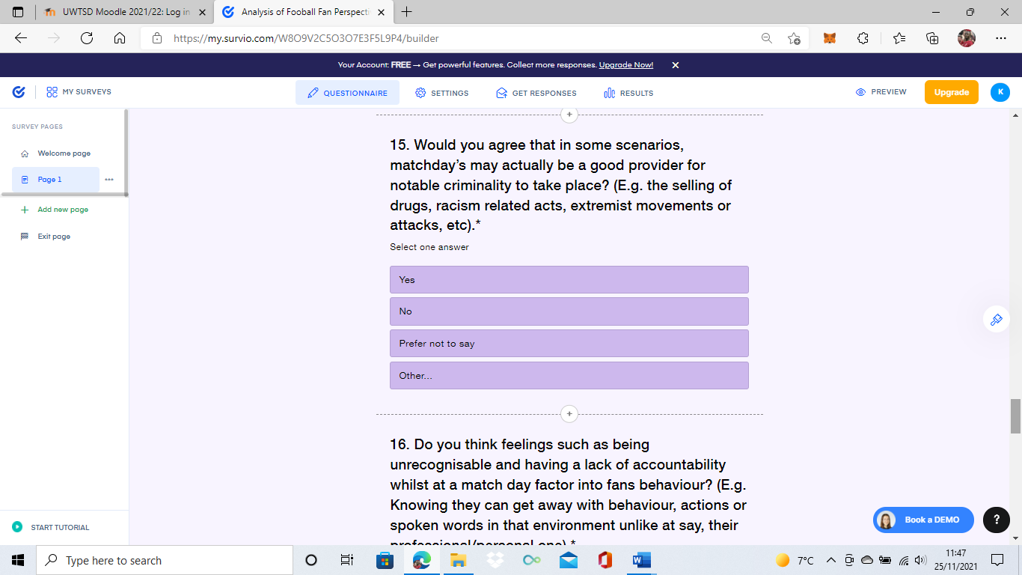

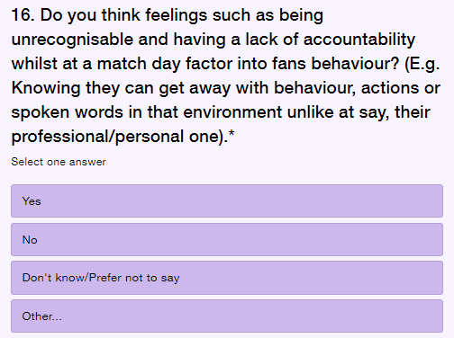
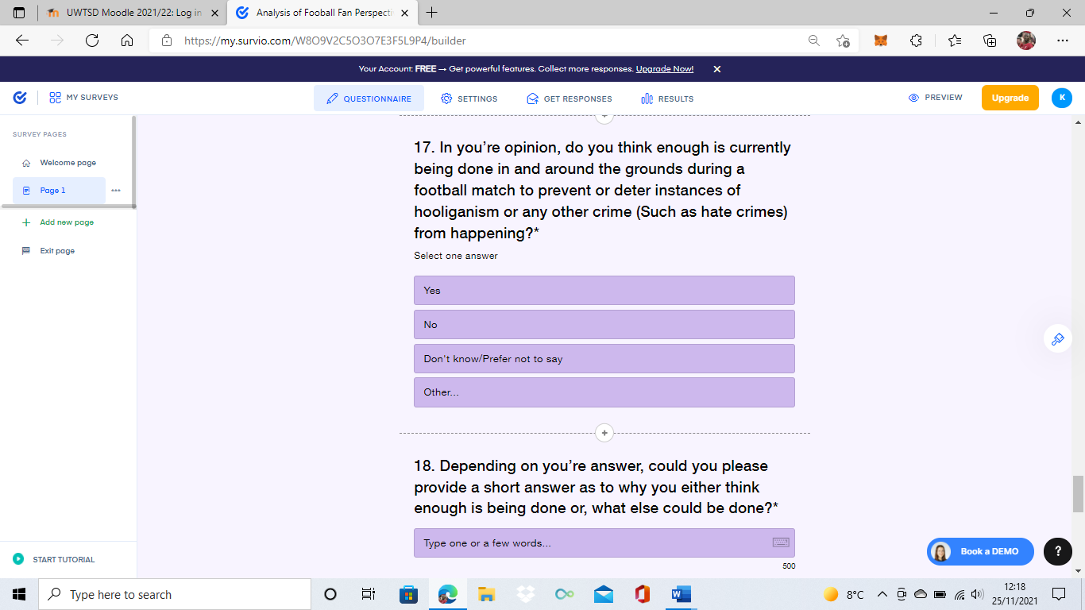

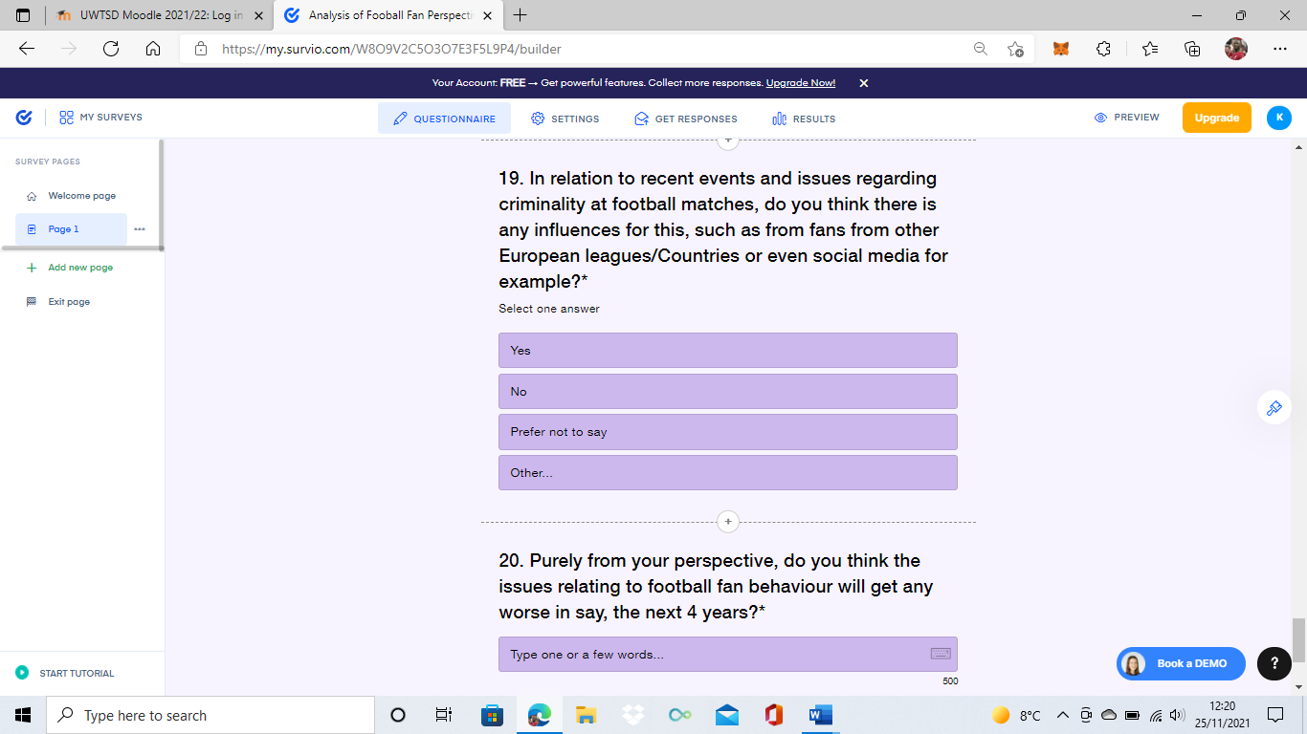

Appendix G: Template of some of the questions that were used for both guidance and parameter for the two remote interviews that were undertaken for the qualitative data aspect for the overall research.



