Intensive Latin 1
Homework 1
p15 – translate the Latin sentences into English. Then translate the English sentences into Latin.
- Coquus aulam Demaeneti portant
The cook’s carry Demaenti’s garlands
The slave has the cooks’ garlands
Seruus habet coquum aualum

- Tu clamas, ego autem aulas porto
You shout, I however carry the pot
The slave girl is afraid. Therefore I am calling the cook.
Serua est timet. Igitur uoco coquum.

- Cur scaena plena est seruorum?
Why is the stage full of slaves?
Why is the household full of cooks?
Cur familia plena est coquos?
- Ego Lar te uoco. Cur me times?
I call to you, god. Why fear me?
- (it is) I, Phaedra (who) enter. Why are you (pl) hiding the pot?
Phaedra intro. Cur celatis aulum?

- Si aurum habet, Demaenetus timet.
If they have the gold, Demaenetus fears.
If they hide the pot, the slaves are afraid.
Si aulam celant, serui timent.
- Coronas et aulus portant serui.
The slaves carry the garland and pot.
(It is) a cook and a slave-girl Demaenetus is summoning.
Coquum et seruam Demaenetus uocat.

p24
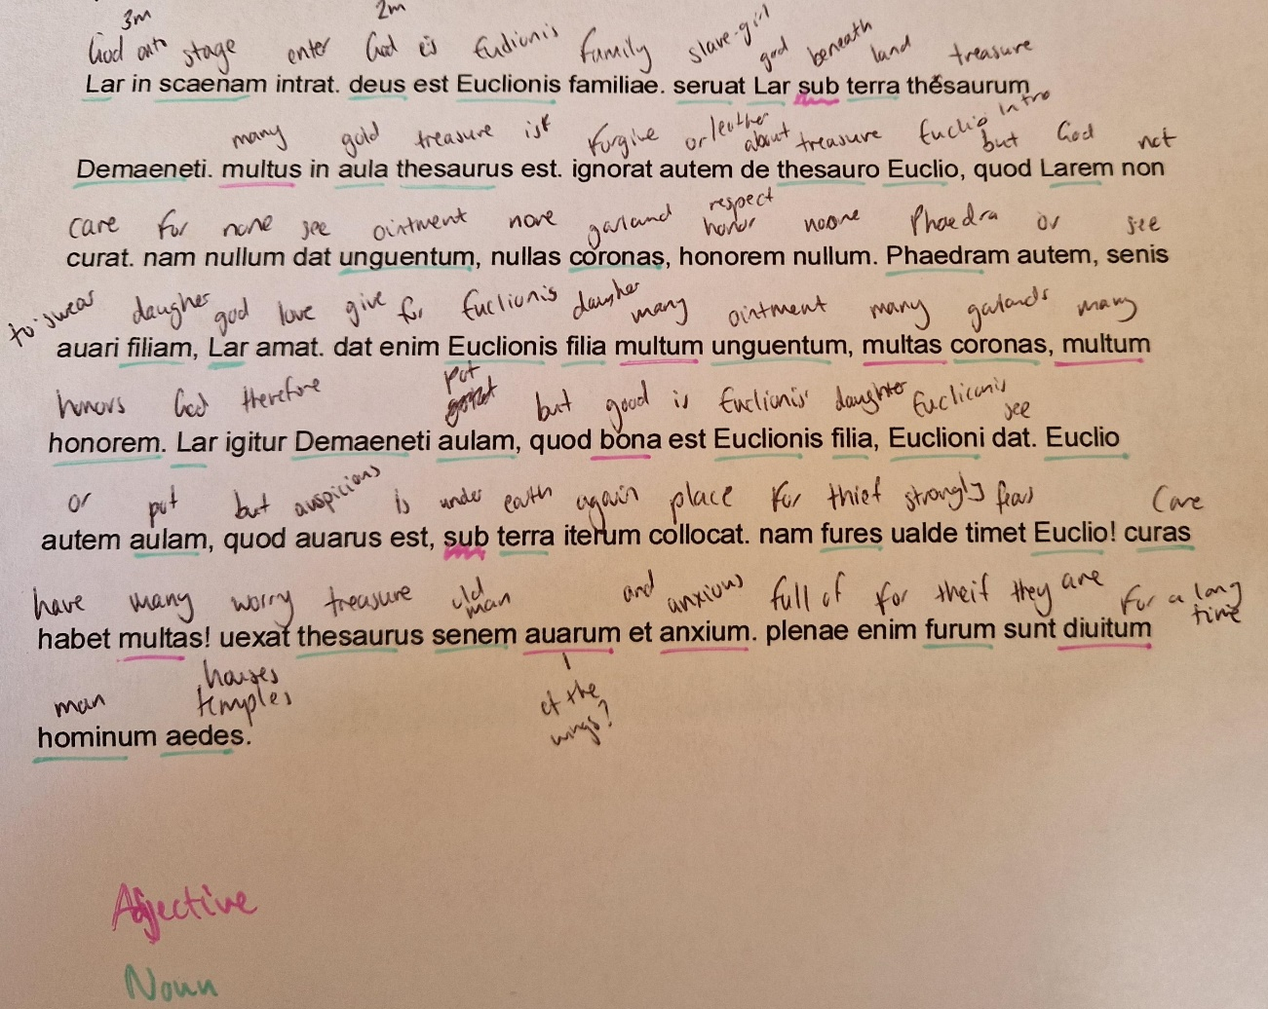
i)
Multus – belongs with thesaurus
Multum – belongs with unguentum
Multas – belongs with coronas
Multum – belongs with honorem
Bona – belongs with filia
Multas – belongs with curas
Auarum and anxium – belongs with senem
Diuitum – belongs with furum

