STUDENT NAME: Andrea Lester

STUDENT ID: 1912330

MODULE: Introduction to Physiology

MODULE CODE: BMHP5003-BIRM

LECTURES NAME: Mumtaz Goolam

ASSIGNMENT TITLE: Academic Poster and Presentation in Relation to the Digestive System.

DIGESTIVE SYSTEM:

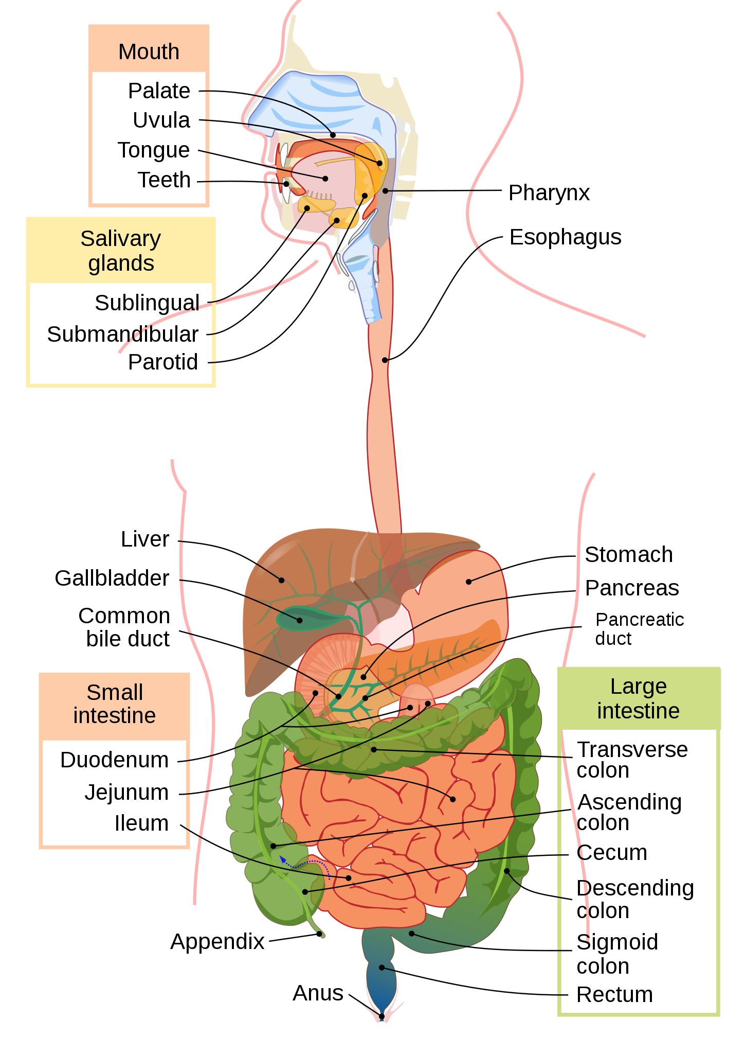

(Wikimedia Commons, 2007).

FUNCTIONS:

MOUTH:
Ingests food
Chews and mixes food
Begins chemical breakdown of carbohydrates
Moves food into the pharynx
Begins breakdown of lipids via lingual lipase.

PHARYNX:
Propels food from the oral cavity to the esophagus.

ESTOPHAGUS:
Propels food to the stomach.

STOMACH:
Mixes and churns food with gastric juices to form chyme
Begins chemical breakdown of proteins
Releases food into the duodenum as chyme
Absorbs some fat-soluble substances (for example, alcohol, aspirin)
Possesses antimicrobial functions.

SMALL INTESTINE:
Mixes chyme with digestive juices
Propels food at a rate slow enough for digestion and absorption
Absorbs breakdown products of carbohydrates, proteins, lipids, and nucleic acids, along with vitamins, minerals, and water
Preforms physical digestion via segmentation.

ACCESSORY ORGANS:
Liver, produces bile salts, which emulsify lipids, aiding their digestion and absorption
Gallbladder: stores, concentrates and releases bile
Pancreas: produces digestive enzymes and bicarbonate.

LARGE INTESTINE:
Further breaks down food residues
Absorbs most residual water, electrolytes and vitamins produced by enteric bacteria
Propels feces towards rectum
Eliminates feces (Betts et al., 2017).

PROCESS:

INGESTION- Represents the entry of food, ingested into the alimentary canal, through the mouth.
PROPULSION- Represents the movement of food, through the digestive tract.
MECHANICAL OR PHYSICAL DIGESTION- Represents the physical process, that does not change, the chemical nature of the food.

CHEMICAL DIGESTION- Starts in the mouth, then the secretions break down, complex food molecules into their chemical building blocks.

ABSORPTION- Takes place primarily within, the small intestine.

DEFECTION- The final step in the digestive process, removes all undigested materials from the body as feces (Betts et al., 2017, p1093-1094).

DISEASE THAT CAN AFFECT THE DIGESTIVE SYSTEM:

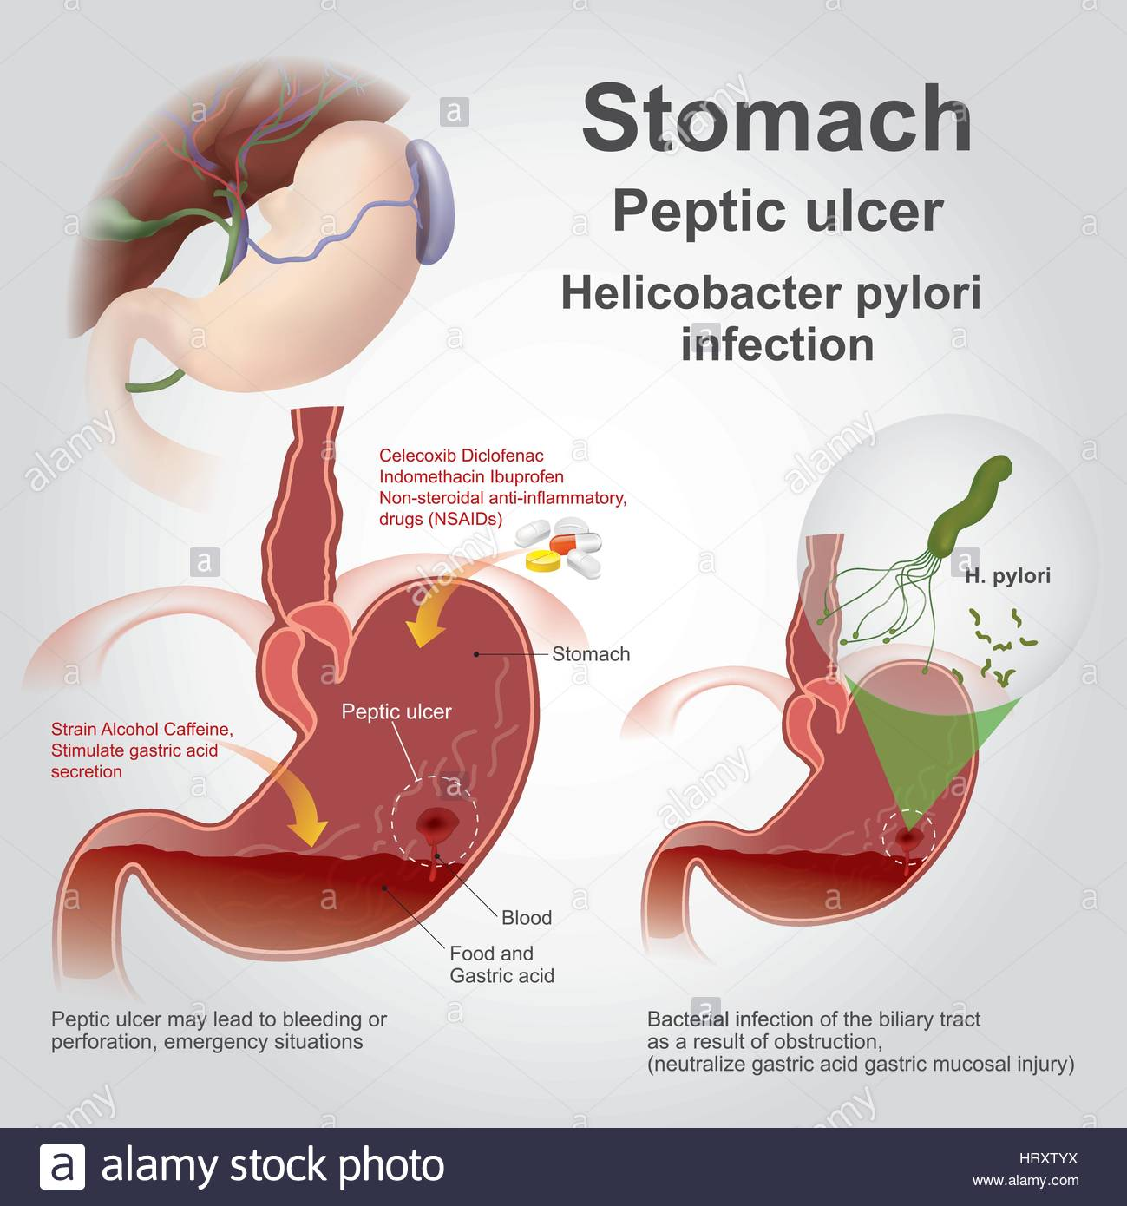
(Alamy, 2021).

There are two types of peptic ulcer disease, that can affect the digestive system:
Acute peptic ulcer- can occur in the digestive system as a single disease, but has the potential to multiply, this can happen, in different areas of the stomach, and when first entering the duodenum area, the symptoms that may be experienced are:

- Acute Gastritis
- Severe Stress
- Severe Illness
- Shock
- Burns

Chronic peptic ulcers- these types of ulcers, are said to be, more common within the duodenum, than the stomach, and usually develop singly, in the pylorus of the stomach, shrinkage may cause the following symptoms:

- Stricture of the lumen of the stomach
- Gastric flow may cause obstacles or blockages within the pylorus esophagus.
- Resistance to joining structures, for example the pancreas, liver or transverse colon (Waugh and Grant, 2018, p353).

Patients who have contracted peptic ulcer disease, within the digestive system, may suffer from mucus, the mucus covers the cavity membrane, which will contain less domestic integrins, this is said to be the greatest change, that has been identified in patients, experiencing gastric ulceration (Venables, 1986).

Peptic ulcer disease can affect 1 in 10 individuals, and can develop anytime in their lives, a research study was conducted, on 456,327 people from the United Kingdom, this was based on how peptic ulcer disease occurs, the results discovered that eight people, with genetic imbalance, were connected and at risk of getting the disease (Technology Networks Neuroscience News + Research, 2021).

HOW TO TREAT THE DISEASE:
Treating ulcers within the stomach, requires a intake of certain healthy foods, that can contribute to reduction of peptic ulcer disease or at least reduce the symptoms they cause such as:

Probiotics- this helps in restoring the natural balance of bacteria.
Fermented foods- eating fermented foods can help to restore the balance within the gut microbiome.
Broccoli- broccoli sprouts can help to reduce the growth of peptic ulcers.
Berries- berries are extremely recommended to inhibit the growth of ulcers
Honey- helps to reduce the appearance of ulcers (Eagle, 2020).

A research study conducted by the department of pharmacology at Hamdard University in India, discovered that polyphenols found in apples, can contribute to the healing process of reducing peptic ulcers, and act as an ant-secretory, and antioxidant agents, the five components found in apples are:

Flavonoid
Carbolic Acid
Dihydrochalcones
Phytonutrients

Also, some other foods recommended by Hamdard University, rich in flavonoids and can help in the reduction of stomach ulcers such as peptic ulcers are:(Georgina, 2021).

GREEN VEGATABLES: Broccoli, Carrots, Asparagus, Kale, Spinach and many more.

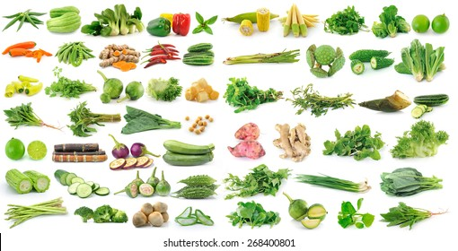
(Shutterstock, 2021).

BEANS: Black Beans, Tofu, Soya Beans, White Beans
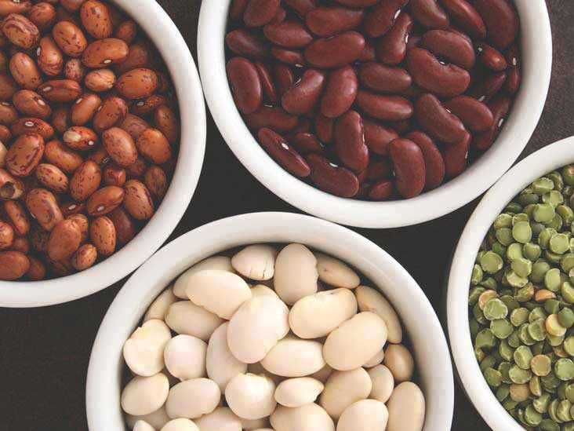
(Preiato, 2020).

NUTS: Almonds, Walnuts, Hazel Nuts, Pecan Nuts, Sesame Seeds, Flaxseeds and more.

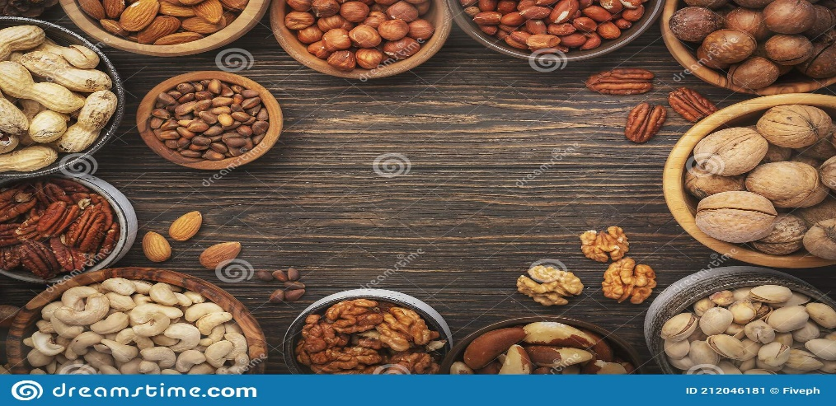
(Dreamstime, 2021).
The following medications may be prescribed in order to treat peptic and stomach ulcers, these are antimicrobial agents that are linked with inhibiting drugs such as antibiotics (Yuan, T Padol and H Hunt,2006).

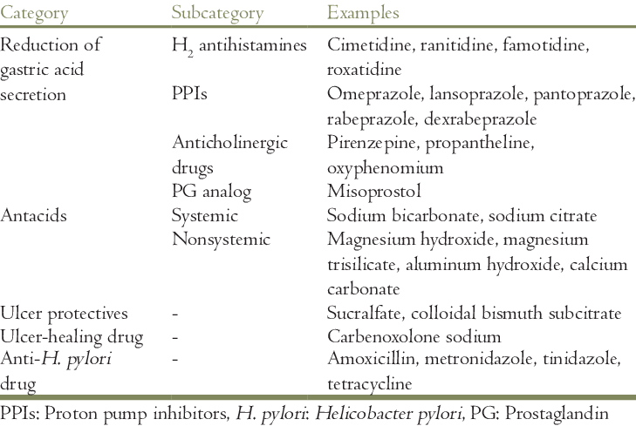
(Kuishreshtha, M., Srivastava, G. and Pratap Singh, M, 2017).

To conclude this presentation, there is still little-known facts, about the type of stomach bacteria, that causes peptic ulcer disease, mainly in the illumination process of the disease and the growth of the spread, reliable therapies and prevention programmes, say reducing the spread of the disease is reliant on, identifying the weak links in the spreading chain, and possibly in the future a development of a vaccine (Scarpignato and Bianchi Parro, 2004, p14).

REFRENCES:

Alamy (2021) Stomach Ulcer High Resolution Stock Photography and Images Alamy. Available at: http://www.alamy.com/stock-photo/stomach-ulcer.html
(Accessed: 9 October 2021).

Betts, J. et al. (2017) Anatomy and physiology. Houston Texas.

Dreamstime (2021) 70 Hazelnuts macadamia nuts pecans walnuts. Available at: https://www.dreamstime.com/photos-images/hazelnuts-macadamia-nuts-pecans-walnuts.html
(Accessed:10 October 2021).

Eagle, R. (2020) ‘What are the Best Foods to eat with a Stomach Ulcer’, Medical News Today. Available at: https://www.medicalnewstoday.com/articles/stomach-ulcer-diet
(Accessed: 10 October 2021).

Georgina, C. (2021) ’Stomach Ulcer Treatment an Apple a day may Keep the Doctor Away’, Express Black History is our History. Available at: https://www.express.co.uk/life-style/health/1389784/stomach-ulcer-treatment-apple-polyphenols-fruits
(Accessed: 10 October 2021).

Kuishreshtha, M. Srivastava, G and Pratap Singh, M. (2017) ‘Pathophysiological status and nutritional therapy of peptic ulcer an update’, Wolters Kluwer- Medknow, pp.80. Available at: http://file:///C:/Users/User/Downloads/Pathophysiological_status_and_nutritional_therapy_.pdf
(Accessed: 10 October 2021).

Preiato, D (2020) Are white beans good for you Nutrients and more. Available at: https://www.healthline.com/nutrition/white-beans-nutrition
([Accessed: 10 October 2021).

Scarpignato, C. and Bianchi Parro, G. (2004) Clinical pharmacology and therapy of helicobacter pylori infection. Karger.

Shutter stock (2021) Broccoli asparagus spinach high res stock images. Available at: https://www.shutterstock.com/search/broccoli+kale+asparagus+spinach
(Accessed: 10 October 2021).

Technology Networks Neuroscience News + Research. (2021) ‘Is there a link between depression and stomach ulcers. Available at: https://www.technologynetworks.com/neuroscience/news/is-there-a-link-between-depression-and-stomach-ulcers-346052
(Accessed: 10 October 2021).
Venables, C. (1986) ‘Mucus, pepsin, and peptic ulcer’, Gut, 27(3), pp.235. Available at: https://www.ncbi.nlm.nih.gov/pmc/articles/PMC1433413/pdf/gut00363-0005.pdf
(Accessed: 9 October 2021).

Waugh, A. and Grant, A. (2018) Ross and wilson anatomy + Physiology in health and Illness. 13th ed Edinburgh London New York Oxford Philadelphia St Louis Sydney Toronto: Elsevier.

Wikimedia Commons (2021) File digestive system diagram. Available at:http://commons.wikimedia.org/wiki/file:Digestive_system_diagram_en.svg
(Accessed: 1 October 2021).

Yuan, Y. T, Padol. I and H Hunt, R. (2006) ‘Peptic ulcer disease’, Nature Publishing Group, pp.84. Available at: https://www.researchgate.net/profile/Yuhong-Yuan-2/publication/7316803_Peptic_ulcer_disease_today/links/00463525856299fd76000000/Peptic-ulcer-disease-today.pdf (Accessed: 10 October 2021).

