

Proposal for the development of a control, management, and logging system for the performance evaluation of TETRA PMR networks

by
Rhys Higgins

Supervisor: TBC

Project submitted as part of the requirements for the award of
BEng (Hons) Embedded Electronic Systems

October 2024

Contents
TETRA 3
Background 3
Literature Review 4
Aim 5
Objectives 5
Proposed Project Plan 7
Resources 8
References 9

Table of Figures
Figure 1: Airbus TH9 TETRA Radio [4] 3
Figure 2: Motorola DIMETERA Express [7] 4
Figure 3: Hytera DIB-R5 Outdoor [8] 4
Figure 4: Provisional System Network Setup 5
Figure 5: Independent Project Gantt Chart 7

TETRA

TETRA (Terrestrial Trunked Radio) is a digital radio communications standard developed by the ETSI (European Technical Standards Institute), launched in 1995, focused on delivering a highly reliable digital wireless communications infrastructure which is capable of supporting PTT (Push-to-Talk) communication and single (point-to-point) and group (point-to-multipoint) call capability [1].

TETRA-compliant PMR (Private/Professional Mobile Radio) systems are used by a plethora of organisations where reliability and security are of elevated important, including, but by no means limited to: Oil & Gas Sector, Policing, Utilities Sector and Military organisations [2]. Major vendors of TETRA hardware and systems include businesses such as Thales, Hytera, and Motorola [3].

Background

The evaluation of TETRA PMR (Figure 1 networks in real-world conditions is both a time-consuming and resource-intensive exercise. This success of this activity is critically dependent on participants numbers, for both the establishment and maintenance of the network, and their understanding of radio voice procedure to enable effective communication between nodes.

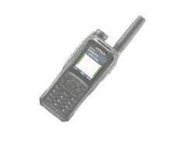
Figure 1: Airbus TH9 TETRA Radio [4]
When conducting site-testing on any PMR-type network in an outdoor environment, it is often exceedingly difficult to maintain a network for any significant duration of time. People involved require welfare facilities, regular breaks, and PPE (Personal Protective Equipment) under the legal obligations of the MHSWR (Management of Health and Safety at Work Regulations) which comes under the umbrella of the Health and Safety at Work Act, 1974 [5]. This is compounded by PMR radios operating in the VHF/ lower UHF (Very High Frequency, 30MHz to 300MHz, and Ultra High Frequency, 300MHz to 3GHz) bands, therefore having a large typical effective working range of ~5km in non-trunking mode [6]. Ultimately meaning that the individuals manning each node could potentially be spread over a large area with limited access to welfare facilities. Furthermore, each individual used to conduct the site-testing will have a time-cost, both in terms of immediate cost to the organisation in hours, and time that could have been spent conducting other research activities.

However, it is critically important that key network data is captured at each node. It is also important that each node can have an active role in the network. To ensure the reliability of testing, it is also important to ensure that the environmental conditions and location of each node in the network are captured with a high degree of accuracy. Both factors would typically rely on the radio operator to observe and document the information.

Literature Review

Existing solutions found within this research area are limited and typically focused at larger-scale infrastructure housed within a fixed-platform, such as a rackmount server, as will be discussed below.

An example of an existing system would be the Motorola DIMETERA Express, Figure 2. This system offers the ability to provision and manage multiple TETRA networks, potentially spread across multiple sites, via a web-based management interface. Solutions such as this often consume significant amounts of power, >60W, and when installed may weigh over 100Kg [7], rendering a system like this wholly unsuitable for short-term (up to a fortnight) testing of a TETRA PMR network.

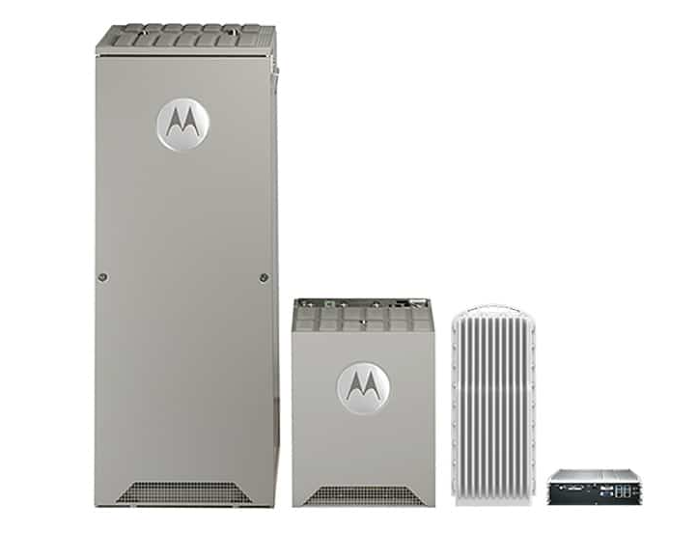
Figure 2: Motorola DIMETERA Express [7]
Smaller scale solutions are available from vendors such as Hytera, more specifically the DIB-R5 outdoor, Figure 3. This system integrates features such as GNSS (Global Navigation Satellite System) and is suitable for outdoor use, being IP65 rated. However, akin to the Motorola DIMETERA Express, the Hytera DIB-R5 requires a 44Vdc to 55Vdc power supply and weighs 10Kg – making it install in remote areas [8].

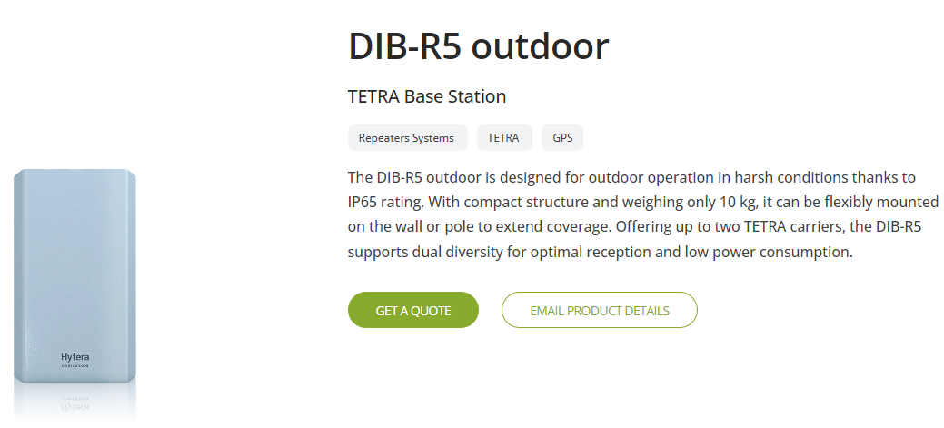
Figure 3: Hytera DIB-R5 Outdoor [8]

Aim

The proposal is to formulate an artefact dependant on microcontroller platform which can establish, maintain, and test a TETRA PMR network. The proposal would utilise the extended TETRA AT command set, SDS (Short Data Service) commands, and potentially a secondary interface to control, manage, and log data on a TETRA network – as shown in Figure 4.

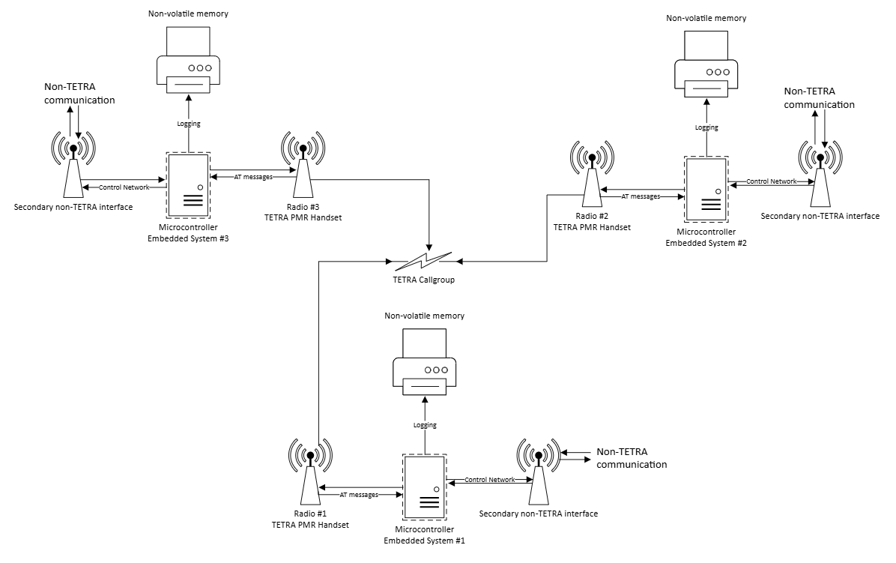
Figure 4: Provisional System Network Setup

Objectives

The artefact would make use of the vendor-independent TETRA PEI (Peripheral Equipment Interface) AT (Attention) command set (as defined in the ETSI TS 100 392-5 standard) to provide the basis to automate radio functions and provide the capability for network maintenance, with the proposal enabling elements of the functionality of a dedicated TETRA base station with remote management features [9]. These remote management features may require a secondary interface to the TETRA PEI, depending on the implementation of the ETSI TS 100 392-5 in the evaluated radio; the secondary interface could feasibly be a low-speed (100Kbit/s) implementation of RS485, ZigBee, 10Mbps Ethernet, GSM (Global System for Mobile) or LoRaWAN (Long Range Wide Area Network). With the secondary interface, the system should be able to provide functionality such as scanning the network for nodes that are within the same TETRA call group. The secondary interface medium will be defined by the requirements of the workplace and potential implications of a wired vs wireless interface.

The artefact should also be sufficiently rugged to ensure that it is able to withstand the adverse environmental conditions which would be representative of the conditions in which a TETRA PMR would be expected to operate. This would include the enclosure and connector specification which must hold a sufficient IP-rating to be left to operate without physical user interaction for periods of up to 120 hours (5 days). The internal hardware will also have to be designed for manufacture and operational usage/testing, constituting the design and manufacture of PCB (Printed Circuit Board), ensuring the system hardware would be robust and reliable in contrast to prototyping media such as breadboard.

The software component of the artefact should be written in a popular and well-understood programming language, like C, so that the software can be modified and built-upon for future functionality – should it be required by the customer. The software should also be capable of supporting TETRA PMR handsets from multiple vendors without significant alterations being required to the codebase.

Regarding the hardware interfaces, the artefact should incorporate the serial interfaces RS232 (Recommended-Standard 232) and RS485 (Recommended-Standard 485) both of which are protocols typically used as the PEI (Peripheral Equipment Interface) for the transmission and reception of AT commands between a TETRA PMR handset and computer-based system. The key differentiator between the two being RS485 uses differential signalling and therefore a has a much greater feasible transmission distance [10].

The artefact must be capable of capturing and storing network data without the need for a radio operator at that given node. A suitable NV (non-volatile) storage medium will be identified for the purpose of storing logged TETRA network data. The storage medium must be readable via an external interface, such as USB (Universal Serial Bus), and stored in a filesystem and file format which is compatible with ubiquitous operating systems such as Windows and Linux, such as FAT16/32 (File Allocation Table 16/32) which is platform agnostic and reliable [11] [12]. An electronically erasable read-only memory device, such as an EEPROM, should be separate from the NV storage medium and used to store node identification and configuration information, which is read by the software on the microcontroller to configure the system to interface properly with the connected handset.

Alongside this, the artefact must contain a sensor-suite providing the GPS (Global Positioning System) location, orientation, and elevation of the system at its given node, to ensure that the testing the system is used for is repeatable and to ensure that the artefact has remained in its installed location and orientation. The sensor suite should be sufficient to capture basic environmental conditions of the node when deployed, for instance the air/ground temperature and the relative humidity at the node station.

Finally, the artefact should be self-powering and provide the ability to monitor the battery level of the connected PMR handset (and itself) and have sufficient battery capacity to remain operational for the 120-hour duration of a workplace trials activity, whilst still ensuring that the artefact remains portable.

Proposed Project Plan

Figure 5 is the proposed project timeline. This article covers the entire scope of the proposed project and considers the possibility of issues at key gateways to project delivery. This article will also be used to track and assure that sufficient and timely progress is being made towards each objective.

Figure 5: Independent Project Gantt Chart

Resources

To be able to effectively design and evaluate this system, the following resources will be required. Most of these resources are already available in the academic and workplace laboratories, resources with additional cost will include an estimated costing.

- Windows/Linux/Mac OS computer system with 2+ modern 64bit microarchitecture, 4GB+ RAM, 64GB+ internal storage and a 2D/3D graphics processing unit.
- Peripherals (Mouse, Keyboard, and Monitor)
- KICAD v6.0+/Easy PC (or equivalent PCB design package)
- PuTTy, Picocom, Minicom (or equivalent)
- CCS PIC C compiler (Familiarity, no learning requirement)
- Microsoft Visual Studio, Proteus Professional 8+, CCS Studio, MPLAB X (or equivalent) for software development.
- 2+ USB to TTL RS232 and /or RS485 serial converter (One for each handset), £40 (~£20 each).
- PICKit 4 ICSP (In-Circuit Serial Programmer), or similar
- 2+ (Ideally 3+) TETRA PMR Handsets (Lab stock)
- Soldering Iron, with lead-free & rosin-free solder.
- Sufficient laboratory space and desk area (Electronics Laboratory)
- Soldering facilities and sufficient fume extraction
- PCB manufacturing (External)
- Potential for people required to assist lab test setup.
- Verbal feedback from SMEs in the subject area (Subject Matter Experts) to inform design choices, which will be stored on a word document and comply the GDPR.

References

[1] | ETSI, “Technical Committee (TC) Terrestrial Trunked Radio and Critical Communications Evolution (TCCE),” European Technical Standards Institute, [Online]. Available: https://www.etsi.org/committee/1416-tcce. [Accessed 21 10 2024].
[2] | ETSI, “TETRA, Introduction,” European Technical Standards Institute, [Online]. Available: https://www.etsi.org/technologies/tetra. [Accessed 21 10 2024].
[3] | Research and Markets, “Global Terrestrial Trunked Radio (TETRA) System Market 2017-2021,” PR Newswire, 30 10 2017. [Online]. Available: https://www.prnewswire.com/news-releases/global-terrestrial-trunked-radio-tetra-system-market-2017-2021---key-vendors-are-airbus-group-jvckenwood-motorola-solutions--sepura-300545367.html. [Accessed 21 10 2024].
[4] | Secure Land Communications, “TH9 TETRA radio,” 2024. [Online]. Available: https://www.securelandcommunications.com/th9-handheld-tetra-radio. [Accessed 25 10 2024].
[5] | HSE, “Temperature in the workplace,” Health and Safety Executive, [Online]. Available: https://www.hse.gov.uk/temperature/employer/print.htm. [Accessed 22 10 2024].
[6] | Hytera Global, “The Communication Distance of Two Way Radios,” Hytera Connect, 24 12 2021. [Online]. Available: https://www.hytera.com/en/connect/blog/the-communication-distance-of-two-way-radios. [Accessed 23 10 2024].
[7] | Motorola Solutions, “DIMETRA Express - TETRA System,” Motorola, 2024. [Online]. Available: https://www.motorolasolutions.com/en_xu/products/tetra/infrastructure/dimetra-express.html. [Accessed 23 10 2024].
[8] | Hytera, “DIB-R5 outdoor, TETRA Base Station,” 2024. [Online]. Available: https://www.hytera.com/en/product-new/digital-radio/tetra-system/dib-r5-outdoor.html. [Accessed 24 10 2024].
[9] | ETSI, “ETSI TS 100 392-5 V2.4.1 (2016-03), Technical Specification,” 03 2016. [Online]. Available: https://www.etsi.org/deliver/etsi_ts/100300_100399/10039205/02.04.01_60/ts_10039205v020401p.pdf. [Accessed 24 10 2024].
[10] | T. Kugelstadt, “The RS-485 Design Guide,” Texas Instruments, 05 2021. [Online]. Available: https://www.ti.com/lit/an/slla272d/slla272d.pdf?ts=1729690656798. [Accessed 24 10 2024].
[11] | OSDEV.org, “FAT,” 06 06 2024. [Online]. Available: https://wiki.osdev.org/FAT. [Accessed 24 10 2024].
[12] | ARM Keil, “FAT File System,” ARM, 2024. [Online]. Available: https://www.keil.com/pack/doc/mw/filesystem/html/fat_fs.html. [Accessed 24 10 2024].

