Activity 1
This code checks what type of number x is (positive, negative or zero) using if and else in R.
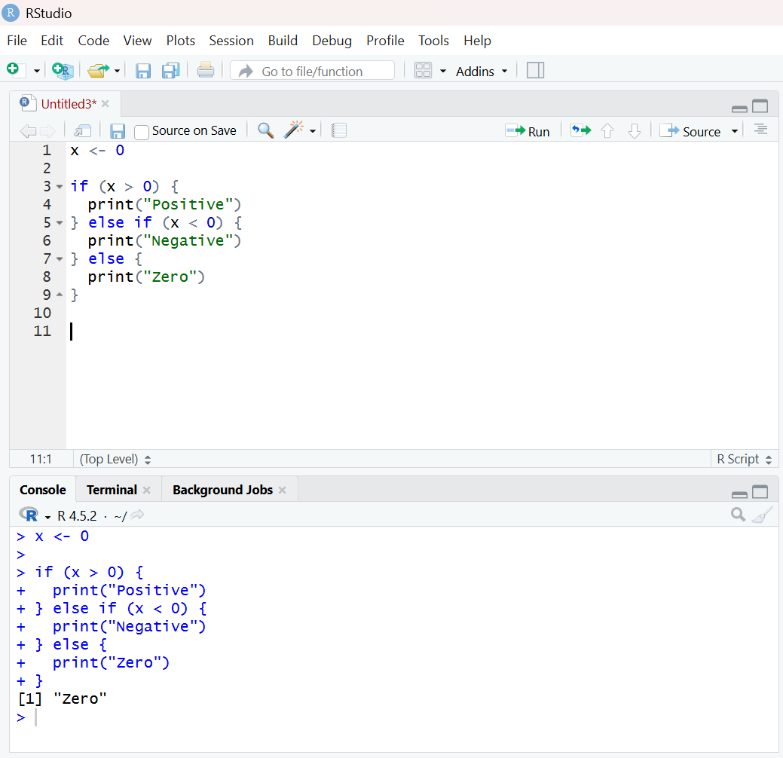
Activity 2
This R code uses a for loop to add all numbers from 1 to 100 together and prints the total, which is 5050.
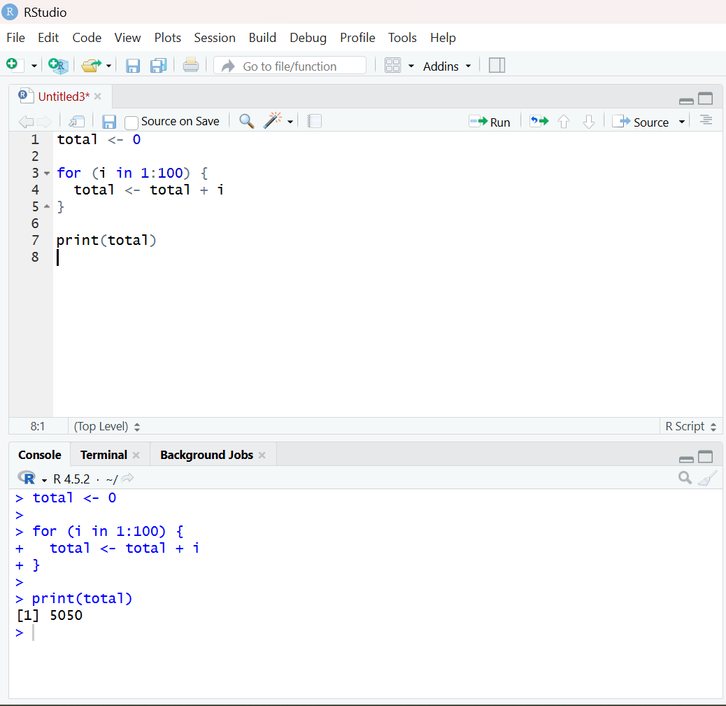
Activity 3
This code keeps generating and printing random numbers between 0 and 1 until a number greater than 0.9 appears.
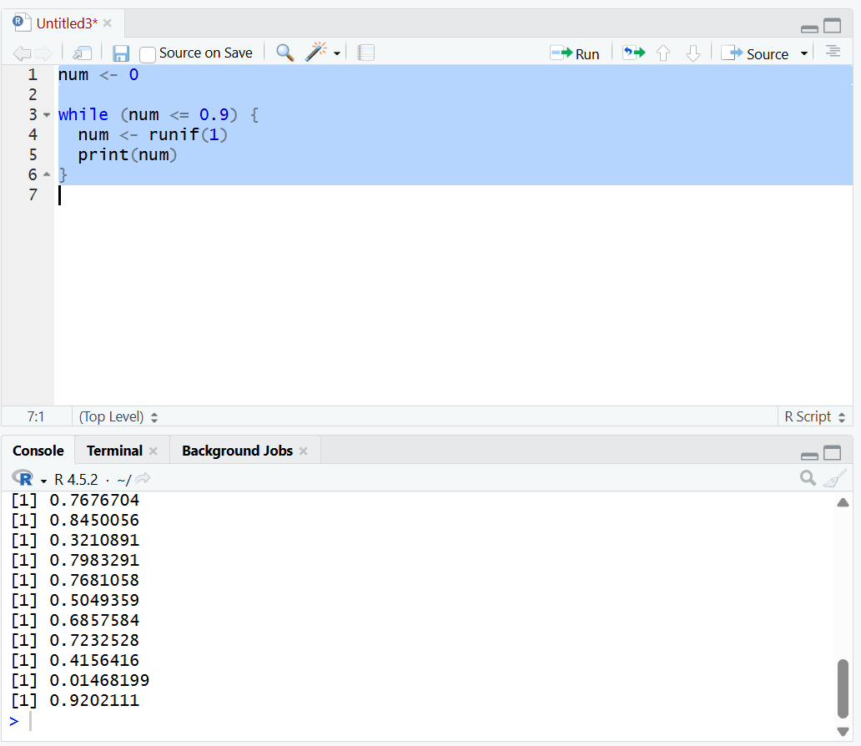
Activity 4
Vectorisation replaces the loop by applying the operation to the whole vector at once, making the code shorter and faster.
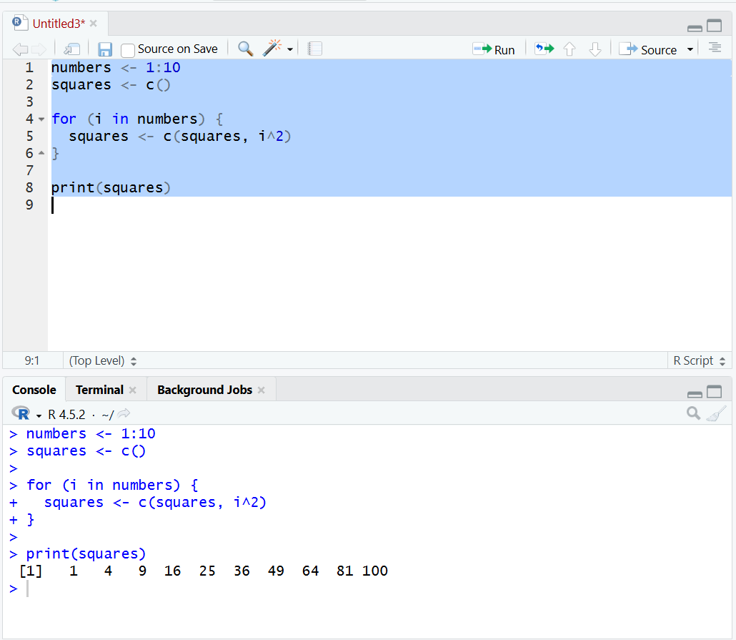
Activity 5
The function multiplies a given number by 3 and returns the new value.
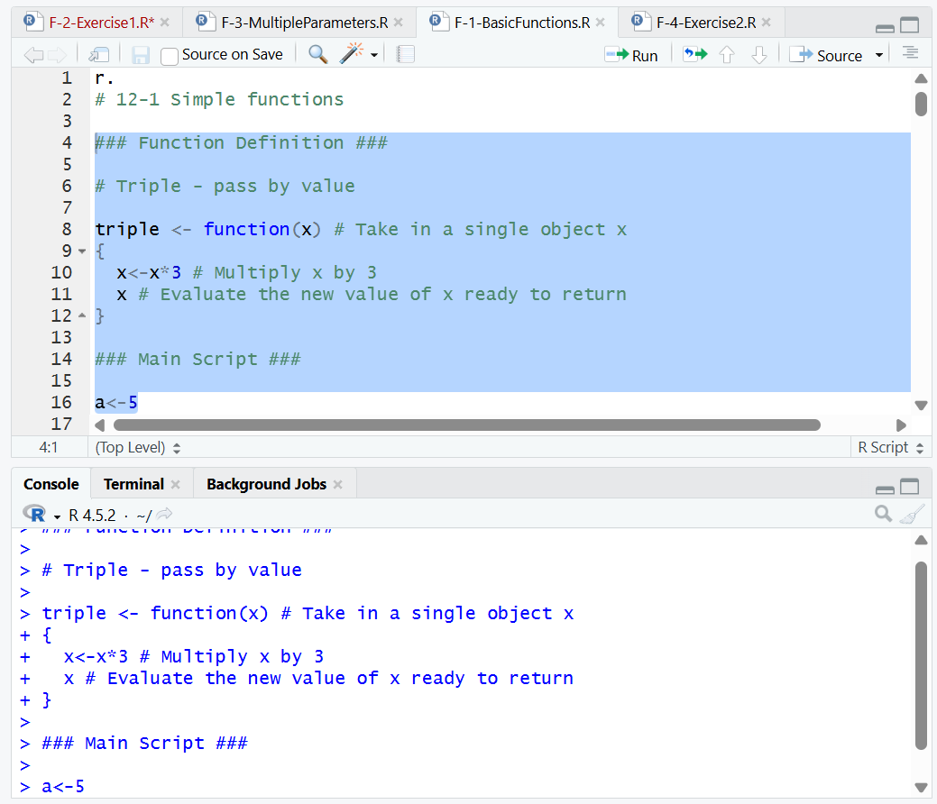
Activity 6
The script compares two ways of finding the mean of numbers using a loop and using R’s built-in mean function and both give the same answer.
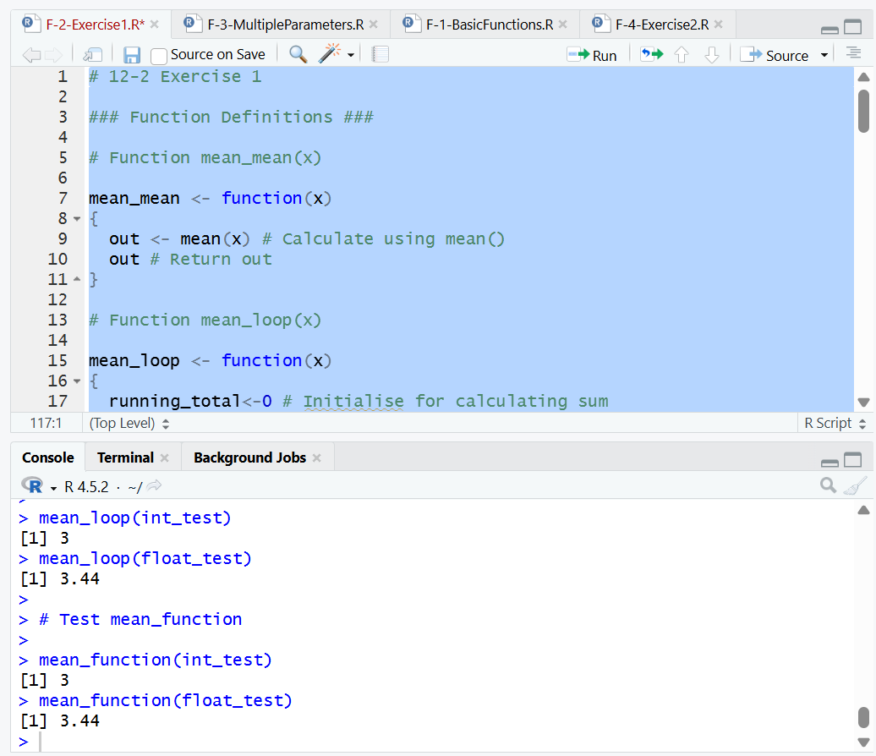
Activity 7
The code shows functions with multiple inputs, one calculates powers and the other repeats strings several times.
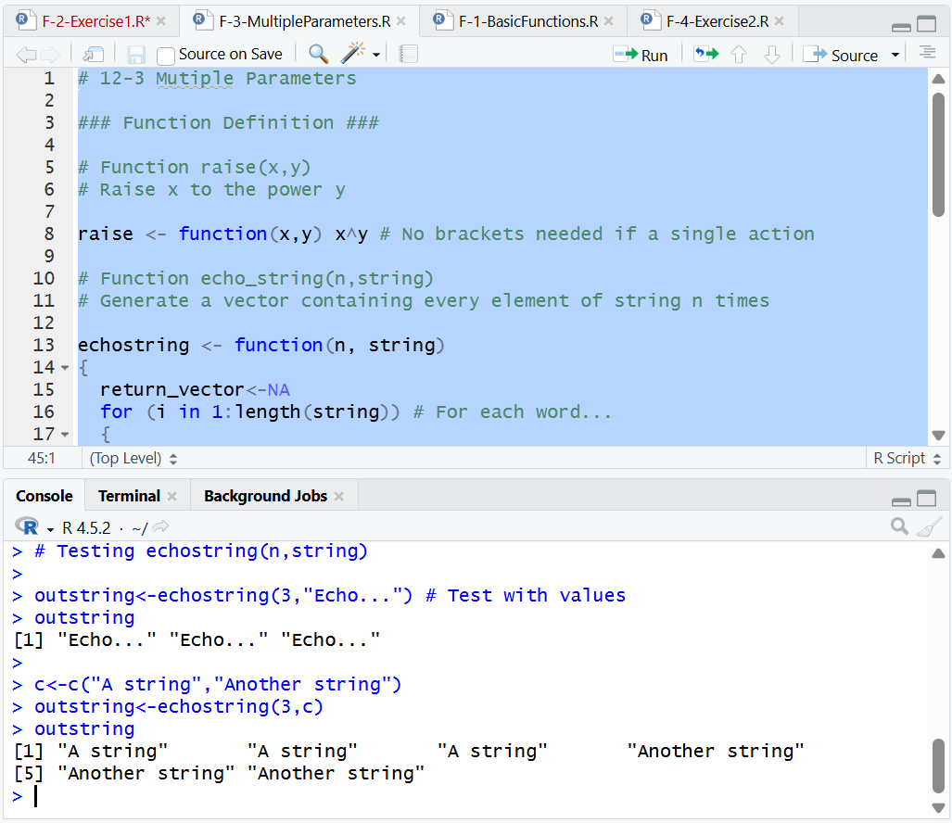
Activity 8
The code creates a number range and prints squared values below a limit, working for both whole numbers and decimals.


