Geraint Jones (1908119)
1908119@student.uwtsd.ac.uk

synthesize a solution to a potential REAL-LIFE scenario

Name of the author – Geraint Jones
Course – Computer Forensics
The Faculty name – School of applied computing
The date of submission – 21/03/2020

Declaration

The work of this report is completed under the supervision of Gareth Jones. I declare that this report is the product of my own work and is not being submitted for any other degree etc.

Acknowledgement

I would like to thank my family for giving me the additional time to undertake a degree, my employer for sponsoring the degree and the many lecturers for giving their time and knowledge to arm with the necessary to complete the tasks at hand.

Abstract

This report is split into two sections. Section one which attempts to out line the landscape of computer forensics, and section two which follows a fictional case, therefore putting what was discussed in section one into practice. Combined the two sections cover the concept, method and tools used in computer forensic and their application. Each section offers an introduction, with an overall conclusion to the report, with evidencing of studies provided via appendix and supporting material sections.

Keywords include computer digital forensics, law, court, criminal, computer forensic investigative process, acquisition, identification, evaluation, admission, faraday, Access Data FTK, WireShark, Oxygen Forensics Detective, Gargoyle, Volatility, Autopsy/Sleuth Kit, Network Miner, Cellebrite UFED, Xsteg, Windows SCOPE, X-Ways Forensics, Xplico, XRY, RAM Capturer, EnCase, NMAP, Kali, Parrot, Cyborg Linux, chain of custody, Mapping Process of Digital Forensic Investigation Frameworks (DFIF), surface web, deep web, dark web, proxy chaining, preparation, collection and preservation, examination and analysis, disseminating

Contents page
Declaration 1
Acknowledgement 1
Abstract 1
Contents page 2
Main chapters 3
Introduction 3
1. Research 3
1.1 Concept 3
1.2 Method 3
1.2.1 Computer forensic investigative process (1984) 3
1.2.2 Improvements 4
1.3 Tools 4
1.3.1 Hardware 4
1.3.2 Software 5
1.3.3 Information 9
2. CEC Mobile Manufacturing Company 11
2.1 Documented Forensic Methodology 11
2.1.1 Preparation 11
2.1.1.1 Plan 12
2.1.1.2 Authorization/notification/Confirmation 13
2.1.1.3 Chain of custody 13
2.1.2 Collection and preservation 14
2.1.3 Examination and analysis 15
2.1.4 Presentation and reporting 17
2.1.5 Disseminating the case 18
3. Conclusion and Evaluation 18
3.1 Future work 18
References 19
Supporting material 23
Professional Forensic Report (Sample) 23
Invoice (Sample) 23

Main chapters

Introduction

This paper is broken into two parts. The research of forensic tools, and the application of the required tools, to solve a manufactured potential real-life scenario. It aims to show case the authors fundamental understanding of computer forensics, the legal aspects, best practice and its relationship to IT in general.

1. Research

Is there anything in the modern human world which isn’t shaped by the computer ? From conception they have made things easier and quicker to accomplish, to the modern networked world where exponentially growing amounts of data are at the end of a mouse click[1]. Of course, the same is true for nefarious criminal activities[2]. Perpetrators of which are afforded a fair trial[3], as do all UK citizens under law.

1.1 Concept

Forensics, is the use of scientific practice, to produce evidence for use in the court of law[4]. Digital forensics is a subset of this practice as defined by the Forensic Science Regulator[5], digital forensics is
“the process by which information is extracted from any digital system or data storage media, rendered into a useable form, processed and interpreted for the purpose of obtaining intelligence for use in investigations, or evidence for criminal proceedings”
As its ultimate purpose is, use in court, information must be meticulously gathered, stored and catalogue, so that upon its use it’s admissibility cannot be questioned[6].

1.2 Method

Due to the requirements of the court, methodologies have been constructed over the years to guarantee suitability for court.

1.2.1 Computer forensic investigative process (1984)

The “Computer forensic investigative process (CFIP) (1984)” created by Pollitt broke his method into four distinct phases[7]
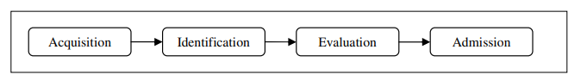
Figure 1[7]
As shown in figure 1, this system runs from stage to stage starting on the left and finishing on the right.
The Acquisition phase deals with the start of an investigation, where authorisation to begin forensic work will be evidence, along with setting up a case and starting the documentation processes.
After which Identification would occur, where digital assets would be highlighted for evidence acquisition, and extracted data would be captured in a document “understood by humans”[7].
The third phase Evaluation would be reviewing the material from identification and ensuring it is relevant to the case.
With the final phase being Admission, where the case would be presented to the court of law.

1.2.2 Improvements

Due to the passage of time, changes in technology/scope newer models has been built upon and/or new ones created with the view to improve the methodologies of the time. Some examples of newer models are the “Digital Forensics Research Workshop (DFRWS) Investigative Model (2001)”, “Abstract Digital Forensics Model (ADFM) (2002)”, “Computer Forensics Field Triage Process Model (CFFTPM) (2006)”, “Mapping Process of Digital Forensic Investigation Frameworks (DFIF) (2008)” or “The Advanced Data Acquisition Model (ADAM) (2012)”.
Process improvements will continue into the future, as recognised by the National Institute Of Forensic Science, when they commissioned and published “Strengthening Forensic Science in the United States : A Path Forward” in 2009[8]. This resulted in the first large scale black box test against the Computer Forensic community to give insight into it and methodologies used, for the purpose of advancement[9].

1.3 Tools

As an investigator could be looking at extracting data from physical storage, email, network/internet, software, a running system or mobile phone; an investigator will use a range of physical and virtual tools while following a method depending on the desired outcome. When following CFIP, during the identification an investigator would gather all the tools they require for the specific case in hand.
Due to the already discussed outcome, of presentation of evidence in court, it is important that all equipment is continually maintained and calibrated to a satisfactory standard[10].

1.3.1 Hardware

A computer forensic investigator should have a well prepared toolkit, which contains basic IT tools for example screwdrivers, anti-static bags, wrist straps, cables etc[11]. They will also make use of crime scene kits, which include evidence/faraday[12] bags, labels, digital cameras, forensically clean storage media, report forms, gloves etc[13]. To bespoke requirements such as hard disk write blockers which will aid in ensuring evidence is not tampered with[14], as well as purpose built laboratories for evidence storage, which include powerful workstations and large capacity servers for working with forensically captured images[13][15].

1.3.2 Software

Software tools could be loosely categorised as[16]
- Computer forensics tools, dealing with retrieval of data from disk (hard disk, smart cards etc), which includes the operating system and application on a computer (including laptops). This includes Windows, Mac and Linux file systems.
- Network forensics tools, packet analysis of network traffic, to discover a wide variety of information such as source and destination addresses, further incidents such as viruses and other malicious software.
- Mobile device forensics tools, which deal with IOS/Android operating system found on smart phones and tablets.
- Visual / Audio forensics tools, dealing with authenticity, steganography, recovering file data specifically related to the image, video or audio file.
- Memory forensics tools, or live acquisition which deals with retrieval of information from computers which are running. As recently accessed data is temporarily held in RAM, it can hold a wealth of data, which needs to be investigated before the computer is shutdown.
Some example open source and commercial tools are noted in the following table, under the above categories -
Computer | Network | Mobile | Visual/Audio | Memory
Access Data FTK | WireShark | Oxygen Forensics Detective | Gargoyle | Volatility
Autopsy/Sleuth Kit | Network Miner | Cellebrite UFED | Xsteg | WindowsSCOPE
X-Ways Forensics | Xplico | XRY |  | RAM Capturer
EnCase | NMAP

As well as individual tools, there are Forensic platforms of note which contain a range of tools built on top of Linux, such as Kali, Parrot or Cyborg.
Some of these tools are expanded upon on the next page.

1.3.2.1 Access Data FTK

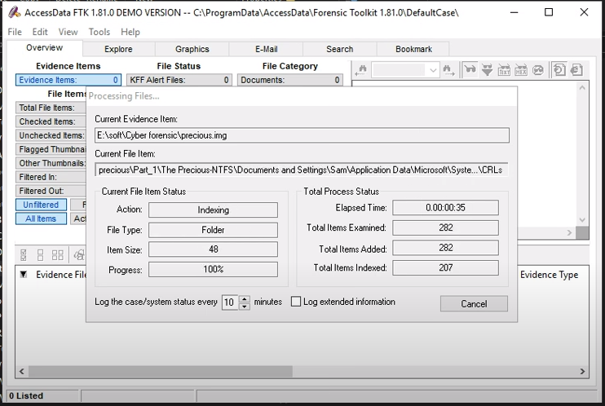
Figure 3[17]
Commercial, supported, complete suite of forensic tools built around best practice for larger forensic teams, which starts with case file generation which can be stored in a shared database. The tool generates bit stream disk images, which are bit by bit copies[18] of all major operating systems (including mobile), during which data is indexed, as shown in Figure 3, allowing faster querying of registry, events, file and other data using keywords. Built in preview system allows quick review of evidence, along with deleted data retrieval, export of files/folders and hash file generation[19]. Recently acquired by Exterro Inc, with a vision to add artificial intelligence, in the form of “Virtual Assistance” to speed the interrogation process[20].

1.3.2.3 Wireshark

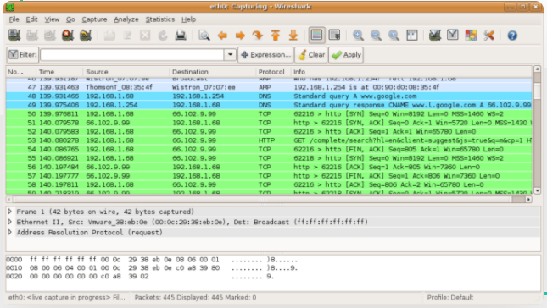
Figure 4[21]
Wireshark is a free, open source network packet analyser, which allows you to see the traffic which is flowing through your network in granular detail. As well as monitoring live packets, captured data can be saved and imported, as well as searched and filtered[22].
Useful to many aspects of IT, in the forensic setting it allows network traffic to be base lined, so in the result of an attack new data can be compared against what was known, to speed investigation and recovery, as well as giving immediate insight if no base line exists. This can allow an investigator to answer important questions like who was the attacker, how did they undertake the attack, is anything currently running and what steps can be taken to disable the attack now and in the future[23].

1.3.2.4 Volatility

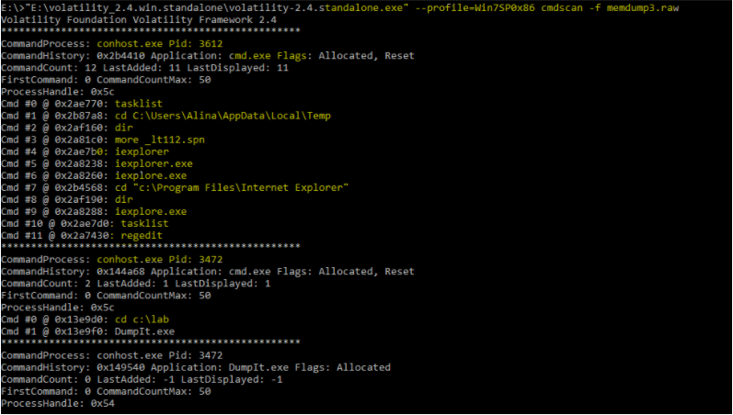
Figure 4[24]
Volatility shown in Figure 4 and tools like it, represent an important aspect of computer forensics, evidence retrieval from random access memory (RAM). Computers contain small amounts of RAM which is much faster than the hard disk within a computer. Data and applications, currently in use, are loaded in and out of RAM for the performance benefit it brings. When a computer is shut down, intentionally or not, RAM is cleared, and all data within it is lost, as it is volatile storage[25].
Volatility allows an investigator to see the data within RAM (on all major operating systems including Android and Virtual machines memory files), data which might not be present on the disk, or could have been unencrypted, to be placed in memory, such as usernames and passwords (if common they could allow access to other information) or the contents of a chat program[26]. This data shows what the user of the device was doing in the moment of seizure, information which would be invaluable in a court case. It is imperative that this data if possible, is captured before the device is powered off.

1.3.2.5 xsteg

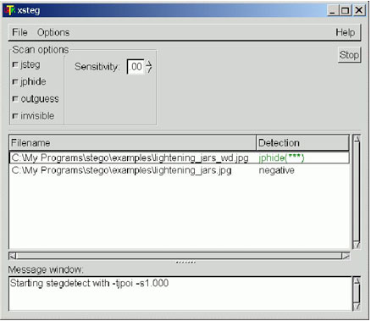
Figure 5[27]
Steganography is a process of hiding something secret in plain sight. In computers this is done for the purpose of covertly moving data through the system, either to deliver a message, a file for someone else to use, either intentionally or unintentional where it could be used to install malware[28][29].
There are several ways a bad actor can accomplish this, such as using the least significant bit method. This is where software is used to identify bits of information within a file, such as an image, which can be readily replaced with other information without compromising the original file. The replaced information can then be recalled for its intended purpose, but to the casual eye, the file appears just like the original[28].
Xsteg is an open source tool for the analysis of “jpg” files. It analyses the file to detect if Steganography has been used, and as shown in Figure 5 what process was used to achieve this, in this example “jphide”. This information could allow an investigator to extract the hidden information which could be used in the court of law.

1.3.2.6 Kali Linux

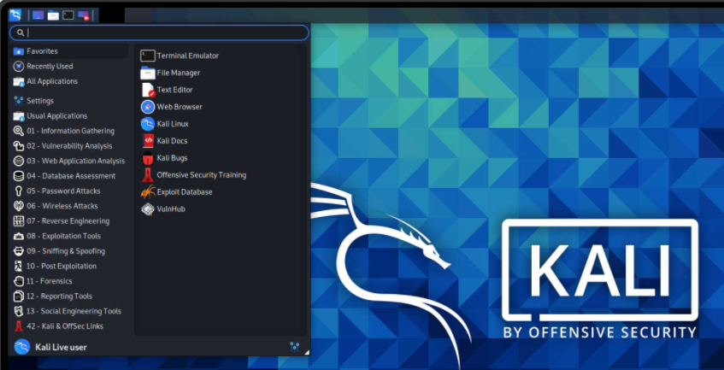
Figure 6[30]
As touched upon above, Kali Linux describes itself as a platform for cyber security, a section of which is dedicated to computer forensics. It is a complete operating system, which can be installed on a device, or made into a bootable USB drive which importantly does not make changes to the host system[31].
It contains over six hundred pre-installed tools, with over 20 specifically for forensics[32][33]. It can be configured to run in “Live Forensic Mode”, which never touches the internal hard disks, swap partition, or mounts removal media which guarantees the source disk remains forensically sound.
Kali Linux is open source and community driven, which saves the professional user time maintaining and updating their own image. This allows them to focus on the job at hand although they are able to customize their installation, as well as feed into the development of the platform[32].

1.3.2.7 MD5 hash calculator

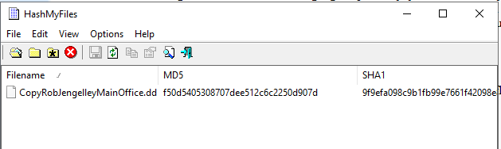
Figure 7
As discussed, it is paramount that integrity of any digital information gathered is maintained. One way of achieving this, is using a piece of software to generator a MD5 hash. MD5 is an algorithm ran against a string, which will result in an output. Provided the string remains the same, the output will.
Consider for example, a bit stream copy is taken of a hard disk. That bit stream copy must not change. Instead of working on the original, a copy will be taken, which will then be investigated. However, how can we guarantee that during this copy, that nothing changed ?
A tool such as HashMyFiles, can be ran against the original bit stream image (the string), which will result in a MD5 hash. If the same process is then ran against the copy, if the string is the same, the MD5 hash will match[34].

1.3.3 Information

As well as software and hardware, information is a corner stone of forensic investigation. This is true in two sense, the processing of and knowledge of.

1.3.3.1 Chain of custody

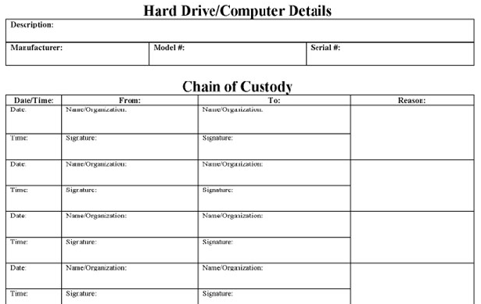
Figure 8[35]
It is important that information which is collected and could be used in court remains admissible. For this to be true, forensic investigators will generate a range of documentation, one such piece is a chain of custody document an example of which is shown in figure 8.
This is a document which clearly shows how compromised systems and evidence have been preserved. It will give reassurance that neither could have been comprised by recording how assets are transferred between bodies, by recording each parties signature and date[36]. The log will also contain
- Details of the device, serial number, media access control (MAC) addresses, IP information, make, model
- Name, title, contact number of individual handling or transporting equipment
- Time/date of above transaction
- Location of where the evidence is stored
- Reason

1.3.3.2 Knowledge

“If you know the enemy and know yourself, you need not fear the result of a hundred battles – Sun Tzu, The Art of War”
Across many walks of life, knowledge is a powerful weapon, the same is true in the cyber security space. With 2020 breaking all previous records when it comes to data loss and breaches, the scale of innovation and adaptation of malicious actors is clear[37]. It is not a stretch of the imagination to understand that these actors would have a sound understanding of computer forensics, which gives them the ability to undertake counter computer forensics, for example data destruction[38][39].
With that said it is important to understand the internet, is made up of three sections
Name | Description
Surface web | Websites which are indexed by search engines, such as Bing, Yahoo and Google. Accessible to all.
Deep web | Websites which are not indexed but are in the public interest. For example, your bank account, which requires authentication to access, and websites such as Government and Education systems.
Dark web | Websites hidden from search engines, which rely on word of mouth transfer of complicated web site links. Can require specialised web browsers and systems to access content, if it is necessary to bypass country wide censorship.
[40][41]
The dark web is the section of the internet used by criminals to communicate, share ideas, digitally meet, distribute etc, and as such can be a valuable resource of information for the cyber security industry. It is important to be respectful of using the dark web, both legally and from the perspective of the forensic information you will leave when visiting it, and it would be advisable to use virtual private networking[42], proxy chaining[43] and other tools to mask your source[44].

2. CEC Mobile Manufacturing Company

Barry Lynch a CHFI and CEH certified professional, has been hired by the CEO of CEC Mobile Manufacturing Company, Ms Dee Ford, to investigate alleged fraud by an ex-employee, Rob Jengelley.
The company designs mobile phone interfaces, using Autodesk Maya. After Rob left the company, CEC’s engineers noticed many of the mobile phone designs he was working on are missing from his computer. The belief is Rob sabotaged the design before he left, and there is no backup known to the company.

2.1 Documented Forensic Methodology

The following sections outline the steps taken by Barry while investigating the case, following the DFIF methodology[45] which is summarised in figure 9
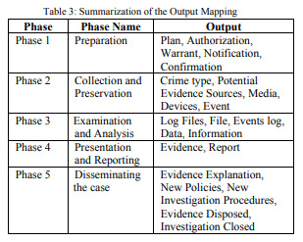
Figure 9[45]

2.1.1 Preparation

Once Barry is contacted by Ms Ford, an informal discussion will occur to understand what is required. During this conversation Barry instructs Ms Ford that CEC engineers/ and or other should no longer use any of Rob Jengelley’s devices, and those that have not been powered off prior to his resignation should be left powered on. Barry will confirm Ms Ford’s contact numbers, address and will explain that he will be in touch with a high-level plan, which she will need to sign giving him permission to begin working on the case. Barry will confirm with his team that they are able to progress with the request ensuring there is capacity to take on a new case.
From the first point of contact, to the very last step in the case, all actions pertaining to the case will be documented in a case file. The case will be given a unique number, as well as retaining all administrative information such as case owner, case initiator, contact numbers, dates, details, steps, issues, risks etc. It is of paramount importance, to ensure that everything is documented for the court of law.

2.1.1.1 Plan

With confirmation Barry can work on the case considering the specifics
- CEC engineers have been on the computer
  - Data may have already been lost, overwritten in memory or the hard disk.
- Autodesk Maya
  - Forensic data may need to be retrieved from mobile phones, both IOS and Android[46].
  - The product supports all major operating systems will need to confirm scope[47].
  - Design data can be large, appropriate storage devices will be required during first response and for the multiple copies Barry will need to undertake an investigation[48].
- Only Rob Jengelley had access to the designs, he has resigned and left CEC
  - Will need the company to confirm all devices he could have used, is Bring Your Own Device (BYOD)[49] a consideration.
- No backup was taken
  - What licensing does the company have with Autodesk, as their “Autodesk Drive” may have been enabled, and some data could be provided from there[50].
Barry will look at best practice documentation which has been generated from past cases, to confirm any lessons learnt and to accelerate his preparation for this case.
Based on the above, a variety of tools will be required to undertake the work
Name | Purpose
Laptop and mobile printer | Run tools from, produce documentation materials (for example witness statements)
Camera | To record the crime scene
Faraday bags | Store any data, such as hard disk
Screwdriver kit etc | Tools to remove hardware from a computer
Permanent markers, pens | For labelling
Anti static kit | Straps and bags
Write Blocker | To stop writes to hard disks
Access Data FTK | Recovery of Volatile memory of personal computers, capture image of local media, investigate files
Kali Linux with Autopsy | Capture Android data
Elcomsoft iOS Forensic Tookit | Or similar, to capture iOS data
WireShark | Network analysis

He will ensure that the above tools are up to date, both individual software and the operating systems they run on. That they are appropriately charged, and/or external power source is available in his pack ready to travel to site.

2.1.1.2 Authorization/notification/Confirmation

Barry will produce a high-level plan based on the above, which will be put into an authorization document which will be forwarded to Ms Ford. This high-level plan will include informing Rob Jengelley of the investigation.
Once Barry has received signed confirmation from Ms Ford, authorising him to begin the investigation, he will begin executing the plan, by sending notification to Rob Jengelley and inviting him to give an account of the missing files which would be recorded in a witness statement, he would be asked to sign.

2.1.1.3 Chain of custody

A chain of custody document will be produced, to capture the ownerships of devices. This document is used in a court of law to prove a devices integrity was not compromised. When Barry begins working on the devices, the first line will be filled in, containing his and Ms Fords signature and date. It will continue to be filled in for example if someone working with Barry was to move the equipment to an offsite location for storage, this would be reflected in the document. For each collection of evidence, one will exist, and each time it is transferred a line will be added to the document. An example is shown in figure 10.
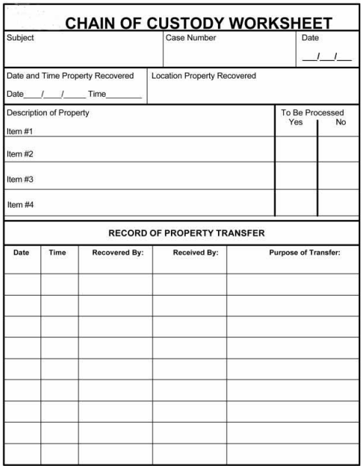
Figure 10[51]

2.1.2 Collection and preservation

All devices would be photographed in their initial locations and labelled appropriately.
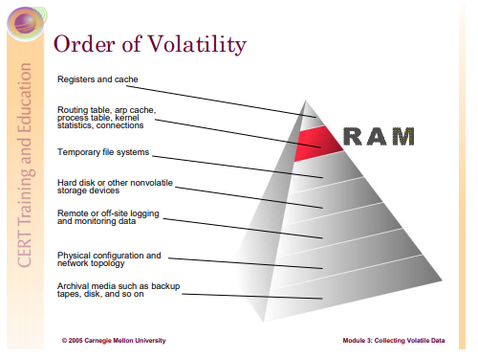
Figure 11[52]
Paying specific attention to the order of volatility the investigation would follow the order of figure 11.
Barry would begin trying to preserve this information
- Starting with mobile phones or devices with little power and no power source
- Then personal computers without a battery or UPS
- Then on to other personal computers/mobile phones which had a power source
In the first instance, a Wireshark trace would be captured of the network traffic to see if anything was left running from the endpoints Rob Jengelley had used. This information could be stored in a log file to analyse later.
An over the network capture would then be attempted of devices which had remained powered on, so information within their memory could be preserved. By doing it over the network it should result in the best possible results[53].
If that was not possible then a run time version of FTK imager, would be launched from a USB key, via FTK Imager Lite, to capture memory in a forensically sound manner, as this does not make changes to the original disk[54]. The page file would also be captured.
The same process would then be used to capture a disk image. Saved as the appropriate file format, for example Raw, .dd[55].
After this the machines would be powered down, and the hard disk removed. It would then be connected to a hard disk write blocker (following anti-static measures), which in turn would be connected to Barry’s laptop. From here he would do another capture to ensure a sound image[54][55].
Each file that was captured, would have a MD5 hash number generated, and it would be backed up using the appropriate methods. All of which would be entered into the case documentation.
Once this process is complete devices would be appropriately stored, for example in faraday bags, with accompanying documentation. A hard disk would need to be stored with a label noting the serial numbers, mac address, model information etc of the computer it was taken from. Further digital photographs can be taken, to add to the documentation.
With forensically sound images having been captured, all original evidence would be physically transferred to secure remote storage, as well as a copy of the forensically sound image. If required, a copy of this image could be retrieved if something was to happen to the copies. The chain of custody document would be updated to reflect any change of ownership.
Witness statements will be taken from Ms Ford, and any engineers involved with Rob Jengelley or his devices. These witness statements will outline any areas of concern and any steps which were taken on the devices. They will be signed and dated by Barry and the witness they were taken from.
Exports of data from key Infrastructure components should be taken and recorded in a forensically sound manner. For example, log files exports from proxy servers, or backup of Exchange email systems which could contain information about those under investigation. MD5 hashes would be captured of these backups, and they would be stored appropriately[56].
Barry would travel with a copy of the forensically sound image back to this base of operations.

2.1.3 Examination and analysis

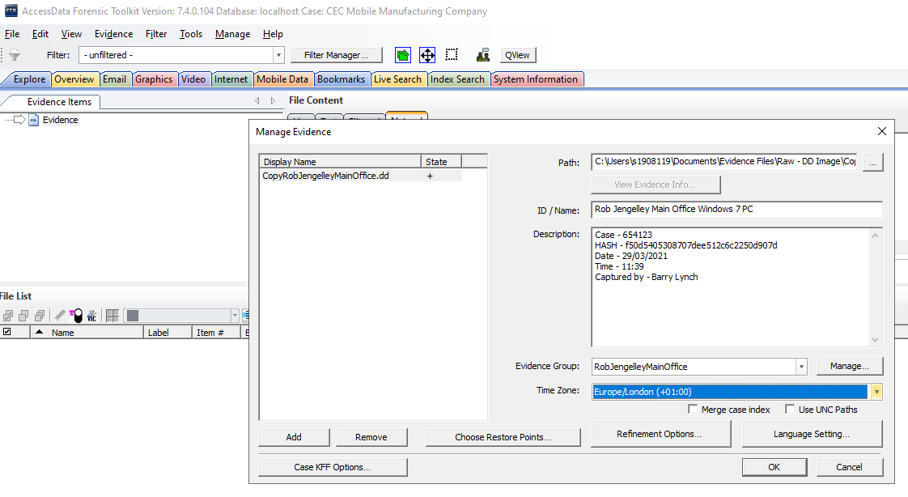
Figure 12
At Barry’s base of operation, he would transfer the forensically sound images from his laptop, to larger capacity servers. These would allow more copies of the data to be taken, as well as backups (allowing them to be recovered easily if something was to go untoward), and an increase in CPU and RAM would speed the interrogation of the images. Using the appropriate software this work would begin on copies of both the volatile and non-volatile images of Android, iOS or personal computer operating systems.
Using FTK Imager as an example, shown in Figure 12, a case file would be generated, and the image file to be worked on imported. Once complete the image can be interrogated in multiple ways, for example Figure 13 shows a keyword search, where the investigator is attempting to search for the Maya file type .iff.
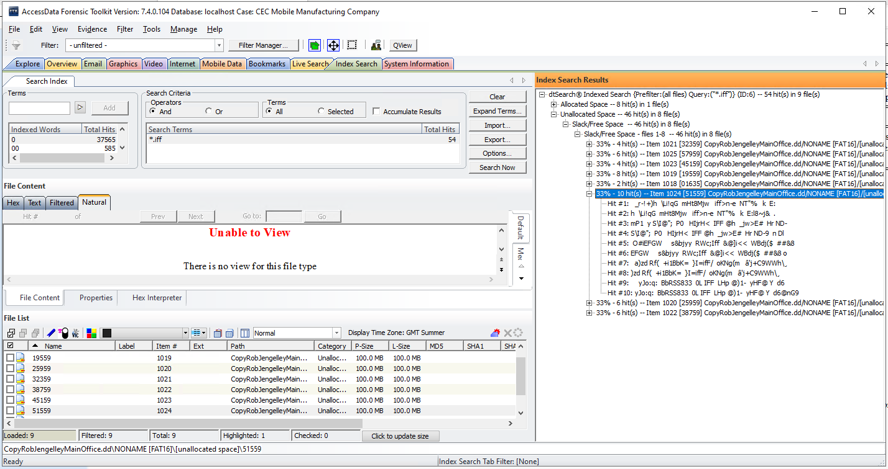
Figure 13
Anything could be entered into this keyword search, for example if/when the same search is repeated against Rob Jengelley’s email, it is found he sent .iff attachments to someone, and on further inspection that was found to be the Samtech domain then that could be used as a keyword, to find further evidence.
Files which appear relevant should have their file metadata gathered, information like file creation, last access, written etc, as this will help build up patterns which could be relevant to the case. This is important for building a timeline which can add context to many aspects of a case for a court[57]. For example, mass copying of files regarding trade secret theft would show last access times across multiple files that were being copied. Although not in itself proof, if is still evidence[58].
Deleted files may appear in “Unallocated” section, in the example of this case, this would be a good place to start looking, shown in Figure 14
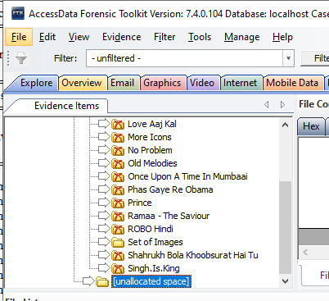
Figure 14
Files which could be relevant to the company, or investigation can be exported as shown in Figure 15
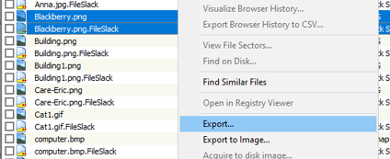
Figure 15
Once all images have been thoroughly investigated, repeating as necessary if more keywords, or other information comes to light, Barry would move onto pulling the documentation into a formal report.

2.1.4 Presentation and reporting

The documentation created during the investigation, such as the chain of custody, diary of each step of the process meticulous recorded in chronological order, templated documentations such as witness statements or reports exported from tools such as Access Data FTK shown in figure 16, would be condensed down into formal documentation shown in figure 17 in the supporting material section. This report would be read by the prosecutor, investigators, expert witness and opposing parties.
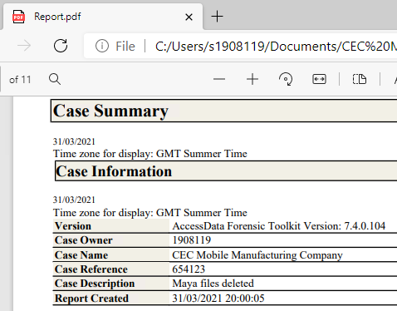
Figure 16
The formal documentation usually contains[13]
- Reporting agency identification
- Identification numbers pertaining to the case
- Identify of the person submitting the case and the investigator
- Dates or report and receipt
- Detailed description of evidence submitted, including serial, model, has numbers and so on
- Identity of the examiner
- Description of the steps taken during the examination process
- Results and conclusions
It is important to remember
- No assumption should be made while writing the report
- Refrain from specifying the leads
- Reports should be well structured
- Follow a logical order
- Avoid slang, colloquial terms and jargon
- Define any acronyms and abbreviations
- Employ active voice in writing

2.1.5 Disseminating the case

After a case has concluded, which maybe after a court case, all property must be returned to the proper owner.
Any criminal evidence must be removed by the appropriate authorities.
The case should be reviewed to identify any areas of improvement, and any lessons learnt preserved.
A final invoice would be submitted to Ms Dee Ford an example is shown in figure 18 in the supporting material section.

3. Conclusion and Evaluation

Computer forensics is a complicated topic area, which is honed through field experience. This is compounded by the fact that as an industry, it must be respectful of the additional complexities of the count of law. Due to this, an investigator must document, document and document further. This all starts with good preparation and following the right methodology for each case. Being successful in this discipline would be both rewarding and challenging, due to the pressures of keeping up with cutting-edge technology, and the various laws and procedure which apply gravity to the investigator.

3.1 Future work

I would like to better understand iOS forensics, as there seems to be some challenges here. Along with what benefits block chain could bring to computer forensic documentation, such as the chain of custody.

References

[1] “The computer revolution: how it’s changed our world over 60 years | World Economic Forum.” https://www.weforum.org/agenda/2016/06/the-computer-revolution-how-its-changed-our-world-over-60-years (accessed Mar. 22, 2021).
[2] “Cybercrime - prosecution guidance | The Crown Prosecution Service.” https://www.cps.gov.uk/legal-guidance/cybercrime-prosecution-guidance (accessed Mar. 22, 2021).
[3] “Your right to a fair trial - Citizens Advice.” https://www.citizensadvice.org.uk/law-and-courts/civil-rights/human-rights/what-rights-are-protected-under-the-human-rights-act/your-right-to-a-fair-trial/ (accessed Mar. 22, 2021).
[4] “Forensic scientist job profile | Prospects.ac.uk.” https://www.prospects.ac.uk/job-profiles/forensic-scientist (accessed Mar. 23, 2021).
[5] F. Science Regulator, “Codes of Practice and Conduct for forensic science providers and practitioners in the Criminal Justice System,” 2020.
[6] “Key rules of evidence - Court Stage - Enforcement Guide (England & Wales).” https://www.hse.gov.uk/enforce/enforcementguide/court/rules-key.htm (accessed Mar. 23, 2021).
[7] Y. Yusoff, R. Ismail, and Z. Hassan, “COMMON PHASES OF COMPUTER FORENSICS INVESTIGATION MODELS,” Int. J. Comput. Sci. Inf. Technol., vol. 3, no. 3, 2011, doi: 10.5121/ijcsit.2011.3302.
[8] “Strengthening Forensic Science in the United States: A Path Forward | The National Academies Press.” https://www.nap.edu/catalog/12589/strengthening-forensic-science-in-the-united-states-a-path-forward (accessed Mar. 28, 2021).
[9] “NIST to Digital Forensics Experts: Show Us What You Got | NIST.” https://www.nist.gov/news-events/news/2020/06/nist-digital-forensics-experts-show-us-what-you-got (accessed Mar. 28, 2021).
[10] “Computer Forensics Tool Testing Program (CFTT) | NIST.” https://www.nist.gov/itl/ssd/software-quality-group/computer-forensics-tool-testing-program-cftt (accessed Mar. 27, 2021).
[11] “42+ Things You Should Have In Your Repair Bag - DEV Community.” https://dev.to/codemouse92/33-things-you-should-have-in-your-repair-bag-2kgd (accessed Mar. 27, 2021).
[12] “Everything You Need to Know about Faraday Bags | JEMIC.” http://www.jemic.com/faraday-bags.html (accessed Mar. 30, 2021).
[13] “The Basics of Digital Forensics : The Primer for Getting Started in Digital Forensics.” https://web.b.ebscohost.com/ehost/ebookviewer/ebook/bmxlYmtfXzkyNDkyOV9fQU41?sid=8da80c4d-7fec-4b27-835c-a1d21aad66a7@sessionmgr102&vid=3&format=EB&rid=1 (accessed Mar. 27, 2021).
[14] “Write Blockers - CRU.” https://www.cru-inc.com/data-protection-topics/write-blockers/ (accessed Mar. 27, 2021).
[15] “FTK® Imager | AccessData.” https://accessdata.com/products-services/forensic-toolkit-ftk/ftkimager (accessed Mar. 27, 2021).
[16] “Digital forensics: 4.3 Different types of digital forensics - OpenLearn - Open University - M812_1.” https://www.open.edu/openlearn/science-maths-technology/digital-forensics/content-section-4.3 (accessed Mar. 25, 2021).
[17] “How to use Access Data forensic toolkit. - YouTube.” https://www.youtube.com/watch?v=aoQbbmkOdY4 (accessed Mar. 27, 2021).
[18] “What-is-a-Bit-Stream-Image.” http://www.computer-forensics.net/what-is-a-bit-stream-image.html (accessed Mar. 27, 2021).
[19] “Forensic Toolkit (FTK)® | AccessData.” https://accessdata.com/products-services/forensic-toolkit-ftk (accessed Mar. 27, 2021).
[20] “Exterro Acquires AccessData to Form the Leading… | AccessData.” https://accessdata.com/blog-press-releases/press-releases/exterro-acquires-accessdata-to-form-the-leading-enterprise-legal-grc-software-platform-across-data-privacy-forensics-and-e-discovery (accessed Mar. 27, 2021).
[21] “What is Wireshark? - InfoSec Addicts | Cyber Security.” https://infosecaddicts.com/whats-wireshark/ (accessed Mar. 27, 2021).
[22] “Chapter 1. Introduction.” https://www.wireshark.org/docs/wsug_html_chunked/ChapterIntroduction.html#ChIntroWhatIs (accessed Mar. 27, 2021).
[23] “(PDF) Network forensics analysis using Wireshark.” https://www.researchgate.net/publication/281573989_Network_forensics_analysis_using_Wireshark (accessed Mar. 27, 2021).
[24] “Volatility Memory Forensics Framework | Black Hat Ethical Hacking.” https://www.blackhatethicalhacking.com/tools/volatility-framework/?__cf_chl_jschl_tk__=da86ae78ff93afd756103e62271f3fa1318d32ba-1616864353-0-ASR66Yyej3lq3eNxpmGLOtw-oDNlC3zkWGKY4VijJyMSqSQVPgbYkHdhE_Ibzjhsb9F1Iw1Wb_9QQrXWm0CGzZTHAC9uiLPb4t3Zf4xdB3e_LU1AZ9ckyk4DmngAglbOw27aRjGw7H9O5CqbXVV1YVyvK4suMTk4e87h8pFcWvQryUEASzjtC-IaK7MuFVHdpWJ2AV-nkdK1iaB38UiHM2PHxUH7GRacXNTJ7TxnRTcEbjeAH9bGb7IecrEHlJCovnDqGjSQDAPGM6MKge24vdn1menNuxjDIUZBHRgDL7CECav1cghFX7VBbgLVhSLym8E2JZ05XnJ-meINuxcW-r-4LeanRVpcGA7WdVLFpSXp (accessed Mar. 27, 2021).
[25] “What Is RAM? Here’s Everything You Need to Know About It | Digital Trends.” https://www.digitaltrends.com/computing/what-is-ram/ (accessed Jul. 06, 2020).
[26] “All you need to know about Memory Forensics | Tools for Memory Forensics | EC-Council.” https://blog.eccouncil.org/all-you-need-to-know-about-memory-forensics-identifying-potential-volatile-data/ (accessed Mar. 27, 2021).
[27] “FBI — Forensic Science Communications - July 2004.” https://archives.fbi.gov/archives/about-us/lab/forensic-science-communications/fsc/july2004/research/2004_03_research01.htm (accessed Mar. 25, 2021).
[28] “What is steganography and what are its popular techniques? | EC-Council.” https://blog.eccouncil.org/what-is-steganography-and-what-are-its-popular-techniques/ (accessed Mar. 27, 2021).
[29] “What is Malware? Defined, Explained, and Explored | Forcepoint.” https://www.forcepoint.com/cyber-edu/malware (accessed Mar. 27, 2021).
[30] “Kali Linux | Penetration Testing and Ethical Hacking Linux Distribution.” https://www.kali.org/ (accessed Mar. 27, 2021).
[31] “Making a Kali Bootable USB Drive (Windows) | Kali Linux Documentation.” https://www.kali.org/docs/usb/live-usb-install-with-windows/ (accessed Mar. 27, 2021).
[32] “What is Kali Linux? | Kali Linux Documentation.” https://www.kali.org/docs/introduction/what-is-kali-linux/ (accessed Mar. 27, 2021).
[33] “Kali Linux Tools Listing | Penetration Testing Tools.” https://tools.kali.org/tools-listing (accessed Mar. 27, 2021).
[34] “MD5 Hash Generator.” https://www.md5hashgenerator.com/ (accessed Mar. 27, 2021).
[35] “Computer Forensics & Electronic Discovery Services | Resources | Legal Tools | Sample Chain of Custody.” http://www.setecinvestigations.com/resources/legaltools/legaltool11.php (accessed Mar. 27, 2021).
[36] P. Cichonski, T. Millar, T. Grance, and K. Scarfone, “Computer Security Incident Handling Guide Recommendations of the National Institute of Standards and Technology,” doi: 10.6028/NIST.SP.800-61r2.
[37] “Alarming Cybersecurity Stats: What You Need To Know For 2021.” https://www.forbes.com/sites/chuckbrooks/2021/03/02/alarming-cybersecurity-stats-------what-you-need-to-know-for-2021/?sh=326e544e58d3 (accessed Mar. 27, 2021).
[38] “Counter Forensics.” https://www.digitalforensicsmagazine.com/index.php?option=com_content&view=article&id=315:counterforensics&catid=39:issue2 (accessed Mar. 27, 2021).
[39] “Black Hat Hacker - an overview | ScienceDirect Topics.” https://www.sciencedirect.com/topics/computer-science/black-hat-hacker (accessed Mar. 28, 2021).
[40] “Cybersecurity Spotlight – The Surface Web, Dark Web, and Deep Web.” https://www.cisecurity.org/spotlight/cybersecurity-spotlight-the-surface-web-dark-web-and-deep-web/ (accessed Mar. 27, 2021).
[41] “BBC News launches ‘dark web’ Tor mirror - BBC News.” https://www.bbc.co.uk/news/technology-50150981 (accessed Mar. 27, 2021).
[42] “VPN into a secure private network.” https://cloud.ibm.com/docs/solution-tutorials?topic=solution-tutorials-configuring-IPSEC-VPN (accessed Nov. 11, 2020).
[43] “Configuring Proxy Chaining | Zscaler.” https://help.zscaler.com/zia/configuring-proxy-chaining (accessed Mar. 27, 2021).
[44] “tor - Google Search.” https://www.google.com/search?q=tor&rlz=1C1ONGR_en-GBGB946GB946&oq=tor&aqs=chrome.0.69i59l3j46i131i433j0j69i60l3.399j0j7&sourceid=chrome&ie=UTF-8 (accessed Mar. 27, 2021).
[45] S. R. Selamat, R. Yusof, and S. Sahib, “Mapping Process of Digital Forensic Investigation Framework,” 2008.
[46] “Autodesk Mobile Apps for IOS & Android | Product Design Apps.” https://www.autodesk.com/mobile-apps (accessed Mar. 30, 2021).
[47] “System Requirements for Autodesk Maya 2020 | Maya 2020 | Autodesk Knowledge Network.” https://knowledge.autodesk.com/support/maya/troubleshooting/caas/sfdcarticles/sfdcarticles/System-requirements-for-Autodesk-Maya-2020.html (accessed Mar. 30, 2021).
[48] “Evidence Storage - an overview | ScienceDirect Topics.” https://www.sciencedirect.com/topics/computer-science/evidence-storage (accessed Mar. 30, 2021).
[49] “Bring Your Own Device (BYOD) - NCSC.GOV.UK.” https://www.ncsc.gov.uk/collection/mobile-device-guidance/bring-your-own-device (accessed Nov. 10, 2020).
[50] “Subscription Benefits | Cloud Storage | Autodesk Drive.” https://www.autodesk.co.uk/subscription/drive (accessed Mar. 30, 2021).
[51] “Improving Cyber Forensics & Cybersecurity through Block Chain Technology with Truth Based Systems Interna(onal Symposium on Forensic Science Error Management Introductions,” 2015.
[52] “(No Title).” https://resources.sei.cmu.edu/asset_files/Handbook/2005_002_001_14429.pdf (accessed Mar. 30, 2021).
[53] “Responder - an overview | ScienceDirect Topics.” https://www.sciencedirect.com/topics/computer-science/responder (accessed Mar. 30, 2021).
[54] “Run FTK Imager from a flash drive (Imager Lite) – AccessData Help Center.” https://support.accessdata.com/hc/en-us/articles/203681809-Run-FTK-Imager-from-a-flash-drive-Imager-Lite- (accessed Mar. 30, 2021).
[55] “Evidence Acquisition Using Accessdata FTK Imager - Forensic Focus.” https://www.forensicfocus.com/articles/evidence-acquisition-using-accessdata-ftk-imager/ (accessed Mar. 30, 2021).
[56] “(PDF) Analysis of Web Proxy Logs.” https://www.researchgate.net/publication/221352730_Analysis_of_Web_Proxy_Logs (accessed Apr. 13, 2021).
[57] “Timelines In Digital Forensic Investigation: From Investigation To Court - Forensic Focus.” https://www.forensicfocus.com/articles/timelines-in-digital-forensic-investigation-from-investigation-to-court/ (accessed Mar. 30, 2021).
[58] “About Metadata and its Use in Investigations.” https://www.computerforensics.com/news/what-is-metadata (accessed Mar. 30, 2021).
[59] “Digital Forensic report- sample - With File HTML_redacted.” http://online.fliphtml5.com/rllbc/zdmn/#p=2 (accessed Mar. 31, 2021).
[60] “Problem: ActIvIty - Rice University-Flip eBook Pages 1 - 14| AnyFlip | AnyFlip.” http://anyflip.com/zgcu/edwb/basic/mobile/index.html (accessed Mar. 31, 2021).

Supporting material

Professional Forensic Report (Sample)

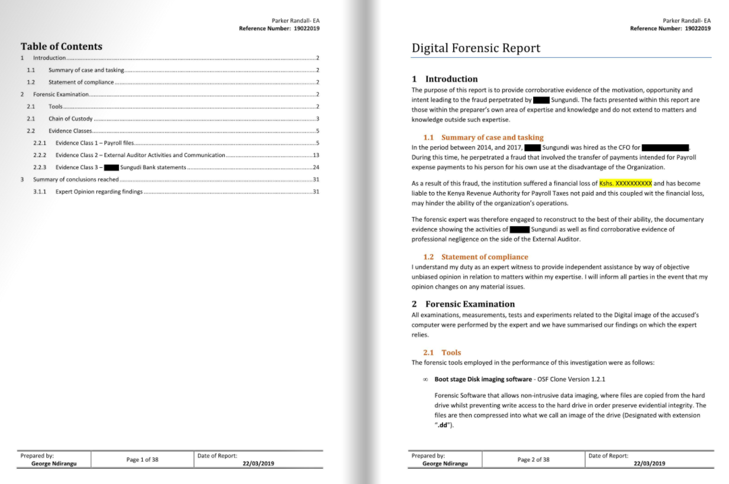
Figure 17 [59]

Invoice (Sample)

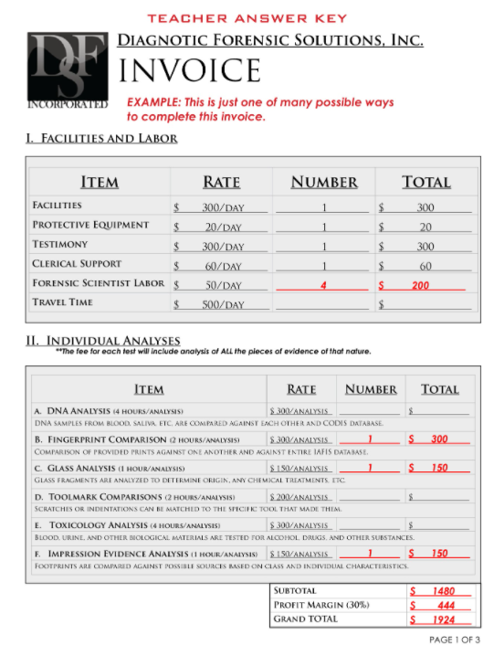
Figure 18 [60]

