Visit Argentina- The Most Geographically Diverse Country in the World?

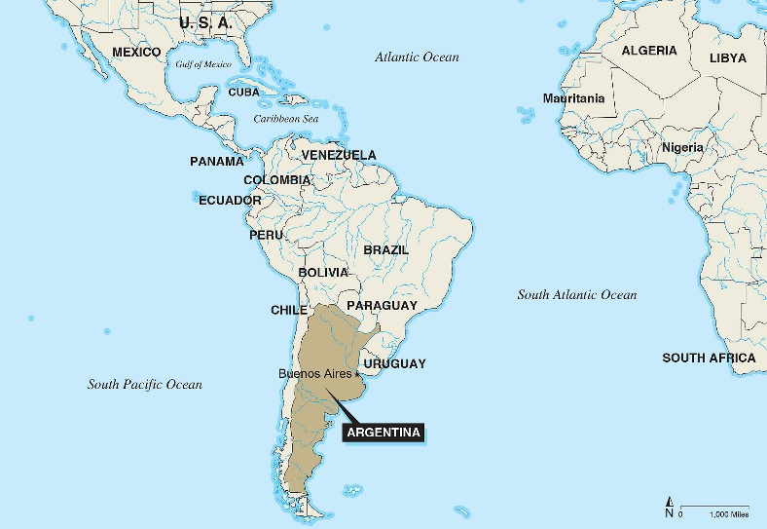
The independent state and republic of Argentina is situated in South America. With a total area of 2,780,400 km2, it holds the title of 8th largest country in the world and the 2nd largest country in South America following Brazil. It is a largely urban country. The currency is the Argentine Peso and presently the British Pound is very weak counter to the Peso, making it an incredibly inexpensive destination for British people to visit. The population of Argentina, as of 2016, is 43.5 million people; Argentina’s populace consists of a variety of different ethnic groups who largely have progenies originally from Spain and Italy (Nations Online, 2019). The national religion is predominantly Roman Catholic. Although many religious people are non-practising, religious influence is palpable in Argentina’s culture and government (Britannica, 2019).
Source: FBI.GOV

Tourism in Argentina is a bourgeoning industry. The Argentinian economy is recently becoming more contingent on contributions to the country from international tourists. In 2017, there were 5,922,000 inbound visitors- an increase of 363,000 from the previous year. It is speculated to grow to the percentage of 5.8 per annum which would equal an increase of 12,425,000 visitors by 2027 (Tourism Prof, 2019). Gov.UK (2019) articulates that 99,391 of the visitors in 2017 were British nationals. Visitors to Argentina mainly come from contiguous countries such as Bolivia, Brazil, Chile and Paraguay and Uruguay. Visitors also come from Peru and Dominican Republic. The top European countries to visit Argentina are Spain, Italy, France, Germany and the UK (Tourism Prof, 2019). In the 1990’s, the figure of international tourist arrivals was close to 5 million (Britannica, 2019). Leisure tourism has contributed an immense 69.8% of total revenue generated from travel and tourism in 2017. Business travel created 30.2% in comparison, which demonstrates the main reason for travel to Argentina being leisure (CIEC Data, 2018).
Argentina currently tries to attract international tourists by making the experience as inexpensive as possible. Incorporating Kotler’s Marketing Mix, which identifies the four P’s which are Price, Promotion, Place and Product- Price is considered by Argentina for international tourists (Purely Branded, 2019). This is done by creating competitive prices. For example, when staying in Buenos Aires, ‘International visitors receive a direct and automatic reimbursement of the 21% value added tax (VAT) charged on accommodation’ (Turisimo Buenos Aires, 2019). This applies to all foreign tourists who pay with foreign credit/debit cards from a foreign bank.
Source: Cleverism.com
By doing this, Argentina is taking advantage of the approving exchange rates and coupling it with refunding the VAT to try and reach more international tourists, particularly from the UK (Turisimo Buenos Aires, 2019). According to Lonely Planet (2019), Argentina is an innocuous country to visit and is also considered a safe country within South America. World Travel Guide (2019) states that the society is accepting with respect to same sex marriage and human rights, and they take discrimination very seriously. Argentina is as safe as London, Paris or New York. For British tourists, accessibility to Argentina is good. In 2018, 7 flights departed from Britain every week and these are all direct routes, such as British Airways flight from Heathrow to Buenos Aires (Visit Britain, 2019).
Included in ABTA’s Travel Trends report for 2017 in the Destinations to Watch category is Argentina- ‘The best steaks in the world, a sophisticated capital city, the wide plains of the Pampas, glaciers of Patagonia and the breath-taking Iguazu falls, all at very affordable prices’ (ABTA, 2018). Global tourism has seen ‘uninterrupted growth from 25 million to 278 million in 1930, 674 million in 2000, 1087 million in 2013 and 1186 million in 2015’, according to WTO Highlights (2013). Tourism is projected to see a continuation of the same rapid growth, particularly for emerging markets including Argentina. The tourism market segment for emerging economies has seen a rise of 15%, from 30% in 1980 to 45% in 2015. By 2030, this percentage is anticipated to grasp 57%. This would mean 1 billion additional international tourists and bodes well for Argentina’s international tourist figures. (WTO Highlights, 2013). Argentina is a large country and does have enough space for the increase in tourists. However, when aiming to attract more visitors, extra infrastructure would need to be implemented to support this.
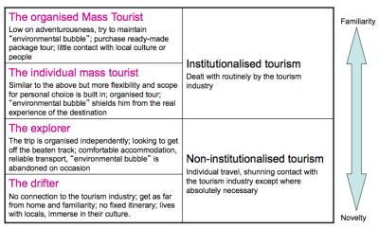
Conferring to Cohen’s Classification of Tourists (1972), there are 4 types of tourist on a scale of curiosity and security. These are the Drifter, Explorer, Individual Mass Tourist and Organised Mass Tourist. The Organised Mass Tourist is the least curious of the 4 and prefers security and familiarity and has an extremely organised trip. The Individual Mass Tourist is very similar to the previous but with a slightly less rigid itinerary. The Explorer leaves their comfort zone and visits unusual areas but still seeks comfort and reliability. The Drifter will organise the whole trip on themselves to a unique area and will make substantial efforts to mix with the local people and live according to local customs.
Source: Study Blue
Another angle to Cohen’s Classification of Tourists is Plog’s Psychological Theory (1974). Following this theory, tourist behaviour can be split into 3 categories. Allocentric travellers are people enthusiastic to travel to new and unique destinations and have diminutive fear about doing so. These tourists prefer more independence for exploration. Psychocentric tourists are less audacious and recurrently visit the same destinations on each occasion they travel. The Mid-centric tourist falls in the middle of these two categories. Most of the population falls into the Mid-centric category. The type of visitors that Argentina would attract would be Allocentric since Argentina is perceived as a unique destination and it can be argued that it appeals to the niche market (Tutorials Point, 2019).
Argentina is an incredibly geographically diverse country. Bordering Argentina is Bolivia, Paraguay, Brazil, Uruguay and Chile. It is also bordered by the Atlantic Ocean and has thousands of miles of coastline. According to Nations Online (2019), Argentina has seven geographical regions. These are the Argentine Northwest, Gran Chaco, the Sierras Pampeanas, Mesopotamia, Cuyo, the Pampas and Patagonia. All seven regions are very dissimilar to each other, some even adopting their own climates. Gran Chaco is described by Nations Online (2019) as ‘a hot and semi-arid lowland’. Mesopotamia is a subtropical expanse amid both Parana and Uruguay rivers.
Cuyo is a rocky desert region located at the bottom of the Andes mountains and can be found to the west of the country (Andean Trails, 2019). The Pampas grasslands are fragmented into the Dry Pampa and the Humid Pampa to reflect the weather conditions of the area. The Pampas are situated in central Argentina. The final region, Patagonia is south of the Pampas. Patagonia is a very dehydrated and cold part of the country. From north to south across these regions, Argentina has an array of different climates, oscillating from subpolar to tropical (Britannica, 2019).
A notable part of Argentina’s topography is the Andes Mountains. The Andes mountain range is detached into two sections- the Northwest and the Patagonian Andes. This complete section spreads the distance from Bolivia to southern Patagonia (Nations Online, 2019). According to Britannica (2019), Argentina also ‘claims a portion of Antarctica, as well as several islands in the south Atlantic, including the British-ruled Falkland Islands’. Sections of jungle can be found in the Northeast of the country (Britannica, 2019).
The different regions of Argentina being largely unique to one another means that Argentina attracts tourists seeking all different natures of holidays. Buenos Aires, the country’s capital city, has a very colourful ambience but in disparity, the North West is home to Andean culture and Patagonia offers a secluded and quiet atmosphere. Argentina appeals to adventure tourists- they travel to see places including Patagonia, Tierra Del Fuego and the ski resorts in the Lake District, whereas Buenos Aires, or The Paris of South America, as it is sometimes referred to, attracts a different type of tourist with its spectacular nightlife and cultural attractions (Britannia, 2019). Argentina has an impressive range of incredible tastes to be appreciated. Tourists can find Choripan, chorizo in a bread roll; Parrillada, a mixed grill with a twist; Puchero, an earthy stew; and Carbonada, a mixture of tomatoes, onions and minced beef (Andean Trails, 2019).
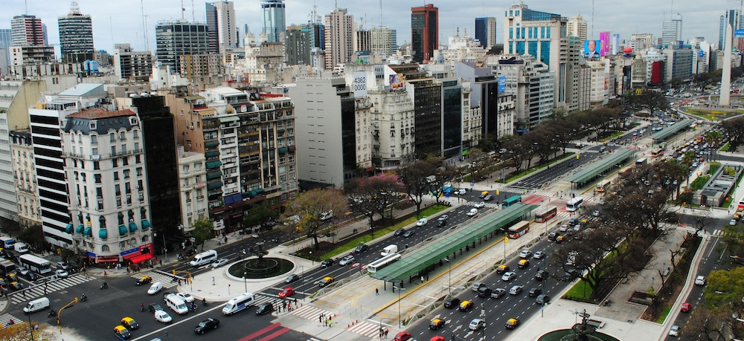
Argentina is best well known for its multicultural capital of Buenos Aires, a vivacious and lively city with lots to offer for tourists. It is arguably one of the world’s most stimulating capital cities with respect to tourism. It has a warm and friendly atmosphere and the people are known to be hospitable.
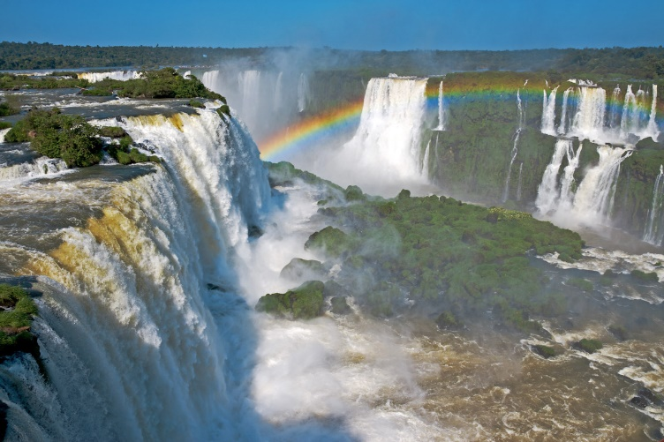
The city and its people are avid about football and this passion is reflected in the electric atmosphere during games, which attracts sport tourism. Buenos Aires has an appealing contemporary and artistic aptitude in amongst its wealth of architecture and culture. The architecture is debatably like that featured in Rome or Paris. The city is well known for its imposing nightlife where many tourists and locals party all through the night in an assortment of bars, clubs, pubs. Argentina also caters for the niche market when it comes to its club scene and offers a more dissident experience. Buenos Aires also has brilliant shopping and is known for its classic Latin American fashion and design. The city presents colourful 19th century constructions, which gives a unique appearance and aids to attract many tourists each year. Amongst these buildings is the famous Casa Rosada, translated to ‘pink house’, which is the presidential office and seat of the Argentine government. Most of Casa Rosada was designed by Italian architect Francisco Tamburini who is also known for his designing of the Colon Theatre, also in Buenos Aires (Turisimo Buenos Aires, 2019).
Source: Institute for Transport and Development Policy
Distancing from the animated capital city and its sparkling culture, is the copiousness of exotic wildlife and areas of natural beauty that occupy the country (Tourism Prof, 2019). Across Argentina’s colossal expanse are 11 UNESCO Heritage Sites and many other natural attractions worthy of visiting (UNESCO, 2019). The fact that there are so many World Heritage Sites means that visitor figures are increased as people will travel to see them. Iguazu Falls is a UNESCO world heritage site, declared in 1984. The waterfall is made up of a collection of reduced waterfalls. Iguazu is translated to ‘big water’ from Guarani- the Iguauzu River can be found between Brazil and Argentina in a great stretch of national park, the river is a large body of water which moves into the Parana River. The river finally reaches a lava cliff where the water falls (Iguazu Falls, 2019).
Source: VamosSpanish.com
The Tierra del Fuego province comprises of the Argentine Arctic Islands and the Islas Malvinas. Ushuaia is the capital of this jurisdiction. It is southernmost city in the world, the only thing south of Ushuaia is Antarctica. Upon arrival to the city, there is a distinct feeling of distance and a feeling of being at the end of the world. It is a very small city which lies between the Andes mountain range and the Beagle Channel and is an unforgettable place to visit. Ushuaia attracts a host of tourists as it is often described as mystical. The landscapes are remarkable and there are plenty of outdoor activity opportunities which attract adventure tourists (Vamos Spanish, 2018). Outdoor activities on offer consist of skiing and snowboarding in the winter, as the city is blanketed in snow. Ushuaia is best relished in the autumn and spring, where its brilliant colours can be best appreciated (Argentina Travel, 2019).
Argentina also is home to a range of stunning attractions. The most notable are its natural attractions. Parque Provincal Ischigualasto, a UNESCO heritage site, in San Juan is home to one of the most relevant fossils find of in history. It holds the ‘most complete known continental fossil record from the Triassic Period’ UNESCO, 2019. Otherwise known as Moon Valley, the area is a protected zone and contains more dinosaur remnants and unearthly rock constructions (UNESCO, 2019).
Quebrada de Humahuaca is an impressive attraction in Jujuy, located to the north of the country. It is a ravine bursting with immense rock. Native Quechuan villages can be found around the gorge and these are very interesting for tourists to visit. Quebrada de Humahuaca is a UNESCO world heritage site (Culture Trip, 2017). It is a very cultural attraction and can be found on the Camino Inca, which is a route of most important cultural sites through Argentina. There is evidence that Quebrada de Humahuaca was a trade route for the aboriginal people of the Inca Empire in the 15th to 16th centuries (UNESCO, 2019).
On the outskirts of El Calafate is the Los Glaciares National Park. This national park is home to the Perito Moreno Glacier. This glacier is 60 meters tall and only getting larger- unlike most glaciers in the world which shrink, Perito Moreno Glacier grows an impressive 2 meters a day. It is a stunning natural attraction and tourists come from afar to behold it (Culture Trip, 2017).
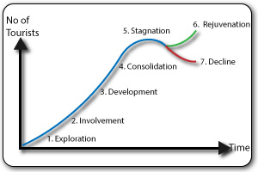
To conclude, Argentina has recently benefited from increased tourism figures which are only rising, and the future for tourism looks bright (OECD Tourism Trends and Policies, 2014). Butlers Life Cycle (1980) is a model used to establish the ways in which tourist resorts develop (Geography Field Work, 2019). Applying this model, Argentina is in the stage of growing and developing currently to reach its full potential as a resort. With the help from government and tourism authorities, Argentina could become a very successful resort in the future.
Source: GetRevising.co.uk

Bibliography

ABTA (2018), ‘Travel Trends Report’, [Online]. Available: www.abta.com, [Accessed: 2019, February 20].
Andeantrails.co.uk (2019), ‘Introduction to Argentina’, [Online]. Available: www.andeantrails.co.uk, [Accessed: 2019, March 5].
Argentinatravel.com (2019), ‘The City of Buenos Aires’, [Online]. Available: www.argentinatravel/#!/?lang=en, [Accessed: 2019, March 5].
Beautifulworld.com (2019), ‘Iguazu Falls’, [Online]. Available: www.beautifulworld.com, [Accessed: 2019, March 5].
Britannica.com (2019), ‘Argentina’, [Online]. Available: www.britannica.com, [Accessed: 2019, February 20].
CIECdata.com (2019), ‘Argentina Tourism Statistics’, [Online]. Available: www.ciecdata.com, [Accessed: 2019, February 20].
DEAs, K. (2017), ’15 Must Visit Attractions in Argentina’, [Online]. Available: www.theculturetrip.com, [Accessed: 2019, February 20].
Geographyfieldwork.com (2019), ‘Butler Model of Tourist Resort Development’, [Online]. Available: www.geographyfieldwork.com, [Accessed: 2019, March 1].
Gov.uk (2019), ‘Foreign Travel Advice Argentina’, [Online]. Available: www.gov.uk, [Accessed: 2019, March 1].
Iguazufalls.com (2019), ‘Iguazu National Park: The Argentinean Side of the Falls’, ‘Online]. Available: www.iguazufalls.com, [Accessed: 2019, February 20].
Lonelyplanet.com (2019), ‘Iguazu Falls’, [Online]. Available: www.lonelyplanet.com, [Accessed: 2019, March 5].
Lonelyplanet.com (2019), ‘Ushuaia’, [Online]. Available: www.lonelyplanet.com, [Accessed: 2019, February 20].
Nationsonline.org (2019), ‘Argentina’, [Online]. Available: www.nationsonlineorg, [Accessed: 2019, February 20].
Nexusholidays.ca (2019), ‘Argentina Overview’, [Online]. Available: www.nexusholidays.ca, [Accessed: 2019, March 5].
OECD (2014), OECD Tourism Trends and Policies 2014, OECD Publishing: Paris.
Purelybranded.com (2019), ‘The 4 P’s of Marketing’, [Online]. Available: www.purelybranded.com, [Accessed: 2019, February 21].
Torkildsen, G. (2005), Leisure and Recreation Management, (5th Edition), Oxon: Routledge.
Tourismprof.com (2019), ‘Argentina Tourism Statistics’, [Online]. Available: www.tourismprof.club, [Accessed: 2019, March 1].
Tradingeconomics.com (2019), ‘Argentina Tourist Arrivals’, [Online]. Available: www.tradingeconomics.com, [Accessed: 2019, March 5].
Turisimobuenosaires.gob.ar (2019), ‘Buenos Aires Cuidad’, [Online]. Available: www.turisimobuenosaires.gob.ar/en, [Accessed: 2019, February 20].
Turisimobuenosaires.gob.ar (2019), ‘Casa Rosada’, [Online]. Available: www.turisimobuenosaires.gob.ar/en, [Accessed: 2019, February 20].
Tutorialspoint.com (20190, ‘Plog’s Model of Tourist Behaviour’, [Online]. Available: www.tutorialspoint.com, [Accessed: 2019, March 5].
UNESCO (2019), ‘Quebrada de Humahuaca’, [Online]. Available: www.whc.unesco.org, [Accessed: 2019, February 21].
Vamosspanis.com (2018), ‘Discover Ushuaia, Tierra Del Fuego, Patagonia’, [Online]. Available: www.vamosspanish.com, [Accessed: 2019, February 20].
VisitBritain.org (2019), ‘Argentina’, [Online]. Available: www.visitbritain.org, [Accessed: 2019, February 17].
Welcomeargentina.com (2019), ‘Argentine Provinces’, [Online]. Available: www.welcomeargentina.com, [Accessed: 2019, February 21].
Worldtravelguide.net (2019), ‘Argentina Travel Guide’, [Online]. Available: www.worldtravelguide.net, [Accessed: 2019, March 5].
WTO (2013), ‘UNTWO Highlights 2013 Edition’, [Online]. Available: www.e-untwo.org, [Accessed: 2019, February 21].
WTTC.org, (2017), ‘Travel and Tourism Economic Impact 2017 Argentina’, [Online]. Available: www.wttc.org, [Accessed: 2019, March 1].

