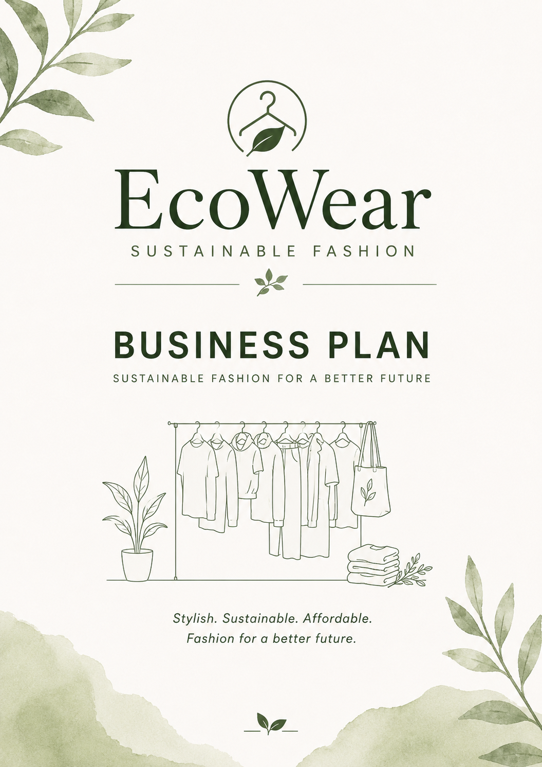  UNIVERSITY OF WALES TRINITY SAINT DAVID BA (Hons) Business Management LCBB5013 – Entrepreneurship Business Plan Development  ECOWEAR – SUSTAINABLE FASHION BUSINESS | Abstract  This business plan introduces EcoWear, an online clothing business that offers affordable and sustainable fashion in the UK. The plan outlines the business idea, target market, competitive environment, marketing strategy and financial planning. EcoWear aims to provide stylish clothing made from sustainable materials while keeping prices affordable. By focusing on customer satisfaction, transparency and effective online marketing, the business aims to build a strong brand and achieve long-term growth in the sustainable fashion industry.  ionela turcanu  Student Name: Alina Turcanu Student ID: 2321536 Module Leader: Balendran Kandasamy Module Code: LCBB5013 Assignment Title: Portfolio – Task 1: Business Plan Development

Contents
Introduction 2
Element 1: Business Idea, Products/Services, Objectives and Unique Selling Point (USP) 2
Business Idea 2
Products and Services 3
Business Objectives 3
Short-term Objectives 3
Long-term Objectives 4
Unique Selling Point (USP) 4
Element 2: Business Environment and Competitor Analysis… 5
SWOT Analysis 5
Competitor Analysis 6
Direct Competitors 6
Indirect Competitors 6
Competitive Position 7
Element 3: Business Model, Market Segmentation, 4Ps and Marketing Strategies 7
Market Segmentation and Target Customers 7
Business Model 8
Marketing Mix (4Ps) 8
Product 8
Price 8
Place 9
Promotion 9
Online Marketing Strategies 9
Element 4: Financial Planning 10
Start-up Costs 10
Operating Costs 10
Sales Forecast and Break-even Analysis 11
Funding Source 11
Conclusion 12
Bibliography 13

Introduction
This business plan focuses on EcoWear, a proposed online clothing business that aims to offer fashionable, affordable and environmentally friendly clothing to customers across the UK. As more people become aware of the environmental impact of the fashion industry, the demand for sustainable clothing continues to grow. This creates an opportunity for businesses that can combine style, quality and responsible production.
The purpose of this business plan is to assess whether EcoWear has the potential to succeed in the current market. It examines the business idea, competitive environment, marketing approach and financial planning by applying recognised business tools and concepts. Overall, the plan demonstrates how EcoWear could develop into a competitive and sustainable business within the UK fashion industry.

Element 1: Business Idea, Products/Services, Objectives and Unique Selling Point (USP)

Business Idea
EcoWear is a proposed online clothing business that aims to provide stylish, affordable and sustainable fashion for customers across the United Kingdom. The idea behind the business is to make environmentally friendly clothing more accessible to people who want to make responsible purchasing decisions without paying premium prices. As environmental awareness continues to increase, many consumers are looking for fashion brands that combine quality, style and sustainability. This change in consumer behaviour creates a valuable opportunity for businesses that focus on ethical and environmentally responsible practices. (Company, 2024)
(Deloitte, 2024)Unlike many sustainable clothing brands that mainly target higher-income consumers, EcoWear aims to reach a wider audience by offering fashionable products at competitive prices. The business will operate entirely online, allowing it to reduce operating costs, reach customers throughout the UK and respond more quickly to changing fashion trends. Selling online also provides greater flexibility, making it easier to introduce new collections and communicate directly with customers.
The overall purpose of EcoWear is not only to sell clothing but also to encourage more sustainable shopping habits by offering products that balance affordability, quality and environmental responsibility.

Products and Services
EcoWear will offer a range of clothing and accessories for both men and women. The collection will include casual wear, sportswear, jackets and everyday accessories designed for customers who value both comfort and style. Wherever possible, products will be manufactured using recycled or responsibly sourced materials to reduce their impact on the environment.
Alongside its products, EcoWear will provide services that improve the customer experience. These include secure online payments, fast delivery, an easy returns policy and responsive customer support. As the business grows, a loyalty programme will also be introduced to reward repeat customers through exclusive discounts and special offers.
I believe that combining high-quality products with reliable customer service will help EcoWear build long-term relationships with customers and encourage repeat purchases.

Business Objectives
Setting clear objectives is important because they provide direction for the business and help measure its progress over time.

Short-term Objectives
During the first year, EcoWear aims to successfully launch its online store and establish a presence within the UK sustainable fashion market. Another important objective is to increase brand awareness through social media and digital marketing campaigns. The business also plans to attract at least 500 customers while maintaining high levels of customer satisfaction through quality products and dependable service.

Long-term Objectives
Over the next five years, EcoWear intends to expand its product range by introducing new clothing collections and accessories that reflect customer preferences and market trends. Once the business has established a strong customer base in the UK, it will explore opportunities to expand into international markets.
Another long-term objective is to strengthen partnerships with ethical suppliers and continue improving the sustainability of its products and packaging. The overall ambition is to build a trusted fashion brand that is recognised for offering affordable and environmentally responsible clothing.

Unique Selling Point (USP)
The main feature that differentiates EcoWear from many competitors is its ability to combine sustainability with affordability. While a large number of sustainable fashion brands focus on premium products with higher prices, EcoWear aims to make eco-friendly clothing available to a wider range of consumers.
Another important aspect of the business is its commitment to transparency. Customers are becoming more interested in understanding where products come from, how they are produced and whether businesses follow ethical practices. By providing clear information about suppliers, materials and manufacturing processes, EcoWear aims to build trust and encourage customers to make informed purchasing decisions. (Deloitte, 2024)
Overall, EcoWear aims to demonstrate that sustainable fashion does not have to be expensive. By offering fashionable products, competitive prices and excellent customer service, the business hopes to build a loyal customer base and establish a strong position within the UK sustainable fashion market.

Element 2: Business Environment and Competitor Analysis…

SWOT Analysis
A SWOT analysis is a useful planning tool that helps identify the internal strengths and weaknesses of a business, as well as the external opportunities and threats that could influence its performance. Understanding these factors allows EcoWear to make informed decisions and prepare appropriate strategies before entering the market.
Strengths | Weaknesses
Offers affordable sustainable fashion, making eco-friendly clothing accessible to more customers. | As a new business, EcoWear has limited brand recognition and no established customer base.
Operating exclusively online reduces overhead costs and allows nationwide sales. | Limited financial resources may restrict advertising and business expansion during the early stages.

Opportunities | Threats
Demand for sustainable fashion continues to increase as consumers become more environmentally conscious. | Strong competition from well-established fashion retailers with larger marketing budgets.
Social media and e-commerce provide cost-effective ways to reach potential customers. | Rising manufacturing, material and delivery costs may reduce profit margins.
Research shows that sustainability is becoming an increasingly important factor when consumers choose fashion brands. This creates a positive opportunity for EcoWear because the business is designed around environmentally responsible products and ethical values. However, the fashion industry remains highly competitive, meaning EcoWear will need to build strong customer relationships and continuously differentiate itself from existing brands. (Deloitte, 2024)

Competitor Analysis
Understanding competitors is important because it helps identify market gaps and opportunities for differentiation. EcoWear will compete with both sustainable fashion brands and larger clothing retailers that attract similar customers.

Direct Competitors
Patagonia
Patagonia is one of the world's best-known sustainable clothing brands. The company has built a strong reputation through its commitment to environmental responsibility, durable products and ethical manufacturing. Although Patagonia has a loyal customer base, its premium pricing makes many of its products less affordable for average consumers. EcoWear could appeal to customers who value sustainability but are looking for more budget-friendly alternatives.
People Tree
People Tree specialises in ethical and Fairtrade fashion. The company focuses on sustainable production and works closely with certified suppliers. While People Tree has established credibility within the sustainable fashion market, its product range is relatively limited compared to larger retailers. EcoWear plans to offer a wider variety of modern clothing while maintaining similar environmental values.

Indirect Competitors
H&M Conscious
H&M Conscious offers clothing made from recycled and sustainably sourced materials at affordable prices. However, because it forms only one collection within a global fast-fashion company, some consumers question the overall sustainability of the brand. EcoWear differs by placing sustainability at the centre of its entire business rather than treating it as a single product line.
Primark
Primark competes mainly through its low prices and fashionable clothing. Although sustainability is becoming more important within the company, many customers still associate Primark with fast fashion. EcoWear aims to attract consumers who want affordable clothing while also making environmentally responsible purchasing decisions.

Competitive Position
Although EcoWear will enter a highly competitive industry, I believe the business has the potential to develop a strong market position. Instead of competing directly with premium sustainable brands or large fast-fashion retailers, EcoWear focuses on the growing group of consumers who want clothing that is both affordable and environmentally responsible.
By combining competitive pricing, sustainable production and transparent business practices, EcoWear can create a clear market position that appeals to modern consumers. Building customer trust through honest communication, reliable service and consistent product quality will also be important in encouraging repeat purchases and developing long-term customer loyalty. (Company, 2024)

Element 3: Business Model, Market Segmentation, 4Ps and Marketing Strategies

Market Segmentation and Target Customers
Identifying the right target market is an important part of any business because it helps ensure that products and marketing activities are aimed at customers who are most likely to make a purchase. EcoWear is primarily targeted at adults aged between 18 and 35 who are interested in fashion and are becoming more aware of environmental issues. This age group regularly shops online, follows fashion trends through social media and is generally more willing to support brands that promote sustainability.
The business will mainly target students, young professionals and individuals who want fashionable clothing without contributing to the negative environmental impact often associated with fast fashion. Although this is the primary market segment, EcoWear may also attract older customers who value ethical production and high-quality clothing. (Deloitte, 2024)

Business Model
EcoWear will operate as an online retail business, selling products directly to customers through its own website. This business model reduces the costs associated with operating physical stores and allows the company to reach customers throughout the UK.
The value created by EcoWear comes from offering clothing that combines sustainability, quality and affordability. Customers receive fashionable products made from responsibly sourced materials while paying prices that remain competitive within the fashion market.
Revenue will mainly be generated through online sales of clothing and accessories. As the business develops, additional income may be created through exclusive product collections, seasonal promotions and customer loyalty programmes.
Operating online also allows EcoWear to collect customer feedback, monitor purchasing behaviour and improve products based on consumer preferences.

Marketing Mix (4Ps)

Product
EcoWear will offer sustainable clothing and accessories designed for everyday use. The products will focus on comfort, quality and modern fashion while using environmentally friendly materials wherever possible. Maintaining consistent product quality will be important in building customer satisfaction and encouraging repeat purchases.

Price
The business will use a competitive pricing strategy. Prices will remain affordable while reflecting the quality and sustainability of the products. This approach allows EcoWear to compete with both premium sustainable brands and lower-priced fast-fashion retailers.

Place
EcoWear will operate exclusively online through its official website. Selling online enables the business to reach customers across the UK without the additional costs of maintaining physical retail stores. Orders will be delivered directly to customers using reliable courier services.

Promotion
Promotion will focus mainly on digital marketing. Social media platforms such as Instagram, TikTok and Facebook will be used to showcase new collections, engage with customers and increase brand awareness. EcoWear also plans to collaborate with influencers who promote sustainable lifestyles and to run seasonal promotional campaigns throughout the year. (Kotler, 2022)

Online Marketing Strategies
As an online business, EcoWear will depend heavily on digital marketing to attract and retain customers. Social media will be one of the most effective tools because it allows the business to communicate directly with its target audience through photos, videos and interactive content.
Search Engine Optimisation (SEO) will also be used to improve the visibility of the website in search engine results. This can increase website traffic without relying entirely on paid advertising.
Email marketing will help maintain communication with existing customers by promoting new collections, discounts and exclusive offers. In addition, EcoWear will introduce a loyalty programme where customers earn rewards for repeat purchases. This strategy is expected to increase customer retention and strengthen long-term relationships.
I believe that combining these online marketing strategies will help EcoWear build a strong brand identity while encouraging both new and existing customers to continue supporting the business. (Ellis-Chadwick, 2022)

Element 4: Financial Planning
Financial planning is an important part of any business because it helps estimate the costs of starting the business, expected income and long-term financial sustainability. For EcoWear, careful financial planning will help ensure that sufficient resources are available to support business growth while reducing financial risk.

Start-up Costs
The table below presents the estimated start-up costs required before EcoWear begins trading.
Item | Estimated Cost (£)
Website design and development | 2,500
Initial clothing inventory | 5,000
Branding and logo design | 800
Packaging materials | 700
Digital marketing (launch campaign) | 2,000
Business registration and insurance | 500
Office equipment and software | 1,500
Total Estimated Start-up Costs | 13,000
The largest investment will be the initial inventory because product availability is essential when launching an online clothing business. The website and digital marketing are also important as they represent the main sales channel and the primary way of attracting customers. Typical start-up costs for a UK clothing brand vary depending on the business model and initial inventory levels.

Operating Costs
After the business has launched, EcoWear will have several ongoing monthly expenses.
Monthly Expense | Estimated Cost (£)
Website maintenance | 150
Marketing and advertising | 800
Packaging and shipping | 900
Stock replenishment | 2,000
Customer service and administration | 650
Miscellaneous expenses | 500
Total Monthly Costs | 5,000
Managing these expenses effectively will be important to maintain healthy cash flow and support future business growth.

Sales Forecast and Break-even Analysis
During the first year, EcoWear expects sales to increase gradually as brand awareness improves. Based on the marketing strategy and target market identified in this business plan, the business aims to achieve approximately £8,000 in monthly sales by the end of the first year.
Using the estimated operating costs, EcoWear is expected to reach its break-even point once monthly revenue exceeds approximately £5,000. Achieving this milestone will indicate that the business is covering its operating expenses before generating profit.

Funding Source
EcoWear will initially be funded through personal savings. I believe this is the most suitable option because it allows the business to launch without taking on debt or making regular loan repayments. Self-funding also gives the owner full control over business decisions.
However, relying on personal savings also has some disadvantages. The amount of available capital may be limited, which could slow business growth or reduce marketing opportunities during the early stages. If EcoWear expands in the future, additional funding such as a small business loan or external investment may be considered to support further development. (Xerox, 2026)

Conclusion
This business plan has demonstrated that EcoWear has the potential to become a successful online clothing business within the UK sustainable fashion market. The business is built around a clear concept of offering fashionable, affordable and environmentally responsible clothing, meeting the growing demand for sustainable alternatives to fast fashion.
The analysis of the business environment identified both opportunities and challenges, showing that although competition is strong, EcoWear can achieve a competitive advantage through its affordable pricing, commitment to sustainability and transparent business practices. The proposed marketing strategy and online business model support the company's ability to reach its target customers while keeping operating costs relatively low.
The financial plan suggests that the business is realistic and financially achievable, provided that costs are managed effectively and sales targets are met. Overall, EcoWear has a strong foundation for future growth and has the potential to build a loyal customer base by delivering quality products, excellent customer service and long-term value to consumers.

Bibliography
Company, M. a. (2024). The State of Fashion.
Deloitte. (2024). Global Consumer Traccker.
Ellis-Chadwick, C. a. (2022). Digital Marketing,(SStrategi Implementation and Practice).
Kotler, k. a. (2022). Marketing Management.
Xerox. (2026, 08 02). How To Start a Clothing in the UK.

