

Evaluating Nike’s marketing activity
[Nike’s Marketing Plan]


Month: July 2025.
Course Name and Code: Managing Marketing Change.
BMMB7026
Name: Simo Victorine.
Student Number: 2423778.

[24.07.2025]
University of Wales Trinity Saint David

Executive Summary
The purpose of this report is to analyse Nike's marketing activities, assessing their effectiveness and outlining future developments to address identified challenges, particularly in the context of sustainability and climate change. Nike's marketing strategy excels by selling an ethos of athleticism and perseverance, not just products. Through powerful storytelling, iconic athlete endorsements, and a sophisticated digital presence, Nike builds deep emotional connections and community with its customers. Its strategic use of market segmentation, omnichannel distribution, and continuous innovation, including sustainability, has historically driven strong brand loyalty and market leadership, despite recent recalibrations to address digital sales and inventory.

Table of Contents
Executive Summary 1
Introduction 2
Task 1: 3
1.1 Evaluating NIKE’s Marketing Activity 3
1.1.2 Marketing 3
1.2 NIKE’s macro and micro-marketing environment 4
1.3 Ansoff Metrics 4
1.4 Nike's Marketing Objectives 4
1.5 NIKE’s Target Market [STP] 5
1.5 NIKE’s Marketing Mix 7
1.6 How NIKE targets its audiences 10
1.7 Nike’s Budgeting 11
1.8 NIKE’s Metrics and Control 12
1.9 Marketing Strategy Effectiveness & Control 12
Task 2: 13
Conclusion Addressing Shortcomings of Nike’s Marketing Strategy 13
Task 3: 14
Recommendations for Improving Nike’s Marketing Strategy 14
Reference 15

Introduction
Nike, a well-known worldwide manufacturer of clothing, footwear, and sporting goods, has continuously shown that it can stay ahead of the competition by developing cutting-edge products and employing successful marketing techniques. Its powerful "Just Do It" motto and the recognisable "Swoosh" logo, which are widely acknowledged and ingrained in popular culture, further enhance the brand's strength [Nike, Inc. 2025]. Nike has a complex price strategy that includes selective limited-edition releases to foster exclusivity, tiered options for wider appeal, and premium pricing. Traditional factors such as rising sports participation, urbanization, and changing fashion trends are driving the growth of the athletic apparel market. But as consumers become more conscious of how their purchases affect the environment and society, the market is moving towards more sustainable and ethical practices [Vianello 2019]. As a result, brands must now exhibit ethical and environmental responsibility in addition to product innovation and style to succeed. The two guiding principles of Nike are "if you have a body, you are an athlete" and "to bring inspiration and innovation to every athlete in the world." The Nike goal is to carry on his legacy of innovative thinking by being the most authentic, connected, and distinctive brand, whether to develop products that help athletes of every level of ability to reach their potential or to create business opportunities that set Nike apart from the competition and provide value for our shareholders," reads the company's vision statement. [Nike, Inc. 2025].
Nike's marketing strategy must successfully appeal to both the growing market of environmentally conscious consumers and traditional consumers who place a higher value on performance and aesthetics. This calls for careful messaging and product development balance because overpromising runs the risk of being accused of greenwashing, while failing to truly incorporate sustainability runs the risk of alienating a significant future demographic [Grandemange 2024]. A successful marketing plan can meet customer needs, foster growth and increase financial gains for the business, and continuously introduce new ideas to the public so that its worth is recognised.
With a focus on Nike's target market and how it sets itself apart from competitors through segmentation, targeting, positioning, and marketing mix, this report aims to critically evaluate Nike's marketing initiatives, evaluating their efficacy and describing future developments to address identified challenges. The conclusion of this report discusses the omnichannel imbalance and consumer lack of trust as some of the challenges Nike's marketing strategy has encountered. It also offers some suggestions for how Nike can strengthen its marketing strategy by using authentic storytelling in their advertisements and expanding on its supply chain accountability.

Task 1:

1.1 Evaluating NIKE’s Marketing Activity

1.1.2 Marketing
By creating and exchanging value with others, it is a social and managerial process that helps people and organisations get what they need and desire [Philip et al. 2017]. Nike's transformation from a struggling shoe company to one of the most recognisable brands in the world is largely due to its marketing strategy. Nike's USP centres on performance and innovation, continuously establishing the brand as a leader through cutting-edge design and technology. Products like Flyknit and Air Max, which have transformed the sportswear industry, are clear examples of this focus.

1.2 NIKE’s macro and micro-marketing environment
1.2.1 Macro Environment [PESTLE]
Consumer awareness of environmental and social impacts has increased demand for brands to be accountable. Nike, particularly for Gen Z, is combining sustainability with product innovation and recycling initiatives [Jung 2023]. Technological advances in AI and digital platforms have improved customer experiences and optimised supply chains. Nike's "Move to Zero" initiative aims for zero carbon and waste, directly influencing product design, material sourcing, and marketing messaging. [Find detailed analysis in Assignment 1.]
1.2.2 Microenvironment [Porter’s Five Forces]
Post-pandemic, Nike's focus on direct-to-consumer (DTC) strategies has led to a need for a reshaping of wholesale partnerships. The company faces fierce competition from brands like Adidas and Puma, as well as emerging sustainable brands like Allbirds and Veja. The increased demand for certified sustainable materials and ethical manufacturing practices also influences Nike's sourcing and production costs. [Find detailed analysis in Assignment 1.]

1.3 Ansoff Metrics
The main drivers of Nike's growth, according to the Ansoff Matrix, are product development (constant innovation for existing customers, frequently with a sustainability focus) and market penetration (increasing sales in existing markets via expanded retail and marketing). A supporting tactic that extends current products into new regions is market development. Diversification is becoming more prevalent, particularly in digital endeavours such as the Metaverse.

1.4 Nike's Marketing Objectives
Every organisation sets goals that it will adhere to take advantage of opportunities for rapid growth; for Nike, Inc., 2025, these goals are
- To boost each of its product lines' profitability by 3–4% (i.e., improve sales growth by 10% per year).
- To improve marketing communication strategies
- To create affordable, high-quality products
- To satisfy the target market's needs and desires (young and old consumers' trainer needs)
- To create sustainable product development globally (growing the Middle Eastern market share).
Marketing strategy is the process of identifying related target markets and competitive positioning, choosing new opportunities to pursue and existing trends to support, and developing suitable value propositions and customer engagement plans to meet the corporate strategy's performance objectives (Chernev 2016). Nike uses a variety of tactics, such as advertising campaigns, endorsement deals, and an emphasis on product innovation, to accomplish these goals. Its marketing initiatives are broad, varied, and intricately woven into its overarching business plan. To make the world more sustainable and equitable, they also fund projects that enhance youth access to and enjoyment of sport (Nia 2023).

1.5 NIKE’s Target Market [STP]
1.5.1 Segmentation
This is how consumers in somewhat diverse markets are grouped into more manageable, comparable groups. The process of identifying target customer groups involves grouping customers based on shared needs and purchasing patterns [Rosalind 2017].
Nike bases their product segmentation on the perceived value that they provide to customers. This is consistent with the brand's premium association, which is characterised by its superior quality, dependability, and innovative style and technology. By using behavioural segmentation, the business can develop customised marketing strategies for different customer groups by understanding user preferences, purchase trends, and engagement levels. Nike's segmentation strategy considers a wide range of customers, each with unique needs and preferences shaped by demographic factors. To appeal to stylish teens and fitness-conscious adults, Nike places a strong emphasis on lifestyle and performance goods. Different age groups (usually between 15 and 60 years old), genders (men, women, and children), financial status, and athletic involvement are all included in the demographic segmentation. [Goldsmith-Broussard 2024].
1.5.2 Targeting
These are choices made regarding which market segment or segments an organisation should focus on for its marketing and sales initiatives [Rosalind 2014].
Nike uses data-driven digital advertisements to target customers based on their browsing habits and interests. Its target strategies include aggressive marketing to promote its product to its target audience, and Nike even allows its target audience to customise their purchases by offering athletes their own signature shoe [Hou 2024]. It made it possible for Michael Jordan to have his name on Jordan sneakers, in other words.
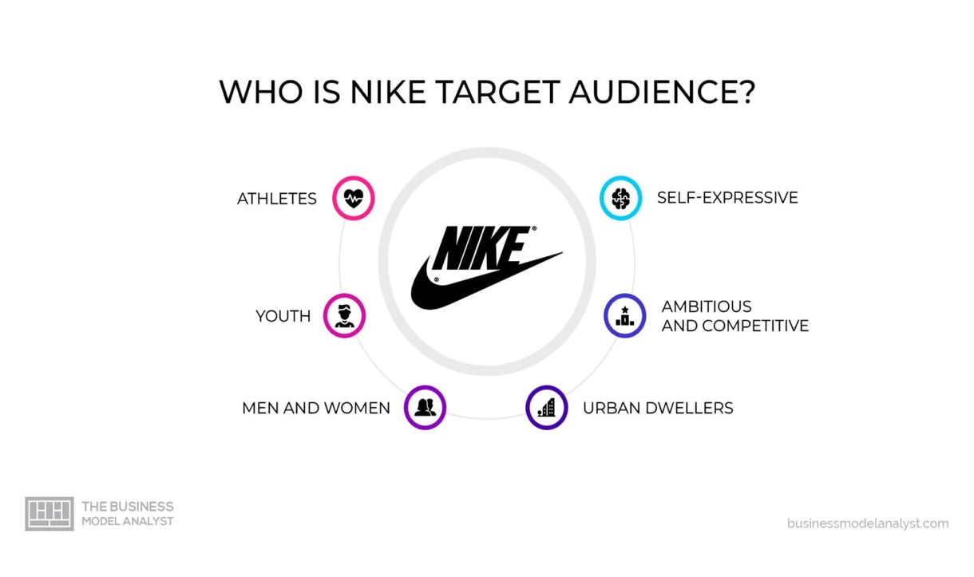
Nike's target audience. Source: https://businessmodelanalyst.com/nike-target-market/
1.5.3 Positioning
Product positioning refers to the psychological space that a product occupies in each market as perceived by its target consumer segment [Ries and Trout 2001, Sally et al. 2019].
Nike has established itself as a high-end brand that is associated with pushing boundaries and athletic excellence in the eyes of its target market. It has produced a wide range of sports-related goods to meet the needs of its niche market. It has become a significant competitor in the athletic industry thanks to its catchphrase, "Just do it," which appeals to the target market to purchase the product with confidence and inspiration. "For every serious athlete, Nike provides the perfect shoe or sports products that give confidence for every sports activity," is the company's positioning statement. Nike distinguishes itself from its rivals by appealing to athletes' emotions in a meaningful and distinctive way [Broussard-Goldsmith 2024].
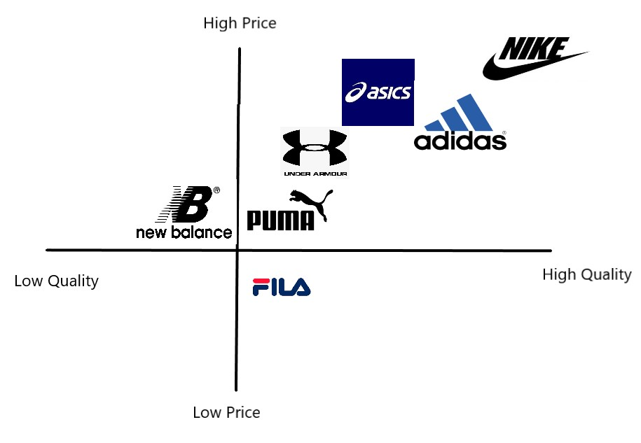
Nike's positioning layout. Source: https://business-essay.com/nike-inc-s-marketing-and-corporate-and-amp-business-strategies/

1.5 NIKE’s Marketing Mix
Marketing involves creating a product or service that meets consumer needs, offering it at a specific price, distributing it through a specific channel, and creating a promotion to increase awareness and interest, as Nike does for sports and leisure activities. (Adrian 2012).
1.5.1 Product
Nike's portfolio places a strong emphasis on ongoing innovation and customer satisfaction. This includes innovative items like Air Max and Flyknit as well as eco-friendly brands like Nike Refurbished that use sustainable practices and circular economy ideas [Li 2023]. Nike is the main innovator in growing the market among young people, whose customers share traits like a passion for sports, admiration for heroes, an active mindset, and an abundance of aspirations. Nike has signed several well-known and well-liked athletes, including Drogba, Serena Williams, and others, in response to this aspect of young consumers. The promotional film "Kick the Legend" for the 2010 World Cup in South Africa, which debuted on May 22 during the Champions League final, is one example of the many creative commercials that were produced. Nike creates the Air Jordan, a new product that has gained a lot of popularity and manufactures hunger marketing. Now, Nike sells roughly 50 limited-edition Air Jordan items annually, and their sales rate has consistently remained at 100%. [Masar 2014].
1.5.2 Place
Online and offline sales currently make up most sales in Europe and the UK, and the two channels work together and communicate with one another to advance product marketing. Nike's official website and the Nike app are the primary sources of online sales, while wholesaler and distributor partnerships are the main source of offline sales. By speeding up the design of e-commerce businesses in the Chinese market, Nike has reinforced this unconventional retail channel, considering the Internet's rapid development of e-commerce models and mobile Internet. [Strmel 2024] Specifically, Nike has been bolstering its online sales business and promoting online sales through fitness applications and other means in the last two years to lessen the effects of the pandemic. Nike saw a notable 82% increase in online sales in 2020, which helped to partially offset the drop in sales at physical stores. By 2025, network sales were supposed to account for at least 40% of Nike's overall revenue [Darmstadt 2023].
1.5.3 Price
Nike uses a tiered pricing structure to strike a balance between exclusivity and accessibility. Utilising the brand's advantages, Nike uses the reputation pricing method for the currently quickly expanding children's sportswear market, entirely ignoring the costs of rival brands. Nike's "Caterpillar Series" has been hard to find, especially for kids' shoes. Some parents even purchase the same style in multiple colours for their kids, without any colour duplication from Monday to Sunday. [Hou 2023]. Once more, there are special products for certain customer groups. For example, the main target market, which is known as SNEAKER, consists of Nike super fans. Despite not prioritising price, these customers possess significant purchasing power. [Shin 2023] They can be impressed, and their brand loyalty can be strengthened if it is a limited-edition product. To ensure that these opinion leaders' customers are enthusiastic and pay attention to the Nike brand, they typically sell high-end products to these customers at prices higher than the going rate.
1.5.4 Promotion
Activities and communication tactics that raise consumer awareness and demand for the product are referred to as promotion. Public relations, sales promotions, personal selling, advertising, and other marketing communications channels are all included. Effectively conveying the advantages of the product, building a favourable brand image, and convincing customers to buy are the goals. (John, 2022). Nike uses creative, daring, and emotionally charged marketing techniques. One of the main factors influencing Nike's capacity to draw in customers is advertising. Within this 7P variable, Nike prioritises online advertising and music videos that appeal to each division's target audiences, particularly the growing fashion scene and the increasing number of active women, as well as advertisements featuring well-known celebrity endorsers like Michael Jordan and NBA teams [Nike, Inc. 2025].
Public relations is another component of this marketing mix, whereby the business funds and sponsors groups, like neighbourhood associations, to advertise its sports footwear, clothing, and equipment. [2024 Nganrungruang] According to the strategies used in this component of Nike's marketing mix, the company relies on its relationships with well-known endorsers to effectively market its goods and services in the global sporting goods market.
1.5.5 People
Nike has made large investments in diversity and inclusion initiatives as part of its commitment to creating a safe and accepting workplace for its staff. The Unconscious Bias Awareness training program and the Juneteenth learning initiative are two examples that aim to increase awareness of racial equality and social change. The organisation places a high priority on employee engagement and well-being because it understands that long-term growth and overall sustainability depend heavily on having a knowledgeable, appreciated, and engaged workforce. In addition, Nike guarantees health and safety procedures and helps workers with disabilities [Audrey 2025].
1.5.6 Process
Nike's procedures are made to reduce waste at every stage of the product lifecycle, from conception and production to sale and, finally, recycling or return. Using lighter, higher-yield materials, improving pattern efficiency, decreasing manufacturing defects, and putting closed-loop recycling of manufacturing scrap materials into practice are all part of this systemic approach.
1.5.7 Physical evidence
Through its digital platforms and physical retail locations, Nike's brand identity is powerfully and instantly recognisable thanks to the iconic Swoosh logo. Additionally, Nike's commitment to sustainability is further reinforced by the strategic repurposing of the "Sunburst" symbol, which was first developed in the 1970s and now visually represents the company's circular design philosophy and ongoing "Move to Zero" journey. Nike strategically uses its "Physical Evidence" as a direct, tangible, and experiential manifestation of its core brand values, especially innovation and sustainability, rather than just for aesthetic appeal or practical utility [Nike, Inc. 2025].

1.6 How NIKE Targets Its Audiences
Nike's innovative products and multi-channel strategy have established a strong reputation, catering to a diverse audience across various platforms and focusing on personalised digital communication.
1.6.1 Social Media
Nike has made a strong presence on several social media sites, connecting with customers through Facebook, YouTube, Instagram, X, and TikTok, which has the largest following at roughly 50 million. Real-time interaction, community development, and storytelling are the main focuses of the brand's social media strategy. Nike, for instance, uses motivational content that highlights athletes' journeys and accomplishments using hashtags like #YouCantStopUs to promote an aspirational lifestyle. Campaigns like "Just Do It" have endured over time, inspiring people to overcome obstacles (Zheng 2022).
1.6.2 Influencer Partnerships
Nike has used influencer marketing as a key tactic to reach specialised markets with a wide range of customer demographics. By partnering with well-known athletes, fitness instructors, and lifestyle influencers and providing athlete endorsement deals, Nike expands its audience and appeal. High-profile athletes like LeBron James, Serena Williams, and Michael Jordan have all signed with Nike in the past. These collaborations increase the brand's legitimacy and visibility, drawing in both casual and devoted sports fans to purchase the shoes—particularly Gen Z buyers who are inspired by these celebrities.
1.6.3 Content Marketing and Storytelling
To connect with its audience's values and lifestyles, Nike uses content marketing to inspire and engage them. This strategy encourages sentimental attachments to the brand. Nike's use of documentaries and television shows has resulted in engaging video content, like the "Nike Training Club" app, which provides a variety of exercise regimens supervised by qualified trainers. This approach places a strong emphasis on usability and invites customers to interact with the product in ways other than just shopping. Additionally, blogging and online forums have enabled Nike to interact with its customers by posting training advice, athlete stories, and health tips on its official website. Nike is positioned as an authority in the fitness sector and a sense of community is fostered by such content.
1.6.4 Personalisation and Customisation
To make sure that its marketing campaigns speak to people's tastes and lifestyles, Nike has also embraced technology to personalise the shopping experience. Nike by You, for instance, is a platform that lets customers create shoes that are tailored to their tastes and style. It functions as a highly customised marketing tool that appeals to customers who respect uniqueness. By leveraging consumer data and insights, Nike can customise its marketing messaging and product recommendations, fostering a sense of relevance and connection that appeals to everyone [Chen 2024].

1.7 Nike’s Budgeting
Nike makes large investments in marketing because it understands how important it is to generate demand and preserve brand equity. For example, in FY25, Nike intends to reinvest almost $1 billion in consumer-facing activities, such as expanding its sports marketing portfolio and investing more in design, product development, and merchandising for major sports. By focusing its marketing on sports and athletes, this investment demonstrates the company's dedication to "bold and clear" brand storytelling [Grace 2024]. Nike's price projections as of December 2024 were $93.01. This suggests a possible upside of $1.62, or 1.75%, when combined with the current share price of $92.72 and the anticipated dividend of $1.34. Even in cyclical markets, the company's strong operational foundation realised the upside potential, which was supported by substantial opportunities to sustain market leadership (Chitu 2024).

1.8 NIKE’s Metrics and Control
Nike uses a variety of metrics to evaluate the success of its campaigns and implements strategic control measures. Return on Investment (ROI), customer engagement, and conversion rates are important metrics, especially for marketing campaigns powered by AI. Nike uses Return on Investment (ROI), which measures the financial gains against the costs of various initiatives, to evaluate the efficacy of its marketing strategies and overall business objectives. [Swetha and others, 2024] These aids in their decision-making regarding future tactics and help them identify the most lucrative investments.
ROI is also used to assess the effectiveness of its marketing initiatives, which include traditional advertising, social media, and digital marketing. [Champaneri 2024] To determine ROI, this entails monitoring key performance indicators (KPIs) such as click-through rates, conversion rates, and sales produced by campaigns. Nike can determine which product innovations are most effective at increasing sales and profitability by using ROI analysis. They can prioritise future product development efforts by weighing the revenue generated by new products against the expenses incurred in their development and marketing [Childs et al. 2017]. Nike can make sure that its strategies are successful, efficient, and in line with its overarching objective of generating sustainable growth and shareholder value by closely observing and evaluating ROI across a range of business domains.

1.9 Marketing Strategy Effectiveness & Control
Even though Nike has a long history of success, recent setbacks suggest room for development. The first drop in Nike Brand digital sales since 2015 occurred in fiscal year 2024, and in fiscal year 2025, there were consecutive quarterly drops of more than 20%. [Nike's 2025 DTC journey]. This was explained by a "weaker product pipeline," "reduced marketing investment" in broad brand campaigns and being "too promotional" (dilution of premium brand positioning). Nike is making a major strategic reassessment in response. Rebuilding wholesale partnerships to regain market reach and shopper visibility, refocusing on full-price sales to restore its premium brand image and profitability, and making significant investments in core sports marketing, consumer-centric innovation, and daring brand campaigns to rekindle excitement and cultural relevance are all part of this strategy. [Camarao, 2021]
Nike's "Move to Zero" initiative is part of their sustainability control strategy. It has set specific goals for 2025 in the areas of carbon, waste, water, and chemistry, and its Impact Reports [Asghar 2023] highlight their progress. However, challenges remain in fully achieving all targets and transparently reporting Scope 3 emissions and waste management data.

Task 2:

Conclusion Addressing Shortcomings of Nike’s Marketing Strategy
Several significant flaws in Nike's marketing strategy are revealed by the critical evaluation, especially when considering sustainability and changing consumer expectations.
- Omnichannel Imbalance: Due to an excessive emphasis on the direct-to-consumer (DTC) approach, there was a misalignment with post-pandemic consumer shifts back to physical retail stores and a reduction in shelf space with wholesale retailers. This suggests a lack of a strong, well-balanced omnichannel presence, which affects consumer visibility and market reach.
- Despite Nike's substantial investments in sustainability initiatives such as "Move to Zero" and the utilisation of recycled materials, the company still faces widespread consumer skepticism and has been the target of class-action lawsuits and accusations of "greenwashing." Nike's sustainability claims are viewed by many customers as "more marketing than genuine commitment." Even sincere attempts become less successful because of the erosion of brand loyalty and trust. This mistrust is exacerbated by the absence of thorough Scope 3 emissions reporting and waste management transparency (Diandra 2024).
- Dilution of Premium Brand Positioning: Nike's premium brand image has been weakened by its recent over-reliance on sales and promotions, which is the result of excess inventory and a "weaker product pipeline." Customers may view the brand as less exclusive or inventive, which has a direct effect on the marketing department's capacity to maintain brand value and command higher prices.
- Attitude-Behaviour Gap: Despite consumers' increasing desire for sustainable products and their readiness to pay more, there is a notable "attitude-behaviour gap" in place. This disparity is frequently brought on by a lack of confidence in sustainability claims, ignorance, restricted availability, and increased expenses. This gap has not been entirely closed by Nike's marketing, which finds it difficult to translate favourable sentiments into recurring purchases of its eco-friendly products.
These shortcomings are interconnected, demonstrating that marketing effectiveness is deeply tied to operational integrity and transparent communication. A perceived disconnect between Nike's aspirational marketing claims and its actual performance in sustainability and ethical practices directly impacts consumer trust and brand loyalty.

Task 3:

Recommendations for Improving Nike’s Marketing Strategy
- Enhance Omnichannel Approach for Smooth, Long-Term Engagement
By heavily reinvesting in and fortifying wholesale relationships, Nike should rebalance the omnichannel strategy and make sure that its products are widely accessible wherever customers choose to shop, including physical retail. Easily incorporate circularity initiatives and sustainability messaging into all online, in-store, and wholesale partner channels (e.g., Nike Refurbished, Reuse-A-Shoe). By providing in-store features and tailored suggestions that emphasise sustainable options, digital tools such as the Nike app can help connect online and offline experiences.
- Create Verifiable Green Marketing and Radical Transparency
Use blockchain technology to trace the supply chain from start to finish for important sustainable product lines. Customers would be able to access verifiable information about the origins of materials, production methods, and environmental impact by scanning a QR code on a product. Broad "sustainable" claims should give way to detailed, fact-based narratives about quantifiable, specific impacts (e.g., "This shoe saved X plastic bottles").
- Increase Supply Chain Ethical Accountability and Share Social Impact
By aggressively re-establishing contact with and providing complete support to independent labour rights organisations (like the Worker Rights Consortium) for external supplier factory audits and monitoring. Publicly convey thorough, transparent procedures for resolving labour and human rights abuses; this goes beyond simply releasing lists of factories and includes showcasing real progress. To build emotional bonds and restore trust, marketing should tell genuine tales of how Nike's ethical sourcing benefits communities and employees.
- Rejuvenate Premium Positioning with Originality and Genuine Narration
Give top priority to funding a strong pipeline of genuinely innovative, customer-focused products where sustainability is a core component rather than an afterthought. Marketing should emphasise "newness and innovation" that naturally lessens the impact on the environment, like fully circular designs or advanced biodegradable materials. Campaigns that highlight performance and planet-first thinking should tell gripping tales of athletes using sustainable products to achieve greatness. Restore the premium brand image by reducing your reliance on excessive discounting.

Reference
- “You can’t stop us.” Available at https://www.nike.com/you-cant-stop-us
- Adrian, P.,2012. An Introduction to Marketing. Theory and Practice. Third Edition. Oxford University Press.
- Audrey, A., 2025. Nike Corporate Social Responsibility (CSR) and Sustainability. (Online). Available at https://www.thomasnet.com/insights/nike-csr/ (Access: 10.07.25).
- Broussard-Goldsmith, A., 2024. Brand Assessment of the Adaptation of Nike to New Consumer Trends. Open Journal of Business and Management, 12(6), pp.4020-4035. Th
- Camarão, R., 2021. The evolution of the direct-to-consumer model in the sportswear industry: an assessment of the model’s application by top industry leaders (master's thesis, Universidade Católica Portuguese (Portugal)).
- Champaneri, A. and Jain, P., 2021. Content marketing as the leading technique in digital marketing: A case of Nike. International Journal of Research and Analytical Reviews, 8(4).
- Chen, T., 2024. A study on Nike’s digital marketing strategy based on the 4Ps theory and analysis of competitiveness maintenance methods. In SHS Web of Conferences (Vol. E207, p. 01007). EDP Sciences.
- Chernev, A., and Kotler, P., 2016. Strategic Marketing Management. Cerebellum Press.
- Childs, M. and Jin, B., 2017. Nike: An innovation journey. In Product innovation in the global fashion industry (pp. 79-111). New York: Palgrave Macmillan US.
- Chitu, A.E., 2024. Can Nike Just do It? Charting the Path into the Future Despite Growing Competition and Shifting Consumer Behaviour (master's thesis, Universidade NOVA de Lisboa (Portugal)).
- Darmstadt, P.R., 2023. Equity Valuation Nike, Inc. (master's thesis, Universidade Catolica Portuguesa (Portugal)).
- Diandra, P., and Aprilianty, F., 2024. The Impact of Greenwashing on Brand Trust and Brand Loyalty: A Study of Nike Move to Zero Initiatives. Mandalika Journal of Business and Management Studies, 2(2), pp. 85-114.
- Grandemange, M., 2024. Sustainability Matters: Exploring the Influence of Unique Sustainability Attributes on Consumer Preferences for Veja and Nike Footwear (master's thesis, University of South-Eastern Norway).
- Grace, G., 2024. Nike revamps up innovation to combat sales slip in ‘transition year.’ (Online). Available at https://www.marketingweek.com/nike-accelerate-innovation/
- Hou, Q., 2023. Analysis of Nike brand operation and marketing strategy in different business periods based on the 4P Marketing Theory. Highlights in Business, Economics and Management, 23, pp. 636-641.
- Hou, Z., 2024. Data-Driven Personalisation:: How to Use Consumer Insights to Generate Customer Loyalty. Kogan Page Publishers.
- Jaybhaye, S.M., Bhosale, Y.P., Walke, T., Weladi, P Sonkusare, S., 2024, April. Suggestosphere: A Sports Recommendation System. In International Conference on Information and Communication Technology for Intelligent Systems (pp. 381-396). Singapore: Springer Nature Singapore.
- John, H., 2022. The Theory and Practice of Change Management. Sixth Edition. Red Globe Press.
- Jung, Z.Z., 2023. The Gen-Z Sneaker Head Paradox: Balancing Sustainability and Streetwear in the World of Nike: Fashion Industry. PQDT-Global.
- Li, D., 2023. Investigation and Analysis of Nike Product Marketing Strategy.
- Masár Masár Vieites, L.V., 2014. Athlete endorsement as a marketing strategy: a case study of Nike and Michael Jordan.
- Nganrungruang, P., 2024. Does Sponsoring Free Athletic Classes Benefit Athletic Apparel Companies? (Doctoral dissertation, Golden Gate University).
- Nia, N.B., 2023. Brand Management Internationalisation: Case Study of Nike. Journal of International Trade, Logistics and Law, 9(2), pp.181-187.
- Nike by You. Available at https://www.nike.com/gb/nike-by-you
- Nike, Inc. 2025. [Online]. Available at https://about.nike.com/en/stories [Accessed: 10.07.25].
- Nike, Inc. “Move to Zero” 2025. [Online]. Available at https://www.nike.com/sustainability [Accessed: 15.07.25].
- Nike’s DTC Journey: Ambition, Challenges, and Realignment. [2025] [Online]. Available at https://zoommetrix.com/marketing-strategy/nike-dtc-journey-ambition-challenges-and-realignment/ [Accessed: 17.07.2025].
- Nike's “Just Do It” Available at https://krows-digital.com/nikes-just-do-it-campaign-a-masterclass-in-marketing-excellence/
- Philip, K., Gary, A., Lloyd, C. H., and Nigil, P., 2017. Principles of Marketing. Seventh Edition. Pearson.
- Ries, A. and Trout, J., 2001. Positioning: The Battle for Your Mind. McGraw-Hill.
- Rosalind, M., and David, P., 2014. Marketing: An Introduction. Third Edition. Sage Publication Ltd.
- Rosalind, M., Nichola, P., and David, P., 2017. Marketing: An Introduction. Fourth Edition. Sage Publications Ltd.
- Sally, D., Lyndon, S., Willams, M. P., and O.C. Ferrel. 2019. Marketing Concepts and Strategies. Eighth Edition. Cenage.
- Shin, D., 2023. An Examination of Participation in Sneaker Culture: Consumer Motivations and Responses to Co-Branding Between Luxury Apparel and Athletic Shoe Brands-Louis Vuitton and Nike. Colorado State University.
- Strmel, M.S., 2024. Innovative Retail: A Framework for the Future of Brick-and-Mortar Retail in an Omnichannel Market.
- Swetha, N., Harshavardhan, P., Kusuma, T., Raja, M.C., 2024. Measuring Marketing Effectiveness and Return on Investment. In Predictive Analytics and Generative AI for Data-Driven Marketing Strategies (pp. 216-224). Chapman and Hal/CC.
- Vianello, S., 2019. Nike’s pricing and marketing strategies for penetrating the running sector.
- Zheng, K., 2022. The analysis of Nike’s marketing strategy from social media and consumer psychology & behaviour BCP Business & Management, 34, pp.436-442.

