IMPACT OF TELEMEDICINE AND TELEHEALTH TECHNOLOGY IN

OBESITY ISSUES AND ITS CONCERN FOR PUBLIC HEALTH

Presently, obesity and overweight issues become critical healthcare problems, nearly 1 billion people have suffered from obesity issues including 39 million children.
WHO estimates that this number has been increasing daily, and it is expected that nearly 167 million adults will become less healthy due to obesity issues by 2025 (Who. int, 2022).
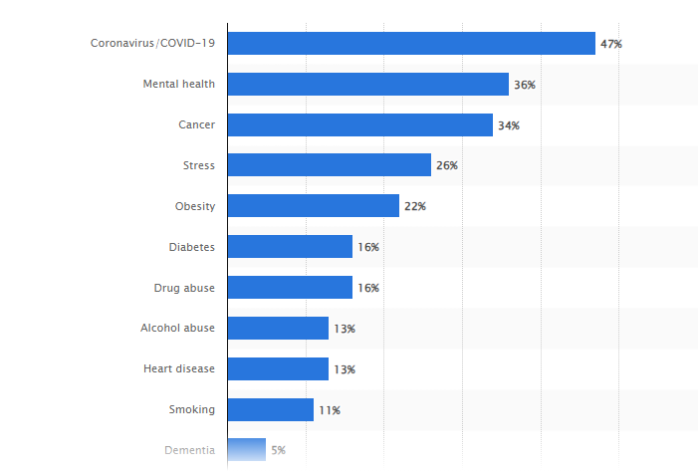
Figure 1: Leading health problem globally and the contribution of obesity to it
(Statista.com, 2023)
From Figure 1, it has been evaluated that globally obesity contributed 22% as a public health problem.
Obesity issues affect the human body including the heart, liver, and kidneys and it leads to different “noncommunicable diseases” (NCDs) like Type 2 diabetes.

Telemedicine and Telehealth Technology
Telemedicine or telehealth use can be used as suitable digital technology to promote awareness about obesity. As observed by Kahan et al. (2022) telemedicine is effective for obesity care treatment, and boosts awareness among suffering patients. Telehealth helps provide guidance to obesity-suffering patients, by connecting medical professionals through mobile.
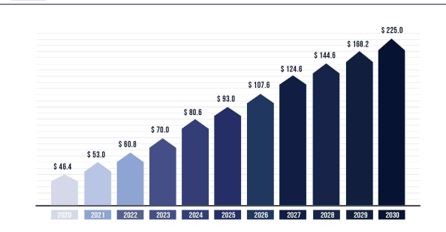
Figure 2: Telemedicine market size insights
(Source: Precedenceresearch.com, 2023)
In addition, by using telehealth patients do not need to visit a doctor every time, doctors can guide patients and give intervention strategies over mobile. Telehealth use has increased since 2020, and nearly 60% of healthcare organisations are using this telemedicine to treat patients globally.
According to López et al. (2022), telehealth use is helpful in boosting awareness of obesity and healthy living among customers and recommended patient interventions.

Advantages of Telemedicine use for obesity intervention

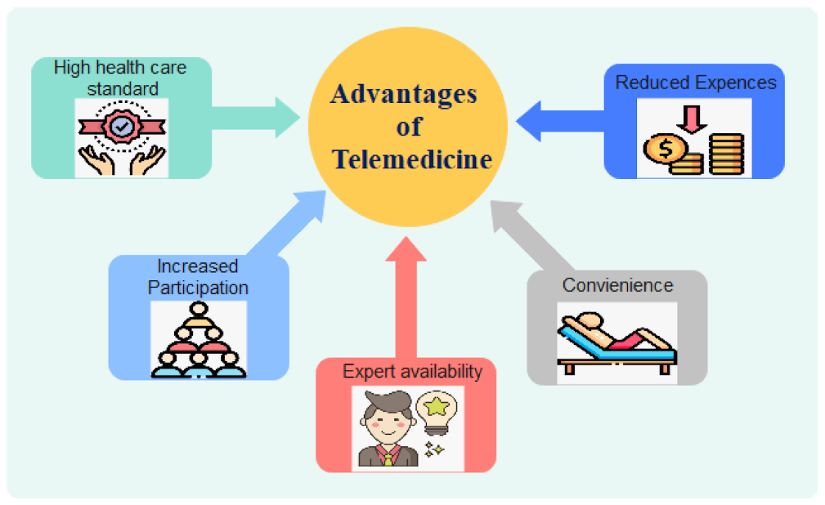
Figure 3: Advantages of telehealth
(Source: Alenoghena et al. 2023)
- The use of telehealth for treating obesity breaks the barrier of treatments, as this technology helps patients to understand interventions required to reduce weight and to anticipate obesity issues, from professional doctors (Partners.livi.co.uk, 2023).

- The telemedicine concept boosts the ideas of individualised care, which is essential for obese patients.

Disadvantages of Telemedicine use for obesity intervention

- However, telemedicine is limited because of its lower opportunity for physical checkups of obese patients, which makes this technology limited to only primary care (Hinchliffe et al. 2022).
- Further, technological difficulties also hampered the promotion of obesity intervention through telemedicine.
THIS SHORTFALL CAN BE OVERCOME BY
- developing high infrastructure for improving telemedicine
- digital literacy can be another option to improve obesity treatments.

AI-driven smartwatch and Cardiovascular disease (CDVs)
What is CVD??
CVDs can be illustrated as a group of diseases of the heart, coronary artery, and blood vessels. Vaduganathan et al. (2022) mentioned CVDs as a present as well as future problems of the earth.

Cardiovascular disease has become the most common reason for death worldwide, and the number of people suffering from this disease has increased.
Cardiovascular diseases (CVDs) are the most critical diseases from which global people suffer continuously, only for these diseases, approximately 17.9 million people die each year (Who. int, 2023).
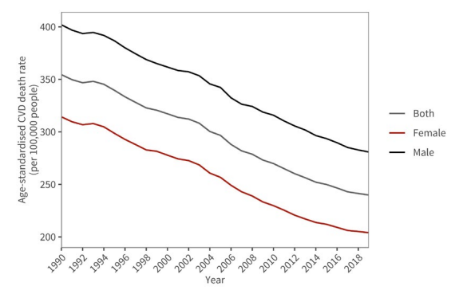
Figure 1: Death rate of Males and females by CDVs
(Source: World-heart-federation.org, 2023)
Further, to bring intervention on CVD it is done by increasing awareness about self-care and by identifying parameters for keeping the heart healthy.

NEW Technology for health promotion against CDVs
AI-DRIVEN SMARTWATCH
It senses the heart condition of patients and suggests possible measures to prevent heart attacks.
This new AI-based smartwatch helps patients to prevent heart attack situations, by continuously monitoring heart condition and enabling suggestions.

- This smartwatch provides medicinal help, by sending a message to doctors if the condition of the heart becomes out of control through precautionary measures.
- Besides, this AI-based Smart watch will facilitate voice commands to the patients and guide them for doing the bedded physical exercise to be fit and make the heart healthy.
As opined by Joshi et al. (2022) AI-technology can be an effective tool for taking cardio health and tracking its conditions.

Advantages and limitations of AI-Based Hart Health Trackers

- ADVANTAGES

The key advantages of AI-based smartwatch healthcare promotion will be to
- Guide patients to keep safe from heart failure
- Give them the opportunity to always be fit.

- LIMITATIONS
- However, in very critical physical situations this smartwatch fails to provide suggestions, rather than only sending emergency alerts to doctors.
- Another possible disadvantage of this AI-based smartwatch will be it needs technology for a person to be habdel.
However, these shortcomings of usability can be reduced by guiding parents before use.

References
BLOG 1
- Alenoghena, C.O., Ohize, H.O., Adejo, A.O., Onumanyi, A.J., Ohio In, E.E., Balarabe, A.I., Okoh, S.A., Kolo, E. and Aleoghena, B., 2023. Telemedicine: a survey of telecommunication technologies, developments, and challenges. Journal of Sensor and Actuator Networks, 12(2), p.20.
- Hinchliffe, N., Capehorn, M.S., Bewick, M. and Feenie, J., 2022. The potential role of digital health in obesity care. Advances in Therapy, 39(10), pp.4397-4412.
- Kahan, S., Look, M. and Fitch, A., 2022. The benefit of telemedicine in obesity care. Obesity, 30(3), pp.577-586.
- López, A., Escobar, M.F., Urbano, A., Alarcón, J., Libreros-Peña, L., Martinez-Ruiz, D.M. and Casas, L.Á., 2022. Experience with Obese Patients Followed via Telemedicine in a Latin American Tertiary Care Medical Center. International Journal of Environmental Research and Public Health, 19(19), p.12406.
- Partners.livi.co.uk, (2023), Obesity care and the promise of digital health, Available at: https://partners.livi.co.uk/hubfs/Obesity%20care%20and%20the%20promise%20of%20digital%20health.pdf [Accessed on: 9/11/2023]
- Precedenceresearch.com, (2023), Telemedicine Market-Global Industry Analysis, Size, Share, Growth, Trends, Regional Outlook, and Forecast 2022 - 2030, Available at: https://www.precedenceresearch.com/telemedicine-market [Accessed on: 12/11/2023]
- Statista.com, (2023), Percentage of adults worldwide who stated select issues were the biggest health problems facing people in their country in 2022, Available at: https://www.statista.com/statistics/917148/leading-health-problems-worldwide/ [Accessed on: 12/11/2023]
- Who.int, (2022), World Obesity Day 2022 – Accelerating action to stop obesity, Available at: https://www.who.int/news/item/04-03-2022-world-obesity-day-2022-accelerating-action-to-stop-obesity#:~:text=More%20than%201%20billion%20people,they%20are%20overweight%20or%20obese. [Accessed on: 9/11/2023]

BLOG 2
- Joshi, R.C., Khan, J.S., Pathak, V.K. and Dutta, M.K., 2022. AI-CardioCare: Artificial Intelligence Based Device for Cardiac Health Monitoring. IEEE Transactions on Human-Machine Systems, 52(6), pp.1292-1302.
- Unblast.com, (2023), Free Heart Rate Monitor Watch Illustration (Ai), Available at: https://unblast.com/free-heart-rate-monitor-watch-illustration-ai/ [Accessed on: 12/11/2023]
- Vaduganathan, M., Mensah, G.A., Turco, J.V., Fuster, V. and Roth, G.A., 2022. The global burden of cardiovascular diseases and risk: a compass for future health. Journal of the American College of Cardiology, 80(25), pp.2361-2371.
- Who.int, (2023), Cardiovascular diseases, Available at: https://www.who.int/health-topics/cardiovascular-diseases#tab=tab_1 [Accessed on: 9/11/2023]
- World-heart-federation.org, (2023), World-Heart-Report-2023, Available at: https://world-heart-federation.org/wp-content/uploads/World-Heart-Report-2023.pdf [Accessed on: 12/11/2023]



