Rebecca Dingwall
2217521
Computer Aided Engineering ACDB5007
Application of Computer Aided Engineering Processes
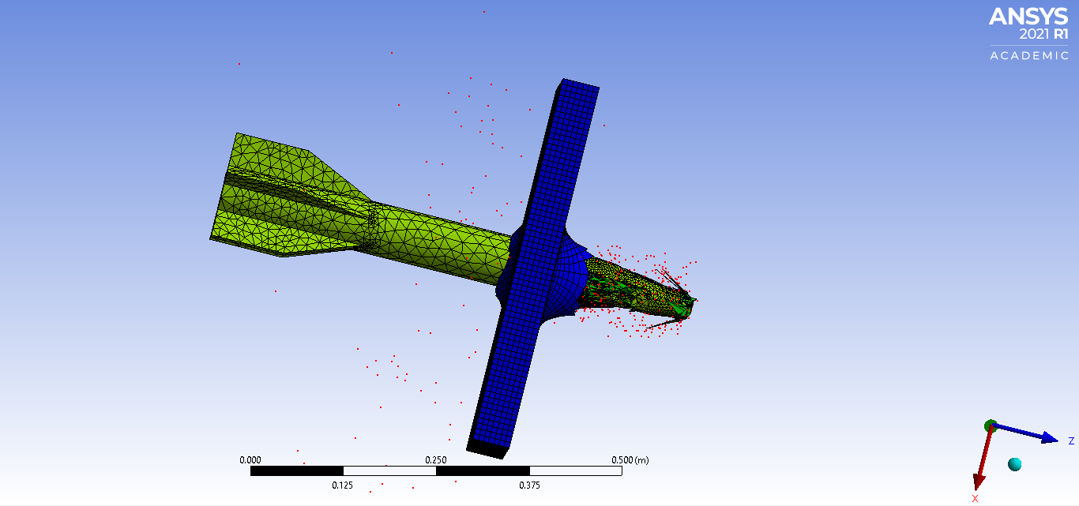

Table of Contents
1. Introduction to CAE 2
1.1 The CAE Process 2
1.2 Key CAE Techniques 2
1.2.1 Finite Element Analysis FEA 2
1.2.2 Computational Fluid Dynamics CFD: 2
1.2.3 Multibody Dynamics and Kinematic Analysis: 3
2. Practical Implementation Case Study 3
2.1 System Modelling 3
2.2 Kinematics Analysis 3
2.3 Static Structural Assessment 3
2.4 CAE in Engineering Design 4
3. Validation 4
4. Conclusion 4
Bibliography 4

1. Introduction to CAE
Computer Aided Engineering (CAE) plays a pivotal role in modern engineering by leveraging software and computational tools to enhance the design, analysis, and manufacturing of products across various industries. CAE encompasses a range of functionalities, including simulation, optimization, and validation. It guides engineers from initial design stages through testing and manufacturing planning. CAE has the ability to reduce the time needed to develop new products while increasing productivity. This is achieved through the optimization of production flow and scheduling combined with providing more flexibility in altering machine operations [1].

1.1 The CAE Process
The CAE process will typically involve 3 steps consisting of: pre-processing, solving and post-processing [2]. During pre-processing engineers model the system, its physical properties and this can sometimes include its operating environment. The constraints and applied loads are defined during this stage which significantly impacts all subsequent simulations. During the solving step, simulations are run to mimic real-world conditions and physics there are a variety of simulations that can be run on the model, some of the essential CAE techniques are: Finite Element Analysis FEA, Computational Fluid Dynamics CFD, Multibody Dynamics MBD and Kinematic analysis. During post-processing the results from the simulations are reviewed, aiding decision making and design refinements.

1.2 Key CAE Techniques
1.2.1 Finite Element Analysis FEA:
Can be used to predict how products respond to real-world forces, vibrations, fluid flow and other physical effects enabling the understanding of a particular products design and behaviour under various conditions. FEA is based on the Finite Element Method FEM, which breaks down intricate systems into smaller, simpler elements. These elements are then analysed individually using differential equations. The results obtained from FEM are interpreted through FEA, providing insights into how structures respond to various loads, temperatures, and other environmental conditions. Assessing stress distribution, deformation and other factors can optimize designs for safety, performance and efficiency due to the reduction of physical prototyping. FEA’s ability to approximate irregular dimensional complications means FEA is applicable to a diverse range of scenarios. [3]
It aids in predicting maintenance needs, predicting long-term general wear as well as well as the prediction of what can be tolerated under extreme conditions [3]. Civil engineers use FEA in order to evaluate the integrity of structures such as bridges, buildings and dams. Within aerospace engineering, FEA can simulate the performance of aircraft components under various conditions and within automotive engineering FEA can evaluate structural crashworthiness among other systems within the vehicle [3].

1.2.2 Computational Fluid Dynamics CFD:
Is a powerful numerical technique used to simulate and analyze fluid flow behavior in various engineering and scientific applications. It analyses fluid flow, heat transfer and other related phenomena. CFD predicts air flow, fluid forces as well as heat transfer around products. CFD focuses on solving the governing equations that describe fluid motion, heat transfer and mass transport in more complex geometries. Some of the applications of CFD can be found in aerospace and automotive industries and energy and environmental engineering to optimize aircraft aerodynamics, engine combustion and vehicle performance, aiding in the design of efficient wings, reducing drag and improving fuel efficiency. CFD can model airflow in wind turbines, simulating pollen dispersion and the analysis of heat exchangers. Within Biomedical and pharmaceutical sciences, CFD can be used to study blood flow, drug delivery and respiratory air flow. It can also be found in civil engineering, process industries, turbomachinery, oceanography and more. Much like FEA, CFD reduces the need for physical trials by providing virtual insights, engineers can explore design alternatives and evaluate performance and refine geometries prior to production and so reducing cost. CFD also gives engineers the opportunity to subject the design to extreme conditions ensuring safety and reliability.

1.2.3 Multibody Dynamics and Kinematic Analysis:
Simulates motion and reaction forces within interconnected systems and provides an insight into motion behavior. Multibody Dynamics MBD deals with the motion and interaction of interconnected rigid or flexible bodies [4]. These bodies can be anything from mechanical systems to biological systems. MBD involves modelling the system as a collection of interconnected bodies, or particles and analyze their kinematics-motion, and dynamics- forces and torques. The interactions between the bodies are described using equations of motion. MBD is crucial for understanding how complex systems move, deform and respond to external forces [5].
Kinematic analysis focuses on the geometry of motion with none of the forces applied. The most common kinematic quantities include position, velocity, angular velocity and acceleration. Kinematics can investigate, for example, how the parts of a mechanism move relative to each other. And, what are the velocities and accelerations of different points in the system. Kinematic analysis helps us design linkages, understand joint constraints, and predict the behaviour of mechanisms. Much of the applications of MBD can be found in robotics for the design and controlling of robotic arms and other moving parts, kinematic analysis can optimize robot trajectories and workspace. Vehicle dynamics and mechanical systems use MBD to aid in the understanding and analysis of more complex moving parts on both vehicles, aircraft and complex machinery, such as engines, cranes and conveyor belts and kinematic analysis aids in the design of suspension systems, drive chains and steering mechanisms.

2. Practical Implementation Case Study
To accurately investigate the process, limitations and practical implementation of using CAE tools the following section of the report is to illustrate how this can be achieved. This case study examines the effects of long-rod penetrators or kinetic energy rounds on a metallic plate.

2.1 System Modelling
Firstly, to model a system in a computational environment this can be done using any Computer Aided Design CAD software. In this instance Solidworks was used to model both the long rod and the plate. The dimensions of the long rod were around ∅60mm and 750mm long. The dimensions of the plate were 500mm X 500mm and 50mm thick. After this has been completed an assembly of parts was put together in Solidworks. This can be defined as a group of components or parts brought together to accurately depict their original relationships and geometric alignment [6]. Solidworks is sometimes described as the more user-friendly option for CAD software [7] and it was shown to be the case whilst using Solidworks to create these simpler geometries. This CAD model can then be imported into another analysis software to conduct more complex simulations. Solidworks does have the ability to conduct more simple analyses like stress, strain and deformation however the types of analysis spoken about previously in this report another CAE software is required for more complex problems [8].

2.2 Kinematics Analysis
To analyze the system in motion under realistic operating conditions and to understand the motion behavior and reaction forces the CAE software used in this case was Ansys.
- Analyze system motion under realistic operating conditions.
- Understand motion behavior and reaction forces.

2.3 Static Structural Assessment
- Assess one component within the assembly.
- Evaluate structural performance (loadings and fatigue life).
- Optimize component mass while maintaining integrity.

2.4 CAE in Engineering Design
- Use this case study as an example of how CAE tools enhance the design process.
- Address limitations and challenges associated with CAE approaches.

3. Validation
- Conduct validation testing to measure software accuracy.
- Select a simplified test case with an analytical solution.
- Compare analytical results with ANSYS simulations.
- Investigate mesh sizing impact on accuracy.

4. Conclusion
CAE tools empower engineers to create better designs, optimize performance, and address limitations. By simulating real-world scenarios, CAE enhances the engineering design process and contributes to innovative solutions. Remember to provide relevant details, examples, and references to support each section.

Bibliography

[1] | The Editors of Encyclopaedia Britannica Article History, “computer-aided engineering,” Britannica, 25 03 2023. [Online]. Available: https://www.britannica.com/topic/computer-assisted-instruction. [Accessed 22 04 2024].
[2] | S. Thorat, “What is CAE – Introduction To Computer Aided Engineering,” LearnMech.com, 12 02 2023. [Online]. Available: https://learnmech.com/cae-introduction-computer-aided-engineering/. [Accessed 22 04 2024].
[3] | Ansys, “What is Finite Element Analysis (FEA)?,” Ansys, [Online]. Available: https://www.ansys.com/en-in/simulation-topics/what-is-finite-element-analysis. [Accessed 22 04 2024].
[4] | F. V. e. al, “A peridynamics approach to flexible multibody dynamics for fracture analysis of mechanical systems,” Springer, 03 11 2023. [Online]. Available: https://link.springer.com/article/10.1007/s11044-023-09948-y. [Accessed 20 04 2024].
[5] | EnginSoft MULTIBODY DYNAMICS SOFTWARE, “What is Multibody Dynamics (MBD)?,” enginsoft, [Online]. Available: https://enginsoftusa.com/RecurDynMBD/What-is-Multibody-Dynamics.html. [Accessed 23 04 2024].
[6] | Study Smarter, “What is Assembly Modeling?,” Study Smarter, [Online]. Available: https://www.studysmarter.co.uk/explanations/engineering/design-engineering/assembly-modeling/#:~:text=An%20assembly%20in%20CAD%20typically,within%20a%20system%20or%20product.. [Accessed 25 04 2024].
[7] | TECHNIA, “SOLIDWORKS or CATIA: Which is Best?,” TECHNIA, [Online]. Available: https://www.technia.co.uk/blog/solidworks-vs-catia-which-cad-software-is-right-for-you/#:~:text=When%20it%20comes%20to%20user,are%20new%20to%20CAD%20software.. [Accessed 26 04 2024].
[8] | I. A. M. a. Z. S. Sebaeva, “Comparative study of finite element analysis software packages,” IOP Publishing, 2020. [Online]. Available: https://iopscience.iop.org/article/10.1088/1742-6596/1515/3/032073/pdf. [Accessed 26 04 2024].

