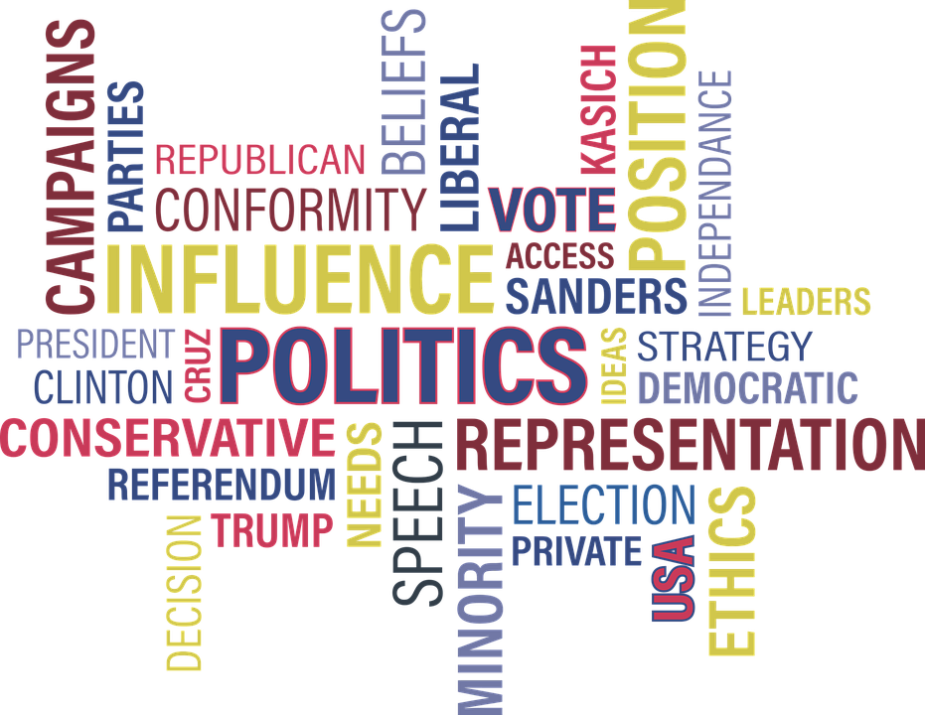
POLITICS AND POLICY
BMSP5021
Natalie Griffiths (2316480)

Table of Contents
Introduction 1
The Two Houses of Parliament 2
Pressure and Lobby groups. 4
Conclusion 5
References 6

Introduction
This report on the UK political system will evaluate and identify aspects and characteristics that I consider to be both positive and negative. The report will focus on the two houses of parliament, The House of Commons and The House of Lords. I will also examine the role of lobby and pressure groups. The UK political system is a parliamentary democracy that has evolved over centuries, characterised by its institutions and practices. Political parties and pressure groups, both of which play a significant role in shaping government policies and influencing decision making processes. Political parties, which represent a wide range of ideological viewpoints, provide structure to the political process, offering voters distinct choices during elections and helping to form the government. Pressure groups function as advocates for specific interests, striving to influence policy and public opinion on issues ranging from environmental protection to workers’ rights. While these elements contribute to a dynamic and responsive political environment, they also present certain challenges, such as concentration of power within major political parties and the undue influence exerted by lobbying groups, (UK Parliament,2024).

The Two Houses of Parliament
The House of Commons and the House of Lords are the two houses in which parliament conducts its business. Their work is comparable in that they both create laws, examine government operations, and discuss current affairs.
The elected lower house of the UK's two chambered parliaments is known as the House of Commons. The House of Commons is chosen by the general public, the government is formed by the party with the most Commons members. The members of the Commons (MPs) discuss proposed legislation as well as the important political concerns of the day. Government ministers such as the Prime Minister and President, as well as the leaders of the main political groups, work there. Only the Commons has the authority to decide on financial bills, including any additional taxes. These bills may be considered by the Lords, but they cannot be blocked or changed ( UK Parliament 2024). The public will choose a Member of Parliament to represent you in Westminster, London, when you cast your ballot in a general election. If they are lucky, your member of parliament will occupy one of the green seats in the House of Commons; there are not enough seats for everyone. Each political party aims to win as many of the 650 seats available in each election, and your MP is often a member of one of those parties, (Bitesize, 2024).
In contrast, the members of the House of Lords are not chosen by popular vote. There are twenty-six bishops of the Church of England who are eligible to sit in, and ninety-two Lords, who are hereditary peers. These individuals inherit their titles since the House of Lords act 1999 by the Prime Minister's recommendation, and the King appointed the remaining individuals. The existence of hereditary peers can be seen as problematic for several reasons such as, lack of democratic legitimacy, limited accountability as peers do not face re-election, meaning they are not directly accountable,(UK Parliament,2024). The House of Lords has three main functions within the UK parliament, these are to question and challenge the work of the government, to scrutinise and shape laws, and to press for action through committees and debates. Members of the House of Lords checks the details of bills, working to address potential problems and any loopholes to ensure laws are effective and workable. Their amendments may or may not be agreed, nonetheless, the Lords are essential in urging the Commons and the Government to reconsider and, in certain situations, offer substitute amendments, (UK Parliament,2024).
According to Seneca (n.d.) by using democracy both houses work together to produce a democratic representation allowing decisions to be made with the use of expertise also, the voting public are given a voice. Minority groups can be given representation, and their interest are protected, Working together enables the interests and demands of voters to be heard, and political proposals are produce which work in everybody’s favour. Representatives can be held accountable for any decisions made. The disadvantages of representative’s democracy includes when representative choose not to act in the public interest and occasionally minority may be excluded. Low levels of participation during elections results in representatives being voted in may not reflect the wishes of the voters. Seneca go on to explain that there are only 7% of the UK that are privately educated compared to 29% of the MP’s that are representing them, therefore it could be said that many of the representatives do not share the views of their constituents, many representatives are known to act in their own best interest or in a select few of their constituents, rather than the majority of them. During the Uk’s withdrawal from the EU (Brexit) both houses of parliament were central in debating and shaping the legislation, both of the houses were perceived to have delayed or complicated the implementation of the public’s decision. The House of Commons were divided over Brexit as they had different views and diverse opinions of their constituents, this lead to proposals rejected by MP’s leading to prolonged debates. MPs debated on various options including a second referendum delaying the process. The House of Lords suggested amendments on the bill prompting further delays, for example amendments on the safeguard citizen rights and ensuring parliamentary for any Brexit deal. (Fleming, et al, 2024). While these processes delayed the implementation of Brexit, it also reflected the power of authority, it was not just about slowing down Brexit but ensuring the decisions made were democratically.
When comparing the British Parliament with the American Congress, it’s important to note that Congress is divided into the House of Representatives and the Senate, similar to the UK Parliament's division into the House of Commons and the House of Lords. In both systems, bills cannot become law unless approved by both houses. The House of Representatives has 435 members, whereas the House of Commons consists of 650 members (Petersen, 2005).
A significant difference lies in the method of selection Unlike the British Parliament, all members of Congress are elected by the public. This ensures that no seats are hereditary, unlike in the House of Lords. This feature is often viewed as a democratic advantage in the American system.
Both the UK Parliament and the US Congress have notable features in their representation. In the UK, constituents elect members who represent local interests, while in the US, the Senate ensures that smaller states have equal representation, and the House reflects population sizes. Frequent elections in the US also allow voters to hold representatives accountable (Petersen, 2005).
However, there are negatives associated with both systems. In the UK, the unelected nature of the House of Lords undermines democratic representation, and the first past-the-post electoral system can lead to unreasonable outcomes, where votes do not always translate fairly into seats.

Pressure and Lobby groups.
Pressure groups, also known as interest groups or advocacy groups, are organisations formed by people who share a common interest, goal, or cause. These groups aim to influence public policy, legislation, or decision-making processes without seeking to hold political power directly. They can operate at various levels, local, national, or international and their primary objective is to advocate for their members interests or promote specific issues, (Bitesize,2024). There are two main types of pressure groups these are the insider and outsider, the insider groups work with the government to achieve their aims, such as British Medical Association (BMA), these represent doctors and medical professionals in the UK, they are consulted by the government on healthcare policies and legislation. The outsider groups do not work with the government and often rely on public campaigns and media coverage to exert influence, such as Greenpeace who advocate for the environmental protection worldwide, they are known for protesting, (Politics,2024).
Lobbying is one of the methods used by pressure groups directly engaging with politicians or officials to advocate for their interests. Lobbyists are professionals hired by businesses, industries or unions acting between their clients or interest’s groups and government officials, their main goal is to influence public policy legislation and regulations to favour the interest they represent, this allows them to provide input on relevant issues. Lobbyists position themselves as experts in their field, offering insights that influence decision making, they supply policymakers with research to support their case. Lobbyists occasionally help draft laws or amendments to make sure they support their goals. Legislators occasionally use lobbyists knowledge to create technically sound legislation, (UK Parliament,2024). Lobbying in the UK has grown in recent years with one hundred and fourteen lobbying firms now registered in the UK, (The Politics Shed, 2024). Lobbyists must register before communicating with a minister otherwise they may be subject to criminal and civil penalties, (Solaiman, 2023, pg 270-297).
Lobbyists build relationships with members of Congress who may be persuaded to support or propose legislation that advances their objectives. They may also interact with cabinet ministers and other important government representatives in their area. Even though it is frequently disputed, lobbying has a number of advantages when done morally and openly, it provides policy makers with specialised information about specific issues especially in complex fields like healthcare where legislation may lack technical expertise, (Solaiman, 2023, pg. 270-297). Lobbying has a voice in diverse groups in the legislation process this balances the interests and needs of various stakeholders in society. It raises awareness and helps the government to understand the current state of a problem as many politicians need to be made aware due to the lack of their knowledge, (Gov Business Review, 2023). Legislative checks and balances are intended to protect the government's integrity, but they may undermine democracy when powerful lobbyists hold wildly disparate positions. Because of this issue the interests of influential lobbyists and their clients are frequently prioritised over those of the general public, (Gov Business Review, 2023).
Powerful lobbying groups representing large corporations may influence policies that favour their bottom line at the expense of the needs of society as a whole. This is an example of how well-resourced lobbying groups can have more influence than others, resulting in a situation where policies reflect the interests of a select few rather than the majority. Brexit triggered one of the most intensive lobbying efforts in modern history, driven by the high stakes for businesses, government, and interest groups across multiple sectors, ( Solaiman, 2023. pg. 270-297). The uncertainty over trade and regulations Companies who depended on easy trade between the UK and the EU had to deal with uncertainty over tariffs, customs inspections, and regulatory differences. The automotive, medication, and farming industries were especially outspoken in their advocacy for beneficial agreements. While some industries advocated for separation to capitalise on reform, others including the IT and banking sectors, lobbied to maintain regulatory alignment with the EU in order to prevent obstacles, (Solaiman, 2023. Pg. 270-297). EU fishing communities resisted to preserve their traditional fishing privileges, while UK fisheries organisations advocated for stricter limits on EU access to British seas.
Concerns about trade barriers, labour shortages, and subsidies were the focus of intense lobbying by food producers and farmers' organisations in the UK and the EU.

Conclusion
In conclusion the two houses of parliament, The House of Commons and The House of Lords play a crucial role in shaping laws and policies in the UK. The House of Commons is composed of elected members of parliament who directly represent the people, its primary function is to propose, debate and vote on laws. The House of Lords is made up of appointed members, Their role is to review and scrutinise the bills, offering amendments. Lobby groups and pressure groups on the other hand, play an essential role influencing policy decisions. These groups which can be either interest based or issues-based attempt to sway politicians and government decisions, through lobbying, advocacy, and public campaigns. These groups represent the interests of various segments of society such as businesses, labour unions, and environmental organisations. While parliament provides a platform for legislation , lobby and pressure groups offer the expertise that can shape policies to reflect a broader range of concerns in society.

References

Bitesize. (2024). What Are Pressure Groups In United Kingdom?. BBC Bitesize.
What are pressure groups in United Kingdom? - Influence - National 5 Modern Studies Revision - BBC Bitesize

Bitesize, (2024). Easy Peasy Politics: How It All Works. BBC Bitesize.
Easy Peasy politics: How it all works - BBC Bitesize

Fleming, T.,& James, L. (2024). Parliamentary influence on Brexit legislation, 2017–2019. Parliamentary Affairs, 77(1), 25–45.
https://doi.org/10.1093/pa/gsac014

Grant,M. (2009). The UK Parliament. Edinburgh: Edinburgh University Press

Gov Business Review, (2023).Advantages and Disadvantages of Lobbying.
Advantages and Disadvantages of Lobbying

Kenny, C., Rose, D.C., Hobbs, A., Tyler, C. & Blackstock, J. (2017) The Role of Research in the UK Parliament Volume One. London, UK, Houses of Parliament.
The Role of Research in the UK Parliament

McKay, W., & Johnson, C. W. (2010). Parliament and Congress: representation and scrutiny in the twenty-first century. New York: Oxford University Press.

Petersen, R.E.(2005). Parliament and Congress: A Brief Comparison of the British House of Commons and the U.S. House of Representatives.p.1-19.

Politics.Co.Uk.(2024). What Are Pressure Groups?.
What are Pressure Groups - Force for good, or a strangle on government

Seneca, ( n.d) Pros & Cons of Representative Democracy.
Pros & Cons of Representative Democracy - Political Studies: Edexcel A Level

Solaiman,B.(2023). Lobbying in the UK: Towards Robust Regulation, Parliament Affairs. Parliamentary Affairs, Volume 76, Issue 2, Pages 270–297, https://doi.org/10.1093/pa/gsab051

The Politics Shed, (2024). Are Pressure Groups Good For Democracy?.
The Politics Shed - Are Pressure Groups good for democracy?

UK Parliament (2024). The Two-House System
The two-House system - UK Parliament

Uk Parliament, (2024). House of Commons.
House of Commons - UK Parliament

UK Parliament, (2024). Speaker and the Chamber.
Speaker and the Chamber - UK Parliament

UCL, (2024). What Does The House of Lords Do?.
What does the House of Lords do? | The Constitution Unit - UCL – University College London

UK Parliament, (2024). Hereditary Peers in the House of Lords.
Hereditary peers in the House of Lords - House of Lords Library

UK Parliament, (2024). What is Lobbying?.
Lobbying Parliament - UK Parliament

