SJIE5006- Keeping Children Safe 1805192- Samantha Howell
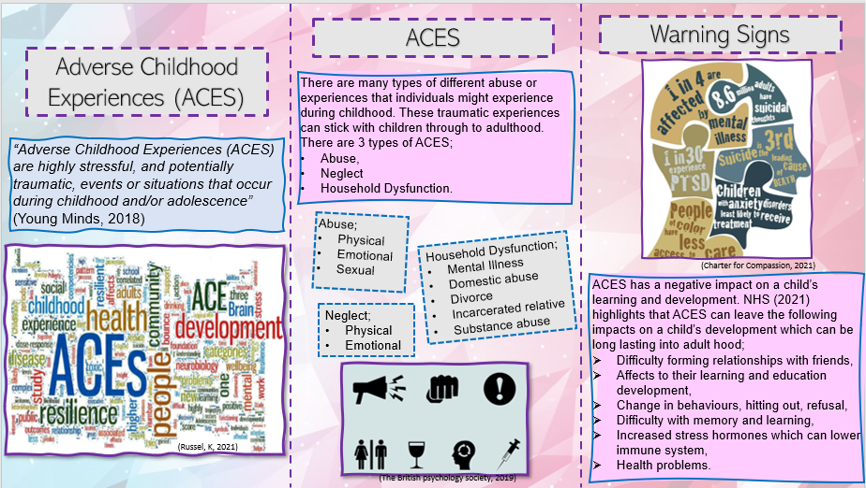
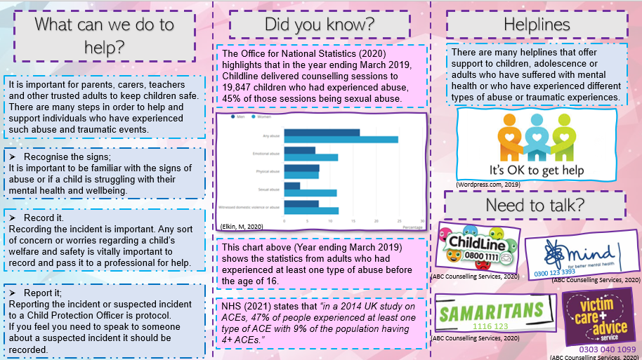
ACEs Image. (2019). Adverse Childhood Experiences (ACES). Available at: https://www.bps.org.uk/news-and-policy/adverse-childhood-experiences-aces (Accessed on 26th March 2021)
Chart. Elkin, M. (2020) Child abuse in England and Wales 2020. Available at: https://www.ons.gov.uk/peoplepopulationandcommunity/crimeandjustice/bulletins/childabuseinenglandandwales/march2020 (Accessed on 27th March 2021)
Elkin, M. (2020) Child abuse in England and Wales 2020. Available at: https://www.ons.gov.uk/peoplepopulationandcommunity/crimeandjustice/bulletins/childabuseinenglandandwales/march2020 (Accessed on 27th March 2021)
Mental health image. Charter for Compassion. (2021). Mental, Emotional, and Behavioral Well-Being. Available at: https://charterforcompassion.org/charter-tool-box-a-framework-for-getting-started/mental-emotional-and-behavioral-well-being (Accessed on 27th March 2021)
Help image. Kate. (2020) Studies in Feminist Activism. Available at: https://umbcactivism.wordpress.com/page/2/ (Accessed on 27th March 2021)
Helpline Images. ABC Counselling Services. (2020) Available at: http://abccounsellingservices.com/links/ (Accessed on 27th March 2021)
NHS. (2021). Adverse Childhood Experiences (ACES) and Attachment. Available at: https://mft.nhs.uk/rmch/services/camhs/young-people/adverse-childhood-experiences-aces-and-attachment/ (Accessed on 26th March 2021)
ACEs image. Russel, K. (2021) Available at: https://survivorswestyorkshire.org.uk/news/why-are-we-waiting-for-them-to-fall-apart-working-towards-a-trauma-informed-west-yorkshire-and-world/ (Accessed on 27th March 2021)
Young Minds. (2018). Addressing childhood adversity and trauma. Available at: https://youngminds.org.uk/media/2141/ym-addressing-adversity-infographic-poster-web.pdf (Accessed on 26th March 2021)

Throughout this paper, the writer will discuss safeguarding and child protection. One will explain what safeguarding and child protection is and why is it important. Safeguarding, according to the NSPCC (2021) is described as the process to protecting children’s welfare and wellbeing. The safeguarding process requires all procedures to care and support children to keep them safe from any harm. Child protection is a part of the whole safeguarding process. The child protection procedures describe how to act on concerns with regards to a child’s welfare and safety. The writer will highlight the policies and procedures that are in place with regards to protecting children and keeping children safe. This paper will be looking upon a case study where the policies have evolved over time due to a failure within the system. The writer will discuss the Child Protection Act (1989) and the importance of support and safeguarding it offers. The writer will discuss how school settings protect children’s welfare. Lastly, one will reflect back on to the leaflet one has created and why that topic has been chosen.
Many are often confused between safeguarding and child protection as they are sometimes seen as the same thing. Safeguarding is considered as the whole process that keeps children safe and promote a child’s welfare. The process involves procedures which all staff and adults who are caring for children should be trained on and able to carry out the relevant procedures in case of any concerns about a child’s welfare and wellbeing. Safeguarding focusses on keeping children safe at school, at home or in any sports or community clubs. All professionals who work with and support children on a day to day basis are aware and are trained with regards to safeguarding to keep children safe in all aspects of their life. Safeguarding training enables adults to more knowledge about the signs of abuse and what to look for when they have concerns about a child’s welfare. HM Government, (2018) highlights that “Nothing is more important than a children’s welfare. Children who need help and protection deserve high quality and effective support as soon as a need is identified.” This suggests that the training for safeguarding is essential and it educates adults on the procedures that need to be taken when a child’s welfare is a concern and who to report any concerns to. Any professional who works with children and families have a massive role in identifying and reporting concerns and it is vital for those to have the relevant and up-to-date training of the procedures when it comes to concerns for a child’s safety.
Child protection works alongside the safeguarding process which involves the recognising, recording, and reporting of a concern. According to the NSPCC (2021) “Child protection is part of the safeguarding process. It focuses on protecting individual children identified as suffering or likely to suffer significant harm. This includes child protection procedures which detail how to respond to concerns about a child.” This explains that the child protection procedures explain in more detail, the guide and instructions on how to report a concern.
In Wales, there is a child protection list which is made up of children who are believed to be at risk of at least one type of abuse whether it be, physical, emotional, sexual, neglect, or financial abuse (NSPCC, 2021).
HM Government (2018) states that
“All practitioners should follow the principles of the Children Act 1989 and 2004 – that state that the welfare of children is paramount and that they are best looked after within their families, with their parents playing a full part in their lives, unless compulsory intervention in family life is necessary.”
This statement suggests that children should be at their safest at home with their families and parent’s, but this is not always the case. There has been many cases where children’s welfare and safety has been a concern and the child protection procedures have been carried out and taken further to social services who then intervene with the families and remove the child from the situation or regularly monitor the child’s safety with home visits.
There has been many cases where the child protection authorities has had serious failures within the system. Looking into The Laming Report of Victoria Climbie, the system of the child protection authorities failed Victoria which led to end her life by murder. BBC News (2003) states that Victoria Climbie was a nine year old girl who moved to live with her great-aunt Marie-Therese Kouao. Kouao met her boyfriend Carl Manning who began to abuse Victoria on a daily basis. Victoria visited the hospital after the daughter of her child minder was concerned about Victoria’s injuries that she believed were non-accidental. As a precaution, the doctor alerted the child protection authorities. A social worker named Lisa Arthurworrey and police officer PC Karen Jones were assigned to the case. Kouao claimed that the injuries were from Victoria picking her own ‘scabies’ and the story was believed by the authorities and they had cancelled a home visit as they thought it wasn’t needed. Victoria had to make another trip to the emergency services at the hospital after scalding injuries to her head and face which were claimed to stop Victoria scratching her scalp and Victoria had apparently caused more injuries herself. The doctors suspected these injuries were caused deliberately and again alerts the authorities who then again believed the false story given by Kouao about how Victoria got her injuries. The child protection authorities allowed Kouao to collect Victoria when she was discharged from hospital. Victoria continued to suffer from tragic abuse, Kouao claimed to the social workers that Manning had assaulted Victoria sexually but then withdrew that statement a day later. PC Jones was asked to investigate further into why Kouao withdrew her statement, but no further actions were taken as the letter to Kouao went unanswered. Victoria was yet again rushed to hospital with hypothermia combined with malnutrition which then led to the doctor transferring her to intensive care where she was declared dead the next day. Victoria was tragically abused to her death and both Kouao and Manning were charged for her murder. “Dr Nathaniel Carey, the Home Officer pathologist who examines her body, finds 128 separate injuries and scars, many of them cigarette burns, and describes them as “the worst case of child abuse I’ve encountered.” (BBC News, 2003). In total, there were 12 chances that were missed that could have been prevented and saved Victoria. BBC News (2003) states that the two social workers who were assigned to Victoria’s case, had both been sacked for gross misconduct which suggests that they failed to protect and follow procedures to look after Victoria and keep her safe from the abuse she tragically experienced. This case shows a massive failure in the system and the social workers had many chances to follow procedure and had lack of communication in the authorities to save Victoria. This article proves that child protection procedures need to be followed and concerns for a child’s welfare and safety need to be taken seriously.
The All Wales Child Protection Procedures (AWCPP) (2008) is in place to protect children with concerns for their health and development. According to All Wales Child Protection Procedures (2008) “The Children Act 1989 introduced the concept of significant harm as the threshold that justifies compulsory intervention in family life in order to protect children.” (Torfaen, 2019. P. 59) The legislation describes significant harm to be mistreatment or the destruction of health and development. The procedures provide a guide for professionals to follow should a concern arise. “They provide a framework within which individual child protection referrals, actions, decisions and plans are made and carried out.” (Torfaen, 2019. P. 47). All children have rights to safety, life, development, protection, education, relationships and to be listened to. The United Nations Convention on the Rights of the Child (UNCRC) is a legal document made up of 54 articles which explains children’s rights and how the government should work to support these.
Schools play a fundamental role in protecting children. Children are in school for a large fraction of their childhood and all school professionals are trained within the safeguarding and child protection procedures. It is vital for professionals who work with children have a good understanding of the training and the procedures in case of a concern or disclosure. Article 3.1 highlights that “In all actions concerning children, whether undertaken by public or private social welfare institutions, courts by law, administrative authorities or legislative bodies, the best interests of the child shall be a primary consideration.” (The United Nations Convention on the Rights of the Child, 1989. P.4) This statement explains that it is vitally important for concerns regarding a child’s safety and welfare need to be reported as the child’s best interests and safety come first. All school professionals take safeguarding training to be able to have a good understanding of the safeguarding and child protection protocols in case of a disclosure or concern. All schools must have a safeguarding and child protection policy which enables all staff and families to be familiar with in order to keep the children safe and protected. Some schools have safeguarding cards with the guide to recording and reporting concerns and disclosures, it is also important to know who the safeguarding officers are should you need to report a concern to someone.
Reflecting back to the leaflet, the writer has chosen to discuss Adverse Childhood Experiences (ACEs) which highlights what ACEs is and the impact it has on individuals. The writer chose this topic as it is important to understand what ACEs is and the impact it has on a child’s learning and development. One believes ACEs are described as experiences which children and young people may unfortunately encounter which has a negative impact on their development with regards to their mental health and wellbeing. The writer highlights the statistics of abuse which is a substantial amount in the most recent years. Children with ACEs are more likely to have mental and physical health issues and are likely to carry those experiences through to adult life. The child centred approach to safeguarding highlights that children are vulnerable to abuse, neglect, and household dysfunction (HM Government, 2018). It is important to identify the warning signs for abuse, neglect, and household dysfunction to offer support and carry out procedures to keep those children safe.
To conclude on this paper, safeguarding and child protection work side by side. Safeguarding is known to be the process of keeping children safe and child protection is described as the procedures to carry out reports and recordings. It is important for all professionals who work with children or have contact with children and their families have safeguarding training to ensure they know the procedures to keep children safe. There has been many cases where some unfortunate children have passed due to being tragically abused to death and the child protection authorities have failed them by not following proceedings properly by law. The Child Protection Procedures are in place to provide protocols for concerns for a child’s welfare. In all schools it is important to provide safeguarding policies for staff to understand the procedures which are essential if a concern or disclosure should arise. These policies provide a guide to reporting and recording disclosures and concerns about a child’s safety, welfare, or health. Referring to the Laming Report of Victoria Climbie, it is sad to see that the child protection authorities ignored the signs of abuse and believed the false stories that the aunt gave them. This case should have been taken further and followed procedures correctly to avoid what had happened. One believes that safeguarding and child protection is vitally important when it comes to caring and protecting children. All children have the right to safety and to stay protected from potential danger. It is important to identify the warning signs for abuse to protect a child’s safety and prevent any further experiences. ACEs can have a negative impact on a child’s learning and development and is important to recognise the signs and be aware of how to deal with concerns. Children have the right to be safe and protected and it is down to the adults who care for them to ensure this is the case.

BBC News. (2003) Timeline: Victoria Climbie. Available at: http://news.bbc.co.uk/1/hi/uk/2062590.stm (Accessed on 28th March 2021)
HM Government. (2018) Working together to Safeguard Children. Available at: https://assets.publishing.service.gov.uk/government/uploads/system/uploads/attachment_data/file/942454/Working_together_to_safeguard_children_inter_agency_guidance.pdf (Accessed on 28th March 2021)
Local Safeguarding Children Boards in Wales. (2019). All Wales Child Protection Procedures (2008). Available at: https://www.torfaen.gov.uk/en/Related-Documents/ChildrensServices/ChildProtection/All-Wales-Child-Protection-Procedures.pdf (P. 47 & 59) (Accessed on 28th March 2021)
NSPCC. (2021). Child Protection system in Wales. Available at: https://learning.nspcc.org.uk/child-protection-system/wales (Accessed on 28th March 2021)
NSPCC. (2021). Safeguarding and Child Protection. Available at: https://learning.nspcc.org.uk/safeguarding-child-protection (Accessed on 28th March 2021)
NSPCC. (2021). What is safeguarding? Available at: https://thecpsu.org.uk/help-advice/introduction-to-safeguarding/what-is-safeguarding/ (Accessed on 27th March 2021)
Save the Children. ( Available at: https://www.savethechildren.org.uk/what-we-do/childrens-rights/united-nations-convention-of-the-rights-of-the-child (Accessed on 28th March 2021)
The United Nations Convention on the Rights of the Child. (1989). Convention on the Rights of the Child. Available at: https://downloads.unicef.org.uk/wp-content/uploads/2010/05/UNCRC_united_nations_convention_on_the_rights_of_the_child.pdf?_adal_sd=www.unicef.org.uk.1616955043478&_adal_ca=so%3Dgov.wales%26me%3Dreferral%26ca%3Dreferral%26co%3Dhttps%253A%252F%252Fgov.wales%252Fchildrens-rights-in-wales%26ke%3D(not%2520set).1616955043478&_adal_cw=1616954809838.1616955043478&_adal_id=7330b764-7b3d-4396-9a83-29de03b5923b.1610742635.7.1616954810.1616954810.0a9cacd3-087a-44fa-8323-27d7da8a7cae.1616955043478&_ga=2.41736162.1194320002.1616954808-1067386509.1610742631 (P. 4) (Accessed on 28th March 2021)

