DS 1 Scott Young

My Screenshots/Photos

Screenshot/Photo 1
[Insert Photo/Screenshot below]

This image shows a picture of my television. I use the television to watch my favourite sports shows and catch up on the news. Prior to this, I used newspaper articles. I also use this for my autistic daughter as it can help with meltdowns and regulation.

Screenshot/Photo 2
[Insert Photo/Screenshot below]
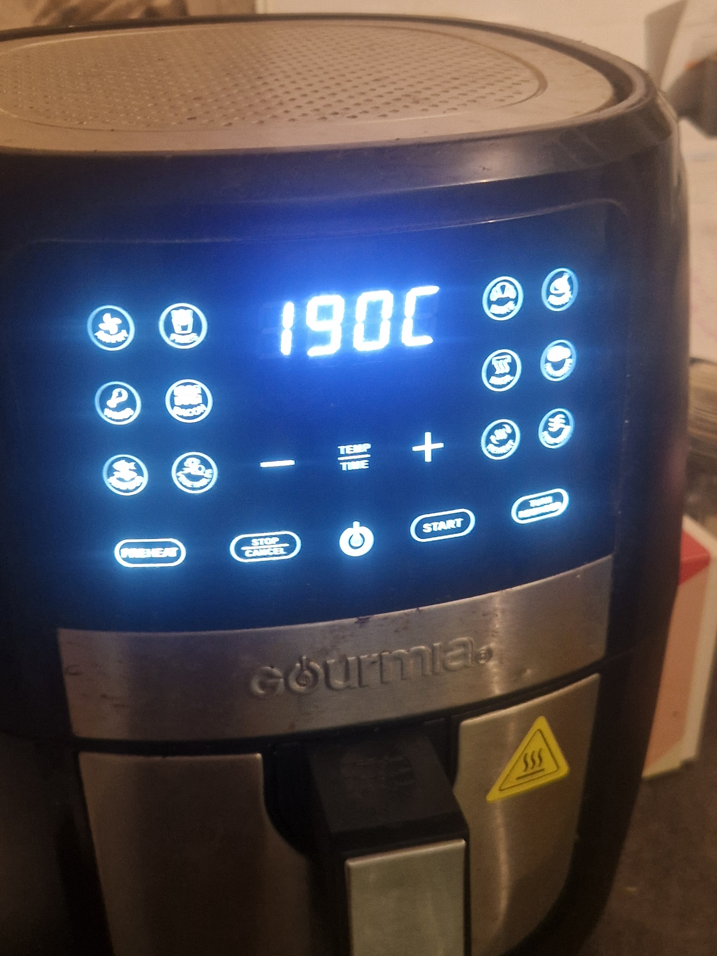
This image shows a picture my airfryer which I use daily to cook with. It can cook a variety of foods and cuts down cooking time quite a lot. It is one of my favourite ways to cook meat as it makes it more crispy.

Screenshot/Photo 3
[Insert Photo/Screenshot below]
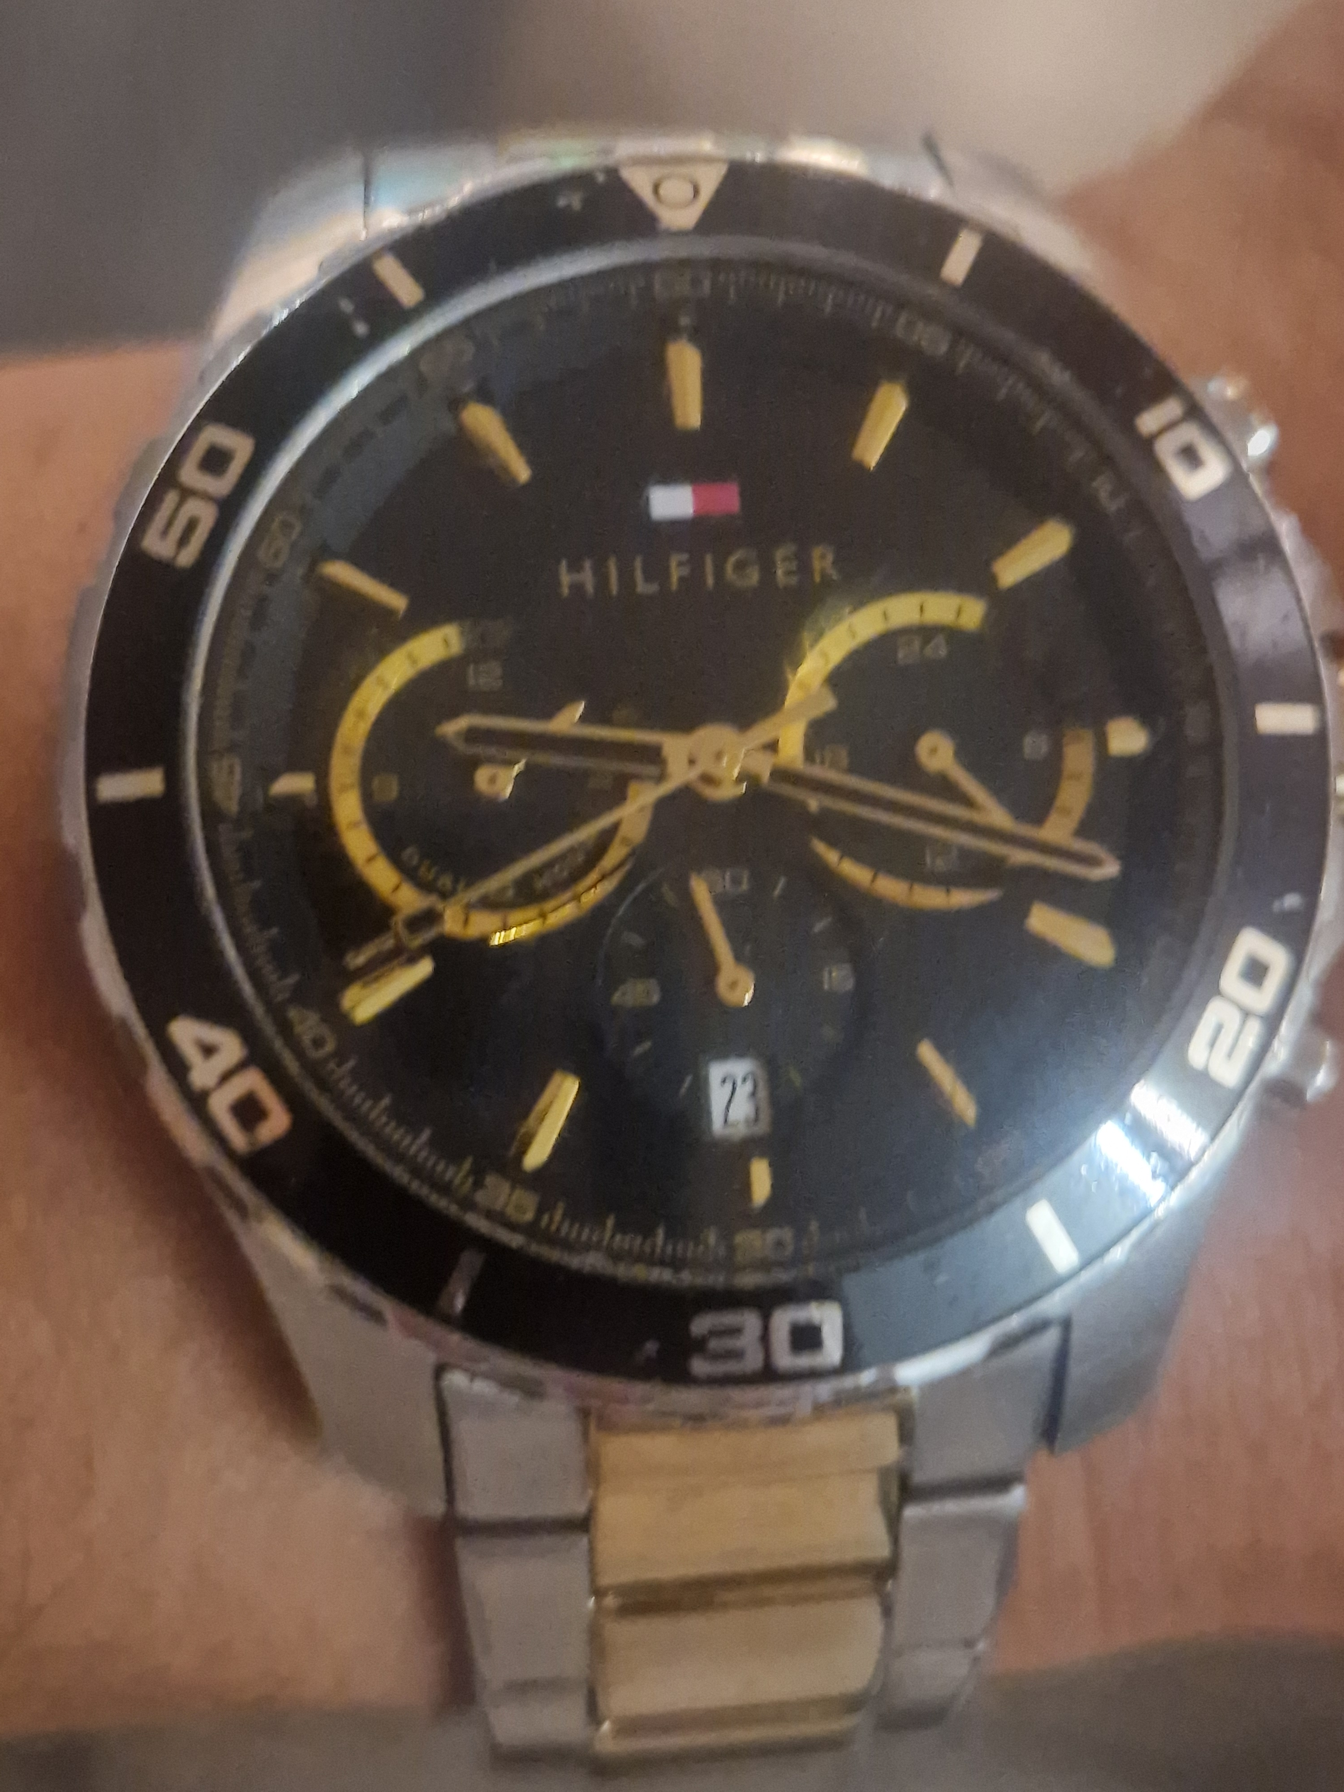
This image shows a picture of my watch which I use daily. I use this everyday to get anywhere I need to be on time e.g. work, university or picking up my daughter. I would be lost without my watch and notice it if it is not on my wrist. It was a gift from my family and I treasure it.

Screenshot/Photo 4
[Insert Photo/Screenshot below]
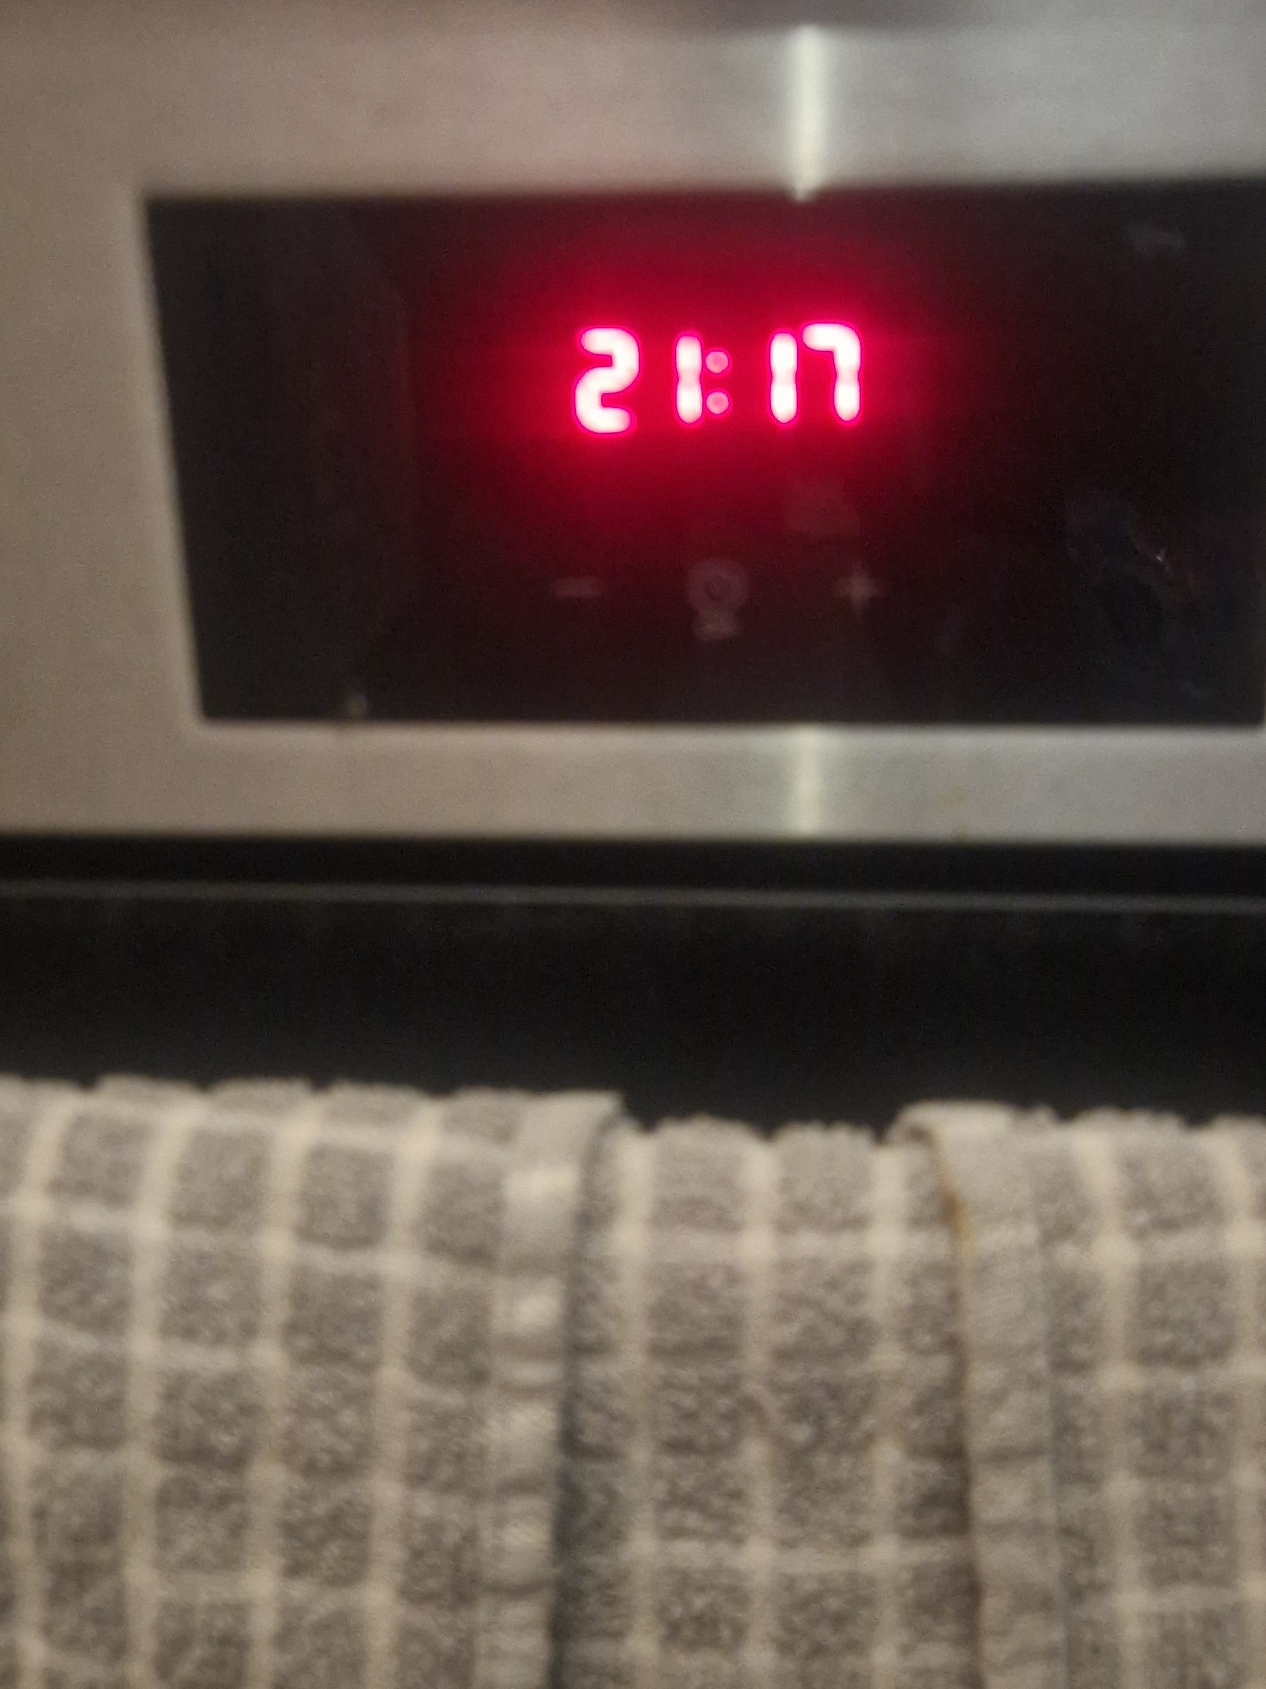
This image shows a picture of my cooker which I use sometimes. I enjoy easy sheet pan meals with meat and potatoes, so this device cooks it perfectly for me. My wife likes to bake and so I enjoy all the products that she makes. It is integral in our lives and we could not live without it.

Screenshot/Photo 5
[Insert Photo/Screenshot below]
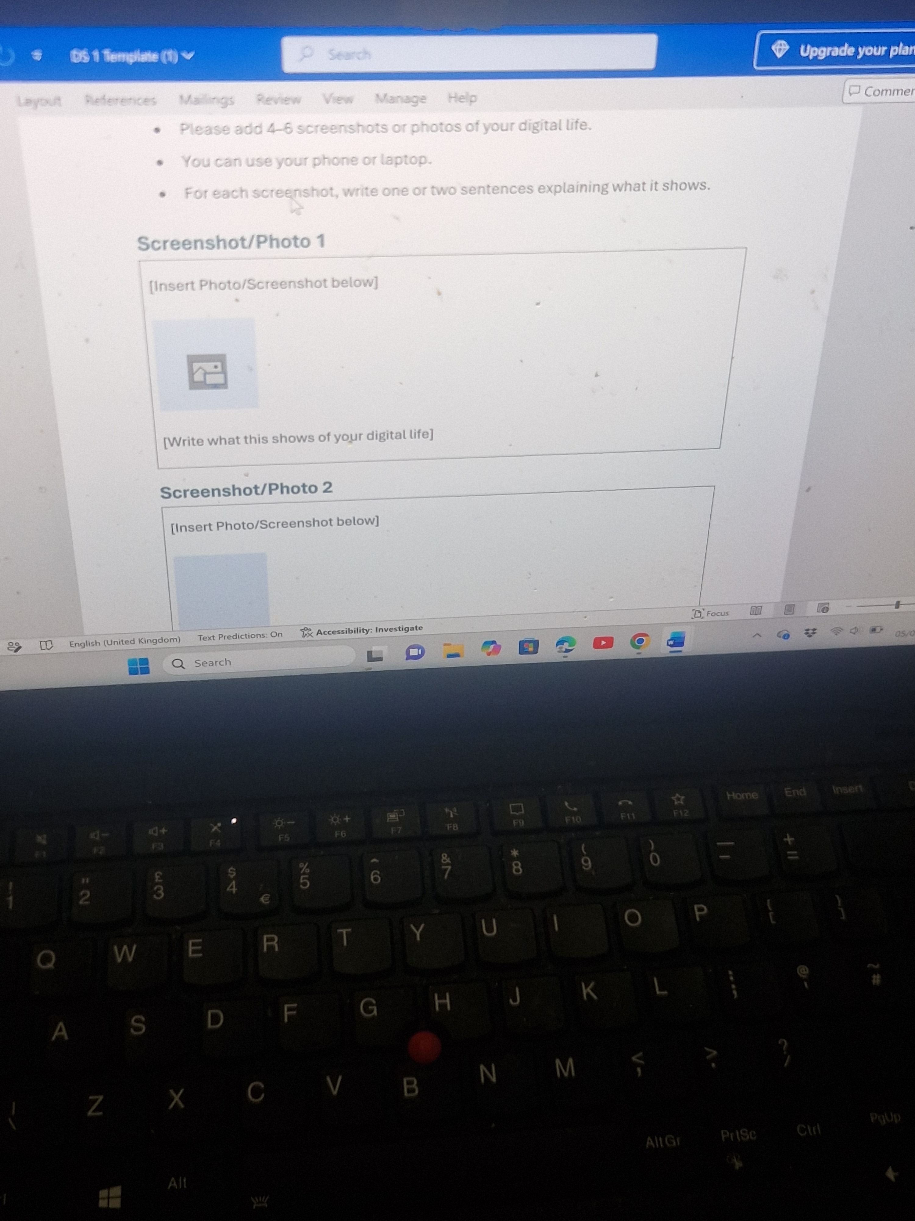
This image shows a picture of my laptop which I do not use that often. This is probably the digital tool I use the least in my house. I do not have a lot of experience with computers in general, as my job is manual labour. I would like to strengthen my skills in this area which in turn, will help with this course. I can use this skill for the rest of my life once learnt.

Screenshot/Photo 6
[Insert Photo/Screenshot below]

[Write what this shows of your digital life]

My Short Reflection

I use digital tools in various aspects of my life, especially at home. I want to improve my skills for example using a laptop. I hope this module teaches me how to better my laptop skills. Digital skills are important to me as we live in a digital world and it will give me the skills I need to complete this course. I sometimes feel nervous that I won’t be able to learn, but I am confident in my resilience to try.

Submission Checklist
Before you submit, please check:
​​​ ☒ I added 4–6 screenshots
☒ I wrote short sentences for each screenshot
☒ I wrote my short reflection
☒ My work is my own
☒ My file opens correctly
​​☒ My file opens correctly

