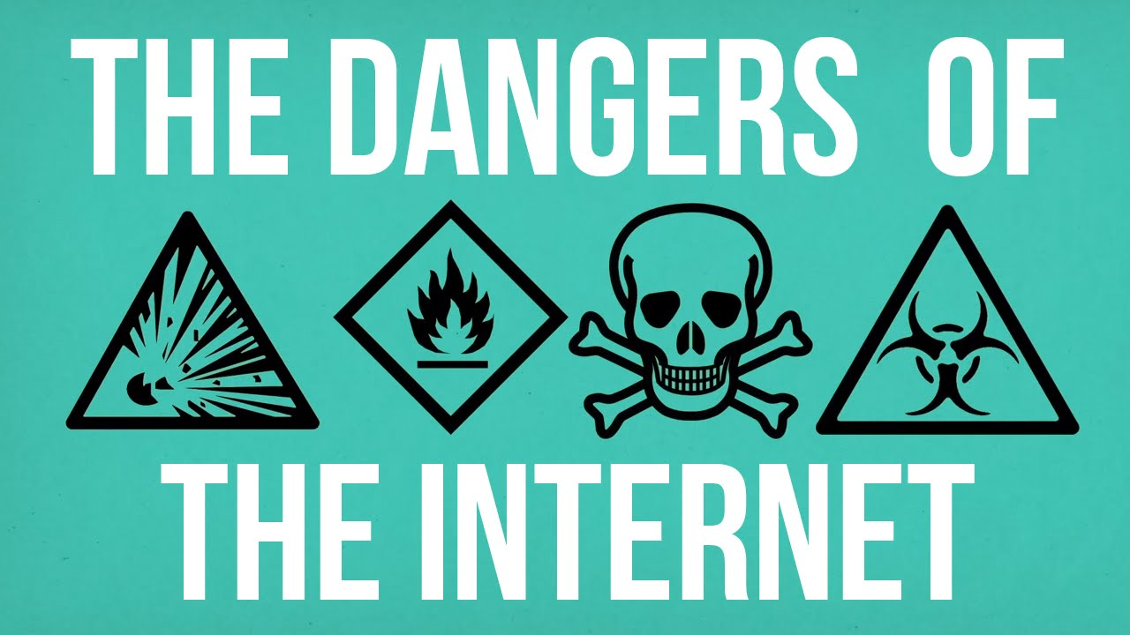

By Jake Eggerton

Introduction
The use of social media is rising with more than 99% of young people between the ages of 16 and 24 using social media platforms once a week or more. This same age group spends an average of two and a half hours a day on FaceBook, Twitter, LinkedIn, Instagram, YouTube and other media sites (Elder, 2016). This practice log will discuss the impact this use is having on young people in the UK and what Youth Workers need to be aware of in order to tackle and ensuing issues. It will focused specifically on issues around role models, body image, physical inactivity, cyber-bullying and the lack of face-to-face communication. Finally it will discuss what youth workers can do to address this.


Creativity
Young people today have a wealth of information at their fingertips yet still complain of boredom. They are also more likely to read brief and quick to finish articles online rather than books, as their attention span is short. This is supported by Jeffries (2013) who states ‘nearly 2,500 teachers’ finds that 87% believe new technologies are creating an easily distracted generation with short attention spans’. It could be argued that this is having a negative impact on creativity and writing skills because if young people are not accessing literature in the form of books then perhaps their writing skills are being weakened as a result. Although there are a plethora of websites that focus on art, music and other creative pursuits many young people prefer to look at what others have done rather than be inspired by them to develop their own creative projects. However, using the internet to become more creative has been argued by Chamorro-Premuzic (2015) who says ‘The internet has lifted the wall between creators and the public, making creativity more meritocratic.’ Young people are less prepared these days to spend time on something and opt instead for a quick fix or easy option. This could be linked to a fear of failing and in part due to them having less staying power to see something through. As youth workers we need to encourage, inspire and develop young people’s creativity through games, activities, challenges and workshops. So that they can get the most out of every day and what it has to offer.

Cyber-bullying
Ofcom (2017) cited on the NSPCC website says that ‘Around 1 in 8 young people have been bullied on social media.’ A survey carried out by the Children’s Society has found that the mental health of young people is at risk because social networking sites are failing to deal effectively with cyber-bullying (BBC, 2018). Of the 1089 who took part in the survey, 50% of them had been subject to unwanted messages, with many of them saying they would not tell their parents. Another survey carried out by Opinium of 1002 children between the ages of 11-18, carried out for a children’s charity, revealed that 235 of 486 girls had experienced online abuse compared with 202 of 510 boys (Marsh, 2017). Furthermore, Lucy Russell (2017), the charity manager, states ‘What we find is the nature of abuse differs, and if you look at what girls are experiencing offline….that is being experienced in the online world.’ They also found that ‘Girls are being told what to wear, how to look, to shut up about their opinions’. Whilst some adults might suggest that young people should therefor limit their internet use this can be seen, as one 15 year old respondent said ‘as taking something away from a young person for something that’s not their fault’ (BBC, 2018). A better and more realistic approach is for youth workers to have regular and open conversations with the young people they work with about staying safe online. They need to encourage young people to report online bullying and give users guidelines for correct online use. Workshops should be organised to address issues around online sexism and the effects of cyber-bullying. For example, Zero Tolerance and YWCA Scotland run training courses to equip their youth workers with the skills to tackle sexual abuse issues both online and in the real world. There is evidence to support this approach, with professionals stating that ‘dealing with it as part of wider bullying and relationship discussions has greater impact’ (Media Team, 2014). In this way youth workers can be seen to be dealing with cyber bullying in a positive impact on young people they work with.


Physical Inactivity
According to the Office for National Statistics (2016) Internet usage is on the increase, especially amongst young people with ‘one in three internet users being children’ (Livingstone, Carr, Byrne, 2015). Young people use the internet for all sorts of reasons including; Gaming, social media, messaging, videos, studying, sharing photos and many other things (No Name, No Date). However, with an ever increasing use of the internet amongst young people comes more young people at risk of physical inactivity. According to Hopkins (No Date) a ‘Lack of physical activity can add to feelings of anxiety and depression’ and according to the World Health Organization (2018) ‘Insufficient physical activity is one of the leading risk factors for death worldwide.’ Last year ‘There were over 12,000 counselling sessions with young people who talked to Childline about online issues’ (Bentley, 2017). This is why as youth workers we should strive to be as fun and active as possible to tempt young people away from the/their computers. Adams (2017) states that the NHS conducted a study that found that ‘nearly HALF of all young people are overweight’ in the United Kingdom. It could be argued that as the use of the internet increases, so would physical inactivity thus suggesting that these interlink. Although, a study carried out by Zack and Lissitsa shows ‘Engagement in three Types of PA (Physical Activities) was higher among internet users than non-users’. As youth workers we must take responsibility for providing young people with activities both physically, and mentally challenging. Taking them away from the internet and the digital world can have such a positive effect on their physical and mental health. Especially when ‘Nearly two-thirds (60%) of teenagers feel no connection with their local community and many are more influenced by people they don’t know than those around them’ (Barclays Spaces for Sport, 2009). That is why in part it is up to us as youth workers to make it fun and interesting to entice young people away from the internet, so we can help build that connection with the community. Youth work can be so crucial to a young person, it is down to the youth worker to help keep them active. Although, some studies like Zach and Lissista show that young people who use the internet participate in more physical activities. The fact that more young people are becoming overweight and more young people are using the internet cannot be ignored, and should be a focus for youth workers.

Role Models
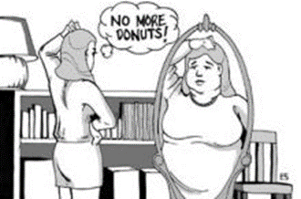
Barclays Spaces for Sport (2009) carried out a survey and found ‘One in four teenagers admit they are more influenced by celebrities than people they know’. If people see that celebrities are luxurious and popular, many young people will try and imitate that celebrity’s life style. This will eventually lead to a life style that that certain person can’t afford. Trying to mimic celebrities’ lifestyles can be so detrimental to a young person’s life. It could impact many aspects of their life, just to name a few, it could impact their ‘personal development, community involvement and existing health lifestyles’ (The Telegraph, 2009). ‘Celebrities are judged by the public on how they portray themselves to us’ (TRIAD Moms on Main, 2014). This can lead to celebrities having break downs. Therefore, young people should not be seen as the same but in fact, young people have already adopted this way of judging one another. This way of judging one another has probably contributed to the statistic that ‘Almost 1 in 4 young people have come across racist or hate messages online’ (Livingstone, 2014). Although comments on social media are only opinions, they still have such a huge impact on the receiver whether positive or negative. Even when young people have positive role models, there is nothing to say that role model will stay a good one. For example when Miley Cyrus started her career on Hannah Montana she was a good role model. But as Miley has got older she has become one of the worst role models (TRIAD Moms on Main, 2014).

Body Image
According to the PrioryGroup, a leading provider of behaviour care , over 1.6 million people in the UK display signs of an eating disorder, with those between 14-25 being most affected and 11% of that figure being male (PrioryGroup, No Date). Furthermore, a treatment centre in Chicago states that 30-50% of its teen patients use social media to support their eating disorder (Goodtherapy, 2016). Whilst there are also websites that fight against those that support anorexia, the link between social media and low self-esteem, leading to a negative idea of body image is strong. In a research article by Groesz, Levine and Murnen (2001) results backed the idea that media ‘upholds a slender ideal that elicits body dysmorphia’. The report states that, whilst the ideas of perfect body image differ between boys and girls, social media still puts pressure on them to conform to the ideals. Youth workers need to not underestimate the role that social media plays in teenagers lives. Donna Wick (No Date), founder of Mind-to-Mind Parenting, says that ‘the power of a visual image is strong. It’s disorienting’. Teenagers who have grown up in a world with social media everything that happens online is real.

Youth workers need to take what young people say seriously and not make light of their problems or dismiss them. Youth Centres should focus on workshops and activities that deal with body confidence that give young people a safe space to discuss and share experiences. The British Youth Council- Youth Select Committee 2017 report ‘A Body Confident Future’ stresses the importance education plays in challenging unhappiness with body image ‘both in encouraging positive behaviours and helping to cope with negative influences’. Positive body image can also be promoted by Youth Workers through sports and other physical activities that shift focus away from what a body looks like to what it can do.

Face-to-Face Communication

These days, young people utilize all the more new current web-based social networking to communicate with friends rather than old-fashioned face-to-face communication. Online networking bonds young people together regardless of distance and time. The more young people communicate online and the less time they spend communicating face-to-face, the more likely they are of losing the skill of interacting face-to-face (No name/No date). This is supported by The Learning Factory (2017) state that ‘Millennials Are Struggling With Face To Face Communication’. Another reason why young people may struggle with face to face communication is because one of the main ways young people communicate is through the internet.



When communicating through the internet you have the ability to edit the message before sending it, thus removing any mistakes or any emotion. Although this way of messaging has its advantages, it also puts pressure on young people to constantly be faultless and to be been seen in a positive way. But this puts pressure on young people to be perfect all the time, this can lead to the creations of personas. This is supported by Jacobson (2018) who says ‘Teens who have created idealized online personas may feel frustrated and depressed at the gap between who they pretended to be online and who they truly are’.

Here are tips by Caroline Knorr (2018) for Parents and Youth Workers to use, to help you understand and manage your young person’s online use.
Tips for Parents and Youth workers of young kids
- Limit screen time. Kids grow and thrive best through personal interaction. Spending time with them, playing, and reading are great ways to build a foundation to impart your values.
- Find age-appropriate content. Kids ages 2-7 should be exposed to media featuring good role moles, racial and gender diversity, and no stereotypes.
- Encourage positive socialization. Look for role models who impart positive social lessons, like sharing and being a good friend.
- Respect differences. Encourage kids this age to accept and respect people who are different by exposing them to media that includes people of diverse backgrounds.

Tips for Parents and Youth workers of teenagers
- Avoid stereotypes. Point out strong female characters or male characters who share their feelings. Try not to reinforce stereotypes in media selection (i.e. princess movies for girls and truck videos for boys), since that can reinforce societal imbalances.
- Reinforce your values. Point out words and behavior in popular TV shows, websites, and music that are both positive and negative examples of what you do and don't want your kids to model. What you say to your child is up to you, but have the discussion.
- Flag antisocial behavior. Teenagers like to imitate and pretend to be their favorite characters. When characters say mean things or behave cruelly, discuss the consequences.
- Go with the good stuff. Teenagers will be inspired by great historical figures, athletes, or TV stars. Take advantage of that adoration by pointing out their good traits, as in, "George Washington was honest. Honesty is an important quality." Not: "Lying is bad. Children who lie get in trouble."

Tips for Parents and Youth workers of young adults
- Embrace what they like. Rejecting your Young adults' love of popular culture can close off avenues of communication. Embrace their world, but establish clear boundaries about what you find acceptable and appropriate. Talk about celebrities that cross the line.
- Help teens balance their need for rebellion and self-expression with an appreciation of acceptable social action. Young adults need to understand how to communicate and use media wisely and ethically. If they engage with media that includes antisocial behavior, make sure they understand the impact and potential consequences.
- Let older kids see things you don't agree with. But then discuss exactly what you don't like with them. Since we won't always be around, we need to make sure to instill critical-thinking skills in our young adults.
- Don't shy away from pointing the finger. If your young adults (or their schoolmates) are heavy media users and they demonstrate or are on the receiving end of any antisocial behavior or experience eating disorders, addictions, low school performance or depression, connect the dots -- and disconnect the source.

Conclusion

This Practice Log has considered the negative impacts that social media could have on young people in the United Kingdom. It has focused specifically on issues around role models, body image, physical inactivity, cyber-bullying and the lack of face-to-face communication. Finally it has discussed what youth workers can do to address this.

Reference List
Adams, S. (2017) Generation fat: Shocking new figures reveal nearly HALF of all young people are overweight and three million now risk dying earlier than their parents. Available at: http://www.dailymail.co.uk/health/article-4636232/Figures-reveal-nearly-HALF-young-people-overweight.html.
Barclays Spaces for Sport. (2009). Diversity back Barclays Spaces for Sports. Available at: https://www.home.barclays/news/2009/08/britain-s-got-talent-winners-diversity-back-barclays-spaces-for-sports.html
BBC. (2017) Schools 'should help children with social media risk'. Available at: http://www.bbc.co.uk/news/uk-42563173.
Bentley, H. et al (2017). NSPCC – Online abuse Facts and statistics. Available at: https://www.nspcc.org.uk/preventing-abuse/child-abuse-and-neglect/online-abuse/facts-statistics/.
British Youth Council – Youth Select Committee. (2017). A Body Confident Future. Available at: http://www.byc.org.uk/wp-content/uploads/2017/11/Youth-Select-Committee-A-Body-Confident-Future.pdf.
Chamorro-Premuzic, T. (2015) Is technology making us more creative. The Guardian; Media and Network. Available at: https://www.theguardian.com/media-network/2015/jun/18/technology-creative-creativity-web-content.
Elder, R (2016). 99% of young British people use social media every week Available at: http://uk.businessinsider.com/99-of-young-british-people-use-social-media-every-week-2016-8.
Goodtherapy. (2016). Thinspiration: The Dangers of a Pro-Ana/Pro-Mia Lifestyle. Available at: https://www.goodtherapy.org/blog/thinspiration-the-dangers-of-a-pro-ana-pro-mia-lifestyle-0415167.
Groesz, L, M. Levine, M, P. and Murnen, S, K. (2001). The Effect of Experimental Presentation Thin Media Images on Body Satisfaction A Meta – Analytic Review. Available at: http://athena.uwindsor.ca/users/j/jarry/main.nsf/0/aa9ed943e56182bf85256abe005bc3f6/$FILE/Groesz%20et%20al%20(2002).pdf.
Hopkins, J. (No Date). John Hopkins Medicine – Risks of Physical Inactivity. Available at: https://www.hopkinsmedicine.org/healthlibrary/conditions/cardiovascular_diseases/risks_of_physical_inactivity_85,P00218
Jacobson, R. (2018) Social Media and Self-Doubt – How parents can help kids resist the pressure created by artfully curated social media feeds. Media and Tech.
Jeffries, D. (2013) Is technology and the internet reducing pupils' attention spans?. The Guardian; The Teaching Network. Available at: https://www.theguardian.com/teacher-network/teacher-blog/2013/mar/11/technology-internet-pupil-attention-teaching.
Knorr, C. (2018). Why Media Role Models Matter - There's no guarantee that a star will stick to a lifestyle that kids can look up to or that you'll approve of. Available at: https://www.commonsensemedia.org/blog/why-media-role-models-matter.
Livingstone, S. (2014). NSPCC – Online abuse Facts and statistics. Available at: https://www.nspcc.org.uk/preventing-abuse/child-abuse-and-neglect/online-abuse/facts-statistics/.
Livingstone, S. Carr, J. and Byrne, J. (2015) Online abuse Facts and statistics. NSPCC. Available at: https://www.nspcc.org.uk/preventing-abuse/child-abuse-and-neglect/online-abuse/facts-statistics/.
Marsh, S. (2017). Half of UK girls are bullied on social media, says survey. Available at: https://www.theguardian.com/uk-news/2017/aug/14/half-uk-girls-bullied-social-media-survey.
Media Team. (2014). New research to tackle abuse online. Available at: http://www.edinburgh.gov.uk/blog/newsblog/post/79/new-research-to-tackle-abuse-online.
No Name. (No Date). Lack of face-to-face communication. Available at: https://lackofcommunicationatou.weebly.com/lack-of-face-to-face-communication-skills-due-to-social-media.html.
No Name. (No Date). Technology and teenagers. Available at: https://parents.au.reachout.com/skills-to-build/wellbeing/technology-and-teenagers.
Office for National Statistics. (2016). Internet users in the UK: 2016. Available at: https://www.ons.gov.uk/businessindustryandtrade/itandinternetindustry/bulletins/internetusers/2016.
Oxfam. (2017) Online abuse Facts and statistics. NSPCC. Available at: https://www.nspcc.org.uk/preventing-abuse/child-abuse-and-neglect/online-abuse/facts-statistics/.
PrioryGroup. (No Date). Eating disorder statistics. Available at: http://www.priorygroup.com/eating-disorders/statistics.
Russell, L. (2017). Half of UK girls are bullied on social media, says survey. Available at: https://www.theguardian.com/uk-news/2017/aug/14/half-uk-girls-bullied-social-media-survey.
The Learning Factory. (2017). Millennials Are Struggling With Face To Face Communication. Available at: http://learningfactor.com.au/millennials-are-struggling-with-face-to-face-communication-heres-why/.
The Telegraph. (2009). Teenagers most influenced by celebrities. Available at: https://www.telegraph.co.uk/news/uknews/6012322/Teenagers-most-influenced-by-celebrities.html.
TRIAD Moms on Main. (2014). The Top 10 Best and Worst Celebrity Role Models. Available at: http://triadmomsonmain.com/my-blog/the-top-10-best-and-worst-celebrity-role-models/.
Wick, D. (No Date) Cited in Jacobson, R. (2018) Social Media and Self-Doubt – How parents can help kids resist the pressure created by artfully curated social media feeds. Media and Tech.
World Health Organization. (2018). Fact Sheet – Physical activity. Available at: http://www.who.int/news-room/fact-sheets/detail/physical-activity
Zach, S. Lissitsa, S. (2016) Internet use and leisure time physical activity of adults – A nationwide survey. Available at: https://www.researchgate.net/publication/295078980_Internet_Use_and_Leisure_Time_Physical_Activity_of_Adults_-_A_Nationwide_Survey.

